Component 2 - Research Report
Student Name: Claudette A Grizzle
Student Number: 2208454
Lecturer Name: Chuen Leung
LCHS4002_BIRM
Digital Skills and Research Methods.

Contents
INTRODUCTION …………………………………………………………………………………….1
2. Research design 3
2.1. Research Question 4
2.2. Method 4
2.3. Ethical Considerations 5
3. Results 5
4. Discussion 7
5. Conclusion 8
6. Reference List 9
7. Appendix A – A blank copy questionnaire. 9

Introduction

This report will explain how a group of researchers, came together to put forward a proposal to collate information from students attending the University of Wales Trinity Saint David. Following the Covid-19 Pandemic, which caused the education system to rethink how students would benefit from online learning and training. All education establishments around the world had to reconsider their academic approach, teaching styles, and ethical practice in delivering various subjects to their students. (Zaidi et al; 2022)
This research proposal will be conducted and shall take place at UWTSD on 3rd October 2022 at Sparkhill Campus Birmingham where students can give constructive feedback on how they study using digital resources at UWTSD to collaborate with their peers.

Research design
How do students use technology at UWTSD?
Students use technology for online learning activities, online research, and general office documentation including , Excel, PowerPoint presentations, and communications for example: email, text, and social media. Online meetings, conferences, and live lectures are often conducted using a video conferencing platform (Zoom, Teams) that can be used through a computer desktop, laptop or mobile app. This allows users to attend remotely. Students can also view or listen to pre-recorded lectures and webinars whilst staying on track in lessons so they can complete all necessary assignments required for the completion of the course.

Research Question

Is there a need to provide training on how to use technology to collaborate?
Yes! there is a definite need to provide training at UWSTD for students as it is critical for the development and learning of all students and teachers alike. (UWTSD, 2022). At the UWTSD lectures are available to provide additional learning and support classes, which take place during the afternoons between the hours 1.15pm-2pm. These sessions, provide additional learning, and understanding at the Sparkhill campus in Birmingham, the insight and understanding of what type of information to research, how to research it, where to find it, and why it is important to gather correct information, and how this is required in the class, and vital when sharing knowledge, and tips on modules. By using various digital applications supports the learning. This is most beneficial for all students, when studying and reading as it supports and identifies a clear understanding of the subject matter, accompanied with additional learning for the individual completion of assignments and challenges the students have by face-to-face contact. Presentations and written work, permits for a deeper understanding of the subject matter, as the content needed for the digital aspect corporates a holistic view of studying at UWTSD. This provides the necessary outcome for all students. The support for all the students, included at UWTSD providing a Digi Centre area, which provides available access, for the individual students to gather, collate, and discuss any queries with available staff members, so they too obtain a much more understanding of the information necessary to complete the course. Therefore, discussing and sharing with a variety of individuals allows for a greater, understanding of the technology used onsite, this permits for the continued understanding whilst the students were working off site, of the university grounds and supports those competent as well as those requiring additional support. (UWTSD, 2022)

Method

The method focused on by the research team, was a question survey being a quantitative approach, as this provided the research team with the opportunity, to contact students’ anonymously of those attendants of UWTSD via email by using an online self-administered questionnaire. The email requested their participation, in a two-minute survey that, they would read through, complete and return it in a timely manner.
The questions are not intrusive or unethical where it infringes on religion, ethnicity, disability, age, gender or race. This method provided practical contact and data which completed the use of the survey. (Equality Act, 2010)
However, due to the lack of response, a decision was made by the research team for a portion of the questionnaires to be handed out and returned to the lectures class reducing intrusiveness as face-to-face contact was by the lecture only, promoting confidentiality and maintaining their identity. The data provided by the questionnaires was collated and input on the system. Therefore 3% of the UWTSD student’s results completed was carried out by face to face contacted and the remaining 7% online. (UWSTD 2022)

Ethical Considerations

The research team considered the storing of all student’s personal information according to the guidance of the General Data Protection Act 2018. According to Article 4 of the GDPR, personal data is defined as, any information that relates to an identified or identifiable natural person. In other words, personal data is any data that is linked to the identity of a living person.

The research teams scoping is a vital point of clarification this stipulation requires discussion during early phases equally, distinctions of methodology and methods must be understood by novice researchers were basic concepts and terminology particular to the research process (Nyame-Asiamah & Patel, 2009; Bouma & Ling, 2004)
The responses that came from the students that participated, were stored on a hard drive and only kept by the research team, who gathered the required information. However, those that were completed face to face, required the paperwork to be stored and kept in a lockable cabinet allowing no access apart from the research team. This ensured that, no stress was added to the participants, as once the work was completed, and submitted all the relevant information and paperwork was destroyed once the semester was over. “The Compliance required by general equality duty is a legal obligation, but it also makes good business sense. An organisation that can provide services to meet the diverse needs of its users should find that it carries out its core business more efficiently.”. Equality and Human Rights Commission (2011).
- Results
The results provided within this report, highlights and strengthens the confidence, of the outcomes obtained throughout the questionnaire are accurate, as this is indicated through the responses listed below. The student’s response and diagrams seen below provides the visible outcomes and supports, how confident students are, at using various applications whilst using technology at UWTSD. I feel confident and convinced about the outcomes provided by students. This is solely based on the questions responses, and answers obtained which supported the outcome of the research.
There were five questions within the questionnaire, this included the first question that related to the 10 participants to provided consent, once consented they would, continue to answer all the remaining research questions. For the research project to have rationality, all questions and diagrams from question 1-5 provided all the necessary outcomes of all participants. This is indicated by its own individual colour and percentage. The most popular digital application is Google, with 6 respondants, this highlighted, applications used by students, and how students were comfortable using google. Whatsapp was the next application, used by students with 4 respondants, the following question highlighted Ms Word respondants strongley agreed confident use of the applicationn. Digicel highligted 6% of useage by students of UWSTD.

According to the questionnaire survey responses to each of the questions are shown below.

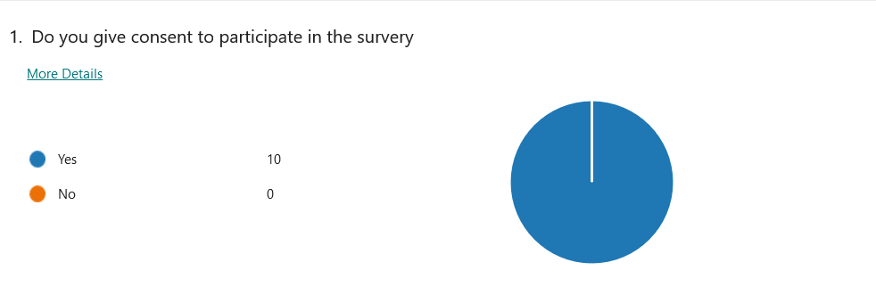

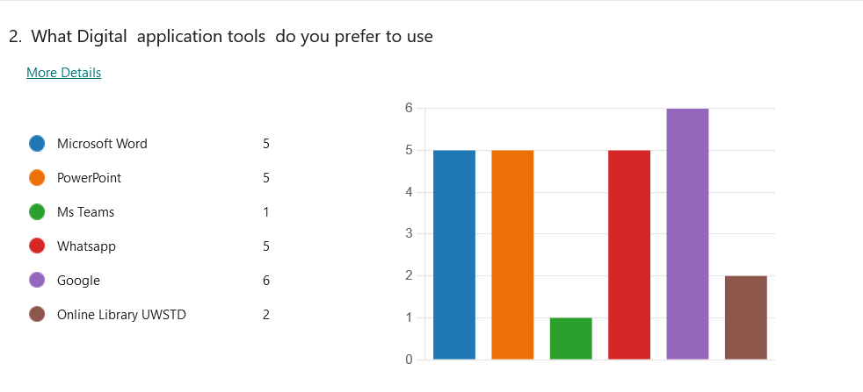
The most popular application is Google with 6 respondants
The next applications is Ms Word, Powerpoint and whatsapp
The least was online library with 2 respondants and Ms Teasm with 1 respondants
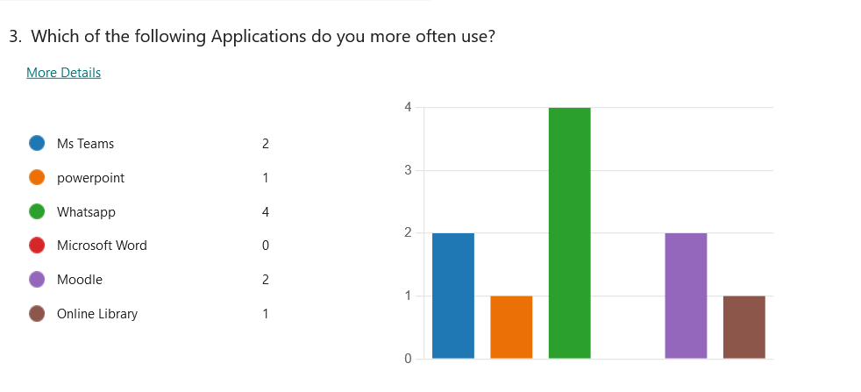
The respondents indicate WhatsApp was used more often.

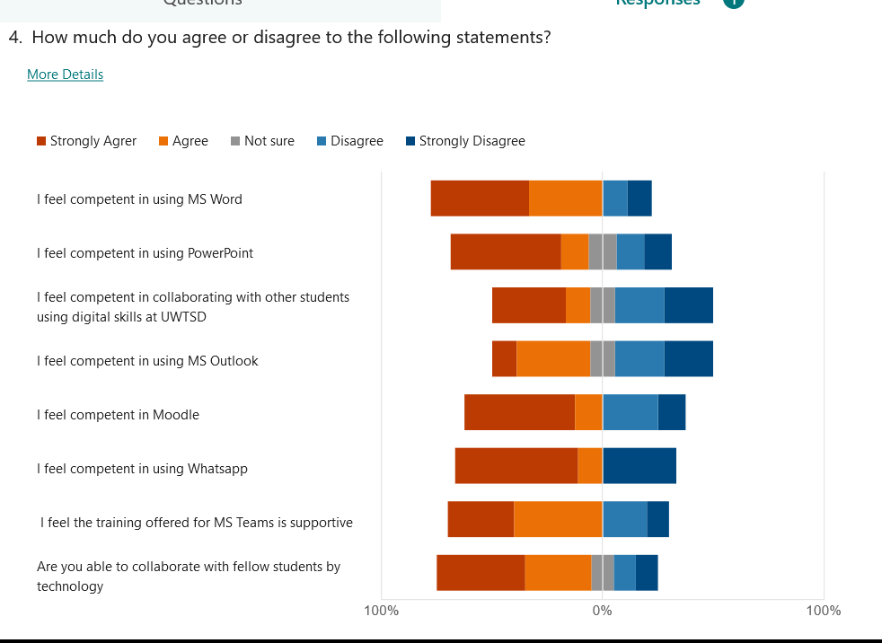
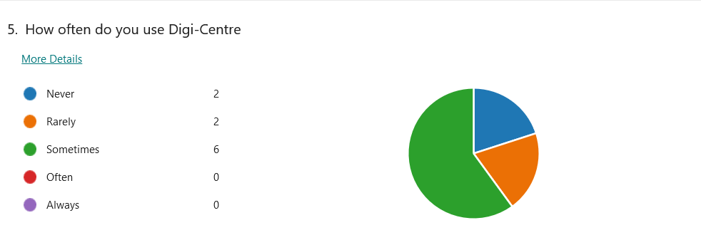
6 respondents indicated they use Digi-Centre .
2 respondents indicated they use Digi-centre rarely.
2 respondents indicated never.

Discussion

According to the results, that were highlighted by students of UWTSD are in general, quite confident in using technology. Therefore, the research team outcomes supports the need for UWSTD students, to be provided with additional training, on all applications that students, are unfamiliar with at UWTSD. This provides an opportunity for students to develops their confidence in using various applications, whilst challenging their learning, and abilities. While still incorporating their aptitude, to learn and understand, the benefits of all applications. As this, helps to determine and promote their job prospects, whilst challenging students. By welcoming the opportunity to enhance, what they have learned, then to apply what they have learned, supports to build the building blocks of becoming more technical by using more applications combined with digital application and skills.

- Conclusions
The conclusions
Within this report contains accurate information, which was gathered, and collated from the student’s questionnaire findings. This produced a color-coded graph, of the outcome findings, of applications that was used, by the students, of UWSTD, that participated in the questionnaire of UWTSD.
This identified the usage, of all applications by, students of UWSTD, by collaborating in groups, for the purposes of accessing meetings, presentations, group work and class discussions. This enriched, the student’s values and learning, while having access to various applications, that they may/may not have used before, on a regular basis. However, these applications would be necessary and required by all the students during the academic term of UWTSD.
The individual students support needs, opened-up other areas of access, and requirements, for the students to learn, or to discover if they are, natural netizen, or not, this helped to highlighted further understanding, of the technical applications, required for students to study, and use at UWTSD, and the type of supported needed if any individual students would require.
UWTSD understanding of how, important training, is for students, and much more collaborating, benefits those students attending UWSTD. This is vital for the understanding, of the teaching, provided by lectures, which includes communication, and language, that is provided by UWTSD.
In conjunction, to help and support those students, with or without the full understanding of technology, UWTSD teaching and student full understanding of the aspects, of applications required for students, to benefit, and learn.
Therefore teaching students effectively produces, better communication skills, and the understanding of each subject module, whilst having, the ability to relay, and document, findings effectively. Through dialog and written communication, not only demonstrates and provides the ability, of understanding, for students, but highlights how various applications, required for use by students of UWTSD.
They are not only obtaining the ability to be understood, for the requirement of study, but the ability to understand the inclusion purpose, alongside the importance of storing data. As it remains, essential as to how, it must be managed, according to current, general data protection legislation, which includes the storing and destroying of personal information once the information is no longer required.

Reference List
Article 4 of the GDPR
https://stock.adobe.com/images/ebbn24-europebannerbluenew-ebbn-padlock-certification-eu-general-data-protection-regulation-gdpr-checkmark-symbol-green-1to1-square-xxl-e6080/203075938 (accessed on 14/10/2022)
https://www.analyticsvidhya.com/blog/2021/07/hypothesis-testing-made-easy-for-the-data-science-beginners/ (accessed on 14/10/2022)
https://depositphotos.com/stock-photos/office-365.html
https://digitalskills.uwtsd.ac.uk/ (accessed on 14/10/2022)
www.equalityhumanrights.com/en/advice-and-guidance/public-sector-equality-duty accessed 22 September 2022
https://www.gov.uk/dataprotection#:~:text=The%20Data%20Protection%20Act%202018%20is%20the%20UK's%20implementation%20of,used%20fairly%2C%20lawfully%20and%20transparently (accessed on 14/10/2022)
https://www.mycustomer.com/experience/voice-of-the-customer/20-stats-that-will-change-the-way-you-survey-your-customers (accessed on 14/10/2022)
Schneider, Z.M and Fuller, J. (2018) Writing research proposal in the health sciences: a step-by-step guide. London: SAGE Publications Ltd (accessed on 14/10/2022)
M Vicars, S. R. Steinberg, Tarquam McKenna, and Marcelle Cacciattolo The Praxis of
English Language Teaching and Learning (PELT), Page55–73 2015 Brill Publishers (accessed on 22/11/2022).
www.upguard.com/blog/how-to-be-gdpr-compliant#toc-1accessed on 22/1/2022

- Appendix A – A blank copy questionnaire.

https://forms.office.com/pages/designpagev2.aspx?lang=en-US&origin=OfficeDotCom&route=MyContent&subpage=design&id=-REPTm4EBUWcuNshUjEeIdWJ7IvNgqhJrv_3D8giVw1UMVROS0lVWVBONjJNRldUVEY4Qk0xUTgyMC4u

