Considering your knowledge of yourself, your motivations, and aspiration, prepare a list (3-5) of career options that you would consider for youself.
Briefly explain why you consider each option and rank them in your preference.
Enter your detail in your reflective report

Below are both results of my Personality test and Skills Assessment :

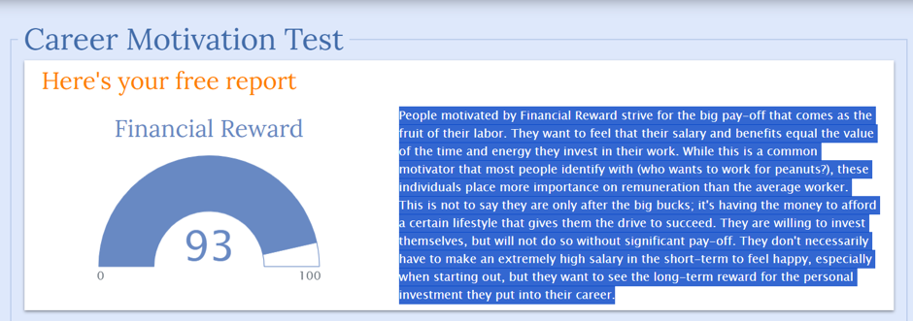



From the above results and some self-reflection the three I have chosen are:

- Gym Instructor
Enjoy helping people and I love to keep in shape very lucrative industry as people are always wanting to keep fit in addition it’s fun! Always learning about the human body. Creating long last relationships in some cases.
- Financial/Data analyst
I love numbers and problem solving, spotting patterns and anomalies
Looking at a business and finding ways to make processes easier, time effective and cost effective.
High paid job and elevation potentials within the company.
- Photographer
Taking photos, videos, promotion and marketing. Never a dull day. The flexibility. Being your own boss catering for thee customer.

