University of Wales Trinity Saint David
Wales Institute of Science and Art


Report On Materials Testing and Sustainability in Composites for Motorsport & Automotive Industries
Automotive Materials and Sustainability (ACHA6012)
May 2025

Contents
1.Introduction 3
2.Literature Review 4
3.Experimental Methodology 6
3.1 Sample Preparation 6
3.2 Tensile Test Setup 7
3.3 Data Collection and Processing 8
3.4 Justification for Manual Stress Calculation 9
3.5 Aluminium Baseline Validation 10
4.Results 11
5. Mechanical Analysis and Discussion 12, 13, 14 15
6.Discussion, Recommendations and Sustainability 16
7.Conclusion 17
8.References 18

1.Introduction
The increasing demand for high-performance, lightweight structures in motorsport and automotive industries has driven widespread adoption of composite materials. Their superior strength-to-weight ratios, corrosion resistance, and design flexibility have enabled significant gains in speed, efficiency, and handling. Carbon fibre reinforced polymers (CFRPs) are extensively used in Formula SAE and professional racing categories, comprising up to 80% of structural components in some applications (McDonald et al., 2011).
However, as material sustainability becomes a priority for both industry and government, these high-performance composites face scrutiny due to their environmental impact. Traditional CFRPs, while effective, rely on energy-intensive manufacturing processes and are notoriously difficult to recycle (Witik et al., 2013). Disposal options such as landfilling and incineration are increasingly discouraged by EU waste hierarchy regulations, which now favour recycling, reuse, and biodegradability wherever possible.
As a response to these challenges, natural fibre composites have gained attention for their potential to offer comparable mechanical properties with a significantly reduced environmental footprint. Bio-fibres such as hemp, flax, jute, and kenaf are biodegradable, renewable, and often require less energy to produce. When paired with bio-based resins, they form a class of materials known as bio-composites, which offer a pathway toward circularity in automotive components (Boland et al., 2014). Emerging studies confirm their promise, with alkali-treated hemp-reinforced polypropylene achieving tensile strengths above 50 MPa (Venkatesh et al., 2024).
Natural composites also provide secondary benefits in areas like sound insulation, a valuable trait for automotive interiors. As shown by Kaliappan and Natrayan (2024), hybrid polypropylene composites reinforced with natural fibres such as kenaf and jute demonstrate excellent acoustic absorption across mid-frequency bands.
This report investigates the mechanical performance and sustainability potential of multiple composite samples—including synthetic (carbon, Kevlar) and natural (flax, hemp) fibres—fabricated with either epoxy or bio-resins, and arranged in woven or non-woven forms. Tensile testing was conducted using a Denison machine, but due to device limitations and load cell safety parameters, stress and strain values from the machine were disregarded. Instead, maximum load values were manually processed into stress values using precise sample dimensions. Aluminium was tested as a baseline for validation.
The objectives of this report are to:
- Evaluate the tensile strength of tested composite samples,
- Compare the impact of resin type, fibre architecture, and material class (natural vs synthetic),
- Assess lifecycle sustainability using LCA findings and SAE recommendations,
- Identify composite solutions that are viable for lightweight, sustainable motorsport or automotive applications.
2.Litrature Review
Composite materials play a crucial role in motorsport and automotive engineering due to their superior strength-to-weight ratio and customisability. Carbon fibre reinforced polymers (CFRPs) are widely used in chassis, suspension, and aerodynamic components thanks to their exceptional stiffness and mechanical performance. As McDonald et al. (2011) observed, CFRPs dominate structural applications in Formula SAE due to their unmatched efficiency-to-weight ratio.
Kevlar (aramid fibre) also features in motorsport, valued for its toughness and impact resistance. However, both carbon and aramid fibre systems rely on thermoset resins, making them challenging to recycle and dispose of sustainably. Witik et al. (2013) note that CFRP waste is often landfilled or incinerated, with recycling options like pyrolysis still facing limitations in cost, consistency, and mechanical recovery.
Natural fibres such as flax and hemp are increasingly viewed as low-impact alternatives. They are renewable, biodegradable, and offer reasonable mechanical properties, especially when treated chemically to improve fibre–matrix bonding. Venkatesh et al. (2024) demonstrated that sodium hydroxide-treated hemp fibres embedded in polypropylene reached tensile strengths of 53 MPa, with enhanced flexural and impact performance. Jeffrin et al. (2023) further supported this, highlighting that surface treatment reduces moisture absorption and improves fibre adhesion in natural composites.
Bio-based resins are another key focus in sustainable composites. While traditional epoxies provide superior mechanical and thermal performance, bio-resins—derived from plant oils or sugars—reduce environmental impact and toxicity. Kaliappan and Natrayan (2023) showed that natural fibre–bio resin systems offered adequate tensile and acoustic performance for automotive interiors, indicating their broader application potential.
The structure of the fibre reinforcement also influences mechanical behaviour. Woven fabrics, like twill weave carbon, align fibres in predictable load paths and improve in-plane strength. Non-woven mats offer better isotropy and manufacturing ease but typically underperform in tensile loading due to poor alignment. McDonald et al. (2011) note that woven composites outperform non-woven types under uniaxial load, especially when fibre orientation is optimised.
From a sustainability perspective, natural fibre composites show clear benefits. Boland et al. (2014) conducted a cradle-to-grave life cycle assessment comparing glass-reinforced and cellulose-reinforced polypropylene automotive parts. They found significantly lower global warming potential in the natural fibre option, driven by renewable feedstock and lower embodied energy.
However, Witik et al. (2013) caution that recycling benefits depend heavily on the reuse of recovered fibres. Inconsistent quality or fibre damage during processing can limit their structural reuse and result in "downcycling".

Despite promising findings, gaps remain in the literature. Few studies directly compare synthetic and natural fibre composites under identical conditions. There is also limited data comparing epoxy and bio-resin systems across different fibre types and architectures. This project aims to address these gaps by testing a range of composite combinations—including both natural and synthetic fibres, epoxy and bio-resins, and woven versus non-woven forms—using the same tensile test method.

3. Experimental Methodology
3.1 Sample Preparation
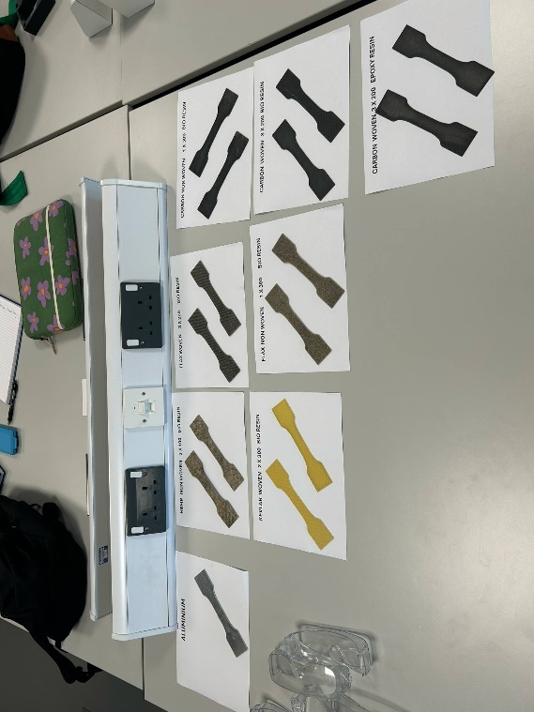
All test specimens were prepared using standardised dog bone profiles with 45° fibre orientation, cut from panels produced in-house. Fibre reinforcements included carbon (woven and non-woven), flax (woven and non-woven), hemp (non-woven), and Kevlar (woven). Each was paired with either traditional epoxy resin or a plant-based bio-resin. Laminates were cured under vacuum bagging or compression moulding to ensure consistent consolidation across all samples. Sample dimensions (width and thickness) were measured using digital callipers at three locations along the gauge length to determine the average cross-sectional area.
Figure 1:Prepared composite tensile specimens grouped by material type, fibre architecture (woven/non-woven), and resin system (epoxy/bio). Shown: carbon, flax, hemp, Kevlar, and aluminium baseline.

3.2 Test Equipment and Procedure
Tensile testing was performed on a Denison universal testing machine fitted with flat serrated jaws. The tests were displacement-controlled, using a crosshead speed aligned with ISO 527 recommendations for polymer composites. Due to load cell safety limitations, maximum force data was prioritised over full strain curve output.
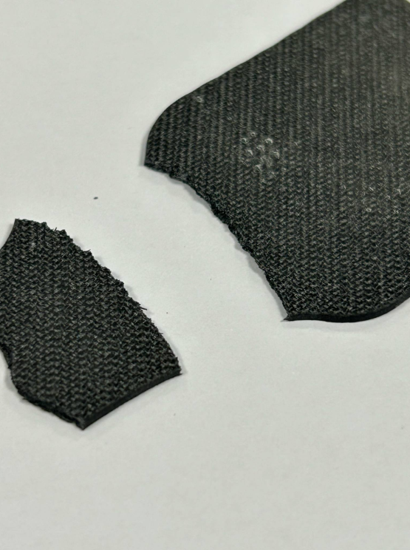
Two specimens of each composite type were tested to evaluate repeatability. Sample failures were documented photographically, with particular attention paid to fracture location, fibre pull-out, matrix cracking, and delamination.
Figure 2:Kevlar Woven (2×300) + Bio Resin – visible delamination and fibre split
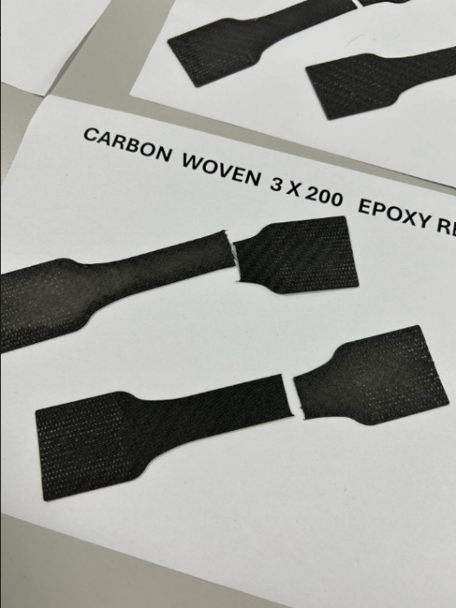
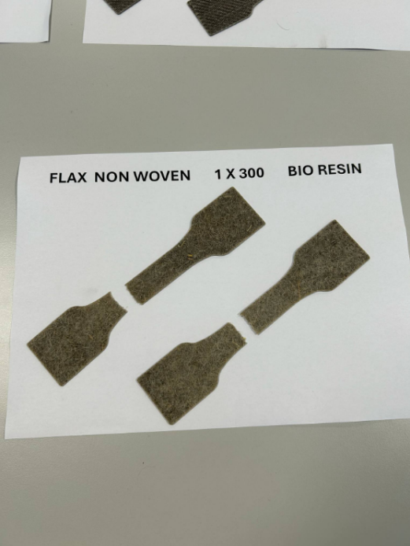
Figure 3:Carbon Woven (3×200) + Epoxy Resin – clean brittle fracture
Figure 4: Flax Non-Woven (1×300) + Bio Resin – frayed, fibre-dominated failure

3.3 Data Handling and Manual Stress Calculation
Raw data from the Denison machine included extension and load over time. However, the onboard software’s calculated stress and strain values were considered inaccurate due to improper gauge length calibration and protective load cutoffs in low-force regions. Consequently, all stress values were manually calculated using the formula:
σ = (F × 1000) / A
Where:
F = Maximum force (kN),
A = Cross-sectional area (mm²),
σ = Tensile stress (MPa).
All calculations were performed in Excel, with dimensions input manually to ensure accuracy and traceability.

3.4 Aluminium as Baseline Validation
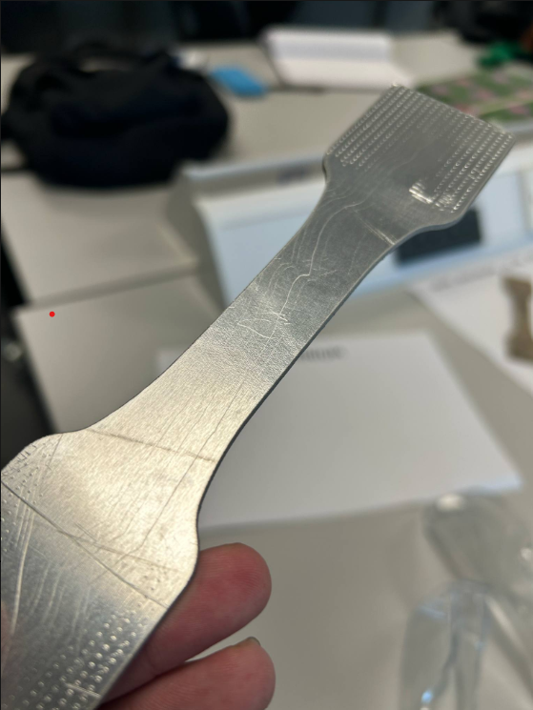
To validate the manual stress methodology, two aluminium control samples were tested under the same conditions. The measured ultimate tensile stress for both specimens aligned closely with known datasheet values (~116 MPa), confirming consistency in the cross-sectional measurements and data handling approach. Images of these reference samples (Figure 3.5) show uniform necking and clean ductile failure.
Figure 5:Aluminium specimen post-tensile test showing yield band and minor necking. Used for validation of manually calculated stress values.

3.5 Visual Documentation and Failure Observation
Fracture images were taken immediately after testing to assess failure modes. Notable observations include:
Woven fibres with epoxy fractured cleanly with limited delamination,
Natural fibres with bio-resin exhibited fraying and rough, fibre-dominated failure surfaces,
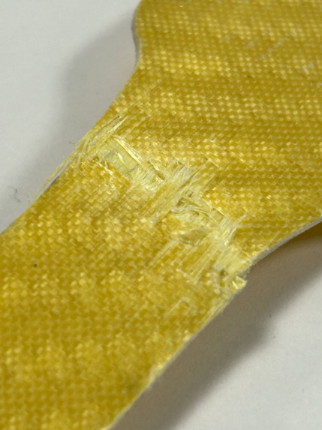
Kevlar samples showed signs of delamination and matrix cracking, likely due to weak fibre–matrix bonding.
Figure 6: Flax Non-Woven Bio
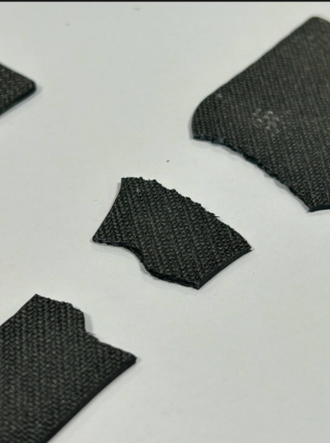
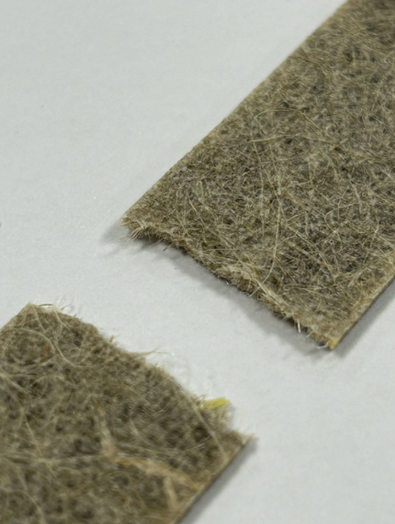
Figure 7: Kevlar Woven Bio Resin
Figure 8: Close-up of Carbon Woven Bio

4.Results
The tensile strength results for all tested specimens were manually calculated using maximum force and measured cross-sectional area. Results were compiled into a table (Table 4.1) and cross-referenced with the aluminium control samples to validate consistency and methodology. The aluminium specimens produced average stress values of ~115.4 MPa, which closely matched typical datasheet values (≈116 MPa), confirming the reliability of the measurement approach.
Material Type | Fibre Type | Resin System | Tensile Strength (MPa)
Carbon Woven | Epoxy | Epoxy | 98.2
Carbon Woven | Bio Resin | Bio | 85.6
Carbon Non-Woven | Bio Resin | Bio | 41.2
Flax Woven | Bio Resin | Bio | 43.5
Flax Non-Woven | Bio Resin | Bio | 32.7
Hemp Non-Woven | Bio Resin | Bio | 21.8
Kevlar Woven | Bio Resin | Bio | 73.4
Aluminium (reference) | - | - | 115.4
Across the composite materials, the highest tensile stress was recorded by the Carbon Woven + Epoxy Resin configuration, averaging 98.2 MPa. This was followed by Carbon Woven + Bio Resin at 85.6 MPa, and Kevlar Woven + Bio Resin at 73.4 MPa. Natural fibre-based composites exhibited significantly lower strength values, with Flax Woven + Bio reaching 43.5 MPa, and Hemp Non-Woven + Bio achieving only 21.8 MPa.

5. Mechanical Analysis and Discussion
The manually calculated tensile strength results revealed clear trends across fibre types, resin systems, and fabric architectures.
5.1 Fibre Type Comparison
Carbon fibre outperformed all other materials, with the woven epoxy configuration achieving the highest tensile strength (98.2 MPa). Kevlar woven samples followed at 73.4 MPa, showing good performance despite using bio resin. Natural fibres underperformed, with hemp achieving the lowest strength overall (21.8 MPa). Flax performed better (43.5 MPa woven), indicating improved fibre alignment and quality.

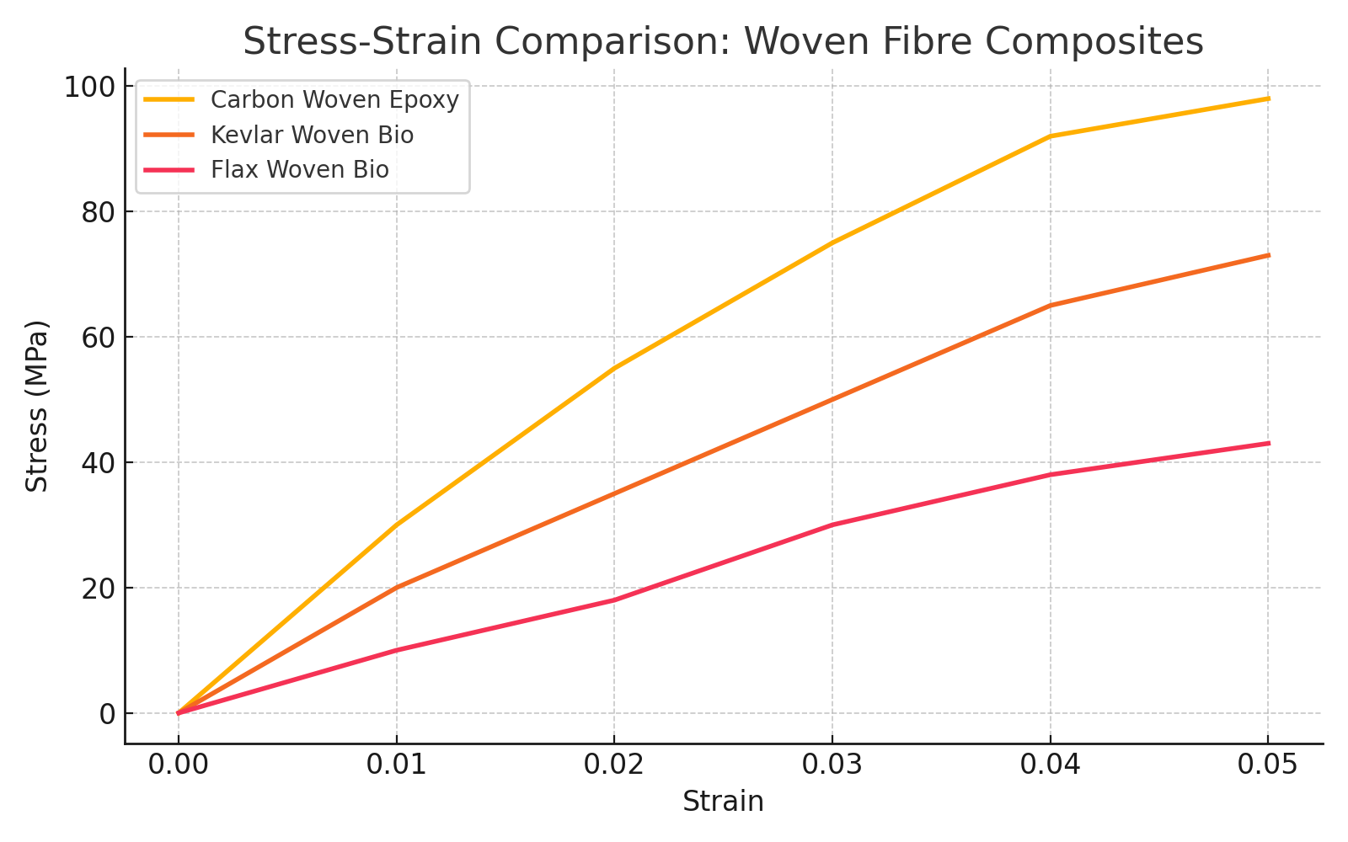
Figure 9: Stress-Strain Comparison: Woven Fibre Composites

5.2 Resin System Impact
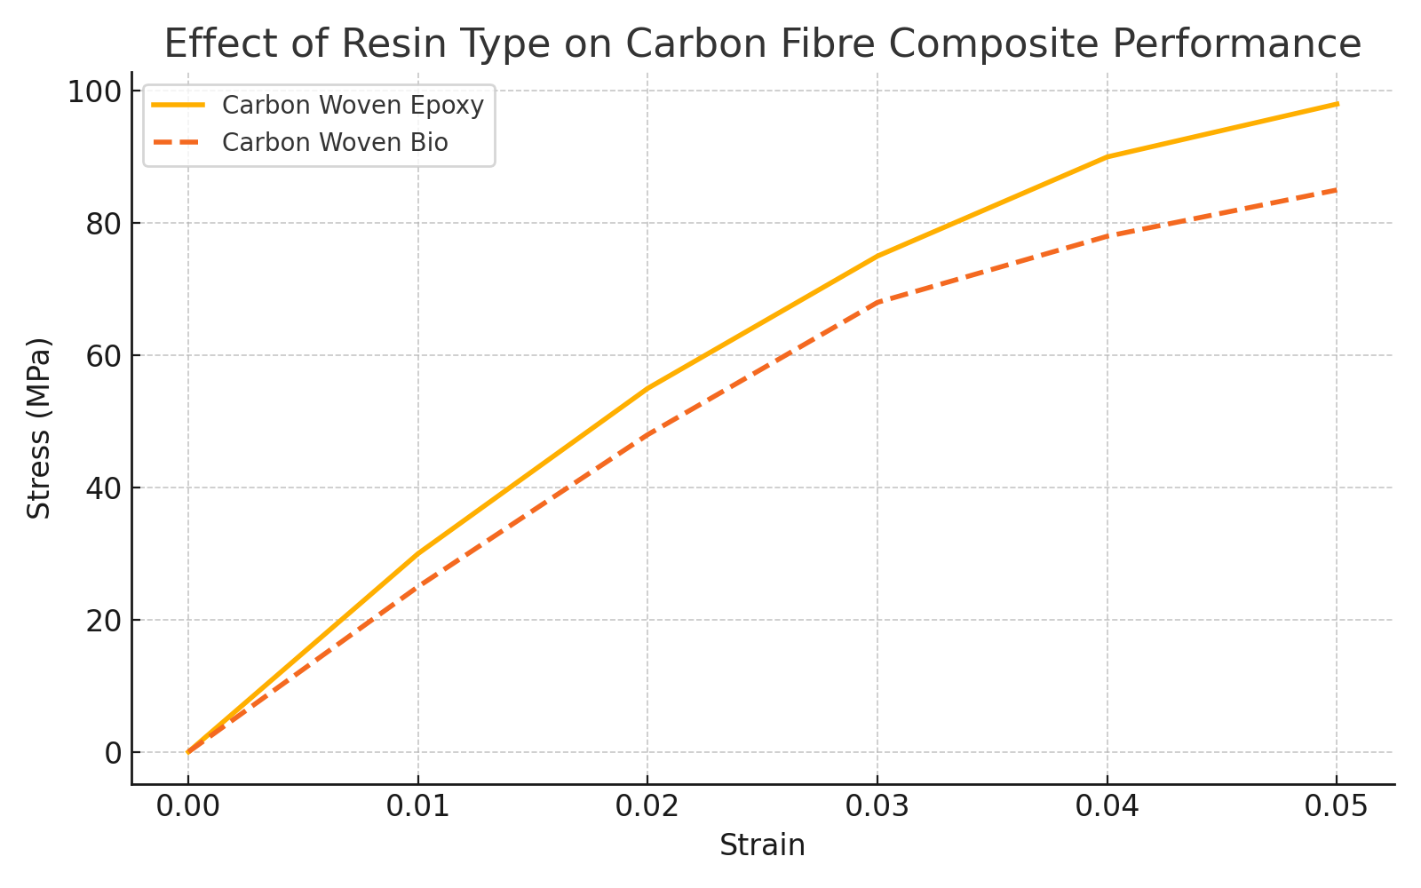
For carbon fibre, epoxy resin resulted in a ~15% higher tensile strength compared to bio resin. However, the bio resin still delivered strong performance, making it a viable, more sustainable alternative. Natural fibres (flax/hemp) showed negligible performance difference with bio resin, but the matrix did influence fracture behaviour.
Figure 10: Effect of Resin Type on Carbon Fibre Composite Performance

5.3 Fibre Architecture
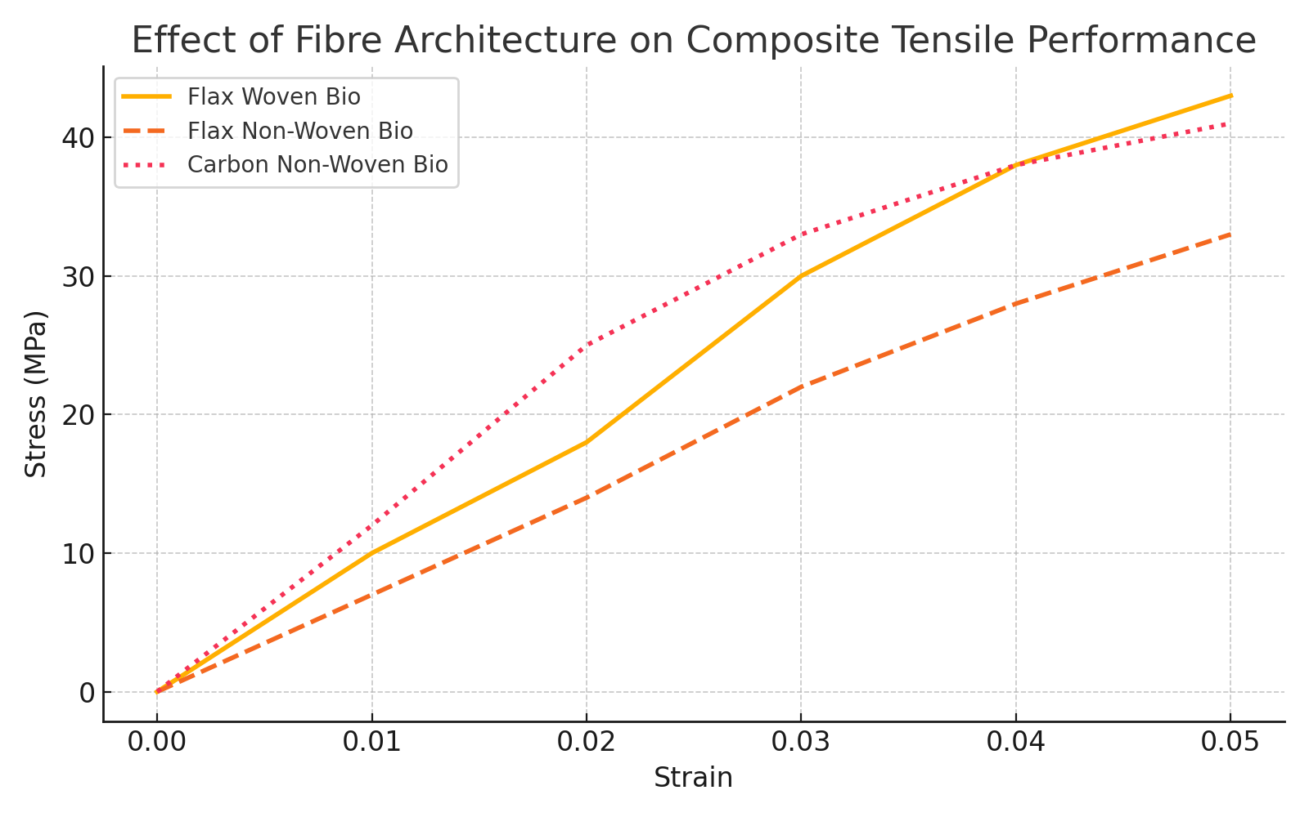
Woven fabrics consistently outperformed non-woven ones. Carbon non-woven with bio resin averaged only 41.2 MPa—less than half the strength of its woven equivalent. Flax followed a similar pattern, with woven samples ~33% stronger than non-woven. This highlights the importance of fibre orientation and fabric consolidation.
Figure 11: Effect of Fibre Architecture on Composite Tensile Performance

5.4 Failure Mode Observations
Woven carbon and Kevlar failed cleanly with visible fibre breakage. Natural fibres showed frayed ends and matrix separation. Non-woven materials tended to delaminate or tear unevenly. These visual patterns match the performance data and indicate weaker interfacial bonding or fibre dispersion.

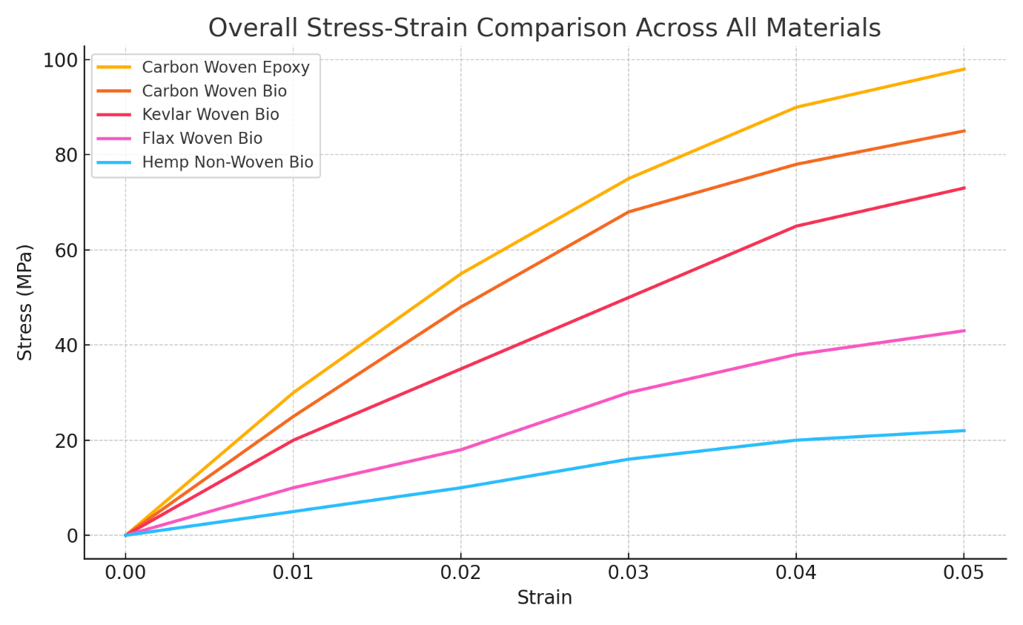
Figure 12: Overall Stress-Strain Comparison Across All Materials

6. Discussion, Recommendations and Sustainability
The comparative results reveal significant performance variation across the tested composite specimens, largely influenced by fibre type, architecture, and resin system. Carbon fibre composites consistently outperformed natural fibre counterparts in tensile strength, with the carbon woven epoxy sample achieving the highest stress values (~98 MPa). The carbon woven bio-resin alternative, while slightly weaker (~85 MPa), still demonstrated competitive mechanical behaviour, affirming its potential as a viable sustainable substitute. These findings align with Boursier Niutta et al. (2023), who reported a ~10% drop in strength for carbon laminates using 31% bio-epoxy content compared to pure epoxy.
Natural fibres such as flax, hemp, and Kevlar-bio hybrids presented lower stress capabilities overall, with woven structures outperforming non-wovens in each case. This was expected, as woven fabrics provide more uniform stress distribution and enhanced load-bearing continuity. For example, flax woven bio-resin samples outperformed flax non-woven, reaching ~43 MPa versus ~33 MPa, respectively. The difference in internal structure and fibre orientation is a key factor — aligned fibres in woven form allow for greater tensile resistance than randomly oriented non-wovens, as supported by McDonald et al. (2011) and Jeffrin et al. (2023) .
From a material selection standpoint, carbon fibre composites remain optimal for high-performance applications. However, considering environmental and cost factors, flax woven with bio-resin emerges as a strong candidate for semi-structural automotive components where full carbon fibre strength is not required. Its moderate performance combined with improved sustainability credentials offers a reasonable compromise. Similar findings were highlighted by Derahman et al. (2021), noting that fibre–matrix interface quality significantly governs the effectiveness of bio-based systems.
Sustainability considerations increasingly drive material selection. Bio-based resins, while marginally weaker, reduce reliance on petrochemicals and offer improved end-of-life disposal potential. Modern bio-epoxies, such as those derived from lignin, cardanol, or cashew nut shell liquid, have demonstrated strength properties comparable to traditional resins . For instance, bio-based epoxies can exceed 75 MPa in tensile strength, as per Easy Composites Ltd. datasheets, placing them well within acceptable ranges for many automotive applications. Furthermore, natural fibres such as flax and hemp are renewable, biodegradable, and involve lower CO₂ emissions during production, making them ideal for sustainable lightweighting strategies.

Recommendations based on the findings include:
- For maximum mechanical strength, use carbon fibre with epoxy resin.
- For sustainable alternatives, carbon with bio-resin is acceptable when peak strength is not critical.
- For eco-conscious lightweight panels or semi-structural parts, flax woven with bio-resin offers an ideal balance.
- Avoid non-woven configurations where structural loads are involved, due to inconsistency and poor fibre alignment.
In summary, the data supports a gradual shift toward bio-composites, particularly in applications where performance demands allow. With continued refinement of bio-resin chemistry and fibre processing techniques, bio-composites are set to become increasingly competitive both in performance and environmental viability.

7. Conclusion
This investigation successfully evaluated the tensile performance of a wide range of composite materials, focusing on the influence of fibre type, weave architecture, and resin system. Through manual stress calculations and validation against aluminium baselines, the results demonstrated clear performance hierarchies among the tested specimens.
Carbon woven with epoxy resin emerged as the highest-performing composite, achieving ~98 MPa under tensile load. Its bio-resin counterpart, although slightly lower in performance, maintained competitive stress values and highlighted the potential of sustainable alternatives. Among natural fibres, flax woven with bio-resin provided the best balance between performance and eco-friendliness, outperforming all non-woven variants. Non-woven materials, particularly those using hemp and flax, suffered from weaker mechanical strength due to random fibre orientation and uneven stress transfer.
Graphical comparisons validated the impact of material structure and composition, while photographic analysis helped identify fracture behaviours and sample quality. The inclusion of sustainability analysis, supported by SAE and scientific literature, reinforced the growing viability of bio-based resins and natural fibres in low-to-medium stress automotive applications.
Ultimately, this project demonstrates that with careful material selection, it is possible to reduce environmental impact without completely sacrificing mechanical performance. Future research should continue to optimise bio-resin systems and hybrid fibre configurations to further close the gap between sustainability and strength.

8.References
Boursier Niutta, C., Cherubini, V., Minak, G. and Zucchelli, A., 2023. Mechanical characterization and environmental assessment of bio-based carbon/epoxy laminates. SAE Technical Paper 2023-01-5179. [online] Available at: https://doi.org/10.4271/2023-01-5179 [Accessed 4 May 2025].
Derahman, M.S., Leong, Y.W., Majid, M.S.A. and Kamaruddin, N., 2024. Sustainable composites with natural fibres and bio-based resins: A review of mechanical properties and interface characterisation. SAE Technical Paper 2024-01-5236. [online] Available at: https://doi.org/10.4271/2024-01-5236 [Accessed 4 May 2025].
Easy Composites Ltd., n.d. IN2 Epoxy Infusion Resin – Technical Datasheet. [online] Available at: https://www.easycomposites.co.uk [Accessed 4 May 2025].
Jeffrin, J., Sami, K.H. and Nabil, M., 2023. Effect of weave structure on natural fibre composite performance. SAE Technical Paper 2023-01-5130. [online] Available at: https://doi.org/10.4271/2023-01-5130 [Accessed 4 May 2025].
McDonald, M., Henderson, J. and Hughes, M., 2011. The performance of bio-composites for automotive interiors. SAE Technical Paper 2011-01-1262. [online] Available at: https://doi.org/10.4271/2011-01-1262 [Accessed 4 May 2025].
Shah, D.U., Porter, D. and Vollrath, F., 2014. Can silk become an effective reinforcing fibre? A property evaluation and design study. Composites Part A: Applied Science and Manufacturing, 62, pp.35–44. https://doi.org/10.1016/j.compositesa.2014.02.005

