Fabiha Begum
Student Number: 1813640
Module Name: Academic and Employability Skills
Lecturer: Gregory Cowan

Table of Contents
- Introduction
- Reflective Paper (Research, Academic writing, etc)
- Conclusion
- References
Introduction
Reflective writing is a form of written expression where the writer looks back on certain events in his life and reflects on the improvements of those events (Wald et al, 2012). In this report I will be discussing various events during the said course and try to relate it and explain how I managed to improve my skillset. Writing a paper with a lot of intellect will help me realise what I have learnt in the past months and also give me the knowledge to improve myself and thrive for further learning (Buck et al, 2013). This paper contains all the skills that I have learnt in this module and how I have used them to improve my skills. I will also focus on specific topics such as, research, academic writing, paraphrasing and public speaking, etc. I will be mainly focusing on how I have achieved good academic skills, research methods, public speaking. This would be the true reflection of what the module has taught me.
Reflective Paper
Any research paper which is reflective in nature is a personal writing of a student’s learning experiences from a course. It is a piece where the individual can reflect on their observations and responds to different environments (Farrell, 2013). These are mostly written to show a personal perspective, which may contain images or other types of references. I would like to draw attention to some topics I have learned and how it created a positive impact on myself.
Research
Research is a detailed method of subjective research, to further develop new data or information in hope to create a better understanding (Bell et al, 2018). Albert Einstein, a famous scientist, once quoted that “if we knew what it was we were doing, it wouldn’t be called research” (Sneyers, 2015). This structure enabled me to understand how different researching and searching for information is and the different ways it can be done. It is crucial to ensure your research is well explored when writing a research paper. Another important thing I learned during this course is that it is my responsibility to check research papers of other authors as well, in order to gain different understandings as to what work has been already done.

The Research Process (Campus Career Club, 2019)
Academic Writing
Academic Writing is a precise, to the point and structured writing that covers a lot of subjective evidence, the goal of which is to help in reader’s observation (Lillis and Curry, 2013). Some of the examples include essays, academic journals, assignments, conference papers, research papers, substantive thesis and many more. The content in the course gives importance to further polish and improve ones’ academic writing skills which helped me a lot in improving mine as well. The lectures enabled us to change our thoughts into structured sentences. It is important to know how to write and outline the important points in a report, to always use a formal tone, use correct language and keep in view the area of argument of the reader. This would also help anyone to understand the predictable format of the academic writing which usually consists of the basic introduction, the body and final conclusions.

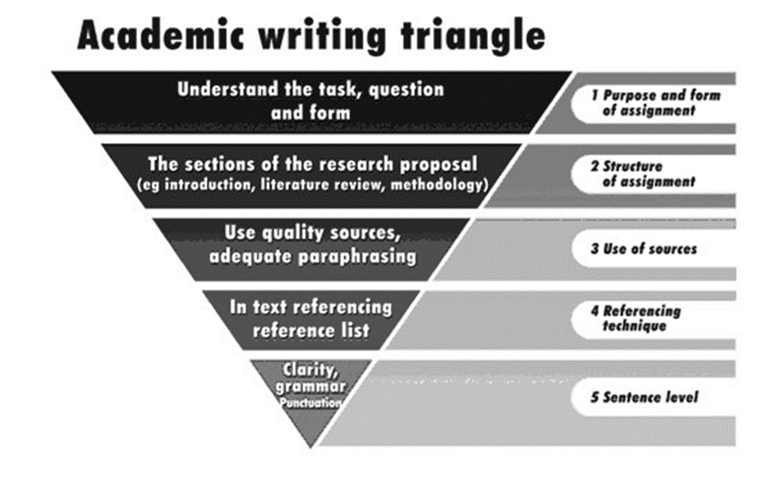

The Academic Writing Triangle (Steve Krause et al, 2010)
Referencing Techniques
Referencing is a method to show that we have expanded our learning. There are 3 main arguments in favor of referencing, they are:
- To help the reader, identify the ideas you wish to use
- To enable the reader go through the information
- To extract information for the benefit of your reader.
There are many referencing methodologies. For example, APA (American Psychological Association) is a more common referencing style used within many platforms (Pears and Shields, 2016). This module also made me realise that plagiarism is an extreme sin and it must be avoided at all costs. Stealing and copying other people’s works is heinous and one should always give credit to any work of any other author used, by citing appropriate references, in the correct format.

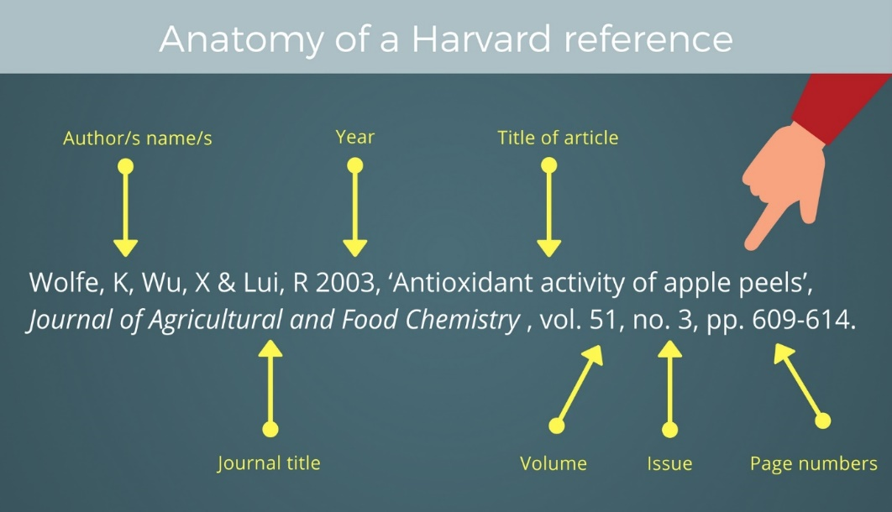

Anatomy of a Harvard Reference (Available at: https://www.anu.edu.au/students/academic-skills/academic-integrity/referencing)
Public Speaking
Public speaking is a way to correctly deliver a speech to an audience. Whenever we say pubic speaking, it is very well known as formal speaking addressed to a huge audience by a single person (Griffin, 2011). Traditionally, we categorise public speaking as a way of persuasion which has a lot of potential to accomplish different purposes of which include informing, persuading, and entertainment. In addition, there are a few different methods, relevant structures and more which can be used in accordance to the current speaking situation. I personally had a lot of difficulty, lacking the confidence, while speaking publicly (Jones, 2012). But I have focused on getting rid of the fear allowing me to confidently speak without any stutter in public.



Public Speaking (TJ Walker, 2018)
Of all the topics discussed above have helped me in improving my skills concerning employability. These types of eccentric skills are essential for the workplace (Mason et al, 2009). Some of these are:
- Positive attitudes
- Willingness to learn
- Communication skillset
- Thinking skills (problem solving and decision making)
- Hard work and teamwork
- Effective self-management
- Resistance and resilience
The development of academic skills is never enough. Employability skills must be developed and improved consistently in order to prepare the individual for their upcoming career (Lowden et al, 2011). This enabled me to concentrate on my weaknesses and prepare myself to answer confidently in interviews. I learnt the true meaning of teamwork and team spirit, due to the group tasks assigned to us regularly within my module. My communication skills also improved considerably, given the focus on public speaking. Communication is the key to success in any career, so this skill is highly likely to be an asset in my future career endeavours. One needs to understand how important it is to know about the company, its operations, its various departments as well as its success story. The research module has allowed me to understand how to research about a company to know all about it, before applying for it. It will help me to familiarise myself with the company and appear confident in the interviews.
Once any prospective candidate gets shortlisted and inspected for the coming process, he or she must focus on background research and other relevant work to prepare thoroughly for the interrogation that can guarantee the job. The individual must do extensive research about the company they want to be a part of (Cuddy et al, 2015). The individual should possess other types of skills, such as, calmness, patience, good body language, maintaining to the tone of the conversation, always keeping an optimistic mind, communication skills, confidence and more interpersonal skills to ensure his candidature. The candidate should focus over questions at hand and must always answer to the point with appropriate facts and figures wherever appropriate (Glavas and Piderit, 2009). The applicant should be able to understand the difference between hearing and listening; hearing is a natural process where only the sound reaches the ears, but listening is the act of understanding what is being said and involves the mind. As the saying goes: “hearing is via ears and listening can only be done through mind” (Ho et al, 2015). Interviewers also prefer interpersonal skills in every candidate as their main priority is to know if their prospective hiring can effectively work with all his upcoming peers, in addition to managing levels of stress that comes with the work, learning agility, ability to cope up with new changes that are constantly being introduced in the business, etc. This module also focuses on teaching basic employability necessities like report preparation, some of the types being financial report, appraisal report or otherwise, constructing a personal as well as professional e-mail, preparing excel sheets, making excellent PowerPoint presentations that are important to any firm in today’s growth of modern technology. In my own personal life, I have led groups in my associations in addition to volunteering with an NGO (Ummah Hands) where I truly learnt to manage the team and giving credit to everyone for their combined efforts and motivated them to always focus on hard work, as then success would come to us automatically. All these are the crucial qualities and abilities that I learnt that would help me to become more employable and successful in my future.
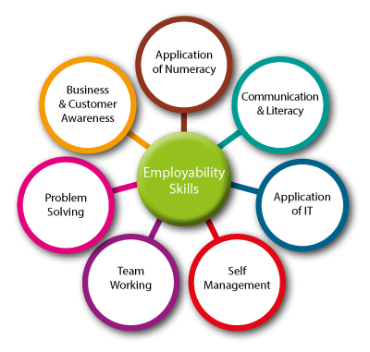
Employability skills (Available at: http://lmihumber.co.uk/skills-for-employment/)
Conclusion
I have analysed and applied every one of these skills mentioned in my report to my own real-life experiences, to improve my academic as well as my employability skills for the future. If I compare my before and after of studying this course, I have to say that I have improved myself to a great extent. I find myself with better communication as well as interpersonal skills. I now know that I know better as to how to behave in an interview, how to showcase my skills in a manner that would be a catalyst to my growth, etc. The module also gave me insights as to what are the ethics associated with working in a business and also how to not exploit other people’s works by giving appropriate credit to any work used of someone else. I am confident that the skills and qualities learnt by me during the tenure of this course is going to help me in all my future endeavors.

References
Wald, H.S., Borkan, J.M., Taylor, J.S., Anthony, D. and Reis, S.P. (2012) Fostering and evaluating reflective capacity in medical education: developing the REFLECT rubric for assessing reflective writing. Academic Medicine, 87(1), page 41-50.
Buck, A., Sobiechowska, P. and Winter, R. (2013) Professional experience and the investigative imagination: The art of reflective writing. Routledge.
Farrell, T.S.C. (2013) Reflective writing for language teachers. Sheffield: Equinox.
Bell, E., Bryman, A. and Harley, B. (2018) Business research methods. Oxford university press.
Sneyers, B. (2015) "Use of guidelines by healthcare professionals in the intensive care: easier said than done? The example of analgesia and sedation” (Doctoral dissertation, UCL-Université Catholique de Louvain).
De Vos, A.S., Delport, C.S.L., Fouché, C.B. and Strydom, H. (2011) Research at grass roots: A primer for the social science and human professions. Van Schaik Publishers.
Lillis, T. and Curry, M.J. (2013) Academic writing in a global context: The politics and practices of publishing in English. Routledge.
Pears, R. and Shields, G.J. (2016) Cite them right: the essential referencing guide. Palgrave Macmillan.
Griffin, C.L. (2011) Invitation to public speaking. Cengage Learning.
Jones, C.R., Fazio, R.H. and Vasey, M.W. (2012) Attentional control buffers the effect of public-speaking anxiety on performance. Social psychological and personality science, 3(5), page 556-561.
Lowden, K., Hall, S., Elliot, D. and Lewin, J. (2011) Employers’ perceptions of the employability skills of new graduates. London: Edge Foundation.
Cuddy, A.J. Wilmuth, C.A. Yap, A.J. and Carney, D.R. (2015) Preparatory power posing affects nonverbal presence and job interview performance. Journal of Applied Psychology, 100(4), p.1286.
Ho, S. Foulsham, T. and Kingstone, A. (2015) Speaking and listening with the eyes: gaze signaling during dyadic interactions.
Campus Career Club (2019) Research Process: 7 Steps Checklist to Conduct a Research [Online] Available at: http://www.campuscareerclub.com/research-process-7-steps-checklist-to-conduct-research/ [Accessed: 29th April 2019]
Jain, R. and Kaur, S (2014) Impact of work environment on job satisfaction. International Journal of Scientific and Research Publications, 4(1), pp.1-8.
Glavas, A. and Piderit, S.K. (2009) How does doing good matter? Effects of corporate citizenship on employees. Journal of Corporate Citizenship, (36), pp.51-70.
Mason, G., Williams, G. and Cranmer, S. (2009) Employability skills initiatives in higher education: what effects do they have on graduate labour market outcomes? Education Economics, 17(1), pp.1-30.

