

School of Engineering
Risk Assessment Technical Report

Joseph Belcher
1803210
Date: 8/05/2021

University of Wales Trinity Saint David
Workshop and Practice
(ACHA4011)

Contents

1. Introduction. 3

2. Research/Literature Review. 4

3. Initial FMEA 6

3.1. Brake Calliper Mounting Bolts Not Torqued to Correct Level. 6

3.2. Incorrect Brake Disc Size Installed. 7

3.3. Brake Pads Installed in Wrong Orientation, With Friction Material Not Contacting Disc Surface. 8

3.4. Brake Line Fitting Not Fully Tightened. 8

4. Post-Mitigation FMEA 10

5. Conclusion 11

6. References 12

Introduction.

The aims of this assignment are to assess an assembly line that is currently being used by a large vehicle manufacturer. We will be assessing this system from a process engineers’ viewpoint and will need to find the potential weaknesses and areas of failure within the current assembly line. We will do this by reviewing a Failure Mode & Effect Analysis (FMEA) which is a document that outlines each stage of the process and associates an overall Risk Priority Number (RPN) with it.

Once we have reviewed the FMEA document, we will need to research potential changes to the assembly line process in order to improve it in regards of safety and failure measures. After completing this task, we are then to carry out another FMEA which includes our changes and score the assembly line again including justifications for our rankings and corrective actions.

It is important to not only understand but to meet these aims too. This is because Health & Safety, FMEA, Risk Management, Legislations, Developing Current Systems etc. are all huge parts of the ever-growing engineering industry. Meaning it is crucial that these constantly evolving topics are understood and practised so engineers within the industry can evolve with it.

Research/Literature Review.

Managing risk has always been a part of engineering and production. In the engineering industry failure can lead to injury or in the worst-case loss of life (E. Roland and Moriarty, 1990). Over time failure has become less accepted by society, these incidents are no longer seen as an unfortunate but rather the fault of those who produced the product. To decrease the chances of failure occurring engineers and companies have been introducing methods such as Failure Mode & Effects Analyse (FMEA) to evaluate potential areas of failure before they cause an issue. They also follow professionally published codes of conduct such as the Institute of Mechanical Engineers (IMeche) code of conduct. These ensure that when followed the engineers are working to the expected and highest level.

The FMEA process was first formally introduced in the aerospace industry in the mid 1960’s and focused specifically on safety issues, it was then adapted by the automotive industry to be used as a quality improvement tool (Mikulak, McDermott and Beauregard, 2017). Today the Failure Mode & Effects Analysis (FMEA) is a design tool that mitigates risks during the design phase before they occur. Risk is measured in terms of Risk Priority Number (RPN) that is a product of occurrence, severity, and detection difficulty (Rhee and Ishii, 2003). While engineers have always analysed production processes and products for potential failures, the FMEA process standardises this approach and enables all skill levels and most languages to understand (Mikulak, McDermott and Beauregard, 2017).

Many engineers and companies use professional codes of conduct to make sure the standard at which they are working not only meets expectations but is of the highest standard possible. One of these published codes of conduct is the ‘IMeche code of conduct’ which has 4 main expectations. These are:
• Practice competently & maintain up to date skills.
• Act with integrity & respect for others.
• Promote sustainability.
• Exercise engineering leadership.
(Institution of Mechanical Engineers, 2021)
These 4 points are seen to be the ethical basis that engineers should work to; however, the code of conduct includes a lot more and gives a detailed description to how individuals and companies should carry themselves within the industry.

Health & Safety legislation is also massive factor in engineering/assembly workplaces. In the UK the legislation in place is from the Health & Safety Executive (HVE). Real-time communication, Big Data, human - machine co-operation, remote sensing, monitoring and process control, autonomous equipment and interconnectivity are becoming major assets in modern industry. As the fourth industrial revolution or Industry 4.0 becomes the predominant reality, it will bring new paradigm shifts, which will have an impact on the management of occupational health and safety (Badri, Boudreau-Trudel and Souissi, 2018). So, it is important that companies as well as any individuals involved abide to the legislations in place as well as stay up to date with every development of it. This decreases the chance of accidents massively and will include precautions such as Personal Protective Equipment (PPE), guards where necessary (to shield moving components) and proper training before operating equipment etc. All the measures within these legislations are designed to keep the workplace and those within it as safe as possible (Lees, 2012).

Initial FMEA

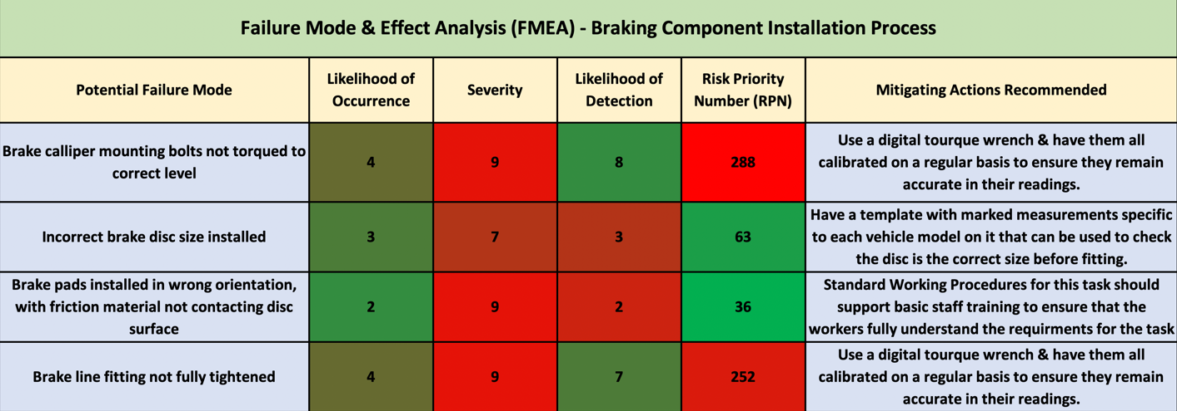

Brake Calliper Mounting Bolts Not Torqued to Correct Level.

The likelihood of this failure occurring has been scored at a 4/10, this is because the torque wrench used should produce a correct or at least very near to correct result. However, this is not to say that it will work perfect every time. This could be down to two main reasons, the first being that the standard ‘click’ torque wrench that is set to a specified value by twisting the lower part of the handle has been accidently altered which can be easy to do. The second reason being that the torque wrench has not been calibrated to make sure its values are correct.

The severity of this failure if it did occur has been scored a 9/10. This is because these bolts are responsible for keeping the mounting securely in place onto which the brake calliper itself is attached. Meaning in the case these bolts loosen or in a worst-case scenario come out, the calliper could become ineffective leaving the driver without sufficient braking. This could easily result in serious injury or even death if it occurs whilst the vehicle is in motion.

Likelihood of detection has been scored an 8/10, this is for a variety of reasons. The first being that just because the bolt isn’t at its correct torque value it does not mean it is loose, the bolt could be relatively tight and if looked at seem like it’s been fitted correctly. The only the failure would be detected in this case is if it was checked with a torque wrench again. The second reason being the location of these bolts, they are located facing the inside of the wheel arch making it sometimes difficult to get a good look at them to check. Finally, the third reason it could be hard to detect is depending on which point of the assembly line it is inspected. If the wheel has been connected to the hub, then the bolts are near impossible to check unless you can get underneath the vehicle to do so.

These three scores bring the Risk Priority Number (RPN) to a concerning 288. Mitigation actions recommended would be to use a digital torque wrench in place of the more analogue ‘click’ wrench. The reasons for this are that the value is set and displayed on an electronic display on the tool, meaning it is more accurate and harder to accidently adjust. The tool itself is also more accurate due to high tech sensors and electronic technology.

Incorrect Brake Disc Size Installed.

The likelihood of occurrence has been scored a 3/10 for this failure. This is because the parts for the assembly are sorted beforehand and delivered to the fitter’s station as necessary. This process is very meticulously organised and effective; however, it is not impossible for mistakes to be made and for the wrong part to be delivered to the fitter’s station.

The severity of this failure is scored a 7/10, this is because other components in the brake system are designed to house a certain disc and fitting the wrong size could cause problems. Fitting a disc that is too big could cause other components not to fit and therefore cause a hold up on the assembly line whilst this failure is rectified. However, fitting a disc to small means that it is more than likely the other components designed for a bigger disc will still fit. This could lead to the failure going unnoticed in the assembly process and making it to the market where the consumer could end up with a faulty or even ineffective brake system.

Likelihood of detection with this failure is good and has been scored a 3/10. The reasons behind this are other components in the system are more than likely not too fit if the disc is too big. Even if a smaller disc is fitted the surrounding components may fit but it should still be evident to the fitter that something isn’t right. And in the worst case of it making it off the assembly line it is more than likely it will be detected in transport where the breaking performance won’t feel as it should.

Risk Priority Number (RPN) for this failure is 63. This may seem low for the severity however the likelihood of occurrence and high chances of it being detected bring the score down. Mitigating actions to lower it even more however would be to use a template specific to each vehicle model, ensuring the disc fitted is the correct one for that vehicle. This check would be swift and therefore barely effecting the overall production time on the assembly line.

Brake Pads Installed in Wrong Orientation, With Friction Material Not Contacting Disc Surface.

Likelihood of occurrence scored 2/10 for this failure. This isn’t to say it won’t happen but with basic training this should not end up occurring as the two sides of the pad are very easy to tell apart and the task of fitting them is simple.

The severity score for this failure was 9/10. This is due to the fact that with the wrong side of the pad in contact with the disc it will not only destroy both the disc & pad but will affect the performance of the brakes drastically. In some cases, the pad can even dislodge from its carrier causing damage to the brake calliper itself. Overall, the score is so high because of the potential risk to the brakes which could end up causing a serious accident.

Likelihood of detection was scored a 2/10, meaning it is very likely to be detected. This is due to the fact when a trained individual such as an inspector looks at the assembly in which this part is included it will be very easy to recognize. The reason it isn’t a 1/10 however is because if the inspection takes place after the wheels are mounted to the hubs it becomes slightly more difficult to see/inspect the area.

36 is the RPN number calculated from the results which is relatively low considering the severity. However much like the previous potential risk the overall score is drastically affected by how likely the failure is to happen as well as how likely it is to be detected. Mitigation actions that could further improve this score however would be to make sure any staff are thoroughly trained so simple mistakes such as this one aren’t made.

Brake Line Fitting Not Fully Tightened.

In this process the brake line fitting will be secured using a spanner. Due to this process being complete by various employees some fittings may not be as tight as the others, and some may even end up loose if this procedure isn’t correctly complete or in the instance of a fitting cross threading. These points end up resulting in a likelihood of occurrence score of 4/10 as they can happen but are not extremely likely due to the simplicity of the task.

Severity of this failure once again scores high due to being a crucial part in the braking system. The line will pass fluid in and out of the calliper when the brake pedal is pressed or released, this process is under high pressures and if the fitting is too loose it could leak and release pressure from the system. Or in the worst case it could come out of place disconnecting the brake line from the calliper rendering the brake calliper useless. In the event either of these failures happen there is a presence of potential injury & threat to life.

Likelihood of detection is high at a 7/10. Like 3.1 this is because although it may not be fully tightened to spec it doesn’t mean it loose, meaning to the naked eye it could look perfectly fine. Also, once again it will be harder to detect in an inspection as more components are placed in the way of it as the vehicle is further assembled. To decrease the chances of this failure taking place and to lower the RPN from 252, the introduction of a digital torque wrench could help drastically. There accurate readings and performance would make sure each fitting was tightened to spec and therefor safe for use.

Post-Mitigation FMEA

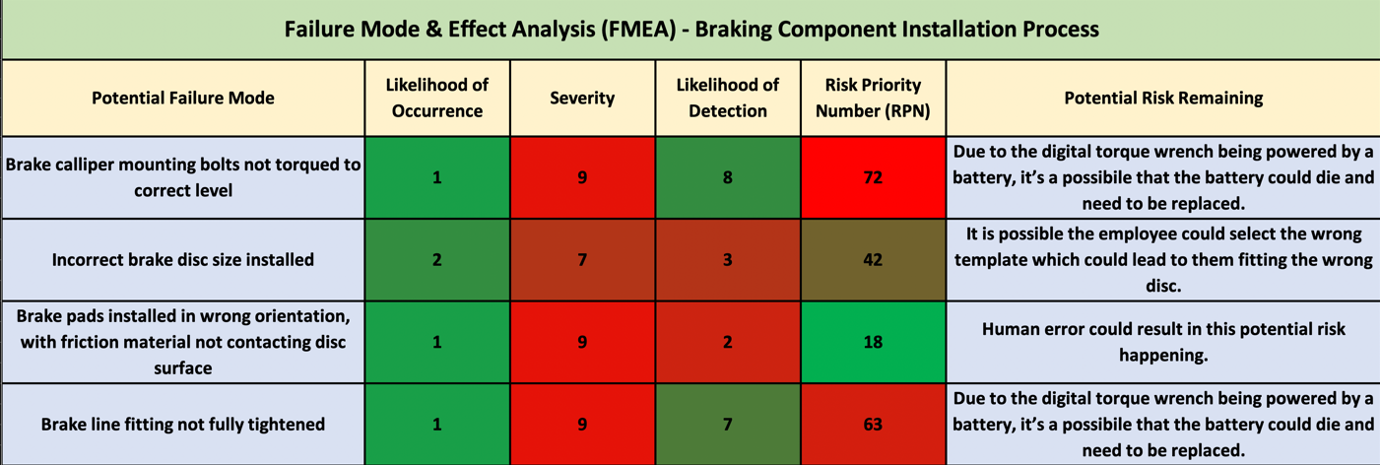

As the table shows, the mitigating actions suggested lowered the likelihood of occurrence and therefore lowering the overall RPN. The reason the severity didn’t change is because if this potential risk did still occur the severity is still the same. This is a similar case to likelihood of detection, the scores in this section did not change either. This is because if the potential risk ended up occurring it is still only as likely as before to be detected, unless changes to processes such as inspections to improve them took place.

By decreasing the likelihood of occurrence alone risk 1 (3.1.) decreased by 216 points from 288 to 72, risk 2 (3.2.) decreased by 21 points from 63 to 42, risk 3’s (3.3.) RPN halved and finally risk 4 (3.4.) decreased by 189 points from 252 to 63. It’s evident that the RPN of each potential risk was drastically changed. However, with further investigation and other mitigations on top these RPN scores could decrease again.

Conclusion

To conclude, the aims set for this task have been met. An assembly line currently being used to produce many automobiles was assessed & potential risks were identified and an FMEA was complete. Research was then conducted to try find solutions to rectify or at least decrease the chances of these potential failures coming into fruition. Once research had been complete the mitigating actions found were put into place and a second FMEA was complete to see if their introduction had met our intentions. As can been seen from the second FMEA displayed in the Post-Mitigation FMEA (4.) section the mitigating actions put into place had a positive effect and in turn decreased the RPN score of each potential risk. This shows an understanding of and an ability to use FMEA which was another of the aims set for the outcome of this task. However, as previously mentioned in section 4 this is no reason to stop looking for other mitigating actions to further improve the assembly line, a good place to start would be the remaining risks listed in the second FMEA which would further cement their improvement to the process.

When looking at FMEA as a process itself it is evident why it is used throughout the industry. The simplicity of FMEA overall makes it easy to complete as a task and more importantly easy to understand. Meaning all types of employees can read and understand the dangers identified within the system as well as the mitigating actions put in place to reduce the likelihood of them happening. These changes can save money, time, respect within the industry and even a life. Which is why a process such as FMEA is a key tool as well as an asset in todays engineering industry.

References
Badri, A., Boudreau-Trudel, B. and Souissi, A.S. (2018). Occupational health and safety in the industry 4.0 era: A cause for major concern? Safety Science, [online] 109(), pp.403–411. Available at: https://www.sciencedirect.com/science/article/pii/S0925753517315035 [Accessed 2 Dec. 2019].
E. Roland, H. and Moriarty, B. (1990). System Safety Engineering and Management. Second ed. [online] Canada: John Wiley & Sons. Available at: https://books.google.co.uk/books?hl=en&lr=&id=BVjmPyhOfDkC&oi=fnd&pg=PA3&dq=Managing+risk+has+always+been+a+part+of+engineering+and+production&ots=Hi1oK3CLBy&sig=cTfdzDiO0vYXX5kglwB6X95709g&redir_esc=y#v=onepage&q=Managing%20risk%20has%20always%20been%20a%20part%20of%20engineering%20and%20production&f=false [Accessed 2 Jun. 2021].
Institution of Mechanical Engineers (2021). Code of Conduct explained - IMechE. [online] www.imeche.org. Available at: https://www.imeche.org/about-us/imeche-governance/governance-and-finance-reviews/code-of-conduct-explained [Accessed 2 Jun. 2021].
Lees, F. (2012). Lees’ Loss Prevention in the Process Industries: Hazard Identification, Assessment and Control. [online] Google Books. Butterworth-Heinemann. Available at: https://books.google.co.uk/books?hl=en&lr=&id=73M6aqqy-uUC&oi=fnd&pg=PP1&dq=All+the+measures+within+these+legislations+are+designed+to+keep+the+workplace+and+those+within+it+as+safe+as+possible.+&ots=_Ec121MtjX&sig=Qz0_ZRthasn_OGUrKeHI4gKCpK0&redir_esc=y#v=onepage&q&f=false [Accessed 3 Jul. 2021].
Mikulak, R.J., McDermott, R. and Beauregard, M. (2017). The Basics of FMEA. [online] Google Books. CRC Press. Available at: https://books.google.co.uk/books?hl=en&lr=&id=rM5Vi_0K9bUC&oi=fnd&pg=PP1&dq=FMEA+history&ots=TM1MpwB-Y2&sig=QbZS9Z4EtLbf3B2qo79kFmkbjAg&redir_esc=y#v=onepage&q=FMEA%20history&f=false [Accessed 20 May 2021].
Rhee, S.J. and Ishii, K. (2003). Using cost based FMEA to enhance reliability and serviceability. Advanced Engineering Informatics, [online] 17(3), pp.179–188. Available at: https://www.sciencedirect.com/science/article/pii/S1474034604000072 [Accessed 20 Aug. 2020].
‌

‌

