Assessment 1

Module: Management Economics

Module code: LCBB5008 Lecturer: Taye Osadiya

“Louis Vuitton Bags”

Analysis report

Simona Filipova Vasileva
University of Wales Trinity Saint David, London Campus,
BA Business and Management, London, United Kingdom
2030587@student.uwtsd.ac.uk

Contents
Louis Vuitton “LVMH (Louis Vuitton Moët Hennessy)” 3
Expert bag makers, Product Overview 4
Demand and Market Equilibrium 5
Price of substitutes: 5
Price of complements: 5
Consumer income: 6
Consumer tastes and preferences: 6
Consumer expectations of the price: 6
Number of Consumers: 7
Elasticity of Demand 7
Consumer point of view 8
Pricing Policy which the business should adopt 9
Conclusion 10
References 12

Louis Vuitton “LVMH (Louis Vuitton Moët Hennessy)”

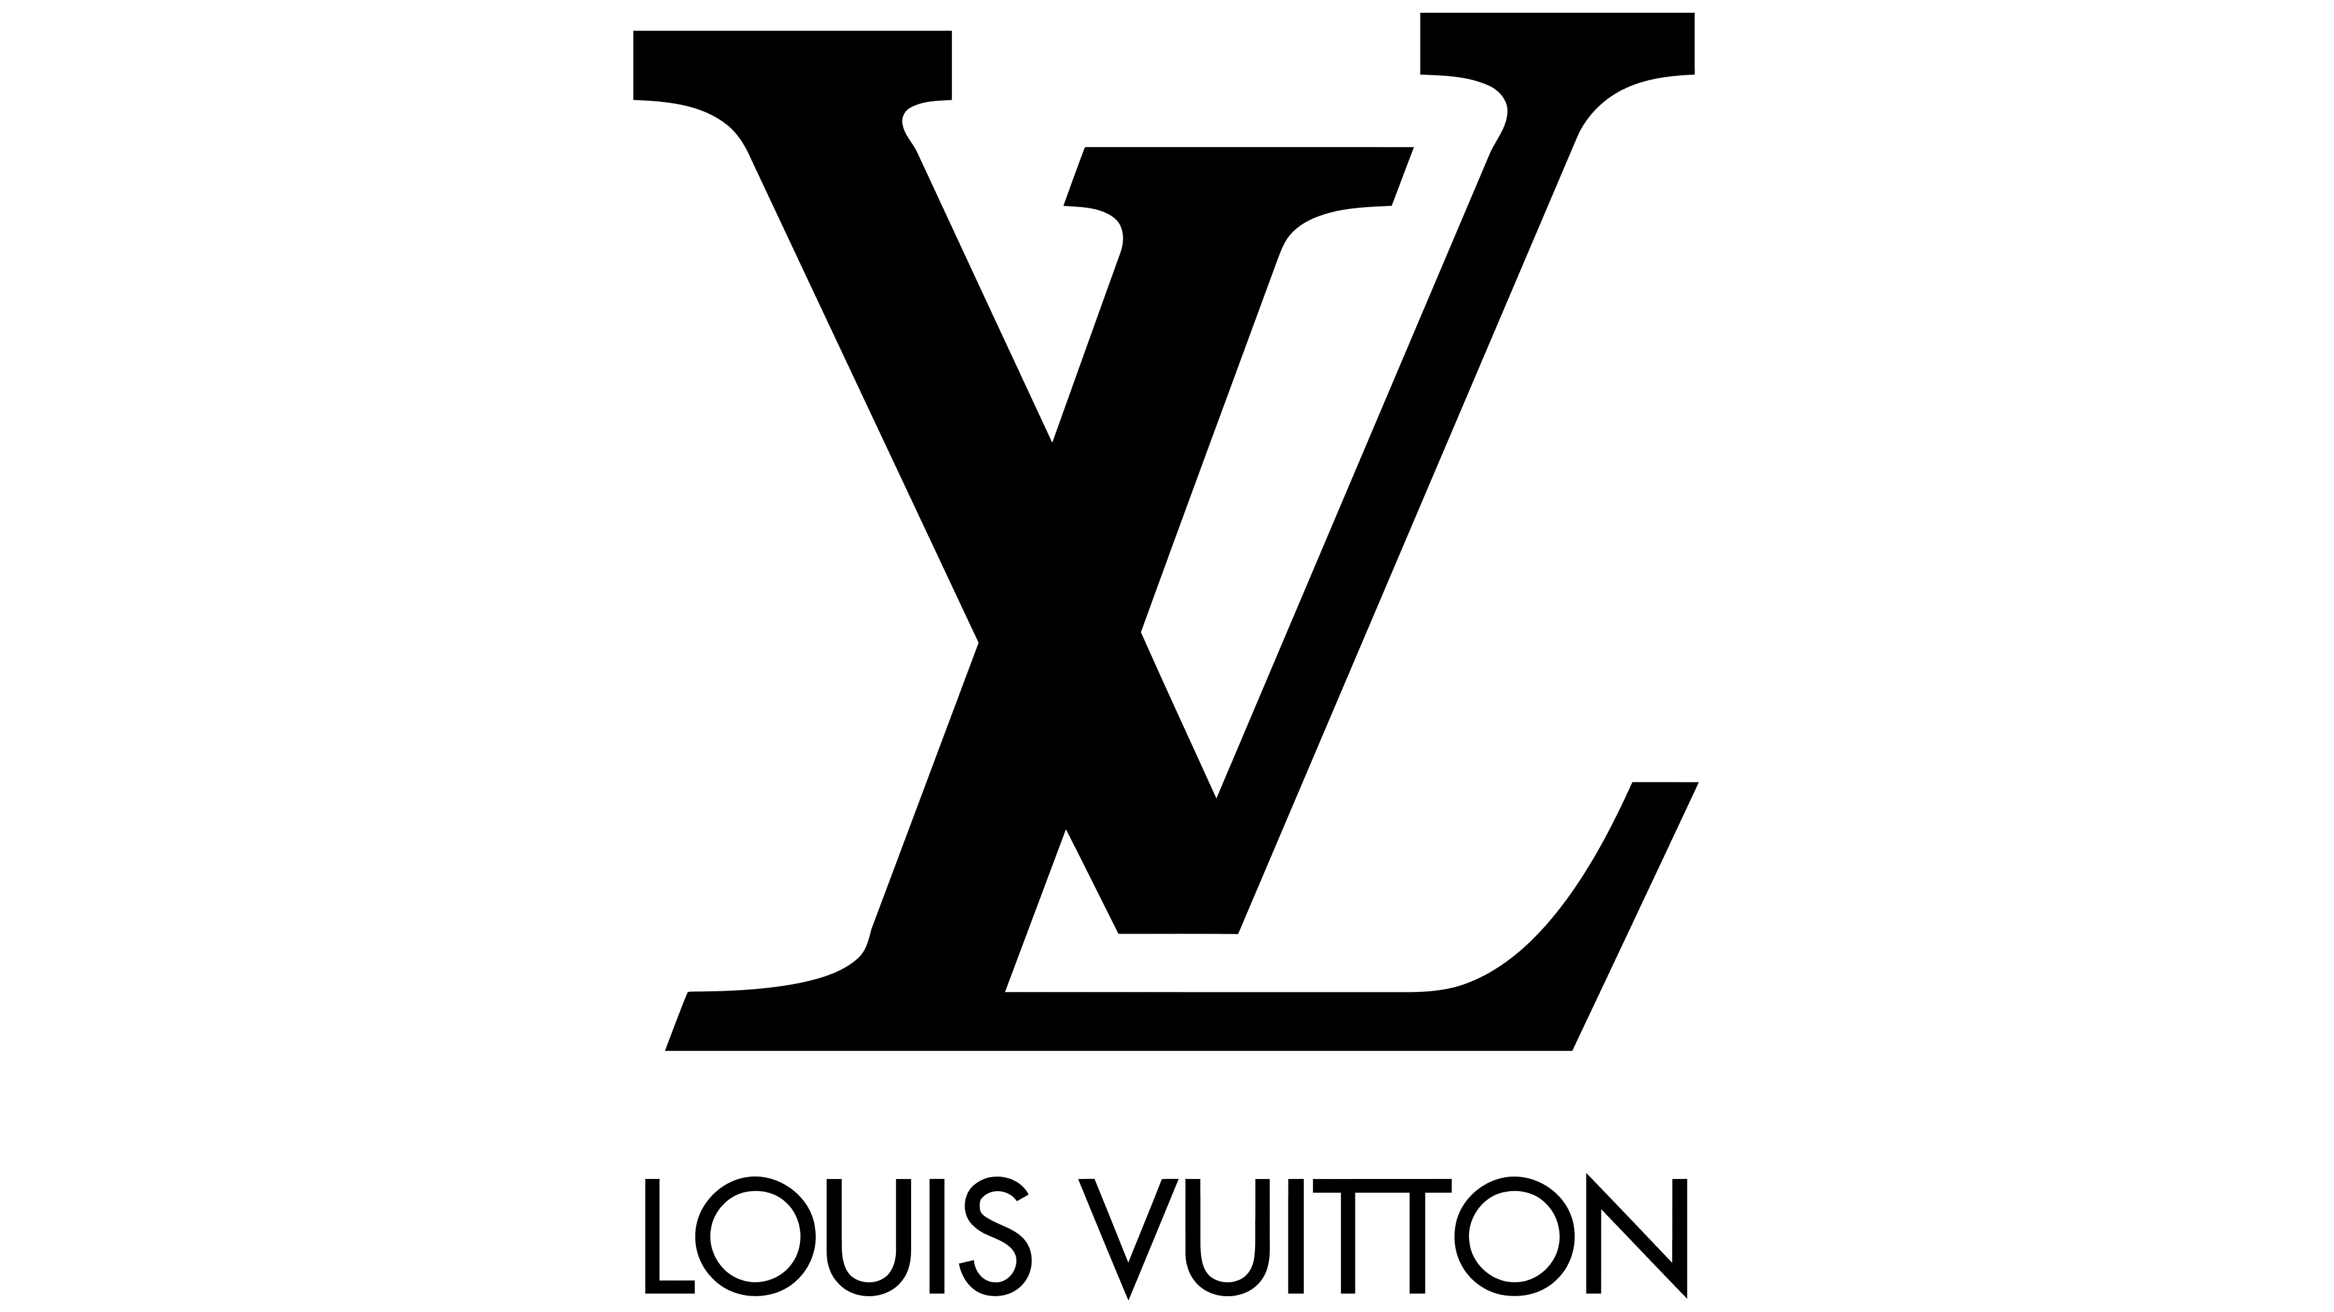
Louis Vuitton is a luxury fashion brand known for its high-quality products, including leather goods, ready-to-wear clothing, shoes, watches, jewelry, and accessories. The brand was founded in 1854 by Louis Vuitton, who was a French trunk maker and luggage designer (Louis Vuitton, 2023). Today, Louis Vuitton is one of the world's most recognized and valuable luxury brands, with a presence in over 50 countries.
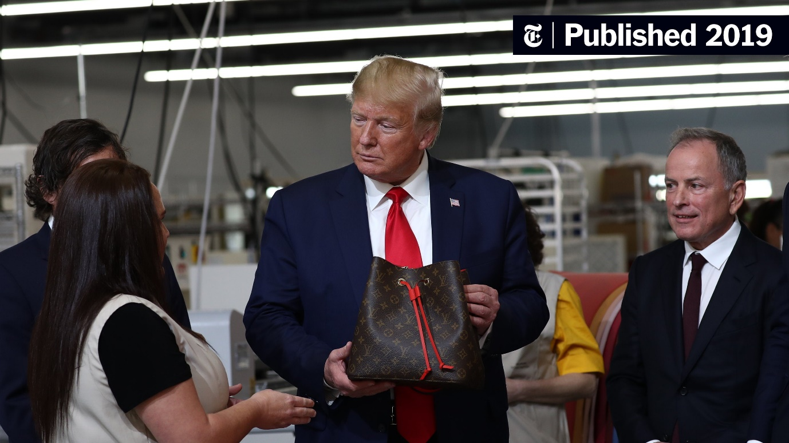
Louis Vuitton's success can be attributed to its commitment to quality and innovation. The brand is renowned for its use of high-quality materials and attention to detail in its manufacturing processes. From the selection of leather to the stitching of each piece, Louis Vuitton ensures that every product meets its high standards. The brand is also known for its iconic monogram pattern, which has become synonymous with luxury and exclusivity. In addition to its commitment to quality, Louis Vuitton has been innovative in its approach to fashion and design. The brand has collaborated with numerous artists and designers, such as Yayoi Kusama, Takashi Murakami, and Stephen Sprouse, to create unique and highly sought-after collections. Louis Vuitton has also expanded its offerings to include men's and women's ready-to-wear clothing, making it a one-stop-shop for luxury fashion. Louis Vuitton's influence extends beyond the world of fashion. The brand has a long history of supporting the arts, including sponsoring exhibitions at the Louvre and collaborating with artists and designers on various projects. Louis Vuitton has also been a leader in sustainable fashion, implementing measures to reduce waste and carbon emissions in its production processes.

Bernard Arnault has served as chair and CEO of Louis Vuitton since 1989 (LVHM, 2023). After acquiring a controlling position in the business, Arnault oversaw LVMH's rapid expansion through acquisition, adding dozens of new companies over the course of the previous three decades.” Today, LVMH owns 75 brands in six business groups: Wines and Spirits, Fashion and Leather Goods, Perfumes and Cosmetics, Watches and Jewelry, Selective Retailing, and Other Activities” (JOHNSTON, 2022).
Overall, Louis Vuitton is a symbol of luxury, quality, and innovation in the fashion world. Its timeless designs and commitment to excellence have earned it a place among the world's most prestigious brands.

Expert bag makers, Product Overview

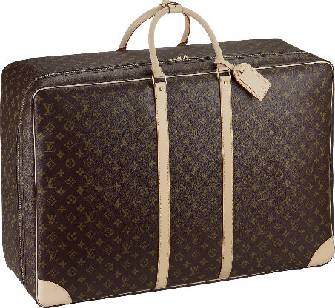
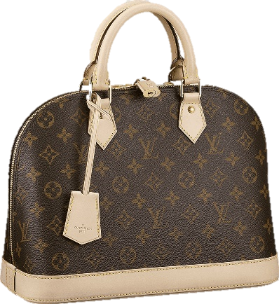
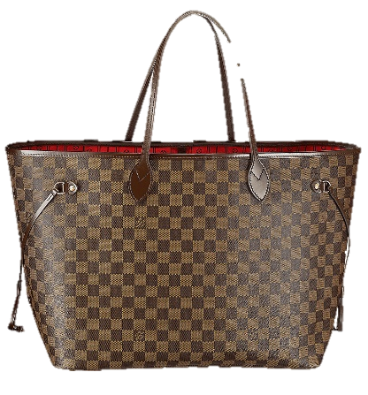
Louis Vuitton is renowned for its high-quality, stylish and functional bags that are designed to cater to the needs of luxury fashion enthusiasts. The brand offers a wide range of bag styles, including totes, shoulder bags, crossbody bags, backpacks, and clutches, each with its unique design and functionality. These bags are made from the finest materials, including premium leather and high-quality hardware.

With a wide range of styles, sizes, and materials to choose from, there is a Louis Vuitton bag to suit every need and occasion. Whether you are looking for a classic and timeless bag or a more contemporary style, Louis Vuitton has got you covered. The iconic Louis Vuitton monogram pattern is also a hallmark of the brand, and is a symbol of luxury and exclusivity.

I chose Louis Vuitton bags for this report because they are a popular and iconic product that represents the luxury fashion industry. The demand for these bags is influenced by a variety of factors, including consumer income, consumer tastes and preferences, and consumer expectations of price. By analysing these factors, we can gain insights into the market equilibrium for Louis Vuitton bags and recommend a pricing policy for the business.

Demand and Market Equilibrium

The demand for Louis Vuitton bags is influenced by a variety of factors. In this section, we will discuss each of these factors and how they affect the demand for these products.

Price of substitutes:
One of the factors that influences the demand for Louis Vuitton bags is the price of substitutes. A substitute for Louis Vuitton bags could be any other luxury fashion brand that produces similar products like Gucci or Prada. If the price of these substitutes is increasing, it is likely that the demand for Louis Vuitton bags will increase as well. Conversely, if the price of substitutes is decreasing, the demand for Louis Vuitton bags may decrease.

Price of complements:
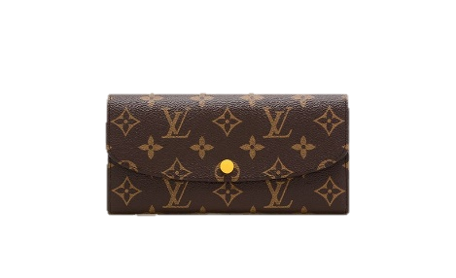
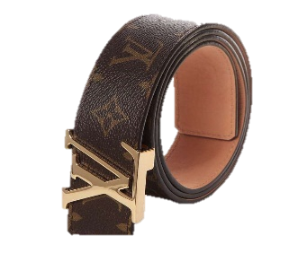
Another factor that influences the demand for Louis Vuitton bags is the price of complements. A complement for these bags could be any other fashion accessory or product that is typically used with the bag, such as a wallet or a pair of shoes. If the price of these complements is increasing, it is likely that the demand for Louis Vuitton bags will increase as well. Conversely, if the price of complements is decreasing, the demand for Louis Vuitton bags may decrease.

Consumer income:
Consumer income is a key factor that influences the demand for luxury products like Louis Vuitton bags. Since Louis Vuitton is a luxury fashion brand, its products are generally priced at a premium, making them inaccessible for many consumers with lower incomes. As a result, Louis Vuitton bags tend to be popular among consumers with higher incomes who can afford to pay the premium prices (Kim & Park, 2021).

When the economy is performing well, and incomes are rising, there is typically more demand for luxury goods such as Louis Vuitton bags. As consumers have more disposable income, they are more likely to invest in high-end fashion and luxury items. Conversely, when the economy is struggling, and incomes are stagnant or decreasing, consumers are less likely to invest in luxury goods, and the demand for Louis Vuitton bags may decline.

Consumer tastes and preferences:
Consumer tastes and preferences play a significant role in shaping the demand for Louis Vuitton bags. As a luxury fashion brand, Louis Vuitton needs to stay attuned to these preferences and adjust its product offerings and marketing strategies accordingly to remain relevant and desirable to consumers. One way that consumer tastes and preferences can affect Louis Vuitton bags is through the design and materials used.

For example, if consumers are more interested in minimalistic designs
or sustainable materials, Louis Vuitton may need to adjust its product offerings to meet these demands. Similarly, if consumers are interested in new or unique designs, Louis Vuitton may need to introduce more limited-edition or exclusive products to meet these preferences (Chen & Lin, 2021).

Consumer expectations of the price:
The effect of price changes on demand for Louis Vuitton bags is complex. While some consumers may be deterred by higher prices, others may see the price as an indication of quality and exclusivity and be even more motivated to purchase the product. This phenomenon is known as the "snob effect," where a product's status or exclusivity is valued even more when its price is high (Kim & Ko, 2021).

However, if the price of Louis Vuitton bags becomes too high and is no longer seen as a justifiable luxury purchase by consumers, demand may decline. Additionally, if competitors offer similar products at lower prices, consumers may choose to purchase from those brands instead, leading to a decrease in demand for Louis Vuitton bags.

Number of Consumers:
Louis Vuitton has reported strong financial performance in recent years, which suggests that the brand's popularity is still high among consumers. The brand has also expanded its product offerings and increased its presence in new markets, indicating that it is targeting a broader demographic of consumers (Budiono et al., 2021).
If the number of buyers is increasing, this can create a sense of scarcity and exclusivity, which can drive up demand for the brand's products. However, if the number of buyers is decreasing, this can create the perception that the brand is losing its prestige or relevance, which can negatively impact demand for its products.

Elasticity of Demand

Considering all of the factors discussed above, the demand for Louis Vuitton bags is generally considered to be inelastic. This means that changes in price have a relatively small effect on the quantity of bags demanded by consumers. There are several reasons for this:

First, Louis Vuitton bags are seen as a luxury item and are purchased by consumers who place a high value on quality and exclusivity. These consumers are often less sensitive to price changes and are willing to pay a premium for the status and prestige associated with owning a Louis Vuitton bag.

Second, Louis Vuitton has cultivated a strong brand identity and reputation for high-quality craftsmanship, which further reinforces the perception of the brand as a luxury product (AZAMSAIT, 2023). This reputation can make consumers less likely to switch to competing brands, even if the price of Louis Vuitton bags increases.

Third, Louis Vuitton has implemented a strategy of controlled distribution and limited edition releases, which creates a sense of scarcity and exclusivity around the brand's products. This scarcity can drive up demand for the brand's products, making consumers even less likely to be deterred by price increases.
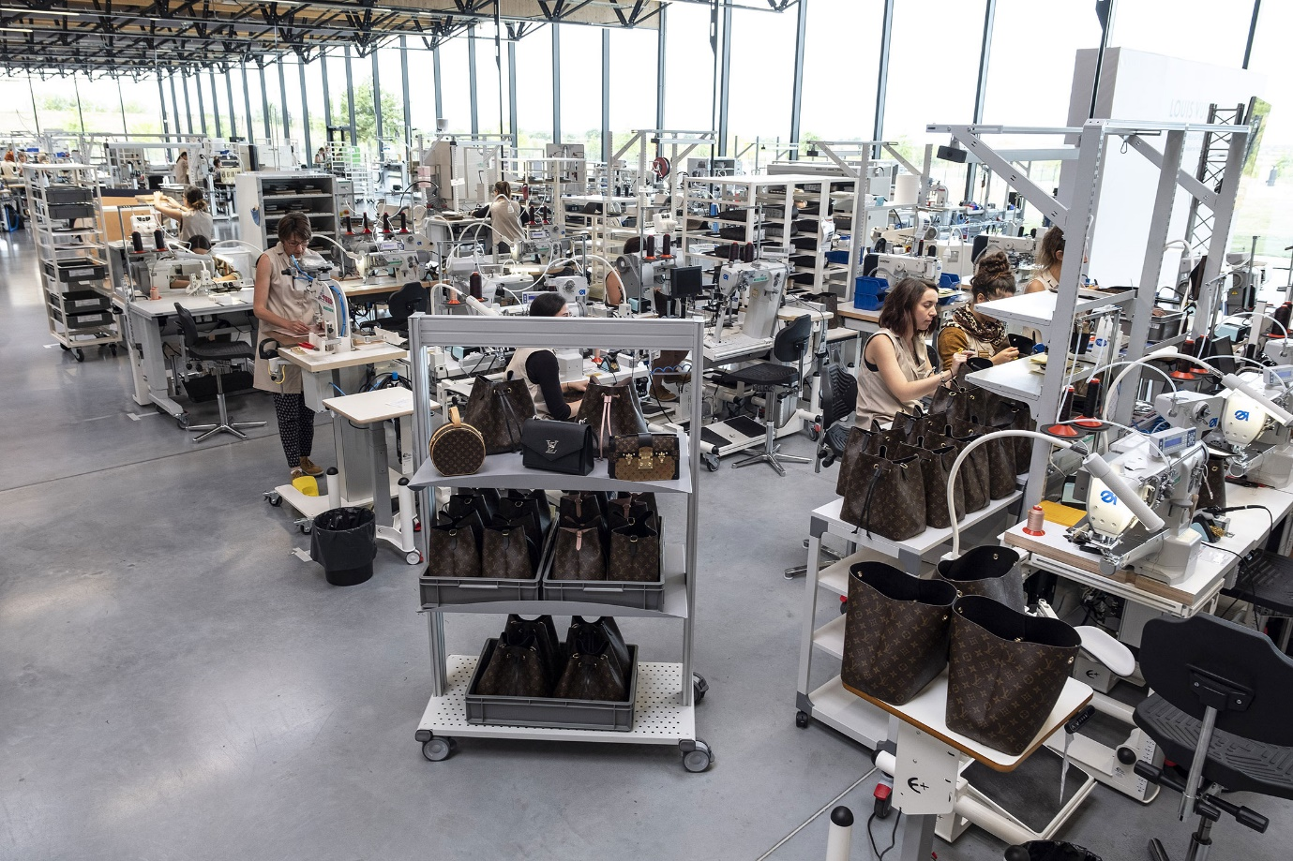

Overall, the combination of high brand value, reputation, and scarcity contribute to the inelastic demand for Louis Vuitton bags. While price changes may have some impact on demand, it is likely to be relatively small, especially for consumers who are highly motivated to own a luxury product with a strong brand identity.

Consumer point of view

From the consumer's point of view, a Louis Vuitton bag is generally considered a luxury rather than a necessity. While a bag is certainly a functional item that serves a practical purpose, a Louis Vuitton bag specifically is seen as a status symbol and an expression of personal style.

Given that Louis Vuitton bags are viewed as a luxury item, this typically indicates that demand is more inelastic. Consumers who are interested in purchasing a Louis Vuitton bag are generally less sensitive to changes in price because they value the quality, craftsmanship, and exclusivity of the product (Lee & Lee, 2020). Inelastic demand means that even if the price of the bag increases, consumers are still likely to purchase it because they place a high value on owning a luxury item from a prestigious brand.

On the other hand, if Louis Vuitton bags were viewed as a necessity, demand would be more elastic. This means that consumers would be more sensitive to price changes, and if the price of the bag increased too much, they might be more likely to seek out alternative, less expensive bags that could meet their functional needs.

Overall, the fact that Louis Vuitton bags are viewed as a luxury rather than a necessity suggests that demand is more inelastic, and consumers are less likely to be deterred by price increases.

Pricing Policy which the business should adopt

Based on the factors we have discussed, Louis Vuitton should consider a pricing policy that reflects the brand's premium status and exclusive image. This means that Louis Vuitton should continue to charge a high price for its products in order to maintain their perceived value and exclusivity. A premium pricing strategy can also help to reinforce the brand's image as a luxury product, attracting consumers who place a high value on quality and exclusivity. However, the business should also be careful not to price its products too high, as this could potentially deter some consumers and impact demand (Schmitt, 2021).
One effective pricing strategy that Louis Vuitton can consider is "price skimming." This involves charging a high price for a new product when it is first released, and then gradually lowering the price as demand stabilizes. This strategy can help to maximize revenue and profitability, while also allowing the brand to maintain its exclusivity and perceived value. In addition, Louis Vuitton should also consider value-based pricing, which involves setting prices based on the perceived value of the product to the customer. This approach allows the business to set a price that reflects the premium nature of the product while also taking into account the perceived value to the consumer.

Overall, Louis Vuitton should focus on a pricing strategy that reflects the brand's premium image, while also taking into account the perceived value of its products to the consumer (Moreno & Breazeale, 2020). By doing so, the business can maintain its exclusivity and profitability, while also attracting and retaining customers who value quality and luxury.

Conclusion

In conclusion, Louis Vuitton bags are a highly coveted luxury item that is known for its exclusivity, high-quality craftsmanship, and iconic design. The brand has a strong reputation for being a symbol of luxury, and the bags are often purchased as a status symbol or expression of personal style.
- When considering the factors that affect demand for Louis Vuitton bags, it is clear that the brand has cultivated a loyal customer base that places a high value on quality, exclusivity, and brand image. The brand's strong reputation and image have contributed to inelastic demand for its products, as consumers are willing to pay a premium for the brand's high-end products, regardless of price changes.

- Demographics have also played a significant role in the demand for Louis Vuitton bags. While the brand has traditionally targeted an older, more affluent demographic, it has recently expanded its appeal to younger consumers through social media and limited edition collaborations.

- Consumer tastes and preferences have also affected the demand for Louis Vuitton bags, as the brand has responded to changing fashion trends and shifted its product line to appeal to a wider range of consumers. However, the brand has remained committed to its core values of quality, craftsmanship, and exclusivity, which has helped it maintain its reputation as a luxury brand.

- Looking ahead, it is likely that demand for Louis Vuitton bags will continue to remain strong, as the brand continues to innovate and expand its product line to appeal to a wider range of consumers. While price increases may have some impact on demand, the brand's reputation and exclusivity are likely to remain key drivers of inelastic demand for its products.

- In terms of pricing policy, Louis Vuitton should continue to focus on a premium pricing strategy that reflects its luxury image and high-end products. By doing so, the brand can maintain its exclusivity and profitability while also attracting and retaining customers who place a high value on quality and luxury.

Overall, Louis Vuitton bags represent an iconic luxury item that is highly valued by consumers worldwide. Through its commitment to quality, craftsmanship, and exclusivity, the brand has built a reputation that has helped it remain one of the most sought-after luxury brands in the world.

References
Budiono, S., Purba, J.T. and Rajagukguk, W., 2021. Robust Least Squared: To Build Consumer’s Purchase Intention at Louis Vuitton Indonesia.

Chen, Y. H., & Lin, S. C. (2021). The Influence of Social Media Marketing on Consumer Purchase Intention: The Case of Louis Vuitton in Taiwan. Journal of International Business and Economics, 19(1), 32-44.

JOHNSTON, M., 2022. 6 Companies Owned by LVMH (Moët Hennessy Louis Vuitton SE). [Online]
Available at: https://www.investopedia.com/articles/insights/081816/top-7-companies-owned-louis-vuitton-lvmuy.asp
[Accessed 4 May 2023].

Kim, J. E., & Ko, E. (2021). From snobbism to sustainability: Exploring consumer attitudes towards luxury brands in the UK. Journal of Business Research, 131, 1-11.

Kim, K., & Park, J. (2021). Effects of celebrity endorsements on consumer attitudes and purchase intention: The case of Louis Vuitton in the US. Journal of Fashion Marketing and Management, 25(1), 84-99.

Lee, J. Y., & Lee, D. (2020). Understanding consumer attitude toward sustainable luxury fashion products: A case study of Louis Vuitton. Journal of Retailing and Consumer Services, 55, 102108.

Louis Vuitton, 2023. A LEGENDARY HISTORY. [Online]
Available at: https://uk.louisvuitton.com/eng-gb/magazine/articles/a-legendary-history#
[Accessed 5 May 2023].

LVHM, 2023. Bernard Arnault CHAIRMAN AND CHIEF EXECUTIVE OFFICER. [Online]
Available at: https://www.lvmh.com/group/about-lvmh/governance/executive-committee/bernard-arnault/#:~:text=Bernard%20Arnault%20is%20Chairman%20and,March%205%2C%201949%2C%20Mr.
[Accessed 5 May 2023].

Moreno, D. C., & Breazeale, M. (2020). The social costs of conspicuous consumption in the era of Instagram: A comparative analysis of the fashion brands Louis Vuitton and Supreme. Journal of Marketing Communications, 26(7), 634-652.

Schmitt, J.B., 2021. Louis Vuitton in China-identifying components of a successful strategy for luxury brands (Doctoral dissertation).

