University of Wales Trinity Saint David
Wales Institute of Science and Art


Electronic Circuits Testing and Applications

Electronic Control Systems ACHA4010

Freddie Watkins
2107574
02/04/2023
Contents

1 Task 1 1
1.0 A 1
1.1 B 1
1.2 C (i) 1
1.3 C (ii) 1
1.4 C (iii) 1
1.5 C (iv) 1
1.6 D 1
1.7 E 1
1.8 F 2
1.9 G 2
2 Task 2 3
2.0 Scope Time Division Calculations 3
2.1 Function Generator output sine wave 3
2.2 Unsmoothed Rectifier Wave 4
2.3 Smoothed Rectifier Wave 4
2.4 Drop in Voltage Question 5
2.5 Rectifiers use in Automotive applications Question. 5
2.6 Probing Question 5
3 Task 3 6
3.0 Scope Time Division Calculations 6
3.1 Function Generator output sine wave 6
3.2 Capacitor charge and discharge wave marked at correct points. 6
3.3 Basic Capacitor Calculations 7
3.4 Capacitor discharge table 7
3.5 Gradient Plot and calculations 7
3.6 Inaccuracies Question 7
4 References 8

Task 1

A
Current = 0.5A
Total Voltage = 12V
V = 12/4 = 3V
Using Ohm’s Law, Resistance of E = 3V / 0.5A = 6 Ohms
Resistance of E = 6 Ohms

B
As resistors B and C are in parallel with resistor A, the current through each must be the same.
Current through A = Current through B and C
Current through A = 0.3A (given)
Current through B and C = 0.3A

C (i)
Power = 0.9J/s = 0.9W
Current through A = 0.3A
Using the equation R = P / I^2:
(0.9W) / (0.3A)^2 = 10 Ohms
Resistance of A = 10 Ohms

C (ii)
As resistors B and C are identical, the total resistance between the two is equal.
Resistance of B = 10 Ohms
Resistance of C = 10 Ohms
Combined Resistance = 5 Ohms

C (iii)
(R of A) = (R of B) = (R of C) = 10 Ohms
I = 0.3A
PD = (10 Ohms * 0.3A) = 3V

C (iv)
PD across A to E = 5V
I = 0.3A
The current passing through E and D is the same as they are in series.
This means that PD across D must be (12V – 5V) = 7V
Using Ohm’s Law, we use this to calculate the resistance.
R = (V / R) = (7V / 0.3A) = 23.3 Ohms

D
Total Current = 0.6A
Lost voltage across one cell = 2V
Voltage across combination of cells = 3V
Therefore, the voltage across one cell = 1V
Internal resistance of one cell = (1V / 0.6A) = 1.67 Ohms
Total resistance of all four cells = (1 / (4*1.67)) = 0.25 Ohms

Task 2

Scope Time Division Calculations
Frequency (Hz) = 10Hz
Period (s) = (1 / Frequency)
1 / 10Hz = 0.1s
0.1 * 1000 = 100mS
From this calculation, we can see that the time division required to see a full period on the screen is 0.1 seconds, or 100 milliseconds.

Function Generator output sine wave
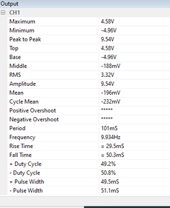
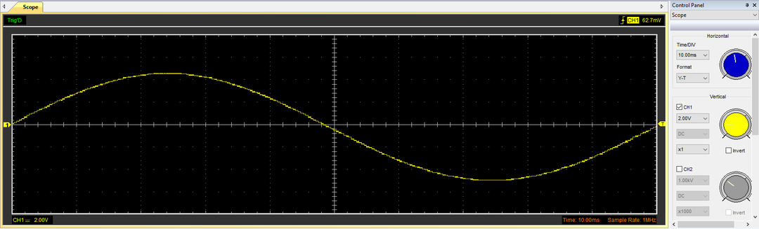
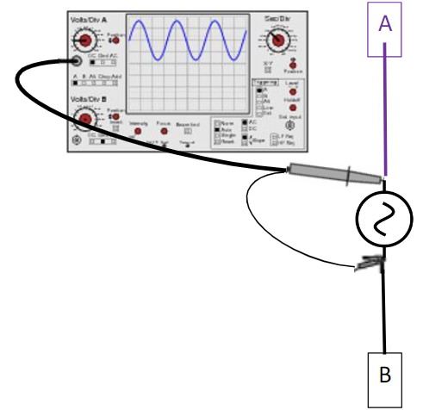

Unsmoothed Rectifier Wave
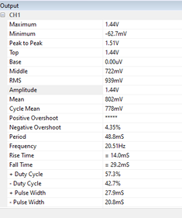
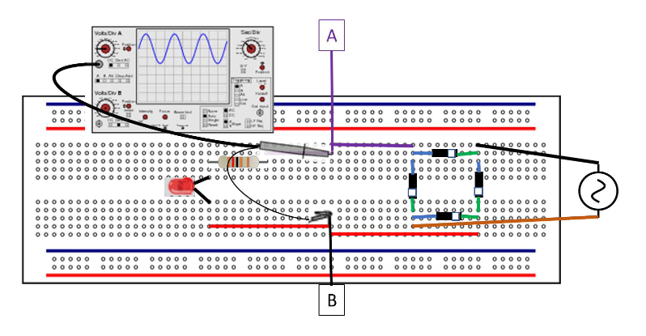
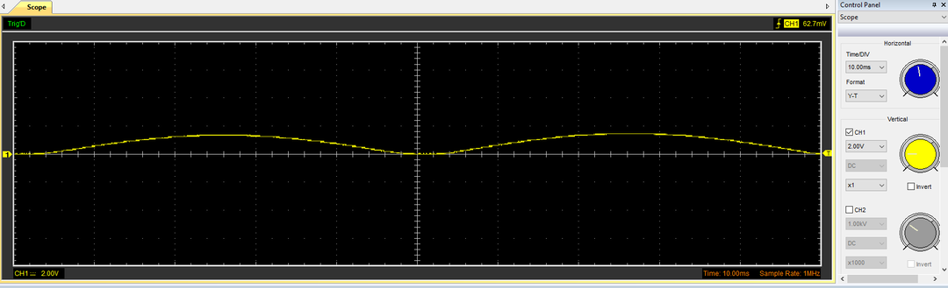

Smoothed Rectifier Wave
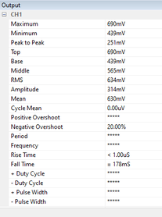
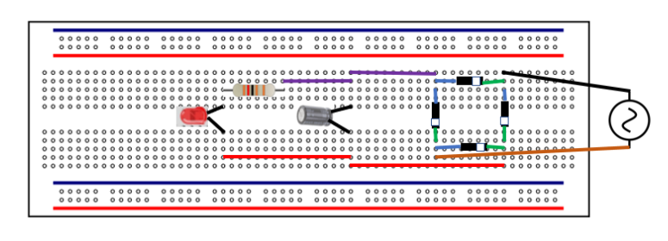
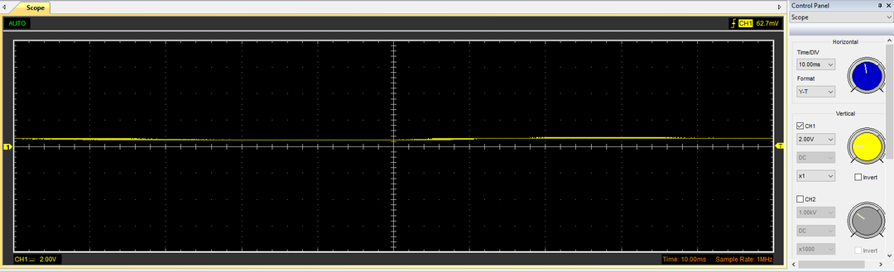

Drop in Voltage Question
The rectified DC voltage output is significantly lower than the output from the function generator. As the function generator output is AC, this output ‘pulses’ as the voltage level reverses with the current (Hymel, Unknown), and is displayed as a continuous sine wave with a peak and base of 4.58V and -4.96V respectively. As the rectified DC output is constant, there is no need for the wave to have an amplitude, this means that the peak-to-peak voltage is virtually eliminated by the rectifier circuit. However, power is delivered by the DC output at a more consistent rate.

Rectifiers use in Automotive applications Question.
In the automotive industry, rectifiers are mostly used in vehicle charging systems, specifically alternators. Rectifiers are used here as the natural electrical output from an alternator is an AC current, however, vehicle batteries use a DC current as this provides more a consistent voltage and allows the chassis to be used as an ‘earth’. Typically, an alternator will use six diodes in order to convert its output to DC, this is because an alternator generates three separate voltages (three phases) at 120 degrees, so two diodes are needed to rectify each phase (Dias, 2022).
It is also worth noting that modern electric car motors are usually driven by a two or three phase AC current. The reason for this is that an AC current is better at retaining higher voltages, whereas a DC current will cause more voltage losses, reducing the power efficiency of the vehicle.

Probing Question
During the class practical, we were unable to scope both the function generator input and the rectified output on the same PC simultaneously, this is due to a multitude of reasons. Firstly, the two outputs are part of their own respective circuits and do not share a ground. Because of this, when both USB cables are connected to the same computer, the ports will share a common ground, which could lead to inaccurate results from either signal.
The function generator used in the experiment also had only one output socket, this means that the signal from the function generator cannot be scoped while this output is used in the rectifier circuit.
Additionally, scoping two circuits simultaneously with a dual-channel oscilloscope can often introduce crosstalk. If there is cross-talk between the two channels, then this may invalidate the data recorded for each signal. In order to mitigate this issue, it’s important to ensure that each channel/circuit is isolated properly, this can be done by using higher-quality equipment or physically separating each circuit. Similar to cross-talk, electromagnetic interference can also cause interference between the circuits if they are not correctly isolated from one another.

Task 3

Scope Time Division Calculations
Frequency = 10Hz
Period = (1/10Hz) = 0.1s = 100mS
Frequency = (1 / 0.1s) = 10Hz
Cap Marking = 106
Resistance = 10 Ohms
Capacitance = 10 μF (Microfarads) = 0.00001 F (Farads)
T = (R * C) = (10 * 0.00001) = 0.0001s = 0.1mS
20T = (20 * 0.0001) = 0.002s = 2mS
12T = (12 * 0.0001) = 0.0012s = 1.2mS

Function Generator output sine wave
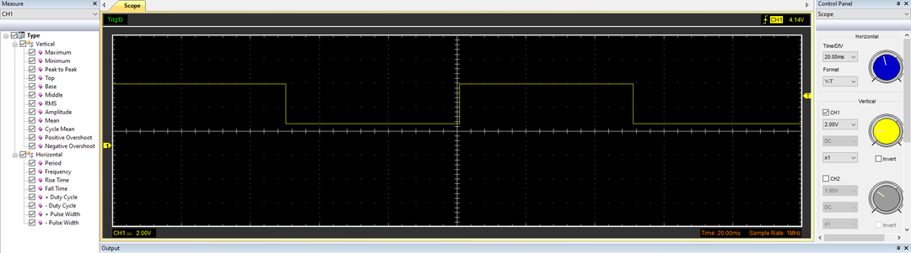
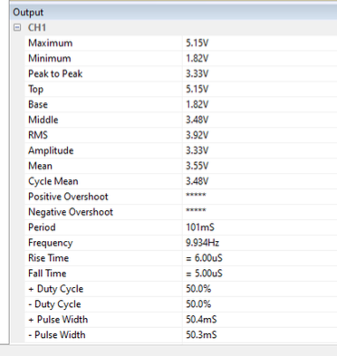
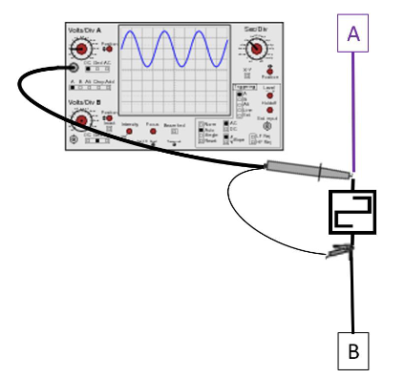

Capacitor charge and discharge wave marked at correct points.
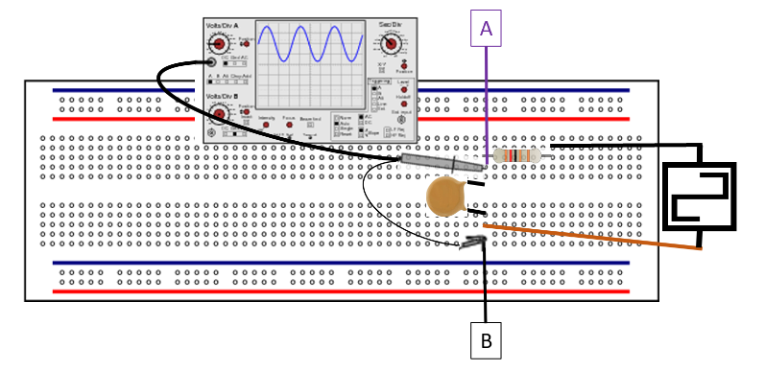
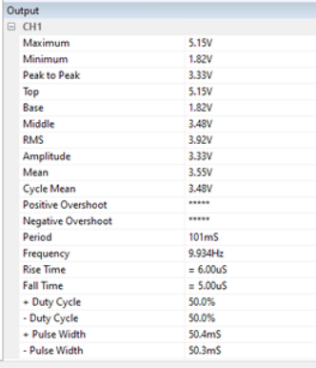
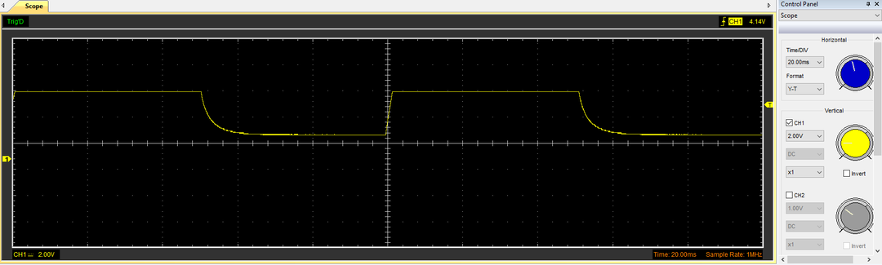
Start of Charge

Start of Discharge

Basic Capacitor Calculations
T = RC = 0.0001s
R = 10 Ohms
C = (T / R) = (0.0001s / 10 Ohms) = 0.00001 F = 10 μF
Using the equation shown above, we can calculate that the capacitance of the capacitor used is 0.00001 Farads, which is 10 Microfarads.

Capacitor discharge table
a = lnV0 = 1.638044805
b = -(1/RC) = -10000
t (s) | 0 | 0.02 | 0.04 | 0.06 | 0.08 | 0.1 | 0.12 | 0.14 | 0.16
Voltage (V) | 5.1451 | 4.7686 | 4.3294 | 3.8902 | 3.3882 | 2.9490 | 2.4471 | 2.0078 | 1.8196
ln V | 1.638 | 201.638 | 401.638 | 601.638 | 801.638 | 1001.638 | 1201.638 | 1401.638 | 1601.638

From this table, we can infer that the voltage decay time constant is likely around 0.15 seconds, as the voltage reaches 37% of its maximum (1.9037 V) between 0.14s and 0.16s.

Gradient Plot and calculations
t (s) | 0 | 0.02 | 0.04 | 0.06 | 0.08 | 0.1 | 0.12 | 0.14 | 0.16
Voltage (V) | 5.1451 | 4.7686 | 4.3294 | 3.8902 | 3.3882 | 2.9490 | 2.4471 | 2.0078 | 1.8196
ln V | 1.638 | 201.638 | 401.638 | 601.638 | 801.638 | 1001.638 | 1201.638 | 1401.638 | 1601.638
Log(V) | 0.7114 | 200.678 | 400.636 | 600.589 | 800.529 | 1000.469 | 1200.389 | 1400.303 | 1600.260
Delta | 0.926 | 0.96 | 1.002 | 1.049 | 1.109 | 1.169 | 1.249 | 1.335 | 1.378
% Difference | 43.431 | 99.524 | 99.750 | 99.825 | 99.861 | 99.883 | 99.896 | 99.905 | 99.914

% Difference = (log(v) / ln V) * 100
This is the percentage of log(v) compared to ln V.

Delta = (ln V - log(v))
This value can be described as the change in voltage.

Inaccuracies Question
While the results show that the two values are very close to one another, we can see that there are consistent inaccuracies throughout the data. Listed below are some of the reasons why this may be.
- Human Error. This can be described as the lack of consistency and precision in an action made by a human. For example, a human cannot stop a stopwatch at the same time repeatedly, as factors such as reaction delay make this almost impossible.

- Quality of Test Equipment. Inaccuracies in the results could be caused by issues with the quality as well as the precision of the equipment used in the practical part of the experiment. For example, the oscilloscope may not be able to provide an entirely perfect result each time it is used, meaning that the data collected is less consistent.

- Interference. It is possible that the accuracy of our results could have been skewed by interference. This is when an electromagnetic field near the scoped circuit disrupts the signal. This can potentially invalidate the results; however, this issue can be eliminated by properly shielding the relevant channel.

References

- S. Hymel, Unknown. Alternating Current (AC) vs. Direct Current (DC). Available at: https://learn.sparkfun.com/tutorials/alternating-current-ac-vs-direct-current-dc/all (Accessed: 01/04/2023)

- C. Dias, 2022. Why is an Alternator Essential to a Car? Available at: https://carorbis.com/blog/what-is-an-alternator-how-does-it-work/ (Accessed: 01/04/2023)

