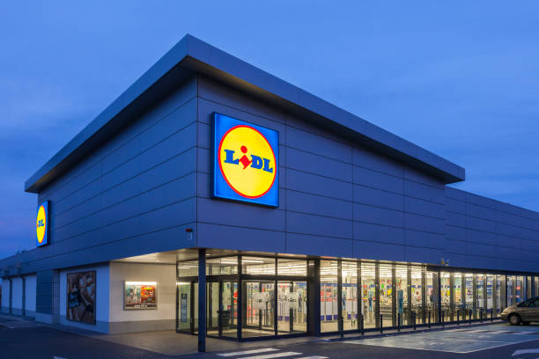
Strategies for Resilience and Prosperity
BMSP6006
Lidl Supermarket
Zoe Vaughan (2015102)

Executive Summary
In 1973 Lidl opened its first store in Germany with only three employees and 500 product lines. Today they have up to 1,600 branded lines (Yahoo!Finance, 2017) and 20,000 staff members in over 900 stores in 13 regional distribution centres across Great Britain. (Lidl, 2022). Lidl is now known as one of the largest European food retailers, with 3,100 stores across Germany. (Ward, L. 2021).
This report reflects upon the strategy approaches Lidl has taken throughout its time to become the successful supermarket it is today. From a small wholesaler to a well-known supermarket which is now loved by many for its low-priced quality products. Throughout this report, I will analyse strategic management tools that Lidl use to remain resilient, sustainable, and prosperous through a competitive, challenging, rapidly changing world.

Contents Page

- Introduction
1.1 - Company background
1.2 - Objectives of the report
1.3 - Competitive Strategy/Business Level Strategy

2.0 Main Findings
2.1 General overview of Lidl’s Strategy
2.2 A detailed Strategy Analysis of Lidl Supermarket
2.3 Advantages & Disadvantages of Lidl’s Strategy Analysis

3.0 - Conclusion
4.0 – References

- - Introduction
Lidl is a successful supermarket that prides itself on providing its customers with high-quality products at a low price. They have a mission and an aim to change the lives of their customers and work to benefit the UK on a larger scale through links with environmental and charitable organisations. (Lidl, 2022).
This report provides insight into Lidl’s sustainability and resilience within the organisation. It demonstrates their approach strategies within management and how they prepare to plan for future opportunities or threats by using a range of theory tools.

1.1 - Company background

Lidl, a German grocery store, was founded by Josef Schwarz in the 1930s. He became a partner in the neighbourhood fruit wholesaler, which later developed into a general food wholesaler. The company was called "Schwarz Assorted Wholesale Foods". (The Solar Navigator, 2022).
As a result of World War 11, the company collapsed, but in 1973, Josef's son Dieter Schwarz (a retailer specialising in discounted supermarkets and wholesalers) began working on building the business. (Yahoo!Finance, 2017). Dieter later inherited the company from his father and opened their first store, "Lidl", in 1973 and became CEO in 1977 when his dad passed away. (Forbes, 2022). In the same year of 1977, 33 more stores opened in Germany, and only three years later, Lidl became a well-known supermarket in the country. In 1990, Lidl opened around the rest of Europe, and in 1994, it opened its first store in the UK. (Ward, L. 2021).
The name "Lidl" (Lidl Stiftung & Co. KG) was purchased from Josef Schwarz's former business partner (a retired schoolteacher), Mr Ludwig Lidl. The rights to the name were purchased from the schoolteacher because the name he originally wanted for the store was Schwarz Markt, meaning - black market. (The Solar Navigator, 2022).
Today Schwarz group is owned by a foundation, technically a limited liability company, although Dieter has complete control and is still Lidl's effective owner. (Forbes, 2022).

1.2 Objectives of the Report
This report will identify Lidl's business strategies and establish who it is as an organisation, its aims to achieve success, and how it strategizes during challenging times. The report will analyse Lidl's internal and external environment, sustainability and resilience, and strategic management approach. In addition, an overall view of the tactics Lidl uses to achieve its future goals and how they gain a competitive advantage and adopt the right approach in a world that changes over time and evolves quickly.
1.3 - Competitive Strategy/Business Level Strategy
Strategic management enables managers to identify and describe strategies they can follow to achieve success. An organisation has a competitive advantage if its profit margin is higher than any other organisation within the industry. To improve the organisation's performance, a manager must have complete knowledge and analysis of its environment to know what decisions to make. (Management Study Guide, 2022).
Corporate management controls strategic planning: They handle all aspects regarding the leading and managing of resources which are then applied to the company to proceed in a direction where it achieves its goals. (PFH Private University of applied sciences,2022).
Strategic management is crucial because it can gain a competitive edge over what their competitor's next step may be. Strategies prepare businesses for future possibilities and potential risks. It helps understand what people want, the global trends and their stakeholders' expectations of the company. Strategic planning strengthens a company's position within its competitors, improves financial gains and motivates the workplace by setting goals and involving employees in its objectives. According to an article by Victoria University, organisations that monitor and review the results of strategic approaches are more likely to see improved financial performance and success. In addition, organisations that are up to date with the change of the world are more likely to adapt and respond to market changes. (Victoria University, 2019).
There are four elements to the strategic management process:
1. First, situation Analysis provides information for the organisation to analyse and evaluate a vision and mission plan. This Analysation can be studied using effective methods such as communicating and observing the company's context and external and internal environment.
2. Strategy Formulation is a short-term strategy that designs, develops, and determines the company's strengths to help formulate the company's strategy. The formulation comprises three organisational parts, operational, competitive, and corporate.

- Operational Strategies are associated with departments within the organisation, such as human resources, finance, marketing, and production, to increase human capital.
- Competitive strategies – Knowledge of the company's competitors' operations to gain a competitive advantage.
- Corporate Strategies are long-term strategies that decide the overall direction an organisation takes.

3. Strategy implementation is executing the strategy; it is developing the steps and methods needed to implement which strategy to use first based on prioritised issues.
4. Strategy Evaluation -examines how well the process of strategy is working, if results are positive and if any adjustments are needed. (MBA Knowledge Base, 2021).

The Strategic Management process is a continuing process that can be adjusted and amended accordingly for the business to reach its goals and succeed. As the company changes, so will its strategies. As the company grows, new strategies will also develop. (MBA Knowledge Base, 2021).
Many businesses find themselves in a "VUCA World" because of unpredicted worldwide events. Everything that happens positively or negatively within the world affects businesses somehow along the line. According to a Forbes article, VUCA represents distinct elements that make an environment. Therefore, the word "VUCA" has gained popularity as a term which means Volatile, Uncertainty, complex and ambiguous. (Kraaijenbrink, J, 2018).

Volatility refers to how quickly things within the world can change.
Uncertainty refers to how uncertain the world is and how we cannot predict the future resulting in the ability for people to understand what is happening.
Complexity refers to what needs to be considered; the more risk factors, the more complex an environment is, and the harder it is to analyse.
Ambiguity is a lack of knowledge on how to act on something. (Kraaijenbrink, J, 2018).

Lidl is a diverse supermarket compared to the well-established grocery stores in the UK, such as Tesco, Asda, Morrisons, and Sainsbury's, which own 74.4% of the market. The long-established oligopoly, whose economic dominance within the industry, gave Lidl a higher barrier to enter, making the market even more of a challenge by requiring significant capital to overcome with a high customer return resulting in higher profit margins. (UK Essays, 2020).
Strategic analysis benefited their marketing strategies, which have proven efficient, effective, and successful with how they rose during the financial crisis. They saw an opportunity during the crisis to begin stocking better and cheaper products to capture market share and earn considerable profits. They gained a larger customer base as people become more interested in the store. Lidl reacted to the change in market conditions by launching incentives. Swot and Pestel Analyses were followed to ensure opportunities were not missed, strengths and weaknesses were recognised, and if needed action can be taken. (UK Essays, 2020).
2.0 - Main Findings
2.1 - General Overview of Lidl’s Strategy

Lidl’s Strategies are to provide a zero-waste, no-frills, easy shopping experience for their customers. They focus on customers using the psychological technique, which means they focus on customers who are price aware and have a limited budget. (Shastri, A, 2022).
Their targeting strategy is an undifferentiated strategy in which they plan to take over the market on a global scale; they aim to do this using a low-price price strategy for quality products. They are cost-effective in paying minimum labour by selling products from their original packaging allowing the opportunity to be able to financially offer low-priced products. (Yahoo!Finance, 2017).
Although they do not hold as much of the market share as other competitors, their marketing positioning strategy has positively impacted business performance with how they positioned the company at places where their audience is active. (Shastri, A, 2022).

2.2 - Detailed Strategy Analysis of Lidl Supermarket
Lidl is the fastest-growing market retailer; it’s evident that the five main forces Michael porter suggested at a strategic business level enabled Lidl to identify the key areas of competitiveness within the UK supermarket industry.
This strategy enables a business to analyse an industry to assess the competitive environment in its market and evaluate investment options. It allows a company to gain insight into the current market and develop a strategy to achieve success. (Mindtools, 2022).

Michael porters five forces, strategic model:
- Competitive Rivalry.
- Supplier Power.
- Buyer Power.
- The threat of Substitution.
- The threat of New Entry.
Low product differential is a rivalry between each supermarket within the industry. Lidl is under pressure to constantly come up with innovative ideas in which it can sell more products than its competitors. Lidl’s low cost is an attraction; however, choice of product availability causes pressure with the threat of customers with the wide choice there is in the market. Furthermore, due to the density of the market, supplier bargaining within the industry may potentially affect Lidl, forcing pressures on securing good relationships with suppliers to ensure they do not pursue better business agreements elsewhere. (Bolton, E, 2022).
Within business, there are two categories Micro and Macro environment. Macro and Micro cover the environment within where the organisation stands. The study of a Mirco environment is known as a SWOT Analysis and refers to all departments within the business; the environment that directly influences the organisation. Examples of these elements may include customers, suppliers, competitors, the media, employees, and shareholders. These internal issues can affect the performance of a business routine for a short time. (Surbhi, S, 2020).
A swot and Pestel analysis are highly effective tools that can provide a company with an insight into internal and external influences.
Swot analysis determines the internal influences within the company; these can be strengths, weaknesses, opportunities, and threats. (Gray, B, 2016)
A pestle analysis is an audit of the company’s external environment. The analysis helps strategic decision-making and planning. The analysis determines issues that could affect the business from an external point of view. (Gray, B, 2016).
The study of a Macro Environment is known as a PESTEL Analysis; these are external forces which have no control over the organisation but can potentially impact the business and how they run daily. These issues can be related to technological, Political, legal, and economic issues (Surbhi, S, 2020).
A Swot Analysis of Lidl:
Lidl’s Strengths are satisfied customers, their own branded products and their baked goods which generate over 80% of the stores sales. (Bhasin, H, 2019).
Lidl has many Weaknesses, such as a Lower market share than competitors. Their low price also gives the impression that the quality of products is not good enough with a perception of their brand looking cheap and standard.
Their Opportunities are expanding in the UK and expanding abroad to enable more funds for investment into the UK economy. Building a new website to allow orders and deliveries can also be an opportunity for potential success.
The Threats Lidl face is the price rivalry with competitors, which is forcing prices to drop with the Internal expansion of other global brands, causing more competition. Aldi is increasing their market share and becoming the dominant discount store. (UKessays, 2022).

A Pestel Analysis of Lidl:

Political issues affecting Lidl can be due to a no-deal Brexit and the UK introducing a food import charge of around 22%. New restrictions will also be applied with the request of documents and border inspections, resulting in increased costs and limited product shelf life due to delayed imports.
Economic issues will be the effect of the UK inflation rates rising, increasing product prices across the industry. Expenditure on food within the UK is predicted to fall by 2.2% by 2030.
Social matters - a change in customer attitudes, such as a rise in diet trends forcing Pressure on the organisation to gain loyalty by introducing food alternatives, such as vegan and vegetarian options.
Technology is improving vastly, with technical innovations such as scanning while shopping and self-serve checkouts. It has also been predicted that by 2023, online shopping will equal to 10% of all grocery shopping.
Environmental changes include increased sustainability awareness, with aims now focused on sourcing produce and stock from local suppliers.
Legal matters such as Health and Safety regulations and laws, Ip around copycat brands
and the employment law regarding alterations to the minimum employee wage. (Bolton, E, 2022).

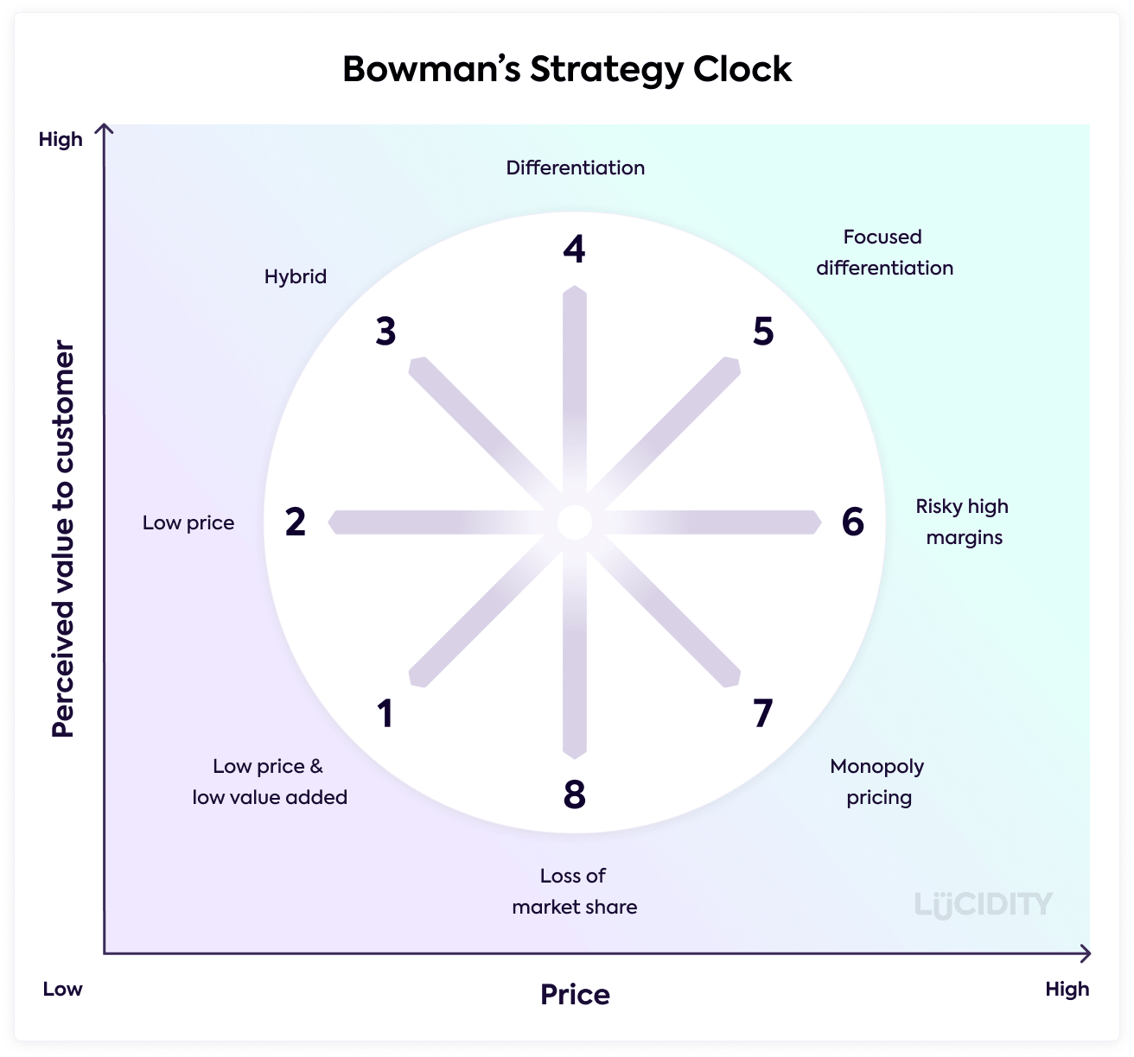
Bowman's strategic clock is another tool to analyse Lidl's environment. The cock represents different positions within the market. It helps managers understand the changes within the market and the choices they make regarding their position and competitive advantage. (Course Hero).
LIDL

I would suggest Lidl is placed at a low price and low value, moving into a hybrid (highly valued products within the market).

Image retrieved from Lucidity. https://getlucidity.com/strategy-resources/introduction-to-bowmans-strategy-clock/.
Lidl has many stakeholders; different people have different interests in the company. These are split into internal and external shareholders. Stakeholder management aims to enhance positive influences and minimise negative influences on the organisation or partnerships. Applying sustainability increases business value and attracts investment resulting in a higher likelihood of success. Stakeholders are individuals who can impact an organisation's strategy and reputation: the more stakeholders, the more potential communication lines. (Anderson, S, May 2020).
Below I have identified the key stakeholders concerning the Lidl grocery store. In addition, external influences should be monitored and kept satisfied. Internal stakeholders are managed closely by communicating regularly to keep them informed. (Rahman, M, March,2022).

Manage Closely/ Keep Informed
Internal Stakeholders
Employees
CEO/Owners Shareholders/ Investors

External Stakeholders
Customers/ Communities/ Governments
Competitors/Suppliers
Monitor / Keep Satisfied

2.3 - Advantages & Disadvantages of Lidl’s Strategy Analysis
The advantages of Lidl have been the approaches they have taken. Lidl used the financial crisis to plan and increase profits by stocking cheaper, better products. As a result, they position themselves well within the market, gaining competitors' advantage every time.
During my research, I also believe Lidl use the 5ps Theory. Henry Mintzberg, a management expert, wrote about the concept of the 5ps in 1987. The 5ps Stand for: (Toolshero, 2022).
- Plan
- Ploy
- Pattern
- Position
- Perspective
I believe Henry Mintzberg’s theory is a tool which businesses can follow step by step to analyse and develop a strategy which will be successful.
Henry Mintzberg also created the "Emergent" strategy, which develops over time as the business changes. (Indeed, 2021).

The disadvantages of Lidl are:
- No option for click/collect or delivery service.
- Lidl does not provide new inventions such as the scan and shop option or self-serve; this is a disadvantage towards the happy customer shopper experience they aim for, and this can potentially frustrate customers with till cue waiting times.
- Lidl only has up to 1,600 branded lines compared to the 15,000 usually sold by other supermarkets. (Yahoo!Finance, 2017).

3.0 - Conclusion
During this research, I have recognised that Lidl has used many strategic tools throughout its history. I believe Michael porters’ model has been followed many times by Lidl, but especially when they took the opportunity, became resilient and thrived from the financial crisis. Although Lidl thrives on delivering excellent customer experience, its primary strategy relies upon the framework strategy of cost leadership, proven by how they have cut labour costs to benefit its customers. In addition, they enhanced their unique selling point by offering products at a low price which made them different to other grocery supermarkets.

4.0 - References

Anderson, S, (May, 2020). Why stakeholder management is essential to sustainable business.
https://www.isystain.com/blog/2020/5/18/stakeholder.

Bhasin, H, (May, 2019). Marketing Strategy of LIDL – LIDL Marketing Strategy. https://www.marketing91.com/marketing-strategy-of-lidl/.

Bolton, E, (2022). Spotlight: Lidl UK Strategy Considerations. https://getlucidity.com/strategy-resources/spotlight-lidl-uk-strategy-considerations/.

Course Hero. And if the management of the company is able to. https://www.coursehero.com/file/pm4ci43/And-if-the-management-of-the-company-is-able-to-understand-these-eight-crucial/.

Forbes, (2022). Dieter Schwarz. https://www.forbes.com/profile/dieter-schwarz/?sh=4464eaa56fea.

Gray, B, (Oct, 2016). How to Effectively Conduct a PESTLE & SWOT Analysis. https://www.linkedin.com/pulse/how-conduct-pestle-swot-analysis-byron-gray.

Bowmans Strategy Clock. Image retrieved from Lucidity. https://getlucidity.com/strategy-resources/introduction-to-bowmans-strategy-clock/.
Indeed.com, (April,2021). What is Emergent Strategy with benefits and examples. https://www.indeed.com/career-advice/career-development/emergent-strategy-defination.
Kraaijenbrink, J, ( Dec, 2018). What does VUCA really mean? https://www.forbes.com/sites/jeroenkraaijenbrink/2018/12/19/what-does-vuca-really-mean/?sh=6cc2ff7517d6.

Lidl Image. Image retrieved from iStock. https://www.istockphoto.com/photos/lidl.
Lidl, (2022). Our history. https://careers.lidl.co.uk/life-at-lidl/our-history.

Management and Study Guide. (2022). Strategic Management - Meaning and Important Concepts. https://www.managementstudyguide.com/strategic-management.htm.

MBA Knowledge Base, (2021). Four Major Elements of the Strategic Management Process. https://www.mbaknol.com/strategic-management/four-major-elements-of-the-strategic-management-process/.
Mindtools, (2022). Porter's Five Forces - The Framework Explained. https://www.mindtools.com/pages/article/newTMC_08.htm.
PFH Private University of applied sciences, (2022). 10 Rules to follow for successful corporate management. https://www.pfh-university.com/blog/10-rules-to-follow-for-successful-corporate-management.html.
Rahman, M, (March,2022). Stakeholders of Lidl (Stakeholder Analysis). https://howandwhat.net/stakeholders-lidl-stakeholder-analysis/.
Shastri, A, (2022). Extensive Marketing Strategy of Lidl – STP Analysis. https://iide.co/case-studies/marketing-strategy-of-lidl/.

Surbhi, S, (Feb 2020). Key Differences. Difference between Micro and Macro Environments. https://keydifferences.com/difference-between-micro-internal-and-macro-external-environment.html.

The Solar Navigator, (2022). LIDL - DISCOUNT STORES.
http://www.solarnavigator.net/solar_cola/super_markets_stores/lidl.htm.

UKEssays. (November 2018). How has Lidl made great strides in the UK grocery market? https://www.ukessays.com/essays/business/how-have-lidl-made-great-strides-in-the-uk-grocery-market.php?vref=1

Toolshero, (2022). 5 P’s of Strategy (Mintzberg). https://www.toolshero.com/strategy/5-ps-of-strategy/.

Victoria University, (May, 2019). What is strategic management, and why is it important? https://online.vu.edu.au/blog/what-strategic-management-and-why-it-important-1.

Ward, L. (March, 2021). The Fact Site. 11 Fast Facts About the History of Lidl. https://www.thefactsite.com/history-of-lidl/.

Yahoo!Finance. (May, 2017). Revealed: how to budget supermarket Lidl is taking over the world.https://uk.finance.yahoo.com/news/revealed-budget-supermarket-lidl-taking-000000605.html?guccounter=1&guce_referrer=aHR0cHM6Ly93d3cuZ29vZ2xlLmNvbS8&guce_referrer_sig=AQAAAAYsIVz2HHdmq5TZRJRTQUUaqPS90N46CVCjI9Nbj8FlQXMmdl0zFLkjrTd9qn9SAuTzlHywyNq1v9S2Fuu1r6wDDliDMDyi6U1Tw-ijE4jfDjeCQ4jPCpZgQ8IDusNrOTjWOzRnIONkzHu7IyThKQs0j9w6JCJLUKRzGxPcefVS.

