University of Wales Trinity Saint David
School of Engineering



Passive RC Filter Networks Report

Electrical and Electronic Principles ACDB4002

Matthew Williams
2308346
March 2024

Contents
1 Abstract 1
2 Introduction 2
2.1 Aims 2
2.2 Objectives 2
3 Circuit Descriptions 3
3.1 Low Pass Circuit 3
3.2 High pass circuit 5
3.3 Theoretical Calculations 6
4 Results 7
4.1 Low Pass Circuit Theoretical Values 7
4.2 Low Pass Circuit Experimental Results 8
4.3 High Pass Filter Circuit Theoretical Values 11
4.4 High Pass Filter Circuit Experimental Results 12
5 Discussion 15
5.1 Low Pass Filter Circuit 15
5.2 High Pass Filter Circuit 16
6 Conclusions 17
7 References 18
8 Appendices 19
8.1 Loss Pass Filter Circuit Theoretical Values 19
8.2 High Pass Filter Circuit Theoretical Values 20
8.3 Low Pass Filter Circuit Experimental Values 21
8.4 High Pass Filter Circuit Experimental Values 22

Abstract

This report will present the results from a series of laboratory experiments performed in setting up and measuring the input and output voltages of a low pass and high pass filter circuit. Two circuits were assembled and connected to an oscilloscope via a function generator, with an AC input voltage applied. By increasing or decreasing the frequency through the function generator, measurements of the corresponding input and output voltages recorded. The attenuation levels were recorded and plotted to show the difference between the low and high pass circuits and at what frequencies the signals passed and which were filtered out.
The results intend to highlight the difference between the low pass and high pass filter attenuation signals and the cutoff point of each circuit. Calculations will be made for capacitive reactance (X_{c}) to calculate the theoretical output voltages for each circuit and comparisons made with the experimental values. Calculations will also be made for attenuation levels for both circuits and the calculated frequency for the attenuation of -3 decibels. The results will show that despite variations between the theoretical and experimental values, the readings were still within the tolerance range of the resistor.

Introduction
Filters in electrical circuits are designed to pass or block signals with frequencies within certain bands and fall into two main categories: high pass and low pass. A simple high and low pass circuit is constructed using a resistor and a capacitor in series with each other and, depending on requirements, one of them will be in parallel with the required circuit load. An RC circuit with the resistor before capacitor, known as a low pass filter, will remove high frequencies and allow only low frequencies to pass, whereas a circuit with the capacitor before resistor, known as a high pass filter, will remove low frequencies and allow high frequencies to pass.
Both high and low pass filters are used extensively in circuits for audio processing. Low pass filter circuits have many uses in electronic equipment including the removal of high frequencies in audio circuits, for smoothing out the signal output to rectifiers and for filtering out the harmonics in inverters. In contrast, high pass filters are used for removing low frequency noise from audio circuits and attenuating high frequency signals in circuits for audio equalization and speech processing. High frequency filters are also used in instrumentation such as sensors and measuring equipment for removing noise to ensure accurate readings. (Bird, 2007, pp. 559-586)

Aims
This report aims to show the theory of capacitor reactance, in that the complex impedance of a capacitors value changes with respect to the applied frequency. This will be shown experimentally by replacing one of the resistors in a voltage divider circuit (figure 1) with a capacitor and varying the frequency through the circuit. The aim is to highlight the position of the capacitor with respect to the resistor and the load, and how this positioning will determine whether the circuit attenuates high or low frequencies.

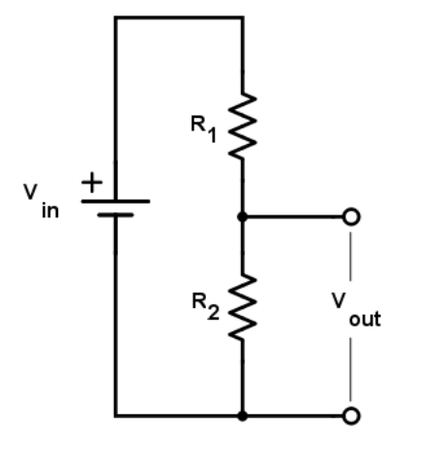
Figure 1- Voltage Divider Circuit

Objectives
- Highlight the theory of capacitive reactance.
- Build a low pass and high pass filter circuit and record the experiment results.
- Compare results with theoretical values.
- Research the effects of capacitive reactance in RC circuits.
- Present results and analyse findings.
- Discuss and explain results and discrepancies between experimental values.
- Present conclusions.

Circuit Descriptions
The two circuits were built using a 10kΩ resistor and a capacitor connected to an oscilloscope via a function generator, with a 5V input voltage applied. By increasing or decreasing the frequency through the function generator, measurements of the corresponding input and output voltages were recorded. The range of frequencies requested were from 100Hz up to a maximum of 300kHz.

Low Pass Circuit
An RC low-pass filter circuit is created by placing a resistor in series with and before a capacitor which is also in parallel with the load (figure 1)
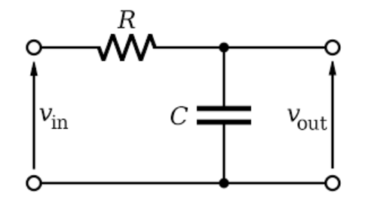
Figure 2-Low Pass Filter Circuit

The circuit in figure 1 was built on a breadboard (figure 2) and the input of the circuit connected to the output of the signal generator whereby a 5v peak to peak signal was applied. The input signal and output signal from the circuit was then connected to the oscilloscope channels 1 and 2 respectively (figure 3).

The key components used on the breadboard were:
- Resistor – 10KΩ (Resistor has a ±5% tolerance)
- Capacitor – 550pF

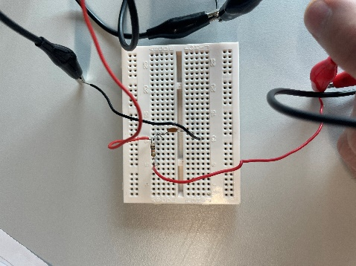
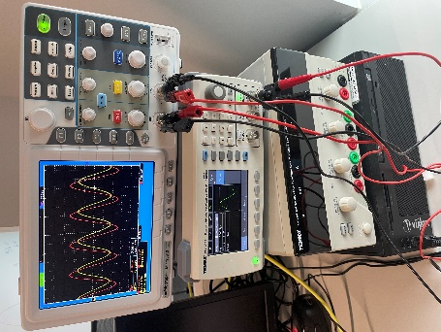
Figure -Signal generator and Oscilloscope.
Figure 3- Experiment 1-Low Pass Circuit

- A range of frequencies from 100 Hz to 300 KHz was applied to the circuits and the input and output voltages recorded for that frequency. It can be seen on the oscilloscope in figure 4 that as the 30 kHz frequency is applied to the circuit the capacitor attenuates the signal and the output voltage drops. This can be seen in the phase shift between the input (red) and output (yellow) waves.
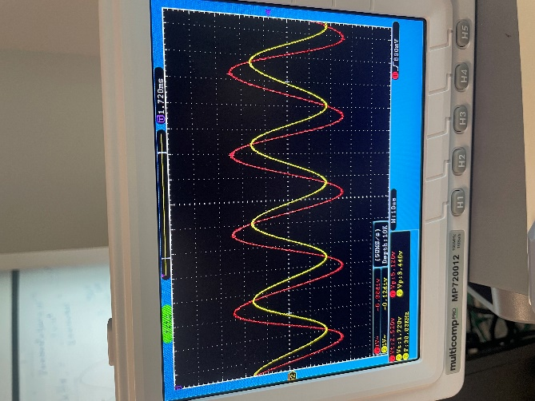
Figure 4-Oscilloscope showing the voltage phase shift.
- Once all the recordings were taken, the attenuation levels for each frequency were calculated using equation 1.
Equation 1
$$A\left(db\right)=20×\log_{10}{\frac{V_{out}}{V_{in}}}$$
- Once the results tables had been compiled (as shown in the appendices), the results were then plotted on graphs for analysis.

High pass circuit
A High-pass filter circuit is created by placing the capacitor in series with and before a resistor which is also in parallel with the load (figure 5)
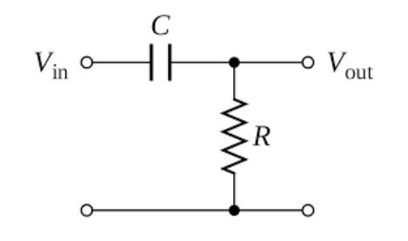
Figure 5-High Pass Filter Circuit
The same procedure for the low pass circuit was followed except in this case the circuit construction (figure 6) was built to figure 5, and the key components were:
- Resistor – 10kΩ
- Capacitor – 15nF

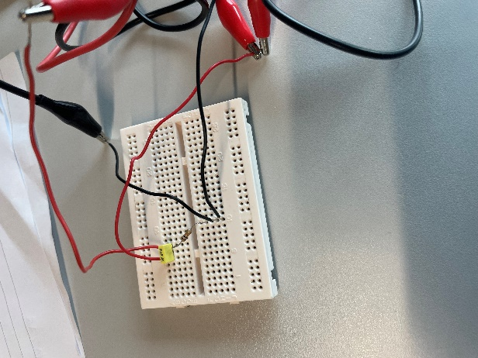
Figure 6- Experiment 2-High Pass Filter Circuit

Theoretical Calculations
To verify the validity and accuracy of the experimental values the first step was to compile a set of theoretical values for comparison. For each circuit, the calculations were as follows:
- Step 1. Calculate the Capacitive reactance occurring for each frequency using equation 2.
- Step 2. Calculate the V_{out} value using equation 3.
- Step 3. Calculate the Attenuation using equation 1.
- Step 4. Calculate the -3-decibel cut off frequency using equation 4.
- Step 5. Calculate the frequency at -3db cut-off for resistor values at ±5% of 10kΩ using equation 4 and apply the results to the experimental results chart.
where:
X_{c} = Capacitive Reactance (Ω)
f = Frequency (Hz)
C = Capacitance (Farads)
Vout = Output Voltage
Vin = Input Voltage
R = Resistor value
f_{c} = Cut-off frequency

Equation 2
$$X_{c }(Ω)= \frac{1}{2πfc}$$

Equation 3
$$V_{out} (V) =V_{in} \frac{X_{c }}{\sqrt{R^{2}+X_{c}^{2}}}$$

Equation 4
$$f_{c}(Hz)= \frac{1}{2πRC}$$

Results

Low Pass Circuit Theoretical Values

Figure 7 - Theoretical Values of Attenuation against Frequency for Low Pass Circuit

The equation for calculating the frequency cut-off as shown in figures 7 and 11, is shown in equation 5.
Equation 5- Using equation 4 to calculate the frequency cut-off.
$$f_{c}(Hz)= \frac{1}{2πRC}$$
$$f_{c}\left(Hz\right)= \frac{1}{2π(10×{10}^{3}) \left(560×{10}^{-12}\right)}$$
$$f_{c}= 28420 Hz$$

Figure 8 - Theoretical Values of Output Voltage against Frequency of Low Pass Circuit

Low Pass Circuit Experimental Results

Figure 9 - Experimental Results of Attenuation Against Frequency in Low Pass Circuit.

Figure 10 - Experimental Results of Output Voltage against Frequency in Low Pass Circuit.

Figure 11 - Graph Showing Resistor Tolerance at Frequency Cut-off.

The resistor tolerance of ±5% was calculated as shown in equation 6 and 7 and plotted on the graph in figure 11.
Resistor (R) = 10kΩ
Resistor (R) +5% =10.5kΩ
Resistor (R) -5% = 9.5kΩ
Therefore: For frequency at +5%
Equation 6– Low Pass Circuit +5% resistor tolerance
$$f= \frac{1}{2πRC}$$
$$f\left(Hz\right)= \frac{1}{2π(10.5×{10}^{3}) \left(560×{10}^{-12}\right)}$$
$$f= 27067 Hz$$
For frequency at -5%

Equation 7 – Low Pass Circuit -5% resistor tolerance
$$f= \frac{1}{2πRC}$$
$$f\left(Hz\right)= \frac{1}{2π(9.5×{10}^{3}) \left(560×{10}^{-12}\right)}$$
$$f= 28420 Hz$$

High Pass Filter Circuit Theoretical Values

Figure 12 - Theoretical Values of Attenuation Against Frequency for High Pass Circuit

The frequency cut-off as shown in figures 12 and 14 was calculated in equation 8.

Equation 8 - Using equation 4 to calculate the frequency cut-off.
$$f_{c}(Hz)= \frac{1}{2πRC}$$
$$f_{c}\left(Hz\right)= \frac{1}{2π(10×{10}^{3}) \left(15×{10}^{-9}\right)}$$
$$f_{c}= 1061 Hz$$

Figure 13 - Theoretical Values of Output Voltage Against Frequency for High Pass Circuit.

High Pass Filter Circuit Experimental Results

Figure 14 - Experimental Results of Attenuation Against Frequency for High Pass Circuit.

Figure 15 - Experimental Results of Input and Output Voltage Against Frequency

Figure 16 - Graph Showing Resistor Tolerance at Frequency Cut-off

The resistor tolerance of ±5% was calculated and plotted on the graph in figure 16.
For frequency at +5%

Equation 9 High Pass Circuit +5% resistor tolerance
$$f= \frac{1}{2πRC}$$
$$f\left(Hz\right)= \frac{1}{2π(10.5×{10}^{3}) \left(15×{10}^{-9}\right)}$$
$$f=1061 Hz$$
For frequency at -5%

Equation 10 - High Pass Circuit -5% resistor tolerance
$$f= \frac{1}{2πRC}$$
$$f\left(Hz\right)= \frac{1}{2π(9.5×{10}^{3}) \left(15×{10}^{-9}\right)}$$
$$f= 1117 Hz$$

Discussion

Low Pass Filter Circuit
The results show that the experiment was successful in terms of accurately measuring the attenuation and output voltages at each frequency point. Comparing the theoretical attenuation values (figure 7) with the values from the experiment (figure 9), the attenuation level remains near zero until around 5000 Hz before starting to fall. What is also apparent from the output voltage results in figures 8 and 10 is that at around the same time the attenuation drops, so too does the output voltage. This is due to Capacitive reactance and the complex impedance of the capacitor and how its reactance decreases as frequency increases.
Capacitive Reactance occurs due to the alternating current continually charging and discharging the capacitor as the signal changes from positive to negative. The electrons that bounce between the plates inside the capacitor generate a charge that increase with an increase in frequency. The increased current flow lowers the reactance of the capacitor. The capacitor acts like a variable resistor with its reactance inversely proportional to the supply frequency.
So, when frequency of the input voltage is low then the impedance of the capacitor is high in relation to the resistor. Most of the input voltage will then go across the capacitor which is in parallel with the load. In contrast, when the input frequency is high, the impedance of the capacitor is low in relation to the resistor, so more voltage is lost over the resistor and less is transferred as output voltage. These results agree with the characteristics of low pass filters in that they allow low frequencies to pass and block high frequencies.
The curves on the graphs of the experimental results also show that they are not as smooth as the theoretical values. There are many reasons for discrepancies between calculated and theoretical values, but the most significant in this experiment will be the tolerance of the resistor. The 10KΩ resistor in these experiments has a tolerance of ±5%. This accounts for the values between the graphs not matching exactly which can be seen as the attenuation curve in figure 9 does not pass directly through the -3-decibel cutoff point that intersects with the frequency cut-off of 28420 Hz, as calculated in equation 5. However, Figure 11 shows that despite this discrepancy, the value is still within the tolerance range of the resistor, which was calculated using equation 4 and applying the 5% tolerance range to the resistor (R) value.
Also to note is the significance of the -3-decibel cut-off frequency as shown in figure 7 whereby signals above this level are passed and ones below are blocked. The frequency cut-off value is where ‘the frequency above which the output voltage falls below 70.7% of the input voltage’ (Kuphaldt, 2024). The value of -3 decibels is chosen because it is the frequency at which the amplitude of the input signal is reduced by 3 decibels.’ (Keim, 2024) This value also intersects nicely with the calculated frequency cut-off and the attenuation curve.

High Pass Filter Circuit

High pass filters work in the same way as low pass filters except that because the resistor is now parallel with the load the circuit has the opposite effect when attenuating the signal.
This can be seen in figures 12 and 14 in comparing the theoretical and experimental attenuation values. At low frequencies, the signal is blocked and only starts to pass as it reaches the -3-decibel cut-off except this time the cut-off frequency is lower. At low frequencies, the output voltage is also low (figures 13 and 15) because this time the capacitor is not in parallel with the load. As the frequency is increased, so too does the output voltage as the capacitor begins to reduce its reactance and the voltage gets dropped over the resistor instead.
Figure 16 shows that despite the small discrepancy in the attenuation value not intersecting the -3db and frequency cut-off value of 1061 Hz as calculated using equation 6, it still lies within the resistor's tolerance range.

Conclusions
In this experiment and report it has been determined that capacitor reactance in low and high pass filters work in a comparable way, but it is the positioning of the capacitor and resistor in relation to the load that defines whether it filters high or low frequencies. It has been found that capacitor reactance (Xc) is inversely proportional to frequency, so the higher the frequency, the lower the reactance which means more voltage is dropped over the resistor as resistors are unaffected by frequency changes.
Low pass filters allow low frequency signals to pass and filter high frequency signals, so when the capacitor is in parallel with the load, it will drop voltage as the frequency is increased and consequently so too the attenuation.
In contrast to this, in a high pass filter circuit, the same reactance occurs in the capacitor as the frequency is increased, but because now the resistor is in parallel with the load, the output voltage readings increase and consequently so too the attenuation.
The results also highlight that all resistors have a tolerance which need to be considered when comparing theoretical and actual values.
It has also been proven by calculation that -3 decibels is the attenuation cut-off point for both low and high pass filters.

References

Bird, J. (2007). Electrical Circuit Theory and Technology. Oxford: Elsevier Ltd.
Keim, R. (2024, March 1). What Is a Low Pass Filter? A Tutorial on the Basics of Passive RC Filters. Retrieved from All About Circuits: https://www.allaboutcircuits.com/technical-articles/low-pass-filter-tutorial-basics-passive-RC-filter/
Kuphaldt, T. R. (2024, March 2). Low Pass Filters. Retrieved from All About Circuits: https://www.allaboutcircuits.com/textbook/alternating-current/chpt-8/low-pass-filters/

Appendices

Loss Pass Filter Circuit Theoretical Values
Low Pass Filter Theoretical
Frequency (Hz) | X_{c} Ω | V_{OUT} (V) | A(db)
100 | 2842052.56 | 5.00 | 0.00
500 | 568410.51 | 5.00 | 0.00
1000 | 284205.26 | 5.00 | -0.01
2000 | 142102.63 | 4.99 | -0.02
3000 | 94735.09 | 4.97 | -0.05
4000 | 71051.31 | 4.95 | -0.09
5000 | 56841.05 | 4.92 | -0.13
10000 | 28420.53 | 4.72 | -0.51
15000 | 18947.02 | 4.42 | -1.07
20000 | 14210.26 | 4.09 | -1.75
25000 | 11368.21 | 3.75 | -2.49
30000 | 9473.51 | 3.44 | -3.25
35000 | 8120.15 | 3.15 | -4.01
40000 | 7105.13 | 2.90 | -4.74
45000 | 6315.67 | 2.67 | -5.45
50000 | 5684.11 | 2.47 | -6.12
55000 | 5167.37 | 2.30 | -6.76
60000 | 4736.75 | 2.14 | -7.37
70000 | 4060.08 | 1.88 | -8.49
80000 | 3552.57 | 1.67 | -9.51
90000 | 3157.84 | 1.51 | -10.43
100000 | 2842.05 | 1.37 | -11.26
110000 | 2583.68 | 1.25 | -12.04
120000 | 2368.38 | 1.15 | -12.75
130000 | 2186.19 | 1.07 | -13.41
140000 | 2030.04 | 0.99 | -14.03
150000 | 1894.70 | 0.93 | -14.60
200000 | 1421.03 | 0.70 | -17.03
250000 | 1136.82 | 0.56 | -18.94
300000 | 947.35 | 0.47 | -20.51

High Pass Filter Circuit Theoretical Values

High Pass Filter Theoretical
Frequency (Hz) | X_{c} Ω | V_{OUT} (V) | A(db)
100 | 106103.30 | 0.47 | -20.55
500 | 21220.66 | 2.13 | -7.41
1000 | 10610.33 | 3.43 | -3.28
2000 | 5305.16 | 4.42 | -1.08
3000 | 3536.78 | 4.71 | -0.51
4000 | 2652.58 | 4.83 | -0.30
5000 | 2122.07 | 4.89 | -0.19
10000 | 1061.03 | 4.97 | -0.05
15000 | 707.36 | 4.99 | -0.02
20000 | 530.52 | 4.99 | -0.01
25000 | 424.41 | 5.00 | -0.01
30000 | 353.68 | 5.00 | -0.01
35000 | 303.15 | 5.00 | 0.00
40000 | 265.26 | 5.00 | 0.00
45000 | 235.79 | 5.00 | 0.00
50000 | 212.21 | 5.00 | 0.00
55000 | 192.92 | 5.00 | 0.00
60000 | 176.84 | 5.00 | 0.00
70000 | 151.58 | 5.00 | 0.00
80000 | 132.63 | 5.00 | 0.00
90000 | 117.89 | 5.00 | 0.00
100000 | 106.10 | 5.00 | 0.00
110000 | 96.46 | 5.00 | 0.00
120000 | 88.42 | 5.00 | 0.00
130000 | 81.62 | 5.00 | 0.00
140000 | 75.79 | 5.00 | 0.00
150000 | 70.74 | 5.00 | 0.00
200000 | 53.05 | 5.00 | 0.00
250000 | 42.44 | 5.00 | 0.00
300000 | 35.37 | 5.00 | 0.00

Low Pass Filter Circuit Experimental Values

Low Pass Filter Experimental
Frequency (Hz) | V_{in} (V) | V_{OUT} (V) | A(db)
100 | 5.2 | 5.04 | -0.27
500 | 5.12 | 5.04 | -0.14
1000 | 5.2 | 5.04 | -0.27
2000 | 5.12 | 5.04 | -0.14
3000 | 5.15 | 5.02 | -0.22
4000 | 5.12 | 4.96 | -0.28
5000 | 5.12 | 4.96 | -0.28
10000 | 5.12 | 4.72 | -0.71
15000 | 5.12 | 4.45 | -1.22
20000 | 5.12 | 4.08 | -1.97
25000 | 5.12 | 3.84 | -2.50
30000 | 5.12 | 3.44 | -3.45
35000 | 5.12 | 3.22 | -4.03
40000 | 5.12 | 2.96 | -4.76
45000 | 5.16 | 2.72 | -5.56
50000 | 5.12 | 2.52 | -6.16
55000 | 5.2 | 2.36 | -6.86
60000 | 5.12 | 2.2 | -7.34
70000 | 5.12 | 1.96 | -8.34
80000 | 5.12 | 1.76 | -9.28
90000 | 5.12 | 1.6 | -10.10
100000 | 5.2 | 1.44 | -11.15
110000 | 5.2 | 1.32 | -11.91
120000 | 5.2 | 1.2 | -12.74
130000 | 5.2 | 1.16 | -13.03
140000 | 5.2 | 1.04 | -13.98
150000 | 5.2 | 1 | -14.32
200000 | 5.2 | 0.8 | -16.26
250000 | 5.2 | 0.64 | -18.20
300000 | 5.2 | 0.56 | -19.36

High Pass Filter Circuit Experimental Values
High Pass Filter Experimental
Frequency (Hz) | V_{in} (V) | V_{OUT} (V) | A(db)
100 | 5.12 | 0.60 | -18.62
500 | 5.12 | 2.24 | -7.18
1000 | 5.12 | 3.52 | -3.25
2000 | 5.12 | 4.52 | -1.08
3000 | 5.12 | 4.80 | -0.56
4000 | 5.12 | 4.92 | -0.35
5000 | 5.08 | 4.96 | -0.21
10000 | 5.04 | 5.04 | 0.00
15000 | 5.04 | 5.04 | 0.00
20000 | 5.04 | 5.04 | 0.00
25000 | 5.04 | 5.04 | 0.00
30000 | 5.04 | 5.04 | 0.00
35000 | 5.16 | 5.16 | 0.00
40000 | 5.16 | 5.16 | 0.00
45000 | 5.16 | 5.16 | 0.00
50000 | 5.16 | 5.16 | 0.00
55000 | 5.16 | 5.16 | 0.00
60000 | 5.16 | 5.16 | 0.00
70000 | 5.16 | 5.16 | 0.00
80000 | 5.16 | 5.16 | 0.00
90000 | 5.16 | 5.16 | 0.00
100000 | 5.16 | 5.16 | 0.00
110000 | 5.16 | 5.16 | 0.00
120000 | 5.16 | 5.16 | 0.00
130000 | 5.16 | 5.16 | 0.00
140000 | 5.16 | 5.16 | 0.00
150000 | 5.16 | 5.16 | 0.00
200000 | 5.16 | 5.16 | 0.00
250000 | 5.16 | 5.16 | 0.00
300000 | 5.16 | 5.16 | 0.00

