Programming 1 ACCA4004
Mike Dacey and Tim Bashford
Richard Davies 1701574

Contents
Part A (Understanding) 3
Variables 3
For-Loop 3
Function Arguments 4
Purpose of a Class 5
Part B (Interpretation) 5
Code Explanation 5
Identified Bugs 7
Part C (Implementation) 8
Exercise 1 8
Exercise 2 8
Exercise 3 9
Exercise 4 10
Exercise 5 11
Exercise 6 11
Exercise 7 13
Exercise 8 14
Appendices 16
Appendix 1 16
Main.h 16
Menu.cpp 16
Appendix 2 21
Appendix 3 21
Appendix 4 22
Appendix 5 22
Appendix 6 23
Source.cpp 23
Calculator.h 23
Calculator.cpp 24
Appendix 7 25
Main.h 25
Menu.cpp 26
Appendix 8 31
Source.cpp 31
FruitMachine.h 32
FruitMachine.cpp 32
Appendix 9 35
Source.cpp 35
Functions.h 49
Functions.cpp 50

Part A (Understanding)
The first part of this assignment is to show the understanding of four areas of programming; variables, for-loop, functions, class.

Variables
Variables are important when writing programs because they add the flexibility of changing values instead of the unchanging values of hard-coded constants.
A variable is something that has 5 properties –
- Data Type
- Unique Name
- Memory Address
- Value
- Size
These properties are what is needed for each variable and some of them cross over for example the type of variable (Integer, String, Float, Double, Boolean) also dictates is size. And by size we are referring to the amount of memory the variable can take up with some types taking up more space. An example of this would be the Boolean type (true or false) takes up less space than an integer (whole number). Another cross over would be the unique name and memory address, while the computer only ever sees the memory address (E.G 0x00001) the programmer gives this address an easy to remember name through the IDE.
Variable make it far simpler for the programmer to remember what the variable is doing for example; instead of ‘0x0001 + 0x0002’ you will see ‘number1 + number2’ and are extremely important in programming because they allow inputted values to change, in the previous example it will allow the user to enter any two numbers to add together which is essentially a very basic calculator. If these values were constant it would only ever chow the addition of the two hard coded numbers.
Below are some examples of variable types and names –
- Int floorNumber (integer/whole number)
- Double taxCalculatorResult (a number that has a decimal place)
- Bool doorIsLocked (true or false)

For-Loop
A for loop otherwise known as a counting loop as used when the number of times the loop has to run is known. If the number of loops is unknown you would use a while loop.
The syntax for a for loop is as follows –
For (int count = 0; count < maxValue; count++)
{
//the code goes here that will be run every time the loop is run.
}
The three main parts of a for loop are the setup, test expression and increment.
- Setup – int count = 0; - this creates and declares a variable for the number of times the for loop will run it will only ever run in whole increments (1, 2, 3) and is always set to zero because the loop hasn’t run yet.
- Test Expression – count < maxValue; - this expression test whether the count of the loop against another variable (this variable can either be hard coded to a set value or be controlled using a variable through user input). In this example it shows it is testing for less than (<) the maxValue but this can be any function (equal to =, less than or equal to <=, etc…)
- Increment – count++ - this is a quick way or writing count = count + 1 which increments the loop every time it is run, without this it will run indefinitely and cause an infinite loop.
This is where it is important to remember that computers start counting from 0 instead of 1 as humans do for example when a person counts the fingers on one hand they would go 1, 2, 3 ,4, 5. But a computer would start with 0 and go on (0, 1, 2, 3, 4). This is why we put a less than (<) symbol instead of an equal to (=) symbol in the test expression. If a computer was to count until it was equal with 5 it would have counted 6 times.
0 | 1
1 | 2
2 | 3
3 | 4
4 | 5
5 | 6
This is the reason a for loop is referred to as a counting loop because it counts to a set value. An example of when you would use a for loop is to assign values to an array. As the size of the array is set when the array is created you know how many times you need to loop to assign values.

Function Arguments
Functions arguments are simply the information the argument needs to solve a problem. For example a function was designed to add two numbers together and return the result the arguments would be both the numbers.
The pattern for a function is as follows – result type problem name (arguments (multiple arguments separated by a comma))
Int NumberAddition(number1, number2)
{
//here goes the code to actually perform the addition
//a function must end with a return and in this case because the function result type is int (integer) it must return a whole number
Return whole number result;
}
Function arguments can either be passed in using variable names (number1, number2) or hard coded (1, 2) and in this case the arguments are similar to the arguments for a loop. This allows a function to be written and used multiple times over the course of the programme, without interfering with the normal running of the program.
A function must be called from the main function of code but it is possible for the actual function that is being called to be in a separate cpp file but it has to be linked with the use of a header file.

Purpose of a Class
To discuss the purpose of a class we must first identify what a class actually is. A class is a user defined type that contains data and functions.
A class has four main parts –
- Attributes – this identifies the data type of the information the class will have like a variable.
- Constructors – this identifies the value the attribute will contain.
- Properties – this section allows external modification of the values set in the constructors section.
- Methods – this section is essentially for functions that can be called to specifically use the class attributes.
The purpose of a class is to define a type or set of types that can be used to create an object that can be used in the place of a normal variable.
Simply put we use classes to create objects. Like a cookie cutter (class) and cookies (object). Doing this we don’t have to write the same code over and over again and instead we write it once and call it multiple times. The difference between functions and classes is that a function will have variable values passed into it and will pass out a changed variable value when classes will have a default value so the object will always work the same way every time it is called.

Part B (Interpretation)
The second part of this assignment is to show the interpretation of the code given in the assignment (appendix 1)

Code Explanation
The simplest way to show what the programme is supposed to do is to use a flow chart.
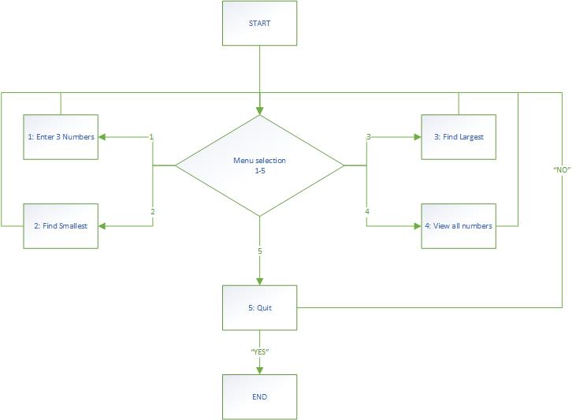
This flowchart has been extrapolated from the main menu and looking over the code, but one of the problems identified is that the code for selection 4 (view all numbers) is missing and instead only contains the code to call the function to quit.
Upon starting, the program will display a menu with 5 options –
- Enter the numbers – because the numbers are held in an array this function takes you to a for loop and asks you to enter a number 3 times and assigns each number a section in the array. Due to the size of the array (MAXNUMBERS = 3) only 3 numbers are added.

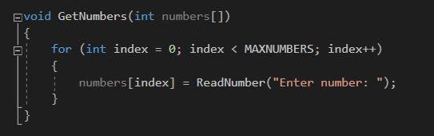
- Find the smallest – this function simply uses a for loop to go through the numbers assigned in the array. And whichever is the smallest in numerical value is returned and displayed in the console window.
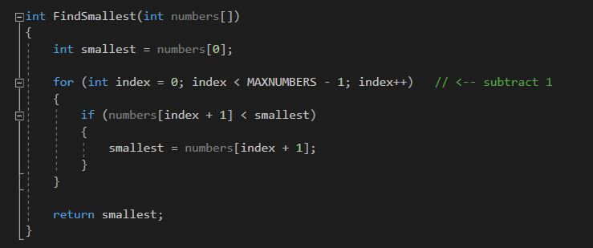

- Find the largest – this function works in the same fashion as the find the smallest function only it finds the largest and returns that value.
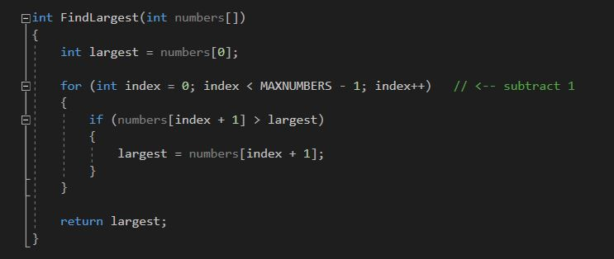

- Display all numbers – this is one of the identified bugs with this code as this just calls the quit function (selection 5) but from the name of the selection we can guess it is supposed to display all the numbers present in the array.

- Quit – this function asks the user if they ‘really wish to quit?’ and the use has to type ‘YES’ to quit any other response will not work and will be taken as a no (including ‘yes’ (lower case)).

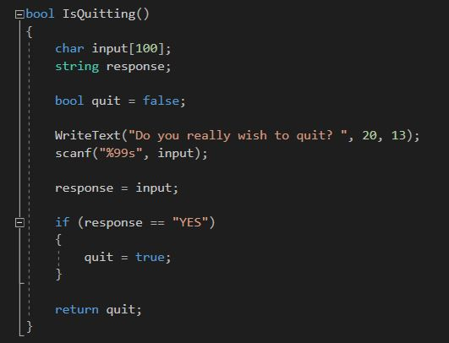
It was possible to extrapolate the supposed function of this program because of the lack of ambiguity of the main menu.
`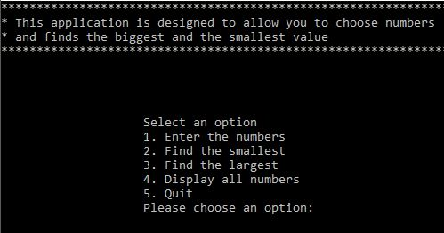
There are other functions present in this code with the comment of ‘just use this function and ‘you don’t need to understand it’ and these deal with the formatting of the console window, things like –
- Moving the text from the top left of the window and putting it in the centre so it will be easier to read by the user.
- Clearing the user inputted values so the console window isn’t filled by all the numbers inputted by the user.

Identified Bugs
Part B only asks to identify these bugs, for the explanations on how they were rectified please see Part C exercise 6.
- The first bug was quickly identified when the code was placed into the visual studio environment and a build was attempted. A build was attempted because it would display error messages which can give some very useful information.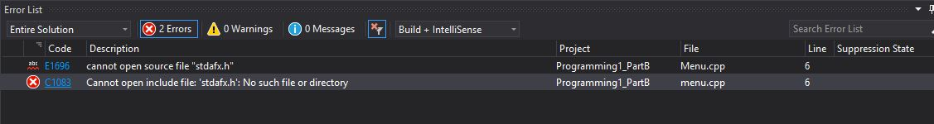
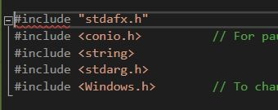
- The second bug identified when the programme was run for the first time and it became apparent that selection 4 was calling the quit function instead of its own function.
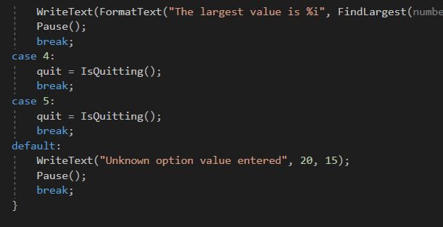
As previously stated the way these bugs were fixed will be discussed in Part C Exercise 6.

Part C (Implementation)

Exercise 1
For this exercise the programme has to have user input for three different types of variables (double, integer and string) and then have them displayed in the console window.
The code for which can be located in appendix 2.
And the console window -
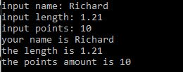

Exercise 2
For this exercise the programme has to be able to calculate the following shape (circle missing a triangle at its centre)
The user should be able to enter the dimensions needed to calculate this (circle radius, triangle height and triangle width at base.
The code for which can be located in appendix 3.
Due to the fact that pi is an irrational number it was decided to round all numbers to two decimal places hence the hard-coded 3.14 in the place of pi.
And the console window-
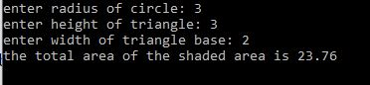

Exercise 3
For this exercise the programme has to calculate the differing tax on different user inputted quantities. The user has to input the quantity in tonnes of gravel and the price per tonne. These values are then used to calculate the purchase price which includes the differing tax amounts.
Tonnage | Discount
Between 5 and 8 | 2%
Between 9 and 40 | 4%
Above 40 | 6%

The code for which can be located in appendix 4.
To test this it was necessary to input 4 different values in order to test the four different branches.
To help with the manual calculations that were performed to check the programme was calculating the correct amount the same cost per tonne was used throughout (10) this ensured the cost before tax was a value that was simple to use in calculations.

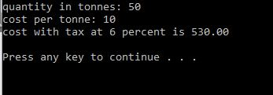
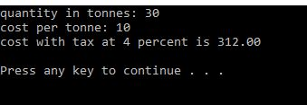
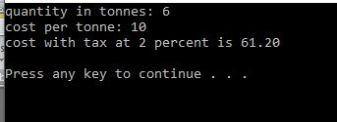
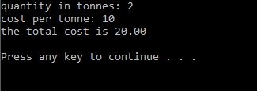

Exercise 4
For this exercise the programme has to draw a cross in the console window using the asterisk (*) symbol. This exercise comes with the restrictions of a counting loop must be used and printf(“%s”, “*”) must be used to display the stars.
The code for which can be located in appendix 5.
In order to thoroughly test this code it is good practice to enter different values. Here are three different values –
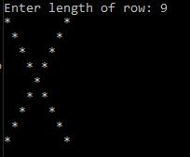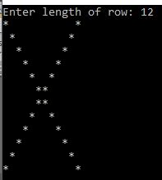
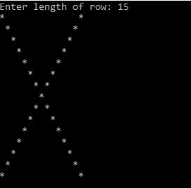

Exercise 5
For this exercise the programme has to work as a payment calculator for 5 products, calculate the total of these five prices including an entered tax value and display the average tax payable. The constraint for this exercise was that a C++ Class had to be used.
The code for which can be located in appendix 6.
For testing the maths, simple values were inputted to allow easier manual calculations in order to check that the maths behind the calculator is correct.
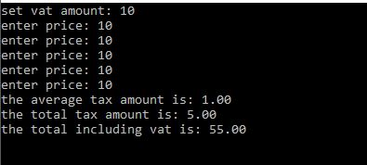

Exercise 6
For this exercise the programme is the fixed version of the code in Part B, it is this section that the fixes for the errors identified will be explained, implemented and tested.
The first error identified was the library #include error on line six, the first step in order to attempt to fix this was to change the syntax so it comes in line with the correct library #include syntax.
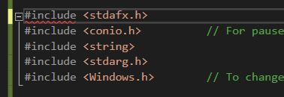
This proved to be unsuccessful so the next step was to comment out the whole line to see if the error was with the file trying to be included.
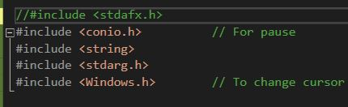
This allowed the programme to be built and run so it was inferred that this library include was the error, wasn’t needed and was removed.
The second error identified in Part B was the missing code for Selection 4 – Show All Numbers, and now that we have the code running we can see what happens when this option is chosen from the list.
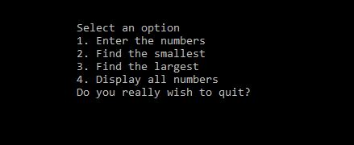
The program asks whether the user wishes to quit instead of displaying all numbers which can be proven by looking at the code for the menu.
From here it was clear that the function to display all the numbers present in the array is missing and would have to be written.
The following is a screenshot of the new function for selection 4
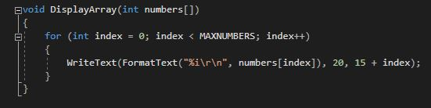
This function simply uses a for loop to go through the array in order and print each value just below the last, it uses the already present WriteText and FormatText functions to keep uniformity in all values displayed in the console window with the addition this the y value (15) had to be changed every time the code looped in order to avoid the value being over written because if it had been left alone it would have displayed the next value over the previous value so adding the index (incremented by one (index++) each loop) changed the y value enough to make the next value being displayed appear below the previous value.
The main selection menu had to be modified to call this new function when the correct option was selected and as you can see form the screen shot below the display function has now replaced the incorrect quit function under selection 4.
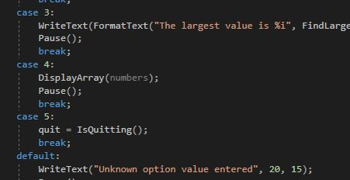
Full fixed code listings can be found in appendix 7.

Exercise 7
For this exercise the programme is basically a fruit machine with three different reels. The constraint for this exercise is that a function had to be used.
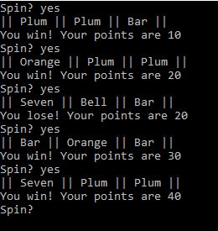
As you can see form this screenshot the reels are randomised with every spin and the screen shot of the header file (FruitMachine.h ) shows the separate functions used.
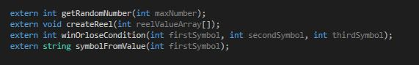
Full code listings can be found in appendix 8.

Exercise 8
This exercise was to programme the game of Battleships. The game that was completed uses functions which goes against the main constraint set forth in the assignment brief which was to use classes, due to time constraints of the upcoming deadline the working game will be uploaded (full code listings in appendix 9).
When the game starts this is the first screen you will see, it is the ship placement screen and you can see you have the choice between horizontal and vertical.
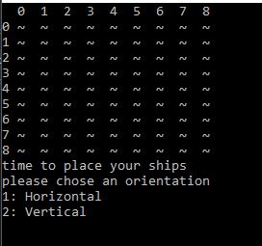.
There are 5 ships to place and even though the brief stated that they are different sizes for simplicity all the ships are the same length.
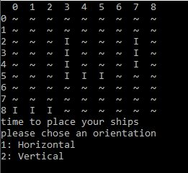

The attack screen starts off blank, similar to the ship placement screen, but with every coordinate entered the screen is updated with the misses (M) hits (H) and shows which ships have been sunk (S).
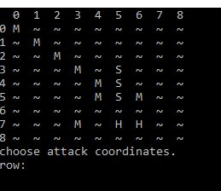
After the players turn it is the turn of the computer and the computers hits misses and sinks are tracked on the player ship board, this will allow the player to track how many ships they have left.
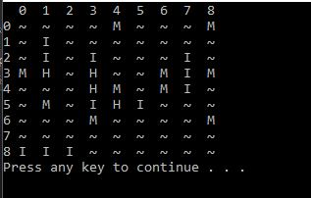
The game continues with this turn based system until either all enemy ships are sunk (WIN) or all player ships are sunk (LOSE).
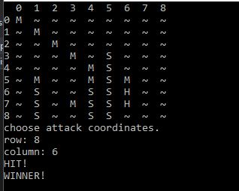
While this is a working game it is by no means complete but it is felt that it shows the main mechanics of the game and shows the thought process behind the creation of the game. This may be a project that is completed in spare time as it was very fun to work on with some difficult problems that where enjoyable to work through.

Appendices

Appendix 1

Main.h

#pragma once

const int MAXNUMBERS = 3;
const int MAXINPUTCHARS = 100;

void InitialiseNumbers(int numbers[], int size);
void DisplayHeader(void);
void DisplayMenu(void);
int ReadNumber(string prompt);
void IgnoreInput(void);
void ClearText(int x, int y, int length);
bool ProcessMenu(int option, int numbers[]);
void GetNumbers(int numbers[]);
int FindSmallest(int numbers[]);
int FindLargest(int numbers[]);
bool IsQuitting();
void WriteText(string text, int x, int y);
void SetCursorPosition(int x, int y);
string FormatText(const char *format, ...);
void ClearConsole(void);
void Pause(void);

Menu.cpp

// AssignCode_Menu.cpp : Defines the entry point for the console application.
//

#define _CRT_SECURE_NO_WARNINGS

#include "stdafx.h"
#include <conio.h> // For pause
#include <string>
#include <stdarg.h>
#include <Windows.h> // To change cursor position

using namespace std;

#include "Main.h"

int main()
{
int theNumbers[MAXNUMBERS];
int chosenOption = 0;
bool quit = false;

InitialiseNumbers(theNumbers, MAXNUMBERS);

while (quit == false)
{
DisplayHeader();
DisplayMenu();
chosenOption = ReadNumber("Please choose an option: ");
quit = ProcessMenu(chosenOption, theNumbers);

ClearConsole();
}

return 0;
}

void InitialiseNumbers(int numbers[], int size)
{
for (int index = 0; index < size; index++)
{
numbers[index] = 0;
}
}

void DisplayHeader(void)
{
WriteText("*******************************************************************************", 0, 0); // Top left hand corner of screen is x = 0, y = 0
WriteText("* This application is designed to allow you to choose numbers *", 0, 1); // Next line down is x = 0, y = 1, etc
WriteText("* and finds the biggest and the smallest value *", 0, 2);
WriteText("*******************************************************************************", 0, 3);
}

void DisplayMenu()
{
WriteText("Select an option", 20, 8); // Display menu at at x = 20, y = 8
WriteText("1. Enter the numbers", 20, 9);
WriteText("2. Find the smallest", 20, 10);
WriteText("3. Find the largest", 20, 11);
WriteText("4. Display all numbers", 20, 12);
WriteText("5. Quit", 20, 13);
}

int ReadNumber(string prompt)
{
int number = -1;
int inputCharCount;

WriteText(prompt, 20, 14);
inputCharCount = scanf("%i", &number);
if (inputCharCount == 0) // Wasn’t a number, so ignore what they typed in!!
{
IgnoreInput();
}

ClearText(20, 14, prompt.length() + inputCharCount); // Clear the text at this line

return number;
}

void IgnoreInput(void)
{
char ch;
while ((ch = getchar()) != '\n' && ch != EOF);
}

void ClearText(int x, int y, int length)
{
// Write space ' ' characters starting at x, y for 'length' times
string spaces(length, ' ');
WriteText(spaces, x, y);
}

bool ProcessMenu(int option, int numbers[])
{
string message;
bool quit = false;

switch (option)
{
case 1:
GetNumbers(numbers);
break;
case 2:
WriteText(FormatText( "The smallest value is %i", FindSmallest(numbers)), 20, 15);
Pause();
break;
case 3:
WriteText(FormatText("The largest value is %i", FindLargest(numbers)), 20, 15);
Pause();
break;
case 4:
quit = IsQuitting();
break;
case 5:
quit = IsQuitting();
break;
default:
WriteText("Unknown option value entered", 20, 15);
Pause();
break;
}

return quit;
}

void GetNumbers(int numbers[])
{
for (int index = 0; index < MAXNUMBERS; index++)
{
numbers[index] = ReadNumber("Enter number: ");
}
}

int FindSmallest(int numbers[])
{
int smallest = numbers[0];

for (int index = 0; index < MAXNUMBERS - 1; index++) // <-- subtract 1
{
if (numbers[index + 1] < smallest)
{
smallest = numbers[index + 1];
}
}

return smallest;
}

int FindLargest(int numbers[])
{
int largest = numbers[0];

for (int index = 0; index < MAXNUMBERS - 1; index++) // <-- subtract 1
{
if (numbers[index + 1] > largest)
{
largest = numbers[index + 1];
}
}

return largest;
}

bool IsQuitting()
{
char input[100];
string response;

bool quit = false;

WriteText("Do you really wish to quit? ", 20, 13);
scanf("%99s", input);

response = input;

if (response == "YES")
{
quit = true;
}

return quit;
}

void WriteText(string text, int x, int y)
{
SetCursorPosition(x, y);
printf(text.c_str());
}

// JUST USE THIS FUNCTION
// This function positions cursor in Console window,
// and you DON'T need to understand it!!!
void SetCursorPosition(int x, int y)
{
static HANDLE handle = NULL;
if (!handle)
{
handle = GetStdHandle(STD_OUTPUT_HANDLE);
}
COORD coords = { x, y };
SetConsoleCursorPosition(handle, coords);
}

// JUST USE THIS FUNCTION
// This function does creates a string
// using a format string and values i.e.
// FormatText("Number is %i", 5) returns "Number is 5",
// and you DON'T need to understand it!!!
string FormatText(const char *c_format, ...)
{
char ch[100];
va_list args;
va_start(args, c_format);
vsnprintf(ch, 100, c_format, args);
va_end(args);
return string(ch);
}

// JUST USE THIS FUNCTION
// This function clears the screen,
// and you DON'T need to understand it!!!
void ClearConsole(void)
{
system("cls");
}

void Pause(void)
{
// Pause
while (1) { if (_kbhit()) break; }
_getch(); // Clear the keypress
}

Appendix 2
string name;
char text[100];
double length;
int points;

printf("input name: ");
scanf("%s",text);
name = text;
printf("input length: ");
scanf("%lf", &length);
printf("input points: ");
scanf("%i", &points);
printf("your name is %s\r\n", name.c_str());
printf("the length is %0.2lf\r\n", length);
printf("the points amount is %i\r\n", points);

Appendix 3
double circleRadius;
double triangleHeight;
double triangleWidth;

printf("enter radius of circle: ");
scanf("%lf", &circleRadius);
printf("enter height of triangle: ");
scanf("%lf", &triangleHeight);
printf("enter width of triangle base: ");
scanf("%lf", &triangleWidth);

printf("the total area of the shaded area is %0.2lf\r\n", \
(3.14*(circleRadius*circleRadius) - ((triangleHeight*triangleHeight) / 2)));

Appendix 4
double totalTonnage = 0;
double costPerTonne = 0;
printf("quantity in tonnes: ");
scanf("%lf", &totalTonnage);
printf("cost per tonne: ");
scanf("%lf", &costPerTonne);
if (totalTonnage > 40)
{
printf("cost with tax at 6 percent is %0.2lf", \
((costPerTonne*totalTonnage)*0.06) + (costPerTonne*totalTonnage));
}
if (totalTonnage <= 40 && totalTonnage >= 9)
{
printf("cost with tax at 4 percent is %0.2lf", \
((costPerTonne*totalTonnage)*0.04) + (costPerTonne*totalTonnage));
}
if (totalTonnage <= 8 && totalTonnage >= 5)
{
printf("cost with tax at 2 percent is %0.2lf", \
((costPerTonne*totalTonnage)*0.02) + (costPerTonne*totalTonnage));
}
if (totalTonnage < 5)
{
printf("the total cost is %0.2lf", (costPerTonne*totalTonnage));
}

Appendix 5
int length;
printf("Enter length of row: ");
scanf("%i", &length);
for (int count = 0; count < length; count++)
{
for (int count1 = 0; count1 < length; count1++)
{
if (count == count1 || count1 == (length - count - 1))
{
printf("%s","*");
}
else
{
printf("%s"," ");
}
}
printf("\r\n");
}

Appendix 6

Source.cpp
#include"Calculator.h"
double price = 0;
double vat = 0;
int limit = 5;
string quit = "no";
Calculator*total = new Calculator(0);
printf("set vat amount: ");
scanf("%lf", &vat);
total->SetVat(vat);
for (int count = 0; count < limit; count++)
{
printf("enter price: ");
scanf("%lf", &price);
total->AddPrice(price);
}
printf("the average tax amount is: %0.2lf\r\n", total->CalculateVat() / limit);
printf("the total tax amount is: %0.2lf\r\n", total->CalculateVat());
printf("the total including vat is: %0.2lf\r\n", total->GetTotalIncVat());
delete total;

Calculator.h

#pragma once
#include<stdio.h>
#include<string>
#include<stdlib.h>
#include<time.h>
using namespace std;

class Calculator
{
//attributes
private:
double _totalExcVat;
double _totalIncVat;
double _vat;
double _averageVat;
//constructors
public:
Calculator(double initialCount);
//properties
public:
void SetVat(double vatAmount);
double GetVat();
void SetAverageVat(double averageVat);
double GetAverageVat();
void SetTotalIncVat(double value);
double GetTotalIncVat();
void SetTotalExcVat(double totalExcVat);
double GetTotalExcVat();
//methods
public:
void AddPrice(double price);
double CalculateVat();
double CalculateTotalIncVat();
};

Calculator.cpp

#include<stdio.h>
#include<string>
#include<stdlib.h>
#include<time.h>

#include"Calculator.h"

using namespace std;

Calculator::Calculator(double initialCount)
{
this->_totalExcVat = initialCount;
}
void Calculator::AddPrice(double price)
{
this->_totalExcVat = this->_totalExcVat + price;
}
//calculate set and return total excluding vat
void Calculator::SetTotalExcVat(double totalExcVat)
{
this->_totalExcVat = totalExcVat;
}
double Calculator::GetTotalExcVat()
{
return this->_totalExcVat;
}
//calculate set and return vat
double Calculator::CalculateVat()
{
double vatAmount = this->_totalExcVat*(this->_vat / 100);
return vatAmount;
}

void Calculator::SetAverageVat(double averageVat)
{
this->_averageVat = averageVat;
}
double Calculator::GetAverageVat()
{
return this->_vat;
}
void Calculator::SetVat(double vatAmount)
{
this->_vat = vatAmount;
}
double Calculator::GetVat()
{
return this->_vat;
}
//calculate set and return total including vat
double Calculator::CalculateTotalIncVat()
{
return this->_totalExcVat + (this->_totalExcVat*(this->_vat / 100));
}
void Calculator::SetTotalIncVat(double value)
{
this->_totalIncVat = value;
}
double Calculator::GetTotalIncVat()
{
return this->_totalExcVat + (this->_totalExcVat*(this->_vat / 100));
}

Appendix 7

Main.h
#pragma once

const int MAXNUMBERS = 3;
const int MAXINPUTCHARS = 100;

void DisplayArray(int numbers[]);
void InitialiseNumbers(int numbers[], int size);
void DisplayHeader(void);
void DisplayMenu(void);
int ReadNumber(string prompt);
void IgnoreInput(void);
void ClearText(int x, int y, int length);
bool ProcessMenu(int option, int numbers[]);
void GetNumbers(int numbers[]);
int FindSmallest(int numbers[]);
int FindLargest(int numbers[]);
bool IsQuitting();
void WriteText(string text, int x, int y);
void SetCursorPosition(int x, int y);
string FormatText(const char *format, ...);
void ClearConsole(void);
void Pause(void);

Menu.cpp
// AssignCode_Menu.cpp : Defines the entry point for the console application.
//

#define _CRT_SECURE_NO_WARNINGS

#include <conio.h> // For pause
#include <string>
#include <stdarg.h>
#include <Windows.h> // To change cursor position

using namespace std;

#include "Main.h"

int main()
{
int theNumbers[MAXNUMBERS];
int chosenOption = 0;
bool quit = false;

InitialiseNumbers(theNumbers, MAXNUMBERS);

while (quit == false)
{
DisplayHeader();
DisplayMenu();
chosenOption = ReadNumber("Please choose an option: ");
quit = ProcessMenu(chosenOption, theNumbers);

ClearConsole();
}

return 0;
}

void InitialiseNumbers(int numbers[], int size)
{
for (int index = 0; index < size; index++)
{
numbers[index] = 0;
}
}

void DisplayHeader(void)
{
WriteText("*******************************************************************************", 0, 0); // Top left hand corner of screen is x = 0, y = 0
WriteText("* This application is designed to allow you to choose numbers *", 0, 1); // Next line down is x = 0, y = 1, etc
WriteText("* and finds the biggest and the smallest value *", 0, 2);
WriteText("*******************************************************************************", 0, 3);
}

void DisplayMenu()
{
WriteText("Select an option", 20, 8); // Display menu at at x = 20, y = 8
WriteText("1. Enter the numbers", 20, 9);
WriteText("2. Find the smallest", 20, 10);
WriteText("3. Find the largest", 20, 11);
WriteText("4. Display all numbers", 20, 12);
WriteText("5. Quit", 20, 13);
}

int ReadNumber(string prompt)
{
int number = -1;
int inputCharCount;

WriteText(prompt, 20, 14);
inputCharCount = scanf("%i", &number);
if (inputCharCount == 0) // Wasn’t a number, so ignore what they typed in!!
{
IgnoreInput();
}

ClearText(20, 14, prompt.length() + inputCharCount); // Clear the text at this line

return number;
}

void IgnoreInput(void)
{
char ch;
while ((ch = getchar()) != '\n' && ch != EOF);
}

void ClearText(int x, int y, int length)
{
// Write space ' ' characters starting at x, y for 'length' times
string spaces(length, ' ');
WriteText(spaces, x, y);
}

bool ProcessMenu(int option, int numbers[])
{
string message;
bool quit = false;

switch (option)
{
case 1:
GetNumbers(numbers);
break;
case 2:
WriteText(FormatText("The smallest value is %i", FindSmallest(numbers)), 20, 15);
Pause();
break;
case 3:
WriteText(FormatText("The largest value is %i", FindLargest(numbers)), 20, 15);
Pause();
break;
case 4:
DisplayArray(numbers);
Pause();
break;
case 5:
quit = IsQuitting();
break;
default:
WriteText("Unknown option value entered", 20, 15);
Pause();
break;
}

return quit;
}

void DisplayArray(int numbers[])
{
for (int index = 0; index < MAXNUMBERS; index++)
{
WriteText(FormatText("%i\r\n", numbers[index]), 20, 15 + index);
}
}

void GetNumbers(int numbers[])
{
for (int index = 0; index < MAXNUMBERS; index++)
{
numbers[index] = ReadNumber("Enter number: ");
}
}

int FindSmallest(int numbers[])
{
int smallest = numbers[0];

for (int index = 0; index < MAXNUMBERS - 1; index++) // <-- subtract 1
{
if (numbers[index + 1] < smallest)
{
smallest = numbers[index + 1];
}
}

return smallest;
}

int FindLargest(int numbers[])
{
int largest = numbers[0];

for (int index = 0; index < MAXNUMBERS - 1; index++) // <-- subtract 1
{
if (numbers[index + 1] > largest)
{
largest = numbers[index + 1];
}
}

return largest;
}

bool IsQuitting()
{
char input[100];
string response;

bool quit = false;

WriteText("Do you really wish to quit? ", 20, 13);
scanf("%99s", input);

response = input;

if (response == "YES")
{
quit = true;
}

return quit;
}

void WriteText(string text, int x, int y)
{
SetCursorPosition(x, y);
printf(text.c_str());
}

// JUST USE THIS FUNCTION
// This function positions cursor in Console window,
// and you DON'T need to understand it!!!
void SetCursorPosition(int x, int y)
{
static HANDLE handle = NULL;
if (!handle)
{
handle = GetStdHandle(STD_OUTPUT_HANDLE);
}
COORD coords = { x, y };
SetConsoleCursorPosition(handle, coords);
}

// JUST USE THIS FUNCTION
// This function does creates a string
// using a format string and values i.e.
// FormatText("Number is %i", 5) returns "Number is 5",
// and you DON'T need to understand it!!!
string FormatText(const char *c_format, ...)
{
char ch[100];
va_list args;
va_start(args, c_format);
vsnprintf(ch, 100, c_format, args);
va_end(args);
return string(ch);
}

// JUST USE THIS FUNCTION
// This function clears the screen,
// and you DON'T need to understand it!!!
void ClearConsole(void)
{
system("cls");
}

void Pause(void)
{
// Pause
while (1) { if (_kbhit()) break; }
_getch(); // Clear the keypress
}

Appendix 8

Source.cpp

time_t t;
srand(time(&t));
int reelValueArray[5];
int symbolValue = 5;
string spin = "yes";
int firstSymbol = 0;
int secondSymbol = 0;
int thirdSymbol = 0;
int points = 0;
string symbolText = " ";
//spin reels
while (spin == "yes")
{
printf("Spin? ");
scanf("%s", spin.c_str());
if (spin == "yes")
{
//spin reel
firstSymbol = getRandomNumber(symbolValue);
secondSymbol = getRandomNumber(symbolValue);
thirdSymbol = getRandomNumber(symbolValue);
//display spun reels
printf("|| %s || %s || %s ||\r\n", symbolFromValue(firstSymbol).c_str(), \
symbolFromValue(secondSymbol).c_str(), symbolFromValue(thirdSymbol).c_str());
//display win or lose and points
printf("", winOrloseCondition(firstSymbol, secondSymbol, thirdSymbol));
}
}

FruitMachine.h

#pragma once
#include<stdio.h>
#include<string>
#include<stdlib.h>
#include<time.h>
using namespace std;

extern int getRandomNumber(int maxNumber);
extern void createReel(int reelValueArray[]);
extern int winOrloseCondition(int firstSymbol, int secondSymbol, int thirdSymbol);
extern string symbolFromValue(int firstSymbol);

FruitMachine.cpp

#include<stdio.h>
#include<string>
#include<stdlib.h>
#include<time.h>

#include"FruitMachine.h"

using namespace std;
int points = 0;
string symbolText = " ";

//create reels for fruit machine
void createReel(int reelValueArray[])
{
for (int count = 0; count < 6; count++)
{
reelValueArray[count] = count;
}
return;
};
// random number generator
int getRandomNumber(int maxNumber)
{
//returns a value between 0 and maxvalue -1
int random = rand() % maxNumber;
return random;
}
//win or lose function
int winOrloseCondition(int firstSymbol, int secondSymbol, int thirdSymbol)
{
if (firstSymbol == secondSymbol || secondSymbol == thirdSymbol || firstSymbol == thirdSymbol)
{
if (firstSymbol == secondSymbol && secondSymbol == thirdSymbol)
{
//three number the same
switch (firstSymbol)
{
case 0:
points = points + 20;
break;
case 1:
points = points + 20;
break;
case 2:
points = points + 20;
break;
case 3:
points = points + 20;
break;
case 4:
points = points + 20;
break;
case 5:
points = points + 2000;
break;
default:
points = points + 0;
break;
}
printf("You win! Your points are %i\r\n", points);
goto SKIP;
}
//two numbers the same
switch (firstSymbol)
{
case 0:
points = points + 10;
break;
case 1:
points = points + 10;
break;
case 2:
points = points + 10;
break;
case 3:
points = points + 10;
break;
case 4:
points = points + 10;
break;
case 5:
points = points + 100;
break;
default:
points = points + 0;
break;
}
printf("You win! Your points are %i\r\n", points);
}
else
{
printf("You lose! Your points are %i\r\n", points);
}

SKIP: return points;
}
//generate the reel symbols from the value
string symbolFromValue(int firstSymbol)
{
switch (firstSymbol)
{
case 0:
symbolText = "Seven";
break;
case 1:
symbolText = "Bar";
break;
case 2:
symbolText = "Bell";
break;
case 3:
symbolText = "Plum";
break;
case 4:
symbolText = "Orange";
break;
case 5:
symbolText = "Cherries";
break;
default:
symbolText = " ";
break;
}
return symbolText;
}

Appendix 9

Source.cpp
#include<stdio.h>
#include<string>
#include<stdlib.h>
#include<time.h>

#include"Functions.h"

using namespace std;

int main(int argc, char** argv)
{
//Initialize default variables
time_t t;
srand(time(&t));
//Player Ship Board array and ship count
string PSB[9][9];
int pShips[9][9];
int pShip = 0;
int playerHitCount1 = 3, playerHitCount2 = 3, playerHitCount3 = 3, playerHitCount4 = 3, playerHitCount5 = 3;
//player attack board
string PAB[9][9];
//Enemy Ship Board array and ship count
string ESB[9][9];
int eShips[9][9];
int eShip = 0;
int enemyHitCount1 = 3, enemyHitCount2 = 3, enemyHitCount3 = 3, enemyHitCount4 = 3, enemyHitCount5 = 3;
//other variables
int shipOrientation = 0, row, column, aRow, aColumn, player = 1;
//win condition used in main game loop
bool win = false;
/////////////////////////////////////////////////////////////////////////////
/////////////////////////////////////////////////////////////////////////////
/////////////////////////////////////////////////////////////////////////////
//Create game boards
//create player board
CreateGameBoard(PSB);
//create player attack board
CreateGameBoard(PAB);
//create enemy board
//although the enemy ship board is never seen i decided to still have one for testing game mechanincs
//it quickly became necessary to be able to see the enemy ship placemnts
CreateGameBoard(ESB);
/////////////////////////////////////////////////////////////////////////////
createNumberedGameBoard(pShips, eShips);
/////////////////////////////////////////////////////////////////////////////
DisplayGameBoard(PSB);
/////////////////////////////////////////////////////////////////////////////
//player place ship
for (int playerShipCount = 0; playerShipCount < 5; playerShipCount++)
{
printf("time to place your ships\r\n");
printf("please chose an orientation\r\n");
printf("1: Horizontal\r\n2: Vertical\r\n");
scanf("%i", &shipOrientation);
switch (shipOrientation)
{
case 1:
//horizontal
printf("Horizontal Chosen\r\n");
printf("enter coordinates\r\n");
//choose row
printf("choose row: ");
scanf("%i", &row);
//choose colum
printf("choose column: ");
scanf("%i", &column);
//chnage array value to I for ship
if (PSB[row][column] == " I " || PSB[row][column + 1] == " I " || PSB[row][column + 2] == " I ")
{
printf("ships cannot intercect, please try again!\r\n\n");
playerShipCount--;
break;
}
PSB[row][column] = " I ";
PSB[row][column + 1] = " I ";
PSB[row][column + 2] = " I ";
//int value for simplicity
pShips[row][column] = playerShipCount + 1;
pShips[row][column + 1] = playerShipCount + 1;
pShips[row][column + 2] = playerShipCount + 1;
//+1 playership
pShip++;
//DisplayPlayerShipBoard(PSB);
break;
case 2:
//vertical
printf("Vertical Chosen\r\n");
printf("enter coordinates\r\n");
//choose row
printf("choose row: ");
scanf("%i", &row);
//choose colum
printf("choose column: ");
scanf("%i", &column);
//chnage array value to I for ship
if (PSB[row][column] == " I " || PSB[row + 1][column] == " I " || PSB[row + 2][column] == " I ")
{
printf("ships cannot intercect, please try again!\r\n\n");
playerShipCount--;
break;
}
PSB[row][column] = " I ";
PSB[row + 1][column] = " I ";
PSB[row + 2][column] = " I ";
//int value for simplicity
pShips[row][column] = playerShipCount + 1;
pShips[row + 1][column] = playerShipCount + 1;
pShips[row + 2][column] = playerShipCount + 1;
//+1 playership
pShip++;
break;
default:
printf("please select either horizontal (1) or vertical (2)");
break;
}
DisplayGameBoard(PSB);
}
/////////////////////////////////////////////////////////////////////////////
system("CLS");
//enemy place ships
for (int enemyShipCount = 0; enemyShipCount < 5; enemyShipCount++)
{
shipOrientation = enemyOrientation(3);
switch (shipOrientation)
{
case 1:
//horizontal
//choose row with random number
row = getRandomCoordinate(7);
//choose colum with ranom number
column = getRandomCoordinate(7);
//chnage array value to I for ship
if (ESB[row][column] == " I " || ESB[row][column + 1] == " I " || ESB[row][column + 2] == " I " || ESB[row][column + 3] == " ~ ")
{
enemyShipCount--;
break;
}
ESB[row][column] = " I ";
ESB[row][column + 1] = " I ";
ESB[row][column + 2] = " I ";
//int value for simplicity
eShips[row][column] = enemyShipCount + 1;
eShips[row][column + 1] = enemyShipCount + 1;
eShips[row][column + 2] = enemyShipCount + 1;
//+1 enemy ship
eShip++;
break;
case 2:
//vertical
//choose row with random number
row = getRandomCoordinate(7);
//choose colum with ranom number
column = getRandomCoordinate(7);
//chnage array value to I for ship
if (ESB[row][column] == " I " || ESB[row + 1][column] == " I " || ESB[row + 2][column] == " I " || ESB[row + 3][column] == " ~ ")
{
enemyShipCount--;
break;
}
ESB[row][column] = " I ";
ESB[row + 1][column] = " I ";
ESB[row + 2][column] = " I ";
// int value for simplicity
eShips[row][column] = enemyShipCount + 1;
eShips[row + 1][column] = enemyShipCount + 1;
eShips[row + 2][column] = enemyShipCount + 1;
//+1 nemy ship
eShip++;
break;
default:
enemyShipCount--;
break;
}
}
/////////////////////////////////////////////////////////////////////////////
DisplayGameBoard(PAB);
//DisplayGameBoard(ESB);//for testing
//system("pause");//for testing
/////////////////////////////////////////////////////////////////////////////
/////////////////////////////////////////////////////////////////////////////
/////////////////////////////////////////////////////////////////////////////
//Game Loop Start
while (win == false)
{
switch (player)
{
case 1://player
DisplayGameBoard(PAB);
//choose row
PVALIDCOORD:printf("choose attack coordinates.\r\n");
printf("row: ");
scanf("%i", &aRow);
//if outside range
if (aRow > 8)
{
printf("must be a valid coordinate!");
goto PVALIDCOORD;
}
//choose colum
printf("column: ");
scanf("%i", &aColumn);
//if outside range
if (aColumn > 8)
{
printf("must be a valid coordinate!");
goto PVALIDCOORD;
}
//if previous used coords
if (PAB[aRow][aColumn] == " H " || PAB[aRow][aColumn] == " M " || PAB[aRow][aColumn] == " S ")
{
printf("you have already used these coordinates");
goto PVALIDCOORD;
}
// Check to see if attack is a hit
// Remove/add damage to hit ships
if (ESB[aRow][aColumn] == " I ")
{
printf("HIT!\r\n");
//hit
//////////////////////////////////////////////////
if (eShips[aRow][aColumn] != 0)
{
switch (eShips[aRow][aColumn])
{
case 1:
if (enemyHitCount1 > 0)
{
PAB[aRow][aColumn] = " H ";
ESB[aRow][aColumn] = " H ";
enemyHitCount1--;
}
if (enemyHitCount1 == 0)
{
searchGameBoard(eShips, 1, PAB);
eShip--;
}
break;
case 2:
if (enemyHitCount2 > 0)
{
PAB[aRow][aColumn] = " H ";
ESB[aRow][aColumn] = " H ";
enemyHitCount2--;
}
if (enemyHitCount2 == 0)
{
searchGameBoard(eShips, 2, PAB);
eShip--;
}
break;
case 3:
if (enemyHitCount3 > 0)
{
PAB[aRow][aColumn] = " H ";
ESB[aRow][aColumn] = " H ";
enemyHitCount3--;
}
if (enemyHitCount3 == 0)
{
searchGameBoard(eShips, 3, PAB);
eShip--;
}
break;
case 4:
if (enemyHitCount4 > 0)
{
PAB[aRow][aColumn] = " H ";
ESB[aRow][aColumn] = " H ";
enemyHitCount4--;
}
if (enemyHitCount4 == 0)
{
searchGameBoard(eShips, 4, PAB);
eShip--;
}
break;
case 5:
if (enemyHitCount5 > 0)
{
PAB[aRow][aColumn] = " H ";
ESB[aRow][aColumn] = " H ";
enemyHitCount5--;
}
if (enemyHitCount5 == 0)
{
searchGameBoard(eShips, 5, PAB);
eShip--;
}
break;
default:

break;
}
}
//////////////////////////////////////////////////
}
/////////////////////////////////////////////////////////////////////////////
if (eShips[aRow][aColumn] == 0)
{
printf("MISS!\r\n");
PAB[aRow][aColumn] = " M ";
DisplayGameBoard(PAB);
}
/////////////////////////////////////////////////////////////////////////////
// Check to see if game is over
// If game over - exit loop/end program
if (eShip == 0)
{
printf("WINNER!");
win = true;
break;
}
/////////////////////////////////////////////////////////////////////////////
DisplayGameBoard(PAB);
/////////////////////////////////////////////////////////////////////////////
// Toggle next player's turn
player = 2;
system("CLS");
break;
case 2://enemy
//choose row
EVALIDCOORD:aRow = getRandomCoordinate(9);
//if outside range
if (aRow > 8)
{
goto EVALIDCOORD;
}
//choose colum
aColumn = getRandomCoordinate(9);
//if outside range
if (aColumn > 8)
{
goto EVALIDCOORD;
}
//if previous used coords
if (PSB[aRow][aColumn] == " H " || PSB[aRow][aColumn] == " M " || PSB[aRow][aColumn] == " S ")
{
goto EVALIDCOORD;
}
// Check to see if attack is a hit
// Remove/add damage to hit ships
/////////////////////////////////////////////////////////////////////////////
if (PSB[aRow][aColumn] == " I ")
{
switch (pShips[aRow][aColumn])
{
case 1:
if (playerHitCount1 > 0)
{
PSB[aRow][aColumn] = " H ";
playerHitCount1--;
}
if (playerHitCount1 == 0)
{
searchGameBoard(pShips, 1, PSB);
pShip--;
}
break;
case 2:
if (playerHitCount2 > 0)
{
PSB[aRow][aColumn] = " H ";
playerHitCount2--;
}
if (playerHitCount2 == 0)
{
searchGameBoard(pShips, 2, PSB);
pShip--;
}
break;
case 3:
if (playerHitCount3 > 0)
{
PSB[aRow][aColumn] = " H ";
playerHitCount3--;
}
if (playerHitCount3 == 0)
{
searchGameBoard(pShips, 3, PSB);
pShip--;
}
break;
case 4:
if (playerHitCount4 > 0)
{
PSB[aRow][aColumn] = " H ";
playerHitCount4--;
}
if (playerHitCount4)
{
searchGameBoard(pShips, 4, PSB);
pShip--;
}
break;
case 5:
if (playerHitCount5 > 0)
{
PSB[aRow][aColumn] = " H ";
playerHitCount5--;
}
if (enemyHitCount5 == 0)
{
searchGameBoard(pShips, 5, PSB);
pShip--;
}
break;
default:

break;
}
}
/////////////////////////////////////////////////////////////////////////////
if (pShips[aRow][aColumn] == 0)
{
PSB[aRow][aColumn] = " M ";
}
/////////////////////////////////////////////////////////////////////////////
// Check to see if game is over
// If game over - exit loop/end program
if (pShip == 0)
{
printf("LOSER!");
win = true;
break;
//miss
}
/////////////////////////////////////////////////////////////////////////////
// Toggle next player's turn
DisplayGameBoard(PSB);
player = 1;
system("pause");
system("CLS");
break;
}
}
/////////////////////////////////////////////////////////////////////////////
//for press any key to continue...
printf("\r\n\n");
system("pause");
return 0;
}

Functions.h

#pragma once
#include<stdio.h>
#include<string>
#include<stdlib.h>
#include<time.h>
using namespace std;

/////////////////////////////////////////////////////////////////////////////
extern void CreateGameBoard(string value[9][9]);
extern void DisplayGameBoard(string value[9][9]);
/////////////////////////////////////////////////////////////////////////////
extern void createNumberedGameBoard(int pShips[9][9], int eShips[9][9]);
/////////////////////////////////////////////////////////////////////////////
extern int enemyOrientation(int maxNumber);
extern int getRandomCoordinate(int maxNumber);
/////////////////////////////////////////////////////////////////////////////
extern void searchGameBoard(int value[9][9], int check, string array[9][9]);
/////////////////////////////////////////////////////////////////////////////

Functions.cpp

#include<stdio.h>
#include<string>
#include<stdlib.h>
#include<time.h>

#include"Functions.h"

using namespace std;

/////////////////////////////////////////////////////////////////////////////
//random number generators
// random number generator for enemy orientation picking
int enemyOrientation(int maxnumber)
{
int random = rand() % (maxnumber);
return random;
}
//random number generator for used by enemy for selecting coordinates.
int getRandomCoordinate(int maxnumber)
{
//returns a value between 0 and maxvalue -1
int random = rand() % (maxnumber);
return random;
}
/////////////////////////////////////////////////////////////////////////////
//for creating the various game boards
void CreateGameBoard(string value[9][9])
{
for (int Row = 0; Row < 9; Row++)
{
for (int Column = 0; Column < 9; Column++)
{
value[Row][Column] = " ~ ";
}
}
}
void createNumberedGameBoard(int pShips[9][9], int eShips[9][9])
{
for (int row = 0; row < 9; row++)
{
for (int column = 0; column < 9; column++)
{
pShips[row][column] = 0;
eShips[row][column] = 0;
}
}
}
/////////////////////////////////////////////////////////////////////////////
void DisplayGameBoard(string value[9][9])
{
system("CLS");
printf(" \ 0 1 2 3 4 5 6 7 8 \r\n");
for (int Row = 0; Row < 9; Row++)
{
printf("%i", Row);
for (int Column = 0; Column < 9; Column++)
{
printf("%s", value[Row][Column].c_str());
}
printf("\r\n");
}
}
/////////////////////////////////////////////////////////////////////////////
void searchGameBoard(int value[9][9], int check, string array[9][9])
{
for (int Row = 0; Row < 9; Row++)
{
for (int Column = 0; Column < 9; Column++)
{
if (value[Row][Column] == check)
{
array[Row][Column] = " S ";
}
}
}
}
/////////////////////////////////////////////////////////////////////////////

