The Impact of Virtual Learning Environment on Students’ Learning Experience

Student Name: | Andrei Alexandru Agopian
Student Number: | 1905498
Module Name: | Digital Skills and Research Methods
Module Number: | BMSW4003-LON
Lecturer Name: | Balan Kandasamy

Table of Contents

Executive Summary 3
Objective 4
Literature Review 5
Primary Research 6
Ethical considerations 9
Results 10
Limitations of the Study 15
Conclusion 16
References 17
Appendix A 18
Appendix B 19

Executive Summary

The other name for VLE in academia is Moodle and since its inception, dating back to 2002, it has been a tool of immense value, both to educators as well as students.
In the following lines we will attempt at quantifying the impact Moodle has had and has on the London campus students. The focus here is to highlight the VLE’s main strong points, its less acclaimed features, and the level of user satisfaction. We will attempt to assess its efficiency in relation to students completing coursework.
In order to collect information about the topic we will rely mainly on an online survey, with the addition of data collected from interviews and our own impartial observations.
What this paper has helped to reinforce the most is that the implementation of Moodle at the London campus of UWTSD is incomplete, users are aware of its features, however they rely more on external sources in order to complete their assignments, the online library being the least performing aspect.
There are numerous benefits of implementing a technology correctly and fully, therefore it is a strong recommendation that an overhaul of the platform to be performed in order to bring it up to modern standards. This, alongside a periodical review on behalf of the IT and HR team, could lead to a more fruitful environment (Polisca, 2006).

Objective

The following research is aimed at establishing the effect of using a virtual environment as a teaching tool in higher education.
Moodle is the main topic in this paper as our area of research is University of Wales Trinity Saint David. The university has campuses across the United Kingdom but the focus is on the London Holborn campus, where the virtual learning environment is named Moodle.
This VLE (virtual learning environment, for short) is used as a platform for students to access course material, various modules, track their progress, monitor attendance, submit assignments and as a means of interacting with each other. It has a vast array of functions, including email integration with Outlook and access to an online library.
The main question to answer here is:

Is Moodle an effective tool for furthering academic studies?
Literature Review

To understand the questions we need to ask, and the methods we need to use we had to look at previous work done on the subject, within other universities or similar environments.
The work we reference in this study is based on some of the most recent academic works available to the public, as well as compliant with the needs determined by our study base.
Firstly, we need to identify our study base – who are the students that compose our demographic – and secondly, we need to single out studies that use models of VLEs who have similar features as the one being discussed (Engelbrecht & Hardin, 2005).
The people who attend the London campus of UWTSD are from the most diverse backgrounds in the world, with the majority of them coming from European countries, followed closely by Africa, Asia and the Middle East, whilst local population represents the smallest fraction of the chart.
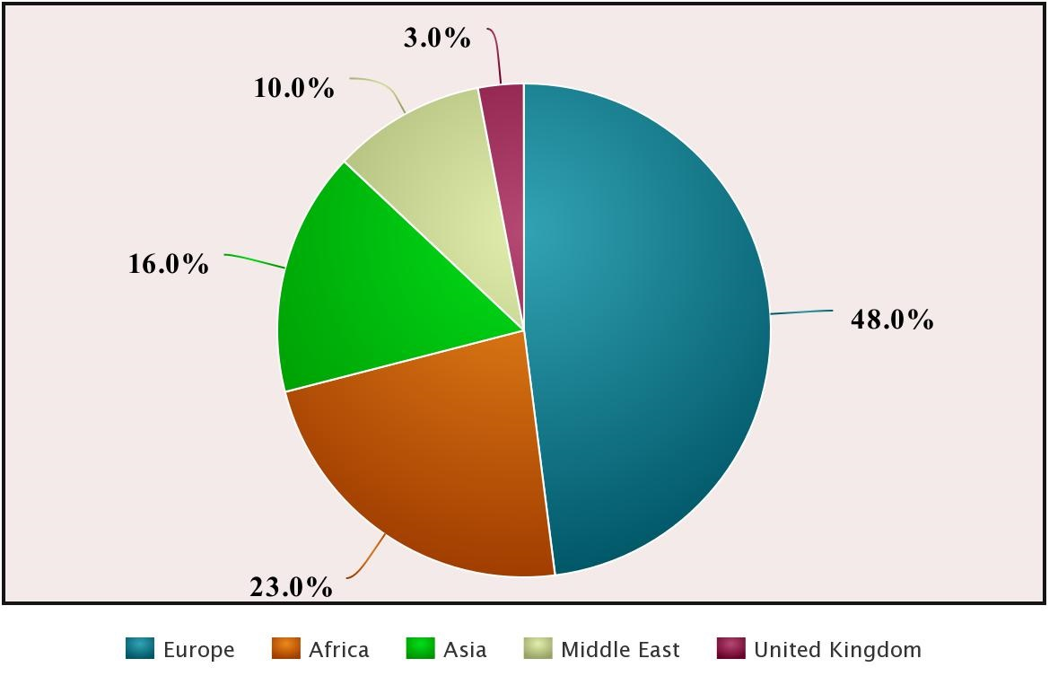

The academic papers mentioned in Appendix B set the foundation for our research, drawing on numerous other authors’ work. Our goal is to respect the complexity of the above models and build upon them. The results that emerged from them forged the idea that VLEs can have a massive beneficial impact – as it is the case in the flipped class scenario, or when it comes to improving communication. These systems are received poorly by students due to improper implementation or lack of supporting technology.

Primary Research

In order to conduct the research a set of ten questions was created, each of which had more or less strength within various methods used to collect the information. We opted for an online survey, interviews, and group discussions, to which we added some personal observation of their behaviour in accordance with their ability to complete their coursework (Sáez-López, et al., 2015).
The first questions address some information such as name (not included in order to comply with the Data Protection Act of 2018 – we use aliases to differentiate between subjects and prevent confusion) and age to allow us to define clearly the people we interview.

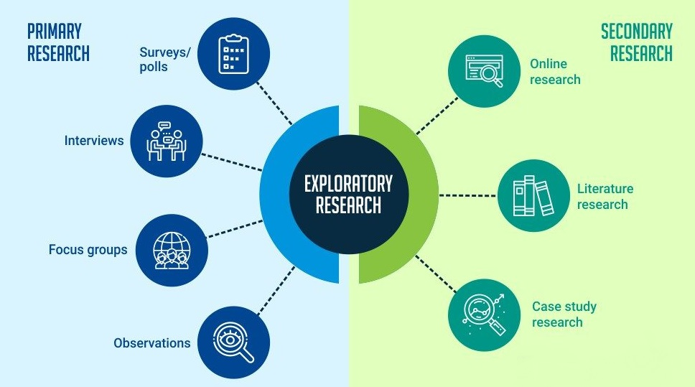
A diagram of the subdivisions of exploratory research according to QuestionPro

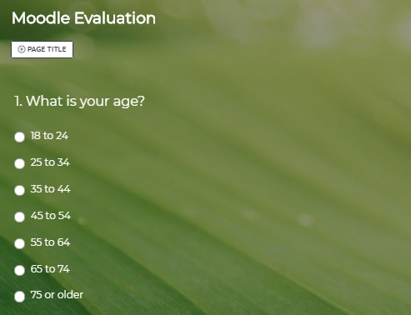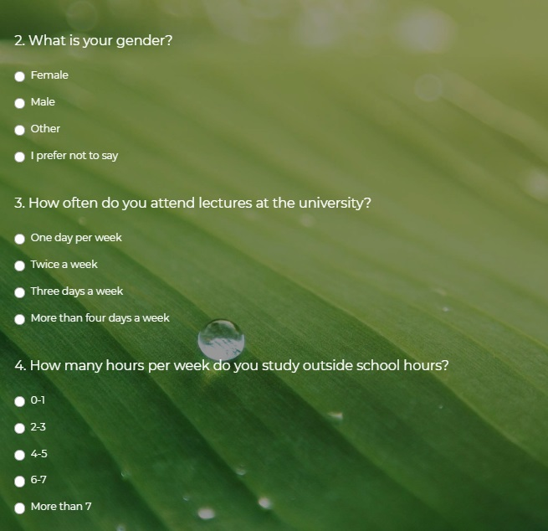
Figure 2. Question Set
Figure 1. Question Set

The next aspect we set out to discover was the attendance issue, which in turn opens the door for a comparative analysis between commitment to studying more on campus premises or at home.

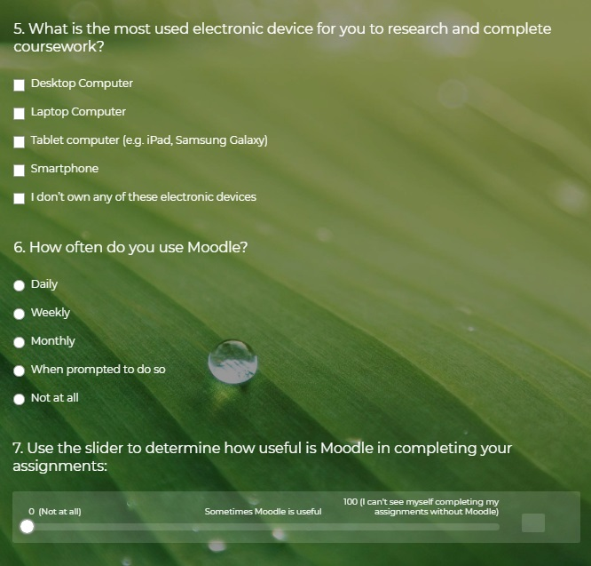
Figure 3. Question Set
Question 5 allowed the respondent to select multiple answers, be that on paper or online, as to highlight the versatility of Moodle and how much is that feature used by students. And next, on number 6, we asked how frequent the usage of our VLE is to establish a connection to question number 7 where we look at the perception have of it.
Moving down the list of question we had prepared, number 8 looks at customization, where it allowed the respondent to expand on certain features the VLE has.
The most used aspect of Moodle is assignment submission, a topic addressed in question 9, and for question 10 we looked at the online library.
Each of the methods we used to collect data has various limitations, seen that we rely on information collected directly from people rather than on scientific measurements (Polisca, 2006). One such issue is the likely-hood of influencing the participants during an interview conducted in person. The tone of voice, the words the interviewer uses, as well as the state of mind of the respondent, to which the environment where the experiment takes place adds, have a significant role in the data collected. All efforts have been made to create the most neutral environment and all these factors have been taken in consideration when the collection occurred. The online survey’s limiting factors of accuracy are the impossibility to verify the honesty of the participants, as well as whether it has been properly restricted to include only UWTSD students.
In order to preserve its accuracy, the online survey was made available via a link sent to the participating students on university email addresses and a counter was kept where the number of requests sent had to equal the number of responses. Once the balance was achieved, the collection was ended.
The method in which our test was conducted was simple random sampling as it was the most adequate to implement (Choi, et al., 2018). It allowed information collection in a short period of time and was the most cost effective one to implement (Lin & Hwang, 2018). If the desired outcome of the study would have been answering a question about a specific group of people and how they have been impacted by Moodle, and if the subject population would have been far larger, stratified sampling would have been more suitable. With the same token, systematic sampling, a method in which population is ordered in base of a criteria and selection occurs at set time intervals, incurs the cost of staff and planning, and the budget for this study did not allow for it.

Ethical considerations

In collecting the information we had to take in account the legal implications that come with it, and protect the people involved (Conole, 2002). This was done by removing their names when the data was compiled in the Excel workbook and by replacing it with aliases. In person interviews were accompanied by the verbal disclaimer that our findings will not be released in a manner that might damage any of the parties involved, we will respect the university’s guidelines as well as the governing bodies of the United Kingdom. The same applies for the online survey, with the participants receiving the disclaimer within the invitation email’s body.
It was in our best interest to remove bias from this study and our intent is to provide a research that adheres to as many groups of people as possible. That being said, we acknowledge our own limitations – our sample size containing only 50 entries – and encourage more studies to be done on the topic, in the hope of creating a more accurate depiction of the impact VLEs have on students.

Results

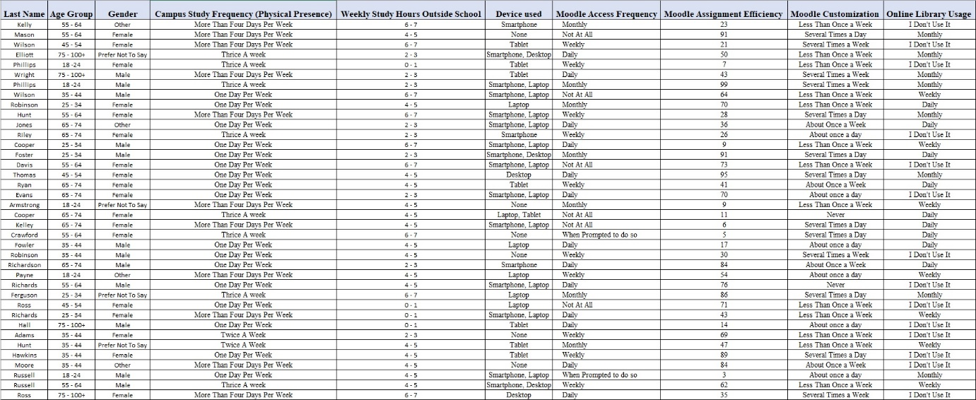
Figure 4. Data Snapshot

The collected information was inserted into an Excel spreadsheet (as seen in the image above) and then simplified with the use of charts and tables.

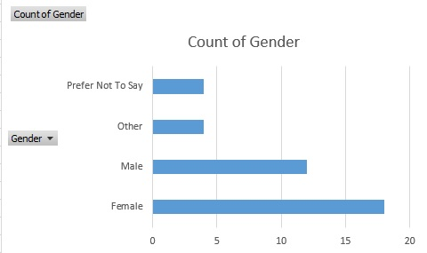
Figure 5. Gender Distribution

We then looked at how our sample population was divided by gender and age group, Figure 5 and 6.
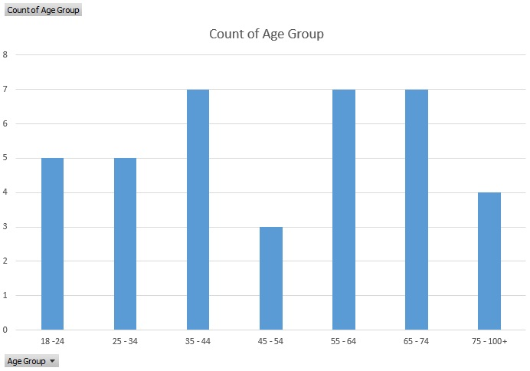
Figure 6. Age Groups

The importance of understanding how people fit into different categories allows us to draw conclusions based on their individual needs and how technology impacts them specifically, without having any ethical implications.

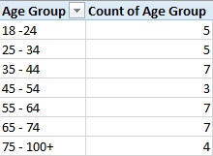
Figure 7. Age Groups Frequency Table

Beyond this point, we looked at how each subject interacts with the university’s VLE (Figure 8).
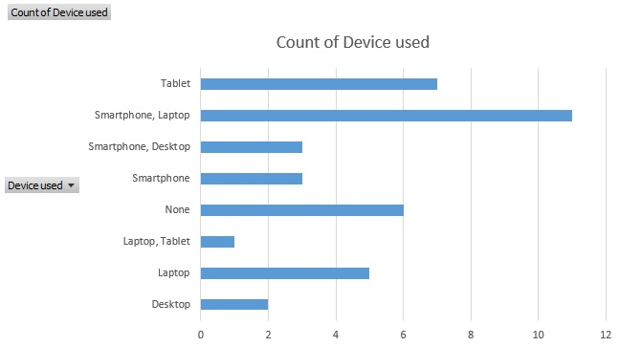
Figure 8. Device Usage

As per Figure 8, we can see the prevalence of dual device usage for accessing Moodle, with smartphone and laptop combination being 40% more occurring than the use of a single device.
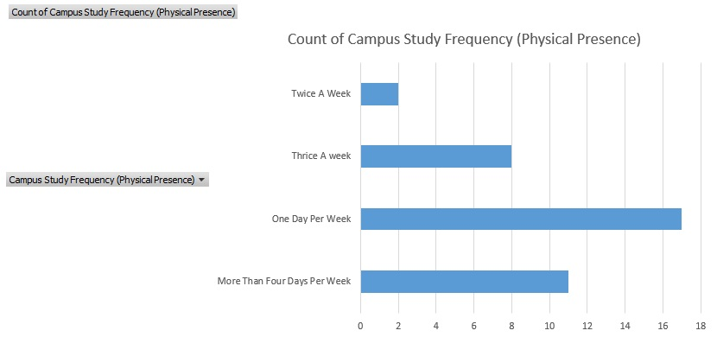

Figure 9. Campus Study Frequency

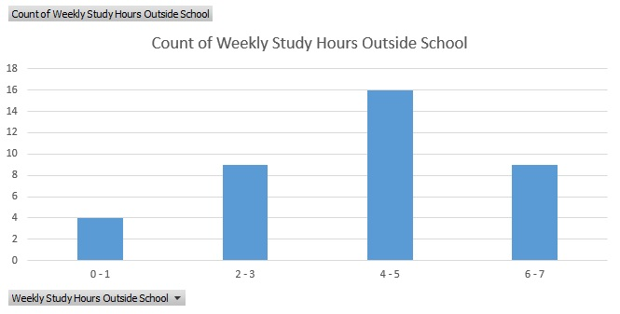
Figure 10. Outside Study

The charts in Figure 9 and 10 look at the time spent by each individual both on the campus premises as well as in their private residences, studying.
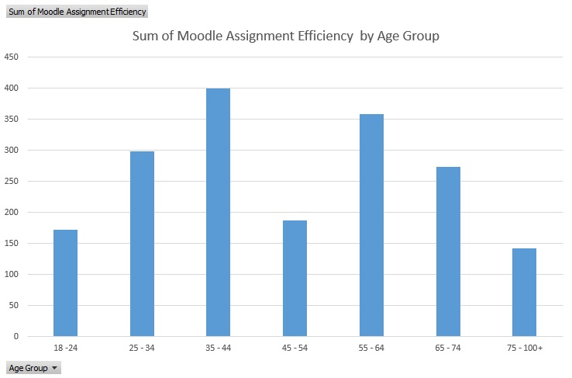
Figure 11. VLE Efficiency A

The Moodle Assignment Efficiency score is the total between the answers the respondents provided to question 7 and 9, where they were asked to use a slider – a scale from 1 to 100 – to describe how difficult was to upload an assignment and how useful was Moodle in helping them complete that same task, divided by 2 (an average between the both). The total number of points possible for our VLE to score on a 50 subject sample size was 5000. From Figure 11 we can see that Moodle is less than 50% below its optimal point.

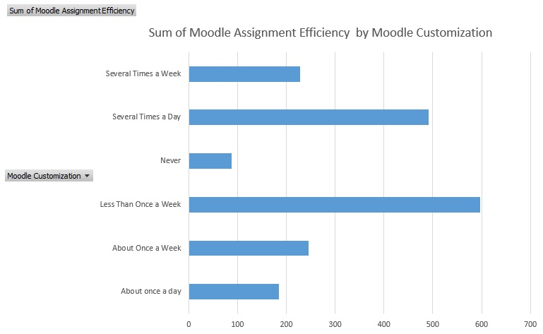

Figure 12. VLE Efficiency B

Figure 12 highlights the efficiency score Moodle has in relations to how people tailor it to their needs, by customizing it.

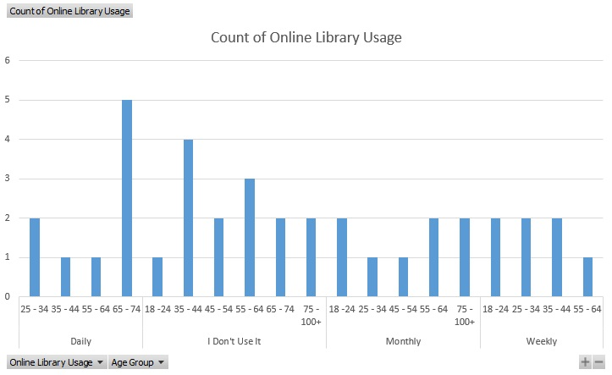
Figure 13. Library Usage

One of the main points that came out of the information collected via interviews and focus groups was the impracticability of the online library, one of the many features our VLE has. In order to gain some insights into it, we looked at the online library usage juxtaposed to the various age groups involved in the research (Figure 13). The most visible information is that the library is very popular with the age group defined from 65 to 74 years old, whilst the age group spanning from 35 to 44 is the least likely to ever use this feature.

Limitations of the Study

There is an overwhelming request of information from individuals in the target area of our study and that leads to a tendency of the aforementioned to provide fictitious information. Another way aspect that limits our research is the sample size. Being that this study had a very low budget, the audience reached was narrowed to 50 individuals, using three means of contacting them. The budget limitation had an impact on the ability to incentivize people to participate, thus expanding the sample size.
As mentioned in the earlier stages of this paper, we have to rely on entirely subjective information - “how did you feel about this?” – Because scientifically, since all the interviewed students have submitted their assignments on Moodle, the VLE’s efficiency score should be perfect. Unless, at the point of conducting the research, Moodle would have had technical problems.
Most importantly, a study limitation comes out of Moodle being such a comprehensive platform and a more adequate approach would be a

Conclusion

The most important observation that comes out of the study is that Moodle can be drastically improved – to at the very least bring it above a 60% efficiency score – and that there is no benefit in customising it, as noted from the fact that those who were doing so with a frequency of less than once a week achieved an efficiency score twice as those who changed its appearance on a daily basis.
More so, another study should be done focusing only on the online library feature as it is the least efficient – fact that was highlighted best during face to face interviews where people had the liberty to express their dissent without the restrictions of a check box.
Where Moodle shines best is in its versatility and portability. It is a system designed to be carried across multiple operating software and has a high integration capacity with a host of different applications.

References

Choi, S. P. M., Lam, S. S., Li, K. C. & Wong, B. T. M., 2018. Learning Analytics at Low Cost: At-risk Student Prediction with Clicker Data and Systematic Proactive Interventions, Hong Kong: Educational Technology & Society.
Conole, G., 2002. Evaluation of Learning Technologies in Higher Education, Southhampton: University of Southampton.
Deepwell, F., 2002. International Forum of EduTowards Capturing Complexity: an interactive framework for institutional evaluation, Coventry: International Forum of Educational Technology & Society.
Eichler, M. L. et al., 2003. Virtual Learning Environments Designed in Brazil, Rio de Janeiro: Educational Technology.
ENGELBRECHT, J. & HARDIN, A., 2005. TEACHING UNDERGRADUATE MATHEMATICS ON THE INTERNET, New York: Springer.
Lin, C.-J. & Hwang, G.-J., 2018. A Learning Analytics Approach to Investigating Factors Affecting EFL Students’ Oral Performance in a Flipped Classroom, Taiwan: Graduate Institute of Digital Learning and Education, National Taiwan University of Science and Technology.
Polisca, E., 2006. Facilitating the Learning Process: An Evaluation of the Use and Benefits of a Virtual Learning Environment (VLE) enhanced Independent Language learning Program (ILLP), Sheffield: Equinox Publishing Ltd..
Sáez-López, J. M., Miller, J., Vázquez-Cano, E. & Domínguez-Garrido, M. C., 2015. Exploring Application, Attitudes and Integration of Video Games: MinecraftEdu in Middle School, California: Educational Technology & Society.

Appendix A
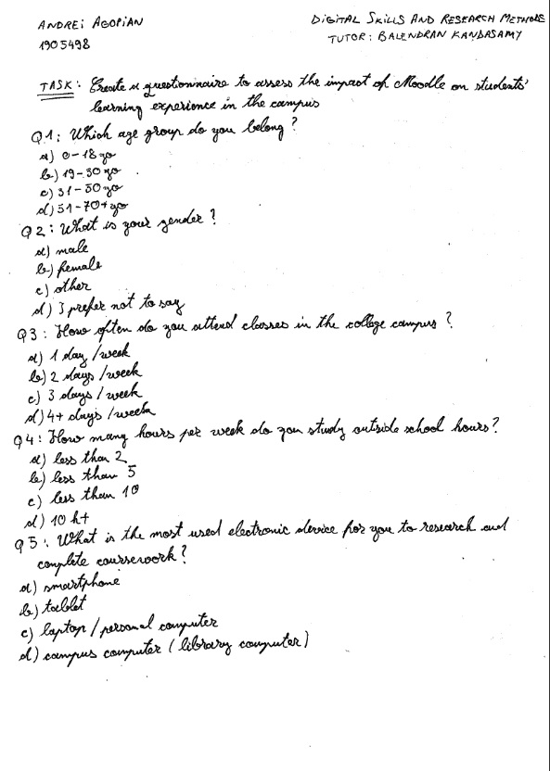
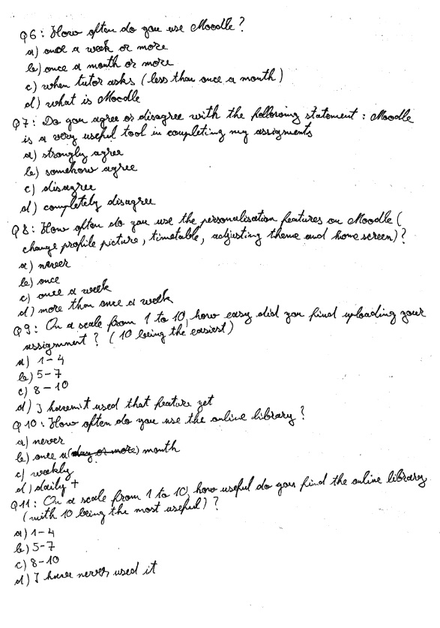

Appendix B

The studies that comply with our demographic demands and VLE complexity are as follows:
- “A Learning Analytics Approach to Investigating Factors Affecting EFL Students’ Oral Performance in a Flipped Classroom” by Chi-Jen Lin and Gwo-Jen Huang. This was a choice because it looked at language barriers and presented the concept of “flipped classroom”. A VLE is a way to flip a class so its relevance was noted both during the research as well as in forming conclusions.
- “Learning Analytics at Low Cost: At-risk Students Prediction with Clicker Data and Systematic Proactive Interventions” by Samuel P. M. Choi, S. S. Lam, Kam Cheong Li and Billy T. M. Wong. The work by the above mentioned authors presents a study case as well as important findings.
- “Exploring Application, Attitudes and Integration of Video Games: MinecraftEdu in Middle School” by Jose-Manuel Saez-Lopez, John Miller, Esteban Vazquez-Cano and Maria-Conception Dominguez-Garrido. From this work we can extract differences between traditional teaching methods and VLEs.
- “Introduction of Learning Technologies in Higher Education” by Grainne Conole. This is a collection of articles aimed at understanding the methodology used in evaluation, socio-cultural issues, how to use communication in modern times, VLE quality and interactive environments.
- “Virtual Learning Environments Designed in Brazil” by Marcelo L. Eichler, Mario R. Goncalves, Flavia O. M. da Silva, Fernando Junges and Jose C. Del Pino. The selection of this material is based upon the need of expanding our vision on the subject and exposing ourselves to a wider pool of knowledge.
- “Teaching Undergraduate Mathematics on the Internet” by Johann Engelbrecht and Ansie Harding. In this academic paper the authors provide information regarding differentiation of VLEs use within a single subject matter. Introduced here in the scope of highlighting the versatility of this environment.
- “Facilitating the Learning Process: An Evaluation of the Use and Benefits of a Virtual Learning Environment (VLE)-enhanced Independent Language-learning Program (ILLP)” by Elena Polisca. A work necessary to us as one of the key features present in our campus attendees is non-native English speakers.
- “Towards Capturing Complexity: an interactive framework for institutional evaluation” by Frances Deepwell. An in-depth analysis of the impact VLE has had on Coventry University, this article is a local view on the issue we try to address, therefore its inclusion is of utmost importance.

