Lloyd Thomas (P147195)

web technologies for buisness
James Williams

Contents
Professional layout and design 2
Responsive to mobile devices 2
Product Catalogue 2
Shopping-cart 2
Payment options: Card & PayPal 2
Allows updates by non-technical personnel via a GUI 2
No hosting maintenance required 2
Final website screenshots 3
Reference should be made to web design guidelines. 4
Simple is beautiful 4
Design is paramount 4
Navigation should be intuitive 4
Consistency is key 4
Colours are crucial 4
Make the website responsive 5
Develop for multiple browsers 5
Check your website for errors 5
Write your own code 5
Don’t forget the content 6
Bespoke graphics should be created to appropriately brand your site. 6
E-Business Applications: 6
Research and analyse current e-Business Applications suitable for SMEs today. 6
ERP-Enterprise Resource Planning 6
MRP-Manufacturing resource planning 6
CRM-Customer Relationship Management 6
Use cropped screen-shots to include some evidence of practical testing. 7
Recommend a suite of useful applications for the SME sector 9
Google 9
Microsoft 9
Bibliography 10

Figure 1 text to welcome users 3
Figure 2background on the company 3
Figure 3shop and banners 3
Figure 4the stores return policy 3
Figure 5opening and closing times for real world store 4
Figure 6website colour image 5
Figure 7mobile phone website 5
Figure 8 home screen 7
Figure 9shops product sale 7
Figure 10empty cart 8
Figure 11 cart giving total of items 8
Figure 12 single item in cart 8
Figure 13social media emblems/links 9
Figure 14checkout 9

Professional layout and design
The layout and design can change from site to site such as in Wix is has a professional layout and the design of the webpage is a simple to use site as it is not too hard for a user to use the site this is cannot be said for web flow as this is a site that will be used by more users who understand how to code as it is used a code that will create part of the web page.

Responsive to mobile devices
The web pages need to be accessible from both a website and a user’s mobile device this must be taken in to the creators mind when they are designing g their own webpage on ether Wix or webbely this is why there is an option which allows the creator to see what there page will look like if a user accesses there website on their mobile device( phone, iPad) and this will allow the creator to design the website to better allow a user to read or accesses areas of the web site easier.

Product Catalogue
As an e-commerce site has to have a product catalogue as that is needed to be used as a way for a consumer to select an item and it will be selected and placed in to a simple cart or basket as this will allow a consumer/user to keep track of what they are buying and of how much the all the products are together.

Shopping-cart
The shopping cart is used as a way to keep as a way for a consumer/user to store their items in as they browses an e-commerce site such as the catalogues or any other information that the site may offer to a user as the user explores the site the products that they have selected to purchase will be saved to the cart and will be simpler for a user to buy with a click of a button.

Payment options: Card & PayPal
There are multiple ways that a user/consumer one way is to us a card to pay for the products they have purchased there is also a way to buy items using PayPal which allows a consumer/user to pay which will allow the user to transfer money from there account to the websites bank site this is how most websites will accept money there is now also the newer way of using bitcoin to purchase items as this is on some site an active currency and is allowed to be used by the users online. [1]

Allows updates by non-technical personnel via a GUI
Sites like wix will allow a non-technical user on how to create a web page with a simple web builder template that will allow the user to select a variety of different templates that the users can select to use as there page where as if a user creates a webpage with Webbley the user will have to create a page with code that will build the website around the code that a user enters that a user enters this can be for a shop or add pictures and colours.

No hosting maintenance required
Sites like Wix and Web flow will allow a user to create a web page that will let that user create there website while the background of the website takes care of the maintence side of the webpage as this will take the pressure off of the created as the web page will take care of the maintence for the site until the company expands and is able to hire better services of a web hosting service or employ a person to regally preform maintence on the site.

Final website screenshots

Figure 1 text to welcome users
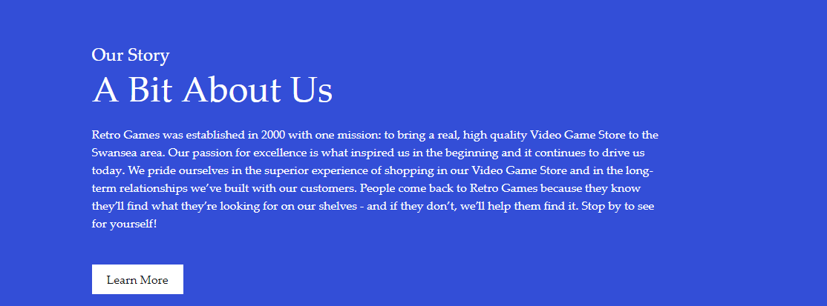
Figure 2background on the company

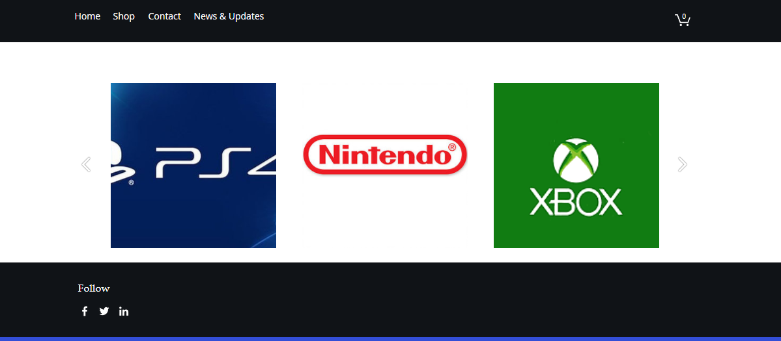
Figure 3shop and banners
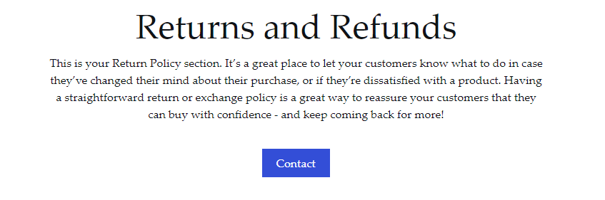
Figure 4the stores return policy

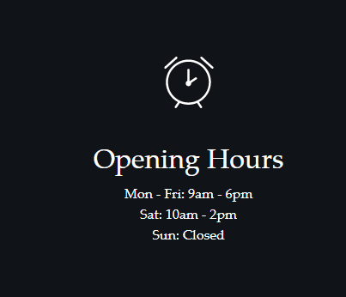
Figure 5opening and closing times for real world store

Reference should be made to web design guidelines.

Simple is beautiful
This is a simple way to explain how if there is a page that has links and images as if there are too many links and images that cover the website as this will create a distraction to the user from there site or the user may find the site will be to cluttered to use as the images and links are everywhere that the users become distracted or give up with the site entirely.

Design is paramount
This is how a website is first recognised by a user as there is a lot of different features on a webpage such as images, videos and blogs/posts that will draw the user’s attention as soon as they enter the web page this will tell a user whether the page will be worth their time or a waste of their time.

Navigation should be intuitive
Users want to use a website with simple to use controls not one with buttons to take a user to a strange and different area in the website, such as if the website was a simple click and scroll then users may spend less time trying to get to where they wanted as the users who used a button can transfer between pages and reach the bottom quicker.

Consistency is key
Once a user has opened the main page, they may want to visited other pages before leaving the website this will allow the users to see how different pages on the site match with the front page and causing the website to not be a mess for users who use the site after themselves.as if a user’s where to visit the created site that was created for the assignment there would be a similar heading colour on each page as to allow the users to know this was the pages top point.as well as there being a shopping cart on each page to allow the user to see in to their cart on any page.

Colours are crucial
On a website there is a need for colour that will attract the users attention while still allowing the user to read what is being written on the site as if the website for example uses a read back ground and green writing this would cause some issues with the visual effect that a user may not be able to read the writing or that the colours just clash and cause problems, where as in the image below the colours chosen are blue and black both are dark colours so the use of light white writing makes the writing stand out to the user more .
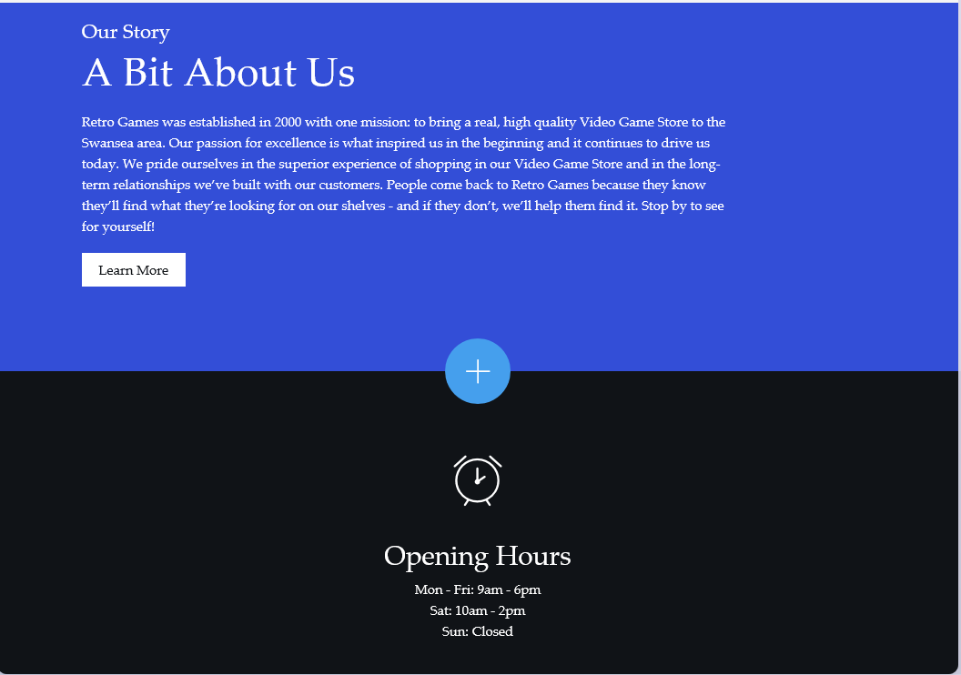
Figure 6website colour image

Make the website responsive
The website is now accessible through mobile phones as with each year as mobiles become smarter it is more in the businesses interests to create a webpage that can function for both the online web screen and a mobile phone screen.
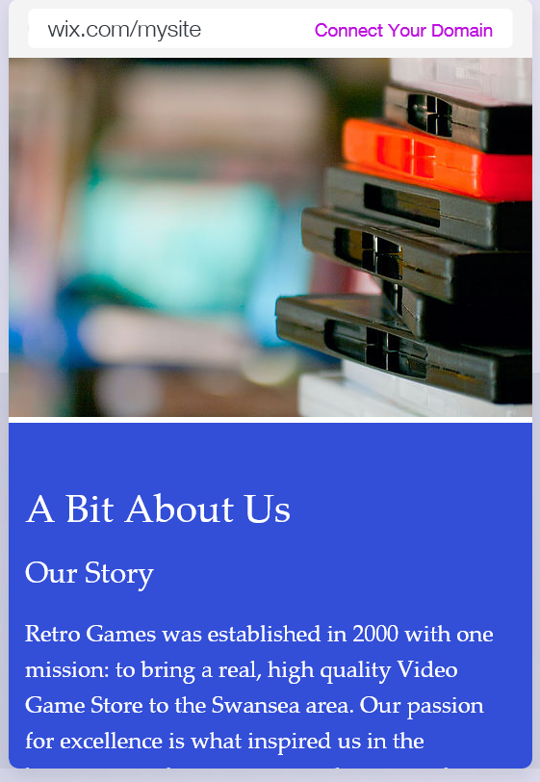
Figure 7mobile phone website

Develop for multiple browsers
There are a range of web browsers such as Microsoft edge, google chrome and Firefox each of these browsers will act differently as each user will have their own favourite browser so this will need to make sure that the website works on each browser.

Check your website for errors
As the website is created there will code that is used in the websites background that will allow a user to transfer that in to a working webpage but if a section of the websites code does not work then there will be a need for the creator to go back and check there code and make sure that it works or that each part of the website will work with each part of their own part programmes.

Write your own code
The website was created using a template as this will create a simple website without using any code as the website can be harder to create without any code as a creator will not always need to know code to create websites but if there was code involved it will allow for more features to be implemented on the website.

There is a range of different code that will be used to create a website such as c# and c++ with these programs a user can create a website with code as this is a programming langue that will let a user implement many features in to a website such as a shop or subscriptions.

Don’t forget the content
This is one of the most important parts of a websites as if there is nothing new on the website users will start to look for their information in new webpages that will update their website information regularly

Bespoke graphics should be created to appropriately brand your site.
The brand that is used for the website is a super Nintendo that is designed in pixel art as this makes the image similar to the main heading of the website as the website is called retro games this will give the website a similar feeling to old time games and 6-bit gaming, the website is also using a background that is also used as a design to keep the users interest.

E-Business Applications:

Research and analyse current e-Business Applications suitable for SMEs today.

ERP-Enterprise Resource Planning
This is a applications that will create way to manage supplies and human resources as there will not always be a human element to keep track of the supplies that have been purchased and the supplies that have been sold as well as the ones that have been sold to customers this will also keep a track of the payroll so it will keep track of how much each employee will be payed for working the hours they have clocked. [2]

MRP-Manufacturing resource planning
In this application there will be QC quality control and QA quality assurance that will make sure that the items both received and shipped are in best quality there is also the control of inventory such as purchasing and how much the cost will come to with all the products. [3]

CRM-Customer Relationship Management
This application will be used as a data base to store consumers information and help with users who have bought items online as this will store their data if they entered any information that will be used again as this will allow a user to enter the details faster the second time they use the site. [4]

Use cropped screen-shots to include some evidence of practical testing.

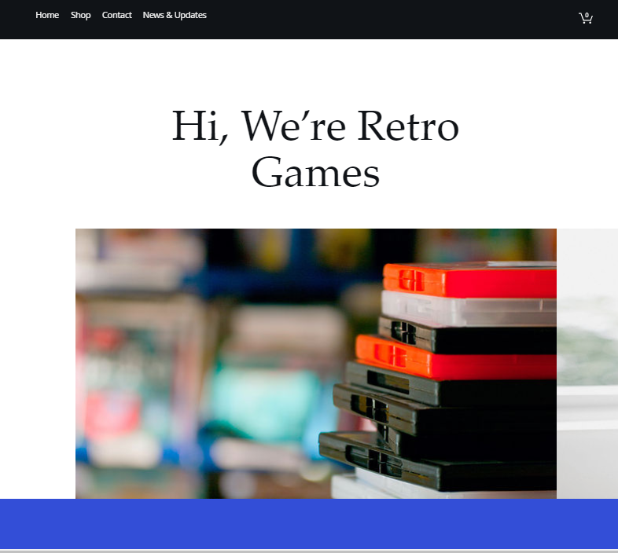
Figure 8 home screen
- Step one is to find a shop that the user can access with ease that will be selling the product that they are looking for such as a video game, clothing and food produce that will be shipped to a consumer that has purchased them from the site.

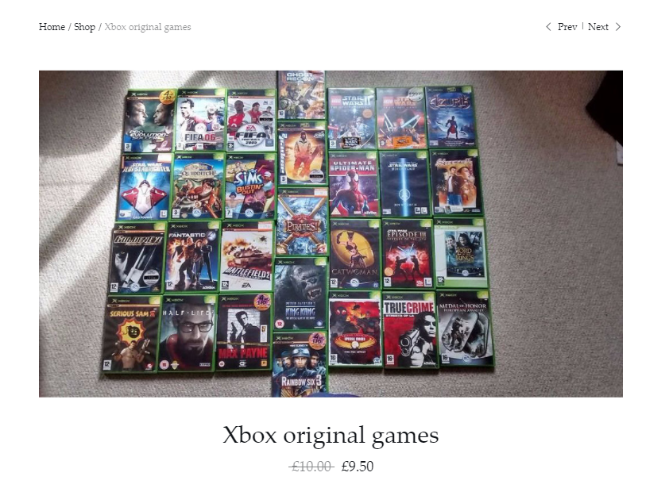
Figure 9shops product sale
- The products can cost as much as the creator wants the items to as the creator can set the price for the item as well as having a price deduction that they can set for specific items on holidays and events.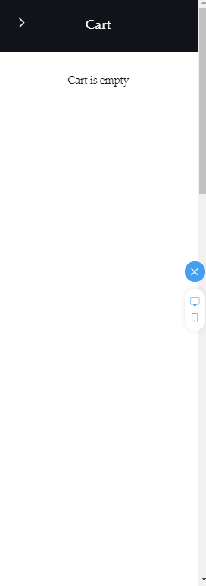
Figure 10empty cart
- This is where a user will send their selected products to this area as shown in the image bellow.

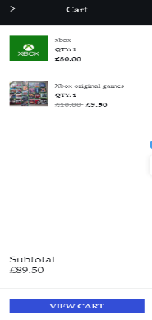
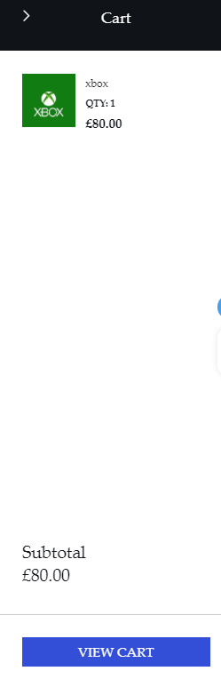
Figure 11 cart giving total of items
Figure 12 single item in cart
- This is where the users will store their product to buy at a later time as if a user stored a multiple of products that will be saved and make a calculation of the mass total that will tally how much the user will spend.

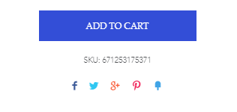
Figure 13social media emblems/links
- This emblems that will send the user to the connected websites such as Facebook, twitter and Google plus this will be used to post about where the user bought their new item from and at how much it cost them so others will buy it if they are interested.

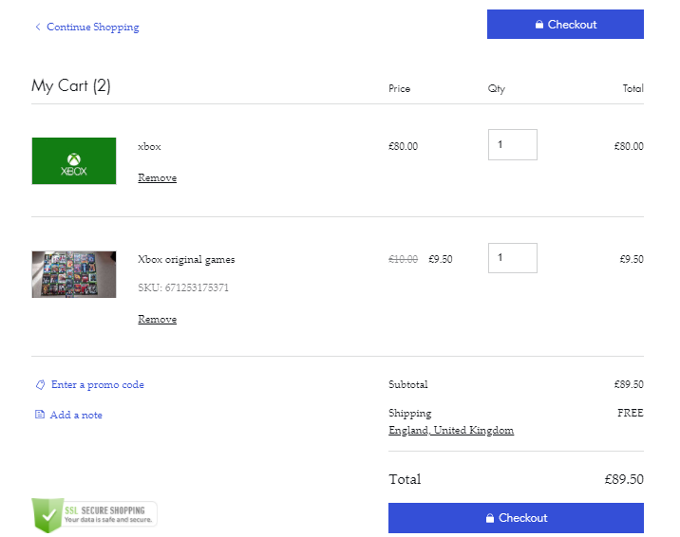
Figure 14checkout
- This is the final cart that a user will see before they pay at the checkout as if they have something in their basket that should not be there they can delete the item and pay for the items that they only need.

Recommend a suite of useful applications for the SME sector

Google
There are multiple apps that are useful to a small company such as Gmail which will allow the company to keep in touch with the company and their employees and suppliers there is also Google docs which is where a user can store data to share with other employees and calendar which will keep the creator in time. [5]

Microsoft
There are multiple apps which can be used by a small company such as Hotmail which will allow a creator keep in message with their company drop box this is a storage app allowing a creator to store items and share them with employees there is also a app called office 365 which has most of Microsoft apps such as word, PowerPoint and one note that can be sent to other users via drop box. [6]

Bibliography

[1] | J. Sophy, “20 Digital Transaction Options for Small Businesses,” Small Business Trends, 1 11 2017. [Online]. Available: https://smallbiztrends.com/2014/06/digital-payment-options-small-business.html. [Accessed 4 5 2018].
[2] | Investopedia, “Enterprise Resource Planning - ERP,” Investopedia, 2018. [Online]. Available: https://www.investopedia.com/terms/e/erp.asp. [Accessed 4 5 2018].
[3] | Investopedia, “Manufacturing Resource Planning - MRP II,” Investopedia, 2018. [Online]. Available: https://www.investopedia.com/terms/m/manufacturing-resource-planning.asp. [Accessed 4 5 2018].
[4] | SalesForce, “What Is CRM?,” SalesForce, 2018. [Online]. Available: https://www.salesforce.com/uk/learning-centre/crm/what-is-crm/. [Accessed 4 5 2018].
[5] | Google, “g Suite,” Google, 2018. [Online]. Available: https://gsuite.google.com/. [Accessed 4 5 2018].
[6] | Microsoft, “Apps,” Microsoft, 2018. [Online]. Available: https://www.microsoft.com/en-us/windows/windows-10-apps. [Accessed 4 5 2018].
[7] | Nitnsoni02, “E business Applications,” SlideShare, 13 12 2012. [Online]. Available: https://www.slideshare.net/nitinsoni02/e-business-application-15625975?next_slideshow=1. [Accessed 4 5 2018].
[8] | “Efficient Office Systems,” Administration Skills, 2018. [Online]. Available: http://www.etu.org.za/toolbox/docs/admin/systems.html. [Accessed 4 5 2018].

