

Effective Teaching and Assessment in Higher Education
Module Code: UNHE7007

Professional Portfolio

Student Name: L. Simona Ferraraccio
Student number: 2418507

I confirm that I have not presented any AI generated materials as my own work in this portfolio.
However, I acknowledge that I have used or may have used the AI in the research , and proof reading of my portfolio
The details are provided below:
I acknowledge the use of Grammarly (https://www.grammarly.com/) and Reverso (https://www.reverso.net/text-translation) on 25 April 2025 to check my work using the prompt(s):
1. Please check the following text for readability, grammar and syntax.
I confirm that I have copies of my drafts, notes, and other resources I used before, and after the use of AI tools which I may be asked to provide in evidence.

Contents
1. My Philosophy of Teaching and Learning 3
2. Reflection on feedback received on the Micro-Teaching session (Appendices E and F) 5
3. Intervention cycle: A teaching intervention focused on Experiential learning and reflective practice 6
1. Introduction 6
2. Basis of the teaching intervention: Learning by doing and reflective practice 6
3. Problem Definition: The "Why" 7
4. Proposed Intervention: The "What" and "How" 8
5. Rationale: “Why it will work” 9
6. Expected outcomes and metrics: The “How we will measure the success?” 9
7. Potential challenges and mitigation strategies 10
8. Conclusions 11
4. Reflection on three teaching observations 12
1. Reflection on the observation by Dr Edward Conley (Appendix B) 12
2. Reflection on the observation by Prof Philip Scott (Appendix C) 13
3. Reflection about the observation of Prof Philip Scott (Appendix E) 14
Reflective evaluation of CPD Events 15
1. Student’s mental health and wellbeing 15
2. Enhancing student engagement through Vevox 16
3. “4 Listening skills educators need to hone” 17
References 18
Appendix A: Teaching hours record 29
Appendix B: Observation by Dr Edward Conley 35
Appendix C: Observation by Prof Philip Scott 39
Appendix D: Observation of Prof Philip Scott 44
Appendix E: Micro-teaching Presentation slides and lesson plan 45
Appendix F: Micro-teaching recording and feedback 49

My Philosophy of Teaching and Learning

Teaching and learning are an ongoing process that shape individuals, communities and societies (Ashwin et al., 2020). For me, teaching is more than simply transmitting knowledge; it’s about creating an environment where students think critically, engage with content, and develop skills and attitude for continuous learning [V1, K1, V3, V4, V2, K2] (Reece and Walker, 2007; Kusumoto, 2018; Vero and Puka, 2018). Learning extends beyond the classroom [V5, V4]; it’s not just about knowledge acquisition but also developing values, skills and attitudes for personal and professional growth [A5, V5] (Reece and Walker, 2007). The Professional Standards Framework (PSF2023) serves as a guiding principle in my work, ensuring that my teaching methods are effective, evidence-based, and inclusive [V1, K1] (Advanced HE, 2023).
I teach in a diverse setting where students have varied cultural, socio-economic, and academic backgrounds [V1, K1, K2]. Each student brings unique experiences, interests, and abilities that should be valued [V1, K1, A2] (Taras et al., 2024). This diversity enriches learning and challenges me to use inclusive and effective teaching strategies [V1, V2, A2, K1] (Race and Pickford, 2007; Molbaek, 2018). A one size fits all approach is ineffective, teaching should align with students’ needs and learning level [A2, V1, K2] (Rincon-Flores et al., no date). I prioritise a supportive, student-centred environment where everyone feel comfortable sharing ideas and ask questions without fear of mistakes [A4, A2, V1, V2] (Estes Cheryl A., 2004; Rayens and Ellis, 2018; Pandey, 2019). I promote a culture of mutual respect and empathy, encouraging students to appreciate and learn from each other's perspectives and experiences [V5, K2, V2, A2]. I also provide personalised support [A3, A4, K3], including one-on-one consultations, timely and constructive feedback, and creating peer mentoring opportunities, to help students achieve their academic and personal goals [A4, A2, V1, K1] (Gardner, 2012; Marshall, 2020).
I emphasise a growth mindset corresponding to the belief that intelligence and abilities develop through effort, perseverance, and learning from mistakes, to create a welcoming, engaging, and supportive learning space [A4, A2, V1, V2, K1, K2] (Robinson C., 2017; A. Buzzetto-Hollywood, C. Mitchell and J. Hill, 2019; Nguyen Doan Hanh, 2020). Using different teaching methods, such as interactive lectures, group discussions, practical activities, and digital tools, help address different learning styles [K4, K2, A1, V3] (Duckworth, 2014). For example, I integrate multimedia for visual learning and collaborative activities to promote teamwork and communication skills [A1, A2, K2, K4, V2, V1] (Bot et al., 2005; Kelly, 2009; Kusumoto, 2018). Learning extend beyond books and lectures to include practical experiences, real-world analysis, and problem-solving opportunities [V3, V4, V5, A5] (Nagel, 1996; Race and Pickford, 2007)This approach helps students connect theory to real-life challenges, supporting their professional and personal growth [V4, A5, A2, A1, K2, K3] (Nagel, 1996; Roberts J. W., 2011).
Understanding how learners acquire knowledge in specific subject areas is fundamental to effective teaching. Continuously researching and staying updated on the latest pedagogical theories and practices is essential for implementing strategies that align with cognitive processes in learning, such as active learning, spaced repetition, and formative assessment [A3, A4, A2, V2] (Sisianu, no date; Gardner, 2012; Race, 2020). My teaching approach is adaptive and tailored to the level of study [K2, K1, V1, A1]. For example, for undergraduate students, I focus on building foundational knowledge and essential skills through structured lessons and group activities [A1, A2, V2, V1, K1, K2] (Race, 2020). For postgraduate, I take a more facilitative role, encouraging independent research, self-learning, advanced critical analysis, and group discussions [K1, K2, V2] (Giuseffi, 2019; Cheng, Hwang and Lai, 2020). This ensures that my teaching remains relevant and challenging across academic level [K2, K1, V1]. Critical evaluation is central to my teaching philosophy; I regularly reflect on my practices, seek feedback from students and colleagues, and engage in professional development [K3, A5, V5] (Belvis et al., 2013). This continuous reflection helps refine my methods and responds to students’ evolving [A5, A1, K3]. Additionally, I encourage self-evaluation and peer review to develop students’ critical thinking and self-assessment skills [K3, A3] (Sisianu, no date; Gardner, 2012; Race, 2020).
In conclusion, teaching and learning are interconnected processes that require a holistic, student-centred approach [A1, K1, K2, K4]. As an educator, I am committed to creating an inclusive and engaging learning environment that encourage critical thinking, collaboration, and a growth mindset. I view teaching not as a one-way transfer of knowledge but as a dynamic process of mutual learning that enriches both students and educators [A5].

Reflection on feedback received on the Micro-Teaching session (Appendices E and F)

This reflection considers colleagues feedback on my microteaching aligning with the PSF2023 [K3] (Advanced HE, 2023). It provided a valuable opportunity for improvement [A5, A3], helping me design more structured, interactive, and student-focused sessions [A1, A2, A5, V1, V2, K1, K2] (Sisianu, no date; Reece and Walker, 2007; Doyle and Zakrajsek, 2023).
One key point was the need for clearer aims and objectives [A2]. While I had them in mind, stating them upfront would provide students a clearer session roadmap [A1, A2]. I think that making more evident how students will apply the knowledge being taught, reinforcing its relevance [A5, K1] (Reece and Walker, 2007). Another suggestion was to have a backup plan when using digital tools [A1, K4]. Technical issues can disrupt engagement, so preparing alternatives (paper-based version or verbal responses) helps ensure a smooth delivery [A1].
Colleagues suggested incorporating more student perspectives to make content relatable [V2, A1], supporting the goal of promoting engagement and interactivity [K4, V3, A1] (Moreillon, 2015; Han, 2021). They also recommended me including more questions to promote two-way communication and check understanding [V2, A1] (Rønsen, no date). I agree that integrating more activities can enhance interaction and active learning (Kusumoto, 2018; Viswanathan R. and Krishnamurthy N., 2023), highlighting the importance of balancing content delivery with participation [V1, V2, A1, A4] (Hunt K. A. et al., 2016). In my session, I included an initial survey to gain students’ entry level knowledge, and a final Q&A for formative assessment [A1, A3, A4, K2] (Gardner, 2012), helping me identifying whether key concepts were understood or if students require further clarifications [A3].

Intervention cycle: A teaching intervention focused on Experiential learning and reflective practice

Introduction
I am part of a lecturing team in Digital health and care at the Institute of Management and Health (IMH), teaching to two different pools of students: postgraduate student, level 7 (L7), enrolled in the online-programme MSc in Digital transformation for the health and care professions, undergraduate students, level 5 (L5) and level 6 (L6), studying IMH programmes [V1, K1, K2]. It is working with final year students (L6), that I developed the idea for this teaching intervention strategy [K1, V1]. I have identified two significant challenges impacting the final-year student experience: a perceived state of overwhelm arising from a demanding academic workload across both semesters, along with a limited opportunity to engage in structured practical experiences that directly translate classroom learning into real-world application [V1, K1, K2, A4] (Kelly, 2009; K. Rukhsana, 2010; Gustems-Carnicer, Calderón and Calderón-Garrido, 2019; Córdova Olivera et al., 2023).
In this report, I will describe and reflect on a teaching intervention cycle strategy aimed at mitigating these challenges by suggesting a possible reorganisation of the final year in accordance with the PSF 2023 guidelines [A1, A5, A4] (Advanced HE, 2023). The core of this intervention strategy involves integrating a dedicated placement experience within the first semester, followed by a focused dissertation project in the second semester [V3, V4, V5, A1, A2, A3, A4, A5, K2] (Kelly, 2009; Ogba et al., 2022). Therefore, this report adopts a prospective approach to reflective practice, rather than retrospectively evaluating a completed intervention (Bolton and Delderfield, 2018). The reflective frameworks Double Diamond Design thinking is used to anticipate potential opportunities, challenges and possible consequences associated with this curricular reorganisation (J. Ball, 2019; L. Fallin, 2022).
By prospectively analysing this strategy, I aim to optimise student learning, well-being and career readiness within the digital health and care sector [A1, A4, A5, V5, K3] (Duckworth, 2014).

Basis of the teaching intervention: Learning by doing and reflective practice
This teaching intervention is based upon the pedagogical approach of “Learning by doing” which is known to be effective in promoting deeper understanding [A3], skill development [A2] and enhance career readiness [V4] (Gibbs, 1998), and upon the concept of reflective practice which is essential for both, teachers and learners, as it promotes continuous professional development [A5], self-awareness [A3], and deeper learning [A2] (Sisianu, no date; Biggs and Tang, 2011). Experiential learning is a fundamental approach in HE as enables students to reduce the gap between theoretical knowledge and practical application [V3, V4, V5, A1, A4, A5, K2] (Kelly, 2009; Beard and Wilson, 2013). I believe that in the Digital Health and Care department this approach is crucial as students can live practical experiences [V5], develop critical-thinking [V2], problem-solving, and professional skills [A5] to be ready for their careers (Pellegrino and Hilton, 2013; Blyznyuk and Kachak, 2024).
During my lectures with L6 students, especially for the module “Facilitating change and managing quality outcomes in health ecosystems”, I found myself questioning if the students were able to visualise the topics in the real world, in the real health and care settings [K1, V1, A1, A2, V2]. I found the answers in the outcomes of group activities where students were asked to identify a problem in a ward of a hospital and develop a change management strategy to solve it [A3, K3, V2]. They were not able to do the exercise. So, how can we as teachers promote reflective practice and enhance learners effective practice? This is where this teaching intervention strategy is positioned [A1, V2, K2].
By embedding “Learning by doing” and the “reflective practice” in the teaching [A1], I can effectively enhance student engagement [V2], reduce cognitive overload [A4], ensure that students are not only knowledgeable but also practice-ready [A5, A2, V3, V4, K3, K5] (Bot et al., 2005; Bolton and Delderfield, 2018). To create an effective and student-centred teaching intervention, I will use the double diamond design thinking process which provides a structured approach to understanding, redefining and addressing the challenged faced by L6 students in Digital Health and Care department [A1, K1, K2].
This iterative process ensures that this intervention is empathetic [V1], practical [V3] and adaptable [A2] to evolving student needs [A4] (Brown and Funk, 2012; J. Ball, 2019; L. Fallin, 2022; Doyle and Zakrajsek, 2023).

Problem Definition: The "Why"
The first step of this intervention is understanding student difficulties and gaining insights into their experiences [V1, A4] aligning with the “Discover” and “Define” phases of double diamond process (J. Ball, 2019; L. Fallin, 2022). Currently, L6 students must complete a full course load across both semesters while also undertaking dissertation project [A1, K2]. This structure places a significant cognitive load, which can negatively impact their learning performance. Research has consistently shown a strong correlation between cognitive load and learning outcomes, with excessive mental demands reducing the ability to process, retain, and apply new information effectively [A4] (Toh and Tasir, 2024). When students are overwhelmed by complex information or competing tasks, their cognitive resources become strained, leading to difficulties in comprehension, critical thinking, and problem-solving [A4, K1, V1]. As a result, managing cognitive load is essential to creating effective learning environments that enhance retention, engagement, and overall academic success [K1, V1, V2, V3,A1, A4] (Murrell and Claxton, 1987).
The first challenges is L6 students feeling overwhelmed, stressed and unable to focus leading to diminished learning outcomes and well-being [A4] (Koschel, Young and Navalta, 2017; Gustems-Carnicer, Calderón and Calderón-Garrido, 2019). The transition from structured learning (lectures, assignments), to independent learning increases anxiety and distress, reducing their academic performance [K1, V1, A4]. Students rely more on memorisation instead of critical thinking and deep understanding, diminishing the long-term value of their education [K1, K2, V1, A4] (Biswas, Thosar and Srimani, 2024). Linares et al. (2022) found that anxiety negatively affect performance, causing academic burnout, low engagement and poor outcomes [V1. A4] (Gázquez Linares et al., 2022). A review of mental health promotion and prevention programmes suggests that skill-oriented interventions with supervised practise enhance social-emotional skills, self-perception, and reduce distress [V5, K2, A5, A1] (Conley, Durlak and Dickson, 2013).
Secondly, the theory-practice gap; the current curriculum lacks practical experience leading to disengagement and difficulties in applying their knowledge professionally [V4, V5, A5] (Kelly, 2009). This is critical as employers seek graduates with demonstrable real-world skills and experience relevant to the field [A5, K2, V3, V4, V5] (Kelly, 2009; Succi and Canovi, 2020). Worked-based learning (WBL) is recognised as essential for workforce readiness [V4, V5, A1, A5] (Byrom and Aiken, 2014), enhancing both, academic experience and students expectations of education value [V2, V3, V4].
This combination of high workload and limited practical experience impacts academic performance, career readiness, and teaching effectiveness leaving graduates feeling underprepared, lacking confidence, and struggling with the gap between theory and practice [V4, A5, A4, K2].

Proposed Intervention: The "What" and "How"
To achieve students satisfaction and teaching quality, I needed a solution that balanced both with minimal disruption for the academic staff and students [A1, V5, K5]. The “Develop” phase of the double diamond process involves brainstorming and experiential learning methods [K1, K2] to address the core issues (Hamer, 2000; J. Ball, 2019; L. Fallin, 2022). This phase applies divergent thinking to explore and understand complex problems [K3, A1] (Runco and Okuda, 1988). The questions that will be addressed in this section are What needs to be done? and How it needs to be done?
In my L6 teaching, I implemented project-based learning (PBL) using real-world case studies to enhance active learning [K2, A1, A2] (Elliott, 2021; Mughrabi, 2021). While engagement improved, students remained due to workload and lacked opportunities for real-world skill application [V2, V1, K1]. First-hand experience from my final year at the Faculty of Biomedical Engineering in Italy reinforced the importance of hands-on learning. Bayerlein’s research highlights placements as a key tool for enhancing practical learning [V3, V4, V5, A5] (Bayerlein, 2020), improving efficacy, and reinforcing student learning [A5, V2, V3] (Leary and Sherlock, 2020). In health and care education, studies showed that placements are essential for applying theoretical knowledge in practical settings [K5, A5, V3, V4, V5] (Nyoni, Hugo-Van Dyk and Botma, no date; Owen and Stupans, 2009; Naumann et al., 2021).
To fully support L6 students, I propose a final-year restructure that integrates project-based, practice and active learning [A1, A2, A3, V3, V5, V4] (Elliott, 2021; Mughrabi, 2021). The first semester will focus on work-integrated learning [A2, V5, V4, V3, K2, A5] through a supervised placement in a relevant environment where students apply their theoretical knowledge [V4,A5], develop professional skills [A2, A5, K3], and build industry contacts [V5, V4] (Murrell and Claxton, 1987; Kelly, 2009; Jackson and Dean, 2023). The second semester will be dedicated to a dissertation based on their work experience [K3, A5, V3], allowing them to focus on high-quality research [K5, K2, A2]. Students will receive supervision and guidance [A4, A3], and additional support through workshops on research methods [A1,A4, K2], writing support services [A4, A2, A5, V5, K2], and one-to-one faculty consultations [A4, A2, V5, K4, V1] (Gardner, 2012; Race, 2020).
The assessment strategy will also align with this structure [A3] (Gardner, 2012; Race, 2020). In the first semester, students will complete a recorded interview simulation as a self-reflection exercise [A3, A5, K4, K1, V1], receiving specific and actionable peer-feedback to enhance self-awareness [A4, A3, V1, K1, K3] (Briceland, Caimano Tackes and Veselov, 2022). They will also present their placement experience [K4, K2, K3], receiving formative feedback from academic supervisors offering guidance on structure, clarity and content through draft reviews and practice runs before submission [A4, A3, K3, V2], and a combination of written and verbal feedback after [A4, A3, K3] (Huma, Ullah and Sarfraz, 2024). Furthermore, the self-assessment will be promoted to induce students to critically evaluate their performance [A3, K3, K1, V1]. Additionally, a supervisor performance review will provide personalised, future-oriented feedback to boost engagement [A3, A4, V5, K3, K4, A5]. In the second semester, dissertation assessment will include comprehensive written feedback on research quality, critical analysis and writing [A3, A4, K3, K1]. Long-term development guidance will help students turn their dissertation into journal paper and apply findings in their careers [A3, A4, A5, V5, K3, K4].
A combination of formative, peer, and self-reflective feedback ensures both, academic and professional growth [A3, A4, K3]. Feedback at key milestones will guide students effectively through their final year. A phased transition will be introduced with clear support including information sessions, career counselling, and placement preparation workshops [A1, A4, V1, V3, V5, K2].

Rationale: “Why it will work”
The proposed teaching intervention reduce cognitive load [A4, V1, V2] and the theory-practice gap while enhancing engagement [V2], academic performance [A5] and career readiness [V4, V5] (Kelly, 2009; Han, 2021). It mitigates final-year stress by allowing students to focus on placement in semester 1, easing the pressure on dissertation work in semester 2 [A1, A4, V2, K5] (Reece and Walker, 2007). This structured, sequential approach enables students to engage more deeply in each aspects of their studies, mitigating the risk of burnout and enhancing their ability to learn effectively [A2, A4. A5, V1, V2, V3, V5, K1, K2] (Murdoch Eaton and Cottrell, 1999; Jensen et al., 2021). Researches on cognitive load theory (Sweller, 1988) confirms that breaking tasks into smaller units reduces mental strain and improves retention [A2, A4], allowing students to concentrate on each major task individually and with full engagement [V2, V3, V1, K1] (Refat, Kassim and Rahman, 2020). The intervention also bridge the theory-practice gap, particularly in Digital Health and Care at UWTSD [V3, V4, V5]. A structured first-semester placement provides hands-on experience, connecting classroom learning with industry practice [A5, V5, V3, K2] (Race and Pickford, 2007; Ogba et al., 2022). Kolb’s experiential learning cycle (1984) emphasises active participation and reflection to enhance learning [A1, A2, A4] (Murrell and Claxton, 1987). Through real-world application and reflection, students develop problem-solving skills, critical thinking, and professional skills essential for their future [V5, V3, A2, A5, A3, V2, K3, K4, K5] (Mertayasa et al., 2024).
By integrating work experience into the curriculum students gain valuable industry contacts [A1, V5, V4, V5], key professional competencies [A5], and sector-specific insights [K4, V3, V4, V5] (Jackson and Dean, 2023). Work-integrated learning (WIL) strengthens employability by fostering teamwork, communication, time management, and leadership [A5, V5, V4, K3, K4]. Studies in health and care education confirm that practical placements boost confidence and workforce preparedness [A5, V4, V5, V2] (Gázquez Linares et al., 2022). This intervention ensures students are both knowledgeable and practice-ready, a crucial factor in today’s job market [A5, V5, V4] (K. Desai, 2021).
Reflective practice is central to this approach, promoting deep learning and teaching effectiveness [A1, V2, K2] (Grant et al., 2006; Hume, 2009; Duckworth, 2014). Reflection during placement (reflection-in-action) and dissertation work (reflection-on-action) support self-assessment, skill development, and critical thinking [A1, A2, A3, A5, K3, K5, V4, V5] (Munby, 1989; Flavian, 2016; Annadurai, 2024). This continuous process enhances academic performance and career outcomes [A3, A5, K3, V5, V4] (Gilliam et al., 2018; Marshall, 2020; Briceland, Caimano Tackes and Veselov, 2022).
Structured support throughout the year further strengthen learning [A4, A3]. Vygotsky’s zone of proximal development (1978) emphasises guided learning, enabling students to tackle complex tasks with appropriate resources and mentorship [A4, A3, A5] (Moll, 1990). This intervention offers clear, evidence-based solutions to student challenges, improving learning experience and career readiness [A4, A5, V5, V4].

Expected outcomes and metrics: The “How we will measure the success?”
The success of this intervention will be measured through academic and professional development outcomes, tracked via key performance indicators (KPIs), students feedback, and longitudinal data [K3, A1, A2] (Gardner, 2012; Caruana et al., 2015; Race, 2020; Selviyanti et al., 2021; Huma, Ullah and Sarfraz, 2024).
An increase in student satisfaction is expected due to a more balanced workload, relevant real-world experiences, and continuous support [A4, A3, V5, V4]. Satisfaction will be assess through annual surveys and feedback sessions on curriculum, placements, dissertation support, and career preparedness [A3, A1]. A high rate of placement completion is anticipated, with students gaining industry experiences that enhance practical skills and employability [A5, V5, V3]. Success will be measured by tracking completed placement, supervisor evaluations, and student's performance against learning objectives [A3, K3, K5]. Any issues will be reviewed and addressed [V5, A3, A4, A5] (Gardner, 2012; Race, 2020). Dissertation quality is expected to improve as students apply their academic knowledge in real-world contexts, strengthening research skills [A2, K2, K3, K4, K5]. Assessment will focus on critical analysis, research depth, originality, and overall academic rigor [A3, K5, K3], and the results will be compared with previous cohorts. Graduate employability should increase due to WIL experience and skill developed with positive placement supervisor feedback on professionalism, problem-solving, communication, and application of learning [V5, A5, K3, V4, A3]. Graduate employability will be tracked via Alumni follow-up surveys six months post-graduation [A4, A5, V5].
By monitoring these outcomes, necessary adjustments can be made to ensure the intervention continues to meet the students, industry, and faculty needs (Race and Pickford, 2007).

Potential challenges and mitigation strategies
This section aligns with the “Deliver” phase of the Double Diamond model, focusing on the implementation plan to ensure successful placement opportunities for students [A1]. A structured approach will be taken to establish partnerships with health and social care organisations, providing meaningful, practical experiences. [V3, V5, A1, A5]. These partnerships will be formalised through agreements that outline expectations, learning outcomes, and necessary support structures [A1, A4, V3, V5]. Additionally, a centralised database of placements will be developed to facilitate effective supervision and mentoring, ensuring students receive guidance throughout their experience [A4, A3] (Bolton and Delderfield, 2018; Gregson et al., 2020). To prepare students for their placements, tailored workshops will be provided on CV building, interview techniques, professional conduct, and workplace expectations [A4, A5, A1]. These sessions will enhance students’ confidence and ensure they are equipped with the skills needed to navigate professional environments [A1, A2, A4, A5, A5, V4, V5] (K. Desai, 2021). Despite these structured efforts, key challenges remain, including securing a sufficient number of placements, maintaining quality and consistency across different organisations, and supporting students as they transition into independent dissertation research [A4, V5, V4, V3, A5].
To mitigate these challenges, a proactive strategy will be adopted, involving engagement with a broad network of organisations across the health and social care sectors [A1, V5]. Alternative placement models, such as virtual placements and consultancy-style projects, will be explored to provide more flexible opportunities [A1, V5, K4, A5] (Akos, Leonard and Hutson, 2022; Wood, Zegwaard and Fox-Turnbull, 2022). Students will also be encouraged to take initiative in sourcing placements through career fairs, networking resources, and institutional support services [A4, V5, V3, K4]. Supervisors will be trained to ensure they are well-equipped to mentor students, adhering to UWTSD guidelines [A1, A4, A5, V5, V3] (Student Placements Protocol 2023/24, 2023). A real-time monitoring system will be implemented to track student progress, promptly address issues, and offer additional support where needed [A1, A3, A4, A5, V5]. Additionally, to facilitate a smooth transition into dissertation research, a series of workshops will be conducted on research methods, academic writing, and ethical considerations [A1, A4, A5, K5, V1, V2]. Preparatory modules introduced in earlier academic years will help students build core research skills, including data analysis, critical thinking, and scholarly writing [A1, A2, A5, V1, K1, K2, K5] (Willison, 2012; Kusumoto, 2018; Vero and Puka, 2018; Bezanilla, Galindo-Domínguez and Poblete, 2021).
These initiatives collectively ensure that students are well-prepared for both their placements and their academic progression.

Conclusions
The proposed teaching intervention strategy presents a structured and innovative approach to mitigating key challenges faced by L6 students in Digital Health and Care. By integrating WBL in the first semester and a dissertation-focused second semester, the intervention is designed to reduce cognitive overload, enhance engagement, and bridge the theory-practice gap [A1, V2, A5, V3, V4, V5, K1, V1]. The strategic incorporation of experiential learning, reflective practice, and structured academic support ensures that students not only develop theoretical knowledge but also acquire the practical skills necessary for their future careers [K2, A5, A4, A2, V1].
This model is supported by established pedagogical frameworks, including Learning by Doing, Double Diamond Design Thinking, and Cognitive Load Theory, which emphasise the importance of hands-on learning, structured problem-solving, and cognitive load management [A1, K1, V1]. By allowing students to immerse themselves in professional settings through placements, they gain valuable insights and practical experience, which in turn enhances their research capabilities for their dissertation projects [K2, K3, A1, A5, V3, V4, V5]. The structured feedback mechanisms, including formative assessments, self-reflective evaluations, and supervisor reviews, further ensure continuous improvement in both academic performance and professional readiness [A3, A4, A5, V4, V5, K3, K5].
The expected outcomes of this intervention include improved student satisfaction, enhanced academic performance, and increased employability [V4, A5]. By aligning assessments, learning strategies, and support mechanisms with industry expectations, students are better equipped to transition into the workforce with confidence and competence [A3, V5, V4, K5, K3]. The effectiveness of this approach will be measured through KPIs, including student feedback, placement success rates, dissertation quality, and graduate employment statistics [A2, A3, A5, V4, K3, K5].
Overall, this intervention represents a forward-thinking approach to curriculum design, aligning with the Professional Standards Framework (PSF 2023) and best practices in higher education. By proactively addressing student challenges and fostering an integrated learning experience, this model enhances the academic journey, promotes professional growth, and ensures that graduates are well-prepared to contribute meaningfully to the digital health and care sector [A4, V3, V4, V5, A5, K3, K5]. Furthermore, this intervention serves as a potential blueprint for future curriculum adaptations, reinforcing the importance of dynamic and responsive educational practices in an evolving professional landscape.

Reflection on three teaching observations

Reflection on the observation by Dr Edward Conley (Appendix B)

Reading this feedback has been both affirming and insightful. I’m particularly encouraged to see that my efforts in curriculum design, assessment development, and student engagement have been recognised. It’s reassuring to know that my structured approach to planning, delivery, and feedback is contributing to a positive learning experience [A1, A2, A3] (Estes Cheryl A., 2004). The comments highlighting my digital literacy, use of learning technologies, and the relationship I’ve built with students reinforce my belief in the importance of being adaptable and responsive in both physical and virtual teaching environments [A1, A2, V1, V2, K1, K2, K4].
What stands out to me most is the emphasis on my ability to promote an inclusive and empathetic learning atmosphere [V1, V2, V3]. I’ve always believed that teaching is as much about human connection as it is about content delivery [A4], so it’s rewarding to know that my efforts to support diverse student needs and encourage participation are being noticed [A2].
Throughout this observation, I have gained valuable insights into the importance of continuous professional development in enhancing teaching effectiveness [A5]. My proactive approach to updating course materials, integrating digital tools, and reflecting on student feedback has demonstrated the significance of staying current with educational trends [A1, A2, K2, K4, V2, V1]. My engagement in training sessions and peer collaboration has reinforced my own commitment to professional growth [V2, A5]. This observation has encouraged me to seek further opportunities for training, collaboration, and curriculum innovation to refine my teaching practices and better support student learning [A5, V5, A4].
This observation will also enhance my practice by helping me become more intentional in how I design learning activities and structure assessments [A1]. Knowing that my use of problem-based learning and hands-on strategies [K1, K2] has been effective encourages me to explore deeper and more varied applications of these methods [A5, K4, V3]. I plan to incorporate more real-world case studies and collaborative problem-solving tasks that align closely with learning outcomes, promoting critical thinking and student autonomy [K3, K4, V4, V3, A1, A2].
Furthermore, the recognition of my formative feedback and structured marking practices motivates me to further improve the quality and timeliness of the feedback I provide [A3, K5]. I aim to create even more opportunities for low-stakes, formative assessment so students can engage with feedback as an ongoing learning tool, not just a final judgment [V2, A3, V1, K3].
The emphasis on inclusion and support [V1, V2] will also shape how I approach classroom dynamics and student communication moving forward [V2, A1]. I will continue to diversify the ways I present content and invite participation, ensuring that all students, regardless of background or learning style, feel seen, heard, and empowered to contribute [V1, V2, V3, K1, A1, A2, A3, A4].
Finally, the observation reinforces the importance of collaboration with peers [V5], which I plan to build on by initiating more peer observations and sharing sessions around teaching practices [A5, V5]. These steps will not only help me continue refining my own approach but also contribute to a stronger, more supportive academic community [V4, A5]. Overall, this feedback validates my current teaching strategies while also providing a clear path for enhancement [A5].

Reflection on the observation by Prof Philip Scott (Appendix C)

The observation by Prof Philip Scott has been incredibly helpful in consolidating my strengths and identifying areas for further growth [A5]. I’m pleased that the session was perceived as clear, well-paced, and structured, particularly with the emphasis on learning objectives at both the beginning and end [A1, A2, V1, K1]. This alignment with clear learning goals is something I strive to maintain consistently, and it’s reassuring to see that it contributed to student engagement and understanding [V2, K3, A3].
His feedback confirms the value of combining lecture content with group work [V3, K2], which encouraged students to connect theory to their professional contexts [V4]. I’m especially encouraged to see that the group activities were recognised as promoting critical evaluation and demonstrating application-based learning [K3, K2, V2, V2, A1]. This reinforces my commitment to integrating more active and experiential learning opportunities in future sessions [A1, V3, V4, K3], ensuring that students don’t just absorb content but also learn how to use it meaningfully [K3, V3, V4, A1, A2].
The observation also affirmed that the use of technology supported learning effectively, which is important given the hybrid nature of many learning environments today including the MSc programme I teach at the UWTSD [K4]. Seeing that students felt comfortable asking questions and participating actively suggests that my efforts to build a positive, open classroom atmosphere are having the desired impact [V2, A3, A4, K2].
One key takeaway from this observation is the suggestion to probe and challenge student contributions more deeply [A3]. This is a valuable reminder that while it’s important to create a safe space for participation [V2], it’s equally essential to push students to think more critically and reflectively [K3, K5]. I intend to be more intentional about using follow-up questions that encourage deeper analysis and invite multiple perspectives [A3, A4, V2]. This will help students stretch their thinking while maintaining the trust and relationship we’ve built [K3, A4].
The observation overall reinforces my belief in the importance of continuous refinement [A5]. It motivates me to further experiment with balancing content delivery and student-led inquiry, particularly in how I guide discussions to promote critical engagement [A1, A2, K2, K3].
Furthermore, this feedback contributes to my ongoing professional development [A5]. It reminds me of the importance of adapting and evolving my teaching materials, something I’ve already begun by modifying content from previous years [A1], and encourages me to continue reviewing and updating resources to stay aligned with current practices and student needs [V3, V4].
This experience has enhanced my awareness of how even small adjustments, like slightly increasing the challenge level in group discussions, can make a significant difference in learning outcomes [A2,A3]. It also reinforces my intention to keep exploring diverse teaching strategies, incorporate feedback loops, and seek out further training and peer dialogue to refine my practice [, A3, A5, K5, V5].
Overall, this observation strengthens my confidence in the core elements of my teaching while providing a clear and constructive direction for growth, particularly around questioning techniques and deeper student engagement [A3, V2].

Reflection about the observation of Prof Philip Scott (Appendix D)

The observed lecture delivered by Prof Philip Scott provided valuable insights to improve my teaching, particularly in the area of time management [A2, A5]. One of the most significant takeaways from the observation is how Philip effectively structured his session, balancing content delivery with student interaction, which allowed for an engaging and focused learning experience [V1, V2, K1, K3, A1, A2]. A critical area for improvement in my teaching is time management [A5]. Philip demonstrated excellent time management throughout his session by carefully balancing content delivery with student engagement [A1, A2, A3, A4, V2, A5]. His careful organisation of group work, class discussion, and the pacing of his lecture ensured that all planned activities were covered within allotted time [A1, V2, V5]. Reflecting on this, I need to prioritise the planning of time for each segment of mu sessions and practice to those timelines [A5, A1, A2, A5, V1, V2]. For example, I could time-box each activity and set clear transitions to stay on track [A1, A5].
Philip’s ability to set clear learning outcomes from the beginning of the session is a crucial lesson for me [A1, A2, A5] and it’s in agreement with the feedback I received after the micro-teaching session. By establishing a focused agenda, he ensured that each segment had a clear purpose. This is something I can incorporate into my practice by clearly outlining learning objectives at the start and being more intentional about structuring the session to meet those objectives [A1, A2, K2]. Clearer planning will help me manage time more effectively, ensuring each lesson segment remains purposeful and on track [A5, A1].
Philip used a diverse range of teaching methods, including a well-organised slide presentation, student interactions, and group work [A1, A2, K2, V2, V5]. This multimodal approach ensured that students were engaged without overwhelming them with too much content at once. I can take this approach to better manage the flow of my sessions and maintain student engagement without running overtime [A1, A2, V1, V2]. For instance, I could integrate more small-group discussions or interactive exercises that align with the core content, allowing for deeper learning without losing track of the session’s pace [A1, A2, A3, K1, K2, V1, V2].
The use of breakout rooms during the online session was an excellent example of maximising technology for both engagement and time efficiency [K4, A3]. By using these rooms, Philip was able to facilitate collaborative activities that kept students engaged while minimising downtime [V2, A1, A2, A3, K4], Breakout rooms will allow me to facilitate group work more efficiently, helping to manage time and ensure that students have meaningful, focused discussions without taking up unnecessary time [A1, A2, A4 V5, K4, A5].
This observation has reinforced the importance of clear planning, effective use of teaching strategies, and maintaining control over the session’s timing [A1, A5]. By focusing on structured transitions, using technology effectively, and sticking to time limits for activities, I can improve my time management and enhance my teaching practice [V3, A5].

Reflective evaluation of CPD Events

Student’s mental health and wellbeing

I completed the training “Student’s mental health and wellbeing” in May 2024, gaining insights and strategies to prioritise student well-being [V1, A4] (Fernandez Howse M et al., 2016). The training covered mental health awareness, resilience, supporting distressed students, and handling challenges [A4, V1, V2]. I recognise the importance of applying these insights in teaching and supervision [V1, V2, A1, A4] which align with the PSF 2023 (Advanced HE, 2023).
I am responsible for creating supportive learning environments, and this training deepens my understanding of how mental health directly impacts student engagement, academic performance, and overall success [V1, V2, A1, A4, K1] (Hindman, Grant and Stronge, 2013; Lakkala et al., 2021; Ma, 2021; Prananto et al., 2025). Promoting resilience in students is crucial to ensure students’ equal opportunity to personally and professionally development [V1, V2, A5]. By equipping students with the tools to handle adversity to develop essential skills for both academic and personal success [V1, V2, A4, A5].
The section “Common forms of mental health conditions” explained problems like anxiety, depression, and eating disorders, which are increasingly prevalent in students population (Aoun et al., 2019; Eck and Byrd-Bredbenner, 2021). These conditions impact learning, making it essential to understand their spectrum to tailor support effectively [K1, K2, K3]. Recognising the institutional context and available resources [K3] (University of Wales Trinity Saint David, 2024) and collaborating with universities services, counselling and mental health professionals, ensure the appropriate support [K3, V5, A4]. A deeper understanding enhances communication, fostering a supportive, non-judgmental environment for students to discuss challenges [A2, A4, V1] (Hindman, Grant and Stronge, 2013; Singh and Pallai, 2023). The course emphasises empathy and proactive support, reinforcing respect for all students, regardless of background or challenges [V1, V1] (Singleton J., 2023).
The training focussed also on providing effective support to students facing difficulties [A4], suggesting practical strategies for engaging with students who may be struggling [V2, A4], like offering a listening ear, knowing when to refer them to professional support [V5, A4], and helping them manage immediate challenges [V1, A4] (Fredricks, Reschly and Christenson, 2019; Watts et al., 2022). Understanding how to respond appropriately to students in distress ensures that I can act with confidence and empathy [V1, A4, A5], with tailored approaches to individual needs [K4, V5, V1, A4]. Recognising the signs of distress early on and responding effectively is essential for ensuring that students are not left to navigate their challenges alone [V4, A4].
The case study provided real-world example of how to respond effectively in different distressing situations [A4]. This allowed me to think about how I would respond to various scenarios and equipped me with the tools and confidence to take appropriate action when necessary [K5, A4]. It is important to guarantee fairness, inclusivity, and the recognition of student’s diverse needs ensuring that every student is treated with respect, dignity, and understanding, regardless of their mental health challenges [V1, V2, V3, A4] (Voltz et al., 2010; Dunn and Brown, 2021).
With this training, I gained a deeper understanding of how to implement these strategies in my work, promoting a supportive learning environment (Hindman, Grant and Stronge, 2013; Pulos et al., 2024).

Enhancing student engagement through Vevox

I attended the “Interacting teaching with Vevox: elevate engagement and inclusivity” session in February 2025 as part of my continuous professional development, gaining valuable insights into enhancing student engagement in higher education [A5]. The session reinforced the importance of using digital tools to create inclusive, interactive, and a student-centred learning environment [K4, K1, V1, V2, K2, A1, A2, A5] (Adami and Ga, no date; Miller, 2021; Guberina, 2023). Through the lens of the PSF 2023, this training aligns with key dimensions of professional practice (Advanced HE, 2023).
Respecting and responding to diverse learning [V1] was a central theme throughout the training. Vevox’s ability to facilitate anonymous questions through the Q&A board promotes inclusivity and removes barriers to participation, ensuring that all students have an equal opportunity to engage, regardless of confidence levels or learning preferences [V1, V2, K2, K4, A1] (Shaeffer, 2019; Urban V. and Bucsa R.-C., 2023). These aspects directly support equity in learning and engagement [V2] by offering multiple modes of interaction that cater to different student needs [V1, V2, K1, K2, K4] (Reid, 2005; Pacala, 2024).
The training emphasised evidence-informed approaches [V3] in learning and teaching. By incorporating real-time polling and asynchronous surveys, I can quantify student understanding and adapt my teaching accordingly [K3] promoting a critical evaluation of student responses, allowing for timely feedback and course adjustments [A3, A4, A1, K2]. Additionally, I was able to fully understand how digital tools like Vevox could enhance engagement increasing the effective integration of technology in my teaching practice [K4, K1, K2, V2].
Furthermore, the training directly supports and equip educators like me with practical strategies to create more dynamic and interactive learning experiences [A2]. One key example, is the integration of Vevox, which I use to collect both real-time and post-session responses from students [A1, A3] (Gardner, 2012; Race, 2020). This tool not only enhance engagement during sessions but also provides me with valuable insights into student comprehension, allowing me to tailor feedback and adapt my teaching accordingly [A3]. Through this process, I’m able to identify areas where students may need support or clarification, promoting a more responsive and inclusive learning environment [K1, V1, K2, A4]. Additionally participating in the training itself serves an effective learning tool for me, enabling continuous professional growth [A5]. It reflects my commitment to staying informed with new pedagogical technologies and applying them thoughtfully to improve teaching and learning outcomes [A5, A1, A4, V2, V4,K1].
Moving forward, I aim to implement Vevox in my teaching, experimenting with different polling strategies to assess their impact on student engagement [A5, K4, V2, V1, A2, A1]. I will also explore how data from Vevox can inform my teaching practice and share insights with colleagues to foster a collaborative approach to educational innovation [V5). This experience has reinforced the role of digital engagement tools in higher education and has strengthened my ability to create more interactive, student-centred learning environments [V1, V2, K1, K2, K4, A2, A4, A5].

“4 Listening skills educators need to hone”

I read the article “4 Listening skills educators need to hone” published by Harvard Business Publishing Education on April 2025 (Debra Schifrin, 2025).
It deeply resonated with me and led to a meaningful shift in the way I approach communication in my teaching practice [V2, V5]. So often, we are trained to focus on presentation, speaking clearly, delivering engaging content, and managing classroom dynamics [A1, A2, V2, K2]. However, effective teaching is as much about listening as it is about speaking [V1, V2, A3, A4] (Hindman, Grant and Stronge, 2013). The article framed listening not just as a skill but as a fundamental tool for promoting trust, empathy, and psychological safety in the classroom [V5, V3, K1, K2, A1, A4] (Hindman, Grant and Stronge, 2013).
The distinction between listening to solve and listening to summarise was particularly impactful. I realised that when I help students overcome challenges [A4], I would often jump straight into offering solutions, p at the cost of truly understanding their concerns [A4. A3, V2, K2]. Since reflecting on this article, I’ve started using more intentional pauses in one-to-one interactions [A2, A4, V1, V2]. Instead of immediately answering their questions, I now fully listen to what students share with me and reflect it back asking, “Did I get that right?”. It’s a small change, but one that has already allowed me to have deeper, more trusting conversations with students [V2, A3, A4].
Another valuable takeaway was the idea of balancing both the relationship and content dimensions of conversations [V1, K1, A2, A3, A4]. In practice, this means to adjust not only to what a student is saying, but how they are feeling and what that tells me about their values [A3, A4, K1, V1, V2]. I’ve noticed that when I acknowledge the emotional weight behind a student’s concern, such as their fears, stability, or self-efficacy, it opens the door to more meaningful support and engagement [V2]. This form of listening has helped me navigate sensitive situations with more empathy and effectiveness [A3, A4] (Brooman, Darwent and Pimor, 2015).
The article reminded me that listening isn’t passive; it’s one of the most active and intentional things we can do as educators [A5]. It’s about being fully present, suspending judgment, and creating the kind of learning environment where students feel genuinely heard and supported. Since applying these techniques into my teaching practice, I’ve noticed stronger relationships with students band a more collaborative classroom culture [V2, V4, K2, A1, A4] (Ghahramani et al., 2022).
The article also led me to reflect on how these listening techniques apply beyond the classroom, particularly in interactions with colleagues [V5]. In academic environments, I think it's easy to fall into the habit of having transactional conversations, about deadlines, policies, or logistics, without creating enough space for genuine listening [V5]. Applying active listening with colleagues has helped me build stronger professional relationships and promote a more collaborative and supportive work culture [V5] (Kluger and Itzchakov, 2022). Just as I encourage students to embrace feedback and adapt their learning [A3], I aim to do the same in my teaching [A1, A2, K2].

References
A. Buzzetto-Hollywood, N., C. Mitchell, B. and J. Hill, A. (2019) ‘Introducing a Mindset Intervention to Improve Student Success’, Interdisciplinary Journal of e-Skills and Lifelong Learning, 15, pp. 135–155. Available at: https://doi.org/10.28945/4465.
Adami, L. and Ga, M. (no date) ‘Paper-Information Communication Technology Use among Students in Inclusive Classrooms’. Available at: https://doi.org/10.3991/ijet.v13i06.8051.
Advanced HE (2023) ‘Professional Standards Framework for teaching and supporting learning in higher education 2023’. Available at: www.advance-he.ac.uk/psf (Accessed: 25 February 2025).
Akos, P., Leonard, A.J. and Hutson, B. (2022) ‘Virtual federal work-study and student career development’, Career Development Quarterly, 70(1), pp. 16–26. Available at: https://doi.org/10.1002/CDQ.12281.
Annadurai, K. (2024) ‘Reinforcing the importance of reflective practices among medical students: The CBME way.’, Journal of Dr. YSR University of Health Sciences, 13(3), pp. 291–294. Available at: https://doi.org/10.4103/JDRYSRUHS.JDRYSRUHS_22_24.
Aoun, C. et al. (2019) ‘The Cognitive, Behavioral, and Emotional Aspects of Eating Habits and Association With Impulsivity, Chronotype, Anxiety, and Depression: A Cross-Sectional Study’, Frontiers in Behavioral Neuroscience, 13. Available at: https://doi.org/10.3389/FNBEH.2019.00204.
Ashwin, P. et al. (2020) ‘Reflective Teaching in Higher Education (Reflective Teaching)’, 2nd edition, Bloomsbury Academic, pp. 194–195. Available at: https://www.bloomsbury.com/uk/reflective-teaching-in-higher-education-9781350084667/ (Accessed: 26 March 2025).
Bayerlein, L. (2020) ‘The impact of prior work-experience on student learning outcomes in simulated internships’, Journal of University Teaching and Learning Practice, 17(4), pp. 1–19. Available at: https://doi.org/10.53761/1.17.4.4.
Beard, Colin. and Wilson, J.P.. (2013) ‘Experiential learning : a handbook for education, training and coaching’.
Belvis, E. et al. (2013) ‘Evaluation of reflective practice in teacher education’, European Journal of Teacher Education, 36(3), pp. 279–292. Available at: https://doi.org/10.1080/02619768.2012.718758.
Bezanilla, M.-J., Galindo-Domínguez, H. and Poblete, M. (2021) ‘Importance of Teaching Critical Thinking in Higher Education and Existing Difficulties According to Teacher’s Views.’, REMIE - Multidisciplinary Journal of Educational Research, 11(1), pp. 20–48. Available at: https://doi.org/10.17583/REMIE.0.6159.
Biggs, J. and Tang, C. (2011) ‘Train-the-Trainers: Implementing Outcomes-Based Teaching and Learning in Malaysian Higher Education.’, Malaysian Journal of Learning and Instruction, 8, pp. 1–19. Available at: http://mjli.uum.edu.my (Accessed: 27 February 2025).
Biswas, S., Thosar, N.R. and Srimani, P. (2024) ‘Self-Directed Learning Versus Traditional Teaching in Learning Gross Anatomy Among First-Year Medical Students: A Comparative Study’, Cureus [Preprint]. Available at: https://doi.org/10.7759/CUREUS.66542.
Blyznyuk, T. and Kachak, T. (2024) ‘Benefits of Interactive Learning for Students’ Critical Thinking Skills Improvement’, Journal of Vasyl Stefanyk Precarpathian National University, 11(1), pp. 94–102. Available at: https://doi.org/10.15330/JPNU.11.1.94-102.
Bolton, G. and Delderfield, R. (2018) ‘Reflective practice: writing and professional development’. Available at: http://hdl.handle.net/10454/17190 (Accessed: 26 March 2025).
Bot, L. et al. (2005) ‘“Learning by doing”: a teaching method for active learning in scientific graduate education’, European Journal of Engineering Education, 30(1), pp. 105–119. Available at: https://doi.org/10.1080/03043790512331313868.
Briceland, L.L., Caimano Tackes, C. and Veselov, M. (2022) ‘A structured self-reflection approach to improve reflection quality and assessment of advanced pharmacy practice experience professionalization’, Journal of the American College of Clinical Pharmacy, 5(5), pp. 516–523. Available at: https://doi.org/10.1002/JAC5.1581.
Brooman, S., Darwent, S. and Pimor, A. (2015) ‘The student voice in higher education curriculum design: is there value in listening?’, Innovations in Education and Teaching International, 52(6), pp. 663–674. Available at: https://doi.org/10.1080/14703297.2014.910128.
Brown, T. and Funk, C. (2012) ‘Design Thinking’. Available at: www.hbr.org (Accessed: 27 February 2025).
Byrom, T. and Aiken, V. (2014) ‘Doing it differently: Re-designing the curriculum to face the challenges of student work-based learning opportunities’, Higher Education, Skills and Work-based Learning, 4(3), pp. 271–283. Available at: https://doi.org/10.1108/HESWBL-05-2014-0017/FULL/PDF.
Caruana, E.J. et al. (2015) ‘Longitudinal studies’, Journal of Thoracic Disease, 7(11), p. E537. Available at: https://doi.org/10.3978/J.ISSN.2072-1439.2015.10.63.
Cheng, S.C., Hwang, G.J. and Lai, C.L. (2020) ‘Effects of the group leadership promotion approach on students’ higher order thinking awareness and online interactive behavioral patterns in a blended learning environment’, Interactive Learning Environments, 28(2), pp. 246–263. Available at: https://doi.org/10.1080/10494820.2019.1636075.
Conley, C.S., Durlak, J.A. and Dickson, D.A. (2013) ‘An evaluative review of outcome research on universal mental health promotion and prevention programs for higher education students’, Journal of American college health : J of ACH, 61(5), pp. 286–301. Available at: https://doi.org/10.1080/07448481.2013.802237.
Córdova Olivera, P. et al. (2023) ‘Academic stress as a predictor of mental health in university students’. Available at: https://doi.org/10.1080/2331186X.2023.2232686.
Debra Schifrin (2025) 4 Listening Skills Educators Need to Hone | Harvard Business Publishing Education. Available at: https://hbsp.harvard.edu/inspiring-minds/top-listening-skills-educators-tips-examples-academic-leaders-faculty (Accessed: 9 April 2025).
Doyle, T. and Zakrajsek, T.D. (2023) ‘Learner-Centered Teaching’, Learner-Centered Teaching [Preprint]. Available at: https://doi.org/10.4324/9781003445630.
Duckworth, Vicky. (2014) How to be a Brilliant FE Teacher : a practical guide to being effective and innovative. Routledge/Taylor & Francis Group. Available at: https://www.routledge.com/How-to-be-a-Brilliant-FE-Teacher-A-practical-guide-to-being-effective-and-innovative/Duckworth/p/book/9780415519021 (Accessed: 26 March 2025).
Dunn, S. and Brown, V. (2021) ‘Supporting Diversity, Equity, and Inclusion for Culturally Diverse Online Learners.’, Online Journal of Distance Learning Administration, 24(4), pp. 1–13. Available at: https://openurl-ebsco-com.ezproxy.uwtsd.ac.uk/contentitem/eue:154187182?sid=ebsco:plink:crawler&id=ebsco:eue:154187182&crl=c (Accessed: 24 April 2025).
Eck, K.M. and Byrd-Bredbenner, C. (2021) ‘Disordered eating concerns, behaviors, and severity in young adults clustered by anxiety and depression’, Brain and Behavior, 11(12). Available at: https://doi.org/10.1002/BRB3.2367.
Elliott, Lori. (2021) ‘Project-Based Learning Anywhere : Live It, Learn It, Love It!’
Estes Cheryl A. (2004) ‘Promoting Student-Centered Learning in Experiential Education’, The Journal of Experiential Education, 27(2), pp. 141–160. Available at: https://www.proquest.com/docview/275055101/82D95C048C4B47A5PQ/1?accountid=130472 (Accessed: 27 March 2025).
Fernandez Howse M et al. (2016) ‘Setting-based interventions to promote mental health at the university: a systematic review’, Int J Public Health, 61, pp. 797–807. Available at: https://doi.org/10.1007/s00038-016-0846-4.
Flavian, H. (2016) ‘Towards teaching and beyond: Strengthening education by understanding students’ self-awareness development’, Power and Education, 8(1), pp. 88–100. Available at: https://doi.org/10.1177/1757743815624118.
Fredricks, J.A., Reschly, A.L. and Christenson, S.L. (2019) ‘Handbook of student engagement interventions: Working with disengaged students’, Handbook of Student Engagement Interventions: Working with Disengaged Students, pp. 1–410. Available at: https://doi.org/10.1016/C2016-0-04519-9.
Gardner, John. (2012) ‘Assessment and learning’, p. 301.
Gázquez Linares, J.J. et al. (2022) ‘Mediating Role of Emotional Intelligence in the Relationship between Anxiety Sensitivity and Academic Burnout in Adolescents’, International Journal of Environmental Research and Public Health 2023, Vol. 20, Page 572, 20(1), p. 572. Available at: https://doi.org/10.3390/IJERPH20010572.
Ghahramani, A. et al. (2022) ‘Team-based and Collaborative Learning Studies in Flipped Classrooms: A Scoping Review in Higher Education’, Interdisciplinary Journal of Virtual Learning in Medical Sciences, 13(3), pp. 149–164. Available at: https://doi.org/10.30476/IJVLMS.2022.95747.1165.
Gibbs, G. (1998) ‘Learning by Doing, A Guide to Teaching and Learning Methods’. Available at: http://www2.glos.ac.uk/gdn/gibbs/index.htm (Accessed: 25 February 2025).
Gilliam, E. et al. (2018) ‘Assessing a Longitudinal Reflection Curriculum: A Case Study Of Student Self-Awareness Expressed Through Rotation Goal Achievement’, Innovations in pharmacy, 9(2), p. 5. Available at: https://doi.org/10.24926/IIP.V9I2.980.
Giuseffi, F.G.. (2019) ‘Self-directed learning strategies in adult educational contexts’, p. 296.
Grant, A. et al. (2006) ‘Students’ views of reflective learning techniques: an efficacy study at a UK medical school’, Medical education, 40(4), pp. 379–388. Available at: https://doi.org/10.1111/J.1365-2929.2006.02415.X.
Gregson, Margaret. et al. (2020) ‘Reflective teaching in further, adult and vocational education’, p. 479. Available at: https://www.bloomsbury.com/uk/reflective-teaching-in-further-adult-and-vocational-education-9781350102002/ (Accessed: 26 March 2025).
Guberina, T. (2023) ‘Cultivating Inclusive Learning Environments: Incorporating Diversity through Culturally Responsive Pedagogy’, Social Science Chronicle [Preprint]. Available at: https://doi.org/10.56106/SSC.2023.003.
Gustems-Carnicer, J., Calderón, C. and Calderón-Garrido, D. (2019) ‘Stress, coping strategies and academic achievement in teacher education students’, European Journal of Teacher Education, 42(3), pp. 375–390. Available at: https://doi.org/10.1080/02619768.2019.1576629.
Hamer, L.O. (2000) ‘The additive effects of semistructured classroom activities on student learning: An application of classroom-based experiential learning techniques’, Journal of Marketing Education, 22(1), pp. 25–34. Available at: https://www.proquest.com/scholarly-journals/additive-effects-semistructured-classroom/docview/204412086/se-2?accountid=130472 (Accessed: 26 March 2025).
Han, F. (2021) ‘The relations between teaching strategies, students’ engagement in learning, and teachers’ self‐concept’, Sustainability (Switzerland), 13(9). Available at: https://doi.org/10.3390/SU13095020.
Hindman, J.L.., Grant, L.W.. and Stronge, J.H.. (2013) ‘The supportive learning environment : effective teaching practices’.
Huma, S., Ullah, H. and Sarfraz, J. (2024) ‘Strategies to develop an efficient feedback system in medical education and its outcome - An interventional study’, Medical teacher [Preprint]. Available at: https://doi.org/10.1080/0142159X.2024.2418586.
Hume, A. (2009) ‘Promoting higher levels of reflective writing in student journals’, Higher Education Research & Development, 28(3). Available at: https://doi.org/10.1080/07294360902839859.
Hunt K. A. et al. (2016) ‘The Effect of Content Delivery Media on Student Engagement and Learning Outcomes’, The journal of effective teaching, 16(1), p. 5. Available at: https://eric.ed.gov/?id=EJ1092702 (Accessed: 27 March 2025).
J. Ball (2019) The Double Diamond: A universally accepted depiction of the design process - Design Council. Available at: https://www.designcouncil.org.uk/our-resources/archive/articles/double-diamond-universally-accepted-depiction-design-process (Accessed: 26 March 2025).
Jackson, D. and Dean, B.A. (2023) ‘The contribution of different types of work-integrated learning to graduate employability’, Higher Education Research & Development, 42(1). Available at: https://doi.org/10.1080/07294360.2022.2048638.
Jensen, C.G. et al. (2021) ‘Creating Landscapes of Practice through Sequential Learning-A New Vision for PBL’, Journal of Problem Based Learning in Higher Education, 9(1 Special Issue). Available at: https://doi.org/10.5278/OJS.JPBLHE.V9I1.6370.
K. Desai, J.R.M.B. (2021) ‘Employability Skill Training Intervention in Higher Education in India: A Model Based Study’, Turkish journal of Computer and Mathematics Education, 12(10). Available at: https://www.proquest.com/docview/2628340989?accountid=130472&pq-origsite=primo_ra&sourcetype=Scholarly%20Journals (Accessed: 26 March 2025).
K. Rukhsana (2010) ‘Perceived Stress, Academic Workloads and Use of Coping Strategies by University Students’, Journal of Behavioural Sciences, 20(1). Available at: https://www.proquest.com/docview/612887679?pq-origsite=primo_ra&accountid=130472&sourcetype=Scholarly%20Journals (Accessed: 27 March 2025).
Kelly, A.V.. (2009) ‘The Curriculum : Theory and Practice’.
Kluger, A.N. and Itzchakov, G. (2022) ‘The Power of Listening at Work’, Annual Review of Organizational Psychology and Organizational Behavior, 9. Available at: https://doi.org/10.1146/ANNUREV-ORGPSYCH-012420-091013.
Koschel, T.L., Young, J.C. and Navalta, J.W. (2017) ‘Examining the Impact of a University-driven Exercise Programming Event on End-of-semester Stress in Students’, International journal of exercise science, 10(5). Available at: https://doi.org/10.70252/VLVY9105.
Kusumoto, Y. (2018) ‘Enhancing critical thinking through active learning’, Language Learning in Higher Education, 8(1). Available at: https://doi.org/10.1515/CERCLES-2018-0003.
L. Fallin (2022) The Double Diamond: Fixing Higher Education Challenges. Available at: https://leefallin.co.uk/2022/08/the-double-diamond-fixing-higher-education-challenges-with-human-centered-design/ (Accessed: 26 March 2025).
Lakkala, S. et al. (2021) ‘Teachers supporting students in collaborative ways—an analysis of collaborative work creating supportive learning environments for every student in a school: Cases from Austria, Finland, Lithuania, and Poland’, Sustainability (Switzerland), 13(5). Available at: https://doi.org/10.3390/SU13052804.
Leary, M.P. and Sherlock, L.A. (2020) ‘Service-Learning or Internship: A Mixed-Methods Evaluation of Experiential Learning Pedagogies’, Education Research International, 2020(1). Available at: https://doi.org/10.1155/2020/1683270.
Ma, Q. (2021) ‘The Role of Teacher Autonomy Support on Students’ Academic Engagement and Resilience.’, Frontiers in psychology, 12. Available at: https://doi.org/10.3389/fpsyg.2021.778581.
Marshall, S. (2020) A Handbook for Teaching and Learning in Higher Education : enhancing academic practice. Routledge, Taylor & Francis Group. Available at: https://www.routledge.com/A-Handbook-for-Teaching-and-Learning-in-Higher-Education-Enhancing-Academic-Practice/Marshall/p/book/9780367200824 (Accessed: 26 March 2025).
Mertayasa, I.K. et al. (2024) ‘A Literature Review: The Impact of Experiential Learning on Developing Students’ Critical Thinking Skills in Indonesia’, International Journal of Current Educational Studies, 3(1), pp. 54–65. Available at: https://doi.org/10.5281/ZENODO.12204345.
Miller, J.Jones. (2021) ‘The student-centered classroom : transforming your teaching and grading practices’.
Molbaek, M. (2018) ‘Inclusive teaching strategies – dimensions and agendas’, International Journal of Inclusive Education, 22(10). Available at: https://doi.org/10.1080/13603116.2017.1414578.
Moll, L.C. (1990) ‘Vygotsky’s zone of proximal development: Rethinking its instructional implications’, Sage Journal, 13. Available at: https://doi.org/10.1080/02103702.1990.10822276.
Moreillon, J. (2015) ‘Increasing Interactivity in the Online Learning Environment: Using Digital Tools to Support Students in Socially Constructed Meaning-Making’, TechTrends, 59(3). Available at: https://doi.org/10.1007/S11528-015-0851-0.
Mughrabi, N. (2021) Exploring Project-Based Learning Practices to Foster Students’ Motivation: Practices from Dubai - United Arab Emirates. Available at: https://librarysearch.uwtsd.ac.uk/discovery/fulldisplay?docid=cdi_proquest_journals_2570105713&context=PC&vid=44WHELF_UWTSD:44WHELF_UWTSD_VU1&lang=en (Accessed: 26 March 2025).
Munby, H. (1989) ‘Reflection-In-Action and Reflection-On-Action’, Current Issues in Education, 9(1), pp. 31–42. Available at: https://doi.org/10.1353/EAC.1989.A592219.
Murdoch Eaton, D. and Cottrell, D. (1999) ‘Structured teaching methods enhance skill acquisition but not problem-solving abilities: An evaluation of the “silent run through”’, Medical Education, 33(1), pp. 19–23. Available at: https://doi.org/10.1046/j.1365-2923.1999.00265.x.
Murrell, P.H. and Claxton, C.S. (1987) ‘Experiential Learning Theory as a Guide for Effective Teaching’, Counselor Education and Supervision, 27(1), pp. 4–14. Available at: https://doi.org/10.1002/J.1556-6978.1987.TB00735.X.
Nagel, N.G.. (1996) ‘Learning through real-world problem solving : the power of integrative teaching’.
Naumann, F.L. et al. (2021) ‘Interprofessional education clinical placement program: a qualitative case study approach’, Journal of Interprofessional Care, 35(6), pp. 899–906. Available at: https://doi.org/10.1080/13561820.2020.1832448.
Nguyen Doan Hanh (2020) Embracing the Growth Mindset in the Classroom - ProQuest, English Teaching Forum. Available at: https://www.proquest.com/docview/2459014584/96D169D59C664408PQ/3?accountid=130472&sourcetype=Scholarly%20Journals (Accessed: 27 March 2025).
Nyoni, C.N., Hugo-Van Dyk, L. and Botma, Y. (no date) ‘Clinical placement models for undergraduate health professions students: a scoping review’. Available at: https://doi.org/10.1186/s12909-021-03023-w.
Ogba, F.N. et al. (2022) ‘How do work placement learning instructional methods enhance students’ learning experiences?’, Industry and Higher Education, 36(6), pp. 705–715. Available at: https://doi.org/10.1177/09504222221129180.
Owen, S. and Stupans, I. (2009) ‘Australian pharmacy programme experiential placements: comprehensive planning for assessment and evaluation’, Assessment & Evaluation in Higher Education, 34(5), pp. 579–594. Available at: https://doi.org/10.1080/02602930802255154.
Pacala, F.A. (2024) ‘Importance of learning styles in teaching and learning during the COVID-19 pandemic: A critical review of recent studies’, Educational Dimension [Preprint]. Available at: https://doi.org/10.55056/ED.808.
Pandey, N. (2019) ‘Technology-Enhanced Student-Centered Learning Environments’, TechnoLearn An International Journal of Educational Technology, 9(2). Available at: https://doi.org/10.30954/2231-4105.02.2019.3.
Pellegrino, J.W. and Hilton, M.L. (2013) ‘Education for life and work: Developing transferable knowledge and skills in the 21st century’, Education for Life and Work: Developing Transferable Knowledge and Skills in the 21st Century, pp. 1–242. Available at: https://doi.org/10.17226/13398.
Prananto, K. et al. (2025) ‘Perceived teacher support and student engagement among higher education students - a systematic literature review’, BMC psychology, 13(1), p. 112. Available at: https://doi.org/10.1186/s40359-025-02412-w.
Pulos, J.M. et al. (2024) ‘Fostering Positive Learning Environments: Are General and Special Education Teachers From One School District Using Research-Informed and Evidence-Based Practices?’, Education and Treatment of Children, 47(4), pp. 325–341. Available at: https://doi.org/10.1007/S43494-024-00141-0/TABLES/3.
Race, Philip. (2020) The Lecturer’s Toolkit : A Practical Guide to Assessment, Learning and Teaching. Routledge. Available at: https://openurl-ebsco-com.ezproxy.uwtsd.ac.uk/contentitem/nlebk:2269436?sid=ebsco:plink:crawler&id=ebsco:nlebk:2269436&crl=c (Accessed: 26 March 2025).
Race, Philip. and Pickford, Ruth. (2007) ‘Making teaching work : “teaching smarter” in post-compulsory education’, p. 182.
Rayens, W. and Ellis, A. (2018) ‘Creating a Student-Centered Learning Environment Online’. Available at: https://doi.org/10.1080/10691898.2018.1475205.
Reece, L. and Walker, S. (2007) Teaching, Training and Learning: A Practical Guide. 5th edition. 5th edition. Edited by Tyne and Wear: Business Education Publishers Ltd.
Refat, N., Kassim, H. and Rahman, M.A. (2020) ‘A Cognitive Approach-Based Instructional Design for Managing Cognitive Load and Improving Learning Outcome’, ETCCE 2020 - International Conference on Emerging Technology in Computing, Communication and Electronics [Preprint]. Available at: https://doi.org/10.1109/ETCCE51779.2020.9350864.
Reid, G. (2005) ‘Learning styles and inclusion’, Learning Styles and Inclusion, pp. 1–180. Available at: https://doi.org/10.4135/9781446212523.
Rincon-Flores, E.G. et al. (no date) ‘Open Access Smart Learning Environments Improving the learning-teaching process through adaptive learning strategy’. Available at: https://doi.org/10.1186/s40561-024-00314-9.
Roberts J. W. (2011) Beyond Learning by Doing: Theoretical Currents in Experiential Education. Routledge, Taylor & Francis Group. Available at: https://doi.org/https://doi.org/10.4324/9780203848081.
Robinson C. (2017) ‘Growth mindset in the classroom - ProQuest’, Science Scope, 41(2), pp. 18–27. Available at: https://www.proquest.com/docview/1942178538/E32C004147B24044PQ/1?accountid=130472&sourcetype=Scholarly%20Journals (Accessed: 27 March 2025).
Rønsen, A.K. (no date) ‘What teachers say and what students perceive Á Interpretations of feedback in teacher-student assessment dialogues’. Available at: https://doi.org/10.3402/edui.v4i3.22625.
Runco, M.A. and Okuda, S.M. (1988) ‘Problem discovery, divergent thinking, and the creative process’, Journal of Youth and Adolescence, 17(3), pp. 211–220. Available at: https://doi.org/10.1007/BF01538162/METRICS.
Selviyanti, E. et al. (2021) ‘Model of developing key performance indicator to increase the quality of education during the Covid-19 pandemic’, Journal of Physics: Conference Series, 1832(1), p. 012030. Available at: https://doi.org/10.1088/1742-6596/1832/1/012030.
Shaeffer, S. (2019) ‘Inclusive education: a prerequisite for equity and social justice’, 20, pp. 181–192. Available at: https://doi.org/10.1007/s12564-019-09598-w.
Singh, A. and Pallai, P. (2023) ‘Paving the Way Ahead: A Systematic Literature Analysis of Inclusive Teaching Practices in Inclusive Classrooms’, Journal of Educational, Cultural and Psychological Studies, 2023(27), pp. 157–171. Available at: https://doi.org/10.7358/ECPS-2023-027-SIPA.
Singleton J. (2023) Placing Students at the Center: Examining How Teacher Empathy Modeling and Empathy-Infused Student-Centered Learning Experiences Cultivate Empathetic Middle School Classrooms and Learning Communities.
Sisianu, A. (no date) ‘Learning, Teaching and Assessing in Higher Education: Developing Reflective Practice’. Available at: https://www.academia.edu/8841259/Learning_Teaching_and_Assessing_in_Higher_Education_Developing_Reflective_Practice (Accessed: 26 March 2025).
Student Placements Protocol 2023/24 (2023).
Succi, C. and Canovi, M. (2020) ‘Soft skills to enhance graduate employability: comparing students and employers’ perceptions’, Studies in Higher Education, 45(9), pp. 1834–1847. Available at: https://doi.org/10.1080/03075079.2019.1585420.
Sweller, J. (1988) ‘Cognitive Load During Problem Solving: Effects on Learning’, Cognitive Science, 12(2), pp. 257–285. Available at: https://doi.org/10.1207/S15516709COG1202_4.
Taras, A. et al. (2024) ‘Noticing inclusive teaching practices in tandems – results from cross-national video clubs at two different school levels’, International Journal of Inclusive Education, 28(12), pp. 2663–2679. Available at: https://doi.org/10.1080/13603116.2022.2119489.
Toh, T.J. and Tasir, Z. (2024) ‘The Impact of a Mobile Learning Application on Students’ Cognitive Load and Learning Performance in Biology’, Journal of Information Technology Education: Research, 23. Available at: https://doi.org/10.28945/5380.
University of Wales Trinity Saint David (2024) ‘Academic Quality Handbook’.
Urban V. and Bucsa R.-C. (2023) ‘Inclusive Education Management: Ensuring Equitable and Quality Educational Experience for Students with Disabilities’, Economy transdisciplinarity cognition journal, 26(1), pp. 86–91. Available at: https://www.proquest.com/docview/2857455418?accountid=130472&parentSessionId=5ejUU9KzMpsuQd8sQOyVuVGQCBio%2BCv4o0VKk4yplD8%3D&pq-origsite=primo&sourcetype=Scholarly%20Journals (Accessed: 1 April 2025).
Vero, E. and Puka, E. (2018) ‘The effectiveness of critical thinking in higher education’, Online Journal Modelling the New Europe, (26), pp. 217–233. Available at: https://doi.org/10.24193/OJMNE.2018.26.13.
Viswanathan R. and Krishnamurthy N. (2023) ‘Engaging Students through Active Learning Strategies in a Medicinal Chemistry Course’, Journal of chemical education, 100(12), pp. 4638–4643. Available at: https://pubs.acs.org/doi/10.1021/acs.jchemed.3c00647 (Accessed: 27 March 2025).
Voltz, D.L. et al. (2010) ‘Connecting teachers, students, and standards : strategies for success in diverse and inclusive classrooms’, p. 159.
Watts, A. et al. (2022) ‘Support for students with additional health and developmental needs: practices and learnings from exemplar schools’, Australian Journal of Learning Difficulties, 27(2), pp. 223–251. Available at: https://doi.org/10.1080/19404158.2022.2115091.
Willison, J.W. (2012) ‘When academics integrate research skill development in the curriculum’, Higher Education Research & Development, 31(6), pp. 905–919. Available at: https://doi.org/10.1080/07294360.2012.658760.
Wood, Y.I., Zegwaard, K.E. and Fox-Turnbull, W. (2022) ‘Special Issue. Responding to COVID-19: Understanding and conceptualizing challenges for work-integrated learning Conventional, remote, virtual and simulated work-integrated learning: A meta-analysis of existing practice’.

Appendix A: Teaching hours record

Candidate: L. Simona Ferraraccio | Campus: Swansea Business Campus (SBC)

Table 1: Teaching hours for the L7 MSc Digital Transformation for Health and Care professions
Date | Session Details | No of Hours | Practice Advisor’s Signature
26.09.2024 | MSc course – Module BMDS7008  Online teaching: Introduction to the module and assignment walk through | 2
17.10.2024 | MSc course – Module BMDS7008  Online teaching: Watcher review and student discussion | 1
24.10.2024 | MSc course – Module BMDS7002  Online teaching: Theoretical frameworks and group work and discussion | 2
07.11.2024 | MSc course – Module 7008  Online teaching: Practical application to interoperability, group work and discussion | 1
28.11.2024 | MSc course – Module BMDS7009  Online teaching: Introduction to FITT framework; Introduction to Project, service and programme management. | 3
09.01.2025 | MSc course – Module BMDS7009  Online teaching: transformation in complex environments | 2
30.01.2025 | MSc course – Module BMDS7009  Online teaching: work as imagines and stakeholder map. | 2
13.02.2025 | MSc course – Module BMDS7003  On line teaching: Overview of Mobilising Computable Knowledge (MCBK) and Introduction to taxonomies and ontologies | 2
20.02.2025 | MSc course – Module BMDS7007  Online teaching: guiding group work about digital strategy | 1
13.03.2025 | MSc course – Module BMDS7007  Online teaching: Overview of the NHS Providers guidance; Overview of evaluation tools. Guiding group work and group discussion about evaluation of digital strategies in health and care settings and about the use of tools to critically evaluate Digital Health and Social Care Strategy for Wales. | 2.5
03.04.2025 | MSc course – Module BMDS7007  Online teaching: guiding students presentations. Delivering lectures about stakeholder engagement and reflective writing. Guiding group work and discussion about CWs. | 4
Hours =22.5 | Hours Carried Over= 0 | Total Hours = 22.5

Participant’s signature

Practice Advisor’s signature ……………….

Table 2: Teaching hours for undergraduate levels in Digital Health and Care

Date | Session Details | No of Hours | Practice Advisor’s Signature
01.10.2024 | L6 course – Module BMHP6026  In person teaching: Introduction to digital transformation in healthcare environments | 4h
08.10.2024 | L6 course – Module BMHP6026  In person teaching: digital health strategy | 4h
15.10.2024 | L6 course – Module BMHP6026  In person teaching: Healthcare data management and regulations | 4h
22.10.2024 | L6 course – Module BMHP6026  In person teaching: Digital innovations in healthcare | 4h
05.11.2024 | L6 course – Module BMHP6026  In person teaching: Applications to public health | 4h
12.11.2024 | L6 course – Module BMHP6026  In person teaching: Impact on community | 4h
19.11.2024 | L6 course – Module BMHP6026  In person teaching: Developing critical analysis of the digital innovations | 4h
26.11.2024 | L6 course – Module BMHP6026  In person teaching: critical evaluation approaches | 4h
27.01.2025 | L5 course – Module BMHP5022  In person teaching: introduction to health economics | 4h
03.02.2025 | L5 course – Module BMHP5022  In person teaching: Universal Health Coverage and Introduction to the NHS funding model | 4h
06.02.2025 | L6 course – Module BMHP6028  In person teaching: types of change and drives to change in healthcare | 4h
10.02.2025 | L5 course – Module BMHP5022  In person teaching: Funding models (Beveridge and Bismarck models) | 4h
13.02.2025 | L6 course – Module BMHP6028  In person: Change models (ADKAR, McKinsey, Kotter change models) | 4h
17.02.2025 | L5 course – Module BMHP5022  In person teaching: Funding models (out-of-pockets, NHI, private insurance model) | 4h
20.02.2025 | L6 course – Module BMHP6028  In person teaching: Change models (PDSA cycle, the Nudge theory and Lewin’s theory) | 4h
03.03.2025 | L5 course – Module BMHP5022  In person teaching: Health outcomes, relevant economic theories and the Barnett formula | 4h
06.03.2025 | L6 course – Module BMHP6028  In person teaching: Behavioural change models and applications in healthcare settings | 4h
10.03.2025 | L5 course – Module BMHP5022  In person teaching: social justice, equity, equality, and efficiency | 4h
13.03.2025 | L6 course – Module BMHP6028  In person teaching: Quality assessment tools in healthcare | 4h
17.03.2025 | L5 course – Module BMHP5022  In person teaching: preparation for in-class debate and workshop | 4h
20.03.2025 | L6 course – Module BMHP6028  In person teaching: Quality outcomes and KPIs | 4h
24.03.2025 | L5 course – Module BMHP5022  In person teaching: and overview of the module in preparation for the in-class debate. Workshop. | 4h
27.03.2025 | L6 course – Module BMHP6028  In person teaching: overview of writing an essay and discussion of case studies. Workshop. | 4h
31.03.2025 | L5 course – Module BMHP5022  In person teaching: preparation for 1000 words paper assignment. Workshop and drafts discussion for the in-class debate. | 4h
03.04.2025 | L6 course – Module BMHP6028  In person teaching: overview of the module. Workshop and discussion of case studies for the assignment. | 4h
Hours = 100 | Hours Carried Over= 60 | Total Hours = 100

Participant’s signature

Practice Advisor’s signature ……………….

Appendix B: Observation by Dr Edward Conley

PGCert tHE OBSERVATION FORM -PSF 2023

Details of the Observation
Observee | Dr Simona Ferraraccio
Practice Advisor / Expert peer observer | Dr Edward Conley
Date of the Observation | Jan 30 2025 (beginning of observation phase)
Campus / Location | Swansea/online
Date, Time, Duration | Jan 30 2025 and similar synchronous sessions between 1300 and 1700 and other sessions as a co-presenter; also observed organisational skills in preparation phases.
Subject Speciality | Health Informatics/Digital Transformation
Type of activity | Teaching
This observation will contribute to the participant’s portfolio of evidence to satisfy the assessment of the PGCert HE and should be undertaken by an experienced academic colleague or professional colleague. Observation by a fellow participant on the programme is not permissible as a means of authenticating practice.

Teaching/Support preparation [A1]: Design and plan learning activities/programmes
i.e. Preparation, selection and organisation of content. Choice of teaching/learning methods.

Comments
Simona has excellent organisational skills for HE support. She has contributed to curriculum design, structuring course content and learning objectives, plus developed a range of teaching materials and delivery methods. Has been active in assessment design and in creating effective assessments and rubrics to measure learning outcomes. She provides constructive feedback to students; is proficient in use of learning management systems for course materials, assignments, and communications online. Has high digital literacy and uses technology effectively in teaching. Highly engaging with students in virtual environments. Has shown design skills in activities and strategies to keep students involved. Good time management – in planning, grading, and administrative tasks.

Teaching [A2: Teach and/or support learning through appropriate approaches and environments.]
i.e. Beginning class, introduction, continuity with other sessions, students’ prior knowledge. Clarity of presentation. Pace. Attitude to the subject matter. Use of appropriate reinforcement. Ending the session – summary, future work etc. Technique and Aids: General apparatus – board, data projector, use of handouts. Was effective communication achieved? Was there good student–teacher rapport? Were the aims/outcomes achieved? Appropriateness of teaching/learning methods.
Comments
Simona was diligent in gathering student feedback, analysing outcomes, and adapting their methods to enhance learning. She routinely uses materials and collaborative spaces and experiential learning settings and is informed about educational technologies to contribute to innovative strategies for learning. She has gained much student rapport.

Effective Learning Environments [A4: support and guide learners /V1 Respect individual learners/diverse groups of learners]
i.e General class atmosphere, level of participation, attention, and interest. Student attitude and ability to carry out classwork. Were learning problems identified and overcome? Awareness of individual needs. Attitude to students.
Comments
Simona is engaging and a student-centred educator. She fosters a positive and inclusive atmosphere, encouraging active participation, sustained attention, and genuine interest in learning. I have noted a very supportive and empathetic approach, highly aware of individual student needs and creating an environment where learners feel valued and motivated.
Assessment [A3: Assess and give feedback for learning]
i.e Formative/summative assessment examples , Question and answer technique. Other evaluation procedures, class management, instructions to students005C.
Comments
Simona routinely practices formative feedback of good quality to students. Has mastered structured marking, gives clear instructions to students.
Core Knowledge
- K1 How learners learn, generally and within specific subjects
- K2 approaches to teaching and or/supporting learning appropriate for subjects and levels of study.
- K3 Critical evaluation as a basis for effective practice.
- K4 Appropriate use of digital technologies / resources.
- K5 requirements for quality assurance, enhancement and implications for practice

Comments
K1: adapts teaching by incorporating problem-based discussions
K2: uses a mix of case studies, hands-on activities, and group discussions
K3: takes strong note of student feedback and assessment results to refine teaching for improvement purposes.
K4: uses a range of tools via Teams and Moodle.
K5: aligns expecctions to level 7 specifications and participtes in peer reviews to enhance course effectiveness.
Professional values
- V1 Respect for individual learners /diverse groups of learners
- V2 Promote engagement and learning and equity of opportunity for all to reach their potential.
- V3 Use scholarship, research or professional learning, or other evidence informed approaches as the basis of effective practise.
- V4 respond to the wider context in which higher education operates, recognising implications for practice.
- V5 Collaborate with others to enhance practice.
Comments
V1: makes efforts to be inclusive for different students with different needs
V2: Very supportive of different learning styles/personalities.
V3: Updates course materials routinely, has written an academic paper reflecting student feedback.
V4: Attends training classes for academics and for necessary admin.
V5: Strongly collaborative and supportive, highly valued.
Examples of good practice:
Most of the above points.
Action points:
It would be constructive to develop some completely new curriculum in line with course updating plans and currency.
For Observee: Write a short statement to address Area of activity [A5]. Describe how this observation will enhance your practice.

Observer  Date 2nd April 2025

Observee 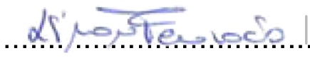 Date 3rd April 2025

PGCert PARTICIPANTS
On completion of the peer observation reports for each module, compose a short reflective paragraph on your observation experiences for inclusion in your portfolio along with the observation sheets.

Appendix C: Observation by Prof Philip Scott

Details of the Observation
Observee | Simona Ferraraccio
Practice Advisor / Expert peer observer | Philip Scott
Date of the Observation | 09/01/2025
Campus / Location | Online
Date, Time, Duration | 1300-1430
Subject Speciality | Digital health
Type of activity | Lecture and group work
This observation will contribute to the participant’s portfolio of evidence to satisfy the assessment of the PGCert tHE and should be undertaken by an experienced academic colleague or professional colleague. Observation by a fellow participant on the programme is not permissible as a means of authenticating practice.

Teaching/Support preparation [A1: Design and plan learning activities/programmes
i.e. Preparation, selection and organisation of content. Choice of teaching/learning methods.

Comments
The lecture and group work were modified versions of last year’s materials.

Teaching [A2: Teach and/or support learning through appropriate approaches and environments.]
i.e. Beginning class, introduction, continuity with other sessions, students’ prior knowledge. Clarity of presentation. Pace. Attitude to the subject matter. Use of appropriate reinforcement. Ending the session – summary, future work etc. Technique and Aids: General apparatus – board, data projector, use of handouts. Was effective communication achieved? Was there good student–teacher rapport? Were the aims/outcomes achieved? Appropriateness of teaching/learning methods.
Comments
Simona introduced the session and described the content for the day. She spoke at a good pace, not so fast that students could not keep up, nor so slow as to lull them to sleep. Simona clearly emphasised the main points and the significance of the topic (transformation in complex environments). The lecture started and ended with a summary of the learning objectives. Plentiful opportunity for student questions was provided. Students seemed happy to come forward, suggesting that a good rapport was achieved.
In my view the learning objectives were achieved for most students, although one or two were distracted by work issues (if attending online from the workplace).

Effective Learning Environments [A4: support and guide learners /V1 Respect individual learners/diverse groups of learners]
i.e General class atmosphere, level of participation, attention, and interest. Student attitude and ability to carry out classwork. Were learning problems identified and overcome? Awareness of individual needs. Attitude to students.
Comments
As above, students were generally well engaged. The group work feedback and discussion showed good participation and application of the topic to their professional roles.

Assessment [A3: Assess and give feedback for learning]
i.e Formative/summative assessment examples , Question and answer technique. Other evaluation procedures, class management, instructions to students005C.
Comments
Questions about coursework were dealt with well and the class was managed effectively.
Core Knowledge
- K1 How learners learn, generally and within specific subjects
- K2 approaches to teaching and or/supporting learning appropriate for subjects and levels of study.
- K3 Critical evaluation as a basis for effective practice.
- K4 Appropriate use of digital technologies / resources.
- K5 requirements for quality assurance, enhancement and implications for practice

Comments
Simona demonstrated knowledge of learning by application (in the group work) and varying approaches to learning (lecture and student discussion). The group work was an example of critical evaluation and the whole online session was an example of good use of technology. The group work also exemplified (by the topic) ways of enhancing services and practice.

Professional values
- V1 Respect for individual learners /diverse groups of learners
- V2 Promote engagement and learning and equity of opportunity for all to reach their potential.
- V3 Use scholarship, research or professional learning, or other evidence informed approaches as the basis of effective practise.
- V4 respond to the wider context in which higher education operates, recognising implications for practice.
- V5 Collaborate with others to enhance practice.
Comments
Simona demonstrated all of these values in the session.

Examples of good practice:
Use of group work to apply formal learning to the professional environment.

Action points:
Sometimes to probe and challenge student comments a little more.
For Observee

Write a short statement to address Area of activity [A5] .Describe how this observation will enhance your practice.
Observer .......Philip Scott........................... Date 08/04/2025

Observee .... ....... Date 09/04/2025

PGCert PARTICIPANTS
On completion of the peer observation reports for each module, compose a short reflective paragraph on your observation experiences for inclusion in your portfolio along with the observation sheets.

Appendix D: Observation of Prof Philip Scott

PGCert tHE OBSERVATION FORM -PSF 2023

Details of the Observation
Observee | Simona Ferraraccio
Practice Advisor / Expert peer observer | Prof Philip Scott
Date of the Observation | 27.03.2025
Campus / Location | Online teaching, MSc
Date, Time, Duration | 27.03.2025, 15:00-17:00, 2 hours
Subject Speciality | Research paradigms and qualitative / mixed methods
Type of activity | Online teaching (Year 2)
This observation will contribute to the participant’s portfolio of evidence to satisfy the assessment of the PGCert tHE and should be undertaken by an experienced academic colleague or professional colleague. Observation by a fellow participant on the programme is not permissible as a means of authenticating practice.

Teaching/Support preparation [A1: Design and plan learning activities/programmes
i.e. Preparation, selection and organisation of content. Choice of teaching/learning methods.

Comments
This lecture focused on qualitative research methods for data collection and analysis. As second-year students are required to select an appropriate data collection methodology for their dissertation project plan, Philip, drawing on feedback from previous cohorts, designed and delivered this session to equip them with the necessary tools for success.
He opened the session with a slide outlining the learning outcomes and clearly stated the main objectives of the lecture. Philip carefully planned the session, using accessible language to ensure clarity for all students. The timing was well-structured, allowing for interaction, student engagement, and short breaks, all within the allocated lecture time.
Teaching [A2: Teach and/or support learning through appropriate approaches and environments.]
i.e. Beginning class, introduction, continuity with other sessions, students’ prior knowledge. Clarity of presentation. Pace. Attitude to the subject matter. Use of appropriate reinforcement. Ending the session – summary, future work etc. Technique and Aids: General apparatus – board, data projector, use of handouts. Was effective communication achieved? Was there good student–teacher rapport? Were the aims/outcomes achieved? Appropriateness of teaching/learning methods.
Comments
Philip demonstrated in-depth expertise in the subject matter, guiding students through the topic from its historical roots to its current applications. His explanations were clear and well-paced, making the content accessible throughout the entire session. The lecture also featured moments of student interaction, during which Philip invited questions and offered clarification. These exchanges were valuable, allowing students to address any uncertainties around qualitative methods, while also enabling Philip to ensure that everyone was keeping up with the material.
Effective Learning Environments [A4: support and guide learners /V1 Respect individual learners/diverse groups of learners]
i.e General class atmosphere, level of participation, attention, and interest. Student attitude and ability to carry out classwork. Were learning problems identified and overcome? Awareness of individual needs. Attitude to students.
Comments
Philip promoted an engaging and interactive classroom atmosphere by incorporating questions throughout his delivery to maintain students' attention and interest. A particularly valuable element of the session was the group activity he organised, which encouraged students to reflect on the material just presented and discuss their proposed methodologies for their dissertations. Although the dissertation is an individual project, this collaborative exercise gave students the opportunity to exchange perspectives and offer constructive feedback, potentially enhancing their own planning process. Following the group work, Philip facilitated an open discussion to address any concerns or issues that had emerged during the activity.
Assessment [A3: Assess and give feedback for learning]
i.e Formative/summative assessment examples , Question and answer technique. Other evaluation procedures, class management, instructions to students005C.
Comments
Although formal assessment was not a central focus of this session, Philip made a point of clearly communicating the expectations for the dissertation project. He provided guidance on how qualitative methods should be integrated and justified within students’ individual research contexts. During and after the session, several students approached him with questions about applying different methodologies to their specific dissertation topics. Philip responded thoughtfully, offering constructive and tailored feedback. He not only helped them refine their methodological choices but also encouraged critical thinking by suggesting alternative approaches when appropriate. This personalised support contributed to a deeper understanding of how to align research design with project goals and demonstrated Philip’s commitment to student success.
Core Knowledge
- K1 How learners learn, generally and within specific subjects
- K2 approaches to teaching and or/supporting learning appropriate for subjects and levels of study.
- K3 Critical evaluation as a basis for effective practice.
- K4 Appropriate use of digital technologies / resources.
- K5 requirements for quality assurance, enhancement and implications for practice

Comments
Philip used a diverse range of teaching strategies to enhance student engagement and learning throughout the session. He began by delivering core content through a well-structured slide presentation, ensuring key concepts were clearly communicated. This was enriched by regular interaction with students, creating opportunities for them to ask questions and seek clarification in real time.
To further deepen understanding, Philip incorporated a collaborative group activity, which encouraged students to reflect on the material and exchange ideas related to their own dissertation methodology plans. This peer interaction not only promoted active learning but also fostered a supportive environment where students could challenge and build on each other’s perspectives.
Following the group work, Philip facilitated a whole-class discussion, offering feedback tailored to the needs that emerged from group conversations. This blended approach, combining visual aids, direct instruction, dialogue, collaboration, and feedback, ensured that students were not only absorbing information but also actively engaging with it in ways that supported their academic development.
Professional values
- V1 Respect for individual learners /diverse groups of learners
- V2 Promote engagement and learning and equity of opportunity for all to reach their potential.
- V3 Use scholarship, research or professional learning, or other evidence informed approaches as the basis of effective practise.
- V4 respond to the wider context in which higher education operates, recognising implications for practice.
- V5 Collaborate with others to enhance practice.
Comments
Philip actively promoted student engagement throughout the session. He provided a range of examples to ground the theoretical content in real-world healthcare contexts, and encouraged students to contribute their own examples based on their professional experiences. This approach not only made the material more relatable but also promoted deeper reflection and discussion. Philip responded to each student question thoughtfully, tailoring his feedback to align with individual needs and dissertation topics, thereby ensuring that his guidance was both relevant and practical.
Examples of good practice:
- Effective use of technology, it was an online lecture delivered through Teams so the use of breakout rooms was essential to allow group work.
- Allowing time for individual student support
- Excellent organisation of the session in terms of content and timing
Action points:
- Consider adding more textual elements to the slides, as several currently rely solely on visuals. Including a few key terms or phrases would help students better understand and recall the content when reviewing the material independently.
Observer  Date 23.04.2025

Observee ......... Philip Scott............. Date 24.04.2025

Appendix E: Micro-teaching Presentation slides and lesson plan

Lesson plan and outline: prior to prepare and deliver the power-point presentation for the micro-teaching session, I developed the following lesson plan.
Introduction (~ 1 minute)
- Brief greeting and overview
- Quick warm-up: give students few mins for answering the question using the QR-code
The Fibonacci Sequence (~ 4 minutes)
- Introduce the historical rabbit problem mentioning some historical origins of the Fibonacci sequence
- Display and explain the recursive formula and show how Fibonacci obtained the sequence: 1, 1, 2, 3, 5, 8...
Fibonacci and the Golden Ratio (~ 4 minutes)
- Explain how the ratio between terms approaches 1.618
- Show visuals and how to obtain them: Fibonacci spiral, golden rectangle
- Brief mention of where the golden ratio appears
Wrap-up (~ 1 minute)
- Key takeaway, summary of the main points of the session
- Offer a thought: ask students to look for Fibonacci in the environment around them and to have a look at more detailed information in the reference provided.

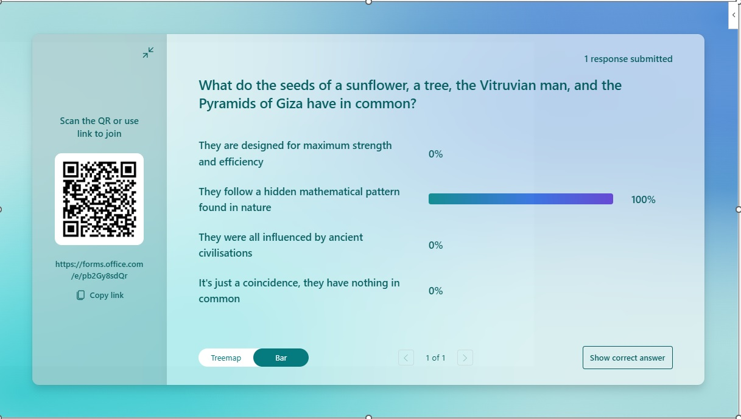


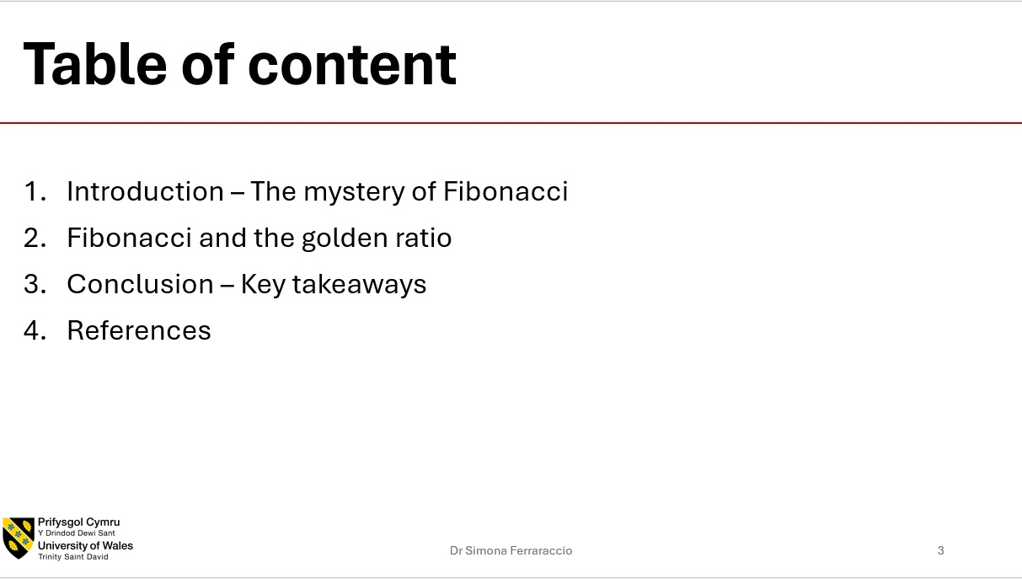

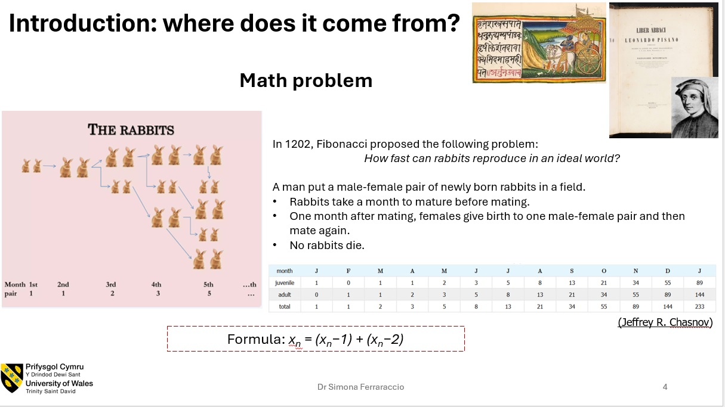
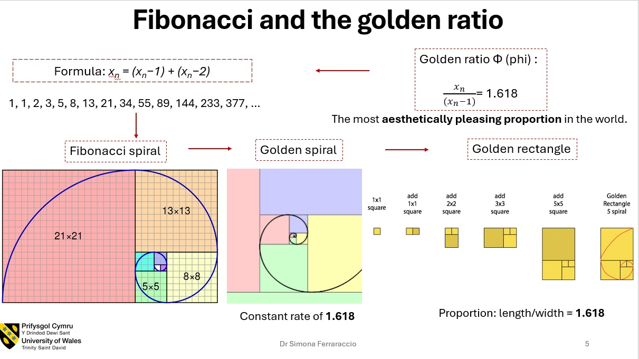

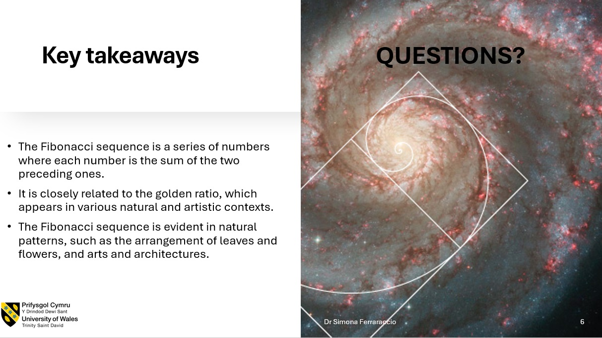
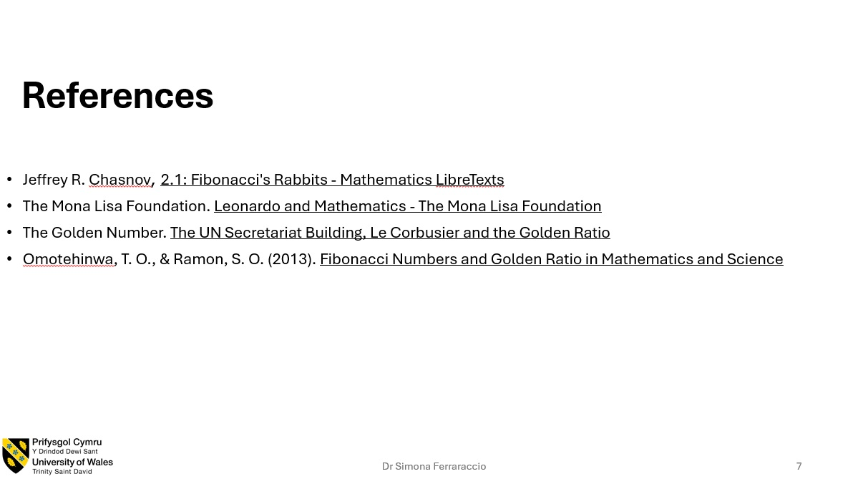
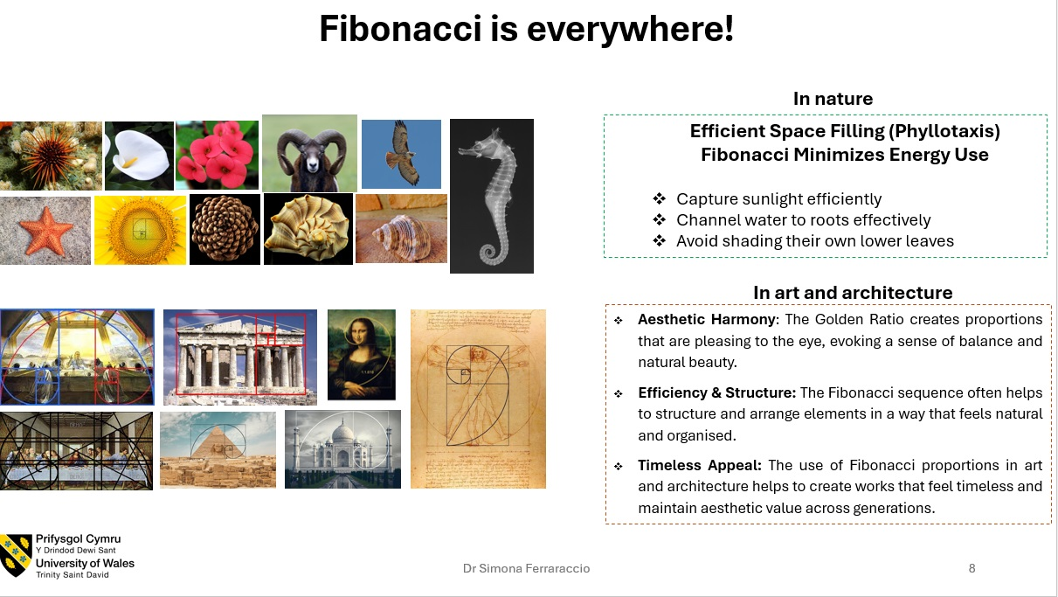

Appendix F: Micro-teaching recording and feedback

Recording of the micro-teaching session is available at this link: Simona Ferraraccio Micro-teaching session recording.
The recording contains the 10 mins presentation and the peers’ feedback discussion. The peers who participated to my micro-teaching session and shared their feedback at the end of the session where the Academic Director Digital Health and Care Kalee Thomas and the lecturer in Digital Health and Care Jonathan Wyatt.

