Module Code: BMMB7005 / BMMB7005D
Module Title: Finance for Business Managers
Executive Summary

Table of Contents
Part 1: Financial Performance Analysis (Shell Plc) 3
Introduction to Shell Plc 3
Methodological Approach to Financial Performance Evaluation 3
Scope and Limitations of Ratio Analysis 4
Ratio Calculations & Graphical Representation 4
Part 2: Capital Investment Appraisal (Westward Plc) 6
Introduction to the Investment Decision at Westward Plc 6
Investment Appraisal Methodology and Analytical Framework 6
Investment Appraisal Calculation 7
Summary 7
Refereences 8

Part 1: Financial Performance Analysis (Shell Plc)

Introduction to Shell Plc
Shell Plc is a multinational energy company that engages in significant activities in the upstream, downstream, integrated gas and renewable energy sectors. The organisation operates in a high capital intensity, volatile price, and escalating regulatory controls with regard to sustainability turnover in the industry. These features of the industry render financial performance analysis especially significant in assessing the efficiency of the managers and the strategy strengths. In this report, the financial performance of Shell Plc in the past two years will be evaluated based on the published annual report data. This analysis aims to discuss the effectiveness with which the company has been able to generate returns, financial risk management, and operational stability in a time of economic and energy market uncertainty. According to the recent academic and professional literature, systematic analysis of finance is essential when the industry is capital-intensive and when structural change and macroeconomic pressure occur (PwC, 2023). This report will evaluate the financial position and performance of Shell Plc proficiently by analysing the key financial ratios, and this analysis will form a framework for informed managerial recommendations and strategic insight.

Methodological Approach to Financial Performance Evaluation
Financial performance measurement is a systematic approach to measuring the financial results of a firm using quantitative measures based on published financial reports. In this report, ratio analysis has been used as the primary method of analysis since it is widely accepted in financial decision-making and managerial evaluation situations. Ratio analysis allows one to compare performance on a time basis and facilitates the identification of trends in relation to profitability, liquidity, efficiency and financial risk. The financial information applied in the course of the analysis is a publicly reported annual report of Shell Plc, which guarantees the transparency and credibility of the source information. Modern accounting studies emphasise the use of ratio analysis as an effective diagnostic instrument in assessing a big, publicly traded organisation that has to operate in a complicated international setting (Atrill McLaney, 2022). The use of ratio analysis in the given report enables systematic analysis of the financial performance, which is in favour of descriptive evaluation and critical evaluation. The given approach to the methodology guarantees the consistency of financial outcomes analysis, which would create a strong platform to depend on, providing further interpretation and developing recommendations.

Scope and Limitations of Ratio Analysis
Although ratio analysis gives significant information regarding financial performance, it should not be used in isolation but instead interpreted critically and in the context of the information. The ratios are based on past accounting data, hence showing the past and not future financial performance. This attribute is essential in sectors like energy, where the externalities, such as commodity price movements and regulations, will have a significant impact on the financial performance. These limitations have been recognised in the analysis of this report, and the application of ratios across two accounting periods has been made to bring forth more interpretive depth. Recent sources of literature on financial reporting emphasise that ratios may not be analysed separately since accounting policy decisions and the macroeconomic environment may mask the observed trends in performance (Deloitte, 2024). To this end, the ratios have been interpreted collectively in this report, and the findings have been correlated in relation to profitability, liquidity, efficiency, and gearing. It is a matter of combined value that reinforces the analytic worth of ratio analysis and classifies a more equitable evaluation of the overall financial management performance of Shell Plc.

Ratio Calculations & Graphical Representation
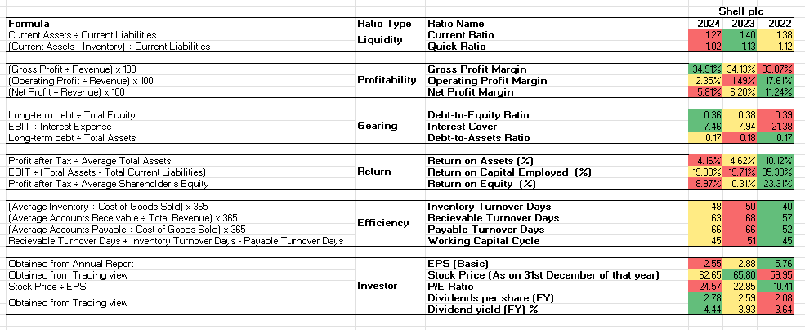
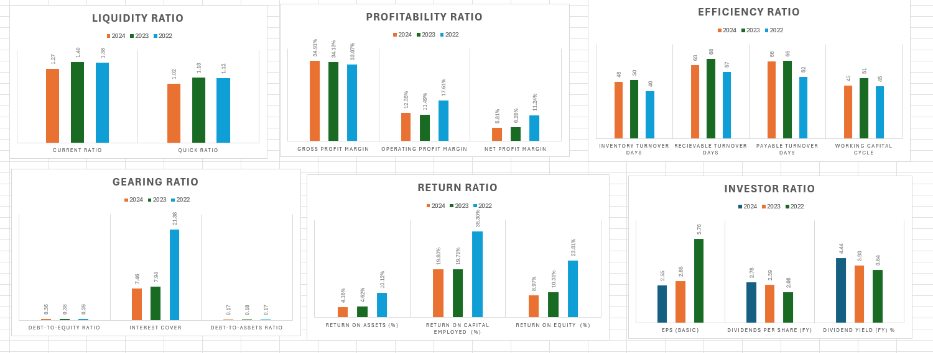


Part 2: Capital Investment Appraisal (Westward Plc)

Introduction to the Investment Decision at Westward Plc
The process of capital investment decisions is one of the highly significant financial management issues, as the capital commitment of resources is involved, together with the determination of the future working capacity. Westward Plc is a company that produces high-quality curtains and is in the process of considering three strategic investment tasks that can help to increase the business operations within a 4-year planning period. These are the expansion of its retailing point, the creation of internet stores to sell to people and the creation of wooden and Roman blinds. All solutions vary in terms of magnitude, the risk picture, and likely cash flow production that needs a thorough financial assessment to help make wise choices. This section aims to evaluate whether or not Westward Plc needs to go on with either of the suggested projects or look into other avenues of investment. The recent literature on corporate finance focuses on the fact that when comparing mutually exclusive projects, the tools of structured investment appraisal are necessarily applied to these types of projects, especially in situations where capital resources are limited, and long-term value generation is the main objective (ACCA, 2022). This analysis is therefore aimed at analysing the financial feasibility of the proposed projects and determining the one that will best further the shareholder value maximisation.

Investment Appraisal Methodology and Analytical Framework
Investment appraisal means the use of financial analysis methodologies that are employed in determining the suitability and viability of capital expenditure initiatives. The discounted cash flow techniques are used as the primary analytical tool of the current report, with a specific focus on the Net Present Value. Net Present Value calculates the worth of projects by discounting future use of cash that is likely to be received at the cost of capital of the firm, thus combining the time value of money and riskiness of an investment. Taxation and capital allowance in analysis have been used in order to make cash flows realistic and assess the post-tax cash flows. Modern finance studies emphasise the use of Net Present Value as the most theoretically sound evaluation approach since it is a direct measure of the anticipated addition of a project to the value of the firm (Brealey, Myers and Allen, 2023). The Internal Rate of Return and Payback methods are also used in conjunction with Net Present Value to ensure the provision of additional information regarding the performance of the project and managerial decision preferences. This methodological approach enables a comprehensive and balanced evaluation of the proposed investments, supporting rational capital allocation decisions.

Investment Appraisal Calculation
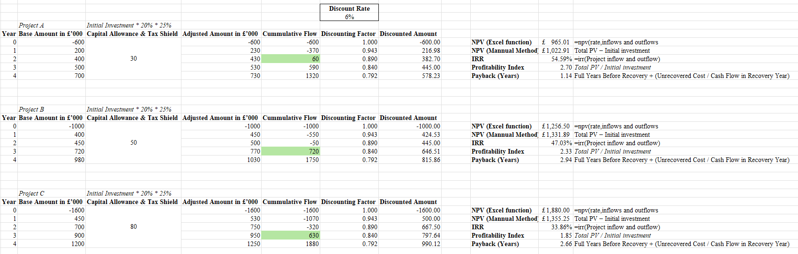

Summary
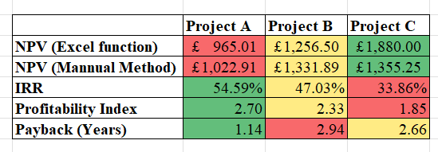

Refereences

