Synthesize a Solution to a Potential Real-life Scenario

Joseff Thomas
Digital Degree Apprenticeship
School of Applied Computing
Date of submission 22nd of April 2021

Contents
1 Introduction 2
2 Static & Live Forensics 2
3 Forensic tools 3
3.1 Forensic Imaging & Write Blockers tools 3
3.2 Data Recovery & Digital forensic Analysis Tools 6
3.3 Network analysis tool 8
3.4 Windows Registry analysis tool 8
3.5 Volatile Memory forensics 9
3.6 Mobile Forensic Tool 10
3.7 Forensic Tool Comparison Table 11
4 Case Study 13
4.1 CEC Mobile Manufacturing Employee Incident Forensic Investigation 13
4.2 Identification stage 14
4.3 Collection Stage 14
4.4 Examination Stage 15
4.5 Presentation stage 22
5 Invoice 23
6 Conclusion 23
7 References 24
8 Appendix 27
8.1 Invoice 27

Introduction

For a forensic investigator to be able to perform their duties effectively, they must utilise computer forensic tools. There are many forensic tools on the market available to investigators which are closed source (paid software) and free open-source software. The report will discuss several types of forensic tools that are used in a forensic investigation, and how they are used to gather evidence for a digital forensic investigation. There will also be an example of the use of forensic methodology, which notes the tools used in a forensic investigation performed at a company that had encountered internal sabotage of a new mobile phone design. There will be in-depth step by step guide on how the forensic investigator acquired evidence and recovered the designs for the company.

Static & Live Forensics

There are two types of data acquisition that can be performed by forensic tools, static and live forensics as discussed by Sasa Mrdovic, Alvin Huseinovic & Ernedin Zajko in their paper “Combining Static and Live Digital Forensic Analysis in Virtual Environment” [1]. The long-established method of data acquisition would be to acquire data using forensic tools that recover static data which remain on the storage device after the power is turned off. This method is discussed by Mamoona Rafique & M.N.A. -Khan in their journal article “Exploring Static and Live Digital Forensics: Methods, Practices and Tools” [2].
Live forensic is a new type of digital forensic analysis when compared to static forensics. A quote from Eric Conrad, Seth Misenar and Joshua Feldman Certified Information Systems Security Professional book “CISSP Study Guide” [3],
“Although forensics investigators traditionally removed power from a system, the typical approach now is to gather volatile data. Acquiring volatile data is called live forensics, as opposed to the post-mortem forensics associated with acquiring a binary disk image from a powered-down system.”

Live forensics acquires and analyses potential evidence whilst the suspected device is still turned on, as discussed by Rafique and Khan’s journal article. Live forensic tools can provide the investigator with a clear picture of the incident that could be taking place which static analysis would not be able to capture. Rafique & Khan further discuss that live analysis can produce forensic evidence or provide activities performed by the suspect, even if the crime is being performed remotely or at the location of the device.

Forensic tools

Forensic Imaging & Write Blockers tools

When performing the data acquisition on a suspected storage device it is critical that the correct forensic method is used to create a duplicate copy of data, so if used as evidence in court, it is legally accepted as explained by Larry E Daniel & Lars E. chapter 4 “Summary of Best Practices” in their book “Digital Forensics for Legal Professionals” [4].
J Sammons chapter 13 on ‘Digital Forensic’ in Timothy Shimeall & Jonathan Spring’s book ‘Introduction to Information Security’ [5] discusses that the Forensic imaging tool creates a forensic image of a local hard drive, network drive, or other storage devices. This will allow the investigator to analyse the seized data for any evidence, without contamination or modification of the evidence when recovery/tagging evidence during the analysing process.
The forensic image creates an exact bit stream image of the entire hard drive, including all its files, folder structured information, hidden and residual data such as slack space and deleted files. To further explain on why binary image is preferred by forensic investigators, see section from Conrad, Misenar & Feldman chapter 8 “Domain 7: Security Operations (e.g., Foundational Concepts, Investigations, Incident Management, Disaster Recovery)” regarding the four basic types of disk-based forensic data.
“Allocated space—portions of a disk partition that are marked as actively containing data.
Unallocated space—portions of a disk partition that do not contain active data. This includes portions that have never been allocated, and previously allocated portions that have been marked unallocated. If a file is deleted, the portions of the disk that held the deleted file are marked as unallocated and made available for use.
Slack space—data is stored in specific size chunks known as clusters (clusters are sometimes also referred to as sectors or blocks). A cluster is the minimum size that can be allocated by a file system. If a particular file, or final portion of a file, does not require the use of the entire cluster then some extra space will exist within the cluster. This leftover space is known as slack space: it may contain old data, or can be used intentionally by attackers to hide information.
“Bad” blocks/clusters/sectors—hard disks routinely end up with sectors that cannot be read due to some physical defect. The sectors marked as bad will be ignored by the operating system since no data could be read in those defective portions. Attackers could intentionally mark sectors or clusters as being bad in order to hide data within this portion of the disk.”

In Daniel & Daniel “Summary of Best Practices” chapter 4, explains that using the forensic method to duplicate the seized storage device so the integrity and authenticity of the duplicate data can be assured. To ensure that the forensic image is identical to the original hard drive, Daniel & Daniel explains that the forensic imaging software matches a hash value of the forensic image to the original data to ensure no data has been modified during the imaging process. The most common hash value calculations used by forensic tools are Message Digest 5 (MD5) and Secure Hash Algorithm (SHA-1). For example, AccessData FTK Imager provides confirmation of both hash values to the user after completing the imaging process [6].
Image from Daniel & Daniel book provides an example of hash value function [4].
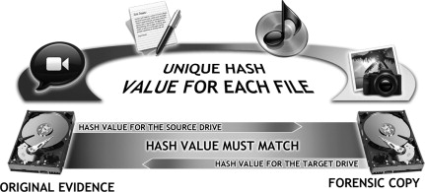
Figure 1

As discussed by Enos K. Mabuto & H Venter report “State of the Art of Digital Forensic Techniques” [7] and Daniel, part of the forensic method of protecting the original data from being modified during the data acquisition requires the use of write blockers. This is essential, as modification of the original data will contaminate the evidence, which will result in the forensic investigation being not legally accepted in court.
There are two types of write blocker that the forensic investigator can utilise; software & hardware write blockers. A hardware version of a write blocker is connected to the storage device which is the source, and acts as a bridge to connect the storage device where the duplicate data will be written too. The write blocker only reads the source disk and writes/reads to the target disk, as shown below by the image from Daniel & Daniel book [4].
Figure 2

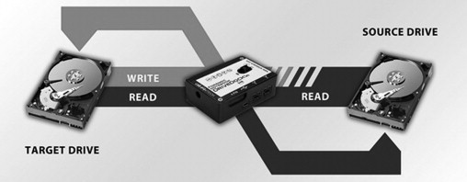
Daniel & Daniel explain that the best method of making a forensic copy is by removing the hard drive from the computer and connecting to the write blocker, then use a standalone computer with forensic imaging software to create the forensic image. The forensic imaging software will also use a hash value write blockers, which can be used to duplicate data if the storage is not able to be removed from the targeted device such as FastBloc SE Acquisitions. This works with EnCase forensic software and FTK & FTK Imager which have built in software write blockers when performing the forensic image.
To ensure that the forensic image is the exact copy of the original data, the integrity of image needs to be checked against the original source. As quoted from Daniel & Daniel’s chapter “Summary of Best Practices” [4]:
“Forensic duplication tools automatically create a “verification” hash for the original and the copy during the duplication process. If these hash values do not match, there is an opening for a challenge to the authenticity of the evidence as compared to the original.”
The imaging tool can create the forensic image in either EnCase evidence file (E01) or EnCase Logical Evidence file (LX01), AccessData FTK Content Image (AD1) or raw (DD) are some of the common forensic image formats that are used, as explained by Sammons chapter 4 “Collecting evidence” in the book “The Basics of Digital Forensics (Second Edition)” [8].
According to Daniel & Daniel, “What to Expect from an Expert”, chapter 10 in their book “Digital Forensics for Legal Professionals” [9] a forensic copy should be made using standard forensic collection tools provides such as FTK Imager, Tableau & EnCase with the forensic image format being either E01, L01, AD1 or DD. The hash value should be done in one or both formats of MD5 and SHA1.

Data Recovery & Digital forensic Analysis Tools

Once the forensic image has been created, forensic analysis tools are used to identify any relevant evidence that is connected to the case. Part of this would be to recover any evidence that could be corrupt, lost, or deleted from the suspected drive.
Forensic analysis tools can import a number of image formats such as in LX01, raw (DD) and E01 for forensic analysis, however, EnCase evidence format is the most common used image file format in digital forensic investigation as mentioned in Karen Schuler, Cathleen P. Peterson & Eva Vincze book” E-discovery: Creating and Managing an Enterprise wide Program”, “Defensible Data Collection Techniques in the Enterprise” [10].
Once the forensic image has been ingested by the forensic analysis tool, it will begin analysing and extracting the data in Allocated space, unallocated space, Slack space, and “Bad” blocks/clusters/sectors. Once the forensic evidence has been imported and analysed, the forensic tool will provide a view of the entire in a tree structure of the disk, allowing the investigator to enter each section that has been extracted to begin the examination to identify evidence as shown in the example figure 1 screenshot from the test lab in FTK forensic software.
Figure 3
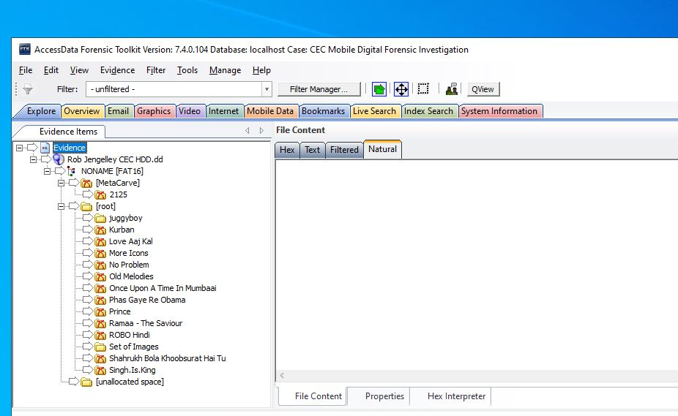
Forensic analysis tool will extract all different types of files and recover deleted files from the bit stream image such as files, emails, videos, images, internet browsing history as discussed in Sriram Raghavan “Digital forensic research: current state of the art” article in CSI Transactions on ICT [11]. Also, Raghavan states, the forensic analysis tools will extract corrupt files, build the Windows events & registry log, system files, data carve and metadata and provided in an easily readable to the forensic investigator. Raghavan also states that digital evidence for a user encompasses “user data, metadata associated with user data, activity logs and if possible, systems logs”.
The investigator can search through the extracted data, so that the investigator can search, filter, and report on all the digital data extracted and the investigator can tag evidence to be added to a list for further examination.
Forensic analysis software such as X-Ways Forensics, Autopsy/Sleuth Kit, EnCase, Belkasoft Evidence Center X and AccessDATA forensic Toolkit (FTK) can perform these types of analysis and data extraction and collate the findings of the investigation into a report.

Network analysis tool

Network forensics consist of examining active network traffic, which can be used by cyber security to detect network intrusion as discussed Conrad, Misenar Feldman book [3]. Network forensics tools can also be used to recover e-emails, web history, file transfers and instant message (IM) conversation history form network equipment by reconstructing the network protocol data as discussed in the Sammons chapter. This also aids the forensic investigator to build a picture from the evidence recovered by using network analysis tools.

Network forensic tools such as Xplico [12] and Wireshark [13] can extract application data from network traffic such as POP, IMAP or SMTP traffic, extract email messages as explained on H011 Digital Forenics article “The Best Open-Source Digital Forensic Tools” [14]. WireShark

Windows Registry analysis tool

A forensic investigator can gain a lot of information from the Windows registry of a seized computer or laptop as studied in Harlan Carvey a computer security engineers article “The Windows Registry as a forensic resource” [15]. Carvey explains that Windows registry can provide a picture of the user’s activity; for example, the registry holds user settings in the NTUSER.DAT file and when the registry creates a log of this. The investigator can retrieve network settings such as IP address from the following registry key “e HKEY_CURRENT_USER hive is created from the HKEY_USERS\SID” to connect the suspected user to a certain IP address.
There are forensic tools that can capture and analyse the Windows registry of a computer over the course of the entire Windows devices history, as discussed in Howard’s article [16]. Forensic tools such as Registry Recon can analyses the Windows registries. The application can parse the registry of what has existed on the Windows device and provides insight into how the registry has changed over time. Also, it can retrieve registry data that has been deleted by normal system activity, re-imaging or maliciously as described by Arsenal Recon, developers of Registry Recon [17].
Autopsy/Sleuth also has a registry analysis tool as part of the forensic toolkit. As part of the Autopsy package, it includes RegRipper software to which analyses Windows Registry and looks for documents and USB devices access [18].
AccessData’s FTK, EnCase, Belkasoft Evidence Center X and X-ways also has a built in registry forensic tool that can retrieve and analyse as part of their toolkit, as discussed on FTK [19], X-ways [20], BELKASOFT [21] product page & EnCase’s documentation [22].
Windows registry analysis tools provide the extract registry and provide the information to the investigator in a readable format that can be searched, filtered, and added to a report.

Volatile Memory forensics

Volatile memory forensic requires live acquisition of the data whilst the suspected device is still powered on, so the memory is not deleted when the power of the device is switched off as explained in Mrdovic, Huseinovic & Zajko paper [1]. This means an investigator could unwittingly delete evidence by turning the device off, . In that incidences it would be advisable to either perform the investigation on site if this type of forensic investigation is required or to place the machine into hibernation as most operating systems (OS) save the current state of the machine including the system memory to the local hard drive, while the device conservers power as further explained in Mrdovic, Huseinovic & Zajko’s paper.
Belkasoft product page for Belkasoft Live RAM Capturer tool [23] can extract memory dumps during the acquisition process, as memory dumps contain valuable evidence such as passwords to encrypted volumes such as TrueCrypt, BitLocker & PGP Disk, or account login credentials for many webmail and social network services.
Furthermore, Daniel & Daniel’s chapter “Summary of Best Practice” [4] explains that it is crucial to recover a password, and that the only way to recover a password is to remove the encryption file or encryption portion of a hard drive, and to do this from the system memory or RAM whilst the device is still turned on.
In addition, Belkasoft states that to be able to bypass active anti debugging and anti-dumping protection is a computer is running these systems which some volatile memory tools are not able to do. Manget Ram Capture is another forensic tool that can retrieve usernames and passwords, decrypted files & keys that are not stored on the local hard drive, as explained on Manget Ram Capture product page [24].
Other memory forensic tools such as Volatility [25] can capture data that has been stored on random-access memory (RAM) sticks in a forensic manner, so the information is useful to the forensic investigator and the data has integrity which Poston discusses in his article [16]. Sleuth Kit is another forensic tool which can capture volatile memory during a forensic investigation [26].

Mobile Forensic Tool

Data from Police Scotland in February 2020 showed a backlog of cases of around 1200 in relation to digital forensic analysis of mobile and computer devices, of which 90% were mobile devices as discussed by Scottish Police Authority report “Digital Forensics Working Group Report” [27]. Using forensic analysis, the law enforcement or private forensic investigator can retrieve a large amount of data from a seized phone, as explained and shown in the list of data noted by Ritika Lohiya, Pooja Shah and Priya John in their collaborative article “Survey on Mobile Forensics” in “International Journal of Computer Applications” [28].

- “Date/time, language, and other settings
- Phonebook/Contact information
- Calendar information
- Text messages
- Outgoing, incoming, and missed call logs
- Electronic mail
- Photos
- Audio and video recordings
- Multi-media messages
- Instant messaging
- Web browsing activities
- Electronic documents
- Social media related data
- Application related data
- Location information
- Geo location data
- Subscriber and equipment identifiers”

Software such as Belkasoft Evidence Center X and Autopsy can do forensic analysis for mobile devices to search for documents, system files, web browsing, and social media chat logs, and web history. These scenarios are discussed on their Autopsy [18] & Belkasoft product page [21]. AccessDATA forensic Toolkit (FTK) can provide analyse mobile data for social chat application such as WhatsApp and Facebook, which is described on their product page [19] .

Forensic Tool Comparison Table
 | X-Ways  Forensics [20] | FTK [19] | FTK Imager [6] | Belkasoft Evidence Center X /Live Ram Capture [21] [23] | Autopsy/Sleuth Kit [26] | EnCase Forensics [22] | Arensal Registry Recon [17] | Xplico [12] | Volatility [25] | Wireshark [13] | Manget Ram Capture [24]
Static or Live Forensic | Static | Static | Static | Both | Static | Static | Static | Both | Live | Both | Live
Disk imaging | Yes | Yes | Yes | Yes | Yes | Yes | No | No | No | No | No
Forensic Analysis | Yes | Yes |  | Yes | Yes | Yes | No | No | No |  | No
Data recovery | Yes | Yes | Yes | Yes | Yes | Yes | No | No | No | No | No
Registry Viewer | Yes | Yes |  | Yes | Yes | Yes | Yes | No | No | No | No
Volatile Memory | No | No | No | Yes | No | No | No | Yes | Yes | No | Yes
Hash Value function | Yes | Yes | Yes | Yes | Yes | Yes | No | No | No | No | No
Network Forensics | No | No | No | No |  |  | No | No | No | Yes | No
Operating system | Windows | Windows | Windows | Windows/Linux/mac | Windows/Linux | Windows | Widows | Linux | Windows/Linux/  mac | Windows/Linux/  mac | Windows
Open source/closed source | Closed | Closed | Open source | Closed(Live Ram Capture standalone is free) | Open source | Closed | Closed | Open source | Open source | Open source | Open source

Case Study

CEC Mobile Manufacturing Employee Incident Forensic Investigation

Barry Lynch, forensic investigator conducted a digital forensic investigation at CEC Mobile Manufacturing company located in Swansea, Wales, UK.
Before arriving at CEC headquarters to investigate the potential crime, a forensic toolkit was prepared, which was essential to complete the investigation. The forensic toolkit consists of the below.
- Standalone computer
- New blank Solid-state drives (SSD, CDs/DVDs and external storage
- Camera
- Screwdriver set & Allen Keys
- Pack of labels, Pens & marker pens.
- Anti-static bags
- Write blocker & cables (Sata, ethernet, IDE etc)
- AccessData FTK & FTK Imager Software

Once Lynch arrived at CEC Mobile to begin the investigation, a mobile lab was setup at CEC headquarter. This involved a restricted room with access only allowed for the investigator.
The investigator followed the forensic model ‘Digital Forensics Research Workshop’ to perform the investigation which consisted of the following steps and which were laid out by Karen Schuler, Cathleen P. Peterson & Eva Vincze in their chapter “Defensible Data Collection Techniques in the Enterprise” in “E-discovery: Creating and Managing an Enterprisewide Program” book [10].
- Identification
- Preservation
- Collection
- Examination
- Analysis
- Presentation

Identification stage

Once the computer was delivered to the mobile forensic lab by the IT department, the identification & preservation stage began. This involved identifying the workstation that was used by the suspected employee Rob Jengelley. The workstation asset & serial number was noted in the chain of custody document for evidence tagging. The workstation internal storage was removed, and the serial number was also noted for the evidence trail. Photographs of the workstation and hard drive was taken for the chain of custody and tagged.
The chain of custody showed the roadmap on how the evidence was collected, analysed, and preserved, and legally acceptable as discussed in Sammons chapter “The digital forensics process” [29]. Preservation stage
The internal storage device was then connected to the write-blocker a tableau forensic portable write-blocker, so that the original data stored on the internal storage was not modified during the data acquisition process.
Once both forensic images were created, the internal workstation hard drive and one of the forensic images stored on an SSD was sealed in an anti-static bag in the presence of CEC CEO Dee Rod & CEC lawyers. Both storage devices were then stored in an evidence locker.
The reason for two forensic images is that one of the images will be a master copy. This is created if the evidence is challenged in court, and the courts provide instructions for the evidence to be re-examined as noted by J Sammons in chapter 13 of ‘Digital Forensic’ in Timothy Shimeall & Jonathan Spring book ‘Introduction to Information Security’ [5].

Collection Stage

During the collection stage, the data on the workstation hard drive was acquired in the pre-approved method that was planned before performing the procedure. An FTK Imager was used to perform the forensic imaging and verify the hash value of the duplicate copies to ensure it matched the workstation hard drive using MD5 & SHA1. The format of the images that were created used E01 (Encase evidence file) format following industry standards.
After the imaging process was completed, the FTK imager provided a log of the data acquired, which was saved on to the same file directory as the forensic images in a text format. The log provided details of the drive, checks sums, evidence information and started & finish dates/times of when the data acquisition occurred.

Examination Stage

A new case was setup in AccessData FTK software to perform the investigation. After entering the relevant information for the new case, the forensic image was imported into FTK as shown in the figure 4 screenshot below. The forensic tool started the examination and analysis process. As it was critical that the investigation was performed in a prompt manner and essential that no evidence was overlooked, a custom evidence processing profile was selected based on the investigation requirements. The forensic processing profile could have been chosen but this would have increased the analysis time considerable as its analysis information from a wide scope, as discussed on AccessData FTK “Optimizing Your Processing Option” video guide [30].
Figure 4
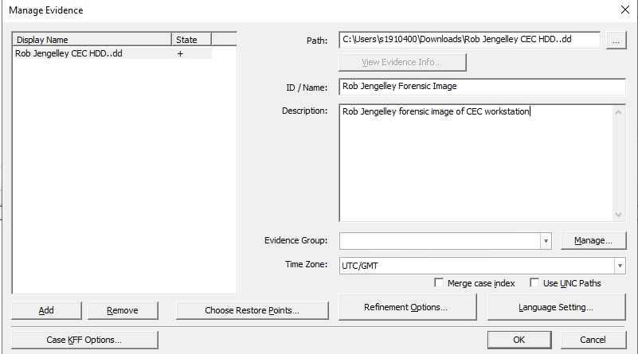

As shown in the screenshot below, a custom-made profile for called ‘CEC investigation’ was created with the selected evidence processing options.
Figure 5
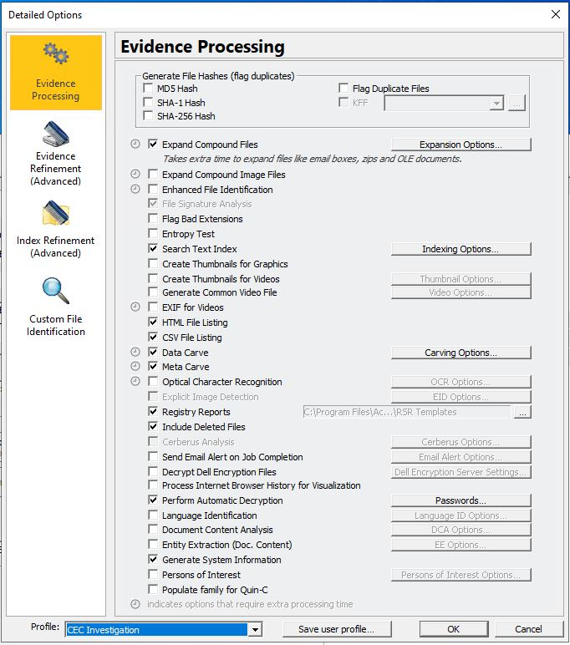

Data Carve allowed for analysis of files signatures to locate the lost or deleted files. The pre-defined formats that AutoDesk Maya supports are .BMP, .GIF, .JPG and .PNG as explained on AccessData FTK V7 user guide [19]. A custom Carver was setup, so that additional file formats that Maya used which is not included in the Data Carve build can be included in the search. These additional file formats not included by default are .ALS, .AVI, .CIN, .DDS, .EPS, .IFF, .PSD, .YUV, .RLA, .SGI, PIC, TGA & TIF.
Meta Carve was used to retrieve the deleted directory entries that provided useful information on when the files were deleted from the file fragments recovered during the analysis. The Meta Carve recovered the modification, access & change (MAC) times of the metadata files which will assist in building a picture of the incident. For more in-depth analysis on MAC times see Daniel & Daniel’s Chapter 30 “Computer Time Artifacts (MAC Times)” in their “Digital Forensics for Legal Professionals” [31].
The ‘Expand Compound Files’ option was selected so that any zip files or emails are opened automatically and processed. This was done to find if the suspect had deleted a zipped folder of the evidence after transferring it off the workstation.
Also, part of the evidence processing options was ‘include deleted files’. This option allowed for recovery of any files that had been deleted. To increase the scope of the search for evidence, the evidence refinement (advanced) options was selected to include file slack and free space processing options as shown in figure 6 screenshot. with and processing time & date that were refined to start from when the employee started to work on the new design for CEC as shown in figure 7 screenshot. This will remove any unnecessary file search and reduced the examination time of the investigation.

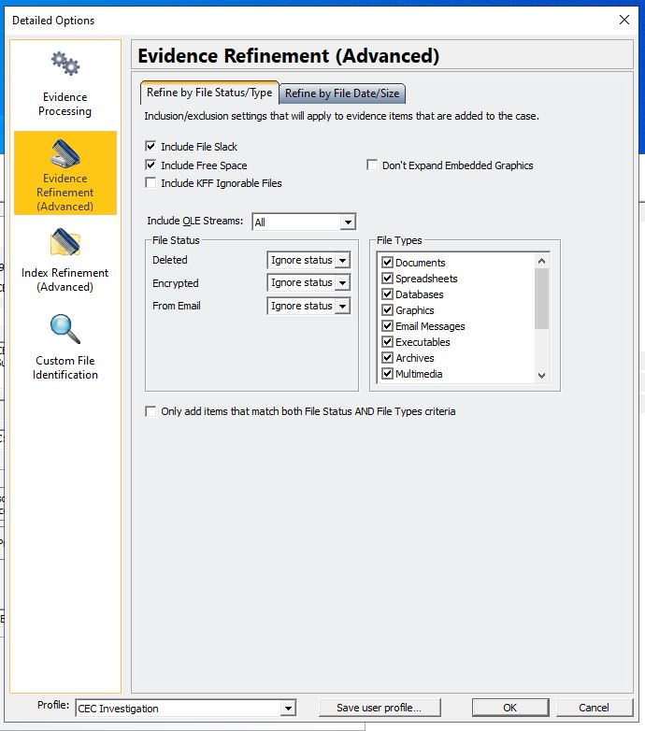
Figure 6

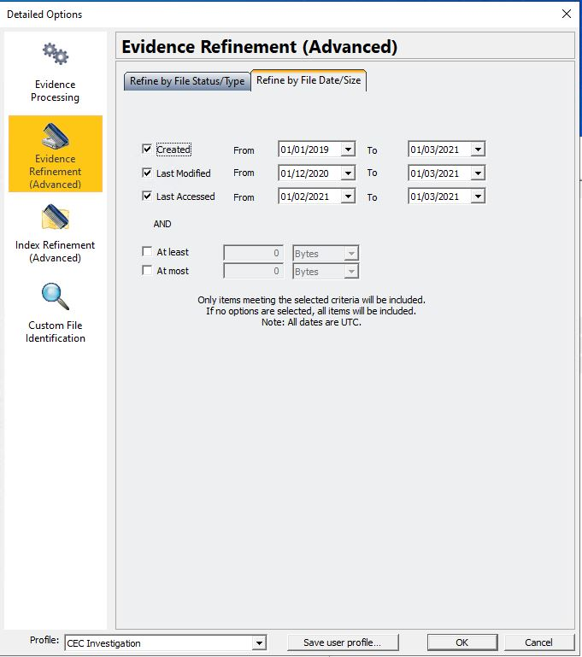
Figure 7
Advanced index refinement option was used to configure the search index option when searching the workstation disk for the deleted design files & other evidence as shown in figure 8 screenshot. Also, the & date that were refined to also start as the same as the evidence refinement settings to reduce the time when analysis as shown in figure 9 screenshot.

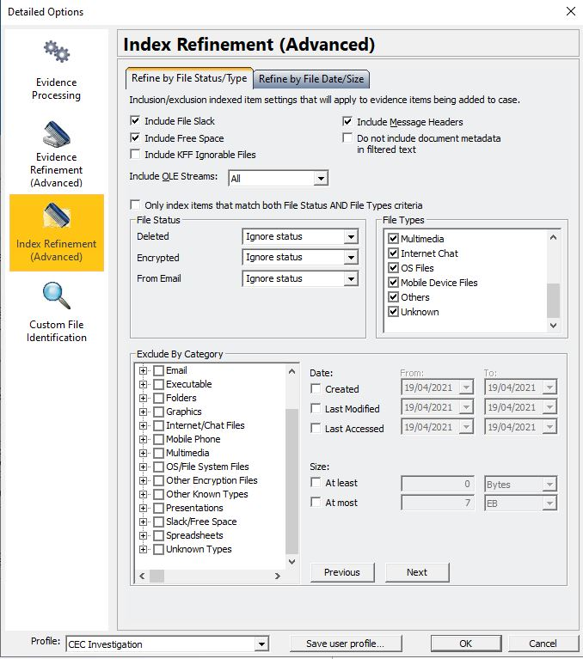
Figure 8

Figure 9

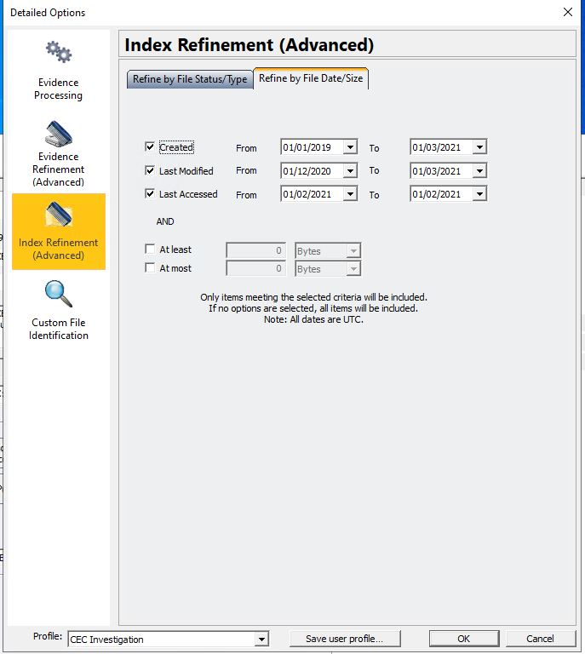

The user interface within FTK has several tabs that allow for quick examination of the different types of extracted data as shown in the figure 10 screenshot from the test lab.
Figure 10

Search index search tab was used to assist in recovering the deleted files. Using the metadata & data carve assisted in the extraction and filtering of the data. Even though search index searches increase the pre-processing time it saves time further in the investigation, when searching for specific file names, formats of files from a configured data carving process to locate the deleted files as explained in FTK video guide [30] .
The reason ‘Create Email Threads’ was selected in the processing option is to recover email thread conversation. Using FTK email tab, it allowed a search through the recovered email threads for evidence of sabotage in an efficient manner.
FTK allowed for searching of Windows registry logs, and Windows event showed that the employee had deleted files that matched the modification of the MAC times from the recovered files and the connection of USB device by using the FTK registry report.
The evidence was exported to a location on the standalone machine for further analysis. The CEO of CEC confirmed that these were the designs that had been deleted by the employee. Once the confirmation was received, a backup of the design file was done and transferred over to CEC to be stored on their file servers.

Presentation stage

The presentation stage required a report to be produced for the client CEC to conclude the investigation. The forensic report was written in a clear, precise and accurate manner, that explain what was analysed, what tool were utilised to perform the investigation, method used to verify data, the processes used to recover an extract the data and the result of the forensic investigation as explained in Daniel & Daniel chapter 2 “Overview of Digital Forensic” in their book “Digital Forensics for Legal Professionals” [32].
The report also included a statement from the examiner regarding what evidence was recovered from the workstation hard drive, a copy of the recovered design files to support the findings in the report. The report was exported in English (United States) language and in PDF format at the request of CEC. An example of a generated forensic report is provided alongside this assignment.

Invoice

An invoice was sent to CEC for the digital investigation work that has been completed. The invoice included the amount of hours that was required to complete the investigation, cost of recovering deleted files and the forensic report as discussed in Daniel & Daniel chapter 9 “Selecting a Digital Forensic Expert” in their book “Digital Forensics for Legal Professionals” [33]. An example of an invoice is provided on appendix 1. Microsoft Excel invoice template was used in creating the invoice [34].

Conclusion

From the research done today it has been shown that forensic tools are essential when investigating an incident that involves digital data. There are many tools that investigators can utilise in their investigations, but they need to make sure that the forensic method has been followed to ensure the finds of the investigation are genuine. Ensuring that the evidence, that has been acquired has not been modified, the authenticity & integrity of the evidence has been checked and has been examined without any alteration will result in a successful forensic investigation.
It is essential that the forensic investigator is qualified and experienced in performing digital forensics as explained in Daniel & Daniel’s “Expert” section 2 in their book “Digital Forensics for Legal Professionals” [35]. This will ensure that the investigator is able to perform a methodical investigation that will not comprise the evidence or the investigation.

References

[1] | A. H. &. Z. Sasa Mrdovic, “Combining Static and Live Digital Forensic Analysis,” 04 12 2009. [Online]. Available: https://ieeexplore.ieee.org/document/5348415?arnumber=5348415. [Accessed 18 April 2021].
[2] | M. R. &. M.N.A.Khan, “Exploring Static and Live Digital Forensics:Methods, Practices and Tools,” International Journal of Scientific & Engineering Research , vol. 4, no. 10, pp. 1048-1056, 2013.
[3] | S. M. a. J. F. Eric Conrad, “Chapter 10 - Domain 9: Legal, Regulations, Investigations, and Compliance,” in CISSP Study Guide, Elsevier , 2012, pp. 343-387.
[4] | L. E. D. &. L. E. Daniel, “Summary of Best Practices,” in Digital Forensics for Legal Professionals, Syngress, 2012, pp. 26-31.
[5] | J.Sammons, “Chapter 13 - Digital Forensics,” in Introduction to Information Security, Syngress, 2014, pp. 275-302.
[6] | AccessData, “FTK IMAGER,” AccessData, [Online]. Available: https://accessdata.com/products-services/forensic-toolkit-ftk/ftkimager. [Accessed 10 April 2021].
[7] | E. K. M. &. H. S. Venter, “State of the art of Digital Forensic Techniques,” ISSA, 2011.
[8] | JohnSammons, “Chapter 4 - Collecting evidence,” in The Basics of Digital Forensics (Second Edition), Syngress, 2015, pp. 47-64.
[9] | L. E. &. L. E. Daniel, “What to Expect from an Expert,” in Digital Forensic for Legal Professional, Syngress, 2012, pp. 78-79.
[10] | C. P. P. &. E. V. Karen Schuler, “Defensible Data Collection Techniques in the Enterprise,” in E-discovery: Creating and Managing an Enterprisewide Program, Elsevier , 2009, pp. 139-175.
[11] | S. Raghavan, “Digital forensic research: current state of the art,” CSI Transactions on ICT, p. 91–114, 2012.
[12] | Xplico, “Xplico,” [Online]. Available: https://www.xplico.org/. [Accessed 10 April 2020].
[13] | Wireshark, “Wireshark,” [Online]. Available: https://www.wireshark.org/. [Accessed 10 April 2020].
[14] | H-11 Digital Forensics, “The Best Open Source Digital Forensic Tools,” 22 January 2018. [Online]. Available: https://h11dfs.com/the-best-open-source-digital-forensic-tools/. [Accessed 18 April 2021].
[15] | H. Carvey, “The Windows Registry as a forensic resource,” Digital Investigation, vol. 2, no. 3, pp. 201-205, 2005.
[16] | H. Poston, “Popular Computer Forensics Top 19 Tools [updated 2021],” 08 January 2021. [Online]. Available: https://resources.infosecinstitute.com/topic/computer-forensics-tools/. [Accessed 28 March 2021].
[17] | Arsenal Recon, “Products,” [Online]. Available: https://arsenalrecon.com/products/. [Accessed 05 April 2021].
[18] | The Sleuth Kit, “Analysis Features,” [Online]. Available: https://www.sleuthkit.org/autopsy/features.php. [Accessed 30 March 2021].
[19] | AccessData, “Upcoming:Forensic Toolkit® (FTK®),” 01 May 2019. [Online]. Available: https://accessdata.com/product-download/forensic-toolkit-ftk-version-7.1.0. [Accessed 10 April 2021].
[20] | X-Ways, “X-Ways Forensics: Integrated Computer Forensics Software,” X-Ways, [Online]. Available: https://www.x-ways.net/forensics/. [Accessed 27 March 2021].
[21] | Belkasoft, “BELKASOFT EVIDENCE CENTER X Features,” [Online]. Available: https://belkasoft.com/x. [Accessed 08 April 2021].
[22] | OpenText, “EnCase Forensic User Guide Version 8.07,” [Online]. Available: http://encase-docs.opentext.com/documentation/encase/forensic/8.07/Content/Resources/External%20Files/EnCase%20Forensic%20v8.07%20User%20Guide.pdf. [Accessed 15 April 2021].
[23] | Belkasoft, “BELKASOFT RAM CAPTURER: VOLATILE MEMORY ACQUISITION TOOL,” [Online]. Available: https://belkasoft.com/ram-capturer. [Accessed 05 April 2021].
[24] | Magnet Ram Capture, “Resource Center,” MAGNET RAM Capture, [Online]. Available: https://www.magnetforensics.com/resources/magnet-ram-capture/. [Accessed 18 April 2021].
[25] | The Volatility Foundation, “The Volatility Foundation,” [Online]. Available: https://www.volatilityfoundation.org/. [Accessed 12 April 2020].
[26] | The Sleuth Kit, “Open Source Digital Forensics,” [Online]. Available: https://www.sleuthkit.org/index.php. [Accessed 30 March 2021].
[27] | Scottish Police Authority, “Digital Forensics Working Group,” Scottish Police Authority, 2020.
[28] | P. S. a. P. J. Ritika Lohiya, “Survey on Mobile Forensics,” International Journal of Computer Applications, vol. 110, no. 16, pp. 6-11, 2015.
[29] | J. Sammons, “Digital Forensic Process,” in The Basics of Digital Forensics (Second Edition), Syngress, 2015.
[30] | AccessData, “FTK Feature Focus - Episode 4 - Optimizing Your Processing Options,” 14 04 2021. [Online]. Available: https://www.youtube.com/watch?v=5FcgBAQ1fNQ.
[31] | L. E. D. &. L. E. Daniel, “Computer Time Artifacts (MAC Times),” in Digital Forensics for Legal Professionals, Syngress, 2012, pp. 207 - 211.
[32] | L. E. D. &. L. E. Daniel, “Overview of Digtal Forensics,” in Digital Forensics for Legal Professionals, Syngress, 2012, p. 13.
[33] | L. E. D. &. L. E. Daniel, “Selecting a Digital Forensic Expert,” in Digital Forensics for Legal Professionals, Syngress, 2012, pp. 72-73.
[34] | Microsoft, “Sales invoice (Simple Blue design),” [Online]. Available: https://templates.office.com/en-gb/sales-invoice-simple-blue-design-tm16410233. [Accessed 18 April 2020].
[35] | L. E. D. &. L. E. Daniel, “Experts,” in Digital Forensics for Legal Professionals, Syngress, 2012, pp. 55-95.

Appendix

Invoice



