University of Wales Trinity Saint David

Practical Session Report
Engineering Applications & Study Skills - M4X02063

Kacper Oskar Kaczmarczyk
1701199
20/04/2018
  - School of Engineering

Contents
Introduction 2
Background Research 3
Legislation 3
Health and Safety at Work Act 1974 3
Personal Protective Equipment at Work Regulations 1992 3
Health & Safety 3
Equipment Used 3
Rules 4
Methodology 5
Equipment Used 5
Steps 5
Discussion and Conclusion 7
Achievements 7
Lessons Learned 7
References 8

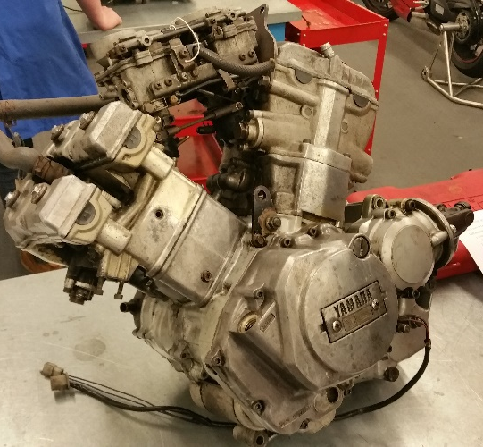
Introduction
This technical report is about engine disassembly and assembly sessions which the author took in the first semester of 1st year studying Motorcycle Engineering in 2017. The author has taken detailed notes in his logbook. Those notes are being used to examine and report on the procedures as well as new knowledge which has been gained over the practical sessions (Tudor & Marotin, 2017).
Figure 1: (Kaczmarczyk, 2017)

The aim of the practical sessions is as follows:
- Fully disassemble and assemble motorcycle ICE and transmission
- Work as an active team member
- Make detailed notes on the processes. Take photographs which can be used in the report.
- Carefully study the engine architecture. Learn how the mechanisms work within the engine and transmission.
(University of Wales Trinity Saint David, n.d.)
The practical sessions are also an opportunity to study and practise health and safety rules which are very common and important to majority of workplaces. Furthermore, this exercise tests the ability of organisation as a single entity as well as part of a group, as many components are going to be taken off and the author is not able to personally handle each and one of them. This ability is then tested again with a substantial list of checks which has to be carried out at many different points of the 8-week long exercise.

Background Research

Legislation
There are two major personal health and safety legislations which apply to workplaces, these are:

Health and Safety at Work Act 1974
This is a general act which allows creation of specific regulations such as the one below. There are three major objectives:
- Protect the people at work
- Protect people which aren’t working but are at the workplace (e.g. customers, visitors)
- Controlling dangerous substances safely (specified in COSHH)
According to this act the author is obligated to:
- Practise health and safety on everyone at the workplace
- Not preventing others from carrying out the 1st point
There are many other duties aimed at other entities (such as employer), which the author checks when he is carrying out his duties.
(HM Govermant, 1974)

Personal Protective Equipment at Work Regulations 1992
As with the previous act, this regulation allows creation of regulations specific to the environment and/or substances.
This regulation requires all people at the workplace to wear PPE at all times where necessary. The workplace itself is required to train and inform people which are going to use PPE, maintain and check the equipment.
(HM Govermant, 1992)

Health & Safety

Equipment Used
The author has used the following PPE:
- Steel toe cap boots
- Gloves – due to sensitive skin

Rules
The author had to follow the following rules:
- Follow the PPE Regulation 1992 and Health & Safety Act 1974
- In case of fire alarm stay calm and go to the assembly point via emergency exit
- Leave the workplace clean and tidy
- Use equipment with care

Methodology

Equipment Used
The author has used large variety of tools, which are:
- Screwdrivers
- Punch set
- Socket set
- Wrenches
- Allen keys
- Rubber and copper mallets
- Levers (as a crowbar)
- Chisel
- Pneumatic impact gun

Steps
The author’s team has carried out the following steps in the session on 23rd October 2017:
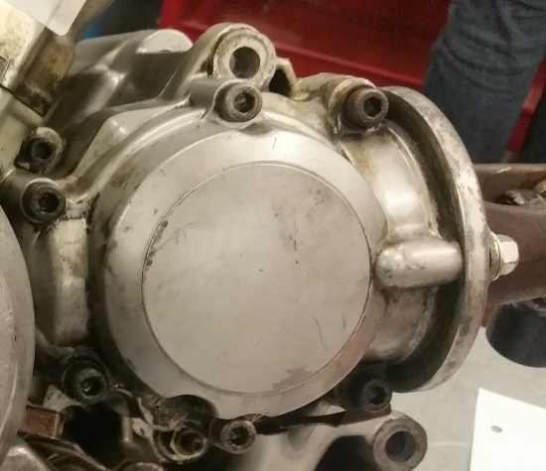
- The 6x m6 Allen head bolts have been taken out of the driveshaft cover.
Figure 2: (Kaczmarczyk, 2017)
- 3x 12mm hex screws have been taken off of the driveshaft output carrier.
- The driveshaft cover has then been taken off the engine.
- The driveshaft itself has been lifted out of the seats with bearings still attached.
  - For the purpose of the exercise the bearings have not been replaced or taken off the driveshaft.
  - The Bearings, bearing seats as well as the driveshaft has been inspected for signs of wear or damage. As suspected nothing was out of ordinary apart from shallow scratches on the bearing seats – most likely caused by the driveshaft being frequently taken out and put back in carelessly.
- After that flathead screwdriver has been used to bend the tab off the nut on the tab-washer – tab washer should be replaced, but it was left alone for the purpose of the exercise.
- Then the author has used pneumatic impact gun as well as impact socket to undo the nut on the input gear which drives the driveshaft – signs of wear on the nut.
- Finally, the input gear has been lifted out of the engine and inspected once more.
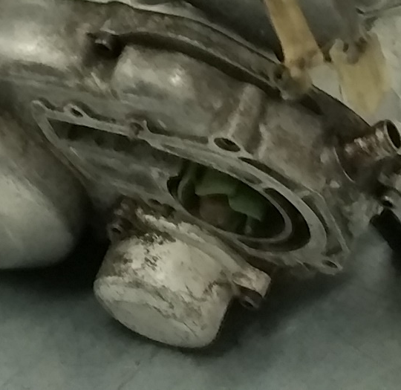
- Once that was done, the team has decided to move over to the disassembly of the oil filter. The first step was to undo 3 Allen head screws which were holding the oil filter cover on.
Figure 3: (Kaczmarczyk, 2017)
- This gave access to the oil filter which has been lifted out of the oil filter chamber – the author has looked for any signs of metal or other substances in the filter, residual oil and the chamber but he was unable to find anything detrimental.
- After that the team has decided to work on the clutch. Seven Allen head screws and three Allen head bolts have been taken out of the clutch cover. This has allowed the clutch cover to be lifted off of the engine – there was no gasket or sealing material between the meeting surfaces.
- Then pneumatic impact gun has been used yet again to undo the big nut on the clutch basket.
- The team has then realised that the clutch cannot be taken off as a assembly, instead it has to be split into two parts. Therefore, 5 x 10mm hex head screws have been taken off of pressure plate.
- This allowed the team to take the pressure plate off.
- Which has then revealed a centre shaft that just lifted out of the assembly.
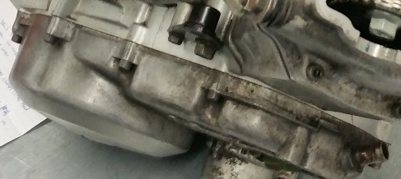
- The last step done on that sessions was when the team has bent the tab washer away from the nut and used the pneumatic impact gun on 30mm nut which was holding the clutch basket on the gearbox input shaft.
Figure 4: (Kaczmarczyk, 2017)
(Kaczmarczyk, 2017 - 2018)

Discussion and Conclusion

Achievements
- Driveshaft assembly completely stripped
- Oil filter taken off
- Clutch pressure plate taken off and clutch assembly ready to be lifted out

Lessons Learned
Author has learned to take care when analysing the job. Previously the author has believed that since he has already stripped and rebuilt many motorcycle engines that he could get this job done without paying much attention. This didn’t go well when he nearly destroyed the flywheel because of a different design that he has never seen before. The clue was that he had experience with high performance sport bike engines and he was working on a cruiser engine.
The author has also learned that the key of teamwork is communication, not getting his job done well and quickly. He has found that communication allows the team to be more efficient and ‘feed’ off of each other which results in higher performance, which he cannot match alone no matter how quickly he would work, 4 slow pace people can achieve more than a single high pace person.

References
HM Govermant, 1974. Health and Safety at Work etc. Act 1974. [Online]
Available at: http://www.legislation.gov.uk/ukpga/1974/37/contents
HM Govermant, 1992. The Personal Protective Equipment at Work Regulations 1992. [Online]
Available at: http://www.legislation.gov.uk/uksi/1992/2966/contents/made
Kaczmarczyk, K. O., 2017 - 2018. Log Book. Swansea: s.n.
Tudor, D. K. & Marotin, D. A., 2017. M4X02063 & M4X00384, Swansea: s.n.
University of Wales Trinity Saint David, n.d. Engine Strip and Rebuild. Swansea(Swansea): University of Wales Trinity Saint David.

