Jac Thomas (2204038)
University of Wales Trinity St David
bmbm5006: Analytical report

Contents
Table of Figures 1
1.0 Introduction 3
2.0 Pre-Processing 4
3.0 Basic Function 5
3.1 Sum 7
3.2 Mean 7
3.3 Mode 8
3.4 Median 9
3.5 Findings from Basic Functions 9
4.0 IF Functions 10
4.1 IF and IFS Functions 10
4.2 Findings from IF Functions 12
5.0 VLOOKUP Function 14
5.1 VLOOKUP Tables 14
5.2 VLOOKUP Analysis 16
6.0 Pivot Table 18
6.1 Creating Pivot Table 18
6.2 Pivot Table Analysis 19
7.0 Tables, Graphs and Charts 20
7.1 Creating Tables, Graphs and Charts 20
7.2 Graph, Chart and Table Analysis 23
8.0 Conditional Formatting 25
9.0 AI in Excel 26
10.0 Conclusion 27
11.0 Recommendations 28
12.0 References 30

Table of Figures
Figure 1: Image to show Pre – Processing 4
Figure 2: Table with Colour Coordination and Highlights for states and dates 5
Figure 3: New Table arranged in chronological order 6
Figure 4: Use the sum of function to find total sales for each year in Arizona 7
Figure 5: Use of Mean Function to find Average of Total Sales in Arizona 8
Figure 6: Use of Mode function to find mode of all sales figures in Arizona 8
Figure 7: Use of Median Function to find median of all sales figures in Arizona 9
Figure 8: Image to show use of IF function 10
Figure 9: Image to show use of IFS function (high IF values) 11
Figure 10: Image to show use of IFS functions (low IF values) 11
Figure 11: Image to show use of Average function to work out Average profit 11
Figure 12: Image to show use of Average function to show use of Average function to determine Average of "high profits" 12
Figure 13: Image to show use of Average function to determine average of "low profits" 12
Figure 14: Image to show total of all sales made to customers in Texas. 14
Figure 15: Image to show formula used to calculate what percentage each Sale to a customer is of the total sales. 15
Figure 16: Use of VLOOKUP to find Classify Percentages of total sales. 15
Figure 17: Use of VLOOKUP to Classify Shipping Costs 16
Figure 18: Data for New Jersey formatted as a table 18
Figure 19: Pivot Table for New Jersey data 19
Figure 20: Pie Chart to show Sales made to customers in Kansas. 21
Figure 21: Line Graph to show relationship between the unit price and the profit of products sold in Vermont. 21
Figure 22: Images 22,23,24 and 25: Table to show Quantity of Products sold and how much revenue they generate. 23

Introduction

This report has been prepared in response to the assignment brief set in which I have been asked to use Microsoft Excel to analyse a set of data containing several years’ worth of sales data and then express the analysis as well as how the data was extracted in a business report. In this report I will address the usefulness of the basic functions such as sum, mean, mode and median, IF Functions, VLOOKUP tables, Pivot Tables, Tables and Graphs, Conditional Formatting and Will briefly discuss AIs involvement in Data Analysis, after all these are covered the report will be finished a brief conclusion as well as recommendations based on the findings of the report. The purpose of this report is to help identify areas of low profit or even loss whereas this seems like data mining which as defined by Sunkpho & Ramjan (2023) Page 1 “is a powerful and increasingly popular tool that uses machine learning to uncover patterns in data and help businesses stay competitive” It differs as it leans more towards data analysis, which as explained by Roberts (2023) N.P. “the objective of Data Analytics is to interpret, analyse, and draw meaningful insights from data to support decision-making and optimise performance”.

2.0 Pre-Processing

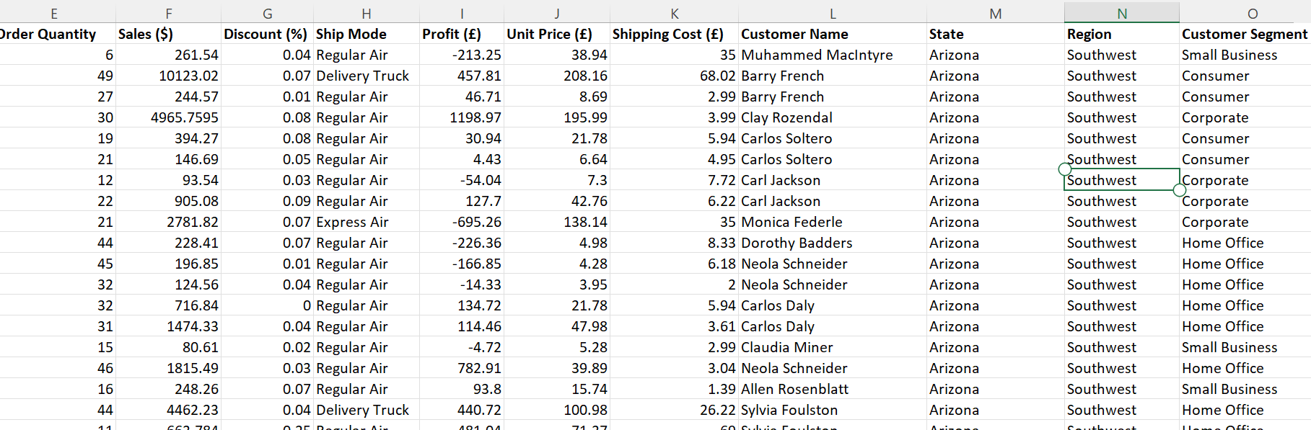
Figure 1: Image to show Pre – Processing
The first step was to preprocess the data, preprocessing data according to Mishra (2023) N.P means “Data preprocessing helps to improve the quality of data, consistency of the data, and compatibility.” with the data set above, the columns have been expanded, the headings boldened and units added in such as £ signs.

3.0 Basic Function

The basic functions are sum which explained by Corporate Finance Institute (2021) N.P. “helps users perform a quick summation of specified cells”, the mean, described by the Cambridge Dictionary (2023) N.P. as “an average number”, mode which is “the number that occurs the highest number of times.” Khan Academy (N.D.) N.P. and median which as described by Microsoft (2023) N.P. “The median is the number in the middle of a set of numbers” To demonstrate use of each I looked at the sales between 2012 and 2015 in Arizona State, before I did any calculations, I separated the data I wished to use by highlighting all Arizona sections within the state column and colour coding the dates based on which year it was in.
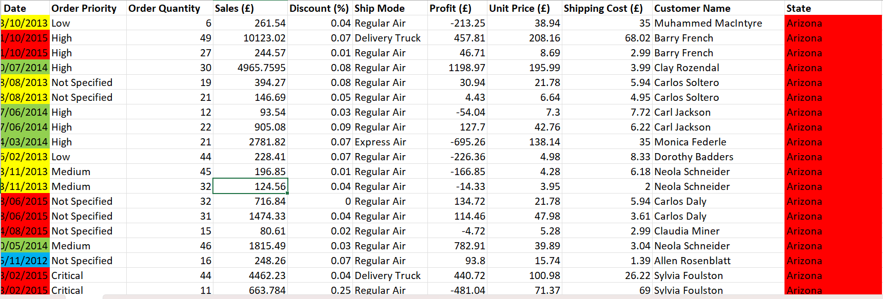
Figure 2: Table with Colour Coordination and Highlights for states and dates
The appropriate data was then transferred into another tab where the dates were organised chronologically.
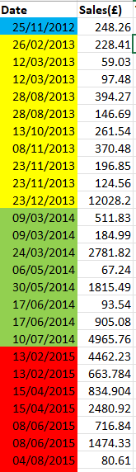
Figure 3: New Table arranged in chronological order.

3.1 Sum

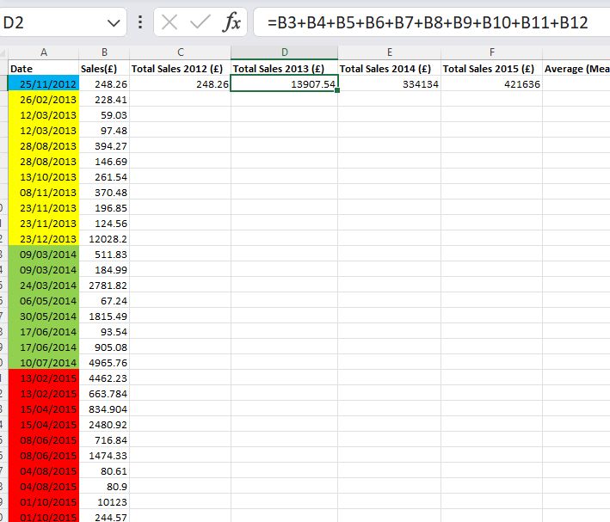
Figure 4: Use the sum of function to find total sales for each year in Arizona.

3.2 Mean

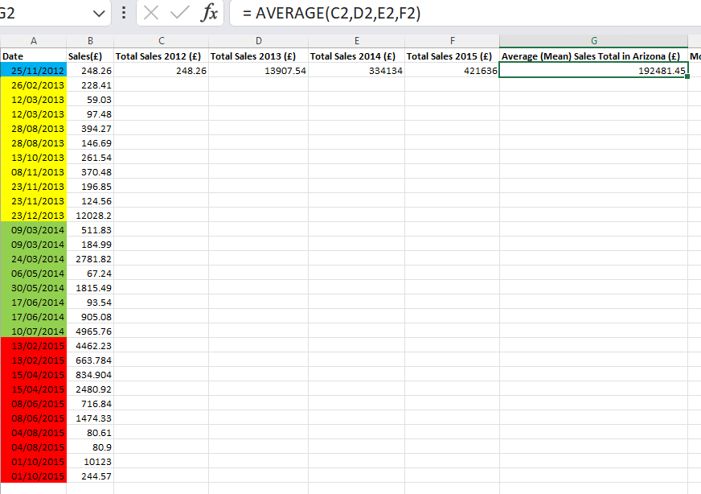
Figure 5: Use of Mean Function to find Average of Total Sales in Arizona

3.3 Mode

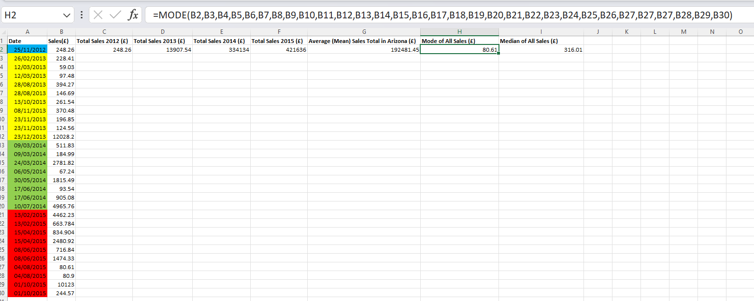
Figure 6: Use of Mode function to find mode of all sales figures in Arizona.

3.4 Median

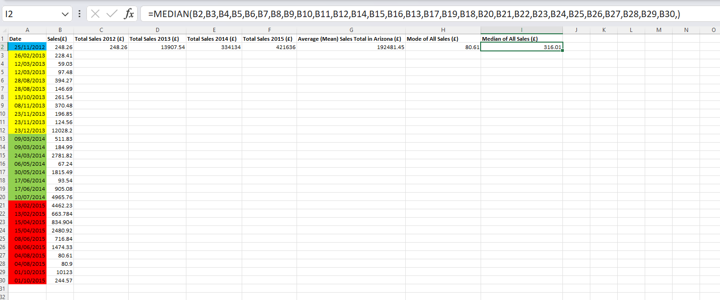
Figure 7: Use of Median Function to find median of all sales figures in Arizona.

3.5 Findings from Basic Functions

From the data above it can be seen that the total sales each year is increasing, this doesn’t show any losses but if the business wants this trend to continue in states like Arizona, they will need to look at the reasons why and how they can ensure sales increase in the next year, however, to attain information like this other excel functions will be needed.

4.0 IF Functions

4.1 IF and IFS Functions

According to Makvana (2022) N.P. “The IF function returns different values depending on whether a condition is true or false.”
According to Ahuja (2023) N.P. the IFS function is a “logical function that, in simplest terms, applies multiple IF functions. It allows the users to test a value against multiple conditions”.
To show use of the IF and IFS Functions, I collected all profits made from sales in Oklahoma state and used each function to separate the items into most and least profitable.
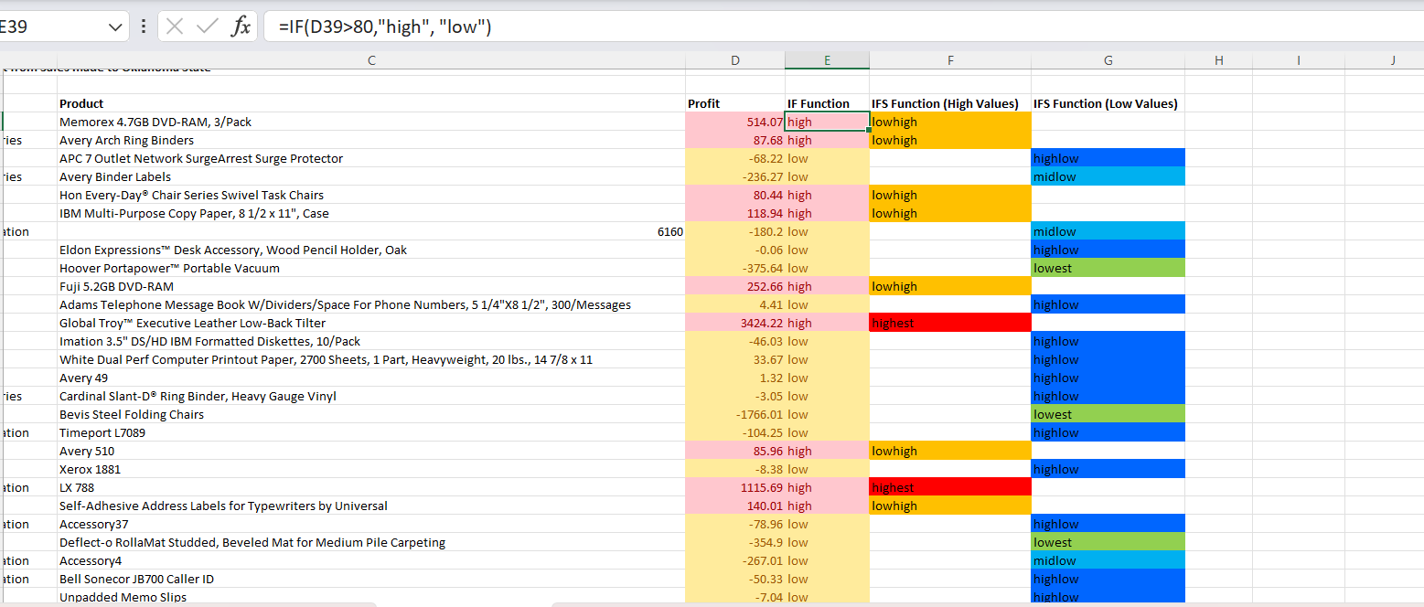
Figure 8: Image to show use of IF function.
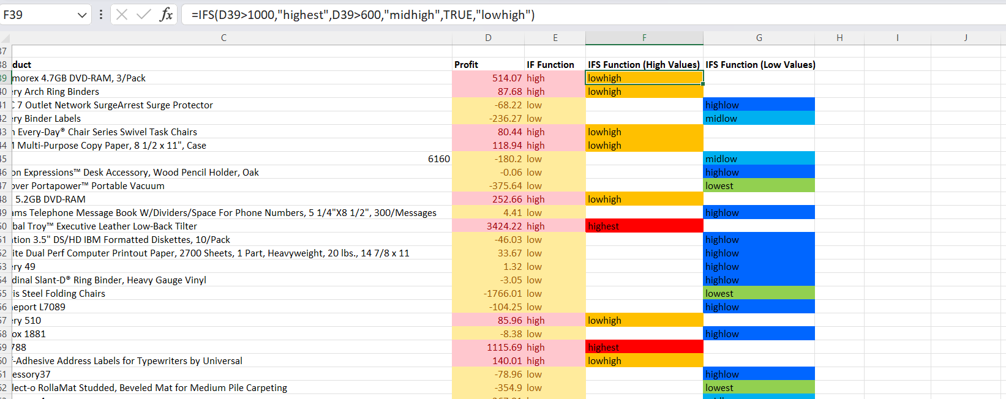
Figure 9: Image to show use of IFS function (high IF values)
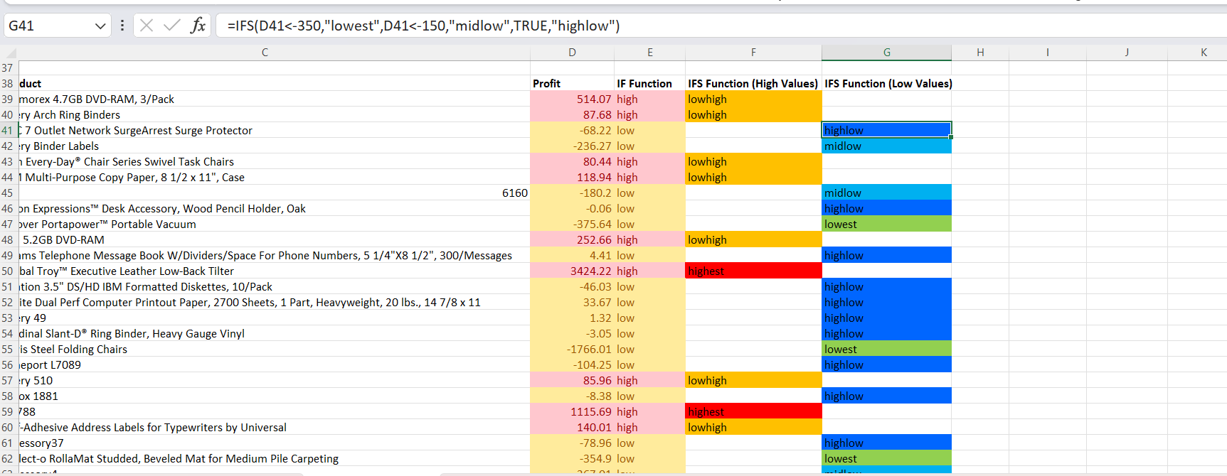
Figure 10: Image to show use of IFS functions (low IF values)
To determine the Value used in the IF formula I decided to find the average of all profits from sales made to Oklahoma.
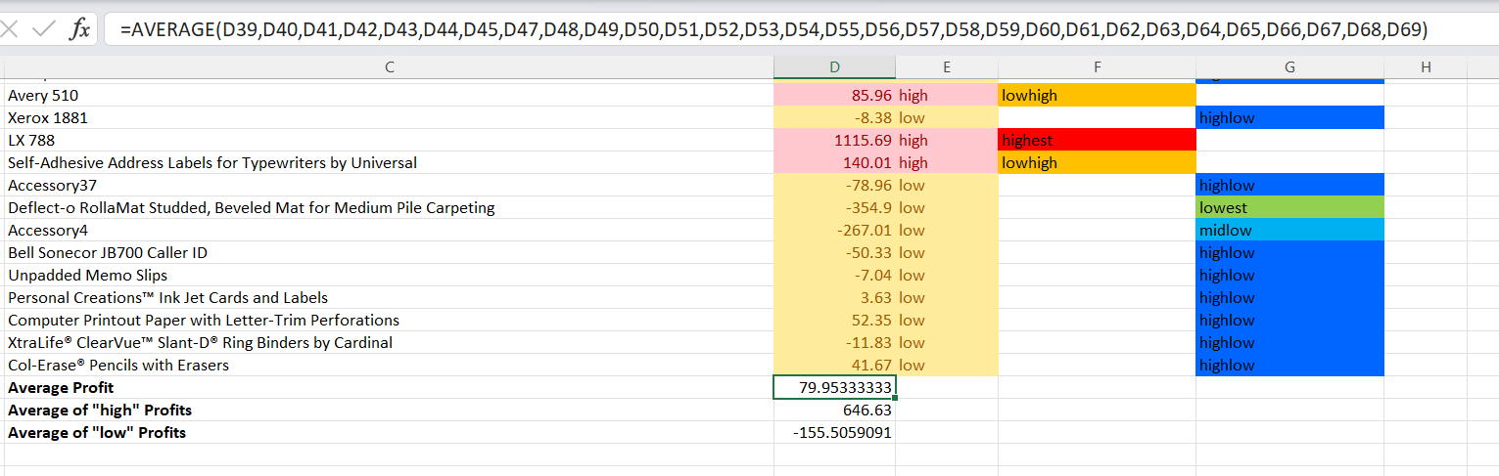
Figure 11: Image to show use of Average function to work out Average profit.
To determine the middle values for both uses of the IFS function, I worked out the average high and low profits using the average function, the “highest” and “lowest” parameters were determined through looking at the higher and lower values in the statistics and picking what I thought would be a good parameter.
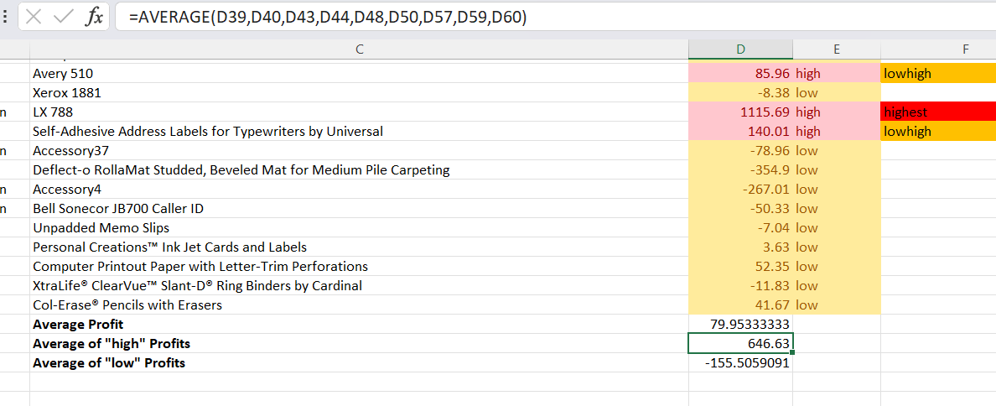
Figure 12: Image to show use of Average function to show use of Average function to determine Average of "high profits”.
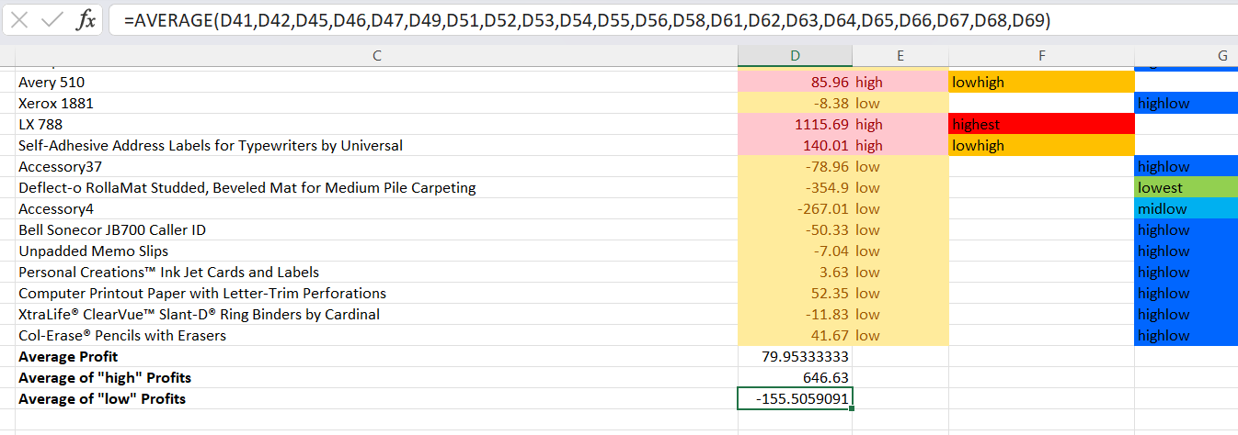
Figure 13: Image to show use of Average function to determine average of "low profits”.

4.2 Findings from IF Functions

The calculations revealed that the Low-Back Tilter and LX 788 were the most profitable Items sold and that the Folding Chairs and Bevelled Mat for Medium Pile Carpeting were the least profitable. Attention should be given to low profit products they could be removed for a short while, Square Up (2023) N.P. agrees believing products should be withdrawn if they do not sell well.

5.0 VLOOKUP Function

5.1 VLOOKUP Tables

Gharani (2017) explains that the purpose of the v lookup function is to find a value within a large set of data and give a corresponding value that is within the same row.
I used the VLOOKUP function to retrieve and classify data, I did so for both the sales figures of each customer and the cost of shipping methods, I have done this to highlight just how high or low a sales figure or cost is and make the data more impactful on decision making.
For Sales, I first found the total of all sales made to customers within Texas.
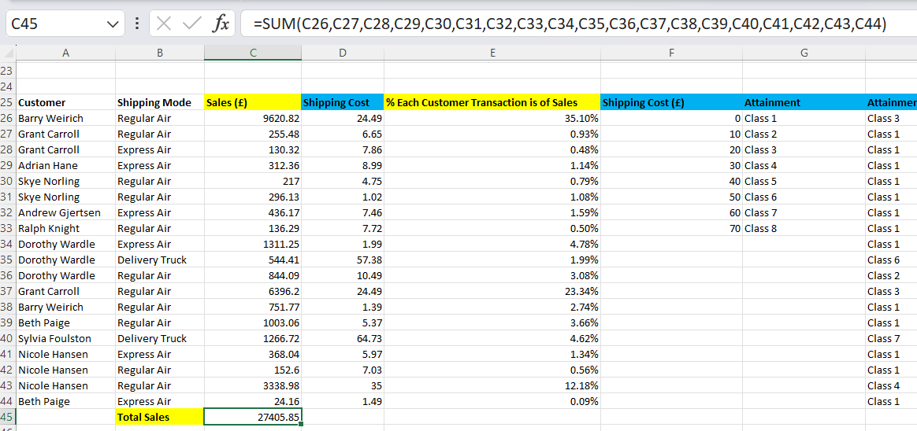
Figure 14: Image to show total of all sales made to customers in Texas.
I then worked out what percentage each sales figure was of the total sales figure.
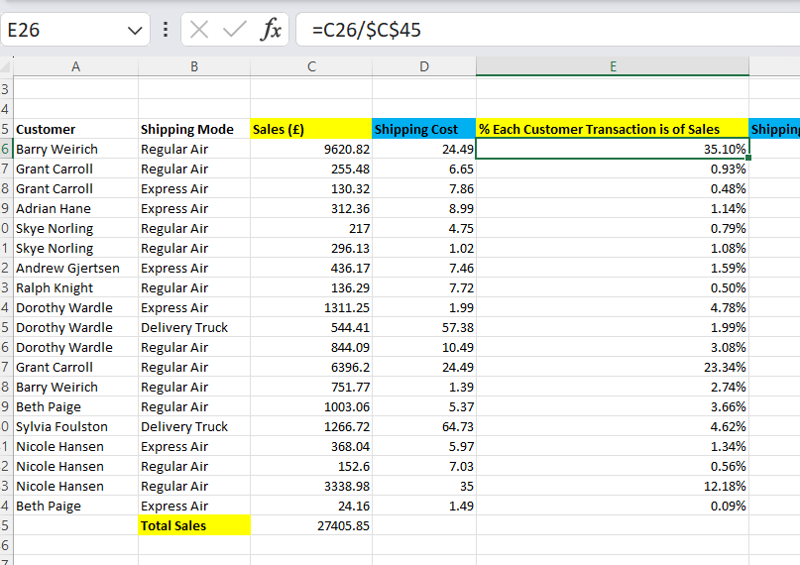
Figure 15: Image to show formula used to calculate what percentage each Sale to a customer is of the total sales.
I then created a VLOOKUP table with different classifications for sales made to customers.
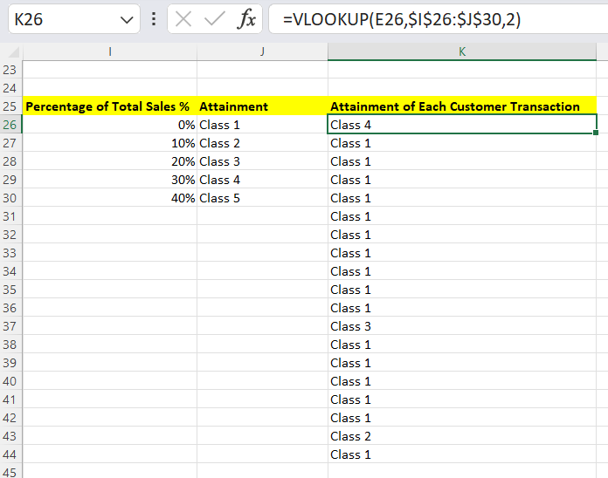
Figure 16: Use of VLOOKUP to find Classify Percentages of total sales.
I also used the VLOOKUP function to classify the shipping costs of different shipping modes made to customers in Texas.
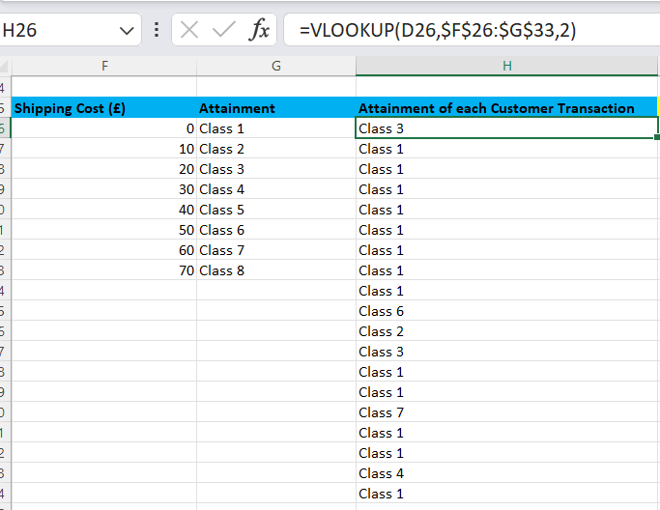
Figure 17: Use of VLOOKUP to Classify Shipping Costs

5.2 VLOOKUP Analysis

Several Shipping costs proved to be very expensive, for example the delivery truck to Sylvia Foulston was a Class 7 which shows it’s an immensely high cost for the company in these instances in comparison to other delivery methods. this shows that delivery trucks may not be the optimal way to deliver these items as they are a high cost and there are cheaper options such as Regular and Express air which can range in price but usually aren’t as expensive for example regular air ranges between class 1 and 4 which shows it is a cheaper alternative to consider for future.
For sales they should look at which customers go into the higher classes such as Barry Weirich (Class 4) and Grant Caroll (Class 3) identifying these two customers as high spenders. knowing these two customers are big spenders the business should think of ways to retain and increase their spending amount.

6.0 Pivot Table

6.1 Creating Pivot Table

Stratvert (2022) says that Pivot Tables save time in analysing data by acting as a drag and drop tool that does not require any knowledge of formulas. I used a pivot table to show discounts could be affecting Profits made from customers in New Jersey State.
Firstly, I sampled all transactional data relative to New Jersey from the main data set, put it in a separate sheet and converted the set into a table.
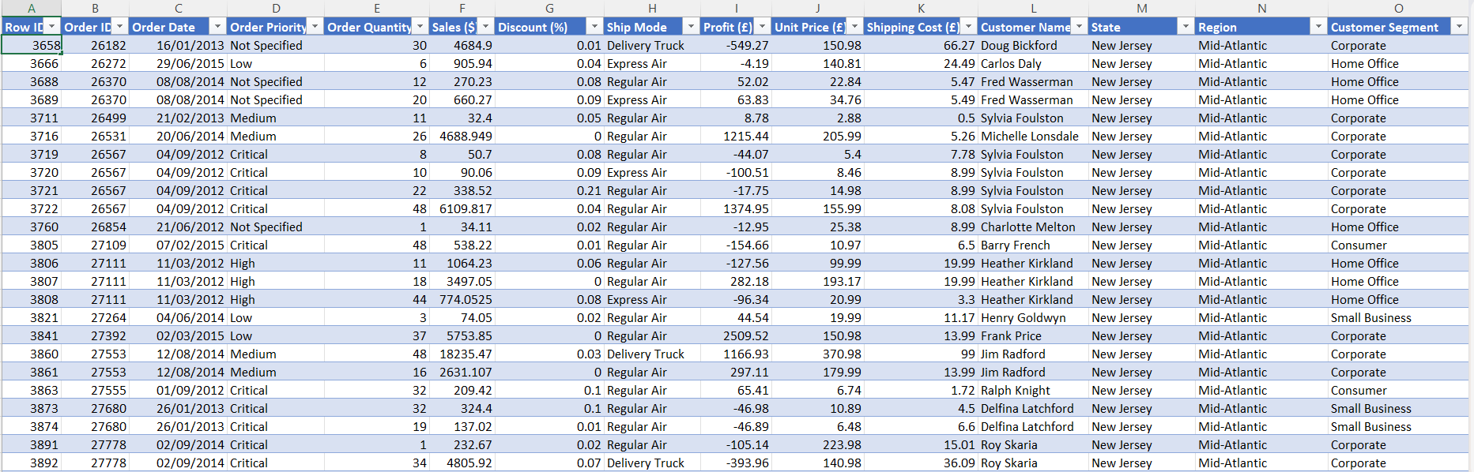
Figure 18: Data for New Jersey formatted as a table.
Once this step was completed, I then selected the table and created a new sheet for the Pivot Table, In the pivot table I selected the customers as a row, the discounts as one column and then two columns for profit, one with the original values and one as percentages to emphasize just how much each customer makes up of the profit.
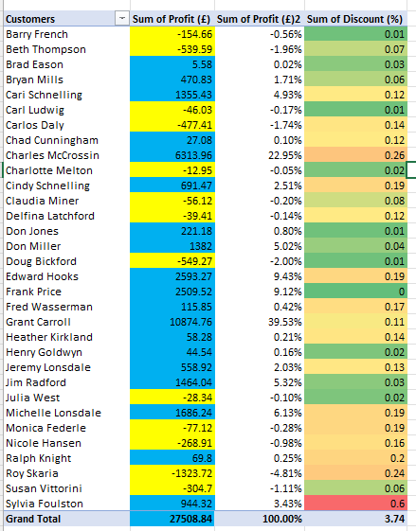
Figure 19: Pivot Table for New Jersey data

6.2 Pivot Table Analysis

Looking at the pivot table something, you can see how the discount has caused potential for greater profit to be missed, for example, Sylvia Foulston had the largest discount of 0.6% whereas this is a good profit there could have been greater profit if not for the discount, the amount of discount should also be revised because of transactions that have a negative profit, such as Roy Skaria who had a discount of 0.24 on his purchase, being worsened by the discount. As Richards (2022) N.P points out that discounts could impact your profit margin.

7.0 Tables, Graphs and Charts

7.1 Creating Tables, Graphs and Charts

Jovanovic (2023) N.P explains that a chart is a visual representation of data, used to show trends within data sets which may otherwise be too complex to understand, the purpose of a chart is to display data in a “simple and comprehensible way”.
As well as this, Jovanovic (2023) N.P. defines a table as “data arranged in columns and rows. It can also include grid lines to separate the data. Each intersection of a column and a row represents one piece of data.”
Merriam-Webster (2024) defines a Graph as “a diagram (such as a series of one or more points, lines, line segments, curves, or areas) that represents the variation of a variable in comparison with that of one or more other variables”.
Firstly, I made a pie chart to show the sales made to customers in Kansas, the pie chart shows which customers are generating the most revenue.
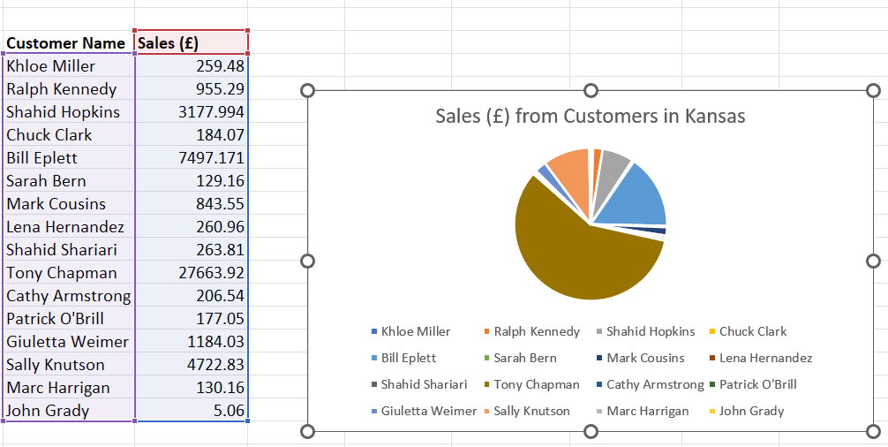
Figure 20: Pie Chart to show Sales made to customers in Kansas.
Next, A bar chart was made to see unit prices against profit made from each item that was sold in Vermont, which will show any relations between the unit price and the profit.
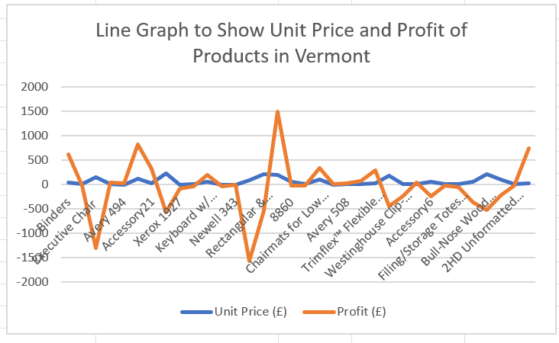
Figure 21: Line Graph to show relationship between the unit price and the profit of products sold in Vermont.
Lastly, I created a table to show the order quantity of certain products and how much sales they generate to see which products are high demand and low demand and how much cash these products generate.
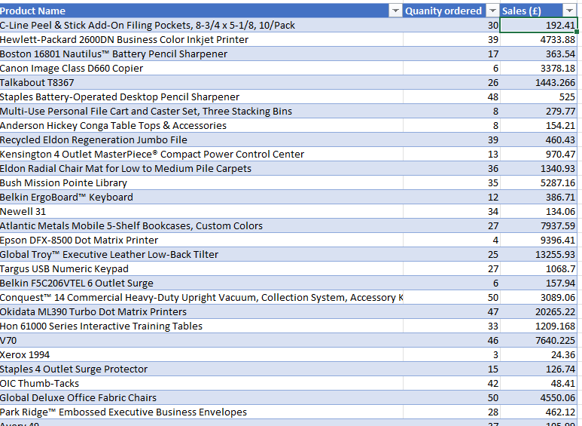
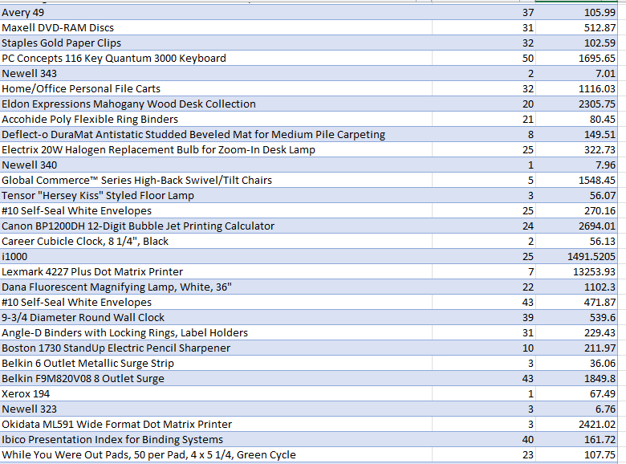
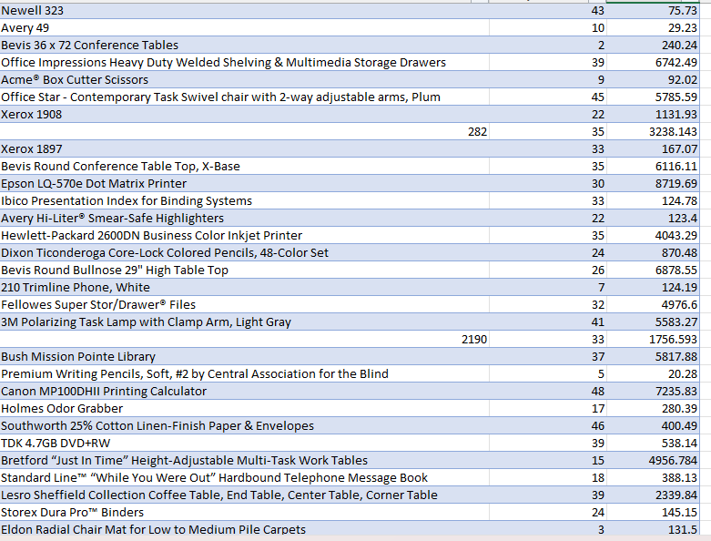
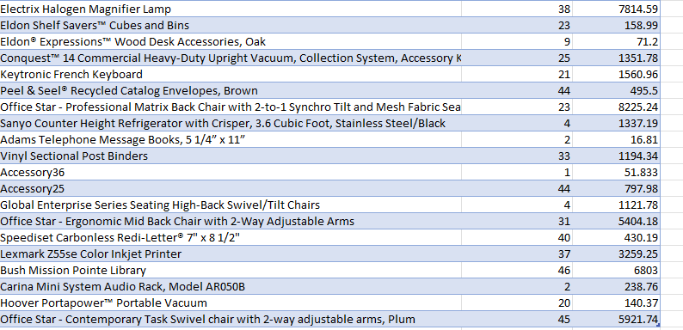
Figure 22: Images 22,23,24 and 25: Table to show Quantity of Products sold and how much revenue they generate.

7.2 Graph, Chart and Table Analysis

The pie chart makes it very clear to see where the greatest source of revenue is coming from, Tony Chapman spends much more than any customer, high spenders like Chapman should be retained by the business, but also several customers can barely be seen or seen at all which shows a stark contrast in spending.
The line graph does not show any correlation between high prices and profit overall but in several areas, profit has dipped quite far, and prices seem to be higher.
The table shows which products are in high demand based on the quantity of products that were ordered and the sales they generated.

8.0 Conditional Formatting

Kim (2024) N.P. “Conditional formatting in Excel is a tool that applies formatting to your data depending on the conditional rules you lay out.” They also explain this could be visualising certain data and locating information.
Within if function greater than was red and less than yellow and text containing high was red and low yellow, this was set through conditional formatting, also did this with the separate high and low bands.
I also used conditional formatting in the pivot table, in the profit section, anything below the value of zero was formatted to appear in a yellow cell and then in a blue cell if over the value of zero for a clear distinction between the two. I also formatted the discount to range between a gradient of green to red based on how low to high the discount is so it can be seen clearer.

9.0 AI in Excel

Microsoft (2023) explain that with Excels new copilot feature it can “analyze and visualize your data”, arrange and filter your data and assist with complex calculations and Horsey (2023) notes that it helps with effective allocation of time and improve productivity. This could save time for the business, as patterns will be recognised for them, Copilot may pick up information that otherwise would have been missed and so will be useful in decision making.

10.0 Conclusion

Overall, the basic sum functions can identify some trends but are not very useful. The If function helped identify high and low profit items. The VLOOKUP function found high costs involved in shipping and revealed some of the highest spending customers. The pivot table showed the impact discounts can have on profit. The pie chart highlights areas of high profit and the stark contrast in spending between some customers. The graph showed no correlation between an increase in price and a fall in profit however there are several areas where this is the case so useful information is still provided. The table shows the most in demand products next to their selling. Lastly, it was found the AI copilot feature could be very useful for the business. Unless the business chooses to use AI, these methods used together make Excel an excellent tool for analysis.

11.0 Recommendations

Looking at the data from the IF function, the business should act based on the levels of profitability, for example, low profitability item could be advertised more or made no longer available to the state and cut down a little on how much they stock which can help save more money. Hausman (2022) N.P. suggests reasons for poor performance could be lack of awareness about your product, awareness could be created through marketing and the ABC of Marketing (2018) N.P states that product discontinuation can achieve economies of scale.
The data from the VLOOKUP function suggests that delivery trucks are a very expensive shipping method, with this in mind the business should focus much more on regular and express air methods on delivery to save costs and with the knowledge of which customers spend the most the business should find ways to retain these customers and find ways to increase their spending, one way to do this would be to make targeted advertisements based on previous purchases, Chakrabarty (2023) N.P. believes that targeted marketing is focused on loyalty attaining a connection and possible retention.
Looking at the Pivot Table, the business should not stop giving out discounts as this could lose some customer loyalty, however the amount of discount given should be revised especially when some sales had a great loss only increased by the discount given, White (2023) N.P. explains it could lead to returning customers but can lose trust from some customers as it can make them believe your regular prices are too high and they may shop elsewhere, this have effected the business in question.
Looking at the stark contrast in spenders we can see in the chart the business needs to try and increase expenditure from low spending customers, some marketing research to find what products these customers want would be a good starting point before further action such as advertising the desired products to the customer to incentivize purchase. Forbes (2021) N.P. agrees that offering products that act as a solution to your market’s issues will help increase sales.
The table provides data that could help the business could decide how they want to market their products, for example focus marketing on poor performing items, as Teneva (N.D.) N.P. suggests social media discussions as a good method of promoting products that undersell.

Using the graph, the business could consider the price of some particularly low profit items as it can incentivise more purchases, the price of successful high sale products could also be brought down to increase the sales of these items even further, Prisync (2024) N.P. agree finding customers prefer a low price and this is why prices are often dropped by businesses to increase revenue.

12.0 References

ABC of Marketing (2018) “Explain Product Simplification, Diversification and Elimination. What are the advantages of Product Simplification and Product Diversification?” Available at: Explain Product Simplification, Diversification and Elimination. What are the advantages of Product Simplification and Product Diversification? (abcofmarketing.com) Accessed: 18th January 2024
Ahuja S. (2023) “Excel IFS Function – How To Use” Available at: Excel IFS Function – How To Use (exceltrick.com) Accessed: 2nd January 2024
Cambridge Dictionary (2023) “Mean” Available at: MEAN | English meaning - Cambridge Dictionary Accessed: 29th December 2023
Chakrabarty A. (2023) “Target Marketing Strategies: Definition, Advantages & Disadvantages” Available at: Target Marketing: Definition & Strategies Explained // Unstop (formerly Dare2Compete) Accessed: 18th January 2024
Corporate Finance Institute (2023) “SUM Function” Available at: SUM Function - Formula, Examples, How to Use SUM (corporatefinanceinstitute.com) Accessed: 29th December 2023
Forbes (2021) “14 Simple But Effective Techniques To Increase Sales” Available at: https://www.forbes.com/sites/forbesbusinesscouncil/2021/03/30/14-simple-but-effective-techniques-to-increase-sales/ Accessed: 18th January 2024
Gharani L. (2017) “Excel VLOOKUP: Basics of VLOOKUP and HLOOKUP explained with examples” Uploaded: 4th March 2017 Available at: https://youtu.be/E7gQ-PgYkMc?si=7fLfrHWpQIRnmZrc
Hausman A. (2022) “4 Reasons Your Product Isn’t Selling and What to Do About it” Available: 4 Reasons Your Product Isn’t Selling and What to Do About it - Business 2 Community Accessed: 18th January 2024
Horsey J. (2023) “5 Ways Copilot for Microsoft 365 can help improve your business productivity”. Available at: 5 Ways Microsoft 365 Copilot can improve your productivity - Geeky Gadgets (geeky-gadgets.com) Accessed: 3rd January
Jovanovic M. (2023) “Charts Vs Tables or When to Use One Over the Other” Available at: Charts Vs Tables or When to Use One Over the Other (wpdatatables.com) Accessed: 4th January 2024
Khan Academy (N.D.) “Mean, median, and mode” Available at: Mean, median, and mode review (article) | Khan Academy Accessed: 29th December 2023
Kim J. (2024) “How to Use Conditional Formatting in Excel” Available at: Conditional Formatting in Excel - a Beginner's Guide (goskills.com) Accessed: 2nd January 2024
Makvana M. (2022) “How to Use the IF Function in Microsoft Excel” Available at: How to Use the IF Function in Microsoft Excel (howtogeek.com) Accessed: 2nd January 2024
Merriam-Webster (2024) “Graph” Available at: Graph Definition & Meaning - Merriam-Webster Accessed: 5th January 2024
Microsoft (2023) “Copilot in Excel” Available at: Copilot in Excel help & learning (microsoft.com) Accessed: 3rd January 2024
Microsoft (2023) “Median Function” Available at: MEDIAN function - Microsoft Support Accessed: 29th December 2023
Mishra N. (2023) “Data Preprocessing in Excel” Available at: Data Preprocessing in Excel - Coding Ninjas Accessed: 28th December 2023
Prisync (2024) “Everyday Low Pricing Strategy: Pros, Cons | +4 Brands That Nailed It” Available at: Everyday Low Pricing Strategy: Pros, Cons | +4 Brands That Nailed It (prisync.com) Accessed: 18th January 2024
Richards M. (2022) “The Pros and Cons of Using Discounts in Your Marketing” Available at: The Pros and Cons of Using Discounts in Your Marketing | Go Charisma Accessed: 18th January 2024
Roberts S. (2023) “Data Mining vs Data Analytics: What's the Difference?” Available at: Data Mining vs.Data Analytics: Detailed Comparison (theknowledgeacademy.com) Accessed: 28th December 2023
Stratvert K. (2022) “How to Create Pivot Table in Excel” Uploaded: October 10th, 2022, Available at: https://youtu.be/PdJzy956wo4?si=2akvasi-HxgVASAF
Sunkpho J. & Ramjan S. (2023) "Principles and Theories of Data Mining with RapidMiner. “Page 1 1st Edition Hershey: IG Global
Square Up (2023) “7 Ways to Increase Business Profitability” Available at: 7 Ways to Increase Business Profitability (squareup.com) Accessed: 18th January 2024
Teneva D. (N.D) “How to sell underperforming products” Available at: How to sell underperforming products | Metrilo Blog Accessed: 18th January 2024
White R. (2023) “The advantages and disadvantages of discounts” Available at: The Advantages and Disadvantages of Discounts | Omnisend Blog Accessed: 18th January 2024

