  Component One:  What are the key skills required when working in the housekeeping team? 750 words (+/- 10%)  Contribution to Overall Module Assessment: 25% | Student No: | 2207491  Cristina Valentina Preda
 | Module Title: | Operating Hotel Facilities
 | Module Code: | BMIH4006
 | Lecturer: | Lisa Bassler
Working in the housekeeping team at Premier Inn Teesside requires diverse key skills that are essential for success (Enz and Siguaw, 2000). Drawing from industry examples and personal reflections, I will explore these skills and discuss their application in the hospitality industry, specifically within the context of Premier Inn.
Housekeeping team requires proper attention to detail activities and manage high standard of working of cleanliness and presentation to ensure guest satisfaction. As a housekeeper, I have learned the importance of paying close attention to work in different aspect in smallest details. Ensuring all the surfaces are spotless, linens are neatly arranged, and amenities are managed for welcoming environment for guests. Detailed identification and maintain all the issues in the rooms helped me to ensure proper maintenance issues in the rooms. Time management is another essential skill in the housekeeping team at Premier Inn. There require proper time management activities through prioritising tasks, following established cleaning procedures, and utilising efficient cleaning techniques. Time management can enable housekeepers to complete duties promptly and maintain a smooth workflow. Adhering to a well-structured cleaning schedule and efficiently managing my time can allow to meet adequate job demands. Teamwork is highly valued in the housekeeping department at Premier Inn (Richmond, 2007). Collaboration and effective communication between team members ensure that tasks are accomplished efficiently. For instance, working with colleagues, assist employees, and maintain adequate communication process helps to manage team working environment.
Effective communication is crucial in the housekeeping team to ensure smooth operations. Getting proper instructions and coordinating with other department can help to deliver a seamless experience to guests. Kaynak and Rogers (2013) argued that clear and conscious working activities can allow to manage effective learning process with others and interact with the guests and colleagues to manage smooth professional practices. Physical stamina is another essential skill for housekeepers that helps to manage individuals to perform in the right aspect. Proper evaluation process through physical demanding allows individuals to work as per objectives and manage proper performance process. Problem-solving abilities are essential to manage different challenges, such as stubborn stains, equipment malfunctions, or guest requests. Having strong problem-solving skill can allow housekeepers to assess different situation in the right direction.
Applying theoretical knowledge in the housekeeping industry can help professionals to establish proper standards, protocols, and industry specific working guidelines (Khadka et al., 2020). Making sure proper understanding of the topic, safe using of the agents and other activities are essential to manage prevention process. Proper knowledge and direct application and directing them can allow to select appropriate cleaning products in different situation. The topic of key skills in the housekeeping team is crucial in the hospitality industry, particularly at Premier Inn. Cleanliness and the overall presentation of the hotel rooms significantly impact guest satisfaction and influence their perception. Premier Inn makes sure different aspects to provide the best services to the guests and contribution to maintain reputation activities. Cleanliness and hygiene are essential part of hospitality industry (Holah, 2014). Managing proper guest environment and hotel staying allows to provide the best facilities. Meeting proper team activities is essential to fulfill all the expectations. Meeting guest expectations and possessing proper skill management can help to ensure proper aspects. Detailed activities and skill evaluation process can allow to contribute proper guest experience and satisfaction. Managing amenities and seeking surface can help to seek proper detailed aspects in comfortable atmosphere for guests, making them feel valued and cared for. Problem-solving abilities are essential for the housekeeping team to evaluate challenges and seek for the course in the right aspect (Meyer et al., 2021). Managing different needs and ensuring proper areas can allow commercial aspects. Housekeeping can allow to manage different aspects to remains seamless and enjoyable.
Required key skills are essential to work in the housekeeping team at Premier Inn. Proper evaluation of different aspects, communication activities, team management, and other activities are essential for managing activities for utmost importance (McCaule et al., 2006). Applying proper activities through standard situation, housekeeping professionals can perform different activities can allow to manage all the meaningful aspects in the comfortable situation. Direct commanding and other aspects can help Premier Inn to develop activities in the comfortable situation. Development of proper activities can help to seek environmental activities in the hospitality areas. There are various activities and maintaining process are required for the environmental development activities and comfortable situation. Performing in the right situation can allow to manage through reputation management activities.
Word Count | 743

Component Two:
Contribution to Overall Module Assessment: 25%
In this scenario – You have just been promoted to team leader for a floor within the hotel. A guest complains that on their arrival, their room had not been properly cleaned. Create an action plan and answer the following questions.

Problem | Why did it happen? | What are you going to do? | How will you prevent this from happening in the future? | What measures would you introduce to improve team effectiveness?
Miscommunication | There are several reasons that creates miscommunication and impact on the overall collaboration process. Miscommunication mainly impacts on the constraints, insufficient training, or human error. Finding out the major reason can allow to make sure proper collaboration and reduction of the miscommunication. | There is the need to personally apologise to the guest for the inconvenience they have experienced. Making sure addressing the concerns and ensure proper evaluation of the needs and fulfilment of then are essential. Offering appropriate room service and proper support are essential for guests. Making sure additional amenities and compensation for them are also needed. | To prevent such incidents from happening again, focusing on the communication practices are highly essential. Making sure proper training and development facilities for employees can allow to manage effective team development activities. Additionally, reinforcement of training and development activities for members can allow to manage proper collaboration between departments. | To improve team effectiveness, there need several measurements. Identification of the areas and conducting proper activities to foster open communication can allow to manage different tasks. Concerning the challenges and work in effective way.
Time constraints | Managing time can allow to perform in the right direction. Utilisation of time can allow to manage all the tasks in the right aspect. Apologise to the guest for the inconvenience. Address diverse concerns and ensuring all the areas can allow immediate need actions. Immediate amenities and making proper evaluation of all the areas. | Review and reinforcement can allow to secure time constraints to seek in all the areas and performance practices. Time evaluation process through identification of checklist can allow to seek proper attention. | Focus on improving communication channels and enhancing training programs. It is crucial to have clear and effective communication between team members and departments to ensure that all instructions and expectations are understood. Additionally reinforcing training programs to emphasise attention to detail, adherence to cleaning procedures, and effective time management. Introducing checklists and inspections would help ensure thoroughness and minimise the chances. | Proper evaluation of time and managing them can allow to seek right direction. Time constraints through identification of the areas can help to manage all the activities and team collaboration practices. There needs to manage and conduct regular team meetings to increase time management practices.
Insufficient training | Adequate training activities for team members can allow to perform in the right direction. Proper collaboration with the team members and identification of the development practices can help to evaluate constructive feedback for everyone. Conducting performance evaluation process | Managing different activities through proper evaluation can allow to perform training and development activities in the right aspect. Constant training activities are essential for employees to manage and develop in diverse areas. | Constant development of the training can allow to manage different aspects. For instance, cultural accountability, communication and management of employees become easier with the training activities. | Establishment of the culture and adequate practices can allow to secure proper training for the employees. Besides, managing different activities through providing the right aspects and constructive feedback can allow to perform without barriers.
Complaint not addressed properly previously | Previous complaint that may have not been addressed and sorted in an appropriate manner. | Meeting with all team members to make sure this will not degenerate in the future. | Identification of different areas and collaboration process can help to secure checklist that are essential to go in detail to perform all the tasks in the right aspect. | Employees needs to make sure comprehensive plan to work with and evaluate all the barriers to find out feedback.
Technical errors with PMS | The Property Management System did not allocate the room at the beginning of the shift and was missed by the housekeeping department. | All lists with the room allocations will be double checked in the morning according to the check-in list and the system. | Taking proper actions through conducting different areas and feedback aspects can allow proper improvement practices. Team management and development practices are highly essential to manage different activities without barriers. | Proper fostering of the communication can allow to manage team members to share and suggest for further improvement.

Component Three:
Contribution to Overall Module Assessment: 50%
Your task is to create and prepare a presentation following the detailed scenario provided below.

As the floor housekeeping manager and given the recent guest complaints you need to put together a basic training presentation for your colleagues within the housekeeping team to get the best out of them, ensure that brand standard is being achieved and that Health and Safety procedures are also being followed.

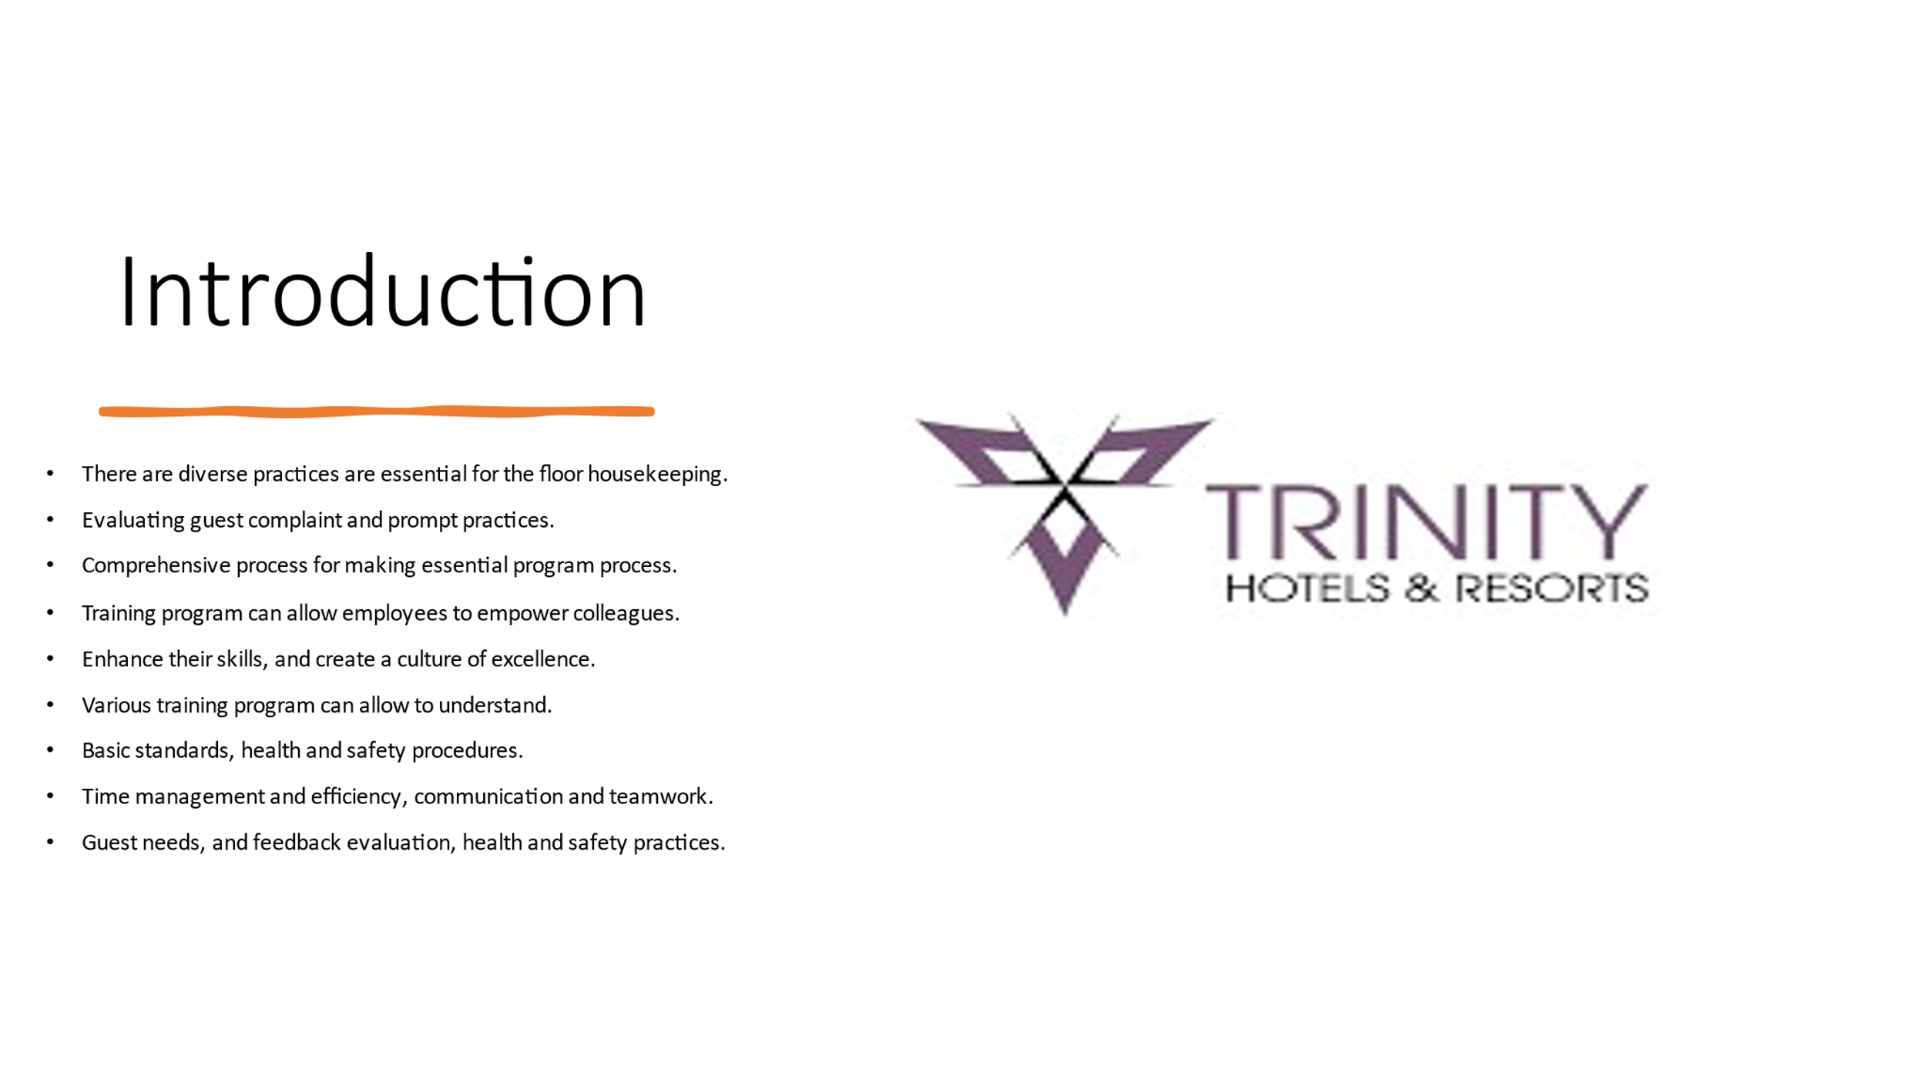

Training Notes: There are diverse practices are essential for the floor housekeeping manager to manage different activities (Bartho et al., 2023). Evaluating guest complaint and prompt practices can help to manage comprehensive process for making essential program process. Besides, the training program can allow employees to empower colleagues, enhance their skills, and create a culture of excellence within our department. Various training program can allow to understand basic standards, health and safety procedures, time management and efficiency, communication and teamwork, guest needs, and feedback evaluation, health and safety practices and others are a major part of training program for housekeeping team.
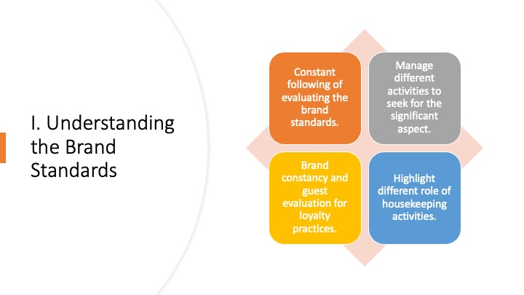

Training Notes: I. Understanding the Brand Standards
Adequate excellency practices and essential for effective team membership and understanding to embrace brand standards of the Trinity Hotel. Contratti et al. (2012) argued that there requires proper evaluation process of the team member to understand embrace different areas to perform. Training and development activities through standard process can allow to perform different activities in the right direction. Understanding the brand standards can allow to suggest different areas and manage activities in significant aspects.

Constant following of evaluating the brand standards and manage different activities to seek for the significant aspect.
Brand constancy and guest evaluation for loyalty practices.
Highlight different role of housekeeping activities can allow to adopt the standards.

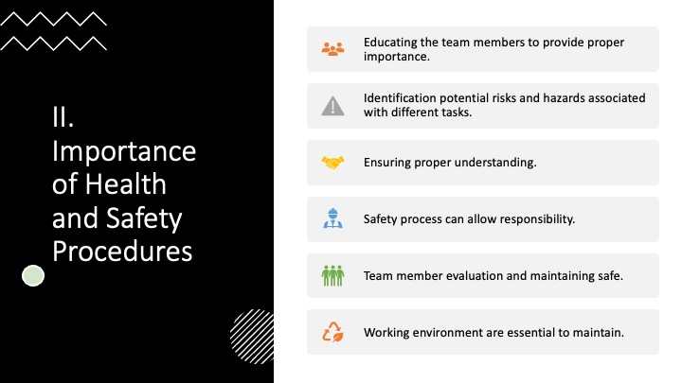

Training Notes: II. Importance of Health and Safety Procedures
There are diverse health and safety procedures can allow to manage team working activities in the right direction. Covering different areas and utmost importance can allow to perform within everyone.

Educating the team members to provide proper importance about the health and safety are essential.
Identification potential risks and hazards associated with different tasks.
Ensuring proper understanding and safety process can allow responsibility.
Team member evaluation and maintaining safe working environment are essential to maintain.

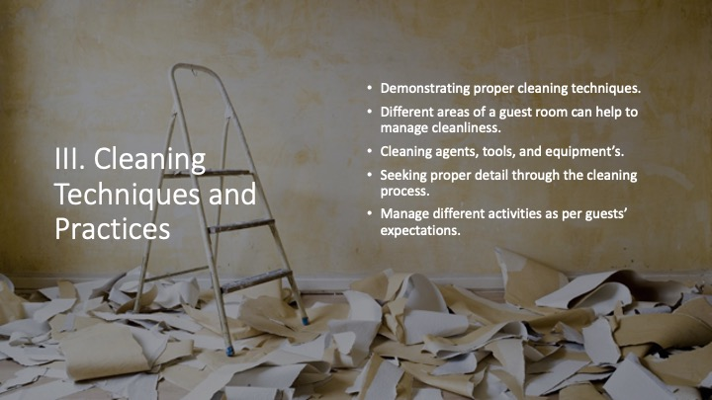

Training Notes: III. Cleaning Techniques and Practices
Seeking different cleaning techniques and practices are essential to maintain cleanliness and guest satisfaction.

Demonstrating proper cleaning techniques for different areas of a guest room can help to manage cleanliness.
Making sure proper guideline on the effective use of the cleaning agents, tools, and equipments.
Make sure different guidelines on the effective use of the cleaning agents.
Seeking proper detail through the cleaning process and manage different activities as per guests’ expectations (Sharma, 2019).

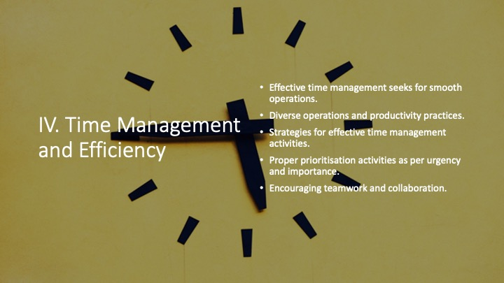

Training Notes: IV. Time Management and Efficiency
Effective time management seeks for smooth operations and diverse operations and productivity practices (Marshall and Manus, 2007).
Strategies for effective time management activities in housekeeping tasks.
Proper prioritisation activities as per urgency and importance are essential to manage efficiency.
Encouraging teamwork and collaboration process can enhance productivity.

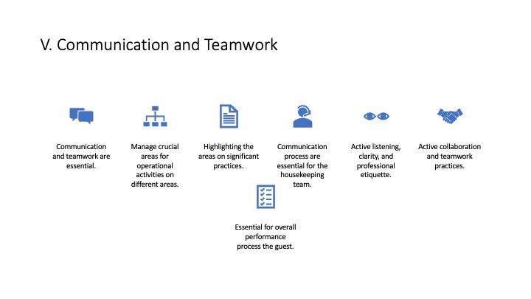

Training Notes: V. Communication and Teamwork
Communication and teamwork are essential for the team members to manage crucial areas for operational activities on different areas.
Highlighting the areas on significant practices on clear and respectful situation for communication process are essential for the housekeeping team.
Active listening, clarity, and professional etiquette can help to perform in the right areas.
Active collaboration and teamwork practices are essential for overall performance process the guest’s satisfaction practices (Mullins, 2013).
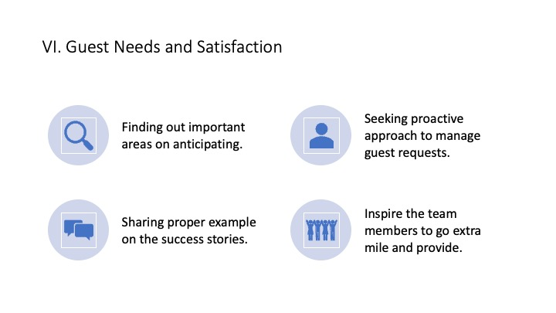

Training Notes: VI. Guest Needs and Satisfaction
Jones (2007) cited that understanding on the exceeding areas for guest expectations is essential to create memorable experiences.
Finding out important areas on anticipating for fulfilling guest needs.
Seeking proactive approach to manage guest requests for feedback practices.
Sharing proper example on the success stories to inspire the team members to go extra mile and provide the most effective service.
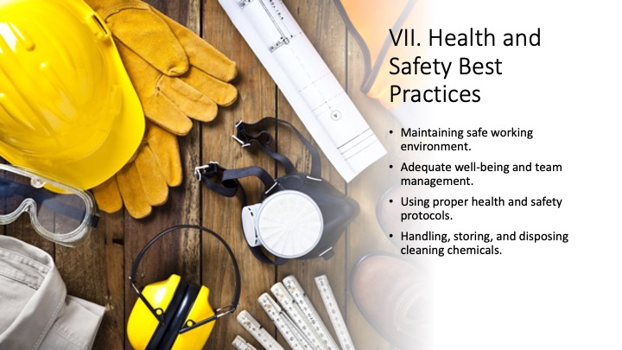

Training Notes: VII. Health and Safety Best Practices
Maintaining safe working environment for adequate well-being and team management for the guests are essential to secure best practices.
Using proper health and safety protocols can help to manage proper safety.
Adequate guidelines for handling, storing, and disposing cleaning chemicals (Ambardar, 2017).
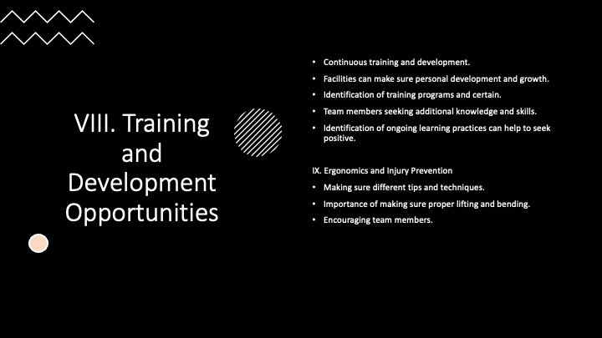

Training Notes: VIII. Training and Development Opportunities
Continuous training and development facilities can make sure personal development and growth.
Identification of training programs and certain opportunities are essential for housekeeping team.
Team members seeking additional knowledge and skills to manage performance.
Identification of ongoing learning practices can help to seek positive impact on individual and team success (Whitelaw, 2009).

IX. Ergonomics and Injury Prevention
Making sure different tips and techniques to manage good practices at the time of housekeeping.
Importance of making sure proper lifting and bending practices are prevent injuries.
Encouraging team members and making sure potential hazards are essential.
Employee Engagement Model
Penna’s model of Engagement
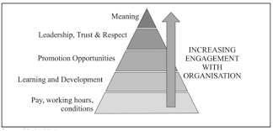
Training notes:
It is an engagement model that can help outline the ways followed by a business for
making its employees engage in its work. The main purpose of this employee
engagement is to ensure proper happiness, satisfaction, and engagement. In the
hotel industry, a good employee engagement program is arranged for supporting the
staff in doing their best function and making them enjoy it (Bridger, 2018).
Engaged employees produce more revenue (Gallup, 2020). A real life example could be Premier Inn: the hotel chain employees are engaged and happy in their workplace, fact that it has been demonstrated through the positive feedback from customers who had a memorable experience across UK. Their training is professional and updated regularly, the employees get discount on Premier Inn rooms and restaurants including a premium deal when they are on shift which according to statistics 67% of full time employees with access to free food at work are “extremely” or “very happy”at their current job and 12% more productive (HR, 2023).

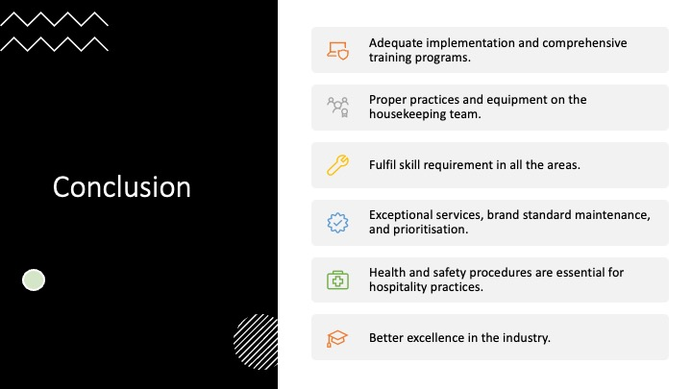
Training Notes: Adequate implementation and comprehensive training programs are essential to manage activities. Proper practices and equipment on the housekeeping team can allow to fulfil skill requirement in all the areas. Delivering proper exceptional services, brand standard maintenance, and prioritisation. Health and safety procedures are essential for hospitality practices and create better excellence in the industry.

References

Alali, S.A., Shrestha, E., Kansakar, A.R., Parekh, A., Dadkhah, S. and Peacock, W.F., (2020) Community hospital stethoscope cleaning practices and contamination rates. American Journal of Infection Control, 48(11), pp.1365-1369.
Ambardar, A. and Raheja, K., (2017) Occupational Safety and Health of Hotel Housekeeping Employees: A Comparative Study. International Journal of Hospitality & Tourism Systems, 10(2).
Bartho, L.A., Kandel, M., Walker, S.P., Cluver, C.A., Hastie, R., Bergman, L., Pritchard, N., Cannon, P., Nguyen, T.V., Wong, G.P. and MacDonald, T.M., (2023) Circulating chemerin is elevated in women with preeclampsia. Endocrinology, 164(5), p.bqad041.

Bridger, E. (2018) Employee Engagement : A Practical Introduction, Second edition. London : Kogan Page.
Contratti, F., Ng, G. and Deeb, J., (2012) Interdisciplinary team training: five lessons learned. AJN The American Journal of Nursing, 112(6), pp.47-52.
Enz, C.A. and Siguaw, J.A., (2000) Best practices in human resources. Cornell Hotel and Restaurant Administration Quarterly, 41(1), pp.48-61.
Gallup (2020) Available at gallup.com/services/178514/state-american-workplace.aspx (Accessed on 11 June 2023).
Hassanain, M.A., (2009) Approaches to qualitative fire safety risk assessment in hotel facilities. Structural Survey, 27(4), pp.287-300.
Holah, J.T., (2014) Cleaning and disinfection practices in food processing. Hygiene in food processing, pp.259-304.
Human Resources (2023) Available at:humanresources.about.com/od/Employee-Engagement/a/keys-for-emproving-employee-satisfaction-and-engagement.htm (Accessed on 11 June 2023).
Jones, T.J., (2007) Professional management of housekeeping operations. John Wiley & Sons.
Kaynak, E. and Rogers, R.E., (2013) Implementation of total quality management: A comprehensive training program. Routledge.
Kenters, N., Gottlieb, T., Hopman, J., Mehtar, S., Schweizer, M.L., Tartari, E., Huijskens, E.G.W. and Voss, A., (2018) An international survey of cleaning and disinfection practices in the healthcare environment. Journal of Hospital Infection, 100(2), pp.236-241.
Khadka, N., Bista, A., Adhikari, B., Shrestha, A., Bista, D. and Adhikary, B., (2020) Current practices of solar photovoltaic panel cleaning system and future prospects of machine learning implementation. IEEE Access, 8, pp.135948-135962.
Marshall, D.A. and Manus, D.A., (2007) A team training program using human factors to enhance patient safety. AORN journal, 86(6), pp.994-1011.
McCaule, L.A., Travers, R., Lasarev, M., Muniz, J. and Nailon, R., (2006) Effectiveness of cleaning practices in removing pesticides from home environments. Journal of agromedicine, 11(2), pp.81-88.
Meyer, J., Nippak, P. and Cumming, A., (2021) An evaluation of cleaning practices at a teaching hospital. American journal of infection control, 49(1), pp.40-43.
Mullins, L, and Dossor, P., (2013) Hospitality Management and Organisational Behaviour, Harlow Pearson Education, Limited.
Osborne, J. and Overbay, A., (2008) Best practices in data cleaning. Best practices in quantitative methods, 1(1), pp.205-213.
Richmond, J., (2007) Developing the role of a ward housekeeper within a multidisciplinary team. British journal of nursing, 16(1), pp.56-59.
Sharma, N. et al., (2019) Management Techniques for Employee Engagement in Contemporary Organizations. IGI Global. https://doi-org.ezproxy.uwtsd.ac.uk/10.4018/978-1-5225-7799-7
Whitelaw, P.A., Barron, P., Buultjens, J., Cairncross, G. and Davidson, M., (2009) Training needs of the hospitality industry. Sustainable Tourism, pp.1-30.

