

BEng OME
ACDB 5015
Design of Shaped Charges
Charlotte McCombe
Student Number: 2411524

Contents
List of tables 3
List of Figures 3
1-Introduction 4
2-Literature Review 4
2.1-Shaped Charge Overview 4
2.2 - History of shaped charges 5
2.3 - Applications 5
2.4 – Shaped Charge Operation 6
2.5 – Shaped Charge Geometry 7
2.6 - Materials used in shaped charges 8
2.7 – Computational Modelling of Shaped Charges 8
3 - Mathematical theories and Material Models 9
3.1 - Hugoniot curve 12
4-Materials used for shaped charge Simulation 13
4 - 2D Modelling 15
4.1 Analysis of 2D Models 16
4.2 - 3D Modelling 25
4.2.1SPH Modelling of 3D Model 30
4.3 - Further improvements to models 33
Conclusion 33
Bibliography 34

List of tables
Table 1 – Material parameters for Octol……………………………………………………………….14
Table 2 – Material Parameters for OFHC Copper……………………………………………………14
Table 3 – Material Parameters for AISI 1006 Steel………………………………………………….15
Table 4 – - Jet formation in Model 1 and Model 2……………………………………………………24

List of Figures
Figure 1 - Comparison of jet created by an EFP and Conical Shaped Charge [10] 6
Figure 2 - Common shaped charge shapes [12] 7
Figure 3 – Gurney Calculation for Velocity [12] 9
Figure 4 – Mie-Gruneisen Equation of State [6] 10
Figure 5 - JWL Equation of State [12]. 10
Figure 6- Johnson-Cook equation [16] 11
Figure 7 - Reduced Johnson Cook Equation [16] 11
Figure 8 - Hugoniot Curve [18] 12
Figure 9 - Design of Model 1 (Left) and Model 2 (Right) 18
Figure 10 - Contact between mesh on liner and HE Charge in model 1 18
Figure 11 - Pressure wave propagation through 2D Design 19
Figure 12 - S22 in 2D Models at a time of 3.8e-5 20
Figure 13 - Velocity-Time Graph for Model 1 and Model 2 21
Figure 14 - Side by Side Comparison of velocity in Model 1 (Left) and 2 (Right) 22
Figure 15 - Final Jet formation of model 1 22
Figure 16 - Strain model 1 (left), model 2 (right) 23
Figure 17 - Strain in model 1(left) and model 2(right) 23
Figure 18 - Experimental mesh of 3D Model 25
Figure 19- Pressure wave in Experimental mesh on 3D Model 26
Figure 20 - Experimental mesh 2 of 3D Model 27
Figure 21- Strain in 3D Model 27
Figure 22 - Refined experimental mesh of 3D Model 28
Figure 23 - Velocity Gradient in 3D Model 28
Figure 24 - Velocity Time Graph of 3D Model 29
Figure 25 - Comparison of 3D Model with SPH and Non-SPH 30
Figure 26 - Jet Formation in 3D SPH Model 31
Figure 27 - Velocity-Time Graphs of 3D Model (Left) and 3D SPH Model (Right) 31
Figure 28 - excessively distorted elements in 3D model 32
Figure 29 - Strain in jet Formation of 3D Model 32

1-Introduction
This assignment will cover the theory, design and simulation of an explosive shaped charge. The shaped charge was constructed of a liner, high explosive and case. The simulation was modelled using the ABAQUS software in both 2D and 3D simulations. The models were analysed to assess the stress, strain, deformation, pressure and velocity in two 2D models and one 3D model.

2-Literature Review

2.1-Shaped Charge Overview
There are various ways that a shaped charge has been defined. Many definitions highlight the differences between a hollow charge which does not have a liner, and a shaped charge that contains a liner material [1]. Shaped charges contain an explosive that when detonated produced a high velocity jet of materials [2]. A shaped charge is also described as an explosive charge with a hollowed-out area on the side facing the target producing directed and piercing effects [3]. Many sources of literature highlight that a shaped charge is an explosive mechanism capable of producing a high velocity jet or material with the main aim of penetrating a target. They have uses in many industries and can create accurate and directed energy at targets in air, land and sea [4].

2.2 - History of shaped charges
The shaped charge was developed through testing of putting a cavity opposite the initiation point in an explosive charge. It was concluded that by using a cavity, a smaller amount of explosive caused a deeper effect [5]. The shaped charge effect is also dated back to 1792 through the discovery of a cavity in black powder producing a greater blasting effect in a metal plate [6]. During the second world war research was conducted into using a liner material in the cavity and this assisted into the production of high explosive anti-tank (HEAT) projectiles and HEAT machine gun grenade [6].

2.3 - Applications
The evolution of the shaped charge has led to many uses in military applications including Anti-Tank missiles, warhead systems, ordnance disposal and demolition [7]. Aswell as military applications, shaped charges have proved to be successful in many civil applications such as the oil, gas, mining and aerospace industries. One example is the use of a shaped charge impact system to create a crater on the surface of an asteroid on the Hayabusa 2 mission [8].

2.4 – Shaped Charge Operation
Shaped charges use the energy provided from a primary explosive in the detonator to provide sufficient energy to detonate the secondary explosive within the case. The spherical wave propagates from the initiation point as a shock wave with a very high velocity. When the detonation wave hits the liner material it is accelerated under extreme high pressures and collapses the line producing an elongated high velocity jet. The material of the jet can experience elongations greater than 1000% of the original length [9]. The jet produced is at variable velocity with the tip capable of reaching speeds greater than $10k{ms}^{-1}$ and the slug reaching upwards of $2kms^{-1} CITATION Ruy21 \backslash l 2057 [2]$. There are many contributng factors to the performance of shaped charges such as the liner angle, diameter and stand off distance. Figure 1 shows the comparison of jet fomation in an explosively formed projectil and a conical liner, highlighting the importance of geomerty for different operations.
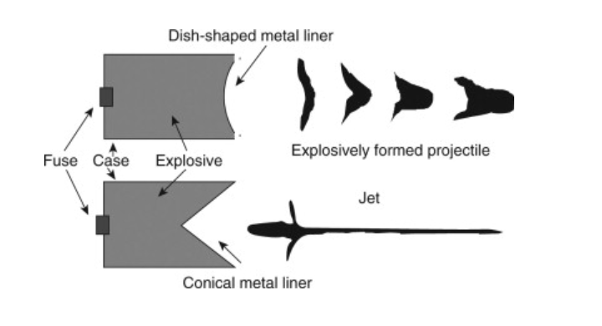
Figure 1 - Comparison of jet created by an EFP and Conical Shaped Charge [10]
The Munroe effect outlined the main principals of the shaped charge explosion and focuses on the formation of the shaped charge jet. The directed force produced through the detonation of an explosive creates local and precision damage to targets. In the form of jets.

2.5 – Shaped Charge Geometry
Shaped charges exist in many different forms such as cone shapes and variable thickness liners. Some of the most common shaped include conical liners and axial symmetric designs. Non uniform varying thickness liners have different jet effects and can create different penetration characteristics into targets [11] . Many shaped charges range from 20mm to 200mm diameters depending on their application [6]. The geometry of shaped charges in influenced by the desired output of the system and the environment in which it is used. Common shapes include conical, truncated and ogive with some designs shown in figure 2.
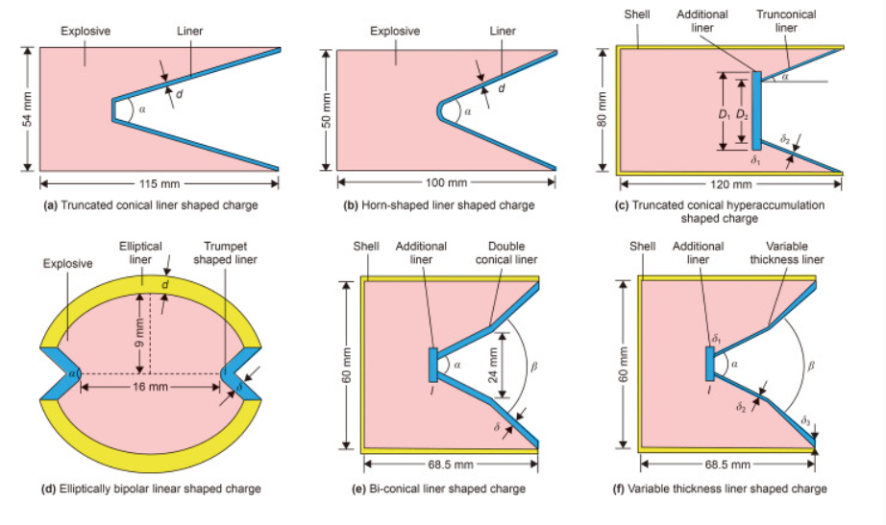
Figure 2 - Common shaped charge shapes [12]
The double angle shaped charge shown in Figure 1(e) and (f) is a deign used that can produce a higher velocity jet and uses more of the liner material. The doubled angle liner features a narrower angle at the apex followed by a change in geometry and a winder angle at the base. There have been studies completed highlighting that a double angles liner improved penetration performance by 14.5% than that of a single angle conical liner [13].

2.6 - Materials used in shaped charges
Materials used for the explosive, case and liner of a shaped charge are selected carefully to meet the optimum and desired performance. The liner is usually a metal to produce a high velocity jet however work has been completed on the use of non-ductile materials such as glass and ceramics. For this application the jet is formed by liner shattering and being forced together to produce a jet [14] . The explosive selected for use in shaped charges is required to have high detonation velocity and brisance to create the formation of the jet [14]. The optimum liner thickness has been validated with theories suggesting the optimum liner thickness to be related to the apex angle with the relationship of sine of one half of the apex angle [15].

2.7 – Computational Modelling of Shaped Charges
Finite element analysis (FEA) is a common method used to solve numerical simulations based on input values and provide solutions. This is done through graphs, simulation and data. The FEA required a model to be broken down into smaller elements through the meshing of an object. Computational modelling provides an efficient and accurate representation of the many complex problems faced withing the defence industry. Using models allows material data and interactions to be defined and allow the behaviour to be modelled in a time and cost-efficient method.
The Abaqus software is a CAE tool that can be used for modelling shaped charges. When using explosive materials in Abaqus it does not use chemical methodology to understand the detonation process and was instead given a specific detonation point and velocity of detonation to produce the shock wave. The J-C model is assumed to be accurate in modelling the high strain in the models and the equation of states accurate in the for the high pressure and stress in the model. The model is assumed to be symmetrical with a quarter model used in the simulations to save computing time and costs. This ensure that the submitted job was as efficient as possible.
The J-C model used assumed that the material was homogenous and isotropic therefore did not capture any imperfections in the materials which could happen in real word simulations. Impurities such as cracks and voids can reduce the material strength in these regions and ductility; therefore, high stress rates and pressure could affect the jet formation.
Boundary conditions were assumed to be perfect with no boundary separation and perfect transitions between each part. Another limitation of simulating a shaped charge on Abaqus is the validation can be difficult. Using new geometries can prove difficult due to the lack of literature for comparison and validation. Experimental research can also be difficult and costly requiring many resources.

3 - Mathematical theories and Material Models
There are many mathematical theories that govern shaped charges. The gurney equations are used in explosives engineering to calculate the velocity of the collapsing liner. It Is reliant on the ratio of the mass of metal to the mass of explosive and assumes that all potential energy of the explosive is transferred to the liner as kinetic energy [12]. The velocity of the collapsed liner can be calculated using the equation in figure 3 where $μ=\frac{Charge mass}{Case weight}$. The gurney constant E is a given value for metal liner materials. Gurney equations assume that all potential energy of the explosive is transferred to the liner as kinetic energy
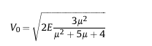
Figure 3 – Gurney Calculation for Velocity [12]

The selected material models used for the simulation were the Johnson-Cook, Jones Wilkins Lee and Mie-Gruneisen. The Mie-Gruneisen is an equation of state (EoS) and is used for materials in extreme states and under high pressures. The EoS is used to model the high. The EoS uses the Gruneisen parameter which is a function of volume for estimating the changes and deformation in the liner collapse. This EOS works alongside the Johnson-Cook model to model the deformation and jet formation. The $U_{s}-U_{p }$ EoS is a linear model and used for calculating the pressure in a material undergoing shock. The equation in figure 4 below is used:
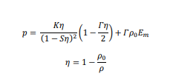
Figure 4 – Mie-Gruneisen Equation of State [6]
$$p=pressure, η=vlumetric compression, K=bulk modulus$$
$$, S=Hugoniot slope, Γ=Gruneisen paramter, ρ=current density,$$
$$ρ_{0}=initial density and E_{m}=specific internal energy$$

The Jones Wilkins Lee (JWL) is an equation of state to support detonation products and unreacted explosives in simulations. The equation models the pressure produced in the detonation of the explosive. It was applied to the Octol explosive to represent the pressure and volume relationship. This is calculated using the equation in figure 5.
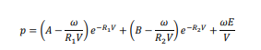
Figure 5 - JWL Equation of State [12].
A,B, R1, R2 and ω are material parameters shown in table 1, E is the internal energy and V is relative volume.

Johnson Cook is a damage model used for materials that undergo extreme strain and deformation. The model is used to express the flow yield stress through the equation in figure 6:
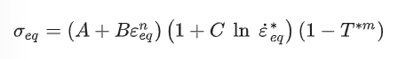
Figure 6- Johnson-Cook equation [16]
This equation can then be reduced using the yield stress under quasi-static conditions to:
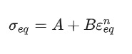
Figure 7 - Reduced Johnson Cook Equation [16]
$$σ_{eq}=flow yield strength, A=yield stress, B=strain hardening modulus,$$
$$ε_{eq}=equivalent plastic strain$$

Using these models in the simulation allowed for an accurate representation of the deformation from explosive detonation to jet formation. This model accounted for the strain in the model and thermal softening.

3.1 - Hugoniot curve
The Hugoniot curve relating to explosives represents the pressure, volume and energy within shock wave interactions. The jump equations establish how materials react to shock waves and the sustainment pf detonation The Hugoniot equations are derived from newtons laws of motions are used to explain the propagation of a shock as well as the conditions either side of the wave moving through a material initially as rest. These equations can be shown in three ways for the conservation of mass, momentum and energy [17]
$ρ\left(U-u\right)=ρ_{0}U$ conservation of mass
$ρ-ρ_{0}=ρ_{0} U u$ conservation of momentum
$ρ u=ρ_{0} U (E-E_{0}+\frac{u^{2}}{2})$ also written as $E-E_{0}=\frac{1}{2}(ρ+ρ_{0})(u_{o}-u)$ conservation of energy
U is the velocity of the shock front, u is the translational particle velocity, $ρ$ is the density of material behind shock front and $ρ_{0}$is the density of material ahead of the shock wave. E ais the energy of the material after compression and $E_{0}$ is energy before.
The Hugoniot curve shown in figure 8 expresses the relationship between the velocity and pressure in both cases of detonation and deflagration.
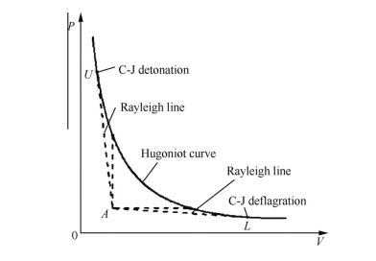
Figure 8 - Hugoniot Curve [18]
The Hugoniot graph shows the initial state of the explosive at point A and the Chapman-Jouguet points at which detonation occurs (Upper point) and where deformation occurs (Lower point). The Hugoniot alone does not characterise an explosive material and only focuses on the shock transition, therefore equation of state and J-C parameters or other behavioural parameters are required.

4-Materials used for shaped charge Simulation
The performance of shaped charges is highly dependent on the materials used for each part. Copper produces greater penetration than materials including steel and aluminium and was selected for use in the liner [19]. Octol is a HMX/TNT mix that is meltable and castable which is ideal for shaped charge applications. It also has high energy density increasing the precision [20]. AISI 1006 Steel was selected for the casing of the model. The material parameters are shown in Tables 1, 2 and 3 using the J-C model, the JWL model for the explosive and the Mie-Grüneisen model for the liner.

Table 1 – Material parameters for Octol [6]
Density(kg/m3) | 1821
JWL
Detonation Wave Speed | 8480
A (Pa) | 7.486 ${×10}^{11}$
B (Pa) | 1.338${×10}^{10}$
Omega | 0.38
R1 | 4.5
R2 | 1.2
Detonation Energy Density ($\frac{J}{m^{3}})$ | 5274000
Pre Detonation Bulk Modulus (Pa) | 34200000000
Table 2 – Material Parameters for OFHC Copper [6] [21]:
Density | 8960
Shear Modulus (GPa) | 46
Us-Up
$$C_{0}$$ | 3900
S | 1.5
Gamma0 | 2
A (Pa) | $$90×{10}^{6}$$
B (Pa) | $$292×{10}^{6}$$
n | 0.3
m | 1.1
Melting Temperature (K) | 1381
Transition Temperature (K) | 293
C | 0.025
Epsilon dot zero | 1

Table 3- Material Parameters for AISI 1006 Steel [6]
Density | 7896
Youngs Modulus | $$200×{10}^{9}$$
Poisson’s Ratio | 1
A (Pa) | $$350×{10}^{6}$$
B (Pa) | $$270×{10}^{6}$$
n | 0.36
m | 1
Melting Temperature (K) | 1811
Transition Temperature (K) | 293
C | 0.022
Epsilon dot zero | 1

4 - 2D Modelling
The 2D shaped charge was modelled using the ABAQUS software with 2D axisymmetric elements. This ensured rotational symmetry ensured boundary conditions, geometry and loading were adhered to throughout the model. An explicit dynamic solver was used which uses finite element solver. This was selected due to the requirements for the analysis of the shaped charge The explicit solver used small time steps suitable for modelling the high velocity, extreme deformation and contact in the shaped charge.
The shaped charge design and parameters were set in the following order: Part, Property, Assembly, Step, Interaction, Load, Mesh, Job, Visualisation.
Part – In the property module the shaped charge was drawn in a 2D plane using 3 separate parts. The liner was drawn first to ensure that the angle of the peak was correct. The HE was then drawn using guidelines from the sketch of the liner, followed by the case using the sketch lines from the liner and the HE.
Property - The property module was the completed incorporating the material parameters in tables1-3. Each part was then designated assigned the connecting material with the detailed material models.
Assembly – The model was then assembled combining the three parts. The initial interaction was set to general contact with all with self. Frictionless behaviour was defined for the tangential behaviour and hard contact for the normal behaviour.
Step – The step module was used to set the maximum run time for the simulation and the frequency for plot dumps was set by having evenly times intervals.
Mesh – The meshing module was used split the model into constituent smaller elements. Each part was meshed individually by using a global seed. This was then refined using a single bias mesh to refine the mesh on the part subject to the most deformation, stress and strain. The mesh chosen for the model used tri element shapes and explicit axisymmetric finite element formulations. A gradual mesh was used by using a local global seen on the main contact areas. The meshing of both models used the same size global seed to ensure similarity for comparison of the two models.
Load – In the load module a plane of symmetry was set for 2D axisymmetric calculation using a mechanical boundary condition of symmetry. This used the areas of the HE, liner and case and were defined as a XSYMM condition, ensuring that no point could move in the x direction.
Job – The job module was used to select the model and submit the job for simulation with an automatic time step and maximum time output.
Visualisation – The visualisation module was used to view the results of the simulation. As the model was axisymmetric this was swept into a 180-degree model for a stronger visualisation of results.

4.1 Analysis of 2D Models
The simulation focused on the comparison of a single and double angle cone to assess how the second angle would affect the jet behaviour Model 1 featured a conical liner with a rounded 60-degree cone. Model 2 featured a conical liner with a rounded 60-degree cone and a double angle liner with a second angle of 120 degrees. The liner thickness was set as 1mm to produce a high velocity jet and reduce radial expansion during jet formation [22]. In the visualisation module the analysis focused on the velocity, pressure, the PE Max in plane strain and the S22 stress. This gave an overview of the behaviour of the models relevant to that of the material models used. The geometries of both models are shown in figure 10 with an experimental mesh. The mesh used for the main simulations was that defined in model 1.
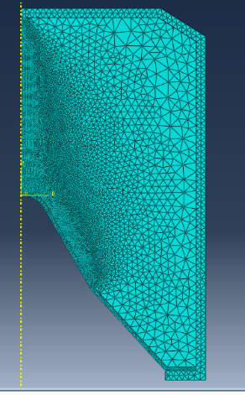
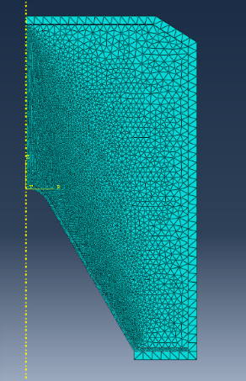
Figure 9 - Design of Model 1 (Left) and Model 2 (Right)
A tri mesh was used throughout all parts due to the curvature on the liner. This produced a smoother transition between the parts and therefore improving the contact under conditions. The mesh was most refined in the contact region between the HE charge and the peak of the liner with the contact shown in figure 11. This created more nodes for numerical calculation to take place. The mesh on the case was not refined as the damage parameters were not included in the model and the focus was on the jet formation.

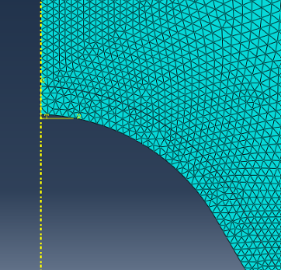
Figure 10 - Contact between mesh on liner and HE Charge in model 1
Upon initiation of the explosive, the pressure wave propagated from the detonation point towards the apex of the liner with a supersonic pressure front with values reaching greater than 68GPa. Furthermore, producing velocities of greater than 10km/s in the jet formation of the liner. The pressure was most dominant during the detonation phase where the shock wave from the initiation point is produced. As the shock wave propagated through the explosive the stress increased due to the force acting throughout the model. From the initiation point the pressure propagated through the shape charge with extreme high pressures at the shock front followed by lower pressures. The initial elongation of the jet occurred under high pressure, whereas the further stretching occurred at a lower pressure. The stress and pressure on the liner ultimately led to an increase in strain throughout the liner producing the jet travelling at a high velocity

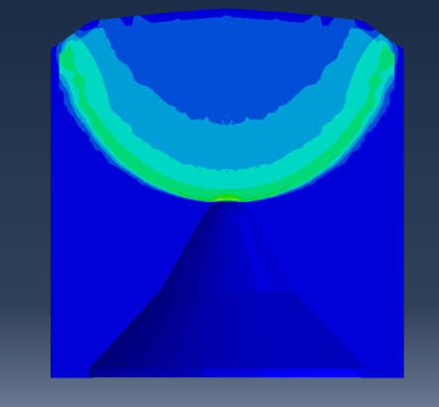
Figure 11 - Pressure wave propagation through 2D Design

In both models there was extreme stress values present throughout each part caused by the initiation of the explosive. The liner underwent a huge compression, ultimately leading to the formation of the jet.
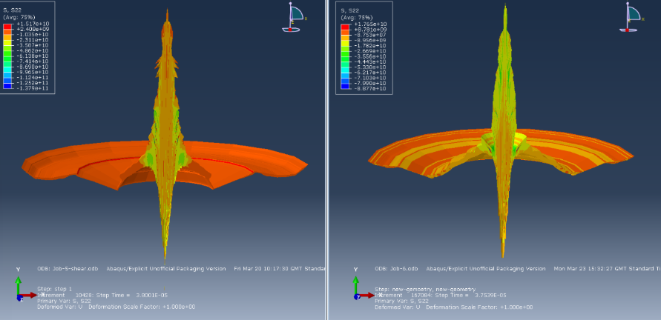
Figure 12 - S22 in 2D Models at a time of 3.8e-5
At a time of 3.8e-5 the jet had formed with a visible tip and slug. The stress in the liner was seen to have a greater maximum value in model 2 with a value of 1.765e10 compared to the maximum of 1.517e10 in model 1. This high stress areas were seen in areas throughout the jet and the slug. In model 2 there was also regions of lower stress in regions of the of the liner not visible in model 1. This highlighted an uneven stress distribution caused by the second angle in the shaped charge. The jet in model 1 was less uniform than that of jet 2 with higher stress concentrations through the central points including the slug. The stress distribution in model 2 highlighted that the design had stronger axial compression producing a uniform and greater jet length at a given time [23] .
The velocity of the jet was expected to reach extreme high speeds due to the material’s high ductility and applications in shaped charges. Literature sources suggest that copper liners are capable of producing speeds greater than 7km/s [2]. Both model 1 and 2 surpassed this value shown on the velocity-time graph in figure 15.
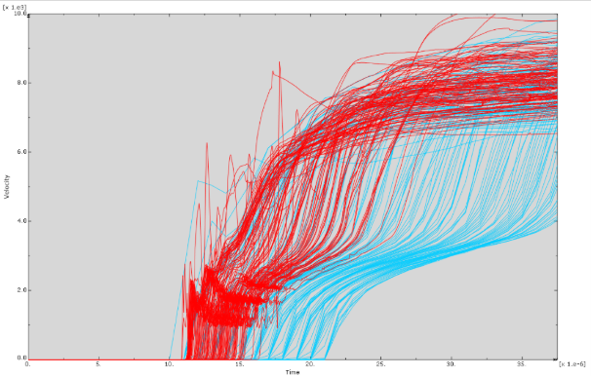
Figure 13 - Velocity-Time Graph for Model 1 and Model 2
The blue lines represent the velocity of model 1 and the red lines represents model 2 with nodes selected from the tip of the jet. The velocity-time graph showed that both jets reached velocity’s upwards of 9km/s with some nodes travelling closer to 10km/s. These nodes were spalling of the material which didn’t form in the central part of the jet and instead travelled alongside main jet formation. It was also seen that the nodes in model 2 took a greater amount of time to increase to the maximum velocity.
In both models, there was a clear velocity gradient from the tip to the slug. The velocity in model 1 was around 9km/s at the tip and around 9.5km/s in model 2. The velocity of the slug was much slower in model 2 travelling between 4 and 5km/s, whereas the nodes in model 1 were travelling between 5 and 6km/s shown in figure 16.
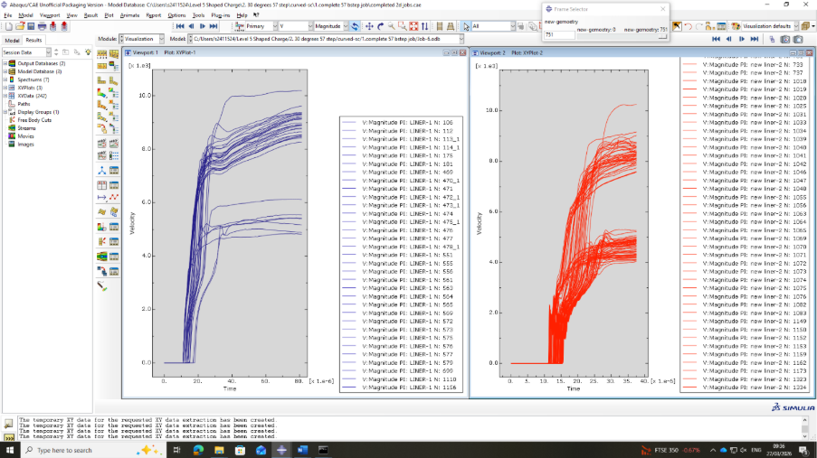
Figure 14 - Side by Side Comparison of velocity in Model 1 (Left) and 2 (Right)
The final jet formation of model 1, shown in figure 17 highlighted that with a successful run time the liner would have produced a streamlined jet with tip velocity of 10km/s and a slug at a lower value 2km/s
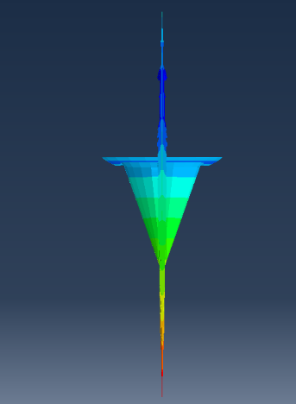
Figure 15 - Final Jet formation of model 1

The liner underwent extreme strain conditions with the material undergoing extreme deformation. At a time of 2.2e-5 the strain within the jets was seen to have a similar maximum of 3.3 In both jets with lower values between 1 and 2 in the outer region of the jet. The maximum strain was concentrated in the central point at which the liner was hit by the detonation wave. At this point the copper was deforming plastically with an extremely high strain rate.
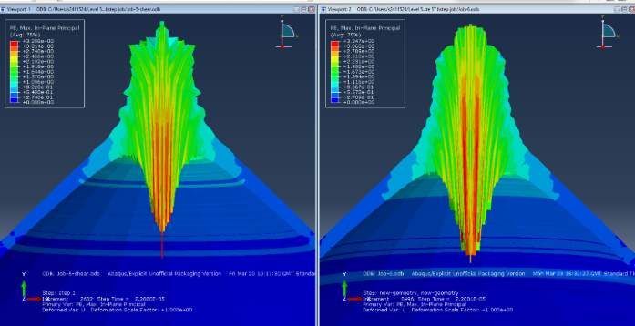
Figure 16 - Strain model 1 (left), model 2 (right)
As the jet continued to form, the strain values remained concentrated across the axis throughout the jet, due to the extreme stretching that occurs in this region. Model 2 aborted at a time of 3.7539e-5 due to excessive distortion. High strain could be seen throughout the liner, with a high concentration in the centre but also in the edges of jet.
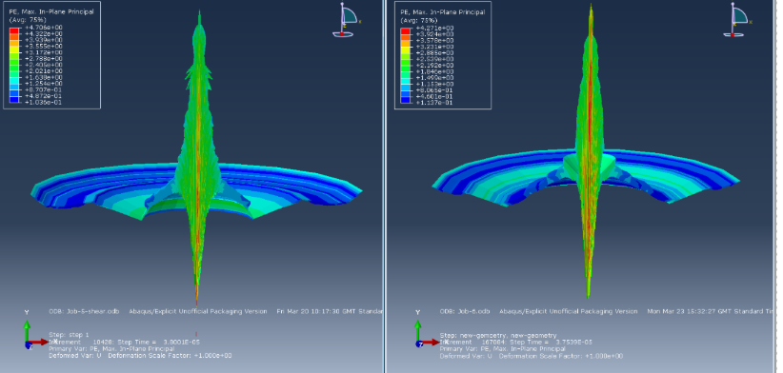
Figure 17 - Strain in model 1(left) and model 2(right)
As the simulation aborted due to excessive distortion it was not possible to see the final formation of the jet in flight from the shaped charge in both simulations and the final strain in the liner. The final formation is shown in table 4 throughout various steps.
Table 4- Jet formation in Model 1 and Model 2
Model 1 | Model 2
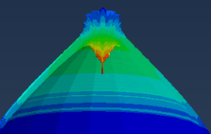 | 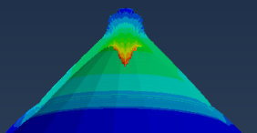
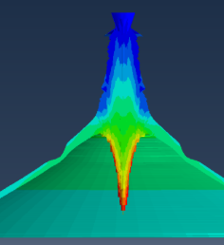 | 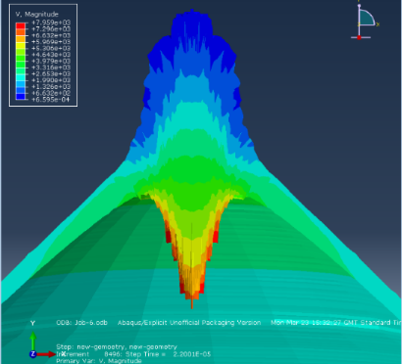
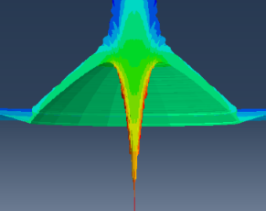 | 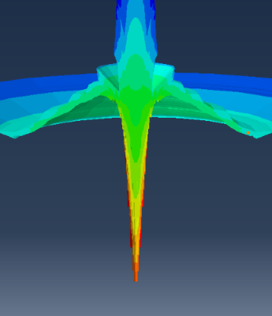
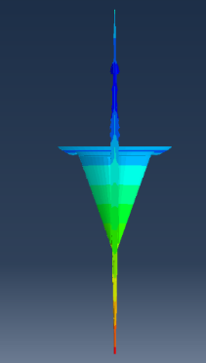 | 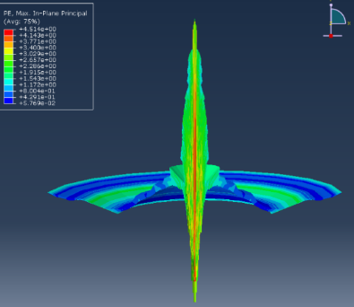
Ultimately the 2D analysis was not ideal for identifying the similarities and differences in the jet formation due to model 2 having a smaller run time.

4.2 - 3D Modelling
The 3D model used the 60-degree cone angle geometry from model 1 and was revolved into a 3D shape maintain symmetry and properties throughout. To allow a smoother energy transfer between the explosive a boundary condition was created between the outer side of the barrier and the inner side of the explosive. This boundary condition allowed smoother surface to surface contact as the shock wave travelled through the materials. This allowed for more accurate values in the contact between the HE and the liner. The viscosity parameter was also increase to a value of 1 to improve the simulation run time ad stability in the model.
The 3D model was initially tested using a very course mesh with little refinement in the contact region between the liner and HE as show in figure 18.
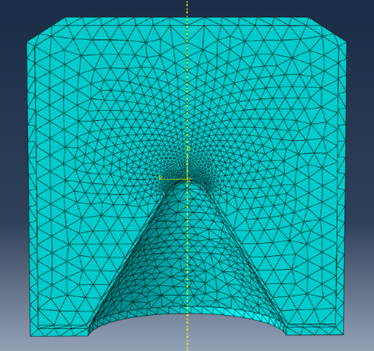
Figure 18 - Experimental mesh of 3D Model
The job was aborted due to excessive distortion which occurred when the pressure wave came into contact with the liner at a time of 1.3001e-5 shown in figure 19. The jump from the coarse mesh to the refined mesh caused issues within the elements due to the number of contact point been the coarse and refined areas.
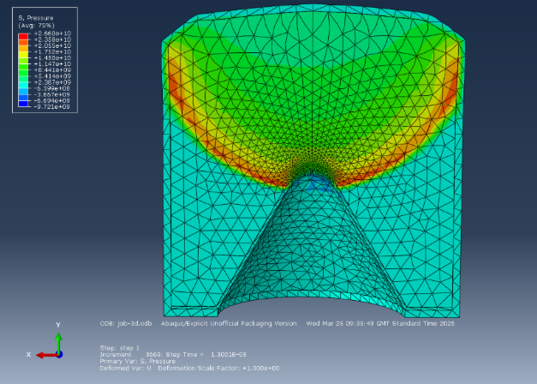
Figure 19- Pressure wave in Experimental mesh on 3D Model
In order to improve the run time of the simulation, the distortion control within the simulation was added with a length ratio of 0.1. An interaction between the outer surface of the liner and inner surface was used to prevent HE spill. The refinement of the mesh around the liner apex was also made coarser for a smoother transition from larger elements to smaller elements shown in figure 20.
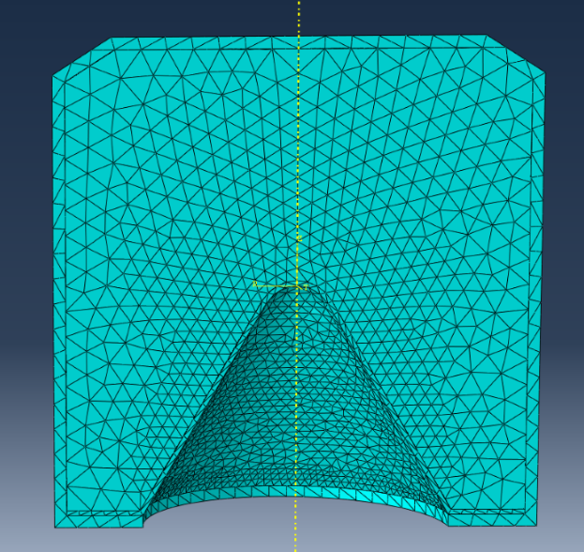
Figure 20 - Experimental mesh 2 of 3D Model
Using this mesh the jet formed however was very inaccurate to that of a real-world example. The elements underwent severe distortion, and the jet was not uniform. This mesh had the advantage of the gradient being like that of the propagation of the shock wave with a convex gradient allowing smoother transitions. The strain in the jet was similar to 2D model 1 with values of around 3 but did not have any concentrated areas in the centre or around the axis, as shown in figure 21.
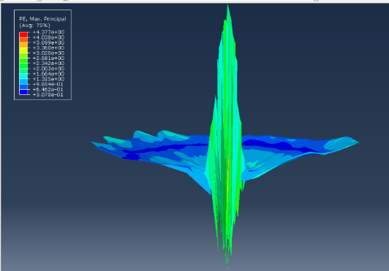
Figure 21- Strain in 3D Model
The mesh was further refined shown in figure 22 to improve the contact between the HE and the liner, however the simulation failed to run due to errors therefore the job used the mesh in figure 20 for analysis.
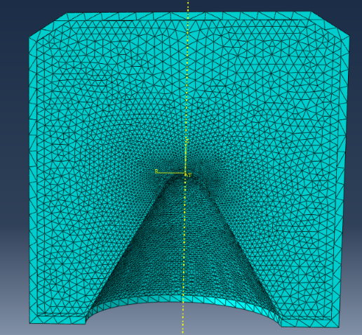
Figure 22 - Refined experimental mesh of 3D Model
The velocity within the jet showed a gradient but it was not as strongly visible as the 2D model. As the jet formed the velocity increased towards the tip with a lower velocity slug travelling behind the tip.
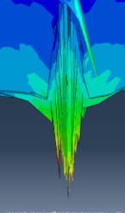
Figure 23 - Velocity Gradient in 3D Model

A velocity-time graph was produced for this model using a selection of nodes from each part of the jet and showed a clear gradient with the tip travelling between 6-8km/s. In comparison to the 2D model graph shown in figure 13. The velocities were travelling in a higher region of between 7 and 9km/s in figure 13 whereas the 3D model had lower velocity between 7-8km/s in the tip.
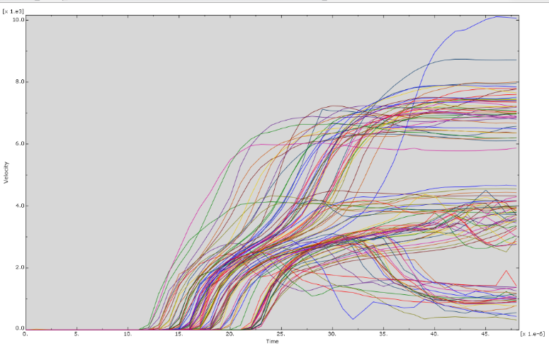
Figure 24 - Velocity Time Graph of 3D Model

4.2.1SPH Modelling of 3D Model
The smooth Particle Hydrodynamics (SPH) method was introduced to the model to deal with velocity detonation and extreme deformation taking place in the model. The SPH was set to act when the stress in the liner supassed a determined value. This increased the run time of the simulation and the formation of the liner in particle form.
At a time of 4.8e-5, the non-SPH model had a maximum velocity of 1.006e4 compared to a much greater velocity of 7.706e3 visible in the SPH model. However, in the SPH model many particles had deleted due to extreme deformation. In this comparison an extremely coarse mesh was used. The comparison between the models can be seen in figure 26.
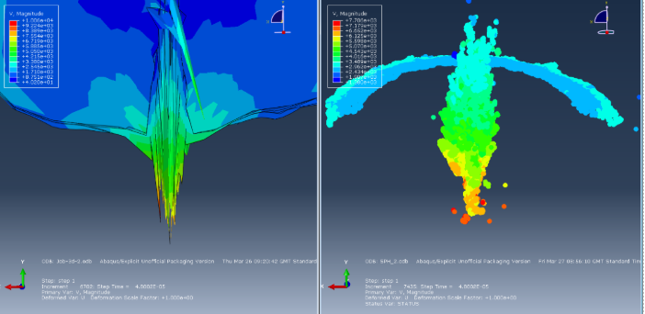
Figure 25 - Comparison of 3D Model with SPH and Non-SPH
In both models, the velocity is clearly seen to be much greater at the tip compared to the slug. The meshing quality of both models hindered the results as it led to incorrect calculations taken place for each time step from the effect of the previous calculations being incorrect. The extreme distortion of elements was also seen with severely deformed mesh elements not expected in shaped charge performance.

The run time of the SPH model was much greater and showed the formation of a high velocity jet in figure 26. It was seen that the jet began to refine towards the tip with a larger area at the slug.
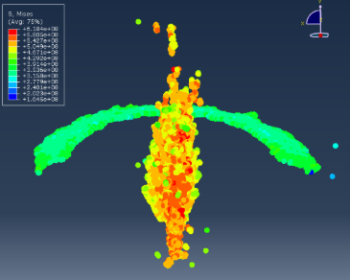
Figure 26 - Jet Formation in 3D SPH Model
Velocity-Time graphs were produced for the 3D models shown in figure 27. It was clear that the SPH model produced results closer to that of the 2D model, however the velocities were much lower. In both 3D models there was a clear velocity gradient shown on the graph.
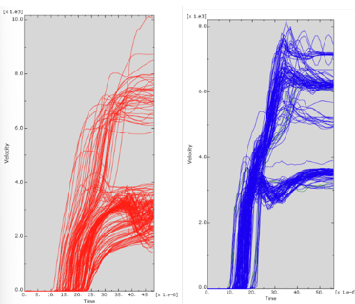

Figure 27 - Velocity-Time Graphs of 3D Model (Left) and 3D SPH Model (Right)

The elements in the 3D simulation underwent sever distortion with some deleted elements show in figure 28. The strain throughout the liner was high with values over 2 times greater than the original length.
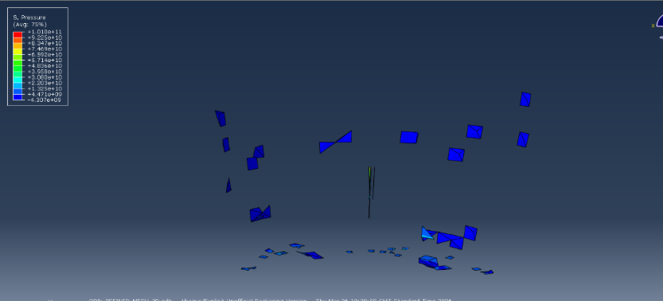
Figure 28 - excessively distorted elements in 3D model
The strain in the 3D liner was not as accurate as the 2D liner with the concentrated areas not appearing in the central axis and not being very saturated in the tip of the jet.
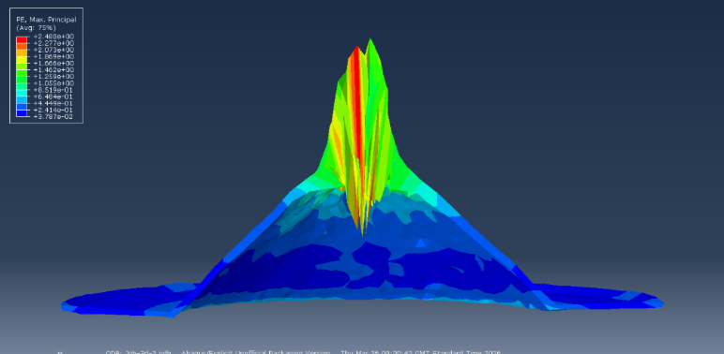
Figure 29 - Strain in jet Formation of 3D Model
In summary the 3D Model did not provide an accurate representation of Model 1 with discrepancies in areas including, stress, strain and jet formation.

4.3 - Further improvements to models
The model could have been improved by adding a target material to the simulation to validate results both experimentally and mathematically. Using a mathematical equation for the penetration depth into a target can be done using the equation below [12]:
$$H=Z( ({\frac{V_{j}}{V_{c}})}^{ \frac{1}{γ}}-1)$$
Z is the jet length from the virtual origin from the target
$V_{j}$ is jet tip velocity
$V_{c}$ is the jet rear velocity
$γ$ is the square root of target jet density ration given by $γ=\sqrt{\frac{ρ_{T}}{ρ_{j}}}$
This would improve the validation of a behaviour of a shaped charge and improve future reach for efficient standoff distances and cone diameter. Within computer aided engineering, using meshing tools such as adaptive meshing would also improve the accuracy of simulated results.

Conclusion
In conclusion shaped charges offer a small and effective geometry suitable for use in many industries. The modelling of shaped charges using computer aided engineering software allowed for the behaviour of liner material, explosive material and behaviour to be analysed. The modelling of the shaped charge can prove difficult due to the many interactions and extreme conditions faced by the mechanisms. This report shown that the geometry of a liner and selection of materials can heavily influence the performance and jet characteristics of a shaped charge.

Bibliography

[1] | W. Walters, “A Brief History of Shaped Charges,” Army Research Laboratory , Aberdeen Proving Ground, MD, 2008.
[2] | A. J. Ruys, “Continuous metal fiber-reinforced silicon carbide,” in Metal-Reinforced Ceramics, Woodhead Publishin, 2021, pp. 69-119.
[3] | A. H. Galvani, “Theory and Application of Shaped Charges,” US Naval Postgraduate School, California, 1951.
[4] | Y. Han, J. Yin, H. Cui, G. Bi, C. Duan, Y. Zhang, H. Li and J. Qi, “Study on the Penetration Performance of Micro,” Journal of Physics:, vol. 1855, p. Article 012013, 2021.
[5] | D. Novotney and M. Mallery, “Historical Development of Linear Shaped Charge,” in Session: ECS-2: Material Aging and Testing, Cincinnati, 2012.
[6] | A. Gustafasson, “Shaped Charge Design,” Karlstad University, Karlstad, 2021.
[7] | J. Hall, “Shaped Charges: Harnessing Precision in Explosive Technology,” Alford Technologies, 20 January 2025. [Online]. Available: https://www.explosives.net/shaped-charges-explosive-technology/. [Accessed 11 April 2026].
[8] | T. Saiki, H. Sawada, C. Okamoto, H. Yano, Y. Takagi, Y. Akahoshi and M. Yoshikawa, “Small carry-on impactor of Hayabusa2 mission,” Acta Astronautica, vol. 84, pp. 227-236, 2013.
[9] | W. Walters, “Shock Waves in the sudy of shaped charges,” US Armt Ballistic Research Laboratory, Aberdeen Provig Ground, MD, 1991.
[10] | M. French and A. Wright, “8 - Developing mine blast resistance for composite based military vehicles,” in Blast Protection of Civil Infrastructures and Vehicles Using Composites, Cambridge, Woodhead Publishing, 2010, pp. 244-268.
[11] | Z. Zhao, D. Sheng, J. Chen, A. Yan, Y. Chen, H. Wang, X. Chen and L. Dai, “Machine learning optimization strategy of shaped charge liner structure based on jet penetration efficiency,” Defence Technology, vol. 39, pp. 23-41, 2024.
[12] | K. Jiang, S.-C. Deng and H.-B. Li, “Theoretical calculation and analysis of the velocity of shaped charge jet with modified collapse velocity model,” Petroleum Science, vol. 21, no. 6, pp. 4311-4327, 2024.
[13] | J. Park and S. Kwon, “Study on the Penetration Performance of a Double-Angle Linear Shaped Charge: Performance Improvement and Miniturization,” Aerospace, vol. 11, no. 4, p. Article 310, 2024.
[14] | C. Austin, “Lined-Cavity Shaped Charges and Their Use in Rock and Earth Materials,” NEW MEXICO INSTITUTE OF MINING & TECHNOLOGY, New Mexico, 1959.
[15] | O. Klamer, “Shaped Charge Scaling,” US Army, 1964.
[16] | B. Hong, W. Li, Y. Li, W. Li, P. Chen and Y. Wang, “Development and experimental validation of the dynamic constitutive model and equation of state for Mo-10Cu alloy,” Defence Technology, vol. 51, pp. 145-58, 2025.
[17] | J. Rinehart, “Compilation of Dynamic Equation of State Data for Solids and Liquids,” US Naval Ordnance Test Station, California, 1965.
[18] | Z. Rui, W. Dan and W. Jianping, “Progressofcontinuouslyrotatingdetonation,” Chinese Journal of Aeronautics, vol. 29, no. 1, pp. 15-29, 2016.
[19] | C. Kong, Y. Li, Y. Jin, J. Xia, Q. Wang and Y. Liao, “Analysis of the influence of charge liner on the penetration effect of shaped charge jet assisted window sidetracking,” Geoenergy Science and Engineering, vol. 243, p. Article 213300, 2024.
[20] | M. Murphy, “The Effect of Gradients in HMX/TNT Content and Porosity on Shaped Charge Jet Charachteristics,” Lawrence Livermore National Laboratory, California, 1989.
[21] | “Copper, Cu: Annealed,” Matweb, [Online]. Available: https://www.matweb.com/search/datasheet_print.aspx?matguid=9aebe83845c04c1db5126fada6f76f7e. [Accessed 30 March 2026].
[22] | X.-w. Hou, X.-f. Zhang, W. Xiong, C. Liu and M.-t. Tan, “Journak of Materials Research and Technology,” Shaped charge jet formation and penetration to steel target of FeNiCoCr high-entropy alloy liners, vol. 39, pp. 2234-2245, 2025.
[23] | Q. X. Xiao, Z. Huang, X. Zu and B. Ma, “The effects of compressibility and target strength on shaped charge jet penetration,” Defence Technology, vol. 56, pp. 244-253, 2026.
[24] | R. Menikoff, “Complete Mie-Gruneisen Equation of State,” Los Alamos National Laboratory, Los Alamos, 2016.

