
APPENDIX GA36a

LEVEL 4 ASSESSMENT SPECIFICATION
Assessment 1

Student name: | NUR SABRINA BINTI KASTAWINATA | Student ID number: | 2527782
Programme: | BACHELOR OF BUSINESS ADMINISTRATION (HONOURS) IN INTERNATIONAL BUSINESS
Module: | Contemporary Challenges: Making a Difference
Module code: | MWBA4000 | Contribution to Overall Module Assessment (%): | 100%
Lecturer: | Emma Roberts | Internal Verifier: | Vic Saunders
Assignment Title: | Group Presentation with supporting material (max 4 in a group) | Word count (or equivalent): | 5 mins each plus 1,500 words supporting material
Submission deadline: | Monday 24th August 2026 (23.55/ 11.55pm British Summer Time BST) | Return date of provisional marks & written feedback: | 21st September 2026
Submission method: | All written assessments, where practical and possible, must be submitted via Turnitin unless otherwise instructed by the Lecturer. (Please DO NOT put this assessment specification into Turnitin or it will match many similarities with other students’ submissions.)  Alternative submission method (if applicable):  Late submission of the assessment will result in a late penalty mark:  Work which is submitted up to 1 week late will be capped at 40% for the first attempt and will be awarded a mark of 0% for re-assessment. Late submission penalties may be lifted only if there is an approved extenuating circumstances claim.  Work submitted more than 1 week late will be considered as a non-submission and will not be marked. The work may be considered as a submission for reassessment if offered by an Examining Board or if there is an approved extenuating circumstances claim.
Academic honesty / referencing: | Academic honesty is required. In the main body of your submission you must give credit to authors on whose research and ideas your work is based. Append to your submission a reference list that indicates the books, articles, etc. that you have used, cited or quoted in order to complete this assessment.

Module Learning Outcomes
(from module syllabus)
- Identify and evaluate historical and contemporary issues and their impact on today's global society.
- Apply appropriate collaborative working practices to manage conflict and support effective decision making.
- Implement Design Thinking techniques to investigate problems in order to generate and evaluate solutions.

Use of Generative AI in Assessment
(Lecturer to indicate Yes or Not against each element)

RESEARCH | For this assessment, you can use Generative AI to support you in research, including searching for bibliography, using tools to summarise, compare and interrogate materials. | Yes ☒  No ☐
STRUCTURE | For this assessment, you can use Generative AI to support you in structuring your submission, including creating a draft argument structure, identifying parts and headings, etc. | Yes ☒  No ☐
PROOFREADING | For this assessment, you can use Generative AI to check your own text/creation for grammatical and syntactical mistakes, including rephrasing of your own work within specific standards. | Yes ☒  No ☐
WRITING | For this assessment, you can use Generative AI to create text for submission. | Yes ☐  No ☒
CREATIVE | For this assessment, you can use Generative AI to create creative materials, such as images. | Yes ☒  No ☐
PROGRAMING | For this assessment, you can use Generative AI to create and check code. | Yes ☐  No ☒
NONE | For this assessment, you are not allowed to use any type of Generative AI support. This includes research support, structure support, writing/proofreading support and creative support. | Yes ☐  No ☒

Assessment – Supporting Guidance for Individual Notes of this Group Assignment (1,500 words)

Section 1 – 5 mins of the group presentation
https://drive.google.com/file/d/1PsED7T-G_0WyGG-u7H56Wlvdi6fGDdVX/view?usp=drive_link
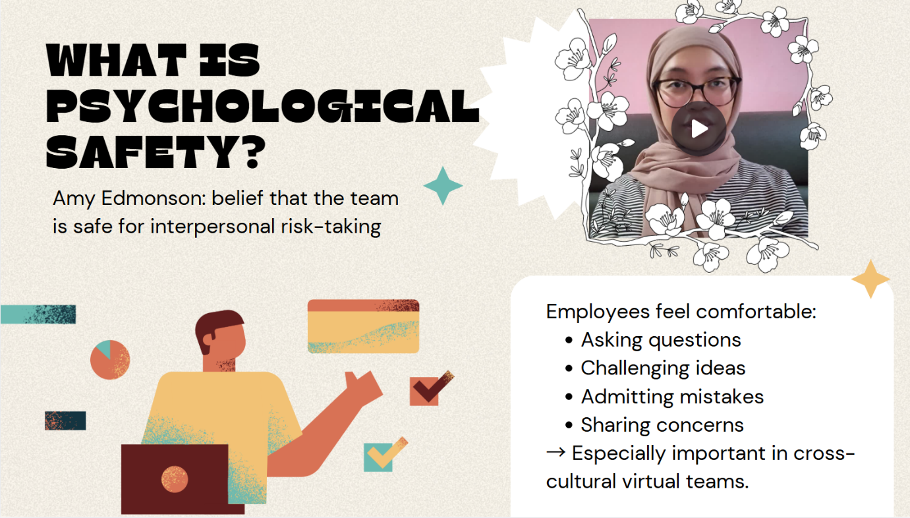
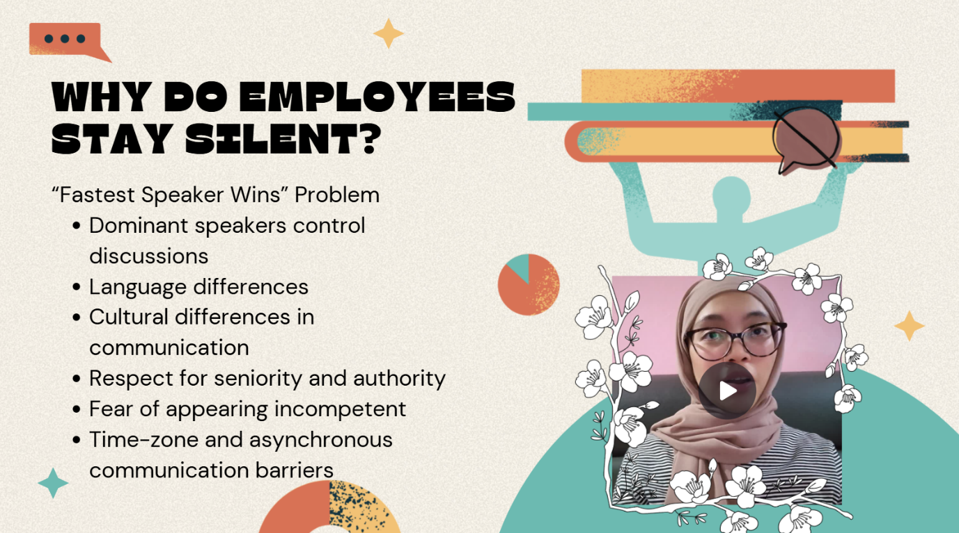
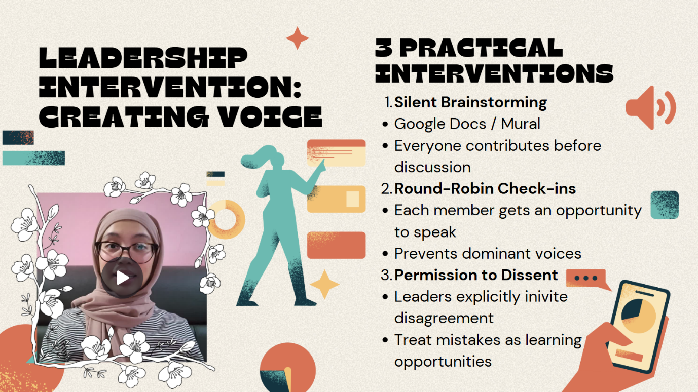
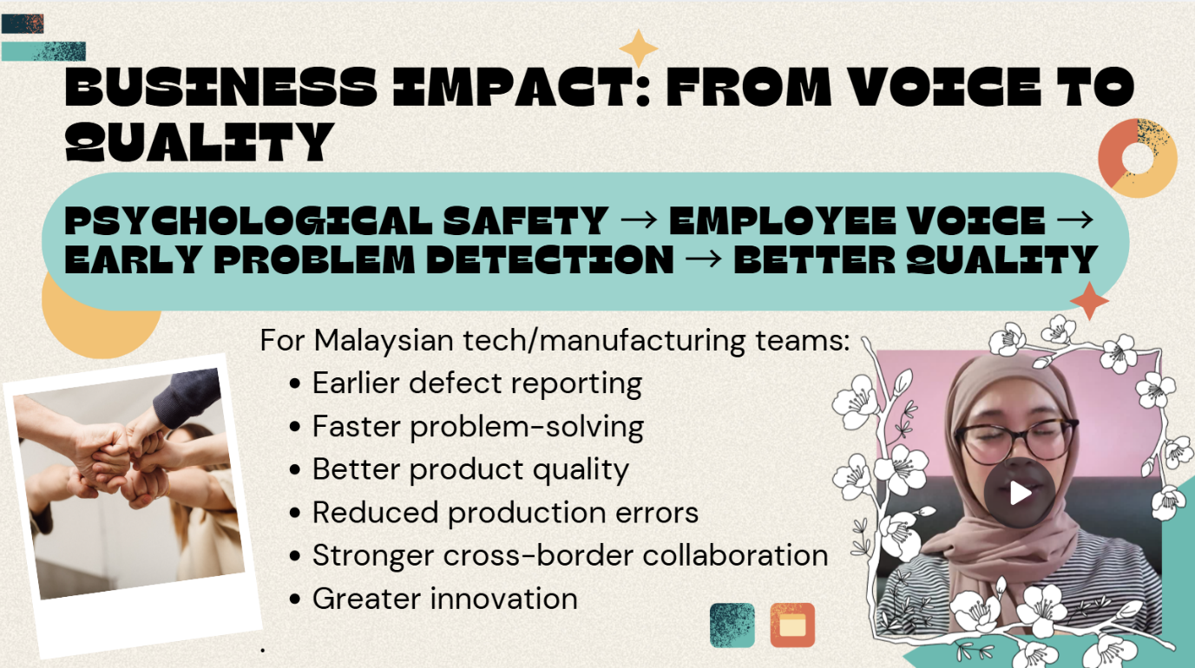

Section 2 – 700 words discussion
2.1 Group Overview and Content Summary
This group presentation consisted of four students and were focused on the context of multinational corporations and technology hubs in Malaysia. The presentation was organized into four interconnected areas, with Member 1,Sarah Binti Johan Shah (2527783), introducing the issue of cultural divide between Malaysian teams and Western headquarters by examining Hofstede's cultural dimensions, followed by Member 2, Nur Sabrina Binti Kastawinata (2527782), discussing on psychological safety and employee voice in virtual teams, Member 3, Madeeha Binti Mohamudiah (2527788), addressed the different time zones, burntout, and trust through virtual meetings through the Job Demands-Resources model and Swift Trust Theory, while proposing asynchronous working practices, and Member 4, Mya Syahindah Binti Ahmad Nasrul Hakim (2538270), concluding with modern virtual leaders and proposed a Malaysian Virtual Leadership Toolkit. Overall, the presentation demonstrated how Malaysian multinational technology hubs can effectively manage cross-cultural, virtual and geographically dispersed teams.
2.2 Inter-Relationship with Other Group Members Content
The content presented by Member 2 was directly related with the cultural challenges identified by Member 1. Member 1 explained the differences in power distance and communication styles may influence how Malaysian employees communicate with international managers or colleagues. For example, it is less likely that employees interrupt, openly disagree with senior colleagues or immediately report problems. Thus, creating a situation where international managers incorrectly interpret silence as agreement. Silence offers few cues and creates misunderstandings and misattribution of motive (Kaderly, 2025). Member 2's discussion of psychological safety provided a behavioural and leadership response to this problem. Based on Edmondson's psychological safety framework, employees are more likely to ask questions, admit mistakes, share ideas and respectfully challenge decisions when they perceive that interpersonal risks are accepted within the team (Edmondson, 1999). Therefore, Member 1 explained the cultural and communication barriers, while Member 2 explained how leaders can create an environment that encourages employee voice. The use of silent brainstorming, round-robin check-ins and invitations to disagree reduces the communication barriers found in the first section.
Member 2's content also provided a foundation for Member 3's discussion of time zone difference and trust. Psychological safety mainly talks about the quality of employee participation, whereas Member 3 explained how communication and collaboration could be maintained when team members were geographically separated. Psychologically safe virtual meetings may support employee voice, however, too much synchronous meetings can create negative impacts such as late-night meetings, constant availability which further lead to burnout. Therefore, asynchronous practices were proposed to ensure flexibility, improved productivity, inclusivity, and better collaboration and documentation (Staff, 2025). The approaches complement psychological safety because employees can give ideas without always need to respond instantly during a virtual meeting. Thus, Member 2's emphasis on employee voice was connected to Member 3's emphasis on flexible communication and sustainable working practices.
Member 4's content was significantly related to Member 2 because the final virtual leadership framework incorporated the central ideas presented by the previous members. Member 4 explained the roles of modern leaders through technology, trust, communication, and emotional intelligence and not only about supervision. Furthermore, global virtual leadership strategies such as structured digital communication, inclusive cross-cultural communication, and trust- based communication was proposed to fix existing problems. Cultural empathy reflected Member 1's discussion of cultural differences, psychological safety directly incorporated Member 2's focus on employee voice, and asynchronous leadership reflected Member 3's discussion of time-zone management and trust.
2.3 Contribution to Overall Group Conclusions
The psychological safety section contributed to the overall conclusion by demonstrating that effective cross-cultural leadership requires more than technological connectivity. Member 1 explored how cultural differences can discourage employees from openly communicating, while Member 2 explained how leaders can intervene to encourage employees to speak. Member 3 showed how asynchronous working can reduce the pressures relating geographical distance and times zones, while Member 4 combined these approaches into a virtual leader framework. Thus, psychological safety represented an important link between the identifying communication problems and the development of practical leadership solutions, while also demonstrating that encouraging employee voice can have organisational benefits.
2.4 Conclusion: Personal Contribution to Key Ideas
The contribution to the group presentation mainly focuses on how psychological safety can change cultural communication barriers into opportunities for employee voice and team collaboration. Overall, psychological safety served as a key behavioural mechanism within the argument, showing that successful global leadership requires employees to voice their opinion and to feel sufficiently supported to contribute to organisational decision making.

Section 3 – 300 words Critique
3.1 Critical Evaluation of Key Ideas
The presentation provided a useful framework to understand cross-cultural virtual leadership, however, several ideas require critical evaluation. Hofstede's cultural dimensions may risk presenting Malaysian and Western employees as homogeneous groups, as individual personality, organisational culture, professional experience and language proficiency influences communication. The presentation suggested that psychological safety encourages employees to speak up, however, psychological safety might not guarantee employee voice. Employees might remain silent due to other unlisted factors such as previous experiences or lack of confidence. Thus, psychological safety should be considered a supporting factor rather than being a complete solution. Not to mention, asynchronous work has its limitations as asynchronous communication may delay urgent decisions, create misunderstandings, and make collaboration difficult for complex issues. Leaders should be able to distinguish between tasks that require synchronous collaboration and tasks that can be completed asynchronously.

3.2 Alternatives Perspective and Critical Thinking
An alternative perspective can be obtained from Morrison (2014), who argues that employee voice is influenced by factors beyond an individual's willingness to communicate, including organisational structures and perceived risks. This implied that leaders must demonstrate that employee feedback leads to meaningful action rather than only encouraging employees to speak. This perspective strengthened the critical evaluation of the group's argument because it highlighted the importance of organisational responsiveness. Although the proposed practices by the group's argument may increase participation, some employees might feel pressured when they are required to speak spontaneously. A combination of synchronous and asynchronous communication may therefore be more appropriate.

3.3 Critical Reflection
The critical reflection showed that effective group work requires more than dividing responsibilities between members. The process strengthened the ability to go through reasoned discussions and to manage disagreements constructively. The experience demonstrated that psychological safety is relevant not only to the presentation topic but also to ensure effective group collaboration. In conclusion, technology and leadership practices alone cannot eliminate cultural barriers as employees also need sustained trust and supportive organisational practices.
Section 4 – 500 word reflection
4.1 Gibbs Reflective Cycle
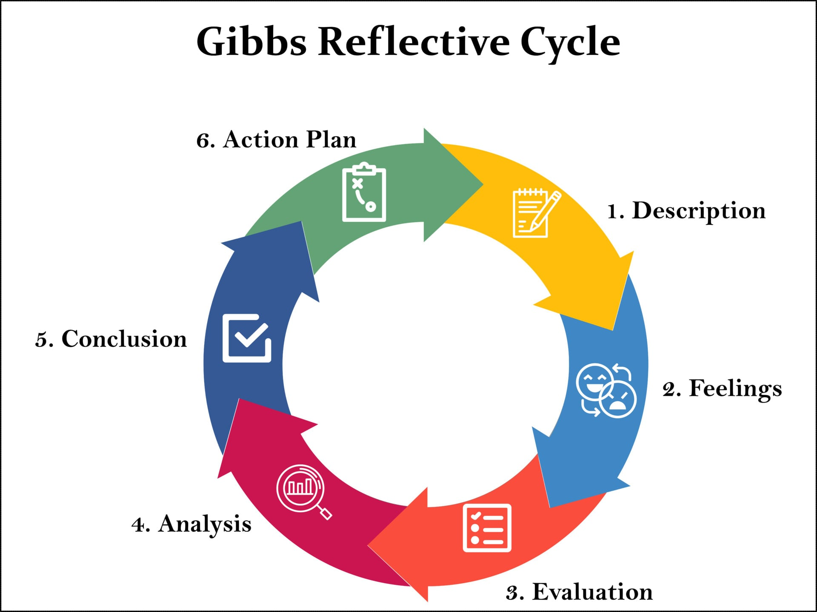
Gibbs’ Reflective Cycle is a theoretical model, developed in 1988 by Professor Graham Gibbs, that provides a structured framework for experiential learning through a structured six-stage process of reflection (McLoed, 2025). It provides a structured approach to reflect on an experience through six stages which includes description, feelings, evaluation, analysis, conclusion, and action plan. The model was used to evaluate the experience of completing the group presentation and to identify the development of collaborative working, communication, decision making, and conflict management skills.

4.2 Description
The group presentation consisted of four members in which each member was responsible for a specific aspect of leading asynchronous and cross-cultural global teams. The responsibilities were divided according to the presentation structure. Member 1 introduced the cultural differences, Member 2 focuses on the aspect of psychological safety, Member 3 discusses time zones and trust, and Member 4 develops the final virtual leadership framework. My responsibility was to research, explain about the psychological safety and how it affects employee voice, and explain how leaders could foster Malaysian employees to participate more actively in virtual meetings. The group collaborated ideas by discussing relevant theories and ensuring that the four sections are connected logically.

4.3 Feelings
Initially, I felt slightly uncertain whether my section would connect effectively with the other members' topics. However, after going through each members' slide and discussing the presentation structure with the group, I was slightly assured that the transition from cultural differences to psychological safety was clear. I also felt responsible in making sure that my section contributed meaningfully to the presentation overall rather than appearing as a separate topic.

4.4 Evaluation
Multiple aspects of the collaboration were successfully. The division of the presentation parts into individual sections allowed each member to take responsibility for their research and preparation. The group also benefited from having different perspectives when selecting theories and parts to present. However, coordinating different sections required additional communication because the content needed to be consistent in terms of structure and argument. Some ideas also required discussions between the members to avoid repetition in points or explanations. These challenges demonstrated that completing individual tasks does not ensure effective teamwork.

4.5 Analysis
The group experience allowed me to develop several collaborative skills introduced in Unit 2. These skills were particularly relevant when coordinating the four individual sections and ensuring that the presentation followed a logical progress. Critical thinking was used when deciding whether theories such as psychological safety were relevant to the Malaysian MNC context. Decision making was also required when selecting parts of the presentation to be included within the limited presentation time.

4.6 Conclusion
The experience showed a successful teamwork that requires more than just completing the assigned task. It required communication, time management, shared responsibility, and willingness to consider other perspectives. My main learning was that an individual contribution becomes more effective when supported by other team members.

4.7 Action Plan
For future group projects, I would make sure to establish clearer deadlines for completing individual sections and schedule earlier group meetings for discussions. I would also recommend using a shared document to coordinate references, slide contents, and to ensure that the researched part is linked to each other. Personally, I would also practice my presentation earlier to improve my confidence and proficiency when presenting.

4.8 Overall Reflection
Overall, the group task provided a valuable experience in collaborative working and demonstrated the importance of the skills introduced in Unit 2. The experience increased my communication, critical thinking, and decision-making. Most importantly, it showed that effective collaboration depends on combining each individual strengths in the group for an effective shared outcome.
REFERENCES
- Kaderly, J. (2025, January 8). A deafening silence — Brave bird. Brave Bird. https://www.gobravebird.com/blog/a-deafening-silence
- Edmondson, A. (1999). Psychological safety and learning behavior in work teams. Administrative Science Quarterly, 44(2), 350–383. [1]
- Staff, C. (2025, December 1). What is asynchronous communication (And why it’s essential)? Coursera. https://www.coursera.org/articles/asynchronous-communication
- Morrison, E. W. (2014). Employee voice and silence. Annual Review of Organizational Psychology and Organizational Behavior, 1(1), 173–197. https://doi.org/10.1146/annurev-orgpsych-031413-091328
- Simply Psychology. (2025, March 26). Gibbs Reflective Cycle. https://www.simplypsychology.org/gibbs-reflective-cycle.html

