Nadine Gayle 1816824

Title: The UK's senior population is continuing to expand, and this has an influence on the delivery of health and social care services.

Assignment: Written
Module code: BMHP6009
Lecture: Joanne Davis

The UK's senior population is continuing to expand, and this has an influence on the delivery of health and social care services.

The question is whether the UK's senior population is continuing to grow, and whether this has an impact on healthcare and social care delivery.
This module will examine and analyse the impact of services such as health care and social care on the elderly, focusing on the distinctions between the two and the effects on the old population at the local, national, and global levels, considering current initiatives and policies. To think about the future of aged care, particularly how technology and artificial intelligence (AI) will be used in health and social care.
Health care refers to the efforts of medical experts to assist us in regaining our bodily and mental health, which will be discussed in further detail later (Roper et al., 1988).
Many types of persons with learning difficulties, physical disabilities/diseases, and mental disorders can all benefit from social care programmes. care Practical activities, personal care, and social work may be included in this support, all of which are aimed at making it simpler for persons receiving social assistance to live comfortably. (CANTOR, 1989).

This essay will conclude a summary of several findings which will also be followed by recommendations that will help future policy and practice.

What is the definition of old age? When a person reaches the age of 65, they are typically considered to be elderly. However, a precise definition is difficult to apply because people age at different rates biologically, therefore someone at 75 might be considered elderly. healthy compared to a person aged 60 (Government Office for Science, 2016).
But this will not be the case in every country in some countries old age is not the same as it states in the United Kingdom.
The phrase "old age" has 2 different meaning. That's an age group or generation made up of some of the population's oldest people, and it's the last stage of a person's life cycle.
The social parts of advanced age are affected by the association between the physiological impacts of maturing, the normal encounters and shared upsides of that age, and the particular association of the general public where they live (The Editors of Encyclopaedia Britannica, 2018).

Some of the things we must remember while looking at old age in society is the aging theory Considers old age to be a time of mutual separation for the older person and society (e.g., retirement from work)
One of the earliest attempts to describe the situation of old age in modern civilization.
that
Doesn't always relate to people's outer behaviour; it may also refer to a person's inner attitude toward life (Introduction to Sociology, 2014).

Over the last couple years the world has had a global pandemic called COVID -19 also known as coronavirus which cause problems with the lungs that can affected the respiratory system, due to the pandemic it has took the lives of a significant amount of lives it’s had a massive strain on people, The broader effects are less visible but no less concerning: health care denied for reasons unrelated to COVID-19; institutional and care facility neglect and abuse a rise in poverty and unemployment this same big effect on well-being and mental health as well as the emotional damage of stigma and discrimination (United Nation, 2020).

Some societal challenges are far more likely to have an impact on the life quality of elderly persons Here are a few examples
- Becoming a lone as the result of the death of a spouse, lover, or close friend who provide one with company.
- Social isolation due to adult children's busy life, occupations, and families, plus the fact that they do not reside close.
- Retirement losing one's feeling of self-worth and motivation to get out of bed.
- Living arrangements (Not been able to live on their own due to health problems)
- Financial difficulty, not been able to maintain a large property
- Unable to eat due to not been able to manage the physical side of things.
- Difficulty with accepting the change in physical that are caused by ageing.
- Eating habits have changed due to aging and not wanting to eat to been alone.
(Netuveli and Blane, 2008)

According to global population forecasts, the share of elderly people is rising and will continue to rise in the foreseeable future. Many nations are already dealing with the issues of dealing with an ageing population, such as greater worker pension payments and higher national retirement ages (McKenna et al., 2020).
Many Statistics are showing a huge difference in the population of ageing and how they've altered in recent year, according to united nations In 2017, the global population of people aged 60 and above totaled 962 million, more than two times the 382 million people aged 60 and up in 1980.
By 2050, the number of elderly people is expected to have increased by more than double, reaching over 2.1 billion. In 2030, more seasoned persons aged 60 and up are expected to outperform youths and adolescents (1.41 billion vs 1.35 billion), while in 2050, more seasoned individuals aged 60 and up are expected to outperform youths and teens (1.41 billion versus 1.35 billion).
(United Nations, 2017).

The age structure of the UK population is migrating towards later ages as people live longer and have fewer children." Cohabiting families are the fastest-growing family form, and more young adults are staying with their parents” (BBC Bitesize, 2011) (Appendix 1)

Having a rise on the global population due to rise over the next 29 years, means there is a global strain on the health and social department as well as other health care providers, meaning that care homes will also be seeing a lot more elderly people coming through the doors. This change has come from the medical advances that have been seen over the last decade, allowing people to live longer. Been able to manage our population's advancing and maturing structure is basically affected by two reasons. First of all, expanded everyday routine anticipation implies that individuals experiencing longer significance individuals having less youngsters or having them further down the road (Storey, 2018).

Since the previous generations such as our grandparents, the Health Status for England study demonstrates that we are not necessarily enjoying healthier lives. This development sparks a debate about the challenges and possibilities that an ageing society brings, such problems as cost pressures arising because of an uprise on ageing population, since the older person are living longer (Raleigh, 2021) (Appendix 2)
Due to more updated medical technology and more excessive research. With patients that are more prone to have chronic illnesses with numerous other types of illnesses, which are more expensive to treat, meaning Death rates have largely improved significantly, especially globally and for a variety of reasons, as stated inside the Health Status for England report, however, there has been a halt in overall progress since 2011 (Sorenson, Drummond, and Bhuiyan-Khan, 2013).
Mortality rates from heart disease and stroke have decreased by half in both males and females since 2001, as have death rates from various major malignancies (e.g., lung cancer in males and breast cancer in females). Dementia-related mortality, on the other hand, have risen among both men and women (Ferguson and Belloni, 2019).

The medical care framework, which joins both general society and private areas, is alluded to as wellbeing and social consideration. Wellbeing is seen as a component of prosperity, which is affected by an assortment of components, for example, natural, ecological, dietary, and everyday environments (Dam, 2019)

There is such a high increase for healthcare services, we ask our self why is this in which is because it’s important for those who are not able to take care with such things as Physical activities, personal hygiene, and social work may be included in this support, all of which are aimed at making it possible for those receiving social assistance to live comfortably (Stevens and Gabbay, 1991).

Social consideration is engaged with regular tasks like eating and fundamental cleanliness upkeep, just as keeping an individual's opportunity, expanding social commitment, shielding them from weak circumstances, and managing confounded connections. Social consideration is basically upheld by humanitarians and social assistance associations, and it centers around youngsters, grown-ups, and the older who are in danger of illness, incapacity, or destitution. Just as areas that aren't generally related with medical care, as lodging, water supply, sewage, and food safety (Stevens and Gabbay, 1991).

Social work - The objective of cultural specialists is to achieve change by resolving social and private matters. This strategy can be miniature work, which includes working with individuals and little gatherings in danger, or full scale work, which includes managing entire networks.
Individual cleanliness
what's more magnificence materials – Such as (tissues, cotton cushions, shaving cream, razors, and different things) are dispersed to the less lucky.
Insurance - This program plans to mitigate destitution, joblessness, and different issues that adversely affect individuals' prosperity.
Social help - Personal direction, a feeling of having a place, and monetary guide are on the whole instances of social help administrations. It additionally contacts ladies and individuals of different societies for help (Godfrey et al., 2011).
Heath care, the essential objective of medical care is to work on personal satisfaction through further developing wellbeing. Business ventures focus on creating monetary benefit to keep up with their worth and suitability. To satisfy its obligation to society, medical care should zero in on producing social benefit (Berry, 2019)
Many people in the country are unable to pay for medical treatment and will sake, care through health care to be able to treat any health problems they may have they do this by attending hospitals controlled by the NHS system/service/sector of healthcare The National Health Service (NHS) is a world-class healthcare system that is available to everyone when they need it (Cambridge Dictionary, 2019)
Emergency clinic care - is separated into two kinds: intense consideration, which incorporates a wide assortment of clinical strengths, and long-stay care, which incorporates mental therapy and long-haul nursing care.
Long haul care is turning out to be less famous over the long haul, with emergency clinics advertising intense consideration administrations.
Essential consideration - by and by, essential consideration is the essential focal point of clinical consideration.
Family professionals, home nursing and treatments, dental, optician, and drug store are instances of essential clinical medicines and non-emergency clinic care.
Public heath - One of the main worries for the overall populace's prosperity is general wellbeing. It centres around deterrent medication just as regions that aren't customarily connected with medical services, like lodging, water sources, sewage, and food handling (Department of Health and Social Care, 2021)

The rise in the number of elderly individuals will almost certainly result in a rise in the amount of people suffering from chronic illnesses, such as cardiovascular disease. The NHS will be put under even more stress and financial strain because of this. We looked studied how the ageing population would affect the number of persons who get three types of cardiovascular illness: heart attack, heart failure, and atrial fibrillation (Majeed and Aylin, 2005)

Perhaps the main qualifications among clinic and social consideration system is the manner by which administrations are conveyed. The National Health Service (NHS) is the UK's openly financed public medical care framework, which can give free therapies to poor people. Nearby legislatures, then again, manage social consideration administrations, and they might can go through cash without government assent. An impressive extent of our total populace falls into the classification of old people, which is an immediate consequence of populace development. Fortunately, medical services suppliers are endeavouring to be all that they can be to assist people with living longer than anticipated. Then again, due of the absence of arrangement among individual and public commitments, social consideration organizations are compelled to manage troublesome situations (Tikkanen et al., 2020)

Generation projected “For the first time, there are more elderly people than young children in the world, what does this mean for societies around the globe” (Duarte, 2019) Old people are now taking over the world.

With the dramatic changes in medicine advances new treatments for common conditions might be developed in more of a positive way, because of pharmaceutical innovation. Have also helped with discovering new therapies for such things such as HIV, Cancer, and heart disease with giving more of a positive treatment.
In many diagnostics and gadgets that have been produced that could improve results, in medication and can help reduce mistakes been made in medicine (The King's Fund, 2012). With medical advance it helps with update NHS digital, to allows records and other things to be updated quicker and be able to access them when they are needed (Appendix 3)

The change in health and social care has anticipated an impacted within the system, they have seen a difference in the future, problems such as climate change, causing a large risk through, out England. Causing difficulty in responding to patients in need of support from the health and social care system. Due to these climate changes, causing a large strain on the NHS, as the vulnerability status will rise (Oven et al., 2012)

With a higher rate of older people living longer, there is a hight strain on the NHS, with them been understaffed and finding it challenge to empty beds, as the hospital beds are important in healthcare.
The number of beds required to deliver good health care. Over the last 30 years, the overall number of NHS hospital beds in England has more than halved, from about 299,000 in 1987/88 to 141,000 in 2019/20, despite a large rise in the number of patients treated. In recent years, most other modern health-care systems have likewise cut bed numbers. However, compared to many comparable health systems, the UK has fewer acute beds per capita. Long-term initiatives to shift these patients out of hospitals and offer care in the community have resulted in the highest percentage decreases in bed numbers in mental illness and learning disability beds since 1987/88. Since 1987/88, the number of hospital beds for general and acute treatment has decreased by 44%, with most of the decrease owing to the closure of beds for long-term care of the elderly. Medical advancements, such as a rise in day-case surgery, have had an influence by lowering the amount of time many patients stay in the hospital. Ageing Policy (2009) Furthermore, community capacity for intermediate care and support services that help older people stay healthy, handle crises, and recover from acute episodes is very variable and often insufficient to meet demand (The Kings Fund, 2017).
The health-care system has not been able to keep up with this enormous structural transformation. The National Health Service (NHS) has created hospital medical specialisations based on single organ illnesses. Patients with various and complicated diseases are not well served by essential consideration discussions and instalment frameworks. Normal clinical sicknesses that influence more established individuals get less financing, less framework impetuses, and lower-quality consideration than general clinical problems that influence individuals in their forties and fifties. There is a great deal of proof of ageism and age segregation in wellbeing and care administrations, going from belittling conduct to helpless treatment access. Besides, people group limit with regards to moderate consideration and backing administrations that help more seasoned individuals in remaining sound, overseeing emergencies, and recuperating from intense scenes is entirely factor and commonly deficient to fulfill need (Oliver, Foot and Humphries, 2014).

Health and social care is just as in a tuff spot as the NHS, with the rise of cost rising and so many unexperienced care workers, or are working under know manger, or a manger without the relevant experiences there is a lot of research that shows that care homes are not getting the same treatment a you would in hospital, In many care homes there is many different types of conditions that need to have access to enhanced services to gain the corrected support.

With the care act 2014 in place to protected patients according to gov UK its important to make all patients aware of all their rights and what they are intitle to.
The care act helps to protected what kind of support, that is available for such things as dementia care, get to know administrations, reablement, individual help, private consideration.
The scope of care and backing administrations accessible to nearby individuals, for example which neighbourhood suppliers offer explicit sorts of administrations; and
With a technique occupants should follow to get accessible consideration and backing, where inhabitants might get free monetary counsel regarding mind and uphold and be helped with acquiring it, and how inhabitants can report worries about the wellbeing or government assistance of somebody who requires care and backing. Neighbourhood state run administrations should likewise help individuals in getting autonomous monetary guidance with the goal that they might get ready for and get ready for
expenditures. All the information that is given to patients must all be explained in a way they can understand making sure it’s made clear (gov.uk, 2016).
According to the health and social levy Its not only healthcare patients or health and social patients that are been affected with all the changes in the sectors its also the staff, as well as the self employed will be the ones that will be paying the national insurance to help pay for the upcoming cost (Gov UK, 2021)

To conclude with what has been wrote in this essay with the struggles that the healthcare and health and social are going through have seen some difficult times with the older generation growing and such a low rise on birth rates the healthcare services and the health and social are losing money, as they can’t keep the cost down with helping ill patients.
Making sure that all has been done to make sure that the staff in these two settings are getting all the corrected support but been able to make sure that medical advances continue to gather the corrected information to help to prolong, the wellbeing of patients.

Some of the recommendations that I am recommending is more research on the current policy, making amendments where possible in current policy to protected people within the healthcare and social care setting.
Been able to raise some funds for health and care social, by taking money out of other pots that can help with supporting healthcare services, and social services such place like the military, space travel and most importantly redirecting other funds.
Having more jobs available with more motives to keep them employment, setting targets and higher wages where possible. Keeping retirement going as long as the person is cable of working.

Appendix 1
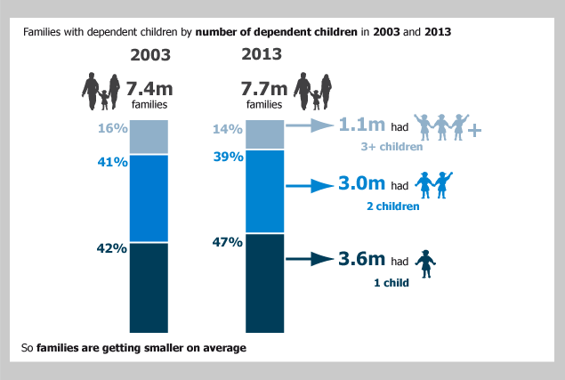

(Knipe, 2013)

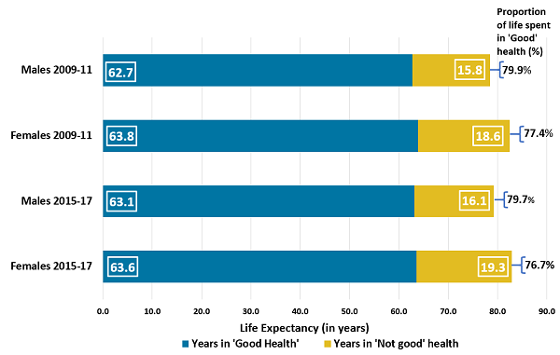
Appendix 2

(Pratt, 2018)

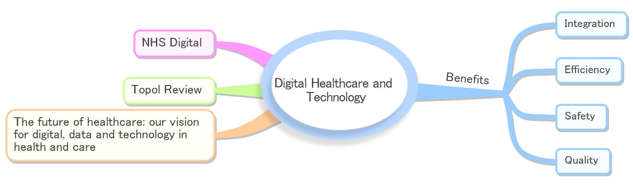
Appendix 3
(invatech health, n.d.)

Appendix 4

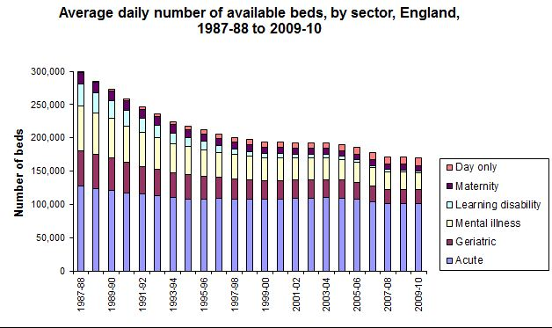

(Team, 2013)

Reference list
BBC Bitesize (2011). Family Life - Revision 2 - GCSE Religious Studies - BBC Bitesize. (online) BBC Bitesize. Available at: https://www.bbc.co.uk/bitesize/guides/zj8qn39/revision/2 (Accessed 1 Dec. 2021).
Berry, L. (2019). Reclaiming Health Care’s Fundamental Purpose. (online) Ihi.org. Available at: http://www.ihi.org/communities/blogs/reclaiming-health-care-s-fundamental-purpose (Accessed 3 Dec. 2021).
Cambridge Dictionary (2019). HEALTHCARE | meaning in the Cambridge English Dictionary. (online) Cambridge.org. Available at: https://dictionary.cambridge.org/dictionary/english/healthcare (Accessed 3 Dec. 2021).
CANTOR, M.H. (1989). Social Care: Family and Community Support Systems. The ANNALS of the American Academy of Political and Social Science, 503(1), pp.99–112.
Dam, D. (2019). What Is the Difference between Healthcare and Social care? - St.Patrick’s. (online) StPatrick. Available at: https://www.st-patricks.ac.uk/blog/posts/2019/april/what-is-the-difference-between-healthcare-and-social-care/ (Accessed 3 Dec. 2021).
Department Of Health & Social (2021). Integration and Innovation: Working Together to Improve Health and Social Care for All the Department of Health and Social Care’s Legislative Proposals for a Health and Care Bill. (online) Available at: https://assets.publishing.service.gov.uk/government/uploads/system/uploads/attachment_data/file/960548/integration-and-innovation-working-together-to-improve-health-and-social-care-for-all-web-version.pdf (Accessed 2 Dec. 2021).
Department of Health and Social Care (2021). Care and Support Statutory Guidance. (online) GOV.UK. Available at: https://www.gov.uk/government/publications/care-act-statutory-guidance/care-and-support-statutory-guidance (Accessed 3 Dec. 2021).
Duarte, F. (2019). Why the world now has more grandparents than grandchildren. (online) Bbc.com. Available at: https://www.bbc.com/worklife/article/20190405-why-the-world-now-has-more-grandparents-than-grandchildren (Accessed 3 Dec. 2021).
Ferguson, B. and Belloni, A. (2019). Ageing and Health Expenditure - UK Health Security Agency. (online) ukhsa.blog.gov.uk. Available at: https://ukhsa.blog.gov.uk/2019/01/29/ageing-and-health-expenditure/ (Accessed 29 Nov. 2021).
Godfrey, C., Harrison, M.B., Lysaght, R., Lamb, M., Graham, I.D. and Oakley, P. (2011). Care of Self - Care by Other - Care of other: the Meaning of self-care from research, practice, Policy and Industry Perspectives. International Journal of Evidence-Based Healthcare, 9(1), pp.3–24.
Gov UK (2021). Health and Social Care Levy. (online) GOV.UK. Available at: https://www.gov.uk/government/publications/health-and-social-care-levy/health-and-social-care-levy (Accessed 6 Dec. 2021).
gov.uk (2016). Care Act Factsheets. (online) GOV.UK. Available at: https://www.gov.uk/government/publications/care-act-2014-part-1-factsheets/care-act-factsheets (Accessed 4 Dec. 2021).
Government Office For Science (2016). Future of an Ageing Population. (online) Available at: https://assets.publishing.service.gov.uk/government/uploads/system/uploads/attachment_data/file/816458/future-of-an-ageing-population.pdf (Accessed 29 Nov. 2021).
Introduction to Sociology (2014). Chapter 13. Aging and the Elderly – Introduction to Sociology – 1st Canadian Edition. (online) Opentextbc.ca. Available at: https://opentextbc.ca/introductiontosociology/chapter/chapter13-aging-and-the-elderly/ (Accessed 29 Nov. 2021).
invatech health (n.d.). Technology in health and social care. (online) invatechhealth.com. Available at: https://invatechhealth.com/resources/blogs/technology-in-health-and-social-care/ (Accessed 3 Dec. 2021).
Knipe, E. (2013). Families and Households in the UK - Office for National Statistics. (online) Ons.gov.uk. Available at: https://www.ons.gov.uk/peoplepopulationandcommunity/birthsdeathsandmarriages/families/bulletins/familiesandhouseholds/2013-10-31 (Accessed 1 Dec. 2021).
Lomax, N., Norman, P., Rees, P. and Wohland, P. (n.d.). What the UK Population Will Look like by 2061 under hard, Soft or No Brexit Scenarios. (online) The Conversation. Available at: https://theconversation.com/what-the-uk-population-will-look-like-by-2061-under-hard-soft-or-no-brexit-scenarios-117475 (Accessed 29 Nov. 2021).
Majeed, A. and Aylin, P. (2005). The Ageing Population of the United Kingdom and Cardiovascular Disease. BMJ, 331(7529), p.1362.
McKenna, G., Tsakos, G., Burke, F. and Brocklehurst, P. (2020). Managing an Ageing Population: Challenging Oral Epidemiology. Primary Dental Journal, (online) 9(3), pp.14–17. Available at: https://doi.org/10.1177%2F2050168420943063 (Accessed 29 Nov. 2021).
Netuveli, G. and Blane, D. (2008). Quality of life in older ages. British Medical Bulletin, (online) 85(1), pp.113–126. Available at: https://academic.oup.com/bmb/article/85/1/113/291398 (Accessed 29 Nov. 2021).
Oliver, D., Foot, C. and Humphries, R. (2014). Making Our Health and Care Systems Fit for an Ageing Population. (online) Available at: https://www.kingsfund.org.uk/sites/default/files/field/field_publication_file/making-health-care-systems-fit-ageing-population-oliver-foot-humphries-mar14.pdf (Accessed 4 Dec. 2021).
Oven, K.J., Curtis, S.E., Reaney, S., Riva, M., Stewart, M.G., Ohlemüller, R., Dunn, C.E., Nodwell, S., Dominelli, L. and Holden, R. (2012). Climate change and health and social care: Defining future hazard, vulnerability and risk for infrastructure systems supporting older people’s health care in England. Applied Geography, (online) 33, pp.16–24. Available at: https://reader.elsevier.com/reader/sd/pii/S0143622811000956?token=4683499F9864DC9CC5D776C641792418912A98648ABEEC67F288DB03B7071025BEDFE5A09F83AD7A0A286BE2E40A70FD (Accessed 5 Dec. 2021).
Pratt, M. (2018). Health State Life expectancies, UK - Office for National Statistics. (online) Ons.gov.uk. Available at: https://www.ons.gov.uk/peoplepopulationandcommunity/healthandsocialcare/healthandlifeexpectancies/bulletins/healthstatelifeexpectanciesuk/2015to2017 (Accessed 1 Dec. 2021).
Raleigh, V. (2021). What Is Happening to Life Expectancy in England? (online) The King’s Fund. Available at: https://www.kingsfund.org.uk/publications/whats-happening-life-expectancy-england (Accessed 30 Nov. 2021).
Roper, W.L., Winkenwerder, W., Hackbarth, G.M. and Krakauer, H. (1988). Effectiveness in Health Care. New England Journal of Medicine, 319(18), pp.1197–1202.
Sorenson, C., Drummond, M. and Bhuiyan-Khan, B. (2013). Medical technology as a key driver of rising health expenditure: disentangling the relationship. ClinicoEconomics and Outcomes Research, (online) p.223. Available at: https://www.ncbi.nlm.nih.gov/pmc/articles/PMC3686328/.
Spring link (2020). Post-COVID-19 Global Health strategies: the Need for an Interdisciplinary Approach. Aging Clinical and Experimental Research, 32(32).
Stevens, A. and Gabbay, J. (1991). Needs assessment needs assessment.... Health trends. (online) Available at: https://www.semanticscholar.org/paper/Needs-assessment-needs-assessment....-Stevens-Gabbay/5598a10baf75e856080898317e9f381dba2ab235 (Accessed 1 Dec. 2021).
Storey, A. (2018). Living Longer - Office for National Statistics. (online) Ons.gov.uk. Available at: https://www.ons.gov.uk/peoplepopulationandcommunity/birthsdeathsandmarriages/ageing/articles/livinglongerhowourpopulationischangingandwhyitmatters/2018-08-13 (Accessed 29 Nov. 2021).
Team, F.F. (2013). Bed blocking - what is it, and is it paralysing the NHS? (online) Full Fact. Available at: https://fullfact.org/health/bed-blocking-what-it-and-it-paralysing-nhs/ (Accessed 4 Dec. 2021).
The Editors of Encyclopedia Britannica (2018). Old age. In: Encyclopædia Britannica. (online) Available at: https://www.britannica.com/science/old-age (Accessed 29 Nov. 2021).
The King's Fund (2012). The King’s Fund. (online) The King’s Fund. Available at: https://www.kingsfund.org.uk/projects/time-think-differently/trends-medical-advances (Accessed 2 Dec. 2021).
The Kings Fund (2017). NHS hospital bed numbers past, present, future. (online) The King’s Fund. Available at: https://www.kingsfund.org.uk/publications/nhs-hospital-bed-numbers (Accessed 6 Dec. 2021).
Tikkanen, R., Osborn, R., Mossialos, E., Djordjevic, A. and Wharton, G.A. (2020). England | Commonwealth Fund. (online) www.commonwealthfund.org. Available at: https://www.commonwealthfund.org/international-health-policy-center/countries/england (Accessed 1 Dec. 2021).
United Nation (2020). Secretary-General’s Policy Brief: the Impact of COVID-19 on Older Persons | United Nations for Ageing. (online) www.un.org. Available at: https://www.un.org/development/desa/ageing/news/2020/05/covid-19-older-persons/.
United Nations (2017). World Population Ageing (highlights). (online) United Nations. Available at: https://www.un.org/en/development/desa/population/publications/pdf/ageing/WPA2017_Highlights.pdf (Accessed 29 Nov. 2021).
Virani, S.S., Alonso, A., Aparicio, H.J., Benjamin, E.J., Bittencourt, M.S., Callaway, C.W., Carson, A.P., Chamberlain, A.M., Cheng, S., Delling, F.N., Elkind, M.S.V., Evenson, K.R., Ferguson, J.F., Gupta, D.K., Khan, S.S., Kissela, B.M., Knutson, K.L., Lee, C.D., Lewis, T.T. and Liu, J. (2021). Heart Disease and Stroke Statistics—2021 Update: A Report From the American Heart Association. Circulation, 143(8).

