Dissertation
Correlation between serious offenders and ACEs
Adverse childhood experiences cause impact to behaviour in adulthood. Does this link to serious convictions of crime?



Name: Ela Roberts
Student ID:1900589
School: UWTSD Swansea
Word count:

Declaration


Acknowledges

Firstly, I would like to thank Rhiannon Lloyd my project supervisor for her knowledge, encouragement and motivation during the procedure and process of writing the paper. I would also like to thank Mike Durke, the main module tutor for his support and for providing relevant resources.
I would also like to thank all the participants that took time to answer my questionnaires, these valuable responses have enabled me to help gather a substantive amount of information and which has contributed to me being able to formulate a conclusion.
As well as these, I would like to again thank my family and friends for their support throughout the three years of my study, particularly during the period where I have been completing my dissertation. They have shown encouragement and support throughout the whole completion of the paper which I am very thankful for.

Abstract

Individuals who have experienced adverse childhood experiences and later gone on to be serious offenders of crime are seen to be linked due to the impact their experience has placed on them in adulthood. The negative impact of such an experience without appropriate support and intervention can be considered as a contributing factor in relation to poor decision making and life course choices for some particularly where there are multiple adverse childhood experiences.

For the purpose of this study a questionnaire was devised and sent out to a range of individuals to confirm the link, what support was missing and whether support at the time of the experiences would have assisted in reducing the risk of serious criminality during adulthood.

Following the conclusion of the data collated it evidenced that many people have experienced adverse childhood experiences but have not gone on to be involved in crime however, for some it has been linked to the lack of support and poor opportunities and guidance at home, school and within certain communities.
Table of Contents

Chapter one: Introduction

  - Background
  - Rationale
  - Objectives
  - Research techniques
  - Conclusion

Chapter two: Literature review

2.1 Introduction
2.2 What are ACEs?
2.3 What are the effects of ACEs
2.4 What is a serious offender
2.5 What are the links between ACEs and offending behaviour
2.6 Preventing ACEs to reduce crime
2.7 Conclusion

Chapter three: Methodology

3.0 Introduction
3.1 Research onion
3.1.2 Philosophy
3.1.3 Approach
3.1.4 Strategies
3.1.5 Choice:
3.1.6 Time horizon

3.2 Techniques for data collection, process and analysis
3.2.1 Data collection
3.2.2 Survey design
3.2.3 Literature review matrix
3.2.4 Pilot Study
3.2.5 Reliability and validity
3.2.6 Limitations
3.2.7 Ethical considerations
3.3 Conclusion

Chapter Four: Findings

4.1 Introduction
4.2 Data Analysis
4.3 Methods
4.4 Demographics and Descriptive statistics
4.5 Data presentation

Chapter Five: Conclusion

5.1 Introduction
5.2 Findings
5.3 Conclusion
5.4 Recommendations

Chapter Six: Bibliography

List of Figures

Figure 3.1: The Research Onion (Saunders et al., 2016)
Figure 4.1: Graph Presenting Data Findings from Question 2
Figure 4.2: Showing the percentage of male and female participants
Figure 4.3: Showing the ethnic background of the participants
Figure 4.4: Showing the amount of people that experienced adverse childhood experiences
Figure 4.5: Showing what way the participants that answered yes experienced childhood experiences
Figure 4.6: showing the percentage of people that stated if parents understood their worries/problems whilst growing up.
Figure 4.7: Showing the participants opinions on if their parents/guardians were aware of what they were doing with their free time when they were younger.
Figure 4.8: Showing whether any of the participants lived with a member who was ever sent to prison.
Figure 4.9: Showing results of if the participants parents were ever separated or divorced.
Figure 4.10: Showing results of participants that have been involved in criminal activity.
Figure 4.11: showing results of the people that answered yes to question eleven and what age they were involved in the criminal activity.
Figure 4.12: Showing if the participants agreed with the statement ‘A stable up bringing leads to less likely hood of being involved in crime in adulthood?’
Figure 4.13: Showing results on if the participants thought that serious crime results from poor models in childhood.
Figure 4.14: Results from asking participants if they think positive education reduces risk of being involved in crime.
Figure 4.15: Results of peoples opinion on if they believe ACEs link to serious crime.

Degree: Professional Policing
Due Date: 6th May 23:59 2022

Chapter One: Introduction

This dissertation is designed to investigate the correlation between serious offenders and Adverse Childhood Experiences (ACE’s). The topic of my dissertation will highlight research and knowledge I have gained in considering connections between adverse childhood experiences and serious offending behaviours. Identification of differing types of behaviours will be discussed along with potential reasonings for such behaviours. Theoretical understanding will be utilised in demonstrating its assistance in analysing behaviour and consequences.

This topic is important to me as it relates to an area of interest, I am keen to further explore within my future career. Evidence gathered as part of criminalised outcomes will be considered to inform knowledge and analysis of convictions imposed for crimes. Interest in this particular domain will consider whether convictions are comparative and whether there are links to reduction of penalties imposed in relation to the ACE’s experienced. Consideration of this will assist in the development of a hypothesis and whether changes to understanding and acknowledging ACE’s for an individual should be considered or whether crime in adulthood should be the same for all no matter what a person has experienced throughout their life.

  - Background

Within In England and Wales at least one ACE has occurred for more than half of the adult population however, over four ACE’s have been experienced by one in ten of the adult population. By eliminating ACE’s, levels of violence would be lowered by half. Additionally, drug and alcohol dependence would be reduced, and general wellness would increase. Adults with fewer ACE’s are less likely to acquire illnesses including cancer, diabetes, and heart disease.
Stressful and/or traumatic events that occur throughout childhood or adolescence are known as adverse childhood experiences. ACE’s can be a single occurrence or a series of events that put a child's or young person's safety, physicality, or trust at threat.
Children's future prospects, as well as their mental and physical health, can be severely harmed by ACE’s in the long term. Traumatic experiences can result in high amounts of toxic stress, which can have an influence on brain development and functioning if they are sustained and persistent. ACE’s are said to have an impact on serious offenders. A serious offender is someone who has committed one of the following crimes in a twelve-month period: car theft, burglary, robbery, stealing from a person, assault with injury, or dealing Class A narcotics.

  - Rationale

The researcher aims to analyse the effect adverse childhood experiences have on individuals and if there is any relation between serious offenders. The researcher feels this topic should be concentrated on as childhood experiences can have a big impact on individuals future’s as it is believed to affect the way people turn out to be. With positive up bringing this could reduce the amount of people that end up criminalised. If the main cause is figured out, then policing and social strategies can help to reduce this.

  - Objectives

Key objectives that will be considered will be:

- Identify whether ACE’s have a clear definition in a person’s adult behaviour when linked to behaviour of crime.

-Access the consideration of ACE’s and whether these have an impact on other siblings/relatives where mirrored experiences have occurred.

-Consideration of preventive work or support implemented for the individual and whether this had any positive effect, re-offending/recurrent behaviours and conviction imposed for the offense

-Evaluate whether ACE’s is considered at the time of conviction.

In this regard, this research study will add value to the existing training by making suggestions and laying the groundwork for future research in the issue area.

  - Research Techniques

This research project will be divided into five chapters to achieve all four objectives. The first chapter will be an introduction; the second will be a literature review; the third will be the method and methodology for research; the fourth will be the data analysis; and the fifth will be the conclusion and recommendations. Information based on an interview with an anonymous individual who has experienced ACE’s and gone on to commit crime in adulthood, will also be referred to and used to formulate an analysis and potential recommendations for change in preventative crime in the future. Consideration will also be given to the work already being done in this area such as restorative justice.

The researcher wants to employ questionnaires and case studies as the primary research methods for this dissertation. It allows participants to go into as much or as little detail as wished whilst staying anonymous when completing the questionnaire. For this dissertation, the researcher intends to use questionnaires and case studies as primary research methodologies. Not all participants within research studies share their sensitive information. This could pose some complications in achieving accurate primary and secondary data results for analysis. The final chapter will be the concluding chapter, in which the research study will be ended by presenting a review of the data discovered and the consequences it entails. This chapter will also highlight potential recommendations in relation to future studies and societal changes including work within this area.

  - Conclusion

The purpose of the study, as well as the reasoning and background of the topic, were explained in this chapter. It has also clearly defined the objectives which are to be met. The next chapter discussed will be the literature review. It will examine, assess, and synthesise research findings, theories, and practises by scholars and researchers in a certain field.

Chapter Two: Literature Review

2.1 Introduction
The purpose of this chapter within the dissertation is to review previous research surrounding the topic of ACE’s and the correlation between offenders. It is to obtain a better knowledge of the ideas and subjects being discussed throughout this dissertation by reviewing previous literature on the subject. Academic journals, publications, and primary research on the issue have all been included in the literature evaluation.

2.2 What are ACEs?

Traumatic events that occur before the age of 18 are known as ACE’s. These events are listed to include physical, sexual, mental and verbal abuse of children and also neglect and being exposed to domestic abuse, alcohol misuse/drug misuse within their home. Children who have been exposed to ACE’s are more likely to develop health-harming and anti-social behaviours as adults, are at a higher risk of developing poor health throughout their lives and may require more healthcare and other public services (Centers for Disease Control and Prevention, 2021).

ACE’s
ACE’s are also described to have a negative impact on well-being, life course and opportunities including education and career. Negative life course can result in maternity issues for mother and child, poor sexual experiences, chronic diseases such as cancer, suicidal tendencies and injury (CDC, 2021).
Children who have to deal with a lot of stress from a young age may struggle to build healthy and secure relationships. During adulthood they might have difficulties sustaining security within careers, suffer long term depression and have ongoing issues with manging finances.

According to a survey in 2015, ACE’s are very common. Nearly half of Adults in Wales have experienced at least one ACE in their life. 24.9 percent of people with four or more ACE’s had been diagnosed with one or more chronic diseases by the time they were 49 years old. The ones with no ACE’s the figure was 6.9% (Welsh government, 2021). Coccoran and McNulty, (2018) state:

“Adverse childhood experiences (ACEs) are traumatic events or chronic stressors that are uncontrollable to the child.” (Coccoran and McNulty, 2018).

An ACE can happen to anyone and having one raises your chances of having another (Felitti et al., 1998). As a result, these childhood events rarely occur in isolation, but rather frequently co-occur (Anda et al., 1999).

2.3 What are the effects of ACEs?

According to KCSEI:

“Where children have suffered abuse and neglect, or potentially traumatic adverse childhood experiences, this can have a lasting impact throughout childhood, adolescence, and into adulthood. It is key that staff are aware of how these childrens experiences can impact on their mental health, behaviour and education.” (KCSIE, 2021).

Adverse childhood experiences can have a negative impact on all aspects of life, not only preventing the development of essential emotional and cognitive skills in young children and adolescents, but also eroding existing talents in older children and adolescents (Daines et al, 2021). Children who have experienced complex trauma may exhibit behaviours or attitudes that match diagnostic criteria for a variety of psychiatric disorders (Furnival and Grant, 2014). Early adversity is linked to poor results later in life, according to ACEs studies. ACE’s activate all of these interconnected stress response mechanisms. When a youngster is exposed to repeated ACEs over time, especially when there are no supportive adult connections to provide neutralising protection, the events will cause an exaggerated and long-lasting stress reaction, which can wear down the body. In addition, there is a growing amount of evidence about the long-term impacts (Harvard University, 2022). From information that has been recognised and a lot of research that has been done by professionals it has proven that adverse childhood experiences can cause diseaeses such as autoimmune or pulmonary (Anda et al., 2008; Danese et al., 2009), as well as these diseases it has aso been proven to cause mental health issues within indiviauls such as depression, post-traumatic stress disorder, and anxiety disorders (Anda et al., 2008; Danese et al., 2009). (Anda et al., 2006; Chapman et al., 2004; DeBellis & Thomas, 2003). ACEs can also cause social or behavioural issues, such as an increase in the use of illegal drugs, tobacco, and alcohol (Mersky, Topitzes & Reynolds, 2013), risky sexual activity (Ramiro, Madrid, & Brown, 2010), antisocial behaviour (Schilling, Aseltine, & Gore, 2007), an elevated risk of suicide attempt (Felitti et al., 1998), and even unemployment are all factors (Liu et al., 2013). It is important that children are helped with their experiences from a young age to prevent any outcomes like these. Children that suffer and experience long term stress in younger years can have an impact on normal brain development. Whilst children are young it can be shown in emotional and certain behaviour issues, as they get older and become more mature it can result in showing as risk taking and could even lead to criminal behaviour (Levinson et al, 2016).

2.4 What is a serious offender?

The Criminal and Justice Act 2003 describe a dangerous criminal to be a person who presents as a significant risk or serious injury as a result of committing a crime. This is deemed as a serios offence. A person is considered dangerous if he or she has committed violent, sexual, or terrorist offences in the United Kingdom, for which a term of at least 10 years or life imprisonment is possible (Crown prosecution service, 2019). In the United Kingdom, dangerous offenders face three types of punishments: imprisonment for public protection, usually known as IPP, life imprisonment, and prolonged sentences. Risky offenders who have committed crimes such as manslaughter, causing death by dangerous driving, and various sexual offences have received such terms (Defence Solicitors, 2018). A court of law can deem an offender dangerous if all relevant information regarding the circumstances of the crimes is evaluated, as well as whether the individual has committed crimes in the past, whether in the UK or elsewhere. Even prior offences can be scrutinised before an offender is deemed harmful to the public and sentenced differently. Solicitors in the United Kingdom can investigate your case and circumstances in order to provide a suitable defence in court, particularly if the status of a dangerous criminal can be resolved (Crown prosecution service, 2019).

2.5 What are the links between ACEs and offending behaviour?

The majority of ACEs have an impact on the justice system.
Children and adults who have been exposed to ACEs may encounter the criminal justice system as victims, witnesses, or perpetrators of crime. This could also mean that they engage with the 'family law' system of civil justice. As a result, the judicial system plays a critical role in preventing and alleviating the effects of ACEs. There is a clear link between ACEs and criminality, according to research (Reavis et al, 2013). People who have had many ACEs are more prone to engage in behaviours that are dangerous to health and, more importantly for the justice system, are occasionally linked to criminal behaviour. According to the Welsh ACEs Study (Public Health Wales NHS Trust, 2015), those with four or more ACEs were: 14 times more likely to be a victim of violence in the last 12 months, 15 times more likely to be a perpetrator of violence in the last 12 months and 20 times more likely to have been incarcerated in their lives. Offenders are more likely than the average population to have had a terrible childhood. ACEs are more common in specific offender groups, according to studies in the United States (Leitch, 2017). While no comparable research exists in the UK, prison surveys in the UK reveal significant rates of childhood maltreatment, family violence, care experience, and school exclusion among inmates (SPS, 2015; MOJ, 2012). The type of future criminal routes is influenced by the age at which delinquent behaviour begins, as well as the intensity and frequency of offending (Liberman et al., 2008; Loeber & Farrington, 2000; Van Hazebroek et al., 2019). From youth until young adulthood, a range of developmental offending occupations have been described: Non-offenders, first-time offenders, recidivists, and chronic offenders these are all types of offenders (Blokland & Palmen, 2015). The life course routes of persistent and adolescent-limited offending conduct were described by Moffitt (2018). Dolescent-limited offending is common and widely regarded as a normal reaction to an adolescent's social environment, whereas life-course persistent offending is less common and frequently linked to adversity in the family, insufficient parenting, neurocognitive issues, and temperament and behaviour issues (Moffitt & Caspi, 2001). According to prior research, children who commit multiple and significant crimes throughout their youth are less likely to succeed later in life than non-offending adolescents: During their adolescence, they are frequently involved in a variety of crimes (Piquero et al., 2012) and they might also find it difficult to completing their studies and finding jobs. This is in relation to the negative quality of life in young adulthood.
Much is unknown about the impact of adolescent criminal history and adverse childhood experiences (ACEs) on multi-problem young adults' return to healthy social functioning. These young adults are socially dysfunctional and suffer from a variety of issues, including financial difficulties, a lack of education, judicial encounters, psychological issues, and substance misuse (Van Duin et al, 2017). According to prior research among young adults, the prevalence of violent and nonviolent crime rises in late adolescence and then declines during early adulthood. However, some research demonstrates that offending peaks later in life, particularly among young individuals with substantial mental health issues (Davis et al, 2015).
Young people with various difficulties are more susceptible than other young adults, they appear to be at an increased risk of continuing their criminal conduct into adulthood. As a result, it is hypothesised that previous violent and nonviolent offences are linked to (non-)violent recidivism. Furthermore, recent research suggests that past (non-)violent offending has a detrimental impact on young adult engagement in education or work (Ministry of Justice, 2012). Research shows that 45 percent of adult prisoner survey respondents said they were physically mistreated as children in their homes, In a study of adult prisoner respondents, 61% said they had been harassed at school or elsewhere and an adult in their household swore at, degraded, or put them down, according to 56% of young people in detention (Ford et al, 2019)

Not everyone who has had a difficult or traumatic upbringing becomes a victim or perpetrator of crime. It's critical to understand why some children succeed despite early adversity. Identifying whether buffers, or 'protective variables,' might mitigate the impacts of early adversity and trauma can assist policymakers and practitioners help more children attain their full potential while reducing crime and victimisation (Welsh Government, 2021).

2.6 Preventing ACEs to reduce crime

ACEs and the problems that they cause can be prevented. ACEs may be prevented, and all children's health and life potential can be realised by creating and maintaining secure, stable, caring relationships and surroundings for all children and families (Centers for Disease Control and Prevention, 2021). Technical packages have been developed to assist communities in utilising the best available evidence to prevent violence, including the various types of violence as well as social, economic, and other exposures in the home and community that harm children. A “technical package” is a select collection of measures to achieve and sustain large reductions in a certain risk\sfactor or result (National Center for Injury Prevention and Control, 2016).

Research has been conducted across sectors to better understand current responses to vulnerability and to explore ways to improve multi-agency, collaborative working to better meet the needs of vulnerable people. In Wales, a public health strategy has been used to build trauma-informed services and allow a whole-system response to trauma victims. Working with the police, jail and probation agencies, local governments, youth justice services, education, and housing are all examples of this (Home Office, 2022). Wales has been given the chance to establish a national response to ACEs and to promote change across sectors thanks to support from the Home Office and the Welsh Government (Violence prevention unit, 2022). ACE Assistance Hub Cymru and the Early Action Together Programme, for example, have made significant progress in reducing vulnerability responses and increasing access to early intervention and preventative support. These programmes which are being introduced can help reduce ACEs and in future reduce certain crime that takes place.

2.7 Conclusion

Within this chapter it has been evidenced that research into the effect of ACE’s within adulthood has highlighted this can be reduced through early intervention where this is identified as a factor. However, early intervention to support and address this can only be achieved where it is noted in the first instance. For children and young people this is not always noted as an issue unless there has been a report to the police or involvement of services such as social care. Many children and young people may go unnoticed as having had adverse childhood experiences until they are themselves involved in crime during adulthood. It is highlighted that working in partnership with multi-agencies at any point is beneficial to the success of reducing potential crime in adulthood and ensuring a child or young person is supported emotionally to understand their life course and emotional management strategies are put in place to assist with coping strategies.

3. Chapter Three: Methodology

3.0 Introduction

Chapter 2 succeeded in offering a knowledge of the current academia around the understanding of Adverse childhood experiences causing an impact to behaviour in adulthood and the link to serious convictions of crime. Providing a detailed understanding of what classifies as adverse childhood experiences, what a serious offender is known as and how these link to offending.

This chapter seeks to examine the decision-making processes involved in developing techniques for acquiring public data on the topic of adverse childhood experiences and serious offenders. The technique by which data will be collected is referred to as research methodology. Saunders et al (2012) describe research as a process by which researchers attempt to learn new things in a systematic way to increase their knowledge (Bakhit Al Zefeiti & Mohammad, 2015). To achieve this, the research onion model which was presented by Saunders et al (2012), will be utilised to help with decision-making process. There will also be talks on reliability, validity, limits, and ethical issues throughout the process of selecting which approach is best and while developing such methods.

3.1 Research Onion:

The fundamental framework for this chapter will be Saunders et al(2016) research onion, which gave a valuable understanding of the importance of research as well as how it should be handled. The research onion described by Saunders explains the several considerations which need to be made while designing a research approach (Crossley, 2021). Its use stems from its flexibility to practically any form of research approach and its capacity to be applied in a range of circumstances (Bryman, 2012).

The following is an onion diagram, as well as the path travelled in this study project:



Figure 3.1: The Research Onion (Saunders et al., 2016)

3.1.2 Philosophy

A research philosophy is a collection of beliefs about the nature of the world under investigation (Bryman, 2012). The research philosophy is the cornerstone of every study since it explains the set of beliefs upon which the research is based. Research philosophy can be defined from an ethical or epistemic standpoint. It is the fundamental definition of what knowledge is. Furthermore, research philosophies might disagree on the aims of research and the best approach to attain these objectives (Goddard & Melville, 2004). These are not always distinct, but the research philosophy chosen is determined by the sort of knowledge under investigation in the research effort (May, 2011).

The outermost layer is the research philosophy, which in this case is a pragmatic research philosophy. With the ability to apply a variety of research methodologies, the pragmatic research philosophy may provide superior research outcomes. The use of the interpretivist research philosophy or the positivist research philosophy, which are the principal philosophies employed in the conduct of research, as an alternative to the pragmatic research philosophy, did not meet with the needs of the research (Crossley and Jansen, 2021).
Pragmatism is a research philosophy that believes concepts are only meaningful if they assist action. Saunders (2012) states that pragmatics “recognise that there are many different ways of interpreting the world and undertaking research, that no single point of view can ever give the entire picture and that there may be multiple realities”.

3.1.3 Approach

The approach layer of the research onion refers to the researcher's approach, which may be broadly classified as inductive or deductive.
The deductive method begins modest and gradually expands. It begins with a particular hypothesis or hypotheses generated based on facts or patterns seen by the researcher. It then attempts to investigate this hypothesis and construct a larger theory based on it. The inductive method is the inverse of this. It begins with a general principle and then delves into smaller, more particular elements. This is referred to be a transition from the specific to the universal.
An inductive technique will be advantageous since it will allow the study to collect more data. The use of interviews allows participants to freely discuss their experiences without being constrained by established approaches (Thomas, 2003). It was considered that a deductive method would be ideal for this research because there are earlier results from comparable studies that looked at public perceptions of ACEs and offending. As a consequence, the findings of this study may be compared to earlier studies to see if there are any parallels or differences (Saunders et al., 2009) and perhaps discover common themes.

3.1.4 Strategies

According to the research onion, strategies such as action research, experimental research, interviews, surveys, case study research, or a systematic literature review can be used. The approach is determined by the amount of data needed for the study and the objective of the investigation (Crossley and jansen, 2021). The methods utilised to collect and analyse data will be part of the study plan (Kirsch and Sullivan, 1992). When planning the assignment, the idea of conducting interviews was considered but lter decided that a questionnaire would be more considerate and the chosen method for primary data collection. According to Saunders et al. (2009), a questionnaire is the best way for obtaining findings fast and comparing them efficiently, especially if the data sought is quantitative (Gillham, 2007; Sue & Ritter, 2012; Fowler, 2008). Questionnaires allow participants to go into as much or as little detail as they want whilst at the same time remaining anonymous if they want to. The questionnaires enabled the researcher to collect a large amount of data from members of the public who might otherwise be hesitant to reveal particularly personal information because they could participate in the survey/questionnaire anonymously.

3.1.5 Choice:

The research onion proposes that you do research using a single technique, a mixed method, or a multi-method approach. The method chosen for the study was the mixed method. The mixed method is based on the employment of two or more research methodologies and generally refers to the use of qualitative and quantitative approach. This method will allow the researcher to gather a range of research and in turn it will allow them to gather more insight on how adverse childhood experiences cause impact to behaviour in adulthood and if there is a way that these have a connection. It would, for example, have restricted the researcher to just employing one form of data collecting, either qualitative or quantitative.

3.1.6 Time Horizon
Cross-sectional research is conducted over a short period of time and data is collected from a single subject at one moment. It is also a less expensive research approach when compared to the longitude method (Lavrakas, 2008).

3.2 Techniques for data collection, process and analysis

3.2.1 Data Collection:
The researcher decided to use a survey/questionnaire to collect primary research. The questionnaire is regarded as a main research instrument used by researchers to collect data from a specific audience. The questionnaires generally featured open-ended, closed-ended, or a combination of the two types of questions. This enables the researcher to obtain both qualitative and quantitative data based on their needs. When it comes to the benefits of questionnaires in research, the list is extensive, especially when it comes to online surveys. The benefits of employing a survey/questionnaire include the ability for participants to complete the survey/questionnaire anonymously if they do not want to attract unwelcome attention as a consequence of giving highly personal information. While surveys have numerous advantages, dishonesty may be a problem. Respondents' replies may not be completely truthful. When using questionnaires, it is possible that certain questions will be skipped or left unanswered. If queries are not necessary, there is always the possibility that they will not be addressed (Debois, 2022).

3.2.2 Survey Design

The researcher employed a survey/questionnaire to gather data, which had three open-ended questions and sixteen multiple-choice questions. This allowed the participants to completely express their thoughts on the topic at hand, as well as provide the researcher with a greater understanding of what and how people’s opinions are on how ACEs cause an impact on adulthood and criminal behaviour and potentially find a theme from the responses that assisted them in reaching a more thorough conclusion to their investigation. However, some of the questions may be regarded intrusive by the participants, which is why the researcher highlighted that the participants were not had to answer all of the questions and could skip any of them.

3.2.3 Literature review matrix
Questions
Q1. I hereby acknowledge that the data collected by this survey will be anonymous and confidential and will be used by the University of Wales Trinity Saint David for academic and educational purposes only. | This question was added to ensure that participants understood what the responses they provided for the research will be used for and by whom.
Q.2 Which age group describes you? | Question 2, 3 and 4 were all demographic questions designed to offer background data for analysis.
Q.3 What is your gender?
Q.4 Ethnic Background
Q.5 What do you understand by the term adverse childhood experiences? | This question has been included to gain an understanding of individuals perception of the term.
Q.6 Have you ever experienced adverse childhood experiences? | This question will provide a key answer to whether the respondents has had direct experience of the overall topic of this assignment.
Q.7 If yes to the previous question were any of them in relation to: | This will provide data in order for an analysis in relation to individual experiences to be collated.
Q.8 When you were growing up, did your parents/guardians understand your problems/worries? | Responses to question 8 and 9 will provide insight in relation to stability during childhood.
Q.9 Did your parents/guardians know what you were doing with your free time when you were not at school or work?

Q.10 Did you live with a household member who was ever sent to prison? | This question will provide information as to whether people have directly associated with someone involved in crime within their own home.
Q.11 Were your parents ever separated or divorced? | This was included as it will give valuable information as to whether parental loss or separation has been experienced.
Q.12 Have you ever been involved criminal activity? | The data sourced from this question and question 13 will provide a direct answer that will be utilised long side the responses regarding childhood experiences for an analysis.
Q.13 If yes at what age were you involved in criminal activity?

Q.14 'A stable up bringing leads to less likely hood of being involved in crime in adulthood?' Do you: | Individual views will provide information in relation to their value base.
Q.15 Do you think serious crime occurs because of poor role models in childhood | The outcome to this will again provide more information into people’s beliefs and values.
Q. 16 Do you think a positive educational experience reduces risk of being involved in serious crime in adulthood? | Information gathered from this question will highlight beliefs in regard to educational retainment and the importance of positive experiences within the education system. The outcome of this will also provide information that can be linked to question 12 for analysis.
Q.17 Do you believe adverse childhood experiences links to serious convictions of crime? | Question 17 and 18 was included to allow the public to give their viewpoint on what they think of link between adverse childhood experiences and serious convictions of crime are.
Q. 18 If yes to previous question, what is your reason for this?

Q.19 Other thoughts or comment | Having a range of qualitative data is important for assessing, analysing and understanding individuals thoughts and feelings regarding the subject.

3.2.4 Pilot study
A pilot study is defined as “A small-scale test of the methods and procedures to be used on a larger scale” (Porta, Dictionary of Epidemiology, 5th edition, 2008).
A researcher can pilot a study to develop or revise a research issue, determine which methodologies are ideal for pursuing it, and estimate how much time and resources will be required to accomplish the bigger final version of the study (Morin, 2013). The survey was published following small adjustments.

3.2.5 Reliability and validity
Replicating the study using the same methodology and attaining consistent findings is how reliability is determined (Saunders et.al., 2019). In contrast, validity refers to the accuracy of data collecting, such as the use of tried-and-true methodologies, research tactics, and approaches (Young, 2015).
The necessity of ensuring that the study is accurate and legitimate cannot be overstated, since the research would become irrelevant without them. The social desirability of replies in surveys exploring sensitive personal matters may have an impact. To come to terms with this each person that participated in the survey were informed that the questions were optional and if for any reason they did not want to continue that was their own choice. They were also informed that all answers were anonymous and confidential.

3.2.6 Limitations
One problem of this sort of study is the lack of solutions that are socially desired. Because the issue under debate is so sensitive, some participants may offer false answers in order to avoid retribution for their responses. To solve and prevent this the researcher ensured that the participant was aware that the answers were anonymous. The questionnaire was made available online to alleviate any anxieties about openly expressing their opinions and to promote honest responses rather than complying to societal standards.

3.2.7 Ethical Considerations
The academic must follow ethical considerations as it matters for scientific integrity, human rights and dignity, and collaboration between science and society. These principles ensure that study participants' involvement is voluntary, informed, and safe (Bhandari, 2021). To reduce the risk of vulnerability participants had to be over the age of 18 to complete the survey. All participants involved gave their consent to take part and had the option to withdraw at any point. The project supervisor authorised this study to ensure that it adhered to the UWTSD's ethical practises.

3.3 Conclusion
The third chapter explained the rationale and specifics of the research plan. To reduce the effect of potential criticism, limitations were identified and remedied. Chapter four will contain an analysis of data that was collected using methods which were discussed in this chapter

Chapter 4: Findings
4.1 Introduction

In this chapter of research that was conducted, the primary data which has been gathered will be analysed and then presented. There were 176 people that took part in the questionnaire which consisted of 19 questions which is not including the declaration at the beginning. The questionnaire was created, and data was collected using google forms. They were sent out to the public to institute their own views on how adverse childhood experiences cause an impact to behaviour in adulthood. It will provide the researcher with the public opinion on if these experiences link to serious convictions of crime.

4.2 Data analysis

The goal of data analysis is to comprehend the trends, patterns, and relationships of the study's setting. It is critical to remember that while analysing data, the usage of valid tools is critical in order to get a legitimate result (Albers, 2017). The data gathered from the questionnaire will be evaluated through google sheets. This will help provide a percentage of each answer to the questions and determine the opinion on childhood experiences. Question 5, 18 and 19 were analysed through google docs as this will provide in detail how the questions were answered. The overall analysis of this chapter will enclose all the data retrieved from each of the questions using google docs.

4.3 Methods

Participants in the questionnaire were asked to provide information about their gender, age, and ethnicity. The answers to these questions will protect the participant's identity while also allowing for easy analysis and clear outcomes. The use of google docs for the questionnaire was beneficial as it was easy to access and share the link through social media and email.

  - 4.4 Demographics and Descriptive Statistics
There was a total of 176 people that gave responses for the questionnaire. Each respondent agreed that they were 18 years or over and they volunteered to participate out of their own choice. All the participants that completed the questionnaire were recruited from social media, direct emails or direct contact numbers. The first question asked if they acknowledged that the data was anonymous and if they were willing to participate, 100% of the people agreed to this and took part. 77.3% of the participants were female and 22.7% were male. No respondents chose “other” to describe their sex. It was made clear to the participants that they could withdraw at any point whilst answering the questions.

4.5 Data presentation

Sixteen of the questions asked were multiple choice and the other two were open ended questions which gave the chance for the participants to voice their opinion. The sixteen multiple choice questions are explained below.

Q.2. Which age group describes you?

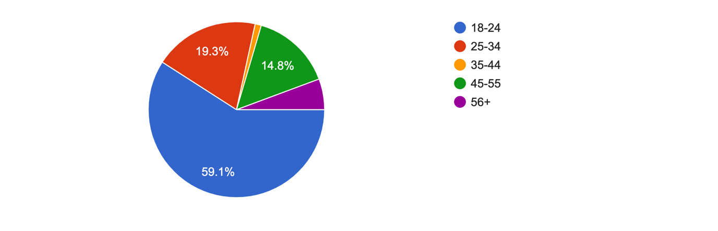
Figure 4.1: Graph Presenting Data Findings from Question 2

Question two of the questionnaire, which was carried out, focused on the age of the participants. The purpose of this question provided help with determining what age group the majority audience was and to provide insight into whether there was a strong correlation between age in relation to the responses to following questions.

Q.3 What is your gender?

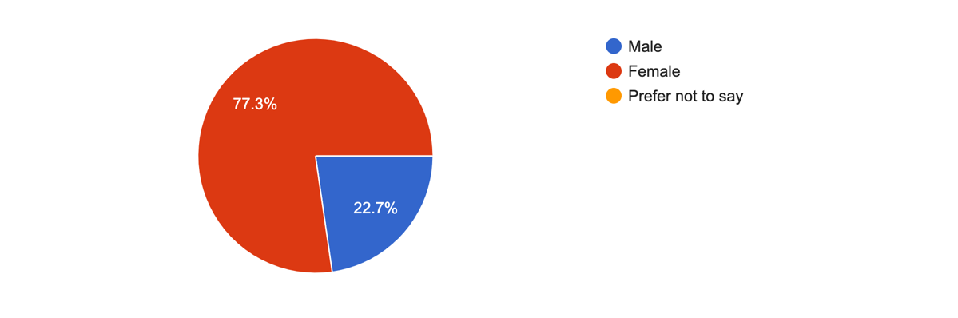
Figure 4.2: Showing the percentage of male and female participants

Question three of the questionnaire asked the question of what gender the participants were. The options included were male, female or prefer not to say. All participants that answered chose either male or female, this gave an analysis of whether being male or female has an impact on adverse childhood experiences and serious convictions of crime. 77.3% of the participants that answered were Female and 22.7% were male. This response also provided detail for further analysis of other question responses as there may have been a difference as to the experiences of males or females in relation to the topic.

Q.4 Ethnic background
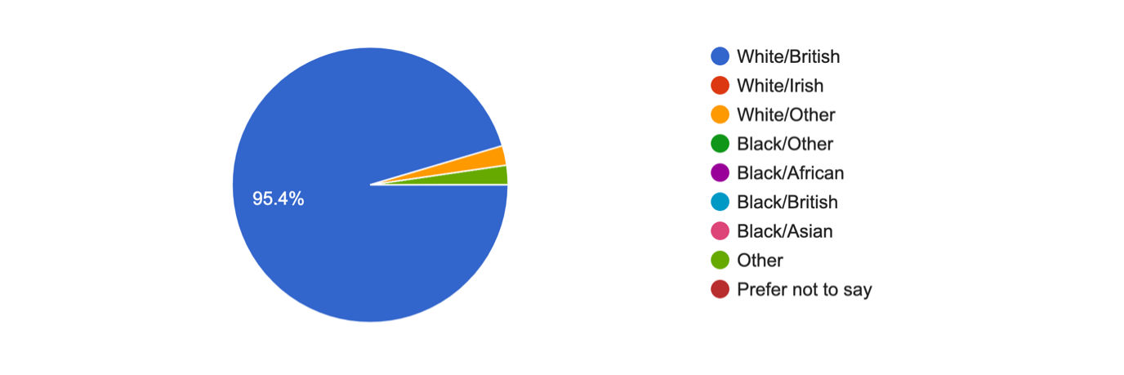
Figure 4.3: Showing the ethnic background of the participants

Question four found out the ethnicity of the people that took part. The majority of responses from people were that they considered themselves White/British. This response highlighted any areas where discrimination could have been present and whether this was a factor for consideration within analysis. This answer also allows the researcher to cross-tabulate and compare the categories to examine the variety in replies and to see if ethnicity has a role in the respondents' decision.

Q.6 Have you ever experienced adverse childhood experiences?

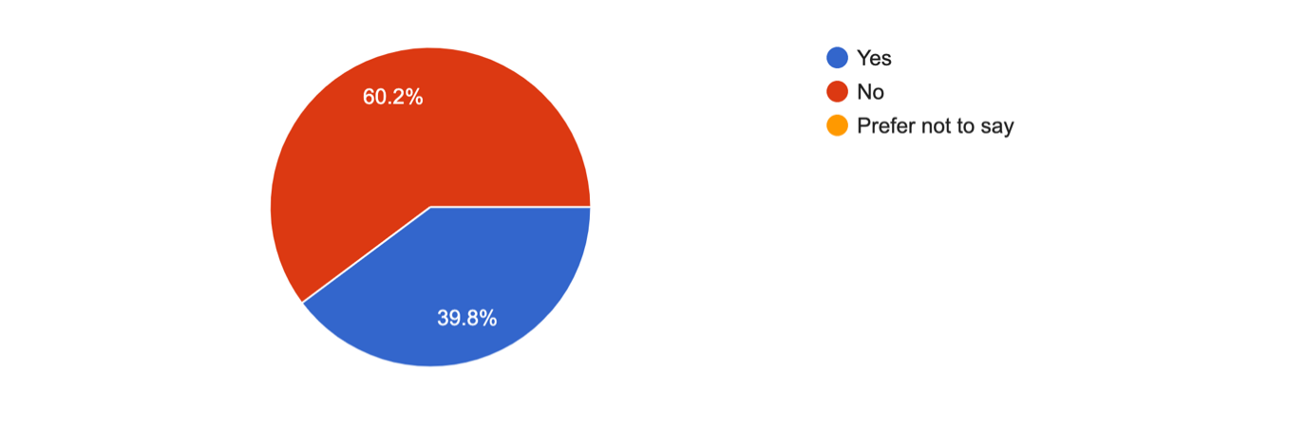
Figure 4.4: Showing the amount of people that experienced adverse childhood experiences

Question 6 asked people if they had experienced any adverse childhood experiences within their life. 60.2% of the participants answered with no and 39.8% of participants answered with yes.
Following on from this question, question 7 then asks the participants that answered yes to question six in what way they had experienced childhood experiences. Below shows the results of the 38.8% participants that answered yes:

Q. 7 If yes to the previous question, were any of them in relation to:
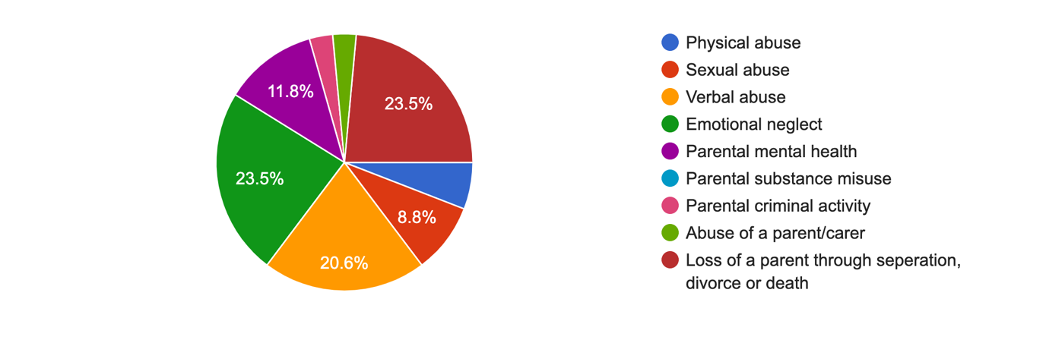
Figure 4.5: Showing what way the participants that answered yes experienced childhood experiences

Question seven had responses from all the participants who answered yes to the previous question. 23.5% of people answered with experiencing a loss of a parent through separation, divorce, or death, 5.9% of people answered with experiencing physical abuse, 8.8% o people experienced sexual abuse, 20.6% of people experienced verbal abuse, 23.5% experienced emotional neglect, 11.8% experienced parental mental health, 2.9% experienced parental criminal activity and 2.9% experienced abuse of a parent/carer. The ACE that was experienced by the most people was loss of a parent through separation, divorce, or death. Divorce may appear more regularly and is more common these days, but its popularity is what makes it such a threat to the younger generation and children. It can affect children’s mental health and physical development. Whilst divorce and separation of parents has grown increasingly in recent years, or even made normalised the experience it has for children is almost uniformly traumatic and can have a major effect in later life (Jamieson, 2019).

Q.8 When you were growing up, did your parents/guardians understand your problems/worries?
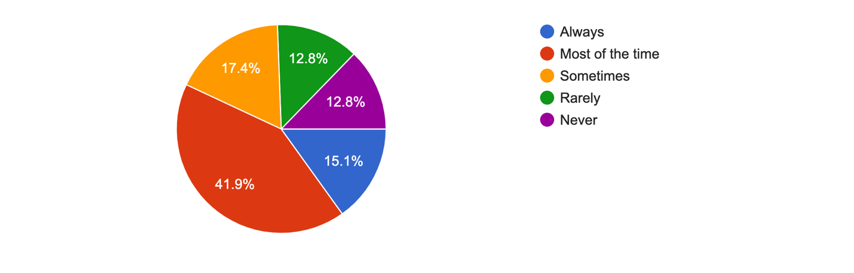
Figure 4.6: showing the percentage of people that stated if parents understood their worries/problems whilst growing up

Majority of the participants answered this question with the answer most of the time, with 41.9%. 12.8% of people answered both rarely and never. When looking at results the participants which answered yes to question six are involved in the 12.8% of the people that have answered rarely and never to this question. This could prevent a child’s cognitive, emotional, and social development.

Q. 9 Did your parents/guardians know what you were doing with your free time when you were not at school or work?

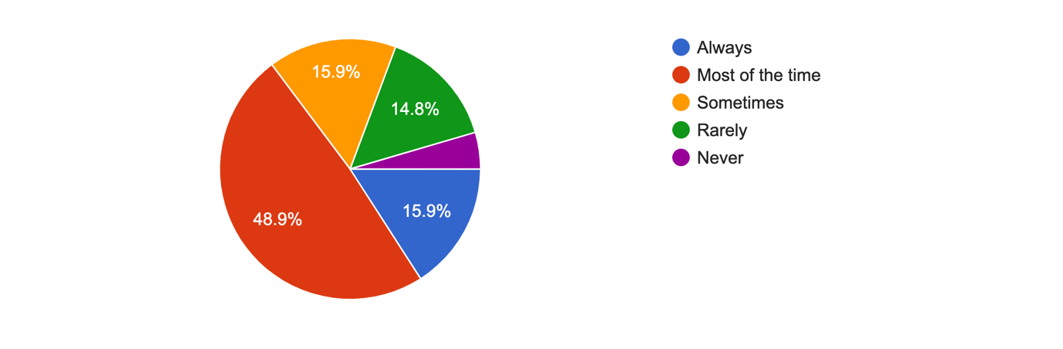
Figure 4.7: Showing the participants opinions on if their parents/guardians were aware of what they were doing with their free time when they were younger.

Question 9 was in relation to question 8 as to whether the participants parents were supportive and aware of what they were doing at a young age. Almost half of the participants with 48.9% answered with most of the time and only 4.5% of the participants answered with never. There were close results with the participants that answered with sometimes and rarely.

Q.10 Did you live with a household member who was ever sent to prison?

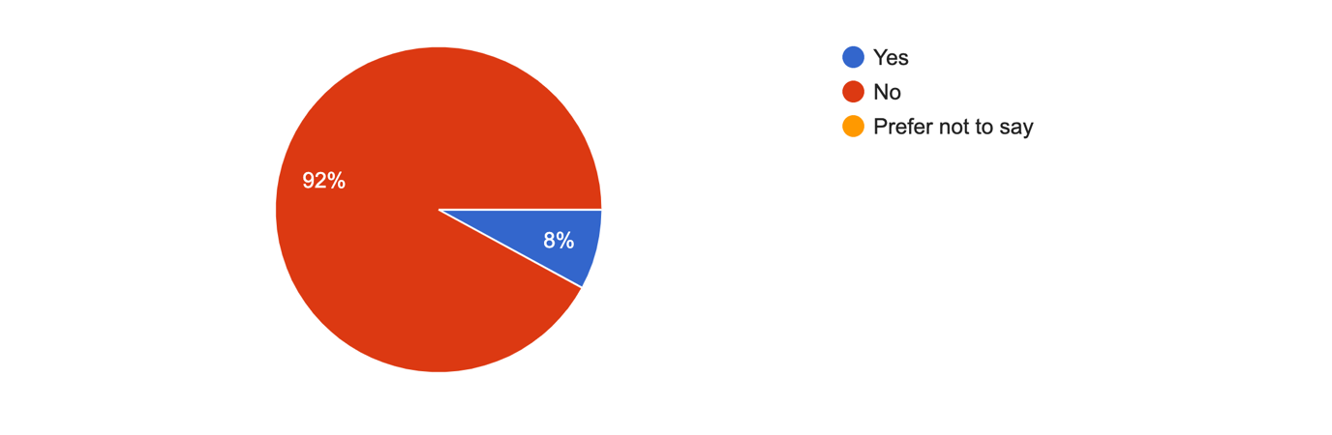
Figure 4.8: Showing whether any of the participants lived with a member who was ever sent to prison.

Almost all the participants answered this question with no but 8% answered with yes. When looking at results there is a relation between the people that answered yes to this question and rarely/never to questions eight and nine.

Q.10 Were your parents ever separated or divorced?

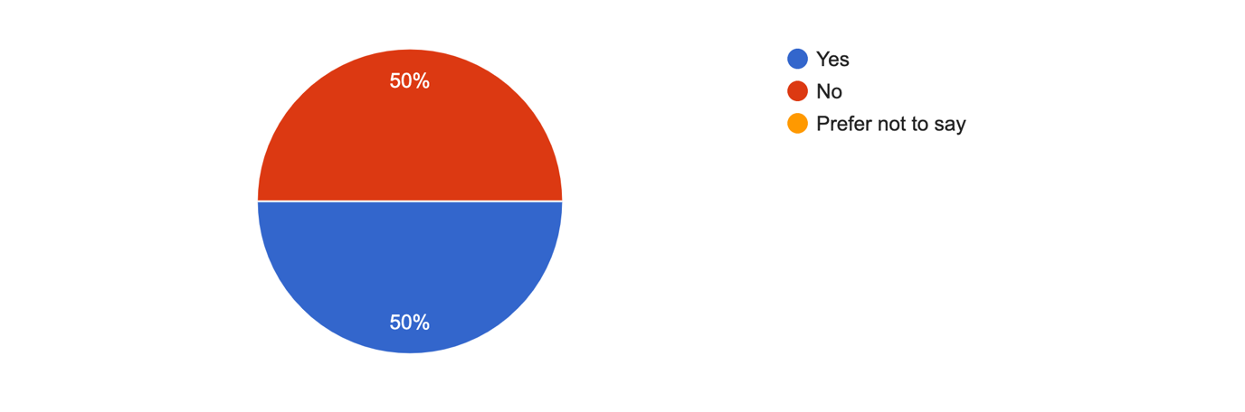
Figure 4.9: Showing results of if the participants parents were ever separated or divorced.

Half of the participants answered yes to this question and half answered no. When looking at the results of the age of participants that participated in this questionnaire the majority of participants were ages between 18 and 34 which suggests it is mainly in the last 15 years where there are more complications in relationships. This can also have an impact as a child as it can make the child become insecure which can result in further complications.

Q. 11 Have you ever been involved criminal activity?

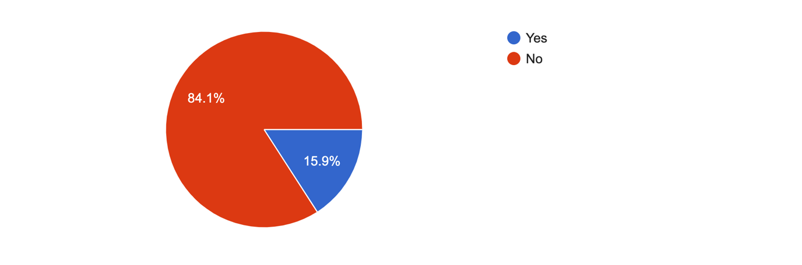
Figure 4.10: Showing results of participants that have been involved in criminal activity.

15.9% of the participants answered yes to this questioning meaning out of 176 participants that is 28 of them which have somewhat been involved.

Q.12 If yes at what age were you involved in criminal activity?

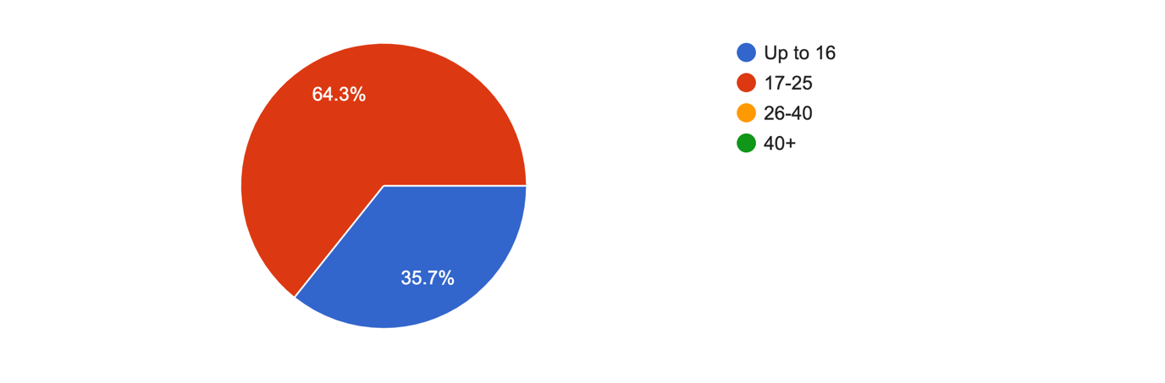
Figure 4.11: showing results of the people that answered yes to question eleven and what age they were involved in the criminal activity.

Following on from question 12 this question asks the participants that answered yes what age they were involved in the criminal activity. The most popular answer to this was ages 17-25 with 64.3%. 35.7% answered with up to age 16. Criminality rates are known to rise during adolescence, peak at 17 years old, and then fall as the individual ages.

Q.13 'A stable up bringing leads to less likely hood of being involved in crime in adulthood?' Do you:
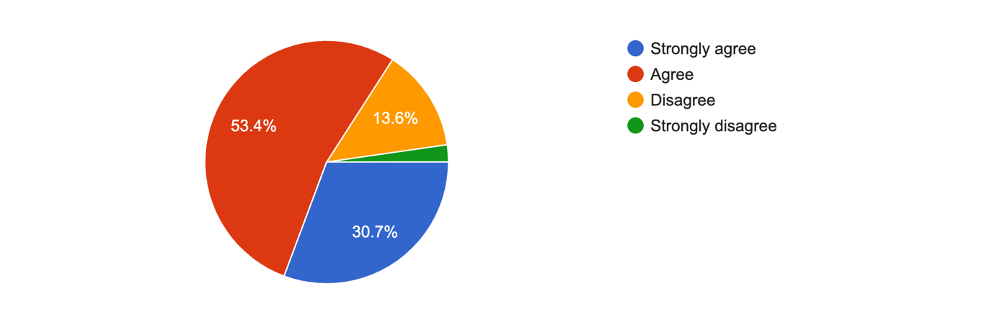
Figure 4.12: Showing if the participants agreed with the statement ‘A stable up bringing leads to less likely hood of being involved in crime in adulthood?’

This question had a mixed range of answers with just over half answering that they agree with the statement, 30.7% strongly agree, 13.6% disagree and only 2.3% strongly disagree.

Q.14 Do you think serious crime occurs because of poor role models in childhood?
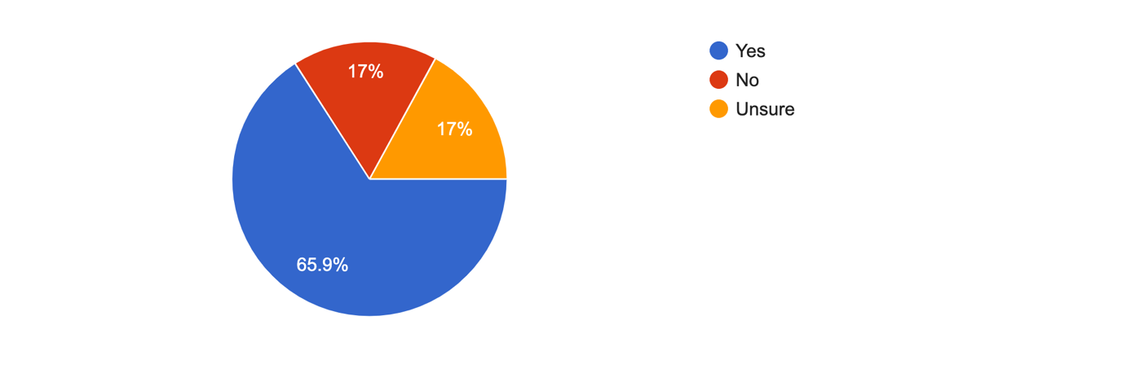
Figure 4.13: Showing results on if the participants thought that serious crime results from poor models in childhood.
Over half the participants agreed with this question with 65.9% answering yes. Some were unsure and 17% answered with unsure and 17% disagreed and answered with no. It is believed that young individuals are more prone to engage in violent behaviour if they lack empathy, shame, and remorse, and do not believe violence is bad. Morality is instilled in children. Morals are taught to us through the people we spend time with. As a result, if someone's moral growth is inadequate, they should not be labelled as "evil," but rather as having received inadequate or erroneous instruction from the essential persons in their lives (Swartz, 2010).

Q.15 Do you think a positive educational experience reduces risk of being involved in serious crime in adulthood?
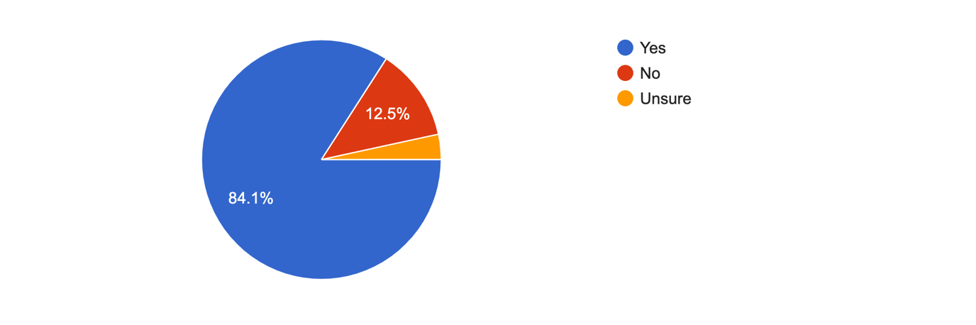
Figure 4.14: Results from asking participants if they think positive education reduces risk of being involved in crime.
Almost all of the participants agreed and answered yes to the fact that educational experience reduces risk of being involved in serious crime. Only 12.5% answered no. Participation in education may help to reduce crime by raising income and hence the opportunity cost of engaging in illegal activities. Education may help enhance parental skills, which are vital in the intergenerational transfer of advantage that may keep young people from being involved in criminal activity.

Q.16 Do you believe adverse childhood experiences links to serious convictions of crime?
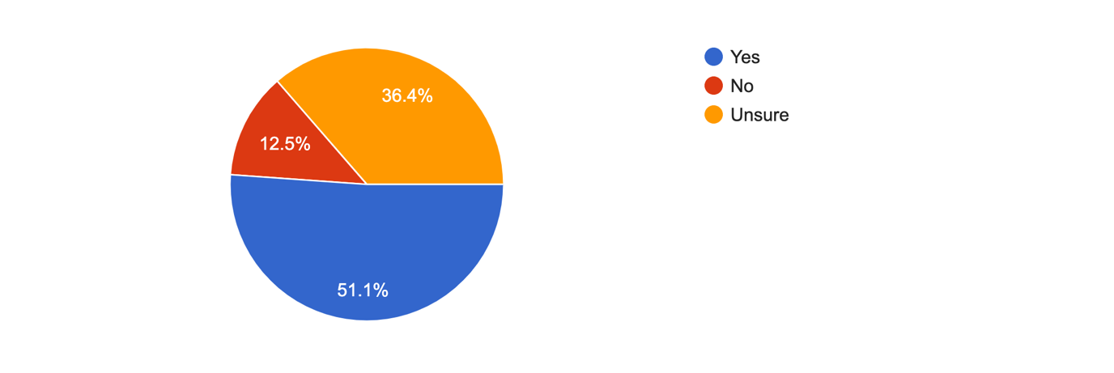

Figure 4.15: Results of people’s opinion on if they believe ACEs link to serious crime.

The open-ended questions gave the participants the opportunity to give their own opinion about the topic in their own words. This would help provide the researcher more detail about certain subjects within the assignment and help give a more effective conclusion. In the survey the first open ended question was Q.5 What do you understand by the term 'Adverse childhood experiences'?. The main responses that the majority of the people that participated in the survey gave were traumatic events or experiences which happen in childhood. The word trauma was used in almost every response to this question. This shows that majority of the participants somewhat have an understanding of what adverse childhood experiences are. The next open-ended question was Q.18 If yes to previous question, what is your reason for this? This question followed on from question 17 of one of the multiple-choice questions which asked Do you believe adverse childhood experiences links to serious convictions of crime? 82 participants responded to this open-ended question, so a range of opinions were stated. Majority of the opinions stated that many people who are involved in the criminal justice system have experienced adverse childhood experiences such as neglect and other forms of abuse, as well as the effects of poverty and poor education experiences and lack of parental/family support. This can be seen in people who access health and social care services as adults and where family narratives commonly point to them having experienced adversity as children. The last open-ended question was question 19 which asked if there were any other thoughts or comments. For this question there were 17 responses which showed people’s opinions on the overall title and on the questionnaire in general.

Chapter 5 - Conclusion and Recommendations

5.1 Introduction
The data gathered from the Survey, which the researcher utilised to obtain some of the general public's perspectives on adverse childhood experiences and criminal activity provided the researcher with a better understanding of how the public perceives the problem. The overall analysis throughout this study has been to consider the link between serious crime and ACE’s and whether a person subject to these is more likely to commit serious crime and why. The study has utilised sources directly and indirectly from individuals who have experienced ACE’s and from studies that have considered the impact of ACE’s.
The use of questionnaires have assisted in looking at the responses and how this direct information feeds into the outcome of the research topic.

5.2 Findings
The data compiled from questionnaires highlighted a response that is believed to be open and honest. It is believed that this is largely due to the respondents being informed that their responses would be anonymous and only used for the purpose of this study. ACEs are often linked to periods of time that are difficult for individuals to revisit in adulthood due to the emotional impact this has when reminiscing therefore, the responses have been greatly received and respected in the detail they contain. According to research, ACEs have a long-term and frequently disastrous influence on adolescents and, eventually, society. Officers of the law are not required to become social workers, medical practitioners, or mental health counsellors. To positively affect the difficulties of juvenile criminality, they must first understand the environment in which many adolescents encounter ACEs and then collaborate with specialists from various protective agencies.

5.3 Conclusion
Any trauma experienced by an individual will undoubtedly have an impact on their well being in the short term and sometimes in the long term. The management of this if often done with the support and stability of those who surround an individual if that support and stability is appropriate and safe. Where ACEs have occurred during childhood or adolescence the impact of this may only manifest later in life/adulthood if it has not been addressed and supported at the time. Much of the information compiled throughout this study indicates that with stable support through education, health, social care, police, and support networks many individuals are able to find sustainable ways to reduce the likelihood of being involved in serious crime.
Based on a review of the literature and current findings, criminal activity can be included to the list of negative outcomes related with the ACE Questionnaire scores. Childhood hardship is linked to adult crime. We propose that, in order to reduce criminal recidivism, therapeutic programmes should focus on the consequences of early life experiences.

5.4 Recommendations
Recommendations for future study and social structures can be made based on what has been learned from the data and the findings reached. Having gathered and analysed the information sourced from the questionnaire that was carried out, it was realised that if a more specific sample group such as those who have been involved in serious crime there could have been more reliable results.

