Name: Danielle Harding

Student Number: 2517154
__________________________________________________________

WORKSHEET 3 – TESTING (Lap Times)

- Original code:
[Copy and paste your original code from Moodle into this box. Do not change it.]
laps = []

for counter in range(0,5,1):
print("Please enter the latest lap times...(in seconds):")
userLapTime = float(input())
laps.append(userLapTime)
target = float(input("What is your target time?:"))

totalTime = sum(laps) + len(laps)
print("The overall time for the 5 laps is:",totalTime, "seconds")

average = sum(laps) / len(laps)
print("The average lap time is:", average, "seconds")

totalTime = min(laps)
print("The fastest lap time was:", totalTime, "seconds")

totalTime = max(laps)
print("The fastest lap time was:", totalTime, "seconds")

found=0
for counter in range(0,5,1):
if laps[counter] <= target:
found=found+1

print(found, "of your laps were better than or equal to your target")

- Code Testing
For each test below, run your code and show the results of the scenarios below. Present a screenshot of what happened when the programme ran. Did the programme behave correctly or did it do something unexpected, and if so, why?

- Test a lap time for your programme:
- 42 seconds
- 2 seconds
- -4 seconds
- 53444 seconds
- Test the target lap time – show that the values entered are reasonable

- Using the same five lap times as the sample output ie

Lap 1: 42.3
Lap 2: 42.1
Lap 3: 44
Lap 4: 44
Lap 5: 39.4

Examine each statistic (1-6) and comment on whether the correct answer(s) are displayed or not. (If any statistics were incomplete after Phase 1 (code completed in class) simply write “Unfinished”)

- Test two further sets of lap times of your own choice.

Part a)

- Test: 42 seconds
Screenshot(s) of output:
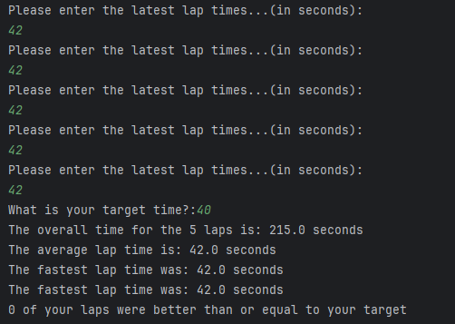
Figure 1: Output for Test 42 Seconds
Result: Did the programme behave as expected ie syntactically and logically correct?
YES
If YES, comment on what happened.
The program behaved correctly. Forty-two seconds is a realistic lap time, and the program calculated the total, average, fastest, and slowest laps accurately. Both the syntax and logic worked as expected.

- Test: 2 seconds

Screenshot(s) of output:
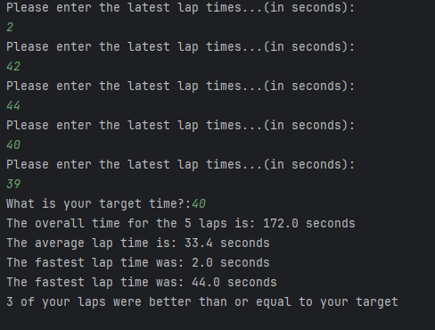
Figure 2: Output for Test 2 Seconds
Result: Did the programme behave as expected ie syntactically and logically correct?
NO
If NO, what went wrong and why? Suggest how things could be improved
The program behaved syntactically because it ran without errors, but it behaved logically incorrectly because it accepted an unrealistic lap time. The program accepted 2 seconds even though this is not realistic. To fix this, I would add input validation, so the program only accepts lap times above a realistic minimum, for example 18 seconds. If the user enters a value below this, the program should warn them and ask for a valid lap time.
seconds. If the user enters a value below this, the program should show an error message and ask again.

- Test:-4 seconds

Screenshot(s) of output:
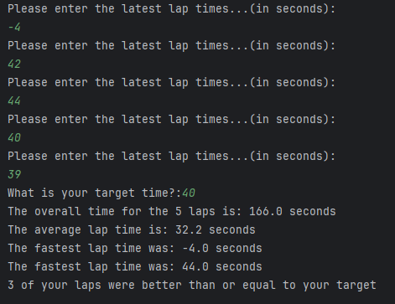
Figure 3: Output Test for -4 Seconds

Result: Did the programme behave as expected ie syntactically and logically correct?
NO
If NO, what went wrong and why? Suggest how things could be improved
The program behaved syntactically because it ran without errors, but it behaved logically incorrect because negative times should not be allowed. It still accepted the value because there is no validation.
To fix this, the program should include validation that rejects any negative number and prompts the user to enter a valid lap time.

- Test: 53444 seconds

Screenshot(s) of output:
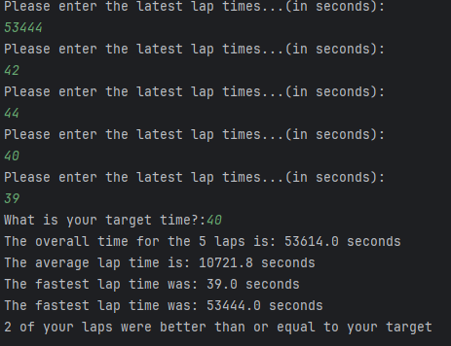
Figure 4: Output Test for 53444 Seconds
Result: Did the programme behave as expected ie syntactically and logically correct?
NO
If NO, what went wrong and why? Suggest how things could be improved
The program behaved syntactically because it ran without errors, but it behaved logically incorrect because it accepted an unrealistic lap time. The program accepted a large lap time that is not realistic. To fix this, I would add a maximum limit, such as 250 seconds. If the user enters a value above this, the program should warn them and ask for a realistic lap time.

- Test
Screenshot(s) of output:
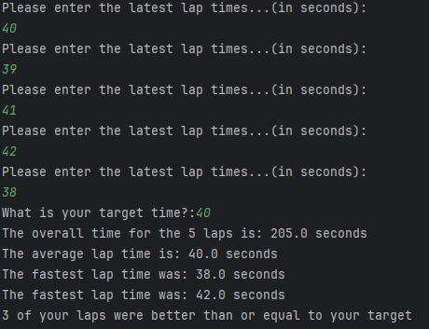
Figure 5: Output for Test Target Lap

Result: Did the programme behave as expected ie syntactically and logically correct?
YES
If YES, comment on what happened.
The program behaved syntactically, and the logic worked for normal target values, but it would still accept unrealistic targets because it has no validation.

Part b)

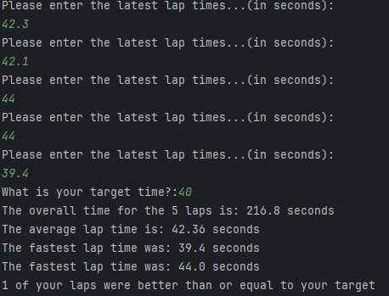
Figure 6: Output using sample lap times

Statistic 1 – Overall Time - This was incorrect .The program showed 216.8 seconds, but the correct total is 211.8 seconds, so the calculation was logically wrong.

Statistic 2 – Average Lap Time -This was correct .The average 42.36 seconds matches the expected value, so this statistic worked logically and syntactically.

Statistic 3 – Fastest Lap Time -This was correct . The program correctly identified 39.4 seconds as the fastest lap.

Statistic 4 Slowest Lap Time - This was incorrect. The value 44 seconds is correct, but the program printed “fastest” twice, so the label for the slowest lap was wrong.

Statistic 5 – This was correct. Only one lap was faster than the target of 40 seconds, and the program displayed this correctly.

Statistic 6 – Faster/Slower than previous Lap - This was unfinished. This part of the program was not completed in my initial code, so no comparison results were displayed.
Part c)
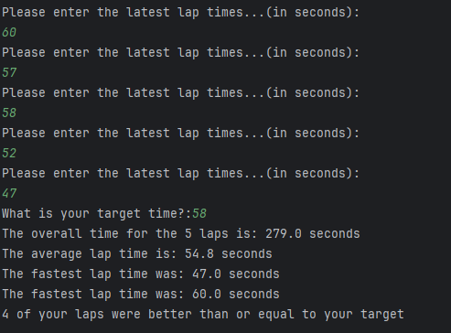
Figure 7: Output for Test 1
The program behaved correctly. It calculated the total, average, fastest lap 47 seconds, and slowest lap 60 seconds accurately. It also correctly identified four laps that were faster than or equal to the target time.

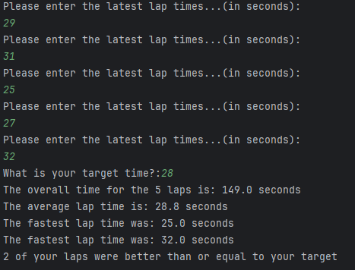
Figure 8: Output for Test 2
The program behaved correctly. The fastest lap 25 seconds and slowest lap 32 seconds were identified correctly, and the total and average were accurate. Two laps were correctly shown as meeting or beating the target time.

- Consider the results of the above tests and revisit your original code in order to address any tests that failed and/or improve code efficiency.

(Note: you may not be able to solve all of the problems that were encountered, but solve as many as you can.)

Paste your full revised code here :

[Copy and paste your full revised code here – note, do not use a screenshot]

laps = []
for counter in range(0,5,1):
print("Please enter the latest lap times...(in seconds):")
userLapTime = float(input())
laps.append(userLapTime)
if userLapTime < 20:
print("Error: Lap time is too low. Please enter a realistic value.")
elif userLapTime > 200:
print("Error: Lap time is too high. Please enter a realistic value.")
else:
valid = True
laps.append(userLapTime)
target = float(input("What is your target time?:"))
totalTime = sum(laps)
print("The overall time for the 5 laps is:",totalTime, "seconds")
average = sum(laps) / len(laps)
print("The average lap time is:", round(average, 2), "seconds")
# Fastest and slowest
fastest = min(laps)
slowest = max(laps)
print("The fastest lap time was:", fastest, "seconds")
print("The slowest lap time was:", slowest, "seconds")
found=0
for counter in range(0,5,1):
if laps[counter] <= target:
found=found+1
print(found, "of your laps were better than or equal to your target")
for i in range(1, 5):
if laps[i] < laps[i-1]:
print("Lap", i + 1, "was faster than lap", i)
elif laps[i] > laps[i - 1]:
print("Lap", i + 1, "was slower than lap", i)
else:
print("Lap", i + 1, "was the same as lap", i)

References

To improve my code, I reviewed how Python lists work so I could correctly calculate totals, averages, and identify the fastest and slowest laps [1]. I also used my lecture notes to help me add validation, correct the logic errors, and structure the conditions and loops more efficiently [2].
[1] W3Schools, Python Lists. Available: https://www.w3schools.com/python/python_lists.asp (w3schools.com in Bing)
[2] University of Wales Trinity Saint David, Introduction to Python Programming – Lecture Notes, 2026.

