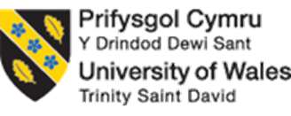
University of Wales Trinity Saint David
Master of Business Administration
HKBM7035: Strategic and Agile Business Management

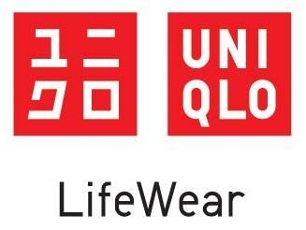

Strategic Management report for Uniqlo in Hong Kong

Student Name: Chan Sze Wan (Wendy)
Student No.: 2425266
Date of Submission: 3 November 2025
Lecturer: Dr. Terence Li

Executive summary

1. Introduction

1.1 Overview of apparel industry in Hong Kong

Hong Kong has long been one of the strategic international apparel brand hubs in the world with the advantages on serving as a bridge between the Mainland China and the global market. Also, it has an efficient global sourcing and supply-chain system (InvestHK, 2021). Status as an international fashion and retail center attracts a diverse range of global and local wear brands tracing to capitalize on its and diverse consumer base and sophisticated retail landscape (Coluccia, 2025).

Despite some of the challenges in recent years, stagnation in COVID-19, decline in traveler arrivals and corresponding decreases in retail sales driven by boarder economic headwinds, these challenges have temporarily slowed growth, but have not decreased the attractive qualities of the market. Significantly, numerous established or emerging global brands continue to invest and expand their footprint in Hong Kong. For example, ESPRIT re-open a flagship in Hong Kong in 2025, an emerging causal Chinese brand BENILAI open a first store in Hong Kong for the internationalization purpose (Marketing Interactive , 2025; (The Government of the Hong Kong Special Administrative Region , 2025)). This highlights the city's enduring market potential.

1.2 Background of Uniqlo
Uniqlo was founded by current chairman and chief of executive Tadashi Yanai who inspired from the warehouse-style retail model of United States and opened first store "Unique Clothing Warehouse" in 1984 in Japan (Campbell, 2023). After the success in Japan, Tadashi has targeted to create own private-brand and expanded to international markets. Today, it is an international clothing company which is the largest subsidiary in the listed-company Fast Retailing Co Ltd (Fast retailing, 2019).
Uniqlo is renowned on its brand philosophy - "Lifewear: Made for all", which emphasize to make life better for everyone via providing functional, practical and high-quality casual clothing at reasonable prices. These clothing focus on the design of simplicity, comfort and durability, and uses high-quality natural materials to meet the basic clothing needs of consumer of all ages, genders and lifestyles. Based on this brand philosophy, Uniqlo has successfully developed its globally popular items, such as HEATTECH series, AIRism series. Additionally, to achieve the low cost, quality-control and efficient response to consumer needs, Uniqlo operates under a model of special retailer of private brand apparel (SPA), which is a lifecycle of apparel from product planning and production to retailing service.
Through its unique brand philosophy and innovative business model, Uniqlo has succeed to expand the international business. As of 2025, Uniqlo operates 2519 stores worldwide and majority of stores serves in Greater China, including 35 in Hong Kong, 902 in China and others in Taiwan.

1.3 Importance of strategic management on Uniqlo in Hong Kong
Hong Kong has served as one of the critical focus market for Uniqlo , representing the company's critical step toward internationalization. Leveraging a city's competitive advantage as a unique international position, Uniqlo has achieved first success oversea in 2005 via significantly enhancement of global visibility in the establishment of first Hong Kong's large-scale store with its brand distinctive Japanese aesthetics and operational standards. Additionally, the diverse consumer base has provided valuable insight into global preferences to drive product innovation and growth strategies. In 2020, based on Hong Kong consumer feedbacks, Uniqlo has successfully developed globally popular items - the AIRism cotton sleeveless T-shirt and DRY-EX sleeveless T-shirt.
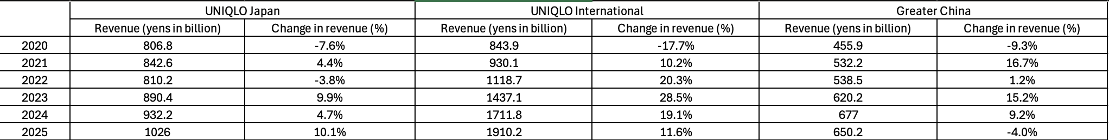
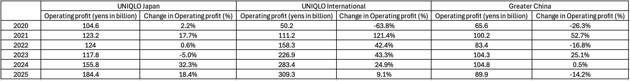
Although Hong Kong has served as a focus market that made substantial contributions in the internationalization, Uniqlo has recently witnessed a slowdown in its financial performance. Table 1 and 2 are shown revenues and operating profits in segments. Japan and international have demonstrated a consistent growth, whereas Greater China has demonstrated a slowdown trend and emerged a decline in 2024. The trend is particular in China and Hong Kong markets due to the weak consumer demand and warm winter season.
To enhance its competitiveness and improve the company performance, strategic management is crucial as it provides a framework for analyzing the internal capabilities and resources and the external environment, to evaluate and formulate effective strategies, thereby fostering the improvement of organizational performance. Particularly, as an international business, its operations are more complex business environments, rising the needs on balancing the global and local market differences and conflicts. As a focus market in Uniqlo, conducting a strategic management in Hong Kong market is critical.

1.4 Research aims and objectives
This report aims to conduct a strategic analysis of Uniqlo's operations in Hong Kong and provide recommendations for its future strategic direction to sustain the company's local competitive advantage.
To achieve the research aims, there are four research objectives.
- To analyze Uniqlo’s vision, mission and core values (VMV) for its strategic directions as the strategic foundation
- To evaluate the external opportunities and threats facing by Uniqlo via assessing the macro-environmental and industry-specific factors within Hong Kong's casual apparel retail sector
- To appraise Uniqlo's internal capabilities and resources by examining its strengths and weaknesses
- To evaluate the effectiveness of existing corporate and business-levels of strategies and to synthesize the findings from all objectives into strategic recommendations for both levels

1.5 Research methodology and coverage
This report adopts the perspective of external change agent to conduct a strategic analysis of Uniqlo's operations in Hong Kong. The research methodologies mainly adopts both qualitative and quantitative research, including observation in secondary data source and studying the strategic management theories.
The adoption of economic, social, environmental and technological perspectives to analyze the macro-environment in Hong Kong, while Porter’s five force analysis is to identify and understand the industrial landscape. Furthermore, adoption of value-chain analysis is to analyze the current internal performance in Uniqlo. Additionally, using a model of Balanced Score Card is to evaluate the proposed strategies for Uniqlo. Lastly, recommendations and action plan provide a guideline how Uniqlo to sustain the company's local competitive advantage.

2. Uniqlo’s vision, mission and values for strategic directions
A strategic direction functions as a lighthouse, defining an organization’s fundamental purpose—its mission—and the reasons for its existence (Dhlamini, 2025). Vision, mission, and values collectively act an interconnected framework for direction formulation that aligns stakeholders, directs decision-making, optimizes resource allocation, and facilitates the achievement of organizational goals. Without articulated clear values, grounded in a compelling vision and mission, company cannot attain outstanding performance or effectively convey its unique identity to employees and consumers. Therefore, the following sub-sections will be conducted the analysis on the Uniqlo’s vision, mission and core values to identify the clear and proper strategic directions.

2.1 Vision
Vision represents a future picture for the strategic direction, while it is a shared future development direction for different stakeholders to provide motivation for the organization’s growth in the market (Akter, 2020; Adebanke Olusola et al., 2022). In the current complex and unpredictable environment, companies must flexible and agile to cope with the environments. Flexible and agile emphasize on the teams and company work together, foster a sense of unity, cohesively toward shared goals and adapt to any challenges that is the key implication why a shared vision is crucial (Zasa and Buganza, 2022). Therefore, a strong vision must have a clear, future-oriented, inspirational, challenging and leading to increased alignment, commitment, and resilience.
To build that strong vision, a visionary leader plays a crucial role who is future-oriented, ability to cope with risk, proactive, and innovative-mind thinking and can define the state and communicate the vision to align employees and stakeholders (Farhan, 2024). In Uniqlo, the founder Tadashi Yanai is a widely recognized visionary leader with the characteristics of ability to clarify vision, innovation, strategic thinking and inspirational communication (Martin Roll, 2021). Uniqlo's vision is “to become a top causal apparel brand in the world” which aims to continuously grow and achieve global leader (The Government of the Hong Kong Special Administrative Region, 2005). Despite the vision seems simplicity, an effective vision should be inclusive to guide the employees and other related stakeholders towards the destination (Kotter, 1999; Kantabutra and Avery, 2010).
The vision has come from founder when he was founded first store in 1984. Over the four decades, this vision has guided Uniqlo’s impressive global expansion and now operating over 2,500 stores across Europe, Asia, and the United States (Yanai, 2024). With increasing its global brand awareness, it has ranked 8 of the most valuable fashion brands in FashionUnited and first listed in top 100 world best brands in recognized brand benchmark of Interbrand (Fashion United, 2025; Fast Retailing Co., Ltd., 2025).

2.2 Missions
Mission serves a fundamental guideline for the strategic direction, articulating its purpose and the current actions undertaken to achieve its vision. Therefore, effective mission is formulated by several elements for providing clear strategic direction, facilitating alignment in organizational planning, fostering a unique corporate identity and culture, and communicating the objectives and priorities effectively to both internal and external stakeholders.
Uniqlo currently articulates two distinct mission statements that collectively guide its strategic and social objectives. Figure 1 is the Uniqlo's core mission statement has established in the initial development. It has clarity declaration as a vision-and customer-oriented mission statement, since the first sentence "to provide everyone...." to response to the vision "....brand in the world". This statement can bring the benefits for ensuring a whole company are aligned toward a shared destination, and assist to prioritize in decision-making process. Therefore, in these forty years, Uniqlo focus on expanding to different countries (Roblek and Meško, 2020).
The mission statement also highlights some components to assist the vision achievement, like strategic on low-cost operations via integrating production and sales operations, commitment to staff for ideal corporate environment and eventually highlighting all above achievements response to the vision "top causal brand in the world". Based on this mission, Uniqlo have been consistently growing Uniqlo to worldwide market and continuously aims to be top causal brand in the world.
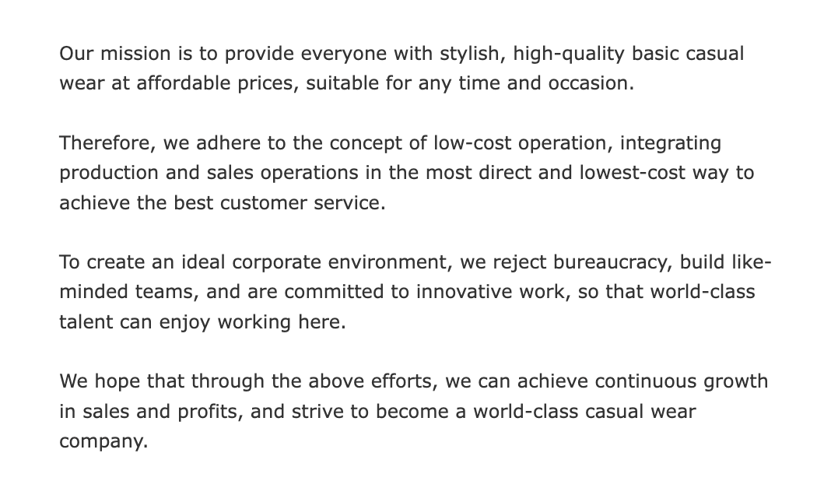

Today's corporation should not only focus on the profitability, growth, but also should consider the overall social, environmental and economic. Most of the top company have integrated the sustainability to business. In 2013, Uniqlo has launched refining "sustainability" mission statement as a supplementary declaration (Figure 2). This statement commits to producing high-quality apparel while maintaining ethical workplace, respecting human-rights, and building positive social-environmental impacts. Although both missions separately, they are complementary rather than conflicting. Together, they reflect Uniqlo’s overarching commitment to sustainable development while aspiring to maintain its status as the casual wear brand globally. Both mission framework demonstrates Uniqlo’s integrated and continuous improved approach to balancing business performance with environmental and social responsibility.
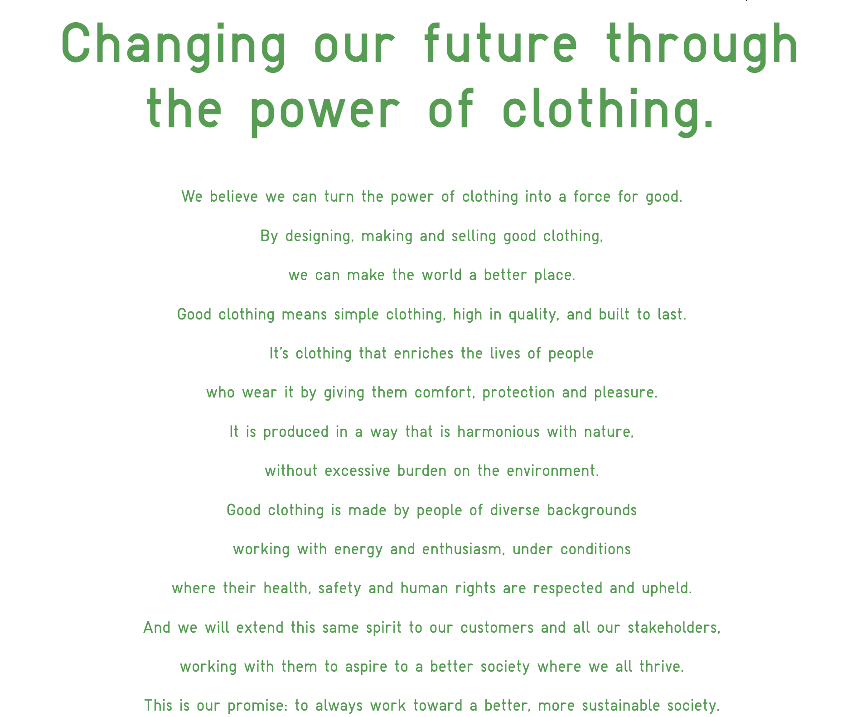

2.3 Core values
Core values represent a set of beliefs to guide company strategy and behavior, acting as its spirit of the strategy by providing a moral compass and a framework for decision-making. Also, it is a principle to lead the company to do right think. Therefore, it should be aligned with vision and mission.

Uniqlo has 5 core values. First is "Approaching issues from the customer perspective". In apparel sector, it should have a full customer understanding first to design, produce and sell an appropriate causal wear. Reflecting mission priority sentence "to provide everyone high-quality basic casual wear..." and " by design, making and selling good clothes”, Uniqlo believes prioritizing and deeply understanding the needs, preferences, and experiences of customers at every stage of the retail journey that can only provide everyone high-quality casual wear.
Second is "Respect and Support for individuals to foster both corporate and personal growth" which is response to the "to create ideal working environment" and "diverse background working..." in the mission. Uniqlo want to become top brand in the world. It must have a respect and support in diversity workplace.
Third is "Embrace Innovation and challenge". This is the founder one of the personal philosophies. He believes only keep innovative and go to challenges that can do the thing best. This also reflects mission" innovative work".
Forth is "Committing to ethical standards and correctness". This is a basic business principle for every corporate. This also is correspondence to the sustainability mission. Only keep ethical and correctness, business can keep operating.
Fifth is "All-staff business engagement” (Zen-in Keiei)" which is the key management philosophy by founder. It encourages every employee to think like a manager and select the best global option or solution, aligning with Uniqlo’s vision to become the top casual apparel brand globally (Tsukagoshi, 2023). This philosophy aligns with Peter Drucker’s concept of knowledge workers which means only worker with the continuous adaptation, learning, and creative application of information, thereby to sustain competitive advantage.

3. External analysis
In the context of strategic planning, external analysis acts a crucial role for scanning the potential opportunities and threats, coping with the dynamic environment and ultimately achieve long-term success. In the following subsection, macro-environment and industrial environment analysis in Hong Kong will be conducted to understand the market, minimize the threats, and capitalize on new opportunities.

3.1 Macro-environments analysis

3.1.1 Economic
In recent years, overall economic environment in Hong Kong has a slightly recovered. However, the retail sale market has experienced a radical structural transformation. As shown on Figure 1, overall retail market was dynamic, and the trend was decline. In 2023, due to impulsive purchasing after COVID-19, overall retail sales values have experienced a dramatic growth. However, in 2024 have experienced a quick decline after the peak in 2023, even overall consumer price index had stable (Figure 2). Also, except Food, alcoholic drinks and tobacco as daily products, other categories, including wearing apparel, have demonstrated a trend of decline.

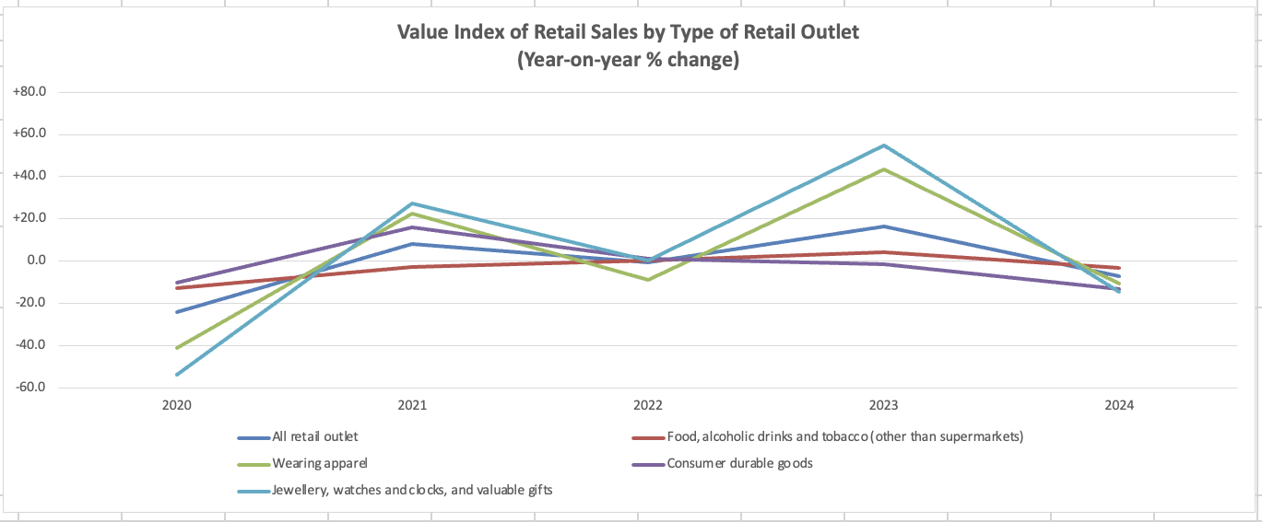
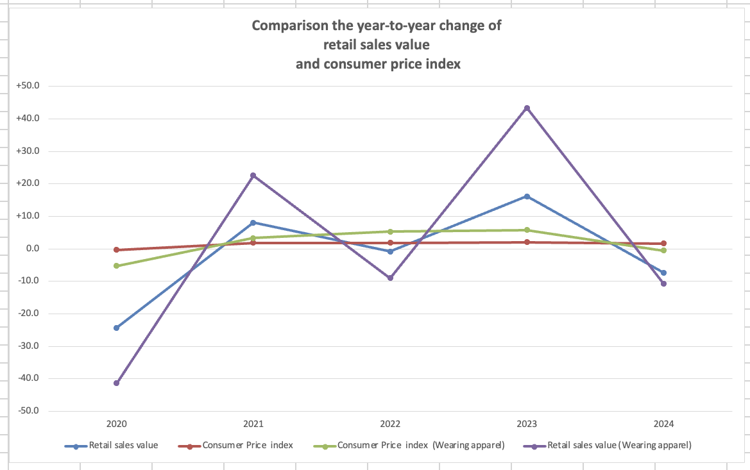

Weak local consumption intention and Changing Mainland China traveler spending pattern are key factors affecting the retail market change. Figure 3 is private consumption expenditure (PCE) with different categories which demonstrated the local citizen's purchasing behavior and habits. Most of the consumption expenditure in the local market, including consumer goods, have decreased while expenditure of abroad keeps in high positive level. Since 2022, Hong Kong residents spending money in the mainland has intensified recently, due to convenient and barrier-free to Mainland China and strong Hong Kong dollar. Meanwhile, Mainland China traveler have shifted from the past "explosive buying" to "experience travel" due to the rise of online shopping, a decline in overall consumption levels. For apparel wear selling, this phenomenon may be threatened the regional performance in Hong Kong and increase the needs to change the marketing strategies to boost the sales.
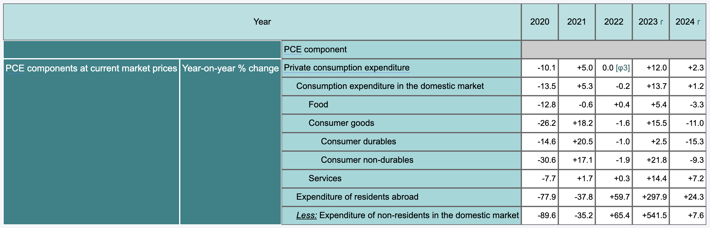

Hong Kong's operating cost pattern has also changed in recent year. Due to the radical retail structural transformation, some retail stores had to dismiss the business, thus affect the overall retail rent market. Figure 4 is shown the trend of retail rent. Since 2020, the rent has kept in stable low level. In past year, due to rent decreasing, some apparel brands have caught these opportunities to expand to Hong Kong, such as Urban Revivo causal wear brand from China, thus might increase the competition in the market.
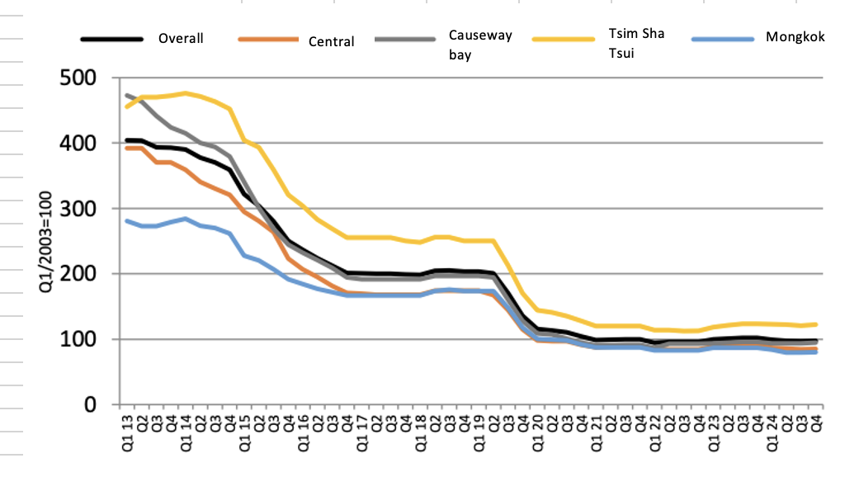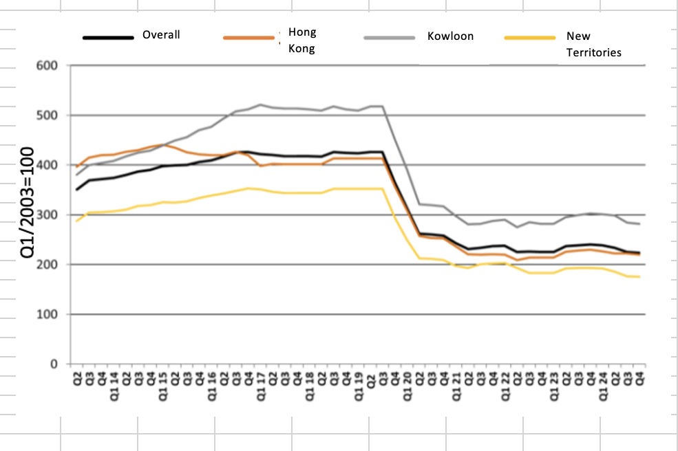

3.1.2 Social
Hong Kong has rapidly ageing population, due to longer life expectancies, low birth rate and increasing 25-44 age younger emigration, with projections showing the elderly will constitute a significant portion of the population in the coming decades, reaching almost a third by 2036, as shown on Figure. Also, these new group of elderly will have a substantial wealth. A survey studied future elder people wealth, people who aged around 58 in 2018, have around HKD$10 million of net assets and will rise each year This wealth, coupled with an aging population, highlights the purchasing power of older adults. Although high purchasing power does not represent their willing intention to purchase, apparel, especially causal apparel, is considered daily necessities products. Therefore, these group of demographics might become a high potential consumer and thus might need to adjust the marketing strategies for attracting them.

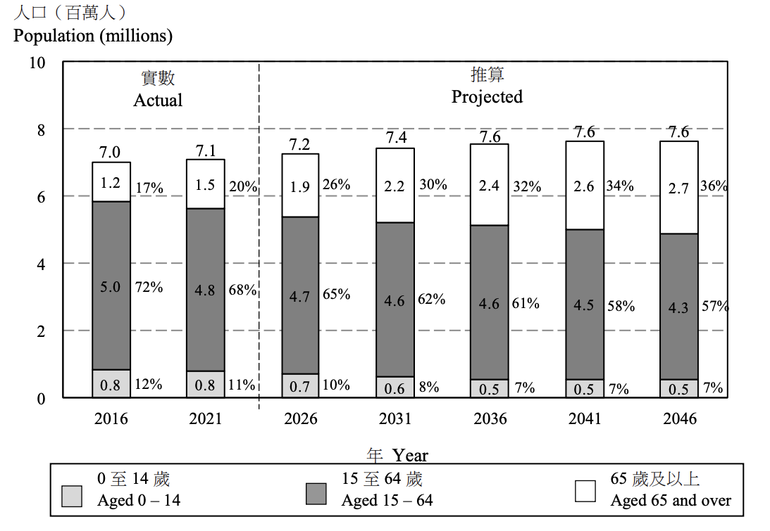
Environmental issue in apparel industry, especially in fast fashion, have been drawn a global attention. There is no exception in Hong Kong. According to a survey on awareness on environmental and sustainability conscience in Hong Kong in 2024, over 70% of people have a significant awareness on environmental issues and sustainability. Also, 80% of respondents reflect the sustainable product will increase their intention to purchase, even with higher price. These implications are for apparel brands in the sector, to enhance corporate image and meet rising consumer expectations, incorporating the sustainability will be a trend.

3.1.3 Environmental
Global warming has become a significant factor impact on the apparel industry. Unusual weather and temperature conditions lead a serious challenge for the sales and product development problems. In recent years, Hong Kong has been almost no winter. According to number of 'cold days' in Hong Kong from Observatory, the trend has been consistently decreasing and 2019 has the lowest, only 1 cold days in a year. In the condition, entire apparel sector in Hong Kong has faced adverse selling cycle, like weak consumer demand for winter items, inventory management challenges, forced early promotions for overstocks, eventually caused the operating profit decreasing.
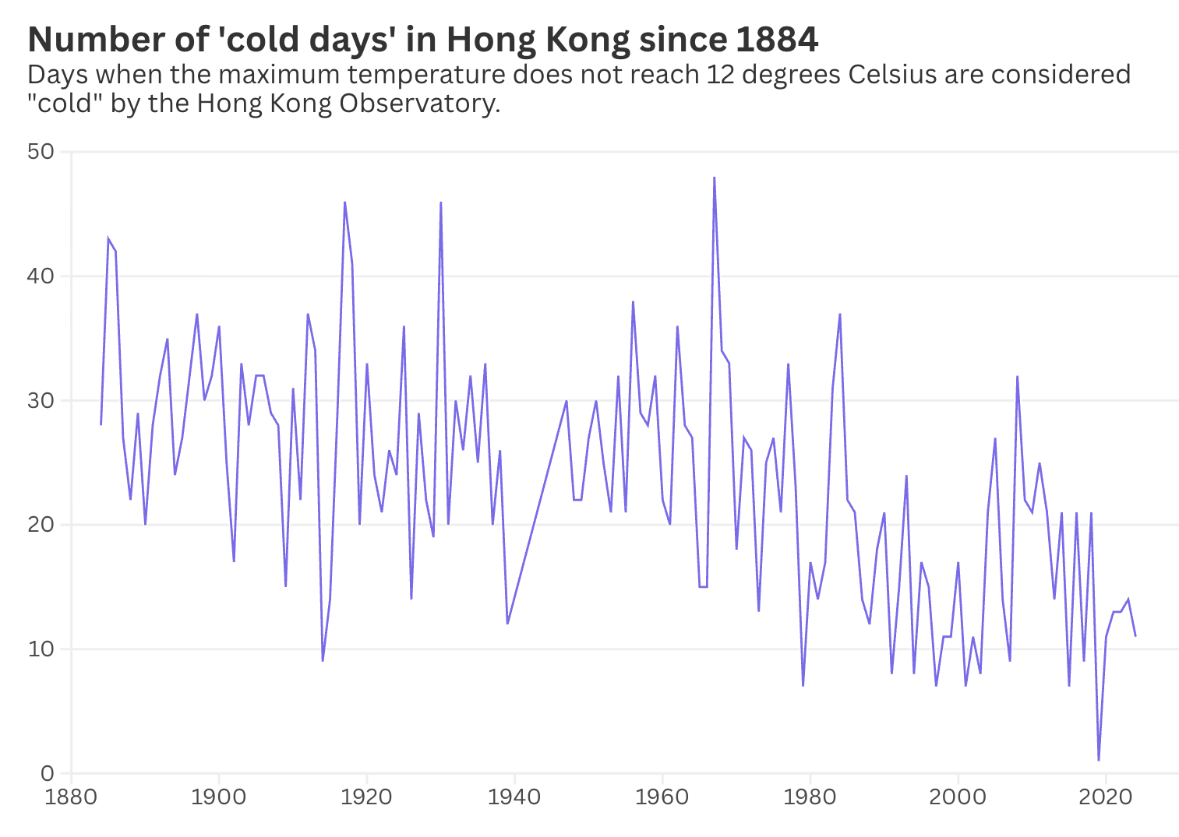

3.1.4 Technological
For seeking efficiency and data-driven, technological innovation is a priority for the apparel industry. In recent years, some of the brands have introduced different new innovative technologies to help to build an efficient design, supply-chain and retail processes, such as Zara introduce artificial intelligence (AI) to forecast apparel trends by analyzing social media, customer reviews, and sales data. H&M has implemented AI-driven demand forecasting and supply chain optimization to predict demand accurately, optimize inventory, and streamline shipping routes, reducing waste and improving operational efficiency in partnership with Google Cloud.

3.2 Competitive five forces analysis
Conducting Porter's Five Forces analysis is necessary to evaluate the industry competitive intensity and attractiveness that can assist to strategic decision about overall profitability. Therefore, the following is to conduct Porter's Five Forces for casual apparel sector in Hong Kong.
3.2.1 Threats of new entrants: Moderate
Hong Kong implements a free port with efficient supply-chain infrastructure and low-tax system, while has simplified the application procedures for import and export license. Also, a sound legal system and intellectual property protection can ensure a positive business environment. However, in causal apparel sector, as a service-oriented sector need a labor-intensive, substantial start-up cost, such as rental cost, distribution cost (Oxfam Hong Kong, 2004). Current market is intensive competition among main competitors, like Uniqlo, since Hong Kong retail market is downside recently that means the competition will be higher. The new entry might need more resources and capital for branding and marketing to compete.
3.2.2 Threats of substitute: Moderate
Casual apparel is characterized by comfort, simplicity, and informal design, intended for relaxed or everyday activities (Kim and Shin, 2011). Sportswear is considered as the primary substitute for casual apparel, but sportswear mainly focusses on functional on exercise and customer prefer wearing when exercise. However, recently, the emergence of "athleisure," which is incorporating sportwear with casual wear, has gained dominant. These types of wear designs apparel that are functional for physical activities while remaining comfortable and appropriate for daily wear that can cope with different consumers for different purpose in different occasion. Therefore, "athleisure" has influenced the casual wear market in Hong Kong. Based on the Uniqlo's consistent understanding consumer preferences, Uniqlo has successfully followed this trend to launch Athlete collection in 2024.
3.2.3 Bargaining power of buyer: High
In Hong Kong's causal apparel sector, there are substantial and diverse customer base while the geographical location is easy to build economic of scale. Also, the technological advancement is increasing for fostering customer price comparison. Meanwhile, the casual apparel basically is not easy to differentiate the product itself. Therefore, the consumer bargaining power is relatively high. To cope with this condition, Uniqlo design a series strategies to solve the above issue. First, Uniqlo provide an image differentiation on high-quality materials with low price. It intend to educate and change a basic conventional wisdom "low price with low quality". Also, Uniqlo adopt direct owned retail stores instead of using intermediaries". In the consumption process, there are "intermediaries" like retail stores offering a wide variety of brands. Retailers may impose significant demands when purchasing finished garments, impacting prices. While quality is inherent, prices can become unreasonable, and alternative garments are readily available. This explains why apparel manufacturers open their own independent stores to sell their products. Importantly, apparel stores cannot rely on a specific customer base. Consumers increasingly prefer lower-priced but higher-quality clothing, reducing differentiation. Direct sales to consumers require a significant portion of their disposable income. Retail stores, too, source inventory at the lowest possible cost, ultimately driving up prices. Uniqlo, through its specialty stores, sells goods with a strategy of "stockpiling low." Furthermore, its no-brand or no-logo design philosophy is considered a major draw for attention.

3.2.4 Bargaining power of supplier: Low
In the casual wear sector, the prices and availability of raw materials are often unstable due to fluctuating demand-supply dynamics, weather, transportation costs, and government support. Even adoption of standardization on raw material procurement, supply chain disruptions remain a possibility. Reducing these risks and maintain a stable, cost-effective supply chain, Uniqlo has implemented vertical integration strategies, distributing its production processes across different countries and managing the entire supply-chain cycle. This approach not only can achieve consistently quality control and operational efficiency but also provides Uniqlo with a competitive advantage by creating a barriers to entry for potential new entry.
3.2.5 Threat of competitors
Whether in their home market or a host country, apparel, accessories, and merchandise always face competition, and their scale typically fluctuates. Modern apparel industry trends include globalization and increased competition, pressure from rising prices and declining profit margins, small-batch, highly complex orders, shorter delivery cycles, multi-location operations, changing customer demands, and relaxed textile and apparel quotas—all creating new market dynamics. To respond to these trends, the apparel industry has shifted its focus to broader product development and improvement at the lowest possible cost. High switching costs force companies to differentiate themselves. In an industry where products are considered "homogenized," key sources of differentiation are brand image, reputation, and existing market position. For Uniqlo, the products themselves are a significant source of competitive advantage. Uniqlo is committed to developing a wide range of high-quality products to reach as many customers as possible. Therefore, competitors face a threat when launching innovative products. Uniqlo's strategic locations in global fashion capitals aim to stay abreast of the latest fashion trends. Uniqlo's ability to quickly adapt to trends and new markets helps it achieve product differentiation, which is key to its success in the apparel industry. Product differentiation is key to distinguishing top competitors from others, but the cost of imitation is not high. Therefore, Uniqlo's product differentiation is only a temporary competitive advantage. A true competitive advantage can only be achieved when a company learns to manage its capabilities to win over end consumers and make it difficult for competitors to imitate.
3.2.6 summary of competitive five forces

4. Internal analysis
4.1 Existing business strategies
4.2 Value chain analysis

5. Evaluate the corporate and business strategies for Uniqlo

6. Recommendations and action plan

7. Conclusion

https://www.emerald.com/sd/article/30/7/42/341096/How-UNIQLO-evolves-its-value-proposition-and-brand

For building a shared vision, Tadashi Yanai’s management philosophy, “All-staff business engagement” (Zen-in Keiei), encourages every employee to think like a manager and select the best global option or solution, aligning with Uniqlo’s vision to become the top casual apparel brand globally (Tsukagoshi, 2023). This philosophy aligns with Peter Drucker’s concept of knowledge workers and the objectives and key results (OKA) framework ((Drucker, 2012; Zasa and Buganza, 2022). These initiatives are because frontline staff should have the best understanding of consumers and store-level challenges. By meritocracy, teamwork, and ownership, employees contribute to enhanced organizational vitality and efficiency, driving the company’s long-term success and thus achieve the core vision.

Reference
Adebanke Olusola, S., Olaleke Oluseye, O., Menyene Saviour, U., Joy Iember, K. and Olamilekan Ayomiposi, D. (2022). A Content analysis of the vision and mission statements of top ten leading Universities in Africa. Cogent Education, [online] 9(1). doi:https://doi.org/10.1080/2331186x.2022.2143648.

Akter, S. (2020). Companies’ vision, mission, and core values focus on human resource management. International Journal of Financial, Accounting, and Management, 2(4), pp.343–355. doi:https://doi.org/10.35912/ijfam.v2i4.412.

Campbell, C. (2023). The Founder of Uniqlo Has a Wake-Up Call for Japan. [online] Time. Available at: https://time.com/6333659/tadashi-yanai-uniqlo-japan-profile/ [Accessed 2 Nov. 2025].

Coluccia, K. (2025). Practical Guide on the Apparel and Fashion Industry in Hong Kong. [online] Woodburn. Available at: https://www.woodburnglobal.com/post/practical-guide-on-the-apparel-and-fashion-industry-in-hong-kong [Accessed 2 Nov. 2025].

Drucker, P.F. (2012). They’re Not Employees, They’re People. Harvard Business Review, 1(1), pp.96–108. doi:https://doi.org/10.4324/9780080942377-15.
Dhlamini, J. (2025). Setting the strategic direction: the role of the mission, vision, values statements and strategic leadership. Journal of strategy and management, 18(3). doi:https://doi.org/10.1108/jsma-08-2024-0193.

Farhan, B.Y. (2024). Visionary leadership and innovative mindset for sustainable business development: Case studies and practical applications. Research in Globalization, [online] 8(1), p.100219. Available at: https://www.sciencedirect.com/science/article/pii/S2590051X24000285.

Fast retailing (2019). Interview with the CEO | FAST RETAILING CO., LTD. [online] Fastretailing.com. Available at: https://www.fastretailing.com/eng/ir/direction/interview.html [Accessed 2 Nov. 2025].

Fast Retailing Co., Ltd. (2025). UNIQLO Ranked Among World’s Top 100 Best Brands in 2025 Interbrand Rankings | FAST RETAILING CO., LTD. [online] Fastretailing.com. Available at: https://www.fastretailing.com/eng/group/news/2510231700.html [Accessed 2 Nov. 2025].

Fashion United (2025). Most Valuable Fashion Brands. [online] Fashionunited.com. Available at: https://fashionunited.com/i/most-valuable-fashion-brands [Accessed 2 Nov. 2025].

Marketing Interactive (2025). Esprit stages powerful HK comeback in Causeway Bay. [online] Marketing-Interactive. Available at: https://www.marketing-interactive.com/esprit-stages-powerful-hk-comeback-in-cwb [Accessed 2 Nov. 2025].

Martin Roll (2021). Uniqlo - the Strategy behind the Japanese Fast Fashion Retail Brand. [online] Martin Roll. Available at: https://martinroll.com/resources/articles/strategy/uniqlo-the-strategy-behind-the-global-japanese-fast-fashion-retail-brand/ [Accessed 1 Nov. 2025].

Oxfam Hong Kong (2004). Oxfam Hong Kong Briefing Paper Turning the Garment Industry Inside Out Purchasing Practices and Workers’ Lives. [online] Oxfam Hong Kong . Available at: https://www.oxfam.org.hk/tc/f/news_and_publication/1458/content_3562en.pdf [Accessed 3 Nov. 2025].

Roblek, V. and Meško, M. (2020). The importance of mission vision in organizational strategy. Normirovanie i oplata truda v promyshlennosti (Rationing and remuneration of labor in industry), 1(11), pp.71–73. doi:https://doi.org/10.33920/pro-3-2011-07.

InvestHK (2021). Future of Sourci ng: 2021 and beyond. [online] InvestHK. InvestHK. Available at: https://www.investhk.gov.hk/media/e3adb4bj/future-of-sourcing-2021-and-beyond.pdf [Accessed 2 Nov. 2025].

Kantabutra, S. and Avery, G.C. (2010). The Power of vision: Statements That Resonate. Journal of Business Strategy, [online] 31(1), pp.37–45. doi:https://doi.org/10.1108/02756661011012769.

Kotter, J. (1999). What Leaders Really Do. Organizational Dynamics, 28(2), pp.90–91.

Kim, J.-H. and Shin, S.-Y. (2011). Clothing Values and Casual Wear Purchase Behaviors according to 20’s and 30’s Male Lifestyles. Journal of the Korean Society for Clothing Industry, 13(4), pp.487–498. doi:https://doi.org/10.5805/ksci.2011.13.4.487.

The Government of the Hong Kong Special Administrative Region (2005). Top Japanese casual wear brand launches first Hong Kong flagship store (with photos). [online] The Government of the Hong Kong Special Administrative Region . Available at: https://www.info.gov.hk/gia/general/200509/30/P200509300200.htm [Accessed 1 Nov. 2025].

The Government of the Hong Kong Special Administrative Region (2025). Global fashion group brings its athleisure brand to Hong Kong (with photos). [online] The Government of the Hong Kong Special Administrative Region . Available at: https://www.info.gov.hk/gia/general/202508/02/P2025080100293.htm [Accessed 2 Nov. 2025].

Tsukagoshi, D. (2023). Making Great Strides Worldwide by Employing Global One and Zen-in Keiei Management Principles. [online] Faster Retailing Co. Limited. Available at: https://www.fastretailing.com/eng/ir/library/pdf/20231012_tsukagoshi_en.pdf [Accessed 1 Nov. 2025].

Yanai, T. (2024). UNIQLO 40th Anniversary . [online] Faster Retailing Co. Limited. Available at: https://www.fastretailing.com/eng/ir/library/pdf/20240411_yanai_en.pdf [Accessed 1 Nov. 2025].

Zasa, F.P. and Buganza, T. (2022). Developing a shared vision: strong teams have the power. Journal of Business Strategy, [online] 44(6), pp.415–425. doi:https://doi.org/10.1108/jbs-04-2022-0065.

