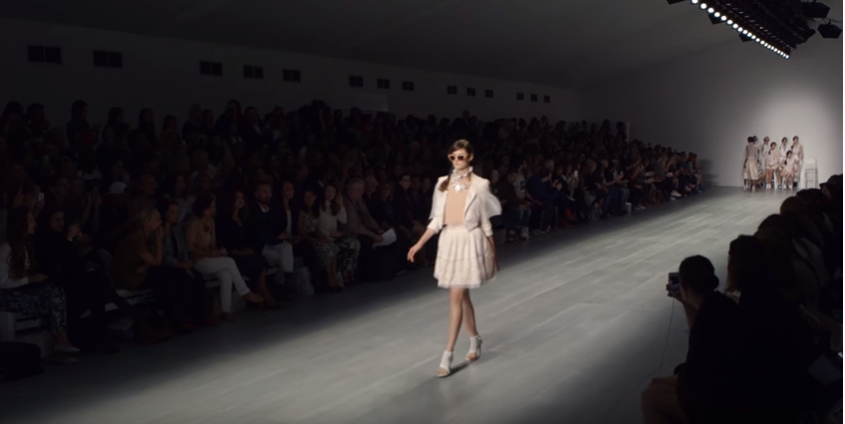
Figure 1 (Andrew Morgan, 2015)
Fast Fashion
Jodie Baker- 1802844
Course title: Surface Pattern Design- year 1
Tutor: Julia Lockheart
Word count: 1440 words
The fashion industry is dyeing, and we are paying the price. The purpose of this exhibition is to bring to light the ever-growing disaster that is the fashion industry. The issues are widely known and yet they still they stand undefeated. This exhibition will suggest ways of tackling the issues found within the industry without compromising the quality of production. The main concerns are the effects on the environment and the health and wellbeing of the people involved in production. It is imperative that we begin to correct the damage done and prevent further damage for generations to come. (Alden Wicker, 2017) A 2015 study from Global Fashion Agenda found that the Fashion industry alone was responsible for approximately 4.3 percent of the Earth’s carbon foot print. While industries such as fossil fuels and agriculture contribute a larger share- fashion is still among the top ten of the worst industrial polluters.
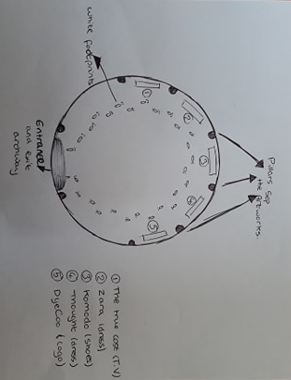
This exhibition will consist of five artworks including three fashion garments, a logo and one informational film piece. The exhibition will be free to the public and tour worldwide in every major western city so that it may reach as many eyes as possible. It is the aim of this art to quietly show consumers that they are responsible- to a degree- for tragic events directly caused by fast fashion. As consumers we must be made to understand that every cause has an effect. We can no longer ignore our Eastern neighbours’ pleas for better working conditions. Fast fashion needs to be understood so that it may be corrected.

Figure 2. (Baker, 2019)
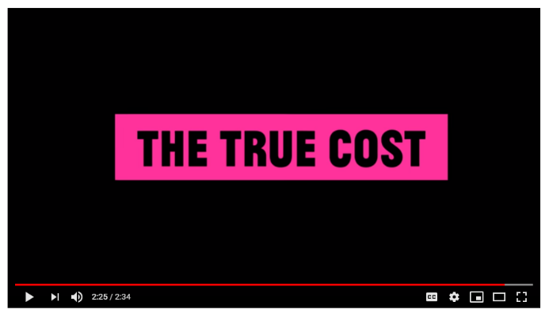
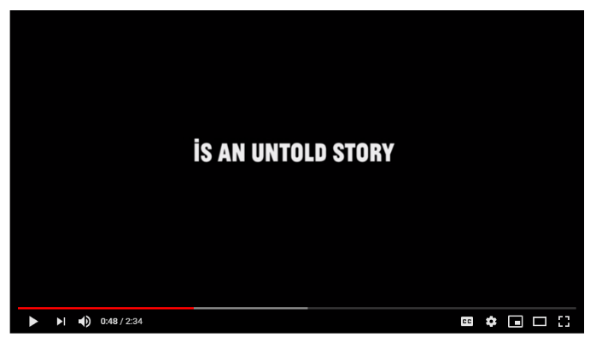
The artwork of this exhibition will be displayed in a large circular room (As seen in figure 2 above). The ceiling is made up of hundreds of windows forming a dome. Every inch of sunlight or darkness is reflected by the blinding white walls. To your left there stands a small television. As your eyes follow the curvature of the room you see a dress followed by a small pair of children’s shoes. Another dress stands alone and finally a large logo on the far right. White arrows on the painted grey floor steer you from the doorway towards the T.V. They then follow clockwise around the remaining objects in the room and back through the archway you entered from.
Figures 3 and 4. (Andrew Morgan, 2015)

On the television a documentary is being played on a loop. Twenty sets of headphones hang around the screen so that many people can watch and listen all at once. The documentary is called ‘The True Cost’ and was created and narrated by Andrew Morgan in 2015. This documentary highlights the long list of negative socioeconomic and environmental effects within the fashion industry. However, it also mentions individual companies such as ‘People Tree’ (a Fairtrade fashion brand). ‘People Tree’ consider the health of their employees across the entire production chain in every decision that they make (Andrew Morgan, 2015). Brands like ‘People Tree’ have proven that a sustainable fashion industry that cares for its workers is entirely possible and within our means.
It explores in great depth the exploitation of offshore workers, particularly in Asian countries, in what we know to be ‘sweatshops’. The documentary follows the experiences of individuals living the nightmarish reality of working in a clothing factory. Andrew Morgan focuses on the tragedy in Dhaka, Bangladesh where in 2013, ‘1,135 people’ (The Guardian, 2016) were killed and hundreds more were injured. Families lost loved ones and some very graphic scenes are shown. It is important that this documentary is the first thing you see in the exhibition as it puts into context everything else in the room.
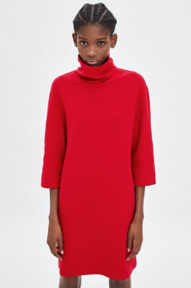

Figure 5 (Zara, 2019)
Continuing to your right you will see a display featuring a stunning garment by the globally renowned brand Zara. This beautiful dress (figure 5) was cut and made by workers from the previously mentioned clothing factories around the world. The dress, seen by the public immediately after watching the documentary, is a visual representation of the damage and suffering highlighted in ‘The True Cost’ (Andrew Morgan, 2015). This garment is a perfect example of ‘Fast Fashion’, it was manufactured by low paid employees in appalling working conditions so it can be sold for the incredibly low price of just ‘£12.99’ (Zara, 2019). Western society ignores the suffering caused by the production of clothing and focuses exclusively on two key factors; the value for money and the aesthetic appeal. With a disregard for little else beyond ourselves, the consumer is enticed by feelings of opulence and joy created by having a wardrobe bursting to the seams with an unnecessary amount of choice. Companies such as ‘Zara’ are capitalising on the suffering of these highly underpaid workers, but as they are not directly employed by ‘Zara’ they can avoid all accountability (Andrew Morgan, 2015).
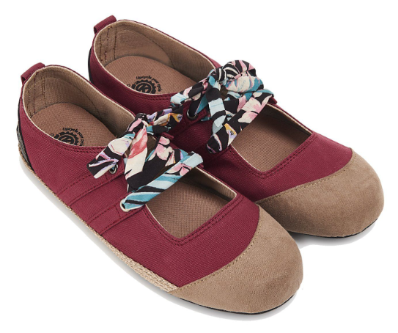

Figure 6 (Komodo, 2019)
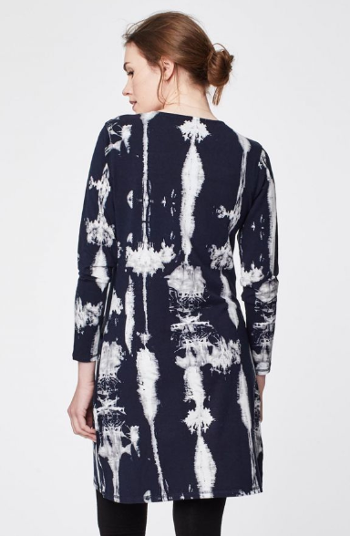
You see next a contrasting change in the mood of the art. A small childlike pair of shoes sit comfortably on a simple white stand in the centre of everything in the room. These shoes are made by the brand ‘Komodo,’ (2019) who are certified by both the Global Organic Textile Standard (GOTS) and the Soil Association. Manufactured sustainably using organic cotton, for every pair purchased ‘Komodo’ will plant one bamboo sapling. The use of upcycled tyres to create the soles of the shoes results in less waste needlessly discarded to landfills. (Komodo, 2019) This ideology of using what we already have to make something new could pave the way to a better fashion world.
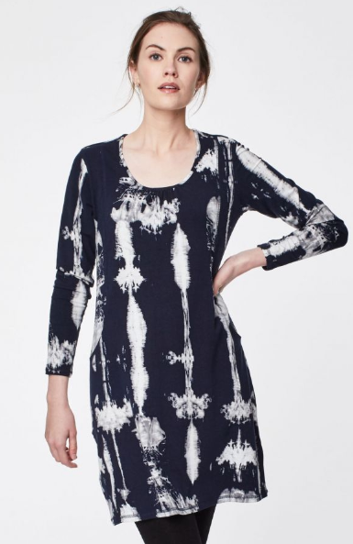
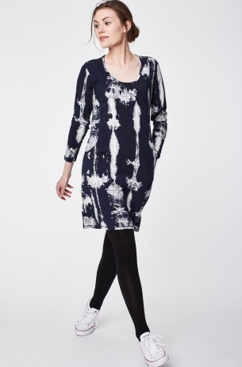
Figures 7, 8 and 9 (Thought, 2019)
The fourth piece in this exhibition is a casual dress created by designers from the organic clothing brand- ‘Thought’. This family run, London based company exercises ‘sustainable fashion’ (Thought, 2019). ‘Thought’ uses sustainable fabrics such as ‘tree friendly Tencel’, ‘Certified Organic Cotton’ (Thought, 2019) and recycled plastic bottles for their ‘Polyester, Reborn’ (Thought, 2019). The environment is at the heart of their decision making, they even use ‘AZO (a harmful and poisonous substance) free dyes’ (Thought, 2019). However, they are still not doing everything they could be to help reduce the amount of pollution generated by the fashion industry. It is certainly a step in the right direction to be using biodegradable fabrics that have been grown without the use of pesticides. Recycling plastic bottles into timeless everyday affordable clothing is helping to reduce the amount of plastic in landfills and our oceans. Recently, a Dutch company called ‘DyeCoo’ has managed to make CO2 fabric dyeing ‘available on an industrial scale’ (DyeCoo, 2019), proving that further change is not only possible – but becoming more readily available.
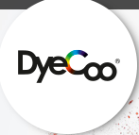

Figure 10. (DyeCoo, 2019)
This brings us to the fifth and final aspect of the exhibition- the CO2 fabric dyeing company ‘DyeCoo’. In the exhibition the logo as shown above in figure 10 is presented as the fifth object. The logo has a two-meter circumference and underneath is a short paragraph explaining the company’s ethos. ‘DyeCoo’ has produced a revolutionary production method, which is exactly what the fashion industry needs. Using supercritical Carbon Dioxide to dye fabric, they have eliminated the need for a constant supply of water, arguably our Earth’s most valuable resource (DyeCoo, 2019). The result of this technique is apparent – no more harmful chemicals flooding back into bodies of water because water is no longer needed (DyeCoo, 2019). Imagine if every factory used this method, the amount of pollution produced by the fashion industry would be drastically reduced. This method lowers the cost of the dyeing process, is ‘energy efficient’ (DyeCoo, 2019) and creates ‘geographical freedom’(DyeCoo, 2019). DyeCoo boasts that they can literally ‘dye fabric in the middle of the Sahara’ (DyeCoo, 2019). This is the most effective change that is currently readily available for the industry to have a significant and positive environmental impact.

As this pop-up exhibition travels it is the hope that people everywhere re-evaluate what they consume. Far too many lives have been lost and too much damage has been done to the environment. We need to start holding ourselves accountable for the actions of corporations which we support in our everyday lives. It can no longer be acceptable for Western society to benefit from the suffering of other cultures.
The sole purpose of this exhibition is to highlight effective and efficient ways of creating a sustainable fashion world. It is important to know where and who your clothing comes from. 1913- Mohandas Gandhi said: ‘If we could change ourselves, the tendencies in the world would also change.’ It is time to think of others and make a change.

Bibliography:
Figure 1: Morgan, Andrew (2015) The True Cost [video] Available at: www.Netflix.com (Accessed: 2nd of May 2019)
Wicker, Alden (2017) Ecocult [blog] Available at: https://ecocult.com/now-know-fashion-5th-polluting-industry-equal-livestock/ (Accessed 2nd May 2019)
Figure 2: Jodie Baker (2019) own artwork
Figures 3 and 4: Morgan, Andrew (2015) The True Cost [video] Available at: www.Netflix.com (Accessed: 2nd of May 2019)
The guardian (2016) ‘Rana Plaza collapse:38 charged with murder over garment factory disaster’ Available at: https://www.theguardian.com/world/2016/jul/18/rana-plaza-collapse-murder-charges-garment-factory (Access date: 2nd of May 2019)
Figure 5: Zara (2019) Zara. Available at: https://www.zara.com/uk/en/plush-jersey-dress-p04174806.html?v1=8069529&v2=1180512 (Access date: 2nd of May 2019)
Figure 6: Komodo (2019) Komodo. Available at: https://www.komodo.co.uk/collections/womens-vegan-shoes/products/spandau-ballet-burgandy (Access date: 2nd of May 2019)
Figures 7, 8 and 9: Thought (2019) Thought. Available at: https://www.wearethought.com/elsenore-bamboo-relaxed-pocket-dress-dark-navy (Access date: 2nd of May 2019)
DyeCoo (2019) DyeCoo. Available at: http://www.dyecoo.com/co2-dyeing/ (Access date: 2nd of May 2019)
Figure 10: DyeCoo (2019) DyeCoo. Available at: http://www.dyecoo.com/co2-dyeing/ (Access date: 2nd of May 2019)

