Stuart Durston 1904979
Professional Career Development
Assessment
Introduction
This is my reflective piece for my professional career development module. In this piece you will see all the different stages I went through to start understanding how to go about completing the biggest goal I have set myself to be able to have the life I envision to be my ideal life.
I will talk about the different styles and models I have looked at to truly understand how to get all the personal growth I need to accomplish everything I wish to in my life, as a class we were all shown the Abraham Maslow’s hierarchy of needs this was a motivational theory that could be looked at to help us in completing our own personal development plans. I found another motivational theory which I believe I am more drawn to, this is the one I will be looking too when I achieve my goal as it is perfect to implement when running a business and that is the Herzberg Theory which I will discuss below.
As you can see below I have used the S.M.A.R.T, S.W.O.T, T.O.W.S and Go mad models to form a better idea of how achievable my goal is and how realistic it is to accomplish in the time frame that I selected. These models have given me a better understanding of the steps needed to achieve my goal and helped me paint a picture of where I want to be in five years.

Herzberg Theory
While it has close links to Maslow’s theory the Herzberg theory is only a two-stage theory and focuses mainly on the management aspect of the workplace by giving example of where people are in the job. It shows all the different factors that could be affecting the productivity of the employees and how eliminating these will help increase the overall business and create a better workplace environment for everyone and if an employer was to use this theory then they would be able to create a job that everyone finds enjoyment from doing. The two different factors that it looks at are Hygiene and Motivation. The ideal state for any business Is to have employees with High Hygiene and High Motivation and hygiene in this theory is not to do with the way an individual smells but are grievances employee’s will have, it really helps to highlight the most common problems in workplaces causing low motivation and as such can be used as an effective tool to build the best workplace you possibly can.

S.M.A.R.T Thinking

Specific
My goal is to run a full-time kickboxing academy by 2025. I will look to find a venue I will be able to have permanent access to and have set up constantly to be able to hold classes whenever I can. I will look to start classes in the following set up; Baby dragons: 3-5 Years
Lil dragons: 5-7 Years
Junior dragons: 7-14 Years
Senior dragons: 14+ years
I will also look to running woman’s only classes multiple times in the week as I know from previous experience that some women find it intimidating to train with men.

Measurable
I will monitor the number of students in each class on a monthly basis to see if there has been a significant drop off of students in any of the classes I will then structure my advertising for the following month to account for any losses in any age group. I believe this will help in developing a continual flow of revenue to build a successful company and establish a career path for any students who like me just want to teach marital arts for a living.

Achievable
I will use my 20+ years of experience to structure extensive lesson plans for week to week lessons. I am hoping to structure them in a manner that students will continually be engaged in and happy with the time they spend within the club. I will also be looking at running programs for each different type of student I have i.e. students who wish to compete, students who wish to teach and students who wish to attain their blackbelt and branch off with their own club.

Realistic
I believe with a strong and well-structured plan to start up the club and with the correct advertising the club could start strong and then build from there. I believe that with the correct starting plan in place I would be able to make the club fully profitable and established within 5 years of opening.
Time Bound
I think this goal could be achieved within five years I will use the first year as a marker to see what aspect of the business needs the most attention focused on it. I will then use years two and three to affirm what strengths I have and what weaknesses I need to tweak before the business will become self-sufficient within the five-year plan. I will look to structure a detailed time frame of certain goal I will have wanted to achieve by specific times over the five-year course.

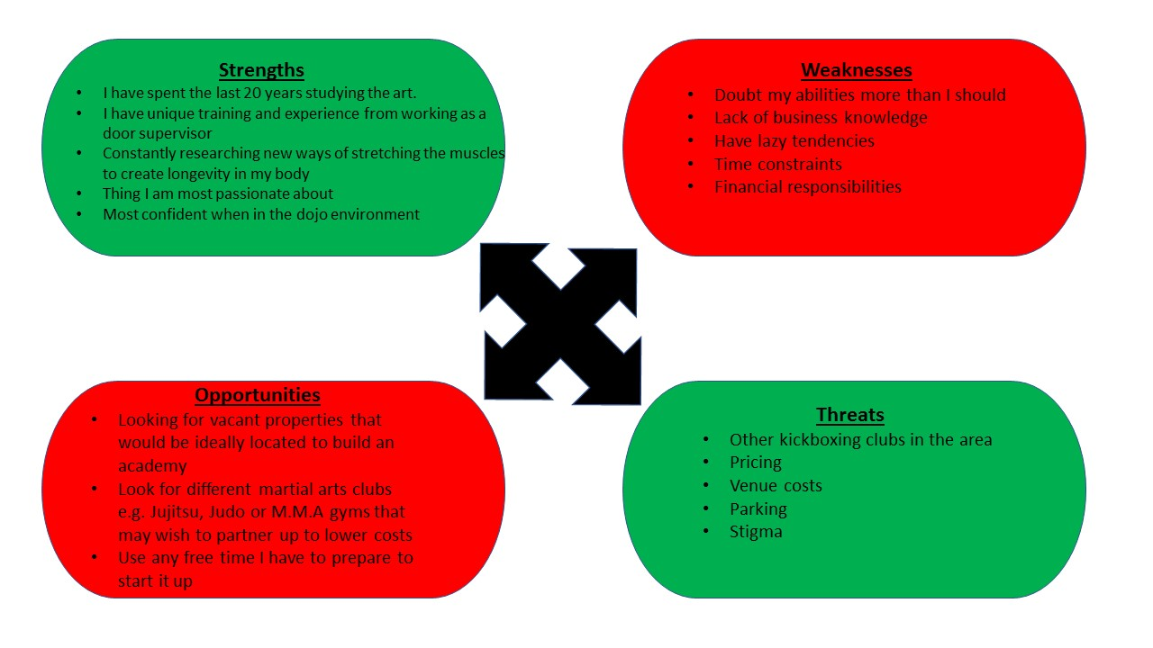
SWOT Analysis

Strengths
- I have spent the last 20 years studying the art.
- I have unique training and experience from working as a door supervisor
- Constantly researching new ways of stretching the muscles to create longevity in my body
- Thing I am most passionate about
- Most confident when in the dojo environment

Weaknesses
- Doubt my abilities more than I should
- Lack of business knowledge
- Have lazy tendencies
- Time constraints
- Financial responsibilities
Opportunities
- Looking for vacant properties that would be ideally located to build an academy
- Look for different martial arts clubs e.g. Jujitsu, Judo or M.M.A gyms that may wish to partner up to lower costs
- Use any free time I have to prepare to start it up
Threats
- Other kickboxing clubs in the area
- Pricing
- Venue costs
- Parking
- Stigma
Swot analysis is a way for a business to create a factual data plan on a company’s strengths and weaknesses and to then be able to create new ideas and fresh perspectives. This can then help a business to grow and achieve more in its specific field.
From looking at my goal in a swot manner I can see a clearer picture of what I would need to look at when getting ready to follow through with my plans. I have found this analysis to be extremely useful in helping me form a more realistic time frame for which I would be able to achieve my goal and move up the Maslow theory of needs chart to find my own self-actualization.
Tows Analysis
Tows analysis is all about converting your Strengths to Opportunities – taking advantage of opportunities with your strengths, Strengths to Threats – minimizing threats using your strengths, Weakness to Opportunities - taking advantage of opportunities to improve weaknesses, Weakness to Threat – avoiding threats by eliminating weaknesses.
Strength to Opportunities – I would use my 20 years’ experience as a marketing tool to convince a potential venue of my capabilities of running a successful martial arts academy, this should help implement faith in the business making money thus making it easier to secure the venue.
Strength to Threat – I would use my unique training I have received from door supervision and studying of helpful books such as The Art Of Fighting Without Fighting: Techniques In Personal Threats and The Fence: The Art Of Protection By Geoff Thompson to stand out from the other martial arts academy’s that would be in the area.
Weakness to Opportunities – I would look to partnering up with another club specializing in a different martial art preferably one that has a established model so that I would be able to learn the ins and outs of running a martial arts academy without making any of the big mistakes that they had made to ensure that my business is continually on the rise and to maintain the highest of standards for my goal to be reach in a timely manner.
Weakness to Threat – Hopefully I would be able to partner up with another martial arts academy with a different style to eliminate the threat of the cost running higher than the income in the starting months.

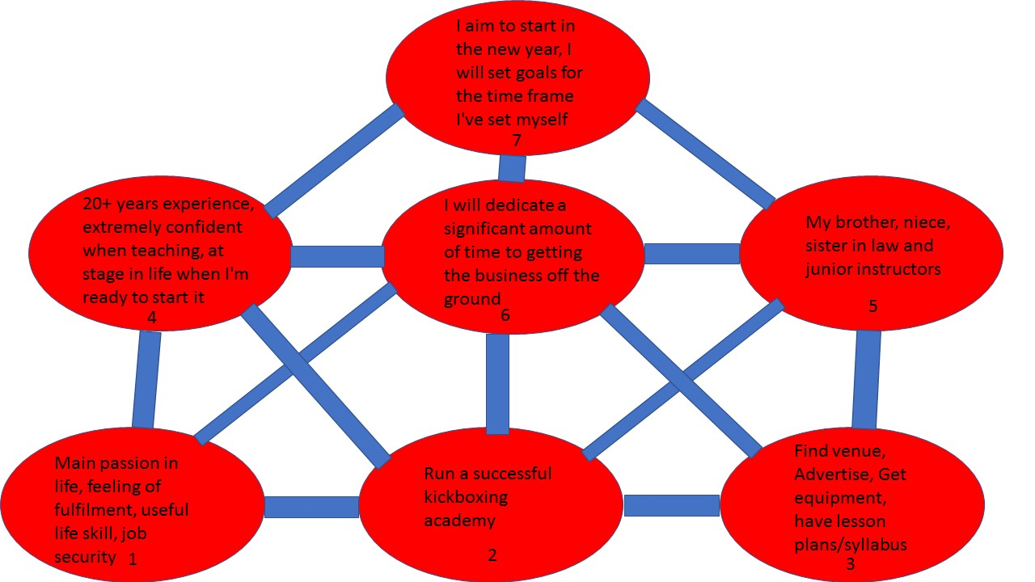
Go Mad Framework
Using the go mad framework has helped people and teams to increase productivity and solve problems and the results are then dramatic when businesses adapt this methodology.
Looking at my goal in this style has given me a better understanding of what order would be best to tackle my challenges in achieving my goal. Above is my go mad framework which I will also include below so it is easier to read.
Reasons why
My reason for this goal is that is my main passion in life, I get a feeling of fulfilment when teaching, I believe that marital arts are incredible life skills to have, it is a job I would be happy to do day in and day out due to my passion for it and it will also provide good job security due to me being my own boss.
Define goal
My goal is to start up and run my own Martial arts academy with plans to train up instructors who will then go off and start offshoot branches of my club.

Plans and Priorities
My plans going forward would be to make sure that I would have a syllabus in place before making any other plans as that will be my guide to establishing my lesson plans. I would then have to look to what I would require venue wise and then investigate the different factors involved in the venue. Finally, I would have to look at advertising costs and the most successful ways to go about the advertising.
Self-Belief
I believe I could accomplish this goal due to the fact that I have 20 years’ experience in this field, I have always felt more confident when I am teaching a kickboxing lesson, I have received positive feedback from teaching on a one to one basis and I believe I am at the stage in my life where I am ready to take this step in my life.
Involve Others
To succeed in my goal, I will need to enlist the help of my brother who runs a marital arts academy and will be able to give me pointers for starting up so I don’t make the same mistakes he made that hampered his business at the start, I would also need to bring on board my niece and sister in law as instructors to help with the running of classes and then the training of any member who wish to follow my instructor program that I will be offering.
Personal Responsibility
I will have to dedicate any free time I have to getting the foundations in place to make the start up of the business go as smoothly as possible that is why given my time restraints at present I would need to set myself a realistic time frame in which to do this.
Take Action, Measure Results and Personal Responsibility
I have set my self a 5 year time frame in which to accomplish this goal, I will be looking to make a start on the foundations of this goal in the new year to then by the end of the first year have my syllabus and first 6 months of lesson plans done and to have made a start on finding a venue. I will be looking at setting my self-tasks to be completed by the end of each year of my five-year plan.

Learning Style Questionnaires
Over the course of this assignment we were shown learning style questionnaires I found out of the 5 we were shown that I agreed with what the big five personality test, the Keirsey questionnaire and the Vark questionnaire results were.
Big Five Personality Test
On completing the big five questionnaire I was deemed Agreeableness; I find this to be quite accurate as I always strive to be polite and open to helping people. I also find that I will adjust my behaviour and mannerisms to suit the different people I am with and find that I am able to adapt well when in new groups due to adjusting my behaviour.
The Keirsey Questionnaire
The Keirsey questionnaire put my personality as some one who has an original mind and great drive for my own ideas and purposes, while also being sceptical, critical, independent, determined and stubborn. I found this to also be accurate as I have found myself most motivated when I was teaching kickboxing and haven’t felt as motivated to go to work like I was when doing that, I have found that in jobs when I am unmotivated I will also find something that I am critical about and as much as I always strive for progression I find a lack of passion to do it for the rest of my life unlike with the kickboxing which is all I’ve wanted to do since I was a kid.
The Vark Questionnaire
In the Vark questionnaire it has me down as someone who has a strong preference for reading and writing when studying, I always thought of myself as a visual learner and one who learns quicker through doing the thing I am trying to learn. I included this questionnaire in my reflective piece even though I disagree with the answer I had from it as I am interested in discovering if this will prove to be correct over the course of time I am completing the degree or if it will show that not everyone can use the Vark questionnaire to get a answer that is correct for them and that the other questionnaires may be more suitable for helping people in completing their goals.
Personal Development Plan
Below I have included my current PDP I plan on continuing to expand on this throughout the coming year in the hopes to have a complete PDP by the time I finish the course so I have a better understanding of how to achieve my goal. I believe that over the course of this degree I will be shown how to create a better PDP and will be able to use it efficiently to achieve my goal.

Development  Objective | Specific  Actions | Blockers and how they will be removed | Support  Required | How I will know when I have achieved the objective
Learn about how to run a successful business. | Complete current university course and then complete a business studies degree | Video games/ tv and other distractions. Moving my computer to a room where I won’t be near these distractions or going to the library to complete my work to make sure I get the marks required to advance in my education | Lecturers and fellow students. | I will know I have completed this objective when I achieve my degree in both studies.
Get the foundations for my club in place. | Design logo write up a syllabus and have pricing done. | Lack of confidence in my ability to do this. I would need to ask for help from a friend who is excellent at art to design the logo and then sit down and go over everything I have learnt from kickboxing to form the syllabus down. Try to create a price list that will be acceptable to people that will also make a profit. | Artistic friend.  Martial arts instructor. | I will know I have done this objective when I have the final drafts of the logo, syllabus and then the price list all printed off in front of me.
Finding a suitable venue for my goal. | Searching estate agent websites | Financial issues. This could be resolve by taking out business loan or looking at places that supply grants for starting up businesses. | Personal assistant to my brother as he has dealt with all the paperwork for starting a business. | I will know that this task is complete when I sign the lease for the venue.

Conclusion
After working on all the different models as displayed in this assessment, I believe I have found the help needed to realistically build a plan for my long-term goal of running my own kickboxing academy. I found that while working on this the Herzberg theory to be one I will really look to implement when I have the business up and running as it is a great model for running a happy business.
By breaking down my goal using the S.M.A.R.T model and then S.W.O.T I was able to identify areas in myself I will need to improve to help to get to where I would like to be in five years, this is a valuable thing to look at as if I continued on without looking at these I would have delayed myself by quite a bit. It has also been beneficial in allowing me to realize that people usually set themselves impossible task to complete in short time frames, I was terrible at doing this but then I started to look at things differently thanks to all the tools I have been shown on this course I now know to space out my tasks more realistically rather than trying to get everything done at once that way I can avoid the disappointment of not completing a list that was never going to be possible in the first place and by creating ones that are doing thus given a boost which will help motivate instead of put down my mentality.

Referencing
tutor2u. (2019). Motivation - Herzberg (Two Factor Theory) | Business | tutor2u. [online] Available at: https://www.tutor2u.net/business/reference/motivation-herzberg-two-factor-theory [Accessed 27 Oct. 2019].
Mindtools.com. (2019). SMART Goals: – How to Make Your Goals Achievable. [online] Available at: https://www.mindtools.com/pages/article/smart-goals.htm [Accessed 25 Oct. 2019].
Mindtools.com. (2019). SWOT Analysis: – How to Develop a Strategy For Success. [online] Available at: https://www.mindtools.com/pages/article/newTMC_05.htm [Accessed 28 Oct. 2019].
Mcleod, S. (2019). Maslow's Hierarchy of Needs | Simply Psychology. [online] Simplypsychology.org. Available at: https://www.simplypsychology.org/maslow.html [Accessed 22 Oct. 2019].
VARK - A Guide to Learning Preferences. (2019). VARK Questionnaire. [online] Available at: http://vark-learn.com/the-vark-questionnaire/ [Accessed 14 Nov. 2019].
Profile.keirsey.com. (2019). Keirsey. [online] Available at: https://profile.keirsey.com/#/b2c/assessment/start [Accessed 14 Nov. 2019].
Truity. (2019). The Big Five Personality Test. [online] Available at: https://www.truity.com/test/big-five-personality-test [Accessed 14 Nov. 2019].
Gomadthinking.com. (2019). Go MAD Thinking. [online] Available at: https://www.gomadthinking.com/ [Accessed 14 Nov. 2019].

Appendices



