Task One

Please answer the following questions within the context of software development and return to the tutor upon completion. Please attempt every question, if you are unsure of an answer attempt the question still or note the lack of clarity.

1: What is a Class?
2: What is an Object?
3: The following is an excerpt from a class, will the grade attribute be accessible from the instantiated Object?
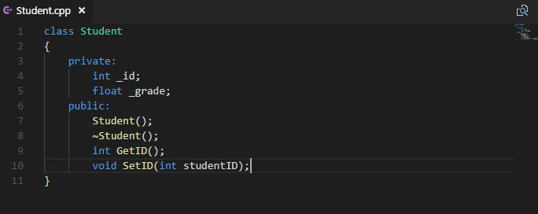
4: The “Student” class has been extended to allow for setting the grade of the student. What is the highlighted element an example of?
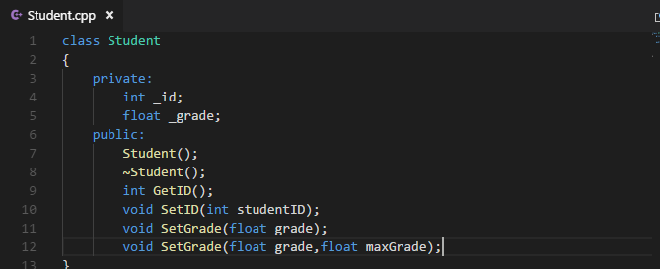
5: which of the following classes is the base or super class; give a reason for your answer


