

BA(Hons) Leadership and Management Skills for the Workplace

Understanding and Engaging in the Customer Experience
BMSW5103
Organisations Quality Systems and Customer Relationship Management

Student name- Jesica Mora Mera
Student No- 2010296

Module Tutor- Nishi Ramsurrun

Table of Contents
Executive Summary 3
Introduction 3
Company Context 5
Marketing Mix 7
Customer and Marketing at Reiss 7
Reiss Product Brand 7
Place Reiss stores 8
Reiss Price 9
Promotion Reiss 10
People Reiss 10
Process Reiss 11
Physical Evidence Reiss 11
Communication Mix 11
Advertising 11
Direct Marketing 11
Public relations 12
Sales promotions 12
4Ps Marketing 14
Model Selection 14
Customer Feedback 15
Reiss Reviews 16
Recommendation 16
Conclusion 16
References 18

Executive Summary
The focus of this report to understand the customer experience of an organisation, quality systems customer relationship management. Critically evaluation the challenge and benefits of developing and keeping good customer relationships. Reiss customers expect luxurious fabrics, impeccable cuts and considered design details. In this assignment we will use Marketing Mix, communication Mix and 4Ps Marketing, also the importance of quality systems and customer relationship management in the Organization. Reiss, the selected organization for this report, the important of CRM and quality processes and Customer Relationship management. Reiss is focussed to give an excellent customer service, the customer needs, how important customers in the business strategy and Reiss is focussed to have loyal customers. The Key Customer Relationship Management theory will be use in this report, Marketing mix, Communication mix. External and Internal factors will be analysed in the organization and how Covid 19 did affect to customers behaviour, customers services, customer experience, marketing, and system.
UWTSD Harvard Referencing Guide at https://uwtsd.ac.uk/media/uwtsdwebsite/contentassets/documents/library-and-learning-resources/infoskills/Harvard-eng_v.1.2.pdf

Introduction

David Reiss in 1071, Reiss has set up a modern, global fashion brand stylish menswear, womenswear and tailored for modern children’s which supplying customer services B2C sales models Business to customer is the process of selling products and services directly between a business and consumer who are the ensure delivering exceptional customer services, original products, quality, and value.
Reiss is focused to offer a premium customer service. Customers' experiences are important in the organization. We offer quality to the clients who choose to shop in-store. Reiss recognizes the customer feels the quality product and affordable price. It makes them need to return to peer us repeatedly and inform all their friends how fantastic we are. It is a high-quality feeling whilst we recognise that we have made someone’s day, so we get to sense high-quality in addition to our clients, it is a win-win. We have the high retailers and international luxury designer brand. At Reiss the customer in in the front line. We offer wonderful product, unique and brilliant sales and promotions.
We love to listened to the clients and if they are have any questions we are open to help them and we are sharing our professional knowledge and skills. We are make sure to constructing high-quality customer relationships. We supply precious advice, insights, and thoughts away to fashion our products. We do it by handing over the Reiss Experience. The Reiss Experience guarantees that each certainly considered one among our valuable clients continually gets excellent, personal, and real provider and advice, no matter wherein they are connecting with Reiss withinside the world, no matter the cause they are visiting our stores Our employees will give excellent customer services, we are haring feedback and experiences to reward from satisfied clients who have been affected by the tough work or been affected by Covid -19 . By understanding the clients have executed over this era Covid -19. Reiss committed is to support customers. We understand the form of demanding situations that our corporations throughout all sectors are up toward however we are seeing positives out there.
(https://dma.org.uk/article/adapting-customer-experience-in-a-postcovid-world).
Value clients
The Reiss customers look for an authentic and directional layout with a robust recognition of exceptional detail. Reiss additionally has high-quality customers delight in its movie star following; from individuals of the Royal own circle of relatives to Hollywood stars, the Reiss imparting appeals to the largest fashionable of celebrities. Reiss is focused on innovation to satisfice the need of the customers. Whether a customer chooses to buy from us or not, our end goal should always be to create a positive energy.
We need and want our clients to return and be a loyalty customer, the propose in Reiss is need the customer bring they are friends and family. It is difficult to keep a loyal customer than smooth as dropping a customer thru poor service or letting a customer down. in-keep is to recognize our efforts and interest in the clients in front of us, those who are already deciding to go to us to make certain we advantage their loyalty, trust, and future business.
Once we have got earned a customer's trust, we must never take it for granted, there will usually be every other brand, every other keep, every other internet site ready and ready to take their custom and it’s comprehensible that the customer will pick whichever one sees to their desires the fine on the time. We must make certain that every time, they pick Reiss. Reiss offer exceptional customer support is all approximately constructing genuine, proper relationships. Exceptional customer support is all approximately constructing genuine, proper relationships. We all, so, have a large obligation to keep this effective customer service. Reiss is focused to keep creating an effective customer experience, to help you to keep the connection with every customer that visits we keep strive the later actions. Purchase or not, display gratitude to your customer and appreciation for their go-to, even if it is for a refund. A refund these days can be ten income withinside the future!

Company Context
Internal and external factors influencing the quality system at Reiss.
Covid 19
Covid -19 June 2020 Reopening Protocol Stores
Reiss reopen the stores and get ready to welcome our customers. The Organisation offering a health and safety protocol to the employees and customers. Reiss want all our customers to feel safe and welcome to the stores during Covid-19 reopening protocol. Reiss is focused to protecting and encourage our most valued our customers to return and coming back to store. We want every customer to feeling delighted that their visit has been safe we offer sanitation station, Reiss design a pre order and pay on collection services this system is online and over the phone, we offer our customer the virtual Reiss experience if the customer needs or ask any question about stock, new collections Reiss has been answered. Simply put, we want their experience in our store to be the best part of their day. Customers feel appreciated, valued, and special by paying them attention and helping them in every way we can. Take time to the customers come back to the stores and feel safe, but the staff at Reiss are ready to help to the customers what they want and needs. Reiss has been some changes in the way we work to improve customers experience, now Reiss are using a new system to benefit to the customers.
- Next day delivery for £5
- Online delivery extended from 7 pm -11pm
- Online orders can now be refunded in store.
- Customer service phone line now open until 11 pm
- New IOS App launching new website
- New sustainable packaging.

BREXIT
On 30 December 2020 and after 4 years of negotiations, the UK and the EU signed the Trade and Cooperation Agreement (the Agreement). The Agreement stands for the primary and crucial step in the direction of a brand-new bankruptcy for the relationship among the UK and the EU. As all withinside the enterprise are acutely aware, at the same time as it's miles too early to install with the fact of the long-time period consequences of Brexit and the Agreement, those trying to shield their emblem and intellectual property rights withinside the EU and ensure compliance ought to be aware of the emblem-new framework and do not forget the way to nice respond to the emblem-new changes. UK shops ought to pay EU import VAT for promoting into the EU. The VAT rate varies and is specific to the Member State into which they'll be exporting. Retailers can follow the emblem-new guidelines through manner of manner of each registering for VAT in each USA they promote into or bypassing the expenses at once to wholesalers and consumers. UK shops ought to don't forget to use the “Authorised Economic Operator” certification to advantage from simplified customs techniques and waivers of sure obligations. Brexit the Reiss expanded the rate of merchandise over £60 by £three in step with gadgets because of better fee of transition of the goods from EU and different countries.
- Huge delays on shipments of product to UK and the company been affect to the customer services.
- Brexit effect the product movement between stores from UK to republic Ireland and Europe and now not possible to move small amount of stock to Europe due to cost being so higher.
Charles Russell Speechlys (2022) https://www.charlesrussellspeechlys.com/en/news-and-insights/blogs/brexit-implications-for-you-and-your-business/retail/

Marketing Mix
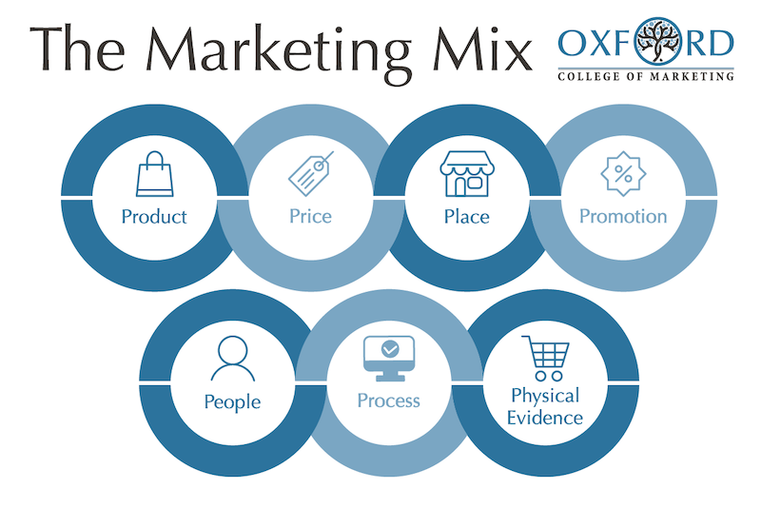
The Marketing Mix Orford college of Marketing (2020)
https://blog.oxfordcollegeofmarketing.com/2020/10/08/understanding-the-7ps-of-the-marketing-mix/

Customer and Marketing at Reiss
Marketing Philosophy, Affordable luxury, Reiss is design-led fashion, where fashion endures over traits and luxury is affordable. The Reiss clients have an interest in fashion, elegant and longer lasting than throw away traits.
A strong product supply sits at the heart of the Reiss brand method and the store strives to encompass its namesake founder David Reiss’s belief in timelessness in place of rapid fashion. CEO Christos Angelides has refreshed the emblem seeing that taking the helm in 2017. His method keeps recognition on full-price sales, pushed via way of means of strong design, styling, and quality, after excessive discounting led to margin erosion in the past.

Reiss Product Brand
Reiss a store of personal brand exceptional style turning in enduring fashion and exceptional, Reiss is committed to the constant improvement of the ethical and sustainable control of its operations. These requirements begin with the choice and traceability of uncooked substances thru to the production, all the manners to our customer services. Reiss has installed a design philosophy concentrated on developing directional, layout-led menswear, womenswear, accessories., shoes, and jewellery. With an uncompromising dedication to turning in revolutionary and authentic merchandise, it fuses great layout, exceptional, and value.
Marketing week (20Nov 2006) https://www.marketingweek.com/assessing-the-reiss-brand/

Product

Reiss fashion is focused on the mid-20s to 30s, it will all the wardrobe classics, the collection dresses, coats, trussers, tailoring, on begging a pleasant luxury brand. whether or not it's miles the decelerate over again of a skirt or the tailoring of the men’s suit, the detail and cut-price define the piece as being classically appealing and that' what makes Reiss unique. Reiss devices are not for those trying to create a good statement. It supplies merchandise the type of detail that makes a larger subtle, loving impression. less complicated parts can, however, lack the Reiss style, and depend on the extraordinarily good of the materials to support the item.

Place Reiss stores
Reiss has 250 stores, 30 stores in UK, those stores are focus on prime, the best place, and their environment is carefully taken into consideration with staffing, vending, and seasonal graphics. In the UK, Reiss works around twenty concessions, mostly in John Lewis, John Lewis, Selfridges, Hoopers, Fenwick, as well as around sixty standalone stores.
USA - distributed in New York, Los Angeles, Boston, Florida, New Jersey, Chicago.
distributed in Berlin, Dusseldorf, Munich, Amsterdam.
Doha, Hong Kong, Lebanon, Moscow, St. Petersburg, Abu Dhabi, Dubai
Montreal, Canada
4 Toronto, Canada
Vancouver, Canada
Sungnam-Si, China
3 Manila, Philippines
Riyad, Saudi Arabia
Seoul, south Korea
3 Abu Dhabi, Unite Arab Emirates
Busan, south Korea
Doha Qatar
Singapore
2 Seoul, South Korea
Lebanon
Riyadh, Saudi Arabia
Dubai, United Arab Emirates

Reiss Price
Value Positioning Marketing week (20Nov 2006) https://www.marketingweek.com/assessing-the-reiss-brand/
Reiss prides itself on being a niche luxurious design-led brand with an excessive street location and price point.
Jackets= £135 - £175 Leather jacket = £295
Trousers = £79 - £110 Skirts = £69 - £110
Dresses = £89 - £130 Shirts = £65 - £75
Cottons = £25 - £79 Top = £65 - £89
Knitwear = £59 - £79 Coats = £129 - £195
Shoes = £95 - £115









Promotion Reiss

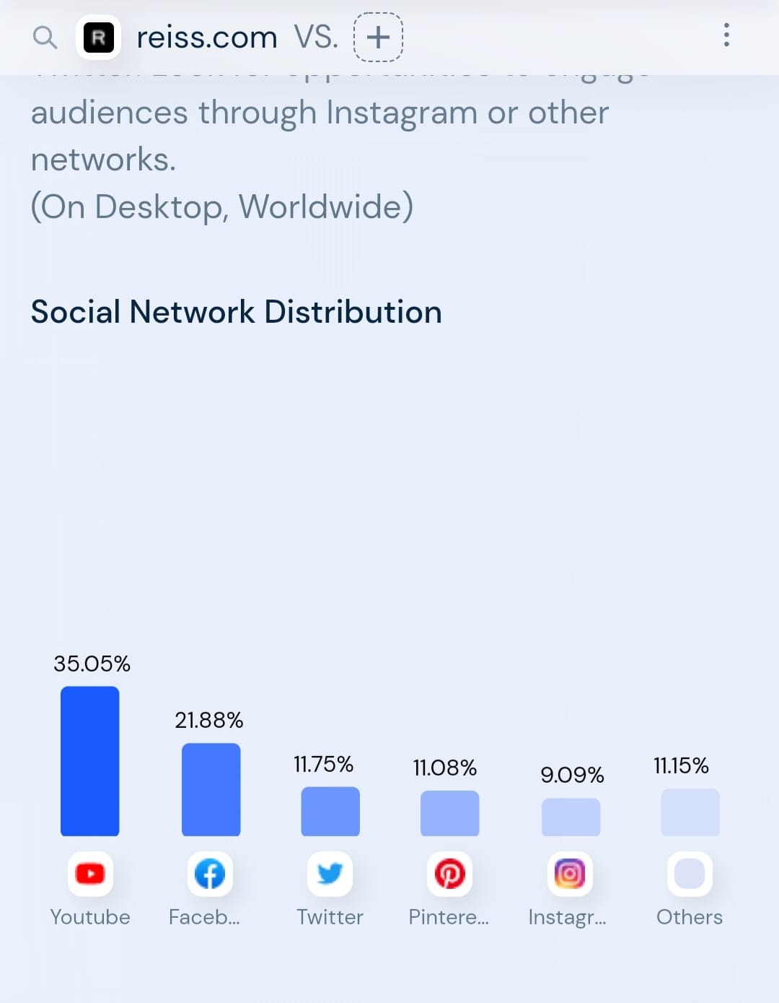

Similar web (2022) https://www.similarweb.com/website/reiss.com/#geography

- Social Median
- Facebook https://www.facebook.com/Reiss/?id=web 205,604 Followers.
- Twitter https://twitter.com/reiss/ 67,600 Followers.
- Printers https://www.printers.com/reissfashion/ 21,000 Followers
- Instagram https://www.instagram.com/reissfashion 86700 Followers.
- Fashion week
- Sponsorship events
- Advertisement
- Loyalty marketing, gift, and loyal card. VIP discounts
- Promotion, emails
- Product are sold with help of celebrities, movie stares, football players.

People Reiss

The employees will be training by line managers specialist how to create a wonderful experience for the customers.

Process Reiss

The customers are especially important, and the staff must give a lot of attention to the customers. The staff need to be friendly, honest, helpful delivering a unique customer experience.

Physical Evidence Reiss

In physical shops, the shop environment can be unique as all the different Reiss shops. The clients will revel in the revel in being there. There can be music in the store and a friendly, expert skilled body of workers to fulfil the want and desires of the clients. Next is part of Reiss and Reiss has open thirty-nine stores during this year.

Communication Mix

Advertising

Reiss has followed a cross channel technique through the usage of special communications to promote their brand, for example, Facebook, Instagram, the Reiss blog, Pinterest, and their internet site This portfolio will examine the manner wherein Reiss digitally sells the enterprise via their internet site and Instagram. Their method of advertising and marketing the logo has constantly remained the same; it has a completely unconventional technique, being usually via phrase of mouth. Reiss Instagram makes a specialty of the lifestyle of the brand, which includes pictures of favourite places and restaurants, in contrast to a competitor, Karen Millen, which makes use of the most effective photos every in their collections. This may be a terrific manner of having their client's attention; clients need this ‘Reiss lifestyle,’ in addition to the clothes.

Direct Marketing

Reiss Digital marketing is the promotion of merchandise or brands thru one or more types of electronic media. Digital marketing differs from traditional marketing in that it includes using channels and strategies that allow a company to examine advertising and marketing campaigns and recognize what is working and what is not – usually in actual time,’ (http//www.SAS.com, 2014, Digital Marketing). By corporations' use of virtual advertising and marketing, their clients can get the right of entry to any records at any time, it is far constant and additionally a dependable supply for humans to receive help from records and buy merchandise via the net. The net lets in for hundreds of thousands of humans to be linked worldwide, with over one billion Internet customers worldwide, agencies are the use of the web to market their campaigns and merchandise faster. Companies are doing this because it reduces prices and savings. (Johnson and Scholes, 2006) told that corporations have exclusive degrees of advertising and marketing strategies, relying on the worldwide scale in their business. Search Marketing is a massive part of any hit internet site, Reiss could have followed a Search engine optimization (SEO) as it is far with paid search ads. Their internet site could be truly clear and engaging, with the enterprise continuously getting new inventory, they may be strict on their inventory consumption and outtake, this lets their internet site now no longer have an excessive amount of choice, in contrast to Asos, in which the consumer is on occasion crushed with choice. There also are filters, which allow the consumer to keep with the aid of using size, coloration, and price, this shows clients can prioritize their records, which means their decision-making manner main as much as the acquisition is made loads easier. HTML (Hypertext Markup Language) is a layout this is used to outline the format of web pages. HTML five has had an effect at the capability of now no longer simplest net pages, however, additionally mobile applications; corporations’ web sites are capable of load quicker from this update. Reiss sends newsletters to the VIP consumer to up to date with activities and gets exclusive dates of while their nearest keep will be going into the sale, earlier than the public. When searching on the shape in their internet site, you could see blueprints, which display a group of smallest internet site concepts, displaying minimum fashion for easy usage. Information structure is the manner of organizing facts to aid the usability of a business’s internet site.

Public relations

Customer Profile
Reiss customers are central to the success of the business, Riss is focus on delivery the high quality, good value clothing our customer, approx. six hundred customers visit the stores per day, 60/ 40 in favour of women. The potential customers at Reiss are 20 – 40 aged.

Sales promotions

Advertising campaigns
Global fashion brand REISS has been one of the most respected high-end streetwear brands for many years, offering a fine range of beautifully designed and well-tailored clothing at honest prices. one of his biggest and most impressive campaigns to date. Brandammo was recruited on board by world-renowned photographer Jamie Morgan to provide a film and stills to be used primarily online and in the future. by Brand Ammo, who then did all the post-production and video writing.




Reiss is to introduce iPads at some point in its 52-save portfolio in June 2012 to grow its in-keep range. The project follows a hit trial of the technology gadgets in a small form of its top-appearing stores.

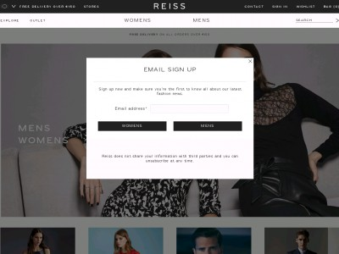





Many companies provide this same promotion online, for example, French Connection lately made a proposal of 10% off all merchandise for just 24 hours. They published an image to Instagram informing their target market of their discount, to be able to have had many greater views, in preference to an in-save promotion, wherein clients may have simplest been knowledgeable if they had been withinside the save, or are at the Reiss mailing list, which presents clients with all upcoming events

4Ps Marketing
The promotional mix is vital in any successful corporation, its goal is to construct the logo focus of the business, so, broaden reputation and appeal to their audience’s attention. The 4 Ps of advertising consist of product, price, area, and promotion; however, a present-day method has been taken to this theory, wherein organizations attention to the human beings, tactics, packages, and performance, internal advertising additionally replicates at the human beings and personnel at Reiss. ‘Marketing is an organizational characteristic and a fixed of tactics for creating, communicating, and transport cost to clients and for managing patron relationships in methods that gain the company and stakeholders, (Kotler, 2012, Page 516). Early levels of the promotional mix are while Reiss will tell their clients thru e-trade and social media, which is to make certain their consumer has a particularly good knowledge of the corporation and the manner wherein it works. The first pop up that looks while you input the Reiss internet site is a non-compulsory field to turn out to be a part of the Reiss mailing list. If a customer chooses to sign on, they may be reminded of the activities and key records this is taking area withinside the corporation, so shifting ahead into the mature segment withinside the product lifecycle. Some organizations are especially desirable at managing incorporated advertising communications, a method installed area which incorporates focus, interest, preference, and action. ‘This exercise persists regardless of the fragmenting of mass markets into many minimarkets, every requiring its personal method; the proliferation of recent varieties of media; and the developing sophistication of consumers,’ Phillip Kotler, Kevin Keller (2012). The images used on the house web page on their internet site are up to date regularly, this keeps the patron fascinated and draws their customer instantly. They are very comparable withinside the manner wherein they snatch their customer’s attention, Reiss do every day updates and style fixes from across the globe, this keeps their clients aware of what is taking place at Reiss, on a far greater international scale.

Model Selection
CRM PROBLEM

SWOT Analysis

Strengths
Reiss is a unique emblem for this position in an opening between high- and low-cost fashion. Reiss cautiously considers staffing, music, seasonal snapshots, and location. Marketing is a vital key interest of Reiss, shop home windows and snapshots campaign, location the emphasis at the assertion emblem, stylish.
Growing clothing collection.
• Total management over brand equity that is instore environment additionally visual selling and products quality.
• Concessions in House of Fraser growth with reduced risk and cost.
• David Reiss entrepreneurial drive and well-known designer.
• Productive expansion on the far side United Kingdom and gained operating expertise with completely different markets.

Weaknesses
Reiss also has several weaknesses; their website might be taken into consideration as a weakness. Some clients might not just like the concept of storing their non-public information with the internet site. They additionally use their internet site thru iPad sales, which may be made in-store; that is precisely the identical system as it might be from your home computer. Whether the customer is new to Reiss or a current purchaser, they may need to conform to the percentage of their credit score card information withinside the system in their purchase. If a client had now no longer logged out in their account, an order might be crafted from some other consumer’s account, this can result in Reiss losing clients from this. Organic growth since the isn't any method riding knitwear forward. Confused brand positioning bridging function among mass marketplace and designer. No portfolio control destiny investment for growth or new knitwear lunches is now no longer defined. Lack of marketplace studies or advertising records ensuing in a false impression of the outside environment. The Reiss Guide does now no longer replace often even though it may be a smart concept to draw customers and get clients involved.
- Organic growth because is no method using knitwear forward
- Confused brand positioning bridging function among mass marketplace and designer.
- No portfolio control destiny investment for increase or new knitwear lunches now no longer defined.
- Lack of marketplace studies or advertising data ensuing in a false impression of the outside environment.
Opportunities
There is a place to grow Reiss can be distribute in more cities and famous capitals. Reiss also can do a campaign featuring celebrity or make collaboration with young perspective designer. The main suggestion be more active on fashion communication field. Increased number of retail outlets. Women’s stores only. Kids stores only. Enhanced use of concessions to evaluate new markets. New fabric technology. The is an increase of the middle class, which is Reiss target group, also business people because of the suits that Reiss sells.
- Greater than before diffusion into existing stores.
- Increased variety of stores.
- Women’s stores only.
- Increased use of concessions to check new markets
- New cloth technology
Threats
- Increased competition forcing to share the income.
- Squeezed bridging position by designers’ kind higher than and from below by middle market retailers.
- Massively saturated market.
- Modification in emptor behaviour towards discounters and designer manufactory outlets devaluing the market.
- Foreign competitors coming into the United Kingdom market with new knitwear.
- Extreme weather harming supply of raw materials associated increasing value of goods.
- Exchange rates deterioration between the placing of an order and also the receipt of end knitwear.

Customer Feedback
Reviews.io (2021) https://www.reviews.io/company-reviews/store/reiss

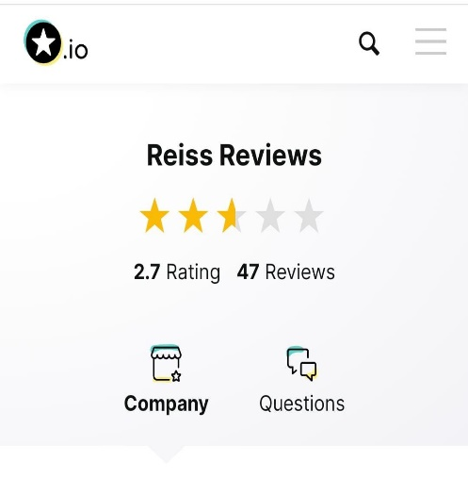

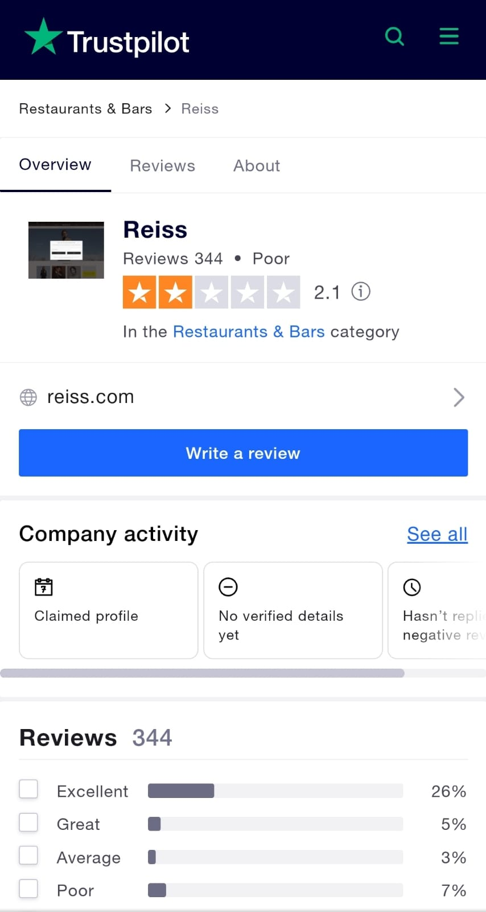

Trustpilot (2022)
https://uk.trustpilot.com/review/reiss.com

Reiss Reviews
Clients are giving terrible feedback about poor nice and in-shop service, poor quality, delivery is delated, the new website is not good, poor customer services, not true sizes and the price has increased.

Recommendation
It is important to improve customer services because the feedbacks and complaints is about customer services. Not customer support Improve Website plastic (environment friendly) and deliveries. It is important to listen the customer feedbacks to improve Reiss customer services, these feedbacks will help to understand and the customer’s needs, expectations. Improve internal management skills.

Conclusion
To conclude, Reiss marketing priority is offer high customer service. Hiring staff experienced in the Dutch market, promotion, focusing to loyal client, loyalty marketing and good leadership management and team work will help to have an excellent customer service.
Reiss have a strong digital marketing techniques are unique and sizable, Instagram and Website. However, the most powerful communique channel is its website, because of its clear and crisp structure. Overall, Reiss has understood the significance of social media and e-commerce techniques, this crucial step has supplied them with a foundation for achievement during several virtual communique channels. Reiss work hard to give the best customer services and the client feel Reiss stores give the best experience customer services.

References

- Charles Russell Speechlys (2022) https://www.charlesrussellspeechlys.com/en/news-and-insights/blogs/brexit-implications-for-you-and-your-business/retail/
- Data & Marketing Association (2022) https://dma.org.uk/article/adapting-customer-experience-in-a-postcovid-world
- Kalbach, J., 2018. Customer journey maps. 1st Ed. O'Reilly Media.

- Marketing week (20Nov 2006) https://www.marketingweek.com/assessing-the-reiss-brand/

- Oliver Blanchard (2011). Social Media ROI. Boston: Pearson Education. Inc. 8.

- Payne, A. & Frow, P., 2013. Strategic Customer Management: Integrating Relationship Marketing and CRM. Cambridge: Cambridge University Press.

- Phillip Kotler, Kevin Keller (2012). Marketing Management. 14th ed. United States: Pearson Education. 516.

- Reviews.io (2021) https://www.reviews.io/company-reviews/store/reiss

- SAS. (2014). Digital Marketing, what it is and why it matters. Available:
http://www.sas.com/en_us/insights/marketing/digital-marketing.html. Last accessed 09/12/12

- Similar web (2022) https://www.similarweb.com/website/reiss.com/#geography

- http://www.Retail week.com Last accessed 09/12/12.

- Style Salvage (2010) http://stylesalvage.blogspot.com/2010/10/experiencing-reiss-personal-tailoring.html

- Value Positioning Marketing week (20Nov 2006) https://www.marketingweek.com/assessing-the-reiss-brand/

- UWTSD Harvard Referencing Guide at https://uwtsd.ac.uk/media/uwtsdwebsite/contentassets/documents/library-and-learning-resources/infoskills/Harvard-eng_v.1.2.pdf

