Conservation Assignment

Introduction

This heritage impact assessment has been carried out to assess the impact of an extension to a Grade II Listed Building within a conservation area. The appraisal is concerned with identifying how the new addition has impacted the building as well its setting the surrounding conservation area.

The building in which this assessment is based is the Swansea College of Art Alex Building belonging to the University of Wales Trinity St David.

This assessment has been carried out in accordance with the guidelines set out in the British Standard 7913:2013 “Guide to the Conservation of Historic Buildings” as well as taking into consideration guidelines and recommendations from Cadw which is the historic environment service of the Welsh Government.

In order to conduct this assessment a site survey and visual inspection was carried out in April 2022. This was of both the exterior and interior of the Swansea School of Art Alex Building. This assessment is further supported by historic records and photographs relating to the architectural style and usages through time of the building.

Objective of the New Extension

The UWTSD Alex building was extended with a modern glass extension. The objective of this addition to the existing listed building is the need for the Alex building to reflect a creative environment which houses leading art and industrial design courses. The striking design also needed to fit with UWTSD’s Creative City Strategy so therefore an unexpected but aesthetically pleasing design was needed to showcase this. (UWTSD, 2016).

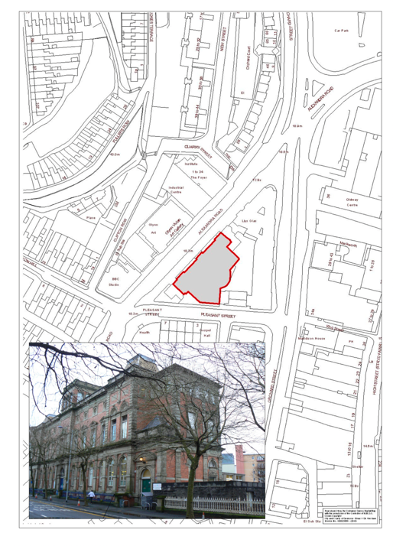
Location and Site Information

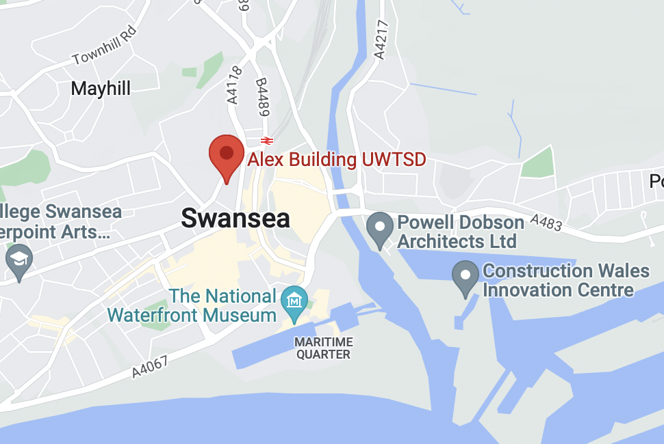

The Alex Building also referred to as “the building” in this assessment in Swansea within the Alexandra Road conservation area and can be found at the following address:

7 Pleasant Street, Swansea, SA1 5DS.

Map reference: (Swansea Council, 2022)

Conservation area

As previously stated, the Alex building is situated within the Alexandra Road conservation area. Other listed and important buildings within this conservation area are:

- Centre for Great Self Awareness
- Glynn Vivian Art Gallery
- Swansea Working Men’s Club & Institute
- Central Police Station

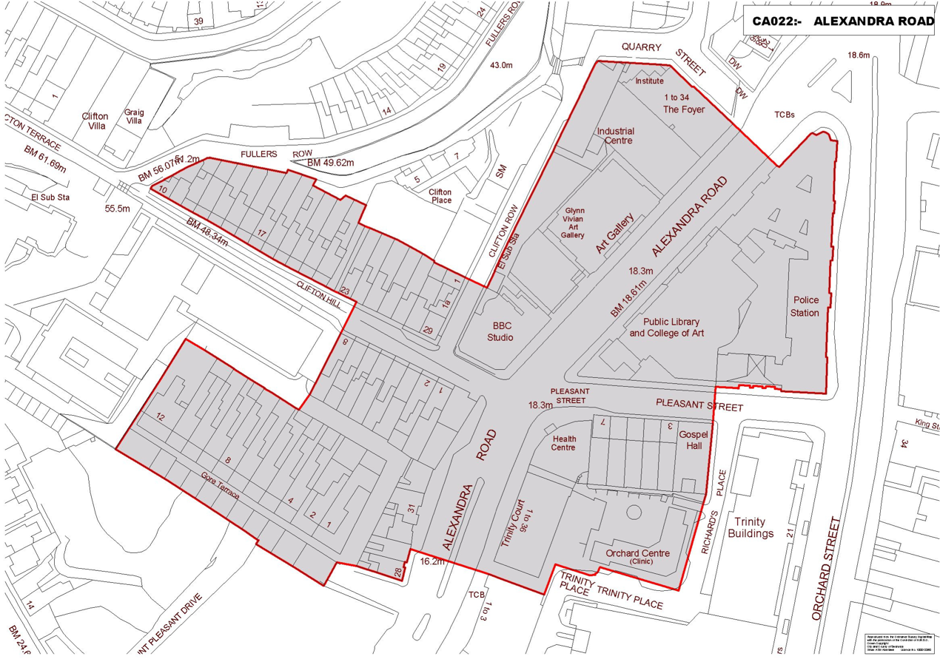

Map of the Alexandra Road Conservation Area (Swansea Council, 2022)

Listing Description

The Alex building has been designated a Grade II Listed Building by Cadw and has been recognised for its importance and special interest.

Reference Number: 11550
Location: Swansea
Grade: II
Date of Designation: 30/03/1987

Description of Alex Building

The Alex Building is constructed within a Victorian architectural style with Italianate and classical influences. It consists of a symmetrical design with red brick façade. There is also the presence of ended central bays with tower to the centre and pavilion roofs and parapets. There are multiple tripartite arched windows with pediments. The windows are divided into a 2-4-1-4-2 arrangement. Other decorative elements consist of banded quoins to the upper floors with angle and fluted pilasters below. There is swagged and fluted oculi to inner bays over pedimented and keyblocked studio windows. The glazing is mostly T-frame. There is a main entrance and porch to the street with segmental pedimented doorcase, panelled pilasters and carved tympanum. Doors are panelled. There is a smaller doorcase to the left with decorative ribbon style surround. (Cadw, 2022)

Existing and Historic Images

The images below showcase the building in its original form before the building was acquired by UWTSD and extended. Photographer of images unknown
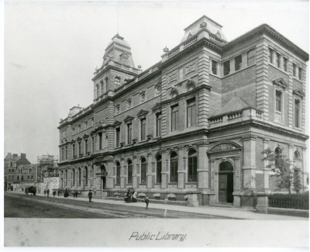

Swansea Central Library, 1887
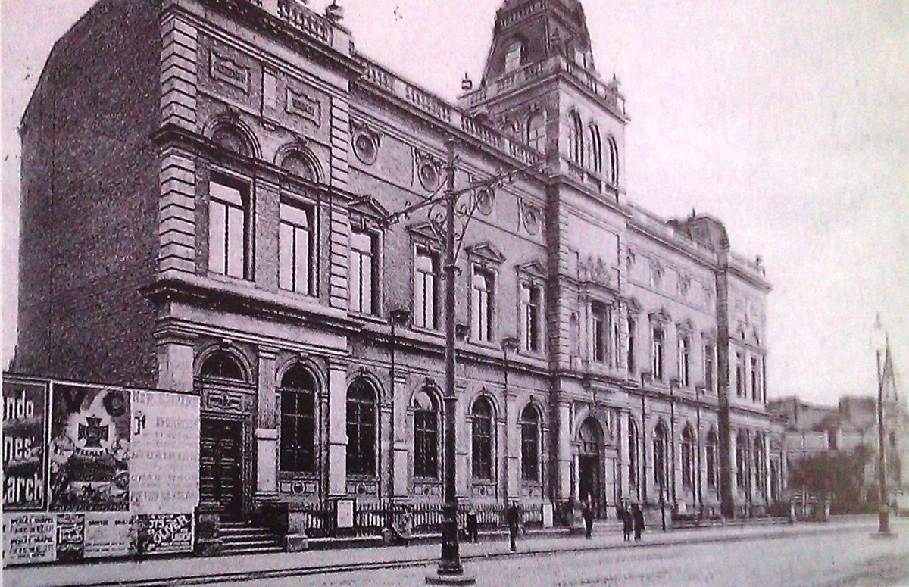

Swansea Central Library, Date Unknown

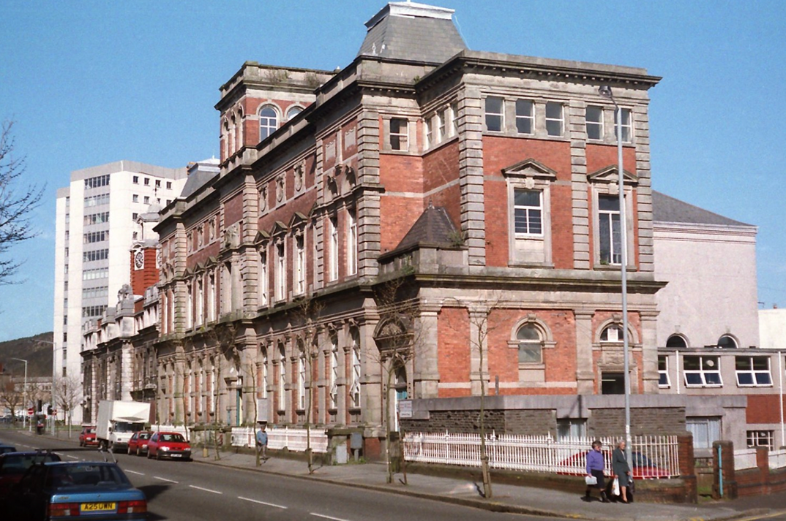

Swansea Central library circa, 1980

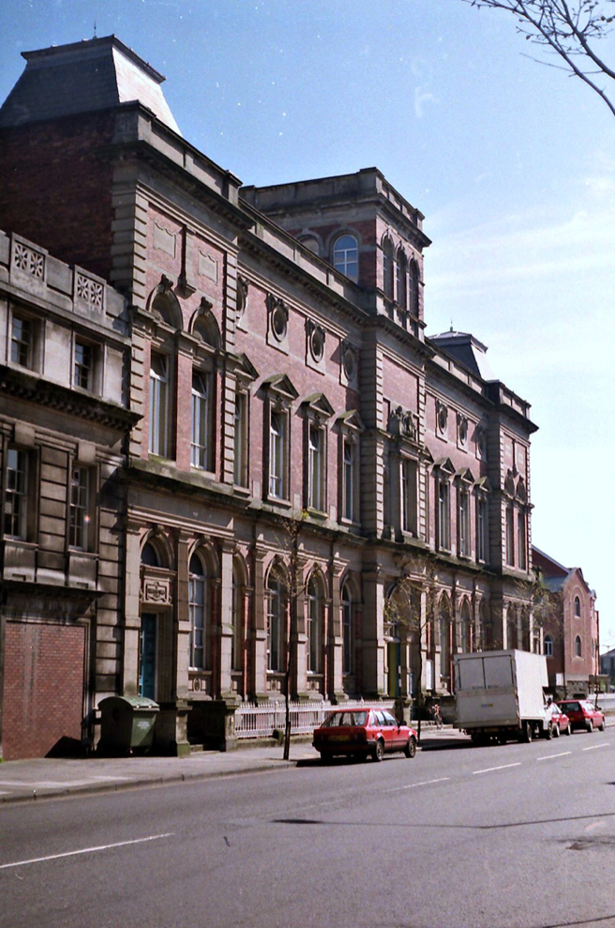

Brief Historic Background and Interpretation

The building was previously Swansea’s Central Library. It was constructed to be a library by Henry Holtom in 1886. It was constructed in an Italianate architectural style in the Victorian period.

It functioned as a public lending and reference library located on Alexandra Road housing notable works by Dyaln Thomas who also frequently visited. It was also the set of the 1960s Peter Sellers movie Only Two Can Play. (Walesonline, 2013)

The building has a red brick facing with a two-storey attic and basement. The building appears symmetrical with advanced centre and end bays with slate pavilion roofs. (Cadw, 2022)

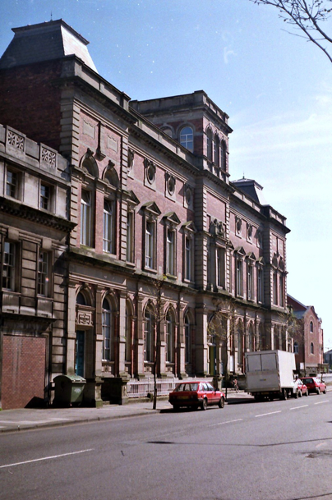
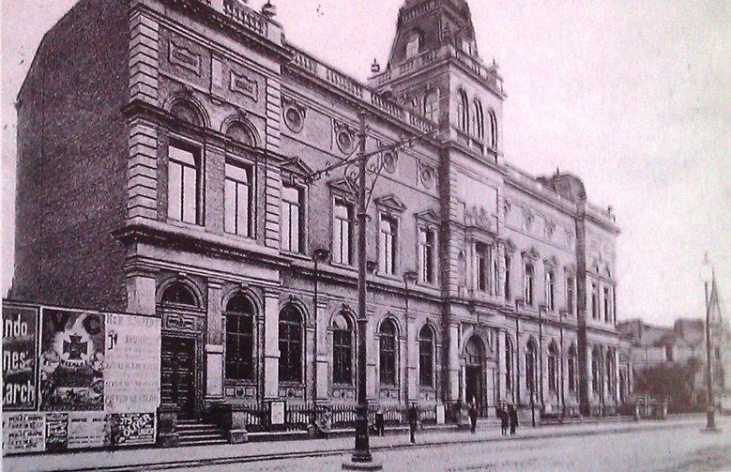

The two photographs above showing the building in 1890 and 1996 respectively. The front facades are almost identical with the only exception being the removal of the pavilion roof on the advanced centre section which was destroyed in the war. (Cadw, 2022)

Assessment of Heritage Values

An assessment of the heritage values associated with the building has been carried out. The heritage values assessed are based on the values outlined by Cadw. These values have been sectioned into the following headings: Evidential value, historical value, aesthetic value and communal value.

Front Elevation/façade

The front elevation retains a high number of Victorian architectural eras including elements from the Italianate, classical and Gothic Revival eras. These include the highly decorative window pediments and quoins, red brick construction and central pavilion roof of the tower all of which are examples of classic Italianate architectural style. Overall, the façade of the building is highly symmetrical with these architectural detailing making the symmetry somewhat obvious to any viewer.

The Alex building is directly opposite the Glynn Vivian Art Gallery which is another listed building, and it could be said they mirror each other due to their similar architectural styles. These two buildings dominating the street contribute to a very historic streetscape.
Due to the Alex Building being in an urbanised area the only long-distance view is possible from Grove Place. Although alternative long-distance views are probably possible from the upper stories of surrounding buildings however these are not accessible.

The front façade of the building is also the main building element that people regardless of if they were intended to access the building would have seen and passed judgement on.

For the above-mentioned reasons, the front elevation/facade of the building has high aesthetic, communal and historic significance.

Main Reading Room

The main reading room on the ground floor of the building is a central component of the building. The room is circular in shape with a domed glazed ceiling. The decorative wood panelled walls and cast-iron railings for the upper storage shelves remain as well as a small matching spiral staircase. The room remains true to its open plan layout although it’s unclear when the radiators were added to the wooden columns.

The domed ceiling in the room is a striking architectural feature and acts as the rooms primary source of natural light. The large amount of light provided by the glazed dome would have been essential for library users to read and supports the theory that the room was very active with library users.

As the main reading room of the library the reading room would have been one of the main places for lower and middle-class people to educate themselves and share knowledge. This increased knowledge could have then increased people’s contribution to the community both socially and economically.

For the above reasons the main reading room and dome have high evidential, historical and aesthetic value and very high communal value.

Entrance Hall

The black and white Victorian mosaic flooring reflets the era in which the building was built. The mosaic flooring has signs of wear but this can be seen as evidence that the building was heavily used. The tiles are ceramic and hard wearing and the signs of wear and tear today reflect that every visitor that came to the building would have passed through the entrance and walked on those tiles.

The main double door entrance with each door consisting of 8 panels are another highly prominent feature of the building. The grandeur of the double doors sets the tone for the interiors you will be greeted with such as the domes ceiling in the main reading room.

For these reasons the entrance hall elements are of high aesthetic and communal value.

Impact Assessment

The proposed changes to the Alex Building will not damage any of the front façade but it will extend the façade length ways and take away from its symmetrical visual appearance. The East elevation will have the most impacts as a result of the changes as it will result in the removal of windows and decorative pediments and quoins. The East elevation with the addition of the modern glazed structure will now also be the main view from Grove Place and due to glare from the glazing it may no longer be that easy to identify that there is an historic behind it.
However, the front façade of the building and the view over to the Glynn Vivian Art Gallery would remain unchanged therefore meaning there will still be a historic streetscape. There is a risk though of the glazed side extension distracting from some of the prominent features of the building such as the central tower and entrance way resulting in the new addition being too overpowering especially when viewed from Grove Place. On the other hand, it’s been decided to construct the whole extension from glass which is a light material and may work well in conjunction with the historic part of the building as the contrast may allow for the historic features to become even more noticeable.

In terms of communal value, the proposed new addition will enhance this as it will once again be turning the building into a viable educational building that meets the needs of modern-day learning. This means that people will continue to use the interior of the building for educational purposes just as they did when it was Swansea Central Library resulting in its purpose in the past and present being linked. Universities also mainly consist of young adults which allows for the historical building to be appreciated and used by a new generation who otherwise may have had no interest in such building and in return the building provides them with an education just like it for its past library users.

Even though the proposed new addition will provide a sustainable new use for the building there are still risks associated with the new owners and those responsible for it having a lack of knowledge on how to properly maintain the historic part of the building as well as how these maintenance techniques will differ when compared to the maintenance required for the new extension.

Overall damage to the east elevation and the symmetrical design to façade are negative impacts regarding the proposal and the impact the glass will have, whether positive or negative, cannot be guaranteed until project completion. However, ensuring the building will continue to be used as a learning environment in a sustainable way is a positive impact that outweighs any negatives. The sustainable use of the building when the new extension is completed will ensure longevity for the buildings life and maintenance needs compared to it just being left to deteriorate.

Retrofitting Philosophies

The first philosophy associated with retrofitting is the ‘whole building approach’. This approach considers the whole building and integrates fabric measures, building services and occupants into the approach. It understands that they all interact with each other and that a single retrofit measure will to some extent impact all the previously mentioned areas. It also considers elements such as the building’s location, weather conditions, heritage and communal value.
On one hand, the ‘whole building approach’ can be seen as a good philosophy regarding the retrofit of a building as it highlights the importance of fully understanding the building and its context including things such as its past and present uses, how it functions, heritage value and its historic significance. This means it would be an excellent approach for the Alex Building as the retrofit measures will be decided upon based on ones that won’t take away or distract from its heritage value but will still allow it to function more efficiently as an educational building. Another benefit to following this approach is that before any works can take place it recommends there is a strategy in place of how any retrofitting measures will be integrated as well as if there is any risk or uncertainty surrounding the outcome of the suggested measures. It recommends starting with installing lower risk measures such as draught proofing before considering higher risk measures such a solid and external wall insulation. Solid wall insulation would destroy the historic aesthetic value of the Alex building so it’s good that this approach advice that low impact and reversible measures which will still preserve the heritage are tried and tested first. (May & Griffiths, 2015)
On the other hand, this approach doesn’t consider a situation where low impact measures are unsuccessful within a historic building that it is listed and aesthetically too important regarding its heritage. The Alex building would fall into this scenario and for a building like this installing high risk retrofit measures wouldn’t even be considered due to the listing status rules and regulations. Furthermore, the approach offers no alternative of what can be done to improve energy efficiency in this situation.
An approach that could be taken however, is just simply ensuring the building is maintained well and ensuring users consider their usage habits regarding energy consumption in order to make the building and its use more sustainable and at the same time ensuring all its heritage is preserved. (May & Griffiths, 2015)

Another philosophy regarding retrofitting that could be applied to care for the Alex Building is the ‘fabric first approach’. This approach is when the efficiency and sustainability of the building fabric is considered in the initial design stages. It focuses more on improved thermal properties of the building using air tightness and insulation. (Institute for Sustainability , 2012). The ‘fabric first’ approach can be seen as more advantageous compared to the ‘whole building approach’ system as its more sustainable in the way that it doesn’t reply on energy saving technology or building additions which can be expensive and can sometimes not be used correctly by the building users which compromises efficiency. (Institute for Sustainability , 2012)
However, altering the fabric of the historic section of the Alex Building by installing super-efficient insulation and improving air tightness would be extremely difficult without damaging its aesthetic values. For example, original brick and stonework would have to be sacrificed in order in order to gain access to wall fabric to install new insulation.

If solely looking at just the new glazed extension however, a ‘fabric first approach’ could work excellently as all the required measures could be considered at the design stage before construction begins. This then gives no reason to implement expensive retrofit measures further down the line after construction is complete. A ‘fabric first approach’ was demonstrated by UWTSD in the construction of the new extension as they chose to install a double skin glass façade with peak sun exposure which acts as a thermal flask along with solar shading by coloured glass sheets. These implemented design features result in a highly efficient finish. (Broad, 2015)

Asset Management Approaches and Challenges

Consideration now needs to be taken of how best to approach the management of both the historic and new edition aspect of the building. Now that the building has been acquired and adapted at considerable cost by UWTSD it now represents a significant capital asset that must be protected through well planned, affordable, sustainable and programmed maintenance.

A way in which the building can be managed is through planned and preventative routine maintenance. This would consist of specific procedures that are performed on a regular schedule. The main goal for this approach is to minimise deterioration and extend the life of the buildings existing and original components for the building to function. (Cruzan, 2020) It should be established as part of the approach that regular inspections of the building are carried out to ensure any maintenance issues can be resolved at an early stage otherwise an issue may escalate leading to a more drastic approach with varying consequences needing to be taken. Ideally to make a planned routine maintenance approach successful there needs to be a detailed maintenance plan highlighting all components of the building that are particularly at risk.
An example of planned maintenance that would be beneficial to the Alex building, especially the historic part, is ensuring the roof valleys, gutters and downpipes are all checked and unblocked every six months. This planned periodic check will ensure that a blockage wouldn’t go undetected by resulting in water penetration which could then result in damp issues. If the maintenance schedule wasn’t followed and damp issues did occur, it would lead to a need of a more serious asset management approach which would have a more destructive consequence to the building fabric.

If an issue does escalate to beyond a point where maintenance alone can’t resolve it a repair or replacement approach will need to be taken. Unlike a planned maintenance schedule which preserves the building functionality of the building fabric a repair approach will restore functionality. (Cadw, 2011) As functionality is being restored and preserved it cannot be guaranteed that any of the original building fabric will be kept and it may all be lost. Using a repair approach instead of a planned maintenance approach could become a serious challenge for the historic part of the building because due to the age of the buildings components it could see a lot of components deteriorating to a point where a lot of repairs would be needed at once. This would then result in a lot of heritage being lost within one time period.

When a repair approach is required it’s important to understand exactly why there is a need for repair. This is to ensure the repair enables the component to fulfil its intended function again. When a repair is carried out appropriate materials and techniques should be used with predictable lifespans (Cadw, 2011) As well as reducing the likelihood of premature failure it also ensures the building’s heritage value remains intact to a certain extent. Although for the best results regarding preserving building heritage planned routine preventive maintenance would preserve functionality of components with heritage value rather than requiring them to be replaced. Even a close match in materials with similar visual characteristics is still not the original so a part of the building’s heritage will be lost regardless. (Cadw, 2011) An example of this could be if one of the Alex Building’s entrance doors became very deteriorated beyond repair due to try rot and was replaced with another similar panelled door. Although the new door would have the same function it may not have the same detailing or craftsmanship therefore resulting in a loss of heritage. Also replacing the door would be much more expensive socially if trying to source an exact replica, it would be much more cost effective to instead use a planned maintenance schedule to prevent the need for replacing in the first place.

Finally, a third approach that can be taken for asset management is periodic renewal. Periodic renewal differs from maintenance in that it occurs less frequently but when it does it has far greater consequences regarding the visual impact of the building, and it has the possibility to bring about big levels of change. However, the approach can be justified when compared to if nothing was done it would lead to even greater heritage loss and deterioration of the building. (Cadw, 2011). The losses made by periodic change are usually made up for by the positive contribution it makes in terms of building functionality, useability and accessibility. An example of periodic change is when UWTSD decided to replace the roof of the building. Even though the original roof and its heritage were lost a new roof meant that the building became a habitable and appropriate environment for education and without this change the building may not have been suitable for such purpose and may have been subject to further neglect and abandoned resulting in significant deterioration of all components. In this example the periodic change resulted in the building be able to continue to be used, appreciated and maintained now and in the future. This shows that periodic change is like planned maintenance in a way that they both strive to preserve the buildings original heritage whilst keeping it functional. Even though periodic change should only be occasional it sets an excellent foundation to then lead on to a planned maintenance schedule in order to maintain and preserve the building as a historic asset but also as a functional financial asset to the university.

Overall, the most sustainable approach to managing both the historic and new addition of the building would be using periodic change. This periodic change took place in the form of the roof replacement by UWTSD and the new glazed extension in order to make the building habitable and functional for its new purpose of providing educational courses. These periodic changes should then be followed by a preventative maintenance schedule in order to achieve the functionality and efficiency achieved through the periodic change. (Cruzan, 2020)

Preventative maintenance would be very important regarding the building’s future sustainability if it’s carried out properly as it will reduce the probability of decay. Financially it will also prove to be a very sustainable building management approach as it will mean there will be minimal chance of having to purchase replacement components (Cruzan, 2020) and hire outside contractors to resolve issues that are now beyond resolvable by maintenance alone and that require extremely specialist skills or requirements due to the listed status of the building.
Another way preventive maintenance can be financially sustainable is if good maintenance records are kept alongside the scheduled maintenance checks. These records would provide valuable information on components or equipment pieces’ previous maintenance requirements and detail how they performed before and after the maintenance. This information will be essential when deciding whether to replace a piece of equipment or component as the decision can be based off information and not just the opinion or initiative of the individual carrying out the maintenance. This approach will mean money will only be spent when necessary and not be wasted on unnecessary replacements of equipment or components that could have continued to be maintained and be perfectly functional. (Cruzan, 2020).

References
Broad, S. (2015). Case Study: Trinity Saint David restores Central Library.
Cadw. (2011). Conservation Principles. Retrieved from Cadw: https://cadw.gov.wales/sites/default/files/2019-05/Conservation_Principles%20for%20the%20sustainable%20managment%20fo%20the%20historic%20environment%20of%20Wales.pdf
Cadw. (2011). Conservation Principles. Cadw.
Cadw. (2022). Full Report for Listed Building. Retrieved from Cadw: https://cadwpublic-api.azurewebsites.net/reports/listedbuilding/FullReport?lang=&id=11550
Cruzan, R. (2020). Preventive Building Maintenance.
Institute for Sustainability . (2012). Retrofit Stategies . Institue for Sustainability.
May, N., & Griffiths, N. (2015). Planning responsible retrofit of traditional buildings.
Swansea Council. (2022). Conservation areas. Retrieved from Swansea Council: https://archive.swansea.gov.uk/conservationareasindex
UWTSD. (2016). Faculty News. Retrieved from Unibveristy of Wales Trinity St David: https://www.uwtsd.ac.uk/art-design/news/the-earl-of-wessex-officially-opens-uwtsds-alex-building-on-september-29-2016.html
Walesonline. (2013). New role for Swansea's former Central Library . Retrieved from Walesonline: https://www.walesonline.co.uk/news/wales-news/new-role-swanseas-former-central-1826668
Walesonline. (n.d.). New Role for Swansea's .

