Student Name: Bogdan Pacuraru
Student ID:2245496

Assessment Component 2

Managing People

Individual Report

Table of Contents
1. Introduction 2
2. Organisational Overview 2
3. Benefit of implementing flexible working strategies into the organisation 2
4. Consideration by the firm and the HR department for implementing flexible working for the workforce 4
5. Different implications for different operational sites 5
6. Pay Structure reconfiguration 6
7. Strategies for promoting employee engagement for flexible working 7
8. Recommendations 9
9. Conclusion 9
10. References 11

1. Introduction
Considering this following individual report, a flexible working strategy by the HR department of a selected organisation would be done. In addition, a critical analysis of the implication of HR operations on the main three premises of the organisation such as manufacturing, warehousing and sales would be done for better understanding. Due to the impact of the pandemic, the majority of global organisations practises hybrid or flexible working structures. Following this, the report will discuss the benefit of flexible working strategies in the organisation, consideration of the firm and HRM towards it and different implications of flexible working structure on three premises with critical analysis. Moreover, a justified recommendation for better maintenance of flexible working practices on a long-term basis would be provided to make the report credible.

2. Organisational Overview
The chosen organisation for the report is AgroTools, a company from the West Midlands that manufactures agricultural equipment for the farmers of the region. The organisation considers multiple teams to operate in three premises including the manufacturing, warehousing, and sales. Thus, the employees from these three operational areas requested the HR department to provide flexible working practices through which their motivation and performance would be enhanced on a long-term basis.

3. Benefit of implementing flexible working strategies into the organisation
The study by Castrillon (2022) stated that a flexible working strategy within the organisation could enhance employee productivity. It can be stated that 43% of the employees mentioned that flexible working arrangement enhanced their productivity. In comparison, 30% of the respondents indicated that it could manage time for work, which boosts the work-life balance of the employees (Castrillon, 2022). Besides, a flexible working strategy helps to ensure cost-effectiveness and extended working hours, enhance job satisfaction and employee morale, reduce sickness leave and improve the productivity of the organisations as well (NI Business Info, 2019).
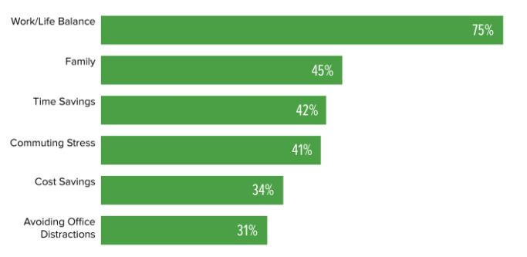
Figure 1: Benefits of flexible working practice
(Source: Maurer, 2019)
Contrarily, Maurer (2019) reported that 75% of the employees stated that flexible working could enhance the work-life balance of the employees while 45% considered its role in spending time with family. In addition, 42% and 41% of the employees stated that a flexible working model could help to save time and stress as well. The study by Gov Wales (2024) reported that the majority of the agricultural companies in the UK started to provide 25 working hours per week. In this way, satisfaction and retention of the workers, work-life balance of the employees, health and well-being and productivity of the employees of the sector could be managed.
For example, famous agricultural companies in the UK such as Syngenta provide flexible employee reward programmes towards the employee, which enhance their performance (Syngenta, 2024). In addition, the organisation allows flexible working hours, and technological advancement in warehousing and manufacturing through which employee satisfaction and productivity become enhanced. Considering this, the HR department of AgroTools should focus on flexible working strategies such as flexible working hours, rewards for motivation and technological advancements for better operational outcomes. It could lead to managing the time, and cost of operation and thereby leading to provide a flexible working structure towards the workers. Besides, the HR department of AgroTools could practice a hybrid model of work that could ensure a better work-life balance for the employees while working in the major three premises of the company.

4. Consideration by the firm and the HR department for implementing flexible working for the workforce
The report from VPSC (2024) mentioned that the HR department of an organisation should focus on the impact of a flexible working strategy towards the employees, management structure and existing skills and competencies among the employees from all departments to cope with the flexible working model. It can be stated that every organisation considers flexible working implementation based on their different working style and employee management. Meanwhile, Cantrell et al. (2022) stated that around 77% of the organisational leaders from global businesses considered the importance of having strong skills and competencies among the employees for managing the new operating model of flexible structure.
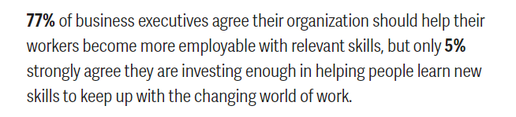
Figure 2: Necessity of employee skills for a flexible working structure
(Source: Cantrell et al., 2022)
Contrarily, Maurer (2019) stated that 52% of the employees stated that a flexible working model is critical to retention, as it requires an effective and constant negotiation process. The organisation such as AgroTools manufactures agricultural products and sells them towards the farmers of West Midlands. In this way, the firm and the HR department should focus on appropriate skill development, knowledge development and availability of expertise and resources within the company before implementing the flexible working practice for the workforce.
Additionally, Putra and Utari (2023) reported that effective communication and collaboration in the workplace culture are necessary for practising a flexible working structure. It has been identified that 70% of the organisational HR urged to ensure active communication and collaboration among the employees to practise a flexible working culture (Mayne, 2023). According to them, the traditional working model could reduce the productivity of the employees as well as the companies. Considering this, firms such as AgroTools and its HR department should consider effective communication processes and tools for maintaining a flexible working strategy. The organisation tends to allow a hybrid model of work based on which technological advancement and tools for employee interaction are required. It would manage the systematic operation of the company with flexibility thereby providing better work-life balance to the employees (Putra and Utari, 2023).

5. Different implications for different operational sites
Considering the case of AgroTools, the company have three different operational sites including the manufacturing, warehousing, and sales for providing high-quality agricultural equipment to the farmers of West Midlands. In these three operational sites, different types of flexible working strategies should be implemented for better employee engagement.

Figure 2: Three operational premises of the company
(Source: Created by author)
Manufacturing site: Davis (2024) has reported that organisations need to focus on flexible working hours by splitting the shifts of the employees. In this way, technological advancements such as automation, drones and other tools could be used for the manufacturing area of AgroTools, which would reduce the workforce pressure and thereby delivering flexible working processes to the employees. In addition, the company would need to maintain the working hours while manufacturing equipment, which would maintain the working flexibility for both the off-site and hybrid workers.
Warehousing site: According to Fernandes (2019), warehousing is considered the systematic process for storing and preserving the products of the company on a large scale. In this way, the warehouse of AgroTools consists of agricultural equipment, which has to be provided to the farmers of West Midlands. In this context, the organisation should provide a better work-life balance, flexible schedule, better pay scale for the employees and safety. It would enhance employee satisfaction with the company thereby ensuring the effectiveness of operational processes in the warehouses in the West Midlands region.
Sales site: Besides, the sales department is another potential area of function, which requires better flexibility in work for high-performance outcomes for the employees. In this context, AgroTools should focus on flexibility strategies in its sales department similar to warehouses. It has been identified that agricultural companies in the UK such as Wynnstay Group Plc reported to practice flexible working in terms of culture, salaries, work-life balance, job security and flexible management practice in the sales department (Indeed, 2024). Considering this, AgroTools should follow these practices in its sales department to ensure better outcomes.
Moreover, the HR department should ensure interactive communication and collaboration between the three departments and employees, which would make the flexible working strategy successful and avoid the chances of error as well.

6. Pay Structure reconfiguration
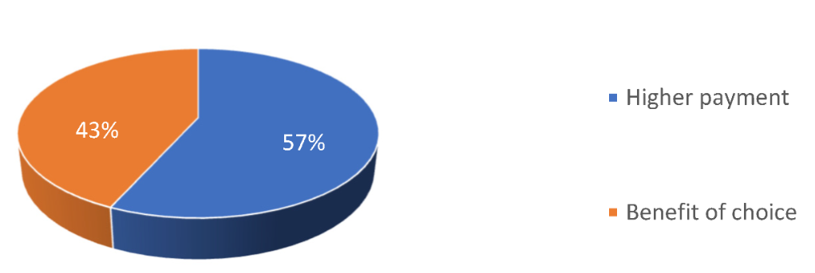
Figure 3: Employee preference on pay structure of the organisation
(Source: Shtembari, Kufo and Haxhinasto, 2022)
The study by Shtembari, Kufo and Haxhinasto (2022) stated that 57% of the global employees focused on the high payment and pay restructurig of the company after the pandmeic scneario. In this way, AgroTools should reconfigure its pay structure for better operational outcome.
Serial No. | Grade | Current Pay Scale (£) | Average range of pay scale after reconfiguration (£)
1 | Administrative Assistant | 26,000 | 45,000-50,000
2 | Finance Manager | 31,000 | 35,000-41,000
3 | HR Manager | 31,000 | 36,000-45,000
4 | Operational Manager | 27,000 | 35,000-45,000
5 | Manufacturing Supervisor | 40,000 | 45,000-50,000
6 | Design Engineer | 31,000 | 36,000-41,000
7 | Warehouse Supervisor | 30,000 | 36,000-40,000
8 | Supply chain coordinator | 31,000 | 36,000-41,000
9 | Sales Manager | 35,000 | 40,000-45,000
10 | Maintenance Supervisor | 35,000 | 40,000-45,000
11 | Employees (Manufacturing Team) | 21,000 | 30,000-33,000
12 | Employees (Warehouse Team) | 21,000 | 30,000-35,000
13 | Employees (Sales Team) | 21,000 | 30,000-35,000
14 | Suppliers | 28,000 | 30,000-32,000
Table 1: Pay Structure reconfiguration by the company
Following this pay structure, the company such as AgroTools would be able to provide performance-based salaries to the employees. In addition, the company need to configure this structure to ensure the implementation on three premises for a flexible working structure. The pay structure of manufacturing, warehousing and sales departments needs to be increased and maintained properly, which would motivate the employees to enhance their performance. Moreover, the HR department of the organisation would follow a reward strategy based on the performance through which modification of the pay structure needs to be done (table 1).

7. Strategies for promoting employee engagement for flexible working
The key strategies for promoting employee engagement would include a flexible working environment, a positive workplace culture, skill development opportunities, transparent communication, and value. In this way, Cooley (2017) opined that the Human Relation Theory considers organisational thought, which focuses on worker satisfaction, informal workplace culture and employee productivity. In addition, the theory states that effective communication; collaboration and empathetic relationships with the employees should be practised within the organisational culture based on which their engagement with the company would be maintained for a long-term basis (Gordon, 2022). Besides, De-la-Calle-Durán and Rodríguez-Sánchez (2021) stated that the 5Cs of employee engagement consider conciliation, cultivation, confidence, compensation, and communication. The elements under these factors would ensure remote working, work-life balance, career development, health and safety, benefits, and networking, which are the key features of a flexible working strategy.
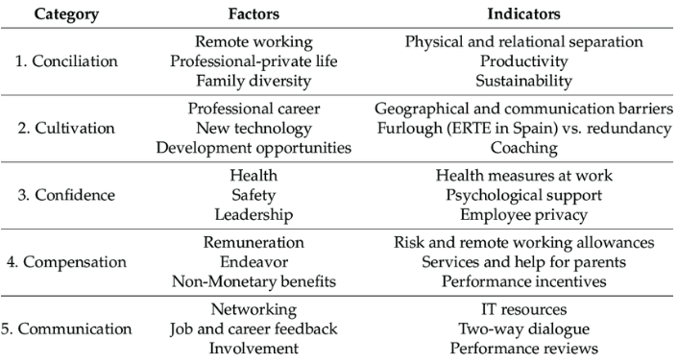
Figure 4: 5C model of employee engagement
(Source: De-la-Calle-Durán and Rodríguez-Sánchez, 2021)
Besides, De-la-Calle-Durán and Rodríguez-Sánchez (2021) opined that the 5C model of employee engagement ensures effective communication and interaction among the employees through which the systematic operation among each department of the company could be done. In the context of AgroTools, the company mainly operates through three departments among which key strategies for employee engagement are required. In this way, better financial benefits following the reconfigured pay structure (table 1), flexible working hours, employee benefits, skill development opportunities and technological advancement for smoother operational flow for each department are required. In this way, employees could be better engaged with the company and enhance the performance of AgroTools for making innovative agricultural equipment towards the farmers of West Midlands respectively.

8. Recommendations
Following the previous aspect, AgroTools should practice the below strategies to employ flexible working practices in the operational areas.
Employee training: The HR Department of AgroTools should provide effective employee training and development programs for manufacturing and warehousing workers. This would generate active communication and collaboration, which would support flexible working practices inside the operational areas.
Financial benefits: Furthermore, the company's HR department should provide better financial benefits to the employees in terms of rewards, incentives, and performance-based bonuses. Additionally, health and safety-related benefits could be delivered mainly to the warehouse employees, which will enhance their motivation.
Flexible working hours for the sales team: Considering the flexible working process, the company should provide hybrid or remote working practices to the sales department and provide them with flexible working hours. It can be stated that the sales department is the most prominent and functional area of the organisation. In this context, flexible working through hybrid or remote working could ensure their high productivity through an extended period of working hours. It could ensure better productivity and long-term engagement of the company.
Digital tools for each department: Moreover, AgroTools should use digital tools such as automation, blockchain, IoT, Data Analytics, and other communication tools to support seamless operation and communication among employees.

9. Conclusion
The above individual report was focused on the HR operation of an Agricultural company such as AgroTools located in West Midlands towards its manufacturing, warehouse, and sales areas. The report stated that HR operations could help to manage the employee engagement and performance outcome of the company. In this way, majority of the similar organisations of the company promoted flexible working model in their operational practice. Additionally, it has been identified that a flexible working model requires proper skill development and the availability of resources to support the strategy. Considering this, a reconfigured pay structure for the employees of the mentioned department of AgroTools has been provided for better understanding. Moreover, the report utilised the Human Relations Theory and 5C model of employee engagement, which ensured further clarity regarding the role of HR in the company for its performance and employee engagement.

10. References
Cantrell, S., Griffiths, M., Jones, R. and Hiipakka, J. (2022) The skills-based organization: A new operating model for work and the workforce, Deloitte Insights. Available at: https://www2.deloitte.com/us/en/insights/topics/talent/organizational-skill-based-hiring.html (Accessed: 24 May 2024).
Castrillon, C. (2022) Why Flexible Work Boosts Employee Productivity, Forbes. Available at: https://www.forbes.com/sites/carolinecastrillon/2022/03/23/why-flexible-work-boosts-employee-productivity/?sh=7d1b8c096e4b (Accessed: 24 May 2024).
Cooley, S. (2017) ‘Human Relations Theory of Organizations’, Global Encyclopedia of Public Administration, Public Policy, and Governance, pp. 1–5. Available at: https://doi.org/10.1007/978-3-319-31816-5_2998-1.
Davis, J. (2024) Flexible Work Arrangements in Manufacturing: 5 Tactics for Employers to Consider, www.aem.org. Available at: https://www.aem.org/news/flexible-work-arrangements-in-manufacturing-5-tactics-for-employers-to-consider (Accessed: 24 May 2024).
De-la-Calle-Durán, M.-C. and Rodríguez-Sánchez, J.-L. (2021) ‘Employee Engagement and Wellbeing in Times of COVID-19: A Proposal of the 5Cs Model’, International Journal of Environmental Research and Public Health, 18(10), p. 5470. Available at: https://doi.org/10.3390/ijerph18105470.
Fernandes, V. (2019) Agricultural growth needs warehousing reforms, Financialexpress. Available at: https://www.financialexpress.com/opinion/agricultural-growth-needs-warehousing-reforms/1654244/ (Accessed: 24 May 2024).
Gordon, J. (2022) Human Relations Theory of Management - Explained, The Business Professor. Available at: https://thebusinessprofessor.com/management-leadership-organizational-behavior/human-relations-theory-of-management (Accessed: 25 May 2024).
Gov Wales (2024) Flexible working and job sharing in the agricultural sector: guidance [HTML] | GOV.WALES, www.gov.wales. Available at: https://www.gov.wales/flexible-working-and-job-sharing-agricultural-sector-guidance-html (Accessed: 24 May 2024).
Indeed (2024) Wynnstay Group PLC Employee Reviews, Indeed. Available at: https://uk.indeed.com/cmp/Wynnstay-Group-PLC/reviews (Accessed: 24 May 2024).
Maurer, R. (2019) Flexible Work Critical to Retention, Survey Finds, Shrm.org. Available at: https://www.shrm.org/topics-tools/news/talent-acquisition/flexible-work-critical-to-retention-survey-finds (Accessed: 30 May 2024).
Maurer, R. (2019) Flexible Work Critical to Retention, Survey Finds, www.shrm.org. Available at: https://www.shrm.org/in/topics-tools/news/talent-acquisition/flexible-work-critical-to-retention-survey-finds (Accessed: 24 May 2024).
Mayne, M. (2023) HR urged to ‘communicate’ as majority of employees unaware of new flexible working right, www.peoplemanagement.co.uk. Available at: https://www.peoplemanagement.co.uk/article/1851715/hr-urged-communicate-majority-employees-unaware-new-flexible-working-right (Accessed: 24 May 2024).
NI Business Info (2019) Advantages of flexible working, nibusinessinfo.co.uk. Available at: https://www.nibusinessinfo.co.uk/content/advantages-flexible-working (Accessed: 24 May 2024).
Putra, A.R. and Utari, P. (2023) ‘Flexible Work Arrangement, Work-Life Balance And Communication: A Systematic Literature Review’, Russian Journal of Agricultural and Socio-Economic Sciences, 135(3), pp. 25–34. Available at: https://doi.org/10.18551/rjoas.2023-03.04.
Shtembari, E., Kufo, A. and Haxhinasto, D. (2022) ‘Employee Compensation and Benefits Pre and Post COVID-19’, Administrative Sciences, 12(3), p. 106. Available at: https://doi.org/10.3390/admsci12030106.
Syngenta (2024) Syngenta Rewards, Syngenta. Available at: https://www.syngenta.co.uk/syngenta-rewards (Accessed: 24 May 2024).
VPSC (2024) How to implement flexible work in your organisation, VPSC. Available at: https://vpsc.vic.gov.au/workforce-capability-leadership-and-management/flexible-work/how-to-implement-flexible-work-in-your-organisation/ (Accessed: 24 May 2024).

