Samantha Davis 1812476
Workplace Culture and its Impact on Organisational Efficiency
Task 1 Video Presentation

Supplementary Notes

(Google's New Logo, 2020)

In August 1998 Google Inc was officially born with its head office still based in California. It was the vision of 2 students Larry Page and Sergey Brain who met in 1995 as students in Stanford University and came up with a vision for creating the world's best search engine. (Google - About Google, Our Culture & Company News, 2020)

With this mission statement in mind and a lot of hard work Google has earned the recognition of being one of the best employers out there. In 2018 Comparably has named Google as the tech company with the best corporate culture. (Editors, 2020)
So, what is Culture and how can we understand it better?
Mullins, 2016: “How things are done around here”
To make things easier Culture can be described as an organisation personality and can be seen as how an individual or company perform/ behave on a regular basis. To understand and analyse culture more effectively managers can relate to one of the many Cultural Models available from Deal
and Kennedy, Charles Handy, Edgar Schein or The Cultural Web.
“The Cultural Web, developed by Gerry Johnson and Kevan Scholes in 1992, provides one such approach for looking at and changing your organization's culture. The Cultural Web identifies six interrelated elements that help to make up what Johnson and Scholes call the "paradigm" – the pattern or model – of the work environment. By analyzing the factors in each, you can begin to see the bigger picture of your culture: what is working, what isn't working, and what needs to be changed.

The Cultural Web

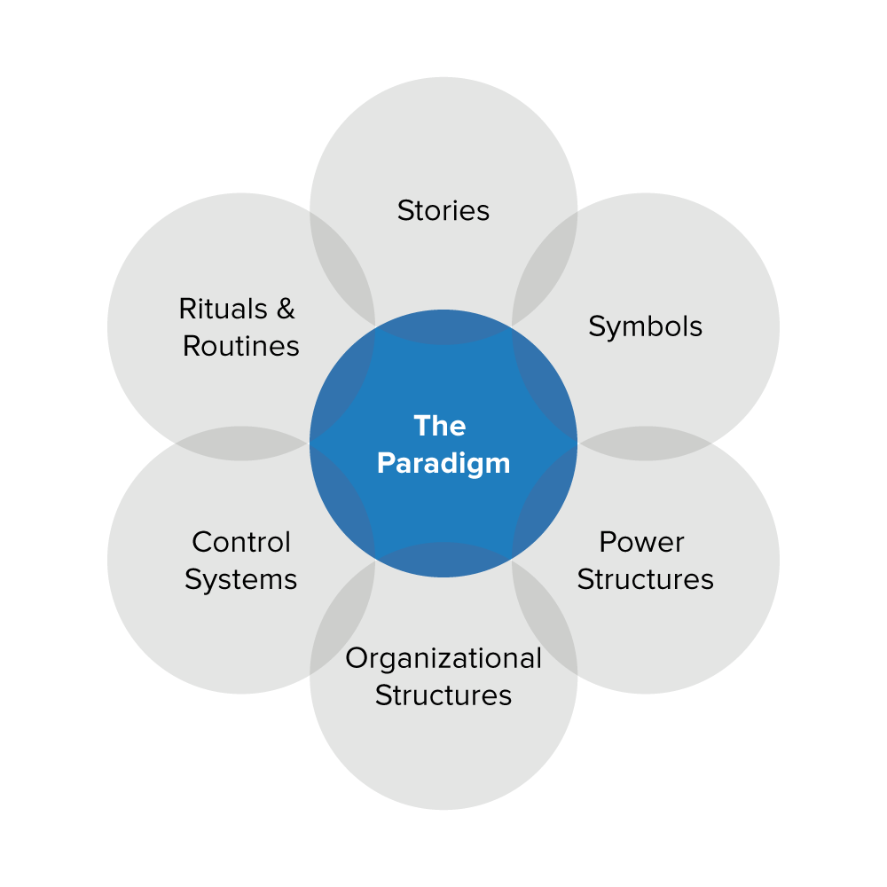
(Fundamentals of Strategy)
It is important for all managers to understand the meaning behind these 6 elements when aligning the Cultural Web to their organisation. A good way to do this and to understand better would be to ask yourself some questions for example
1) Routines and Rituals- What do our customers expect, what do our employees expect?
2) Stories – What reputation do we have? What stories do people tell?
3)Symbols- How recognisable is our logo? What do our company perks promote?
4) Power Structures-Who has the real power? Who makes the decisions?
5) Control Systems- What are the weakest controls? Do employees get rewarded?
6)Organisational Structures- is it formal or informal? Are the hierarchies?
(The Cultural Web: Aligning Your Organization's Culture with Strategy, 2020)

Another useful tool would be the CMI Checklist https://www.managers.org.uk/~/media/Files/PDF/Checklists/CHK-232-Understanding-organisational-culture.pdf

External Context
As a manager it is also important to understand the external context of your organization by doing this you are ensuring that Google will still be competitive in the global market. “The world out there influences the world in here” (Buchanan and Huczynski,2017).
By doing a PESTLE Analysis or SWOT Analysis you will be able to identify the external influences that will be having an impact on our decision making.

(Jossan 2020)

Conclusion
From analysing Googles culture is is evident to see that it is a ‘flat’ company that performs well and encourages employess to have a voice. Its laid-back work environment and staff benefits are what make this one of the best places to work.

References
Google.com. 2020. Google's New Logo. [online] Available at: <https://www.google.com/doodles/googles-new-logo> [Accessed 15 June 2020].
Mission Statement Academy. 2020. Google Mission Statement 2020 | Google Mission & Vision Analysis. [online] Available at: <https://mission-statement.com/google/#:~:text= Based on this analysis,3 Boosting organization More> [Accessed 15 June 2020].
Editors, F., 2020. Council Post: 13 Reasons Google Deserves Its 'Best Company Culture' Award. [online] Forbes. Available at: <https://www.forbes.com/sites/forbestechcouncil/2018/02/08/13-reasons-google-deserves-its-best-company-culture-award/#1935bec13482> [Accessed 15 June 2020].
Chapter 15 (Organisational Culture and Change) of Mullins, L. (2016). Management and Organisational Behaviour. 11th Ed. Harlow: Pearson Education Ltd.
Managers.org.uk. 2020. [online] Available at: <https://www.managers.org.uk/~/media/Files/PDF/Checklists/CHK-232-Understanding-organisational-culture.pdf> [Accessed 15 June 2020].
Mindtools.com. 2020. The Cultural Web: Aligning Your Organization's Culture with Strategy. [online] Available at: <https://www.mindtools.com/pages/article/newSTR_90.htm#:~:text=The Cultural Web, developed by six interrelated elements that> [Accessed 15 June 2020].
About.google. 2020. Google - About Google, Our Culture & Company News. [online] Available at: <https://about.google/?fg=1&utm_source=google-GB&utm_medium=referral&utm_campaign=hp-header> [Accessed 15 June 2020].
"Fundamentals of Strategy" by G. Johnson, R. Whittington, and K. Scholes. Published by Pearson Education, 2012.
jossan, 2020. Strategic Management Google Case. [online] Slideshare.net. Available at: <https://www.slideshare.net/supreetjossan/strategic-management-google-case> [Accessed 15 June 2020].

