Analysis of Xiaomi's social media marketing

Chapter 2 literature review

- Introduction

The purpose of this section in the thesis is to review the existing literature describing social media marketing for Xiaomi.

In this dissertation review, the researcher explores the use of social media marketing in telecommunication, with XIAOMI as an example, to explore the effecting impact of social media marketing on company performance.

Xiaomi is a large emerging technology company in the world and also social media marketing is a new and popular field in recent years. Therefore not much relevant literature has been collected. In this section the researcher will critically analyse the existing literature in the field and what impact Xiaomi's social media marketing has actually had on the company's performance.

XIAOMI is a Chinese company. So researcher may use more Chinese literature, books on social media marketing, and information on this field on the internet will be consulted. Also by summarising the relevant information, it will help to specify the direction of information gathering in the third part.

Finally, the literature review section will attempt to identify existing gaps in the research on this purpose and will be followed up by a thesis that will add to the research in this area.

1.1 social media marketing

Before discussing Xiaomi, researcher have read a large number of papers on the concept of social media marketing.
In recent years, with the gradual development of Internet technology, the technological level of each country is constantly improving. With the increasing popularity of smartphones, more and more social media software such as Facebook, Instagram, Twitter, TikTok, Weibo ,Wechat, Douyin.(Li, 2017)

Based on the huge amount of views caused by the large number of active Internet users, a set of data shows that the daily views of Chinese Internet users based on the software Weibo reached 420018 for just one topic. Such a huge amount of data is one of the most powerful pillars supporting the birth of the new field of social media marketing. (Buffer, 2019)

As mentioned in much of the literature on social media marketing, in every era there is a way of communication for every era, and different ways of communication develop and change people's daily lives.

Kesharwani, Sarkar & Oberoi, (2019) argue that in every era people have their unique way of communication and in two billion actual social media marketing has become an emerging way for internet users to express themselves and communicate with people. People do not write to each other, nor do they call and text as often anymore.

Kesharwani, Sarkar & Oberoi, (2019) argue that in every era, people have their own unique ways of communicating. In today's volume based on 2 billion internet users, social media marketing has become an emerging way for internet users to express themselves and communicate with people. People are no longer writing letters to each other or calling and texting as often .

At the same time this way of communicating with each other has had a huge impact on the marketing activities of businesses. Many companies are realising that if they do not use social media marketing well in today's digital world, it will be difficult for them to stand on the wave of the times. It is even more difficult to make greater gains today. Social media has even more amazing influence in the world, for example if Facebook were a country, its huge user base and usage base would make it the third largest country in terms of population after China and India. It world is connected by social media into a circle where people all over the world can communicate with each other. (Lokumannage, 2020)

(Kesharwani, Sarkar and Oberoi, 2019)

The concept and current state of social media is popularized in this literature, but the researcher believes in reading it. While it is important to use social media for marketing, this cannot be the entirety of a company's marketing interactions. A combination of traditional TV commercials, posters, which are advertising in nature, and social media marketing is the more appropriate direction for businesses today. (Cao et al., 2020)

1.2 different ways of social media marketing

For the basic approach and content of social media marketing, based on a review of the

WeChat is a social media and multi-functional program in China that allows users to not only chat with each other and browse news on WeChat, but even browse articles through 'Public'. So for WeChat is not only a social media software but also a multifunctional application. With over one billion monthly active users in 2018, WeChat has become one of the most popular social media platforms in the world. Although WeChat has a large number of users, it is rarely known in the West. (Montag, Becker and Gan, 2018)

For the basic approach and content of social media marketing, based on a review of the Zheng , (2016) literature. In terms of social media marketing implemented in WeChat, he believes that there are a total of several avenues and modes.These are through advertising, QR code marketing and word-of-mouth marketing respectively, through which effective social media marketing can be carried out to customers from WeChat.

1.2.1 advertising

Social media is a mixed bag of users, with companies or individuals posting messages or comments to their friends to carry out the most basic and cheapest form of social media marketing. This can include relevant advertising messages. This is particularly effective when the main purpose of such advertising is to share life rather than to advertise. In particular, a lot of social media marketing uses not only the sharing of news, but also stories, hot topics, and so on. For example, if a company marketer simply shares an item that he or she finds useful, a friend or customer will ask where to buy it. (Sakshi, 2017)

In the researcher's own experience, this tends to cause dissatisfaction among users when WeChat pushes ads in a forced manner. Users are more likely to trust an inadvertent share on social media, as they tend not to perceive it as an advertisement. Whereas when an ad is pushed by a customer who is aware of it from the outset, often users will doubt the authenticity of the effect of the product in the ad.
So this is called media marketing really brilliant, is to make the ad look like it is not an ad, and thus gain the trust of the consumer.(Alalwan et al., 2017)

1.2.2 QR code marketing model
Another feature on WeChat in China is the 'swipe' function for QR codes, which are a graphic similar to the one in figure 2. The QR code is placed in the viewfinder and the QR code is scanned in front of you to obtain information. When using QR codes for marketing purposes, the will generally be coupons for the merchant, membership information for the merchant, news from the merchant and even the ability to receive payments.

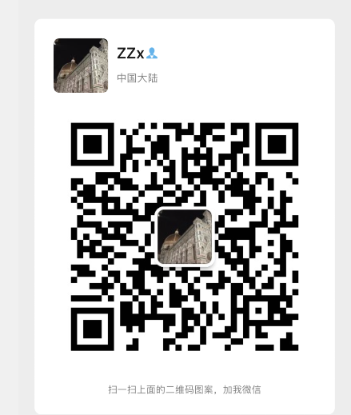

Figure 2 : Researcher’s Wechat QR code.

1.2.3 Word of mouth marketing model

It is a way of using user feedback to attract more potential consumers by placing positive user reviews on the appropriate social media platforms. It is a way of using social media platforms to create a strong relationship between a business and its customers. Customers and customers spread the word to each other, and customers have a better perception and attitude towards the company through positive reviews on social media. And by using the retweeting function of social media platforms, more and more potential consumers can be converted into business performance. The effect of word-of-mouth marketing is achieved.

In this case, the backend of the social media platform records the feelings of individual users about different products, which results in big data. Once the data has been analysed, each user is then recommended the right product for them.
Researchers believe that traditional marketing concepts refer to a similar approach as viral marketing, using word-of-mouth from users' reviews of products. to achieve a promotional effect for a product. However, on social media platforms, social media amplifies the effect of this model, spreading faster, wider and more effectively. (Baccarella et al., 2018)

Re 微信营销模式分析

1.3 Pros and cons of social media marketing

The process of moving from awareness of the importance of social media to actually using social media marketing to achieve improved performance still reveals the problems that some companies currently have when conducting marketing.

1.3.1 Lack of awareness of target customers and media

Liang，Y & Yao, L (2017) believes that there is a lack of clarity in the choice of target customers and social media. Many companies, in pursuit of their own economic benefits, do not target their social media marketing extensively and spend high costs on overwhelming advertising and sharing. But they do not receive the results they should. At the same time, this is a kind of random marketing without design and targeting. Companies do not research the nature of their products and brand positioning, nor do they have good market research to segment their customers, but simply follow the trend of social media marketing. The right target market and the right target customers are not chosen. When a company does not select the exact target audience for social media marketing, for example when the customer is a low income person and the expensive car company does a lot of social media marketing to him. In the short term this appears to be a waste of business resources and the customer is not capable of closing a deal with that business. In the long run the customer may even become bored with the business because he will be looking at ads that have nothing to do with him every day. Social media marketing in this context is obviously not conducive to the development of the company and can even have a side effect on the image of the company.

1.3.2An inauthentic consumer experience

Ultimately, social media marketing is used by companies to promote their own products, to stand out from the competition, to increase their share of the market and thus to improve their performance and economic efficiency. However, with the rise of social media platforms, some customers have a way of directly evaluating and recommending companies. For example, after experiencing a company's services, they share their thoughts directly on social media about their feelings. (Liu, Perry and Gadzinski, 2018) Good reviews can bring more customers to a business, allowing the business to develop a good reputation and convert potential customers into real ones. This can lead to more benefits for the business. (Chen, Liang and Cai, 2018)

But social media is often a double-edged sword in this, with many businesses' would-be rivals maliciously badmouthing a business on social media. The rise of this 'online army' has to some extent used social media marketing as a weapon to attack competitors, deliberately interfering with consumer orientation. (Hearn, 2020) Here, social media influencing consumers' consumer orientation is considered. Consumers buy things that they clearly have no need for and they buy them simply because of the advertising on social media marketing. (Jin, Muqaddam and Ryu, 2019)

There are even 'water armies' who maliciously attack companies and engage in blackmail, thereby seeking to make high profits. There are negative untrue consumer experiences and there are exaggerated untrue consumer experiences. Companies over-exaggerate their products and services to attract customers. And when customers actually experience them, the publicity and the real experience are often very different. So all kinds of untrue consumer experiences interfere with consumers' judgement to a certain extent, making it difficult for them to make a real and correct judgement. (Vashistha et al., 2019)

Re 互联网背景下社交媒体营销模式探究

1.3.3 benefits of social media marketing
But in many cases there are also very many benefits to social media marketing
According to Waad Assaad, Jorge Marx Gómez, social media marketing is a way to help companies better understand their customers' needs and thus help them build customer relationships more effectively.
Through social media, there has been a shift in the way companies use advertising and marketing campaigns, from the traditional newspaper, telephone, radio and television to a new form of online marketing based on social media. The most helpful aspect of social media is that it creates a connection between the company's stakeholders and allows the company to get direct feedback from customers.

At the same time social media can help companies to build a strategy around their product and service communities. It builds brand loyalty, increases the barriers of one's brand and helps companies to promote viral marketing through customer reviews.

Helping companies to listen more themselves to consumer suggestions and opinions. Social media can find a wide range of market research companies that help companies gather brand intelligence.

Social media platforms can also help companies gather information about their customers more effectively, although in many cases it is unethical in business ethics to gather information about customers and use it. However, there is no denying that this can be beneficial to a certain extent in terms of customer development.

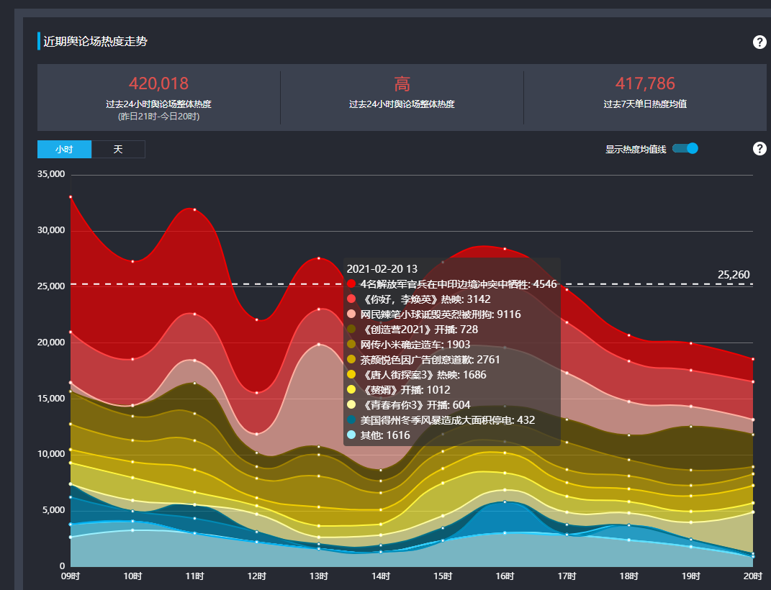
Figure 1：Single topic opinion buzz within 24 hours
Social Network in marketing (Social Media
Marketing)

1.4 social media marketing in telecommunication

In the telecommunication industry, the impact of social media influence is particularly significant. The essence of social media is the emerging communication tools. Companies in the telecommunication industry are mostly focused on the production of mobile phones in China. For example, HUA WEI OPPO ONE PLUS. (Tan et al., 2020) They themselves produce mobile phones with their own community-like apps, which facilitate small sets of their user groups. It is also a kind of social media marketing, where companies can easily make an effective social media marketing to the customers of their own products in a segmented customer market. (Khajuria and Rachna, 2019)

In for marketers, social media has the ability to achieve great results in a much shorter period of time at a very low cost. However, in the communications industry this can bring incalculable risks.

In this study, the results of an online survey of 287 users followed by Egyptian telecoms companies on social media showed that social media marketing campaigns consist of three dimensions; fashion, personalisation and word of mouth. These attributes of social media marketing directly affect brand loyalty and indirectly affect brand equity mediated by brand trust. (Ebrahim, 2019)

1.4 social media marketing of XIAOMI

On how Xiaomi conducts social media marketing, xxx argues in his article. Xiaomi's chosen channels for social media marketing include Weibo and WeChat. Each channel has different characteristics and forms a matrix of communication channels.

Xiaomi has its unique Xiaomi community, which is the equivalent of a portal for the Xiaomi brand as a whole. In this, all kinds of information about Xiaomi's products are presented in a comprehensive manner. Xiaomi's fans are generally known as 'Mi fans' and this community also provides a platform for them to communicate with each other. The Xiaomi community has a unique daily signature slot, which gives 'Mi fans' the opportunity and power to express themselves on a daily basis. Similarly Xiaomi's Weibo account pushes Xiaomi to a much wider audience. Including on the WeChat platform Xiaomi will also have its own unique WeChat public number. All methods are designed so that Xiaomi can maintain a stable and good customer relationship. Making 'Mi fans' feel connected to the company. (Zheng and Huang, 2019)

At the same time, the community has established a good user experience feedback system, where 'Mi fans' share the physical products they have received and their experience of using them with the community after they have purchased them. This way customers who are already 'rice fans' in the community can buy with more confidence. The majority of companies make most of their profits from a small number of loyal customers. In this regard, Xiaomi's use of social media marketing is certainly outstanding. (TIAN, 2019)

Xiaomi has also set up, an online hometown system. This helps 'Mi fans' in a city to meet and get to know each other. From time to time, they hold lucky draws and other activities to promote the relationship of 'Mi fans' in the same city.

Xiaomi's marketing efforts are all aimed at creating a complete Xiaomi eco-system, so that its loyal customers can't live without Xiaomi. Imagine a customer who uses Xiaomi for their mobile phone, Xiaomi smart furniture for their furniture, and a partner they met through an online party. Such a customer who is fully part of the Xiaomi ecosystem will create so much value for Xiaomi. (Wang, 2021)

1.5 Summary of the literature and discovery of research directions

All the literature had already review tell that social media marketing is more environmentally friendly than many traditional marketing models, reducing the waste of paper for example in brochures, leaflets etc. It is also an important way to save on advertising costs for companies in China, compared to the tens of thousands of dollars a second spent on TV commercials. Social media marketing requires little more than manpower and creativity. For example, many of the social media mentioned in today's papers have long since been eliminated, with the old 'qq space, Renren' having been replaced by today's Jitterbug, Sina Weibo and WeChat.

In the reviewed literature, researchers also suggest that it is narrow-minded to arbitrarily assume that social media marketing is necessarily superior to traditional marketing, and that this view is not made of data. The researcher will subsequently investigate the data to determine which is better and which is worse for Xiaomi.

In the case of Xiaomi, Lei Jun, the chairman of Xiaomi, is a very personal and influential entrepreneur. This is something that is not mentioned in many articles.

In this article the researcher will focus on how Xiaomi is marketing itself in the emerging social media. Even how the founder Lei Jun's personal marketing interests have been used to market the company, and how social media marketing has been used to save on advertising costs and thus what benefits have been gained.

Chapter 3

1.0 Introduction

A summary of the literature in this field of study was completed in the previous phase. The reader was made aware of what social media marketing is and the importance of social media marketing to businesses today, but there are still some gaps in the field regarding Xiaomi's social media marketing strategy and consumer perceptions of Xiaomi's social media marketing.

There is even a lack of understanding of how social media marketing can be implemented appropriately and what impact it has on the performance of a company.

Researcher will be focus on the three objectives, in an example XIAOMI company,.

- First is how to use social media to marketing, How social media marketing is being used in the existing communications industry as a whole, with a focus on Xiaomi's current approach to social media marketing.

In this section the researcher will mainly use secondary data to support the analysis, using examples of marketing by various companies collected on various social media networks.

- Then is effect of company's performance by social media marketing. Take Xiaomi as an example. Whether the social media marketing conducted by Xiaomi can influence customers to bring revenue to Xiaomi.

This section will use some of the questionnaire and interview data and Xiaomi's publicly disclosed financial data to support the analysis.

- last one is challenge about social media in future. e. What kind of social media marketing is good and can help companies achieve their strategic goals. What do companies have to do to make complete use of social media marketing.

This section will make extensive use of first-hand data, collected from various sources, to evaluate Xiaomi's current social media marketing and make predictions for the future.

1.1 what is research
Due to the nature of the research in this paper, a mixed methods study is used, which is a complement to the traditional qualitative and quantitative research. (Johnson and Onwuegbuzie, 2004)

Research is often defined as the creation of new knowledge in new and creative ways. Alternatively it is the use of summarising existing knowledge in order to generate a new understanding of the field. (Wright, 1966) This can include analysing and adding to previous research in order to produce new findings. (Westernsydney.edu.au, 2019)

1.2 research onion
The Research Onion Model presented by Saunders, Lewis and Thornhill (2016) in 'Research Methods for Business Students'. It is good research class model in this dissertation that can be effective in helping this part of the research to gather information and more comprehensive research.


Figure 2 research onion (Saunders, Lewis and Thornhill, 2016)

In this dissertation research onion will consists of a philosophy, an approach, a strategy, a selection of methods and a time frame.

1.2.1 Philosophy

Philosophy includes both positivism and interpretivism, with positivist research tending to be more scientific and interpretivism tending to be more qualitative in nature in academic argumentation. Positivism is more of an experimental, field-based study. (Hasan, 2014) Positivism focuses more on objective reality as existing outside of one's subjective perceptions, while interpretivism sees these as constituted by one's experiences. (Ryan, 2018) Often positivism is more realistic because it has real, measurable data. Interpretivism, on the other hand, relies more on the requirement for knowledge. (Weber, 2004)

In this study is more focused on determining the substantial role that social media marketing plays for xiaomi. Thus, interpretivism is used more as a guide, as most of the time this type of research is difficult to collect very accurate and complete data and requires more intellectual analysis and inference. (Irshaidat, 2019)

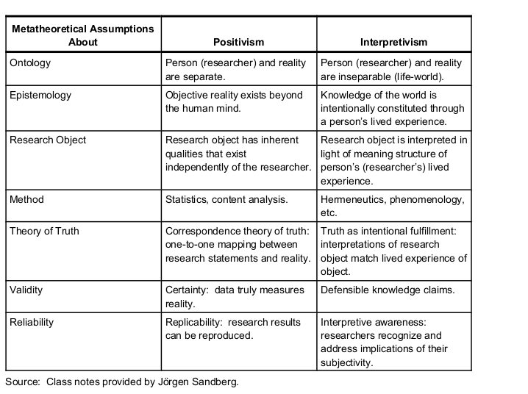

Figure 3: Positivism and interpretivism (Soleymani, 2021)

1.2.2 Approach & strategy

A study of the usual inductive and deductive methods. Even a combination of the two methods in some cases. The inductive approach is suitable for cases where there is little literature and theoretical support, and the limitations of this approach are that it is difficult to really prove and verify.

The deductive approach implies the study and validation of theories based on previous work and is limited to the fact that the deductive approach is difficult to carry out if there is no literature base. (Streefkerk, 2019)

Social media marketing is an emerging marketing model, and Xiaomi is also an emerging mobile phone technology company, and there is no good reference in the overall literature to analyse this company's social media marketing. Therefore, the researcher chose to use an inductive approach, combining data and theories from different companies in the same industry, in order to finally evaluate the social media marketing methods and results of Xiaomi.

In this thesis, all the research and data are based on the foundation Xiaomi Corporation. So this is a case study, for which data was collected and thus analysed.

1.2.4 Choices of Methods

One of the recommendations of the Onion study is to use a single research method mixed methods and multiple methods as the main research guide. The method chosen for this study was a mixed research approach to data collection. Both qualitative and quantitative methods were used in this study . Although the presence of COVID-19 did not prevent the researcher from studying it to some extent. Social media platforms were used to share questionnaires to collect data. The interviews were also conducted through social media, which to some extent also highlights the superiority of social media.

Secondly, there are many ways in which researchers collect and analyse data. Not only from specific websites or direct observation, but in many cases researchers collect more data from public comments . In order to gain a comprehensive understanding of Xiaomi's social media marketing. (Verschuren, 2003).

And, the study needed to first explore Xiaomi's specific social media marketing strategies from its annual report and website, and then from its revenue and customer questionnaires to understand whether its social media marketing was effective and how it was rated by its customers. A mixed research approach was chosen for this study, combining qualitative and quantitative data, hand-held and secondary data, questionnaires and interviews. (Wang, 2018)

The company chosen by the researcher is from China and will use more Chinese "Questionnaire Star" software to create the questionnaire when distributing it, which generates its own graphs and summaries of the data, without collecting personal information, including names.

1.2.5 Data collection

1.2.5.1 Qualitative and quantitative

A quantitative study is a study that is conducted with a large amount of data and information. A large amount of data is analysed to obtain the nature of the object of study. (Ercikan and Roth, 2006)

Qualitative research is usually based on descriptive data and analysis. It is usually based on language, text. (Dixon-Woods et al., 2005)

1.2.5.2 method of collect information

The researcher will design a questionnaire to first-hand data regarding social media marketing, the practical application of social media marketing in Xiaomi. The target audience for distribution is the general social media users.

Using questionnaires gives a clear picture of the information and information and opinions of the people being collected, as it is a direct survey and a way to reach out to the audience directly. However, there are still considered to be some problems in the tradition, firstly the use of large amounts of paper can cause a degree of waste of resources, secondly the large amount of data that needs to be would be aggregated and analysed, there is a huge amount of work involved in this method and finally the time to distribute and collect is a time consuming and labour intensive process. (Parajuli, 2008)

Today researchers use a function in WeChat to conduct questionnaires, which is good for avoiding the above problems, whether it is the initial questionnaire or the analysis and summary of the data or even the graphing that is done by the app.

Based on the data obtained from the questionnaire, the researcher will then conduct in-depth interviews with key users of XIAOMI's products to collect data. An in-depth interview, also known as an unstructured interview, is a type of interview used by the researcher to obtain information in order to gain an overall understanding of the respondent's views or situation. (Rita, 1999)

This method has a significant open-ended character, but at the same time is limited by the personal sensitivities of the interviewees, with the same questions being asked to the same interviewees and even different data being returned depending on the mood of the day. The data collected in this method is often highly unstable. (Lederman, 1990)

1.3 Question and literature review matrix

Questions in survey | Answers | Relation to chapter two
Q1 How old are you ? | 18-22  23-25  25-30  Over 30 | Questions 1-3 were all demographic which will help to gather relevant information. to create charts and use age or occupation to break down further when analysing some key data.  Social media use is related to age and occupation and even gender to some extent. (Vaast, 2019)
Q2 What kind of work do you do? | Corporate employee  Civil servant  Student  Freelance
Q3 What is your gender? | Male  Female
Q4 4 How often do you use social media apps? | Daily  Often  Occasionally  Never | Q4-5, a survey of the amount of time users spending on social media on a daily basis, thus paving the way for subsequent conclusions on the frequency of exposure to social media marketing. (Scott et al., 2017)
Q5 How much time do you spend using social media? (a day) | Three hours or less  Three hours to five hours  Seven hours to nine hours  Nine hours or more
Q6 Which of the following activities have you used social media for? | Making friends  Watching videos  Watching news and gossip  Read forums and articles  Posting comments  Share your daily life  Shopping  Work | Q6-9, in order to gain a deeper understanding of what users are using social media for, and thus analyse the likelihood of them being exposed to social media marketing.  At the same time social media was initially used to provide a channel for people to communicate online and with the development and advancement of technology it has gradually become available for businesses to use for marketing.  So whether users believe in or reject some of the additional items from social media is an important determinant of the success of social media marketing. (Vinuales and Thomas, 2020)
Q7 How would you evaluate the quality of the information you get from social media platforms? | Very good  Good  Moderate  poor  Very poor
Q8 How do you see companies advertising on social media platforms? | Interferes with normal use  Doesn't matter  Makes sense Useful for purchase
Q9 Your views on the additional features of social media platforms (e.g. WeChat applets, public numbers, Jitterbug live streaming with goods) | Very interested  Watch in your spare time  No point
Q10 Have you ever used any Xiaomi products | Used a mobile phone  Used a product other than a mobile phone  Used both of the above  No | Q10-12, The best marketing is meaningless if the product itself is poor, so it is vital to know what customers think of Xiaomi's products. (Wan and Sanders, 2017)  Xiaomi has a wide range of products and different users focus on different products, so it is important to identify the type of products that customers want for marketing.  The company has a wide range of products and different users focus on different products.(Shou et al., 2017)
Q11 How would you rate the Xiaomi products you have used? | Great  Good  Bad  Normal  Haven't used it No comment
Q12 Which do you think appeals to you more when comparing the phone to Xiaomi's other products? | Mobile phone  Home products  Home appliance  Other electronic products
Q13 Are you motivated to buy Xiaomi products by social media marketing? | Yes  No | Q13-22, understanding the true motivation of customers to create a desire to buy is essential for good marketing. (Xiao, 2018) In addition to receiving social media marketing.  Also if the customer's motivation to buy is derived from social media, then which is the dominant social media in China, for which the Chinese social media will be explained in the analysis phase. (Rahman, Khan and Iqbal, 2018)  It also collects user reviews of Xiaomi's existing social media marketing to help Xiaomi improve its social media marketing.
Q14 What is your motivation for buying Xiaomi products? | Browsing offline shops  Recommendation from friends  TV commercials  Loyal Mi fans No motivation needed  *Mi Fans: Long-time loyal customers of Xiaomi
Q15 In which social media did you discover Xiaomi products? | Dou Yin  WeChat  Weibo  Other
Q16 What specifically attracted you to Xiaomi's social media marketing? | The powerful features introduced in the ads  The spokesperson being your idol  The creative of the ad itself  The beautiful look of the product presented in the ad
Q17 How often do you see Xiaomi's ads on social media platforms? | Every day  Once every three days  Once a week  Never
Q18 How would you evaluate Xiaomi's advertisements on social media platforms | Meaningless Not a big deal  Crossed right over No impact  The ads were good No desire to buy  Very eye-catching Desire to buy
Q19 Your attitude towards Xiaomi's marketing activities on social media? | Actively following  Detailed understanding  Automatically ignore, not interested  Don't trust much, doubt authenticity  Relatively disgusted, easily create negative impressions
Q20 Do you actively search for information about Xiaomi Corporation or Xiaomi phones on social media platforms? | Yes  No
Q21 Which Xiaomi companies are you impressed with in terms of social media marketing? | Promotions for Xiaomi phones  Not aware of any Weibo marketing activities by Xiaomi  Branding videos such as the Xiaomi Youth "microfilm"  Links to Xiaomi phones and events  Hot topics for Xiaomi phones or events  Recommendations from big social media platforms with a certain number of followers  Event information retweeted by a friend @ your own sweepstakes
Q22 Your suggestions for Xiaomi's social media marketing | Fill-in-the-blank questions
Q23 What do you think are the advantages of marketing on social media platforms for businesses (including but not limited to advertising, live streaming)? | High speed  Wide Audience  Low cost  not limited by environment  building ecology  environmentally friendly  Your complement | Q23-24, customer perceptions of social media marketing are important, and if some customers hate it, too much marketing will only be counterproductive. (Alalwan et al., 2017)
Q24 What do you think are the shortcomings of marketing on social media platforms? | Mass placement leads to customer resentment of the business  Choosing the wrong platform or promoter leads to counterproductive results  Negative press about the promoter can lead to negative publicity for the company  Extremely time-sensitive  Your complement
Q25 Do you follow Lei Jun's personal account on ShakeYin or Weibo? | Yes  No | Q25-30, Many companies in China are popular in having entrepreneurs as the face of the company, and Xiaomi is a pioneer of this model. Gathering customer perceptions of this emerging marketing model is useful to help use it better.
Q26 Why do you follow Lei Jun's social media accounts? Multiple choice | Bored and want to see  Want to know more about the entrepreneur's life  Want to know more about Xiaomi's corporate culture  Just follow Never read the content
Q27 Would you buy Xiaomi products because of Lei Jun? | Yes  No
Q28 Do you think it is good for entrepreneurs to do social media marketing themselves? | Yes  No
Q29 Your resaons  Based on the second option of question 28 | Entrepreneurs don't bring in as much traffic as celebrities  Entrepreneurs should have more important things to do  It's easy to brand a business with a particular person  Your addition
Q30 Your reason  Based on the first option of question 28 | Savings  Grounding the corporate image  Better promote the company culture  Your complement
Q31Which Xiaomi-related social media platform accounts do you already follow? | Xiaomi Mobile  Redmi  Xiaomi Box  Xiaomi Community  Xiaomi Fan Support Club  Do not follow | Q31-35, a survey based on the real followers of Xiaomi's existing social media accounts to see the potential of Xiaomi's current social media marketing. (Pee et al., 2019)The survey also looked at customer engagement with Xiaomi's social media marketing. (Shih, Lin and Luarn, 2014)
Q32Which social media? | Microblogging  WeChat  Shake  Taobao  Pindoduo  Jingdong
Q33What forms of social media advertising are you more interested in? | Text + image  Short video  Long video
Q34Have you reported or complained about Xiaomi's marketing activities on social media | Yes  No
Q35Have you ever recommended, @ or retweeted information about Xiaomi's social media marketing campaigns to a friend? | There is mutual communication and response  There is communication without response  Self-regarding but no communication  No attention

Table 1: Questions in the questionnaire relating to chapter two the literature review

1.4 Pilot Study

In order to obtain high quality results, a pilot study with relevant experiments and accuracy performance needed to be designed. For this reason it is useful to effectively analyse the feasibility of the main study before it is carried out . (In, 2017)The pilot study is the first step in the overall research protocol and the pilot study is usually carried out before the main experiment to analyse its validity. (Lancaster, 2015)

1.5 Interview design

The researcher conducted three interviews with the researcher's peers, the researcher's elders, and a marketing practitioner. A total of four questions were designed, and because of the covid-19 relationship all interviews were conducted via video call.

1.6 analysis

The researchers will use a Chinese software called Questionnaire Star to collect and analyse the data from the questionnaire and use graphs to present the data. The open-ended interviews will be analysed using a thematic approach to look for any common themes, trends or patterns.

1.7 Reliability and validity

Reliability and validity are concepts used to assess the quality of research.

Reliability indicates the extent to which results can be reproduced when a study is repeated under the same conditions. The consistency of results is checked by different time spans and different observers.

Validity is to a large extent a true measure of the extent to which they should be measured. (Middleton, 2019)

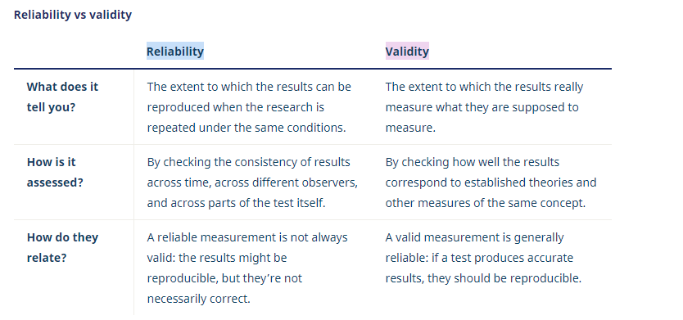
Figure 4: Reliability vs validity: what’s the difference? (Middleton, 2019)

1.8 limitation

As the aim of the study was to find out the opinions of the general public, it was reasonable to use a sampling method. However in this, it is difficult to ensure that every survey is valid because the covid-19 researcher was unable to distribute the questionnaire offline, which made it difficult for the online questionnaire researcher to know if the respondents were scribbling. (Leung, 2001)

People's perceptions of things are very subjective, and often the same advertisement can be viewed differently or even contradictorily depending on gender and age. So there are some errors in this, although the survey is designed to ensure objectivity, it is difficult to avoid such mistakes because each respondent is subjective. (Stone, 1993)

1.9 Ethical Considerations

Ethics usually considers whether research is appropriate in terms of social issues. Ethics are needed to govern the design, use and storage of data. Ethics in research includes whether it is supported by the public, social responsibility, etc. (Kjellstrom, Ross and Fridlund, 2010)

The primary information in this study is anonymous and the data is secure to meet the ethical considerations. All specific personal information, including names, will not be disclosed. The study is also voluntary and all participants are over the age of 18. The data is stored on the researcher's personal account, which is password protected to prevent misuse. This goes some way to avoiding ethical risks and makes the study healthy and ethical. (Dawson et al., 2011)
3.10 Conclusion

This chapter identifies the direction and methodology of the study, the direction of secondary data collection, and the methods of primary data collection (questionnaires and interviews). Also the mixed research approach and the case study strategy used in this study are explained. The analysis of the collected data is explicitly presented in Chapter 4.

Chapter 4

4.1 Introduction

The previous chapter consisted of some research methods and guidelines, in this section aimed at achieving the research objectives of this thesis doing the basis of the data. The survey collected 356 respondents, each with a 100 per cent question completeness rate, along with three interviewed volunteers.

Their perceptions of social media marketing and the evaluation of Xiaomi's existing social media marketing were investigated. This data will be used in this section to respond to the three research objectives covered in the previous chapter. A critical and dialectical analysis is also conducted. (Wodak and Meyer, 2016)

4.2 Data analysis

Data analysis is the process of counting and classifying the data that has been collected so that it can be more easily applied and finally some conclusions can be naturally drawn from it. (Ram Gnanadesikan, 1983)

The main purpose of analysing and managing the data in this dissertation is to respond to three objectives, so the data will be developed based on these three scopes.

4.2 Methods

The online questionnaire generated quantitative data, based on a Chinese online questionnaire software (Questionnaire Star) and automatically generated icons within it. It is possible that some Chinese may appear in the icons, but the researcher has tried to avoid this. The analysis was based on a positivist approach and the researcher was faced with the challenge of managing the large amount of data to ensure that the quantitative data would produce conclusions in the most appropriate and natural way.

By disaggregating by gender, age and occupation, thus avoiding individualised differences due to a number of objective factors. The results of the questionnaire are not presented in full, but are intended to be critical when responding to key objectives. A cross-tabulation of the two questions is used to draw valid conclusions. ...

4.3 Overview data from questionnaire
4.3.1 Demographics

Basic information about the respondents is an important part of the survey, but also in conducting social media marketing. (Ott and Longnecker, 2020) Because of the covid-19. questionnaire was shared via social media, the respondents were mainly of a similar age to the researcher. Of the respondents, 85.95% were between the ages of 18-22 and 86.8% were professional secondary school students. 79.21% of the respondents were female and only 20.79% were male. Here the researcher believes that to some extent it shows that women have a stronger interest in social media related questionnaires.

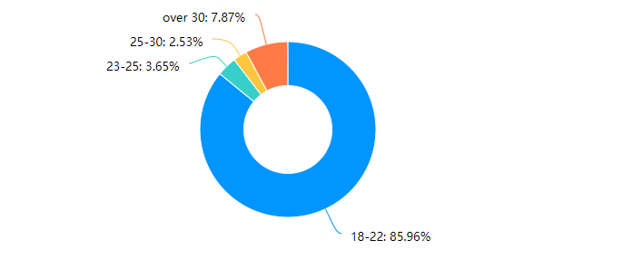

Figure 5: Q1 Age of Respondents

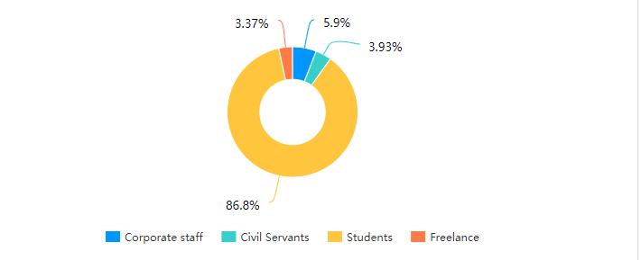

Figure 6: Q2 Job of Respondents

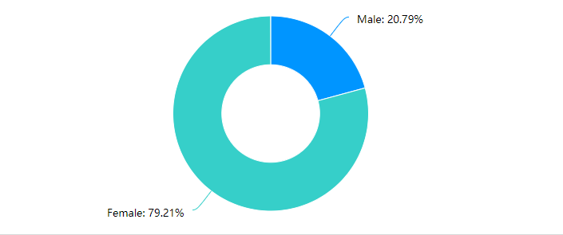
Figure 7: Q3 Gender of Respondents

4.3.2 Social media use

Respondents' use of social media, both in terms of time and specific content of use. The data from several of these questions shows that 67% of people use social media software on a daily basis. At the same time, only 1.97 per cent of the population, based on a sample of 356, or seven people, do not use social media at all. \

The vast majority of people use it for almost three hours. Among the most popular uses of social media are making friends, watching videos and shopping. It can also be seen that only ten people are dissatisfied with the information they take in on social media and the vast majority are more than satisfied.

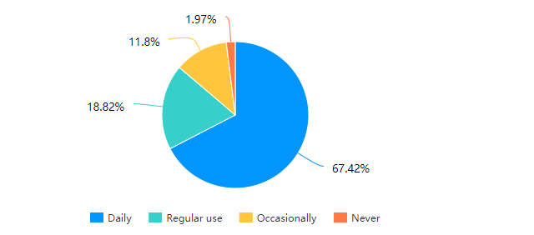

Figure 8: Q4 How often do you use social media apps

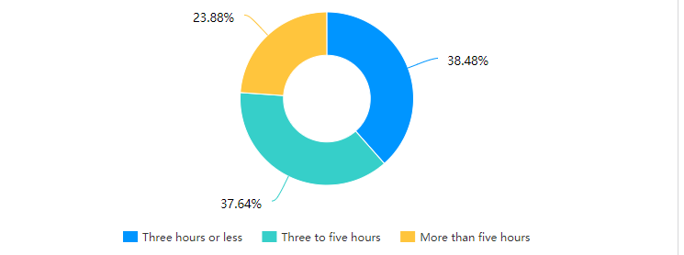

Figure 9: Q5 The amount of time you spend on social media platforms each day

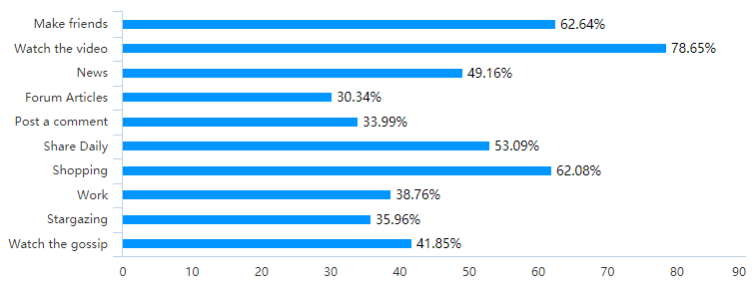
Figure 10: Q6 Which of the following activities have you used social media fo

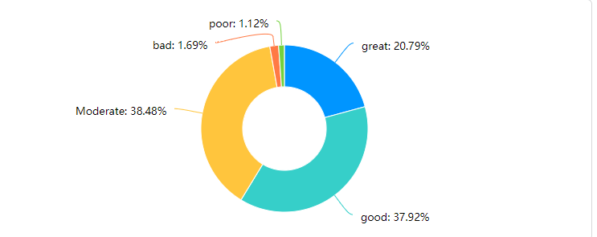

Figure 11: Q7 Overall, how to rate the quality of information you get from social media platforms

It is easy to see from figure12 and 13 that existing advertising on social media is ineffective and only eleven percent of people will make a purchase. Even forty-four percent think that it interferes with normal use. Only sixty-nine per cent of people will pay attention to social media marketing messages at their leisure.

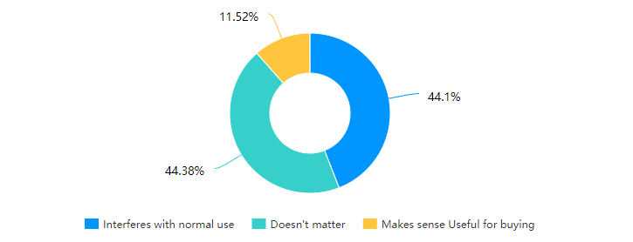
Figure 12: Q8 How to think about advertising for companies on social media platforms

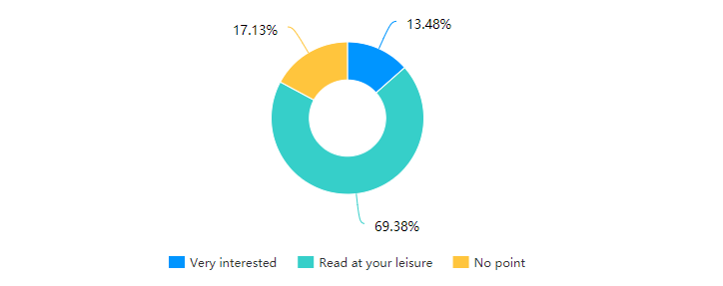

Figure 13: Q9 Your views on the additional features of social media platforms (e.g. WeChat applets, public numbers, Jitterbug live streaming

4.3.3 Reviews of Xiaomi's products

This part of the figures shows that Xiaomi's mobile phones are still the main consumer target, while Xiaomi's non-mobile business has also had a good sales volume. Overall Xiaomi's products are good and the vast majority of users think they are good. Home products and other electronic products such as rechargeable batteries and headphones are well received.

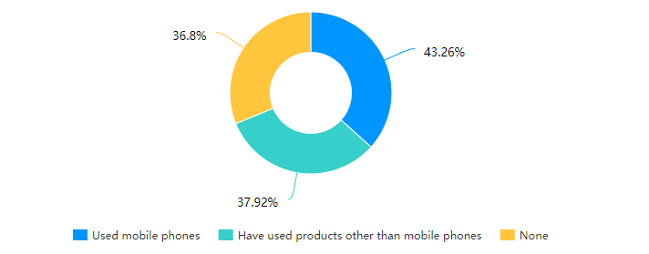
Figure 14: Q10 Have you used Xiaomi products

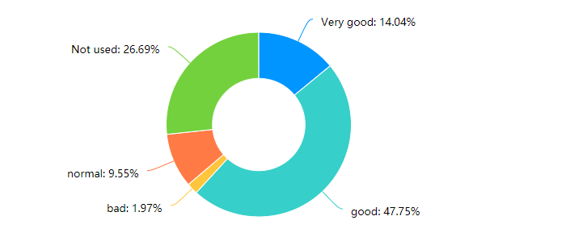

Figure 15: Q11 How do you rate the Xiaomi products you have used

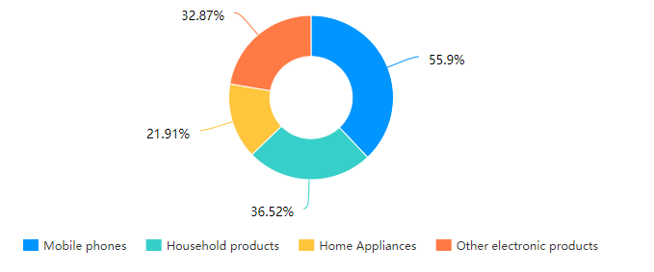
Figure 16: Q12 When comparing it to Xiaomi's other products, which one do you think appeals to you more

4.3.4 Purchase behaviour

With this part of the data, the influence on social media only makes less than half of the people want to buy. Also the most crucial factor for Xiaomi as a brand is the excellent value for money. The three main social media platforms in China are Douyin, Wechat and Weibo, which are similar to Tiktok in that they provide a platform for users to share short videos of their daily lives, Wechat is similar to Fackbook in that it provides a platform for daily chats and sharing of life among friends, and Weibo is similar to twitter in that it is a platform for socialites or celebrities to share their lives. Weibo is a platform for socialites and celebrities to share information. The data shows that Xiaomi's main social media marketing is not on any of the major social media platforms. (Delisle, Goldstein and Yang, 2016)

It is also clear that Xiaomi's marketing is currently low, and that the advertising is inefficient and hardly stimulates the desire to buy. There are even some that have a negative impact on the company, but it is good to see that Xiaomi's social network accounts are still highly visible.

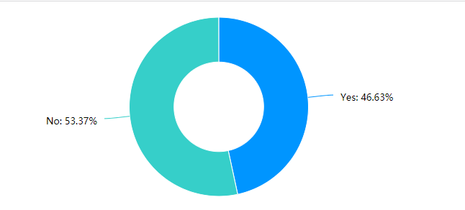
Figure 17: Q13 Has social media marketing motivated you to buy Xiaomi products?

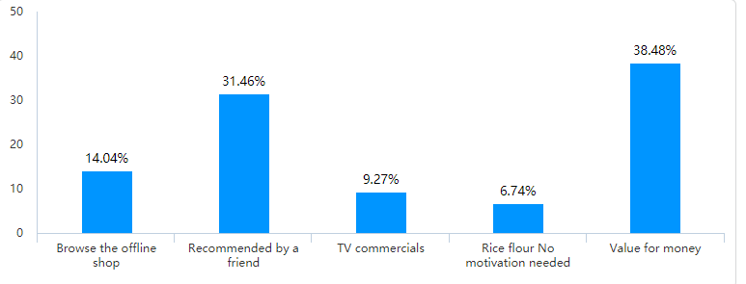

Figure 18: Q14 What is your motivation for buying Xiaomi products

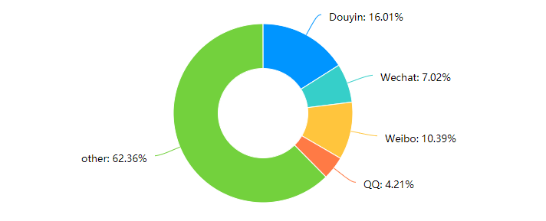

Figure 19：Q15 On which social media did you discover Xiaomi products
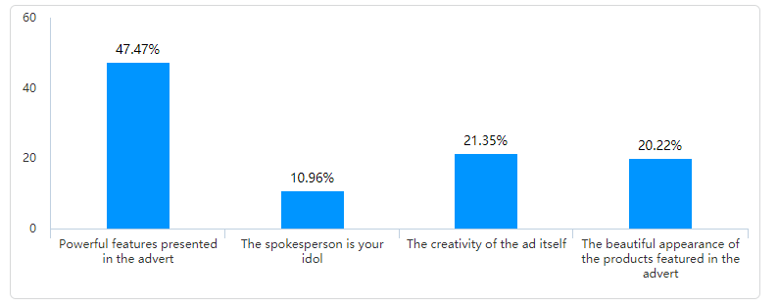
Figure 20：Q16 What specifically appeals to you about Xiaomi's social media marketing

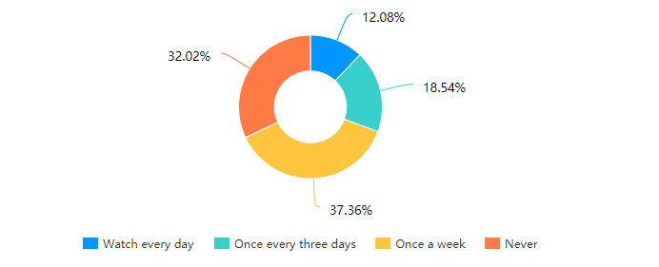
Figure 21：Q17 How often do you see Xiaomi's ads on social media platforms

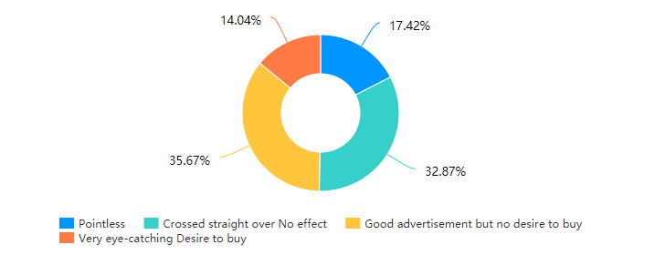

Figure 22：Q18 How do you rate Xiaomi's advertising on social media platforms

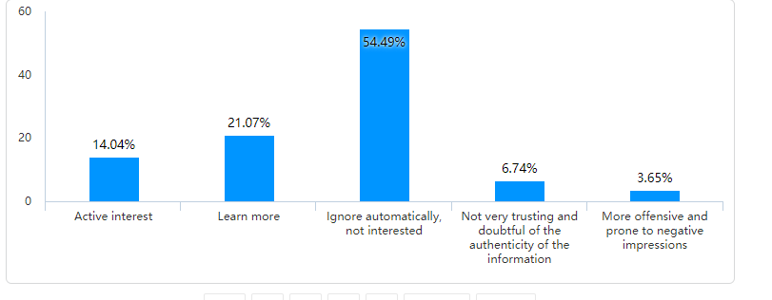
Figure 23：Q19 Your attitude towards the marketing activities conducted by Xiaomi on social media? (e.g. @friends, coupons, etc.)

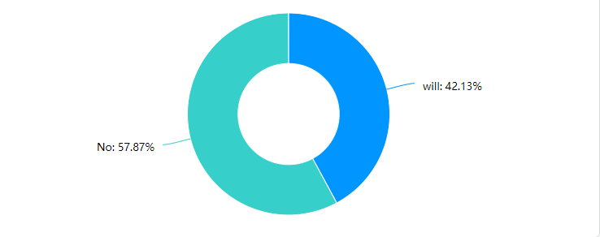

Figure 24：Q20 Do you actively search for information about Xiaomi Corporation or Xiaomi phones on social media platforms

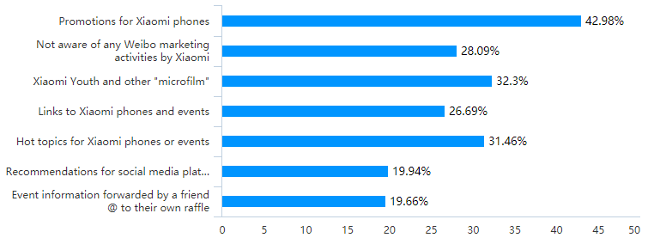
Figure25：Q21 Which Xiaomi companies are you impressed with in terms of social media marketing

Question 22 was a fill-in-the-blank question and the researcher chose a few meaningful answers to create a table.

Respondent Serial Number | Suggestions
1 | Improving quality
2 | More accurate placement on platforms
8 | Better use of social media traffic
20 | More display of Lehman's message
198 | More diversity
209 | More stars
290 | Youthfulness
301 | No advertising

Table: Q22 Your suggestions for Xiaomi's social media marketing

4.3.5 Advantages and disadvantages of social media marketing

The main advantages of social media marketing as perceived by respondents are its wide audience reach, low cost and speed of distribution.
At the same time, the main disadvantage is that it is easy to create a negative impact on customers, and the wrong spokesperson is likely to bring the company down.

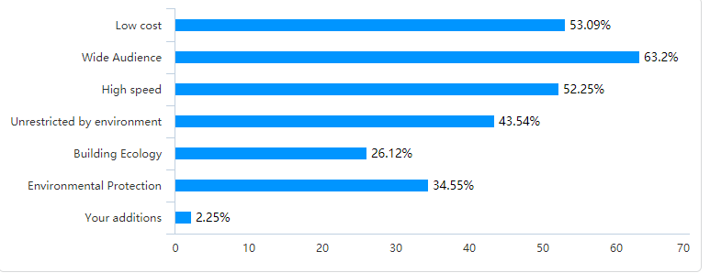
Figure 26: Q23 What do you think are the advantages of marketing on social media platforms for businesses (including but not limited to advertising, live streaming)

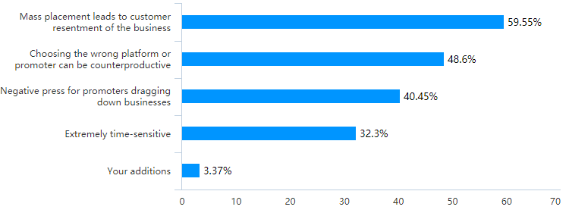
Figure 27：Q24 What do you think are the shortcomings of marketing on social media platforms

4.3.6 The face of social media

While seventy-seven percent of people do not follow Lei Jun's personal account, there are still some who say they will in the future but mainly because of curiosity rather than a liking and desire to know more about the brand. Ninety-four percent of respondents said they would buy Xiaomi products because of Lei Jun, while sixty-eight percent of respondents thought it was good for the entrepreneur to be the face of the company.

The main reason is better promotion of corporate culture and better corporate image. But the main downside comes from the fact that it is easy to brand a company with a particular person.

Meanwhile short videos remain the most popular means of social media distribution for users, while forty-three percent of people don't follow any of Xiaomi's marketing activities on social media at all.

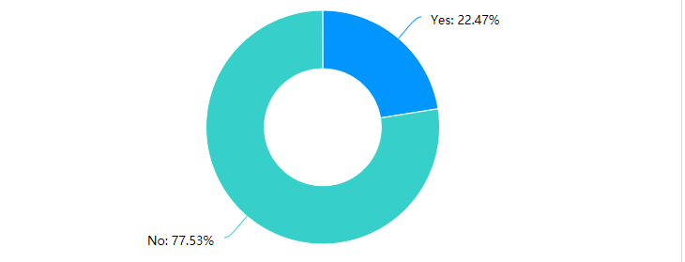

Figure 28：Q25 Do you follow Lei Jun's personal account on Shake or Weibo

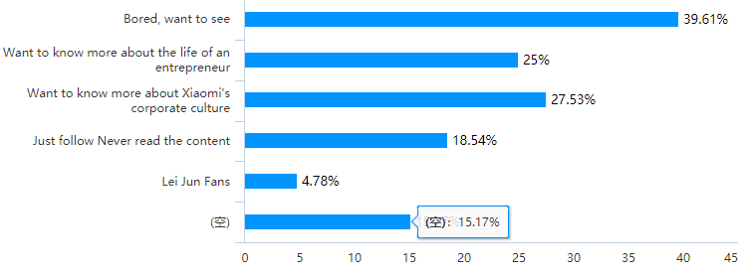
Figure 29：Q26 Why do you follow Lei Jun's social media accounts

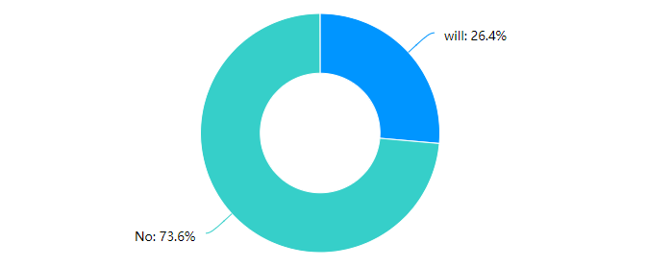

Figure 30：Q27 Would you buy a Xiaomi product because of Lei Jun
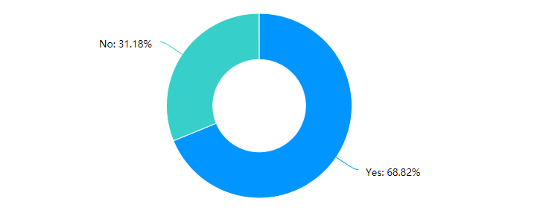

Figure 31：Q28 Do you think it is good for entrepreneurs to do social media marketing themselves
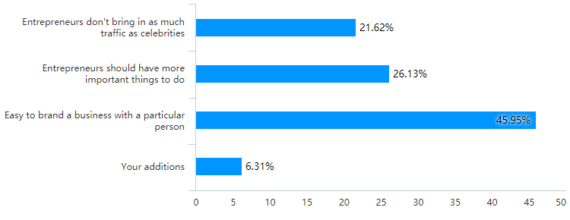

Figure 32：Q29 Your reasons
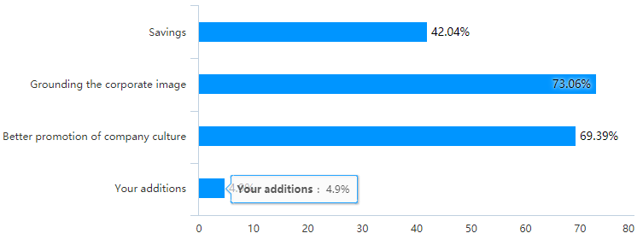
Figure 33：Q30 Your reasons
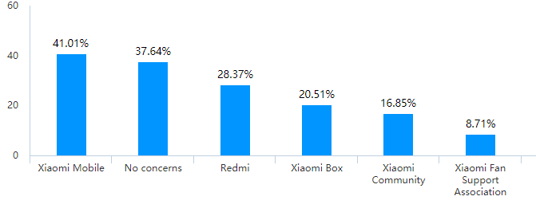

Figure 34：Q31 Which Xiaomi-related social media platform accounts do you already follow

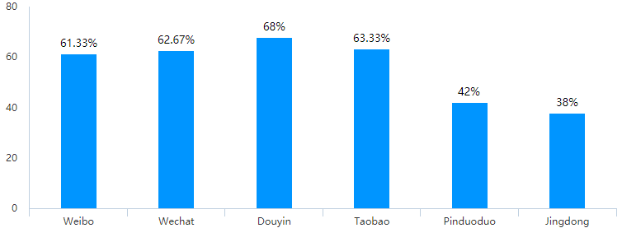
Figure 35：Q32 Which social media

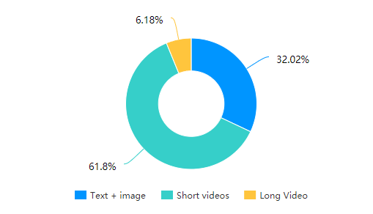
Figure 36：Q33 What forms of social media advertising are you more interested in
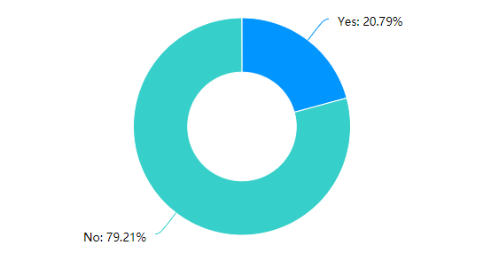

Figure 37：Q34 Have you reported or complained about Xiaomi's marketing activities on social media

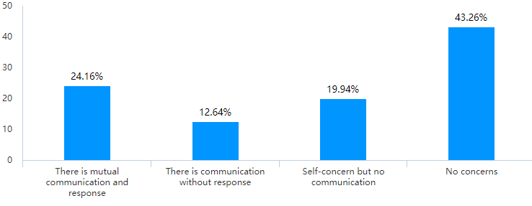
Figure 38：Q35 Have you ever recommended, @ or retweeted information about Xiaomi's social media marketing campaigns to a friend

4.4 Information presented from interviews

The first interviewee
Graduate student in marketing Heavy social media user
One year of experience with Xiaomi products

Questions | Answer
Which social media platforms have you visited for marketing? | The Weibo login screen often features ads from KFC, XIAOMI, HUAWEI, and food recommendations from VW Dianping (a Chinese food review app).  I have also received ads from WeChat and have even seen food podcasts on Douyin
Views on this | Also on social media platforms, they like to see what their friends or online friends share inadvertently, thus creating a desire to buy.  Opinion on social media marketing is that it doesn't matter  It doesn't interfere with everyday use and browsing of information but at the same time it doesn't make you want to buy the product itself except for the food category.
What kind of social media marketing currently exists at Xiaomi, and what do you see as the benefits and shortcomings? | The current placement is not attractive enough for the participant  There are no celebrities that you like The current Xiaomi campaign is still focused on mobile phones but the interviewees want more home products The marketing should be more widespread  Even if there is a favourite celebrity in the live broadcast, it's just a clip of the celebrity  The format itself is limited to a certain range of people
Participatory offline marketing activities | Cosmetics shops will participate in the offline interactions promoted on social media platforms  Will not participate in the offline marketing activities of the company's clubs, but will be eager to participate at a later date, for example in the cosmetics category. Eager to widen their social circle because of a product.

The second respondent
Middle-aged people rarely use social media but are loyal users of Xiaomi

Questions | Answer
Which social media platforms have you visited for marketing? | The general use of social media is still dominated by WeChat and Douyin, mainly looking at some short video ads based on social media marketing.
Views on this | Very good channels allow him to receive a good variety of up-to-date information , such as new product launches. Also will see a variety of short videos sharing Xiaomi home products on short video platforms. Other people's personal experiences make him very eager to buy
What kind of social media marketing currently exists at Xiaomi, and what do you see as the benefits and shortcomings? | Need a channel to get a comprehensive and detailed understanding of the product you don't need to be interested in  It is more likely to be shared by users than direct advertising by companies  Even for celebrities, the impact on consumers is minimal  Purchase behaviour is mainly influenced by demand and price
Participatory offline marketing activities | Never been involved and don't want to be involved in the future

The third interviewee
Marketing practitioner and teacher of marketing

Questions | Answer
Which social media platforms have you visited for marketing? | Various include retweeting discounts, retweeting to collect friends' reviews, social media promotions on various social media platforms. There is also exposure to short and long-form video marketing. Even advertising in front of long videos.
Views on this | Social media marketing is still very new and meaningful, and this new approach can help companies save a lot of money, as well as helping customers to make a better choice of products. However, existing social media marketing is still ineffective, and it is difficult to do social media marketing well. Companies are still figuring it out and trying it out.
What kind of social media marketing currently exists at Xiaomi, and what do you see as the benefits and shortcomings? | For Lei Jun's behaviour, I appreciate that the connection between himself and the brand is greater, with a stronger affinity and persuasive power Celebrity endorsement does not deepen the goodwill of the company The spokesperson and the brand are separate The entrepreneur as founder is better able to convey the brand culture and maintain the brand image  There are many things that a celebrity can endorse, but a brand founder can only endorse his own brand, which is a more prominent image
Participatory offline marketing activities | Have attended some offline new product launches of companies, car clubs. To some extent it will lead to some purchases and widen the social circle, but in general it is a waste of time.

4.5 Second-hand information

There is very little information in this section, as much of the data is difficult to quantify whether it is used for social media marketing or not. In total, there are two paragraphs from the data disclosed in Xiaomi's 2020 annual report.

Xiaomi's sales and promotion expenditure increased by forty percent from RMB2.3 billion in 2019 to RMB3.2 billion in 2020. This is mainly for marketing and promotion. (XIAOMI, 2020)

Of which promotional advertising was noted to increase from six hundred and eighty-one million yuan in the second quarter of 2019 to 1,068 million yuan in the second quarter of 2020. The increase amounted to fifty-six percent. This was mainly due to increased promotion of 5G phones and high-end phones.

R&D spending increased by twenty-five percent from RMB1.6 billion in 2019 to RMB2.0 billion in 2020. (XIAOMI, 2020)

The new social media marketing strategy will also see the launch of a new social app "Xiaomi Youpin". This is Xiaomi's new strategy to focus on a socially accessible e-commerce platform. In it, consumers engage in 'viral marketing' with each other to generate purchases. (XIAOMI, 2020)

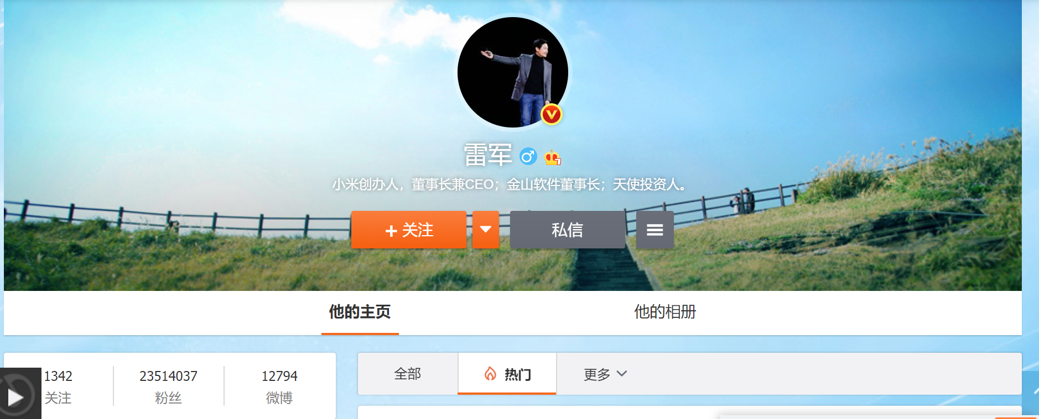
Figure 39 Lei Jun's personal Weibo

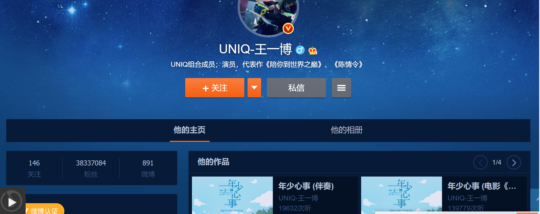
Figure 40 Wangyibo‘s personal Weibo

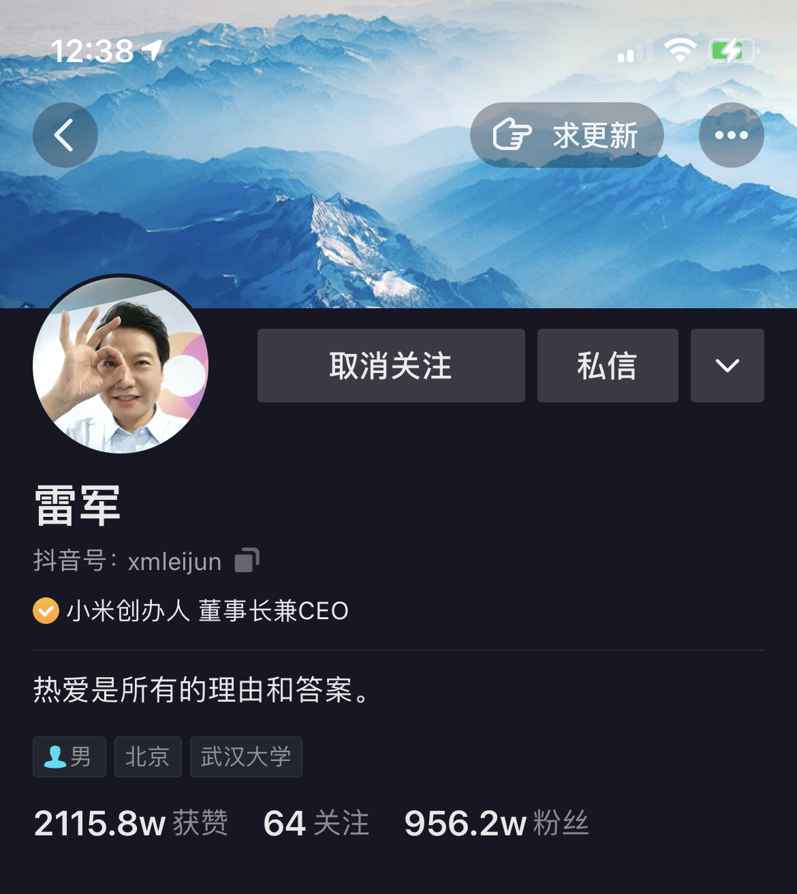

Figure 41：Leijun‘s Douyin F

4.6 Data analysis based on three objectives
All three areas of data collected by the researcher have been listed and in this section the researcher will summarise and analyse the data based on three research objectives

4.6.1 How Xiaomi uses social media for marketing

Xiaomi's social media strategy is as follows. Xiaomi currently has two spokespeople on social media, one is Chinese star Wang Yibo and thought is Lei Jun, Chairman of Xiaomi. Both spokespersons are by Weibo and Douyin accounts respectively and are sharing updates almost daily. The two spokespersons directly reach two of the largest customer audiences, the young and trendy celebrity followers and the loyal Xiaomi users who are focused on product performance and quality.

From figure39-41 you can see that Lei Jun's personal Weibo followers are up to 23 million, while Wang Yibo's is up to 38 million followers. Lei Jun's ShakeYin account has 9.5 million followers.

Both of them have a huge influence on social media, with millions of buzzes from random developments. The economic value that can be created is also unimaginable.

These two types of customers contribute the vast majority of Xiaomi's revenue. Xiaomi's unique social media e-commerce platform gives Xiaomi's loyal users, also known as Mi fans, a place to interact with each other, in which loyal users spread the word and influence each other, bringing huge marketing value to the company.

Xiaomi also has a variety of advertisements on different social media platforms, and even a weekly live stream of Xiaomi's products on its Douyin account. Live streaming is an emerging marketing method in China, where an anchor shows products to customers online in a live stream.

At the same time various retweets of discounted promotions are made on various social media platforms.
Strategically Xiaomi's social media marketing strategy is still very much intact.

Based on the information gathered, the researcher concluded that there is still much room for improvement in Xiaomi's social media marketing.

Users still spend a lot of time using social media in general, which means the future of the industry is huge. However, Xiaomi's social media marketing has not actually been very effective in motivating customers to buy. At the same time customers pay very little attention to Xiaomi's marketing activities.

It is worth acknowledging that the majority of respondents are pushing for the chairman as the spokesperson of the company, which is a social media marketing strategy that Xiaomi deserves recognition.

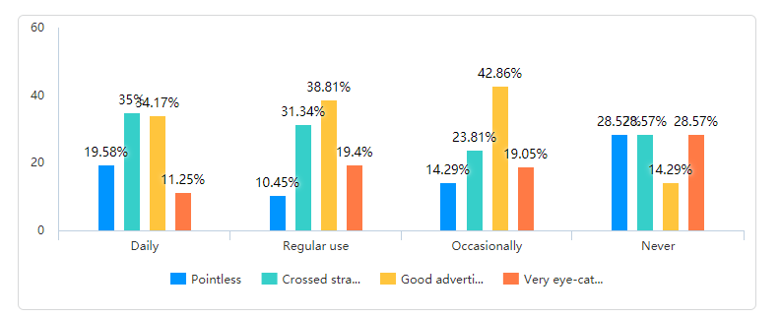
Figure 42：Cross-tabulation, frequency of use of social media and whether purchase desire is generated

4.6.2 The impact of social media marketing on Xiaomi's performance

This part of the data is actually very difficult to collect, as it is difficult to say how much revenue social media marketing actually generates for a business, but it is possible to find out through some details thatThis also goes some way to saying that online shipments are greater than offline. Much of the credit for driving customer purchases is also due to social media marketing. The figures in the annual report also show that Xiaomi spends more on promotion than on marketing, and that it is the quality of a product and its marketing that directly affects its sales. These figures show that Xiaomi's sales are still largely dependent on good marketing.

4.6.3 The future challenges of social media marketing

Social media marketing in general is a promising business, but Xiaomi is actually underutilised, spending huge amounts of money and time but the results actually leave a lot of room for growth. The fact that consumption is the main function of social media for customers is a good indicator of the industry's future, and the fact that Xiaomi's products are recognised by users as being of high quality means that they are, to a certain extent, qualified to be marketed. However, Xiaomi still needs to improve on how to make effective and engaging social media advertising. But this question happened to be answered during the interview. The real social media marketing that customers need is passive and unintentional. Truly brilliant social media marketing doesn't let the customer see that it's an ad, and that's what customers tend to like. Because the person makes the customer have an initiative, the customer actively asks what the product is that is shared on the social media platform and what brand it is. Then the customer takes the initiative to buy. What a good business should do is to reduce some of the advertising, because it is to some extent reducing the goodwill of the customer. Businesses make good products and then show them off unobtrusively and let customers choose for themselves.

Meanwhile Xiaomi's home products have a lot to offer in terms of social media influence and can be a good showcase for the products, and research has shown that many people are more interested in home products than electronics.

In the future Xiaomi should amplify the personal influence of its chairman even more, the company has inevitably become tied to Lei Jun, much like Musk and Tesla. So a more personal approach to marketing with Lei Jun's influence could be a better way to save costs and make social media marketing more efficient.

At the same time carry out more youthful marketing activities, for example, do promotion in college freshmen exchange groups, this promotion should also be unconscious sharing, rather than a brain to invest in advertising in the marketing campaign.

4.6.4

Overall the study was successful, with the appropriate data collected for each of the three objectives set by the researcher, and the method of analysis followed the mixed approach described in the previous section.

Hi Caroline, I have collected 356 samples until today because of covid-19, so my essay is not as complete as it could be, but at the same time I am only missing the last section, the main problem is that I find I am seriously over the word count, will this cause me to lose marks and secondly do I need to move my 4.3-4.4 sections to the appendix or do I need to move them to the appendix? Do I need to move my 4.3-4.4 sections to the appendices or keep them in the same form as I have them?
Thank you for your continued help and I look forward to your comments on my draft.
ZHOU ZIXUAN

6.0 references
15 Writers. (n.d.). Understanding the Research Onion | Writing Guides. [online] Available at: https://15writers.com/research-onion/#:~:text=The%20research%20onion%20suggests%20that%20strategies%20can%20include%20action%20research.
Alalwan, A.A., Rana, N.P., Dwivedi, Y.K. and Algharabat, R. (2017). Social media in marketing: A review and analysis of the existing literature. Telematics and Informatics, [online] 34(7), pp.1177–1190. Available at: https://www.sciencedirect.com/science/article/pii/S0736585317301077.
Baccarella, C.V., Wagner, T.F., Kietzmann, J.H. and McCarthy, I.P. (2018). Social media? It’s serious! Understanding the dark side of social media. European Management Journal, 36(4), pp.431–438.
Bossetta, M. (2018). THE WEAPONIZATION OF SOCIAL MEDIA: SPEAR PHISHING AND CYBERATTACKS ON DEMOCRACY. Journal of International Affairs, [online] 71(1.5), pp.97–106. Available at: https://www.jstor.org/stable/26508123#metadata_info_tab_contents [Accessed 18 Apr. 2021].
Buffer (2019). What Is Social Media Marketing? [online] Buffer.com. Available at: https://buffer.com/social-media-marketing.
Cao, X., Gong, M., Yu, L. and Dai, B. (2020). Exploring the mechanism of social media addiction: an empirical study from WeChat users. Internet Research, 30(4), pp.1305–1328.
Chen, H. (Allan), Choi, W., Liu, Y. (Lucy), Sun, H. and Liu, F. (2021). More or Less? Consumer Goal Orientation and Product Choice. Customer Needs and Solutions.
Chen, Y., Liang, C. and Cai, D. (2018). Understanding WeChat Users’ Behavior of Sharing Social Crisis Information. International Journal of Human–Computer Interaction, 34(4), pp.356–366.
Clarke, C. (2009). Paths between Positivism and Interpretivism: An Appraisal of Hay’s Via Media. Politics, 29(1), pp.28–36.
Dawson, J., Johnston, M.J., Stewart, E.J., Lemieux, C.J., Lemelin, R.H., Maher, P.T. and Grimwood, B.S.R. (2011). Ethical considerations of last chance tourism. Journal of Ecotourism, 10(3), pp.250–265.
Deibert, R.J. (2019). Three Painful Truths About Social Media. Journal of Democracy, 30(1), pp.25–39.
Delisle, J., Goldstein, A. and Yang, G. (2016). Front Matter. In: The Internet, Social Media, and a Changing China. [online] University of Pennsylvania Press, pp.i–iv. Available at: https://www.jstor.org/stable/j.ctt1b3t8nr.
Ebrahim, R.S. (2019). The Role of Trust in Understanding the Impact of Social Media Marketing on Brand Equity and Brand Loyalty. Journal of Relationship Marketing, 19(4), pp.1–22.
EEMEREN, F.H. (1986). Dialectical analysis as a normative reconstruction of argumentative discourse. Text - Interdisciplinary Journal for the Study of Discourse, 6(1), pp.1–16.
ef.zhiweidata.com. (2021). 知微事见. [online] Available at: https://ef.zhiweidata.com/.
Emami, A., Momeni, P., Hossein, M.A.A. and Maddah, S.S. (2010). Developing a questionnaire for conducting cross-national studies -“Self-reported health and needs among elderly Iranians and Swedes.” Scandinavian Journal of Caring Sciences, 24(2), pp.372–379.
Ercikan, K. and Roth, W.-M. (2006). What Good Is Polarizing Research Into Qualitative and Quantitative? Educational Researcher, 35(5), pp.14–23.
Fuchs, C. (2017). Critical Social Theory and Sustainable Development: The Role of Class, Capitalism and Domination in a Dialectical Analysis of Un/Sustainability. Sustainable Development, 25(5), pp.443–458.
Hasan, M.N. (2014). Positivism: to what extent does it aid our understanding of the contemporary social world? Quality & Quantity, 50(1), pp.317–325.
He, S. (2018). Research on Platform Strategy of Enterprises from the Perspective of Value Co-Creation -Taking Xiaomi’s Ecological Chain as an Example. [online] www.atlantis-press.com. Available at: https://www.atlantis-press.com/proceedings/icmess-18/25897285 [Accessed 5 May 2021].
Hearn, E. (2020). Buying Globalization: Consumer Orientation and Perceptions about Trade. Politics & Policy.
Herrington, J., McKenney, S., Reeves, T. and Oliver, R. (2007). Design-based research and doctoral students: Guidelines for preparing a dissertation proposal. [online] www.learntechlib.org. Available at: https://www.learntechlib.org/p/25967/ [Accessed 5 May 2021].
In, J. (2017). Introduction of a pilot study. Korean Journal of Anesthesiology, [online] 70(6), p.601. Available at: https://www.ncbi.nlm.nih.gov/pmc/articles/PMC5716817/.
Irshaidat, R. (2019). Interpretivism vs. Positivism in Political Marketing Research. Journal of Political Marketing, pp.1–35.
Jacobson, J., Gruzd, A. and Hernández-García, Á. (2019). Social media marketing: Who is watching the watchers? Journal of Retailing and Consumer Services, 53.
Jin, S.V., Muqaddam, A. and Ryu, E. (2019). Instafamous and social media influencer marketing. Marketing Intelligence & Planning, [online] 37(5). Available at: https://www.emerald.com/insight/content/doi/10.1108/MIP-09-2018-0375/full/html#loginreload.
Johnson, R.B. and Onwuegbuzie, A.J. (2004). Mixed Methods Research: A Research Paradigm Whose Time Has Come. Educational Researcher, 33(7), pp.14–26.
Kesharwani, D.S.K., Sarkar, D.M. p and Oberoi, S. (2019). PROSUMER�S UNDERSTANDING TOWARDS SOCIAL MEDIA MARKETING: AN EMPIRICAL STUDY. Industrial Engineering Journal, 12(11).
Khajuria, I. and Rachna (2019). Social Media Marketing in Creating Brand Awareness and Brand Trust. MANTHAN: Journal of Commerce and Management, (1).
KILBOURN, B. (2006). The Qualitative Doctoral Dissertation Proposal. Teachers College Record, 108(4), pp.529–576.
Kjellstrom, S., Ross, S.N. and Fridlund, B. (2010). Research ethics in dissertations: ethical issues and complexity of reasoning. Journal of Medical Ethics, 36(7), pp.425–430.
Kusumasondjaja, S. (2018). The roles of message appeals and orientation on social media brand communication effectiveness. Asia Pacific Journal of Marketing and Logistics, 30(4), pp.1135–1158.
L, T. (2017). Social Media Marketing. S.L.: Sage Publications.
Lancaster, G.A. (2015). Pilot and feasibility studies come of age! Pilot and Feasibility Studies, 1(1).
Lederman, L.C. (1990). Assessing educational effectiveness: The focus group interview as a technique for data collection1. Communication Education, 39(2), pp.117–127.
Leung, W.-C. (2001). How to design a questionnaire. BMJ, 322(Suppl S6), p.0106187.
Liao, Z. (2015). Implications of China’s latest statute on internet and the forthcoming real-name registration scheme. International Journal of Technology Policy and Law, 2(1), p.55.
Liu, S., Perry, P. and Gadzinski, G. (2018). The implications of digital marketing on WeChat for luxury fashion brands in China. Journal of Brand Management.
Lokumannage, A. (2020). Social Media Content Regulation in China: Analysis of English Language Wechat Accounts. SSRN Electronic Journal.
Marton, F. (1986). Phenomenography—A Research Approach to Investigating Different Understandings of Reality. Journal of Thought, [online] 21(3), pp.28–49. Available at: https://www.jstor.org/stable/42589189?seq=1#metadata_info_tab_contents [Accessed 6 Feb. 2021].
Mason, R.O. (1969). A Dialectical Approach to Strategic Planning. Management Science, 15(8), p.B-403-B-414.
Middleton, F. (2019). Reliability vs Validity in Research | Differences, Types and Examples. [online] Scribbr. Available at: https://www.scribbr.com/methodology/reliability-vs-validity/#:~:text=Reliability%20and%20validity%20are%20concepts.
Miklian, J. and Hoelscher, K. (2017). A new research approach for Peace Innovation. Innovation and Development, [online] 8(2), pp.189–207. Available at: https://rsa.tandfonline.com/doi/pdf/10.1080/2157930X.2017.1349580.
Montag, C., Becker, B. and Gan, C. (2018). The Multipurpose Application WeChat: A Review on Recent Research. Frontiers in Psychology, 9.
Orth, C. de O. and Maçada, A.C.G. (2020). Corporate fraud and relationships: a systematic literature review in the light of research onion. Journal of Financial Crime, ahead-of-print(ahead-of-print).
Ott, L. and Longnecker, M. (2020). An introduction to statistical methods & data analysis. Pacific Grove: Brooks/Cole.
Overbey, K.N., Jaykus, L.-A. and Chapman, B.J. (2017). A Systematic Review of the Use of Social Media for Food Safety Risk Communication. Journal of Food Protection, 80(9), pp.1537–1549.
Parajuli, B.K. (2008). Questionnaire: A Tool of Primary Data Collection. Himalayan Journal of Sociology and Anthropology, 1, pp.51–63.
Pee, L.G., Pan, S.L., Li, M. and Jia, S. (2019). Social informatics of information value cocreation: A case study of xiaomi’s online user community. Journal of the Association for Information Science and Technology, 71(4), pp.409–422.
Rahman, S. ur, Khan, M.A. and Iqbal, N. (2018). Motivations and barriers to purchasing online: understanding consumer responses. South Asian Journal of Business Studies, 7(1), pp.111–128.
Ram Gnanadesikan (1983). Statistical data analysis. Providence, R.I.: American Mathematical Society.
Riehm, K.E., Feder, K.A., Tormohlen, K.N., Crum, R.M., Young, A.S., Green, K.M., Pacek, L.R., La Flair, L.N. and Mojtabai, R. (2019). Associations Between Time Spent Using Social Media and Internalizing and Externalizing Problems Among US Youth. JAMA Psychiatry, [online] 76(12), p.1. Available at: https://jamanetwork.com/journals/jamapsychiatry/fullarticle/2749480.
Rita, B. (1999). “Collecting data by in-depth interviewing.” Leeds.ac.uk. [online] Available at: http://www.leeds.ac.uk/educol/documents/000001172.htm [Accessed 24 Oct. 2019].
Ryan, G. (2018). Introduction to positivism, interpretivism and critical theory. Nurse Researcher, [online] 25(4), pp.14–20. Available at: 错误!超链接引用无效。.
Sakshi (2017). Social Media: The Future of Marketing. International Journal of Contemporary Research and Review.
Saunders, M., Lewis, P. and Thornhill, A. (2016). Research Methods for Business Students. 7th ed. Pearson.
Scott, C.F., Bay-Cheng, L.Y., Prince, M.A., Nochajski, T.H. and Collins, R.L. (2017). Time spent online: Latent profile analyses of emerging adults’ social media use. Computers in Human Behavior, 75, pp.311–319.
Shih, C.-C., Lin, T.M.Y. and Luarn, P. (2014). Fan-centric social media: The Xiaomi phenomenon in China. Business Horizons, [online] 57(3), pp.349–358. Available at: https://www.sciencedirect.com/science/article/pii/S0007681313002140.
Shou, Y., Li, Y., Park, Y.W. and Kang, M. (2017). The impact of product complexity and variety on supply chain integration. International Journal of Physical Distribution & Logistics Management, 47(4), pp.297–317.
Singer, P.W. (2019). LIKEWAR : the weaponization of social media. S.L.: Mariner Books.
Smith, R., Morgan, J. and Monks, C. (2017). Students’ perceptions of the effect of social media ostracism on wellbeing. Computers in Human Behavior, 68, pp.276–285.
Soleymani, S. (2021). Positivism vs. Interpretivism in research. [online] Medium. Available at: https://saber.medium.com/positivism-vs-interpretivism-in-research-1299e4a6877a.
Stone, D.H. (1993). Design a questionnaire. BMJ, 307(6914), pp.1264–1266.
Streefkerk, R. (2019). Inductive vs. Deductive Research Approach | Examples and Limitations. [online] Scribbr. Available at: https://www.scribbr.com/methodology/inductive-deductive-reasoning/.
Tan, J., Wang, L., Zhang, H. and Li, W. (2020a). Disruptive innovation and technology ecosystem: The evolution of the intercohesive public–private collaboration network in Chinese telecommunication industry. Journal of Engineering and Technology Management, 57, p.101573.
Tan, J., Wang, L., Zhang, H. and Li, W. (2020b). Disruptive innovation and technology ecosystem: The evolution of the intercohesive public–private collaboration network in Chinese telecommunication industry. Journal of Engineering and Technology Management, 57, p.101573.
TIAN, J. (2019). Customer Engagement in Value Co-creation of Xiaomi: A Case Study. DEStech Transactions on Social Science, Education and Human Science, (ermas).
Tuten, T.L. (2008). Advertising 2.0 : social media marketing in a Web 2.0 world. Westport, Conn.: Praeger.
Vaast, E. (2019). A Seat at the Table and a Room of Their Own: Interconnected processes of social media use at the intersection of gender and occupation. Organization Studies, 41(12), pp.1673–1695.
Vashistha, A., Garg, A., Anderson, R. and Raza, A.A. (2019). Threats, Abuses, Flirting, and Blackmail. Proceedings of the 2019 CHI Conference on Human Factors in Computing Systems.
Verschuren, P. (2003). Case study as a research strategy: Some ambiguities and opportunities. International Journal of Social Research Methodology, 6(2), pp.121–139.
Vinuales, G. and Thomas, V.L. (2020). Not so social: When social media increases perceptions of exclusions and negatively affects attitudes toward content. Psychology & Marketing.
Walton, D.N. (1999). One-sided arguments : a dialectical analysis of bias. Albany, Ny: State University Of New York Press.
Wan, X. and Sanders, N.R. (2017). The negative impact of product variety: Forecast bias, inventory levels, and the role of vertical integration. International Journal of Production Economics, 186, pp.123–131.
Wang, K. (2021). Xiaomi in the internationalization process: failures and lessons. bibliotecadigital.fgv.br. [online] Available at: https://bibliotecadigital.fgv.br/dspace/handle/10438/30300 [Accessed 31 Mar. 2021].
Wang, S. (2018). Exploring a Research Method - Interview. Advances in Social Sciences Research Journal, 2(7).
Weber, R. (2004). Editor’s Comments: The Rhetoric of Positivism versus Interpretivism: A Personal View. MIS Quarterly, 28(1), p.iii.
Westernsydney.edu.au. (2019). Western Sydney University. [online] Available at: https://www.westernsydney.edu.au/research/researchers/preparing_a_grant_application/dest_definition_of_research.
Wodak, R. and Meyer, M. (2016). Methods of critical discourse studies. London ; Thousand Oaks, California: Sage.
Wright, M.R. (1966). RESEARCH AND RESEARCH. Nursing Research, 15(3), p.244???245.
Xiao, L. (2018). Analyzing consumer online group buying motivations: An interpretive structural modeling approach. Telematics and Informatics, 35(4), pp.629–642.
XIAOMI (2020). 小米 - 投资者关系. [online] company.mi.com. Available at: https://company.mi.com/zh-cn/ir/financialInfo/ [Accessed 5 May 2021].
YAN, N. and SU, K. (2017). On Transformation of China’s TV Media in Omni-media Era. DEStech Transactions on Social Science, Education and Human Science, (icss).
Yuzhakova, O. (2019). How to Address Cultural Variety in Global Marketing Campaigns? [online] www.theseus.fi. Available at: https://www.theseus.fi/handle/10024/172800 [Accessed 5 May 2021].
Zheng, X. and Huang, K. (2019). Xiaomi Marketing Strategies for Success. [online] eLibrary.ru. Available at: https://www.elibrary.ru/item.asp?id=42742686 [Accessed 31 Mar. 2021].

7.0 APPENDIX

Thank you for your support for this research. It will take about ten minutes of your time, but it will play a key role in my research. Your answers will be treated in strict confidence and will be completely anonymous unless you choose to provide an email address. If you have any questions about this questionnaire, please contact Zhou Zixuan.

1 Your age

18-22
23-25
25-30
Over 30

Q2What kind of work do you do

Corporate employee
Civil servant
Student
Freelance

Q3 What is your gender?

Male
Female

Q4 How often do you use social media apps?

Daily
Often
Occasionally
Never

Q5 How much time do you spend using social media? (a day)

Three hours or less
Three hours to five hours
Seven hours to nine hours
Nine hours or more

Q6 Which of the following activities have you used social media for?

Making friends
Watching videos
Watching news and gossip
Read forums and articles
Posting comments
Share your daily life
Shopping
Work

Q7 How would you evaluate the quality of the information you get from social media platforms?

Very good
Good
Moderate
poor
Very poor

Q8 Do you believe it is safe to share your life on social media?
Yes
No

Q9 Are you concerned that you spend too much time on social media apps each day?
Yes
Yes No

Q10 Your views on additional features of social media platforms (e.g. WeChat applets, public websites, Jitterbug live streaming with goods)

Very interesting
Leisure time
Not meaningful

Q11 Have you ever used any Xiaomi products

Used a mobile phone
Used a product other than a mobile phone
Used both of the above
No

Q12 How would you rate the Xiaomi phone you have used

Great
Good
Bad
Normal
Haven't used it No comment

Q13 How would you rate the non-phone products you have used from Xiaomi

Great
Good
Bad
Normal
Haven't used it No comment

Q14 Which do you think appeals to you more when comparing the phone to Xiaomi's other products?

Mobile phone
Home products
Home appliance
Other electronic products

Q15 Are you motivated to buy Xiaomi products by social media marketing?

Yes
No

Q16 What is your motivation for buying Xiaomi products?

Browsing offline shops
Recommendation from friends
TV commercials
Loyal Mi fans No motivation needed

*Mi Fans: Long-time loyal customers of Xiaomi

Q17 In which social media did you discover Xiaomi products?

Dou Yin
WeChat
Weibo
Other

Q18 What specifically attracted you to Xiaomi's social media marketing?

The powerful features introduced in the ads
The spokesperson being your idol
The creative of the ad itself
The beautiful look of the product presented in the ad

Q19 How often do you see Xiaomi's ads on social media platforms?

Every day
Once every three days
Once a week
Never

Q20 How would you evaluate Xiaomi's advertisements on social media platforms

Meaningless Not a big deal
Crossed right over No impact
The ads were good No desire to buy
Very eye-catching Desire to buy

Q21 Are you a fan of Lei Jun, Chairman of Xiaomi?

Yes
No

Q22 Do you follow Lei Jun's personal account on ShakeYin or Weibo?

Yes
No

Q23 Why do you follow Lei Jun's social media accounts? Multiple choice

Bored and want to see
Want to know more about the entrepreneur's life
Want to know more about Xiaomi's corporate culture
Just follow Never read the content

Q24 Would you buy Xiaomi products because of Lei Jun?

Yes
No

、

1

