Public Health Policy Report
Student Name Samina Jhangeer
Student Number 1810228
Module code BMHP 5013
Lecturer’s Name Besty Jose

Table of Contents

Introduction 1
Background 1
COVID-19 a Pandemic 1
COVID-19 in Elderly Care Homes UK 2
Strategies to measure, monitor and control the incidence 2
General public health strategies and approaches for COVID 19 2
Strategies for surveillance and monitoring of COVID-19 2
Strategies to control the incidence rate of COVID-19 3
Current Public Health Policy Approaches to Reduce Incidence in UK 3
Public health/social policy in UK to reduce the COVID-19 incidence rate 3
Impact of changes in health policies on individual lifestyles 5
Application of Health Behaviour Change Model on COVID-19 to understand the response of people on lifestyle changes 5
Application of the Health Belief Model on COVID-19 Pandemic 6
Impact of legislation and policies on the health and well-being of the elderly 7
Clinical research on different potential vaccines 7
Recommendations 8
Conclusion 8
References 9

COVID-19 and the State of Elderly in UK Care Home

Introduction
During the COVID-19 crisis, the most vulnerable ones in our society with complex needs have been badly hit by the pandemic. The coronavirus outbreak has affected people millions of people worldwide, bringing unprecedented challenges and issues to be resolved on immediate basis. If this pandemic is not addressed timely, millions of people will be living in inequality, exclusion, discrimination and unemployment in short and long run.
In this report, we have analyse the COVID-19 pandemic, situation in UK and the strategies adopted by the government to measure, monitor and control the pandemic. We will also examine the changes in health and public policies and the research regarding the development of COVID-19 vaccines. Lastly, recommendations for the improvement of public health, particularly for the elderly in care homes have been provided.

Background

COVID-19 a Pandemic
The World Health Organisation declared Coronavirus disease a global pandemic, affecting millions of people across the world. Coronavirus emerged from Wuhan, a city in China where few cases of pneumonia with unknown cause were reported, with an unknown virus genetics. According to WHO report, from December 2019 to October 2020 a total number of 37 million cases of COVID-19 have been reported with 1 million deaths across the world (Cucinotta and Vanelli, 2020, pp.157-160). COVID-19 is a contagious disease which can be spread through respiratory droplets of an infected person through person-to-person contact, cough, sneezes or speak. Countries across the world declared a state of emergency after increase in number of cases and informed the people to use face mask, face shield and maintain social distancing to reduce the spread of the virus.
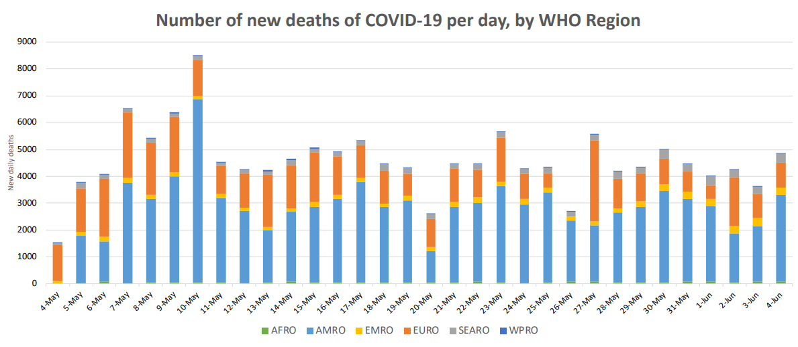
Figure 1.1 Current Global Situation & Incidence Rate Region Wise (WHO, 2020)

COVID-19 in Elderly Care Homes UK
The COVID-19 pandemic is one of the most formidable challenge for the public and social care systems across the world. The cluster of elderly in care homes represent as the most high-risk patients for developing coronavirus due to age and health conditions. According to the Office of National Statistic, 26,000 more deaths occurred in care homes this year until now due to COVID-19 (ONS, 2020). Meeting the needs of elderly in care homes across UK is crucial for their health and well-being. Initially the government and private sector care homes faced issue for providing the right support for the elderly residents which resulted in high number of corona death, as they are the most vulnerable ones (Gordon et.AL, 2020, pp.701-705). However, the situation has improved with funding, staff support and excess to hospitalisation.

Strategies to measure, monitor and control the incidence

General public health strategies and approaches for COVID 19
Public health strategies designed by the government UK ensures healthy environment and conditions in which people can live for as long as possible. In order to reduce the COVID-19 spread, the national government, local government, the NHS, community sector, industry, scientific and academic communities and public health England come together to provide a safe public health system and tackle the pandemic efficiently. Some of the common general public health strategies include (GOV UK, 2020):
- Hand washing on frequent basis
- Wear face covering when in place with close contact
- Stay at least 2 metres apart with face mask in public sites
- People over 60 are clinically vulnerable and at higher risk for virus
- Restrictions regarding visit to relatives in care homes
- Use of face mask and social distancing at educational places
- Isolate yourself if you are having COVID-19

Strategies for surveillance and monitoring of COVID-19
UK government have taken several actions for the surveillance of the disease and taken in account the data to prevent and control the infectious virus. The surveillance and monitoring strategies for COVID-19 are designed to limit the spread and enable social activities to resume for the benefit of socio-economic growth of the countryCOVID-19 surveillance system must be geographically comprehensive including all individuals and communities. Some of the key surveillance and monitoring strategies include following (Rodzinna, 2020, pp.40-44):
- Individuals in the community must be tested for the disease if any of the symptoms arise or get in contact with the infectious person.
- Primary care surveillance must be undertaken through clinics, community and government testing facilities. The data collected from here must be shared within 24 hours to respective authorities.
- Hospital surveillance data on confirmed COVID-19 cases and deaths must be reported to authorities.
- Using the existing global influenza surveillance and response system to update the information on virus and diagnostic tests.
- Enhanced monitoring for the most vulnerable age groups which are aged 60 and above and the elderly in care homes.

Strategies to control the incidence rate of COVID-19
Government in UK and across the world are currently fighting the spread of coronavirus. There are number of strategies to reduce the incidence rate of COVID-19 infection (Brett and Rohani, 2020). Some of them are listed below:
- Avoid close contact with other person who are infected with the virus
- Avoid touching eyes, nose and mouth
- Stay home and isolate yourself if any symptoms present
- Visit clinics and COVID testing sites to get confirmed report for COVID-19
- Use face masks and face shield
- Clean and disinfect surfaces and objects
- Use sanitizer and perform hand hygiene
- Ensure that the vulnerable people are safe at home or care homes, avoiding visits outside

Current Public Health Policy Approaches to Reduce Incidence in UK

Public health/social policy in UK to reduce the COVID-19 incidence rate
The current major human tragedy, COVID-19 has made government to make complex and scalable public health policy changes (GOV UK, 2020). National restrictions which are included in the public policy of UK include:
- Hands – frequent hand wash on regular basis
- Face – Covering of face with mask and shields, according to the social setting
- Space – Stay 2 metres apart from the other person when in public and with who, you don’t live
- Social distancing – to reduce the spread of coronavirus you should avoid unnecessary movement at public places and when around the people
- Care Home – when you are offering services for care homes, practical and possible social distance must be maintained and use of face mask must be made mandatory
- Social contact – You should not meet people who don’t live with you at home, unless they are in your support bubble
- Self-isolation – if any person has symptoms or have been test COVID positive, must immediately isolate themselves to avoid transmission.
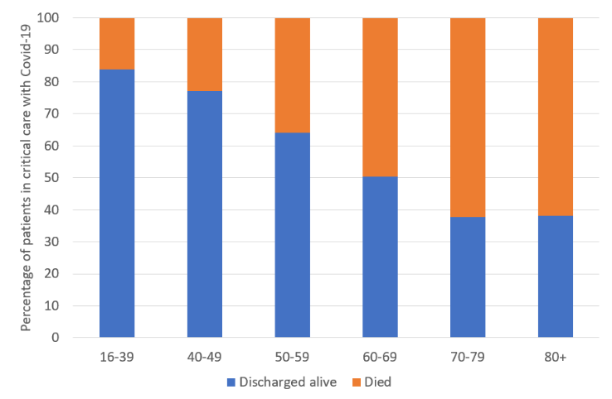
Figure 1.2 COVID-19 Incidence Rate According to Age Groups (Webb, 2020)

The figure above clearly indicates that the elderly are more vulnerable to catch coronavirus, as compared to the younger people. Therefore, public health policies must address the risk and consider special care for the elderly.
For the elderly in care home, home testing facility for COVID-19 test is available. Elderly in care homes who have related symptoms are required to isolate themselves and call for a home test. The government have been working together with private and public care homes and social workers to provide maximum benefits for the elderly during the catastrophic time. The public health policy in UK ensures that care home residents are not put through any avoidable risk of getting infected, as they are vulnerable (GOV UK, 2020). Personal protection equipment must be provided to the staff and residents of care home on immediate basis.

Impact of changes in health policies on individual lifestyles
The current pandemic has changed the lifestyle of individuals across the world and has led to health crisis. The outbreak of COVID-19, an acute respiratory syndrome has led us to life-altering challenges and changes. The economic and social disruption caused by the virus has led millions of people at the verge of falling extremely ill and poor. The changes in the health policies have impacted the lifestyles as half of the global workforce is at the stake of losing their livelihoods, lack major social protection and access to quality healthcare. Moreover, this pandemic has affected the entire health and food system, due to loss of jobs people have low or zero income, closure of trade and restriction have led to domestic and international disruption of food supply chain (Gao et.AL, 2020). As the breadwinners of families are falling ill due to the virus, their families are lacking nutrition, specifically in low-income countries. The government in UK is working to develop long-term sustainable strategies to address pandemic challenges and issues. The people are now gradually starting their daily lives with the new normal, this pandemic has left us with.

Application of Health Behaviour Change Model on COVID-19 to understand the response of people on lifestyle changes
COVID-19 has been one of the most fatal and severe disease ever known in human history in which millions of people got affected. Evident behaviour changes can be seen in people across the globe, as the pandemic becomes worst. In order to understand the impact of behavioural change in people during the COVID-19 pandemic, the health belief model can be applied. The Health Belief Model is based on constructs including perceived susceptibility, perceived severity, perceived benefits, perceived benefits, cues to action and self-efficacy (Alsulaiman and Renter, 2020). This model has been applied to various health setting over the past years and have proved to be efficient in understanding the impact and measure on respective context. Likewise, few researchers and scholars have applied this model on COVID-19 as well in understanding the impact of healthy behaviours around the world.
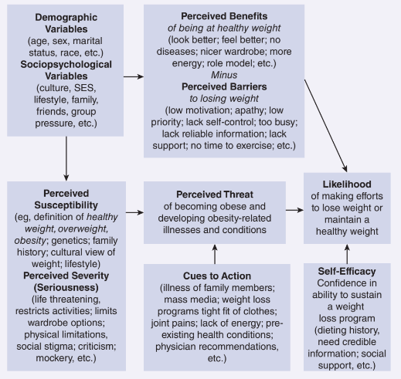
Figure 1.3 Health Belief Model Theoretical Framework (Hayden, 2017, pp.60-75)

Application of the Health Belief Model on COVID-19 Pandemic
Constructs | Applied to COVID-19 Pandemic
Perceived susceptibility | An individual’s assessment of getting affected by the virus changes the perception regarding disease. Changed the perception regarding coronavirus, changed the behavior in public places and start following guidelines issued by the government.
Perceived Severity | This examines the seriousness an individual possess about the risk. The growing coronavirus incidence rate represents the sternness of the disease. People in UK following mandatory guidelines for public health and safety.
Perceived Benefits | Benefits a person associates with adoption of new health guidelines. Benefits of following the mandatory guidelines will help people not get infected and stay protected while visiting public places.
Cues to Action | Actions which will prompt individuals to do a certain action. Frequent hand wash, covering face with masks and social distancing being followed by the people.
Self-efficacy | One’s own belief that healthy actions can reduce the risk of virus transmission.

Impact of legislation and policies on the health and well-being of the elderly
The world is facing a global health crisis due to which the health and well-being of the elderly specially is affected. The elderly living in care homes are susceptible to get infected by the virus, especially who are already suffering health and medical conditions. The legislative changes and policies by the government has now increased the provision of services for the elderly as they have become more vulnerable for COVID-19 virus and through them transmission to young health workers and social care professionals can happen. Social distancing and isolation among the elderly is bringing up new mental and physiological disorders, as the loneliness is acting as a silent killer in such hard times.

Clinical research on different potential vaccines
Currently the evidence shows high demand for the coronavirus vaccines across the world, as we see the second wave of COVID-19. The world together is working for the development of COVID-19 virus vaccine. The UK government has decided to invest $43.4 million in the human challenge study which will be conducted on healthy people aged between 18 and 30 with no history of COVID-19 symptoms and no exposure to infectious person (Eyal, Lipsitch and Smith, 2020). This research will be first of its kind for the contagious virus and will not only benefit UK but the whole world.
- Oxford COVID-19 Vaccine
Under the leadership of Prof Sarah Gilbert, scientists at Oxford Vaccine Group and Jenner Institute have been able to produce vaccines which can protect people from the infectious disease (Smout, 2020). The vaccine has been developed by making necessary changes in the chimpanzee adenoviral vector vaccine, altering the genetics.
- AstraZeneca Vaccine
AstraZeneca a British based pharmaceutical and Biopharmaceutical Company have developed vaccine for coronavirus which is in the third trial phase. The vaccine developed by the company will replicate the parts of COVID-19, train the immune system, develop spike protein in body and act as immuniser for the infected person (Smout, 2020). AstraZeneca vaccine will also be made available for other countries to reduce the cases and normalise the world globally.

Recommendations
The elderly care home sector has shown disproportionately high number of COVID-19 cases due to frailty and vulnerability of age group. Systematic planning to response to the unplanned healthcare challenge raised questions on the care home sector. Some of the key recommendations in context to elderly in care homes during the pandemic are following:
- Standardisation of social distance and hygiene signs across the care homes and hospitals to ensure the elderly follow the advice and stay safe while living in care homes or visiting hospitals.
- Periodic vaccinations for the elderly must be done including flu vaccine, pneumococcal vaccine and shingles vaccine. These vaccines help elderly protect against influenza, respiratory disease and shingles.
- History of the elderly residents must be kept in place for each to ensure they get the right support and medical help.
- Rapid and immediate access to general practitioners for elderly in care homes who are very unwell and need medical help. The government must ensure that the elderly receive priority services and provision.

Conclusion
As approximately 30 percent of the UK population age between 50 to 70 years, it becomes challenging for the government to ensure they stay home and stay save during the pandemic. Care home support staff and health professionals have faced numerous challenges during the present pandemic period. The elderly in care homes had access to limited clinical support and reduced workforce made it further difficult. In order to examine and understand the rate of spread, new cases must be reported and data must be included in the epidemiological analysis. The UK government realised the outcome of lack of immediate responsiveness, therefore new measures are being made including cross-clinical teams and emergency units for the elderly.

References

Alsulaiman, S. and Renter, T. L. (2020) The Health Belief Model and Preventive Measures: A Study of the Ministry of Health Campaign on Coronavirus in Saudi Arabia, Journal of Crisis and Risk Communication, Vol1. Iss.1, data retrieved from https://www.researchgate.net/publication/323743145_The_Health_Belief_Model_and_Preventive_Measures_A_Study_of_the_Ministry_of_Health_Campaign_on_Coronavirus_in_Saudi_Arabia on 16th November 2020
Brett, T. S. and Rohani, P. (2020) Transmission dynamics reveal the impracticality of COVID-19 herd immunity strategies, Proceedings of the National Academy of Sciences Oct 2020, Vol.117, Iss.41, pp.25897-25903, data retrieved from https://www.pnas.org/content/117/41/25897 on 16th November 2020
Cucinotta, D. and Vanelli, M. (2020) WHO Declares COVID-19 a pandemic, Acta Biomed, Vol.91, Iss.1, pp.157-160, data retrieved from https://www.ncbi.nlm.nih.gov/pmc/articles/PMC7569573/ on 16th November 2020
Eyal, N., Lipsitch, M. and Smith, P. G. (2020) Human Challenge Studies to Accelerate Coronavirus Vaccine Licensure, The Journal of Infectious Diseases, Vol.221, Iss.11, pp.1752-1756, data retrieved from https://academic.oup.com/jid/article/221/11/1752/5814216 on 14th November 2020
Gao, C., Zhao, Z., Li, F., Liu, J., Xu, H., Zeng, Y., Yang, L., Chen, J., Lu, X., Wang, C., Guo, Q., (2020) The impact of individual lifestyle and status on the acquisition of COVID-19: A Case-Control Study, PLOS ONE Vol.15, Iss.11, data retrieved from https://journals.plos.org/plosone/article?id=10.1371/journal.pone.0241540 on 14th November 2020
Gordon, L. A., Goodman, C., Achterberg, W., Baker, O. R., Burns, E., Hanratty, B., Martin, C. F., Meyer, J., O’Neill, D., Schols, J. and Spilsbury, K. (2020) Commentary: COVID in care homes – challenges and dilemma in healthcare delivery, Age and Ageing, Vol.49, Iss.4, pp.701-705, data retrieved from https://academic.oup.com/ageing/article/49/5/701/5836695 on 16th November 2020
GOV UK (2020) New National Restrictions from 5 November, data retrieved from https://www.gov.uk/guidance/new-national-restrictions-from-5-november#education-school-college-and-university on 16th November 2020
GOV UK, (2020) Coronavirus COVID-19, data retrieved from https://www.gov.uk/coronavirus on 16th November 2020
Hayden, (2017) Introduction to Health Behaviour Theory, Jones & Bartlett Learning, data retrieved from https://books.google.co.uk/books?id=NJFEDwAAQBAJ&dq=health+belief+model&source=gbs_navlinks_s on 16th November 2020
Martinez, V. B. (2020) Lifestyle behaviours during the COVID-19 – time to connect, Acta Psychiatrica Scandinavica, Vol.14, Iss.5, pp.399-400, data retrieved from https://onlinelibrary.wiley.com/doi/full/10.1111/acps.13177 on 16th November 2020
Office for National Statistics (ONS), (2020) Deaths registered weekly in England and Wales provisional: week ending 30 October 2020, data retrieved from https://www.ons.gov.uk/peoplepopulationandcommunity/birthsdeathsandmarriages/deaths/bulletins/deathsregisteredweeklyinenglandandwalesprovisional/weekending30october2020#deaths-registered-by-age-group on 14th November 2020
Park, S., Elliott, J., Berlin, A., Hamer-Hunt, J., Haines, A., (2020) Strengthening the UK primary care response to COVID-19, BMJ, data retrieved from https://www.bmj.com/content/370/bmj.m3691 on 15th November 2020
Rodzinna, M. (2020) Surveillance strategies for COVID-19 human infection. Interim guidance, Vol.16, Iss.1, pp.40-44, data retrieved from https://www.researchgate.net/publication/342938382_Surveillance_strategies_for_COVID-19_human_infection_Interim_guidance on 14th November 2020
Smout, A. (2020) Britain prepares for COVID-19 vaccine as Oxford forecasts results this year, Reuters, data retrieved from https://www.reuters.com/article/uk-health-coronavirus-britain-vaccine-idUSKBN27K1CS on 16th November 2020
Webb, E. (2020) Coronavirus risk for older people: the updated picture, AGE UK, data retrieved from https://www.ageuk.org.uk/discover/2020/06/coronavirus-risk-for-older-people-updated/ on 15th November 2020
World Health Organisation (WHO), (2020) Surveillance Strategies for COVID-19 Human Infection, data retrieved from https://www.who.int/docs/default-source/coronaviruse/risk-comms-updates/update-29-surveillance-strategies-for-covid-19-human-infection.pdf?sfvrsn=3c2cab92_2 on 15th November 2020

