Operating Systems Assignment:
OS Functions, Command Line Interfaces and Scripting in Windows and Linux
Rami El Tayeb 2523863

Computer Architecture and Operating Systems | ACCA4022

Table of Contents
1. Introduction 3
2. Task 1: Key Functions of General Operating Systems 3
2.1 User Interface Provision 3
2.2 Process Management 3
2.3 Memory Management 4
2.4 File and Directory Management 5
2.5 Device Management and Device Drivers 5
2.6 Network Management 6
2.7 Security and Access Control 6
2.8 Error Handling and System Management 7
3. Task 2: Use of Windows OS CLI Commands 7
4. Task 3: Use of Linux OS CLI Commands 10
5. Task 4: Use of Windows OS Scripts 16
5.1 Script Explanation and Syntax Analysis 18
6. Task 5: Use of Linux OS Scripts 21
6.1 Script Explanation and Syntax Analysis 23
7. Conclusion 26
References 27
Appendix A: Tutorial Activity on OS Types 28
General-Purpose Operating Systems 28
Mobile Operating Systems 28
Network Operating Systems 28
Embedded and Real-Time Operating Systems 28
AI and Quantum Operating Systems 29
Appendix B: Lecture and Tutorial Activity Evidence 29
Appendix C: Certified Course Evidence 34
Course Reflection 36

1. Introduction

An operating system (OS) is the main software layer that controls a computer’s hardware resources and gives applications a place to run. Silberschatz, Galvin and Gagne define an OS as a resource allocator and control programme, because it decides how the CPU, memory, storage, and I/O devices are used fairly [1]. If there were no OS, applications would need direct hardware access, which could be difficult to control and would create security risks. Microsoft Windows and Linux are widely used in professional computing. They share OS functions, but their design, licensing and deployment roles all differ. [2]

The command line interface (CLI) is a key tool people use for working in computing. Shotts argues that the Linux shell gives users access to the full power of the operating system in ways that a graphical interface can’t completely provide [3]. PowerShell brings this kind of control into Windows, while also adding a .NET based scripting environment that can automate complex administrative work [4]. This report covers five areas: key functions of general purpose operating systems (Task 1); Windows CLI commands in CMD and PowerShell (Task 2); Linux Bash commands (Task 3); scripting with PowerShell (Task 4); and scripting with Bash (Task 5). Appendices include tutorial work, lecture engagement, and online course completion from the module work.

2. Task 1: Key Functions of General Operating Systems

A general purpose OS like Windows 11 or Ubuntu 22.04 LTS offers managed functions so that users and applications can use hardware safely and reliably. Tanenbaum and Bos describe the OS kernel as running in privileged mode meaning it manages interaction between user space software and hardware [2]. These functions aren’t separate blocks. In a working system, they run together and depend on each other all the time.

2.1 User Interface Provision

The OS gives users the main interface for working with the computer system. In Windows 11, this is mainly through the graphical user interface (GUI), including the Desktop, taskbar, and Start Menu. Ubuntu provides GUI access through the GNOME desktop environment. Both of these support CLI access: Windows uses Command Prompt and PowerShell, while Linux commonly uses the Bash shell [3].

2.2 Process Management

Process management is one of the key ways to see the OS controlling the computer. The scheduler controls which processes are given CPU time and how long they can run, using approaches such as round robin and priority scheduling to balance responsiveness and speed [1]. In Windows, Task Manager and Resource Monitor show this by displaying PID values, CPU use, and memory data, while top and htop refresh this data live and allow signals to be sent [5]. This matters when trying to spot performance issues or crashed applications or resource use.
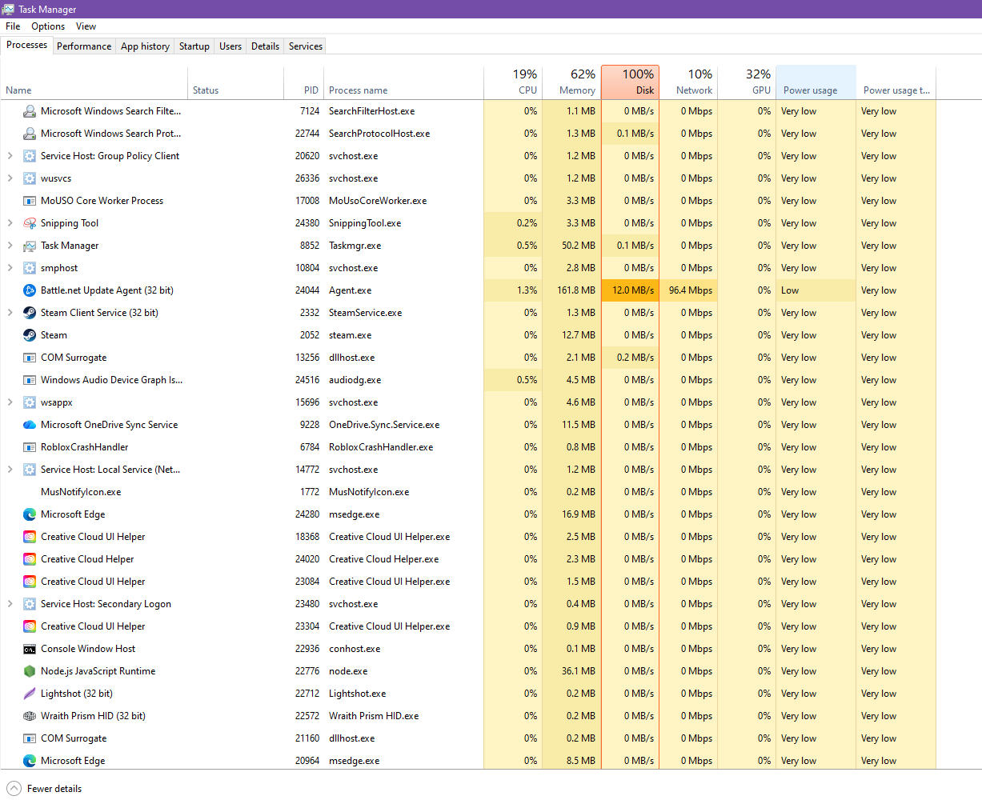
Figure 1: Windows Task Manager showing active processes, CPU usage, and memory consumption.
Task Manager shows the PID, CPU and memory usage for each running process, which directly relates to the process management function covered in Section 2.2.

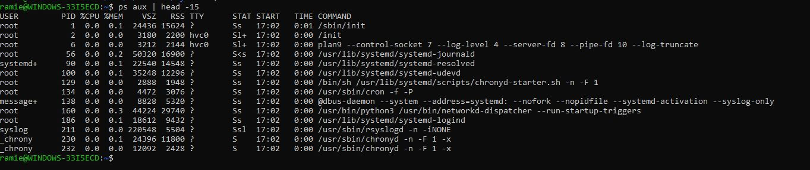
Figure 2: Linux terminal output of ps aux showing running processes with CPU and memory data.
The ps aux command shows the same process information as Task Manager but from the Linux terminal, demonstrating that process management is accessible through the CLI as well as a GUI.

2.3 Memory Management

The OS allocates RAM to processes as they start and take it back when they close. It also provides virtual memory, which maps process address spaces onto physical memory frames and uses swap space or a page file when RAM is full [1]. Windows Resource Monitor shows memory as In Use, Standby, Modified and Free which gives more detail than what would be shown on Task Manager alone. On Linux, free -h shows total, used, free, shared and available memory in readable values. This is useful on servers where graphical tools aren’t installed [5].

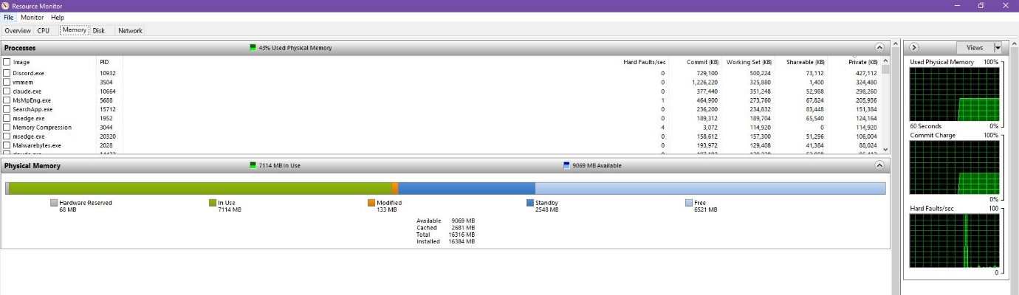
Figure 3: Windows Resource Monitor Memory tab showing the breakdown of physical memory usage.
Resource Monitor gives a more detailed breakdown of memory than Task Manager, showing In Use, Standby and Free values which relates to the memory management function discussed in Section 2.3.

2.4 File and Directory Management

The OS manages data by organising it into folders and files, controlling permissions and linking logical file paths to the physical storage device [2]. Windows normally uses NTFS by default which supports journalling, file level encryption and detailed permissions. Linux distributions often use ext4, which also supports journalling and large files [7]. They use different layouts: Windows uses drive letters such as C:\ and D:, but on the other hand Linux uses a single root directory, /, where other storage locations are mounted beneath it. Windows Disk Management gives a GUI view of partitions, while Linux commonly uses CLI tools like lsblk and fdisk during routine storage administration tasks.

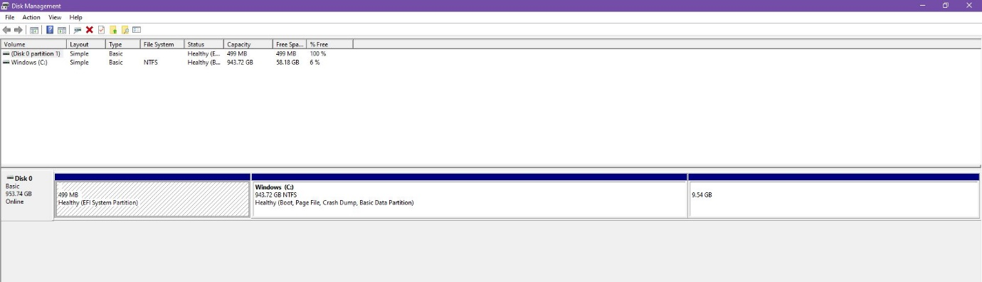
Figure 4: Windows Disk Management displaying drive partitions and NTFS file system information.
Disk Management shows the partition layout and confirms NTFS as the file system on the Windows drive, which links to the file and directory management function discussed in Section 2.4.

2.5 Device Management and Device Drivers

Device management is how the OS manages communication between software and hardware peripherals by using device drivers. These are small hardware components which translate general OS requests into instructions for a set device [2]. Without the correct driver, hardware can fail to work. Windows Device Manager shows connected devices in one place, and driver problems show a yellow warning icon. Linux drivers are normally built into the kernel or loaded as kernel modules while lsusb and lspci display USB and PCI devices [5].

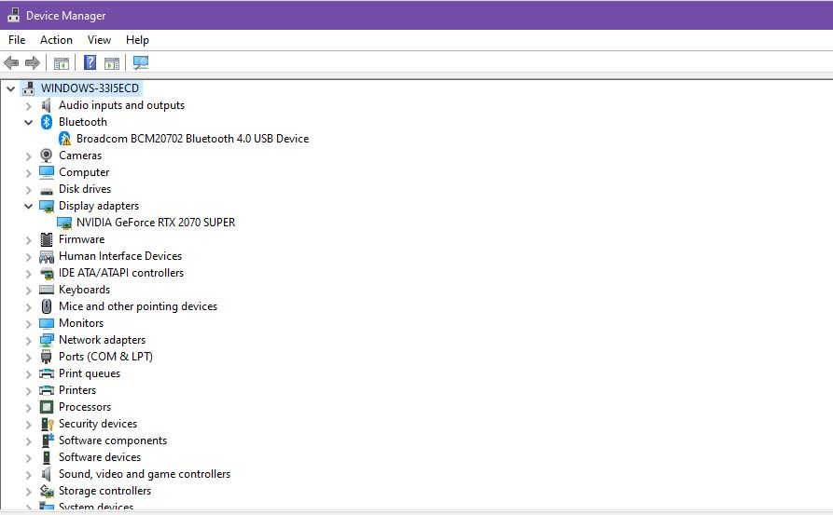
Figure 5: Windows Device Manager showing connected hardware devices and driver status.
Device Manager shows the installed hardware with the Display Adapters category expanded, confirming the NVIDIA driver is loaded correctly and linking to the device management function in Section 2.5.

2.6 Network Management

The OS manages network interfaces, assigns IP addresses via DHCP, and handles TCP/IP communication [8]. In Windows, ipconfig /all shows adapter details including MAC address and DNS servers, whilst PowerShell's Get-NetIPAddress provides the same data in a structured format that is easier to use in scripts [4]. On Linux, ip addr show lists interfaces and ping tests connectivity using ICMP.

2.7 Security and Access Control

Security is an OS function because it connects to nearly every other part of the system. The OS manages user accounts, handles authentication and applies permission based access control to files, processes and devices [9]. Windows uses access control lists (ACLs) on resources, showing which users and groups can read, write or execute them. Linux uses an owner, group, and others model, with extra security layers available through SELinux or App Armor [7]. Both keep security logs. Windows Event Viewer records logons, policy changes, and privilege escalation, while /var/log/auth.log records Linux authentication attempts.

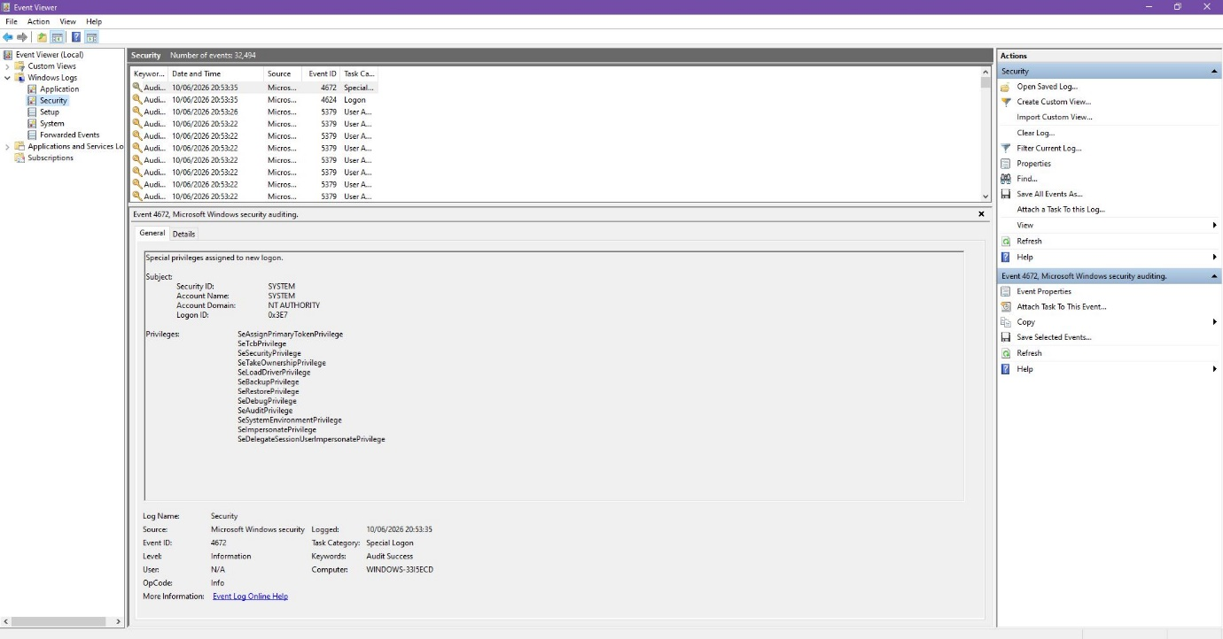
Figure 6: Windows Event Viewer Security log showing recent security-related events.
The Security log shows real audit events recorded by the OS, linking to the security and access control function discussed in Section 2.7.

2.8 Error Handling and System Management
The OS watches its own health and logs errors so issues can be checked later. Windows Reliability Monitor shows a stability timeline, linking crashes with recent changes. On Linux, events are stored in /var/log/syslog, and journalctl can filter them [4]. Performance Monitor in Windows and sar in Linux provide longer term resource data for capacity planning. Overall, this shows the OS is more than an application launcher. It is a management layer supporting secure, reliable computing [1][2].

3. Task 2: Use of Windows OS CLI Commands
Windows has two main CLI environments: Command Prompt (CMD) and PowerShell. CMD is the older interface and uses Batch/CMD syntax inherited from MS-DOS. PowerShell is more modern built on .NET [4]. The key difference is how each shell handles output. CMD works with plain text, but PowerShell passes structured .NET objects through its pipeline. This makes PowerShell easier to sort, filter and export. Table 1 documents both environments, with commands linked to process management, file and directory management, networking, user management and task scheduling.

Command | Area |  | Example |  | Purpose |  | Explanation
dir /p |  | File & Dir |  | dir /p |  | Lists directory contents one page at a time, preventing output from scrolling off the screen. |  | The /p switch pauses output after each full screen. dir /? lists all available switches. Output shows file names, sizes, and modification dates [10].
cd |  | File & Dir |  | cd C:\Users |  | Changes the current working directory to the specified path. |  | cd .. moves up one level; cd \ returns to the drive root. The prompt updates to reflect the new directory, confirming the change [10].
mkdir / rmdir |  | File & Dir |  | mkdir TestFolder |  | Creates a new directory (mkdir) or removes one and all its contents silently (rmdir /s /q). |  | The /s switch includes all subdirectories; /q suppresses confirmation prompts. Showing both creation and deletion demonstrates full lifecycle management [10].
tasklist |  | Process Mgmt |  | tasklist | findstr chrome |  | Displays all running processes with their PID, session name, and memory usage. |  | Piping to findstr filters the output to a named process. This is the Batch equivalent of searching Task Manager and is useful for checking whether a specific application is running [3].
ipconfig /all |  | Network |  | ipconfig /all |  | Displays the full IP configuration for all network adapters, including MAC address, DHCP status, and DNS servers. |  | The /all switch reveals details not shown by ipconfig alone. Essential for network troubleshooting and confirming whether DHCP or static addressing is in use [8].
ping |  | Network |  | ping 8.8.8.8 |  | Tests end-to-end network connectivity by sending ICMP echo requests to a host and reporting round-trip times. |  | Round-trip times indicate latency; packet loss indicates a connectivity problem. ping -t runs continuously until Ctrl+C. Pinging 8.8.8.8 (Google DNS) is a standard internet connectivity test [8].
net user |  | User Mgmt |  | net user |  | Lists all local user accounts, or with additional arguments creates, modifies, or deletes a user. |  | net user /add creates an account; /delete removes it. Requires administrator rights. Listing accounts is a standard step in user auditing and access control reviews [10].
schtasks /query |  | Task Sched. |  | schtasks /query /fo LIST /v |  | Lists all scheduled tasks with verbose detail including status and next run time. |  | /fo LIST formats output as a readable list; /v adds verbose detail. Scheduled tasks are a common vector for persistence in security assessments, making this command useful for auditing [10].
Get-Process |  | Process Mgmt |  | Get-Process | Sort-Object CPU -Desc | Select-Object -First 10 |  | Lists all running processes in PowerShell, sorted by CPU usage descending, showing the top ten. |  | Sorting by CPU immediately identifies the most resource-intensive processes. The object pipeline means no text manipulation is needed, unlike with tasklist [4].
Get-Process | Export-CSV |  | Process Mgmt |  | Get-Process | Export-CSV C:\Users\ramie\Documents\proc.csv -NoTypeInformation |  | Exports the complete process list to a CSV file for offline analysis or reporting. |  | Demonstrates the PowerShell pipeline combined with file output. The CSV can be opened in Excel, making this useful for generating administrative reports without additional tooling [4].
Get-NetIPAddress |  | Network |  | Get-NetIPAddress -AddressFamily IPv4 |  | Retrieves IPv4 address configuration for all network adapters as structured objects. |  | Returns .NET objects rather than text, making it reliable for scripting. The output can be filtered further or exported to CSV without string manipulation [4].
Get-ScheduledTask |  | Task Sched. |  | Get-ScheduledTask | Where-Object {$_.State -eq 'Ready'} |  | Lists all scheduled tasks on the system filtered to show only those in the Ready state. |  | Filtering for Ready tasks shows only active scheduled jobs. The object model allows chaining additional filters or exporting results without text parsing [4].

Analysis: PowerShell vs CMD.
CMD is still useful for quick commands and older Batch scripts, however PowerShell is stronger for serious admin work. The main reason is because of the pipeline. CMD works mainly with plain text whereas PowerShell passes structured .NET objects between commands. This makes it easier to sort, filter and export without messy text handling. For example, Get-Process can be sent to CSV in one PowerShell pipeline, whereas CMD would need several extra text processing steps. Microsoft’s direction also points this way: PowerShell is the default shell in Windows Server 2019 and later, and it supports Azure Cloud Shell and Desired State Configuration [4][10]. For automation and reporting, PowerShell is usually the better choice.

4. Task 3: Use of Linux OS CLI Commands
Bash, short for Bourne Again Shell, is normally the default shell on Linux distributions including Ubuntu and Debian. It lets users work directly with the OS through typed commands, and lets those commands be saved and reused in scripts [3]. On Linux servers, Bash is often the main interface because a GUI is not installed. The commands tested on Ubuntu 22.04 LTS cover file management, processes, memory, networking, permissions, user management and cron scheduling, which are common routine Linux admin tasks [5].

Command | Area | Example | Purpose | Explanation
pwd | File & Dir | pwd | Prints the absolute path of the current working directory. | Confirms the user's location in the file system hierarchy. Essential for orientation after navigating with cd, especially in deeply nested directory structures [3].
ls -la | File & Dir | ls -la | Lists all files and directories including hidden files, with permissions, owner, group, size, and modification date. | -l gives the long listing format; -a includes hidden files prefixed with a dot. The permission string (e.g. -rwxr-xr-x) directly maps to the Linux security model covered in Section 2.7 [7].
mkdir / rm -r | File & Dir | mkdir testdir && rm -r testdir | Creates a directory and then removes it recursively. | Showing creation and deletion demonstrates full directory lifecycle management. rm -r is recursive; rm -ri adds a per-file confirmation prompt for safer deletion [3].
touch / echo / cat | File & Dir | touch testfile.txt | Creates an empty file, writes content to it using output redirection, and reads it back with cat. | Demonstrates file creation, output redirection with >, and file reading with cat. Using >> instead of > appends content rather than overwriting, which is useful in log management [3].
chmod u+x | Permissions | chmod u+x testfile.txt | Grants the file owner execute permission on the specified file. | chmod implements the Linux permission model. u+x adds execute for the owner; g+x for the group; o+x for others. ls -la after chmod confirms the change took effect [7].
grep | File & Dir | grep 'World' testfile.txt | Searches a file for lines matching a given pattern and prints the matching lines. | grep -i makes the search case-insensitive; grep -r searches directories recursively. One of the most frequently used text-processing tools on Linux for log analysis and file searching [3].
ps aux | Process Mgmt | ps aux | head -15 | Lists all running processes for all users, with PID, CPU%, MEM%, and the full command string. | a shows all users, u provides user-readable format, x includes processes without a terminal. Piping to head -15 limits output to a readable length [5].
free -h | Memory | free -h | Displays total, used, free, shared, and available system memory in human-readable units. | -h formats values in MB or GB rather than bytes. The available column accounts for reclaimable cache and is more useful than free for estimating actual headroom [5].
whoami / id | User Mgmt | whoami && id | Displays the current username and full user identity including UID, GID, and all group memberships. | whoami returns just the username; id adds the numeric UID and GID and all group memberships. Useful for confirming privilege level before running commands that require specific group access [9].
sudo useradd / userdel | User Mgmt | sudo useradd testuser | Creates or removes a local user account on the system (requires sudo privileges). | User management requires sudo privileges. useradd -m also creates a home directory. These commands should be practised in a VM or WSL environment with appropriate permissions. Equivalent to net user /add in Windows [9].
ping -c 4 / ip addr | Network | ping -c 4 8.8.8.8 | Sends four ICMP echo requests to test connectivity and displays all network interfaces with their IP addresses. | The -c flag limits ping to four packets. ip addr show is the modern replacement for the deprecated ifconfig command and is the preferred tool on current Linux systems [8].
crontab -l / -e | Task Sched. | crontab -l | Lists all scheduled cron jobs for the current user, or opens the editor to add new ones. | Cron is the standard Linux task scheduler. The syntax is: minute hour day month weekday command. crontab -e opens the editor; crontab -r removes all jobs for the current user [12].

Analysis: Linux CLI in professional environments.

The Linux CLI is useful in professional environments because it works well for servers, scripts and low resource systems without needing a GUI. This matters in professional environments, where many systems are managed remotely or installed with only basic tools. The commands in Table 2 all return plain text, which can be redirected to files, piped into other commands or processed further. Shotts explains this as the Unix philosophy, where small tools can be combined to complete bigger tasks [3]. Windows can do lots of the same tasks but it relies on GUI menus. Linux can inspect processes, check memory, review users and schedule tasks from the terminal. This also means interactive commands can later be reused inside Bash scripts, as shown in Task 5.

User commands such as sudo useradd and sudo userdel should be used more carefully as they need higher privileges. Therefore they should be tested in WSL or a VM with sudo access. whoami and id are safe commands for checking the current user and privilege context before making changes.

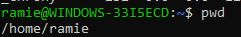
Figure 8a: Linux terminal showing the pwd command output displaying the current working directory path.
The pwd command confirms the current location in the file system, showing /home/ramie as the working directory.

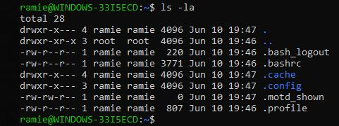
Figure 8b: Linux terminal showing ls -la output with file permissions, owner, group, size, and modification date.
The -l flag gives the long listing format and -a includes hidden files, with the permission strings linking directly to the Linux security model in Section 2.7.

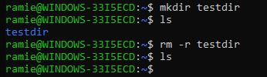
Figure 8c: Linux terminal showing mkdir creating testdir and rm -r removing it, confirmed with ls before and after.
Creating and deleting a directory in sequence demonstrates full lifecycle management of the file system from the CLI.

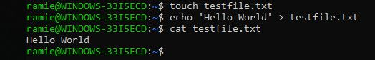
Figure 8d: Linux terminal showing touch, echo and cat used to create, write to, and read a text file.
The output redirection with > writes Hello World to the file and cat reads it back, demonstrating basic file management from the terminal.

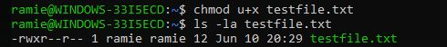
Figure 8e: Linux terminal showing chmod u+x adding execute permission, confirmed by ls -la showing -rwxr--r--.
The execute permission is set for the owner only, directly demonstrating the Linux permission model covered in Section 2.7.



Figure 8f: Linux terminal showing grep searching testfile.txt and returning the matching line.
grep filters file content by pattern and returns only matching lines, making it useful for log analysis and file searching.

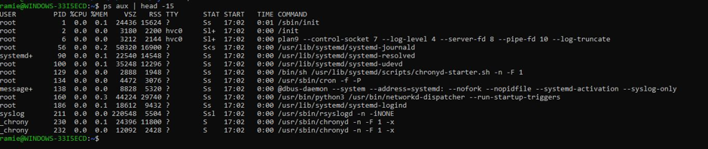
Figure 8g: Linux terminal showing ps aux | head -15 listing running processes with CPU and memory data.
ps aux displays all running processes for all users, equivalent to Task Manager but accessed entirely from the CLI.

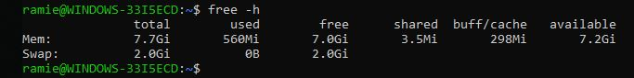
Figure 8h: Linux terminal showing free -h output with total, used, free and available memory columns.
The -h flag formats memory values in GB, giving a quick overview of available RAM which is useful on servers without a GUI.

Figure 8i: Linux terminal showing whoami returning the username and id returning the full UID, GID and group memberships.
whoami and id confirm the current user's identity and privilege level before running commands that require specific group access.

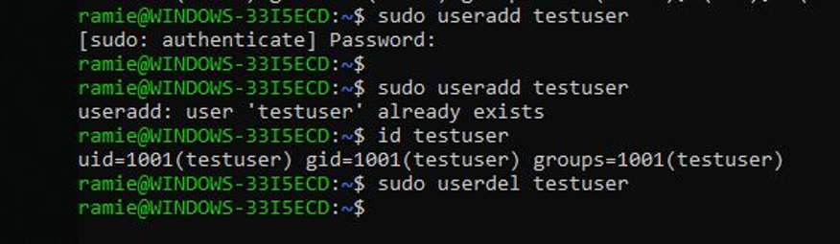

Figure 8j: Linux terminal showing sudo useradd testuser, id testuser confirming creation, and sudo userdel testuser removing it.
User creation and deletion requires sudo privileges and demonstrates Linux user management, equivalent to net user /add in Windows.

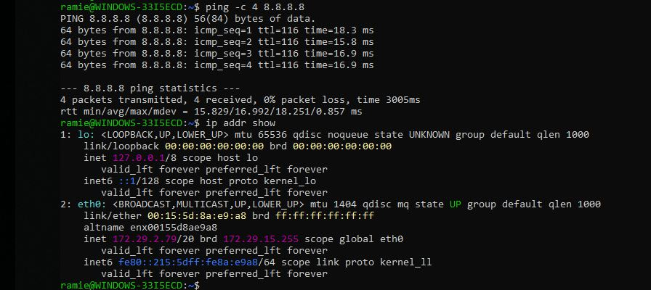
Figure 8k: Linux terminal showing ping -c 4 8.8.8.8 with four replies and ip addr show listing network interfaces.
ping tests connectivity with four ICMP packets and ip addr show lists all interfaces, replacing the deprecated ifconfig command.
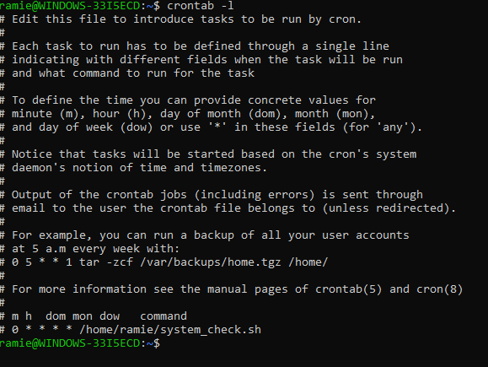

Figure 8l: Linux terminal showing crontab -l output with a commented example entry for scheduling a script.
crontab is the standard Linux task scheduler, using minute hour day month weekday syntax to define when commands run..

5. Task 4: Use of Windows OS Scripts

PowerShell is Microsoft’s main scripting language for managing Windows systems. It runs on .NET and supports object-oriented programming features [4]. PowerShell provides typed variables, functions, loops, arrays, conditional statements and switch statements. It also sits behind Azure automation and Desired State Configuration in enterprise environments [11].
The script I use below, Windows System Information Menu, is a menu driven administration tool that lets the user view system information by choosing a numbered option. It includes all the required syntax features in one working programme. Each feature is labelled using an inline comment.

# ============================================================
# Windows System Information Menu
# PowerShell Script | Task 4 | ACCA4022
# ============================================================

# VARIABLE: stores the hostname using an environment variable
$ComputerName = $env:COMPUTERNAME

# ARRAY: stores the five menu options as a .NET string collection
$MenuOptions = @(
"1. Check Running Processes",
"2. Check IP Configuration",
"3. Check Available Memory",
"4. List Ready Scheduled Tasks",
"5. Exit"
)

# FUNCTION: displays the formatted main menu
function Show-Menu {
Write-Host ""
Write-Host "=============================================" -ForegroundColor Cyan
Write-Host " Windows System Information Menu" -ForegroundColor Cyan
Write-Host " Computer: $ComputerName" -ForegroundColor Yellow
Write-Host "=============================================" -ForegroundColor Cyan
# FOREACH LOOP: iterates through the array to print each menu option
foreach ($option in $MenuOptions) {
Write-Host " $option"
}
Write-Host ""
}

# WHILE LOOP: keeps the script running until the user selects Exit
$running = $true
while ($running) {
Show-Menu

# USER INPUT: prompts the user and captures their keyboard entry
$choice = Read-Host "Enter your choice (1-5)"

# IF / ELSE: validates that input is a single digit between 1 and 5
if ($choice -match "^[1-5]$") {

# SWITCH STATEMENT: routes to the correct system check
switch ($choice) {
"1" {
Write-Host "`nTop 10 Processes by CPU:" -ForegroundColor Green
Get-Process | Sort-Object CPU -Descending |
Select-Object -First 10 |
Format-Table Name, Id, @{N='CPU(s)';E={[math]::Round($_.CPU,1)}}, WorkingSet -AutoSize
}
"2" {
Write-Host "`nIPv4 Network Configuration:" -ForegroundColor Green
Get-NetIPAddress -AddressFamily IPv4 |
Format-Table InterfaceAlias, IPAddress, PrefixLength, AddressState -AutoSize
}
"3" {
Write-Host "`nMemory Status:" -ForegroundColor Green
$os = Get-CimInstance Win32_OperatingSystem
$totalGB = [math]::Round($os.TotalVisibleMemorySize / 1MB, 2)
$freeGB = [math]::Round($os.FreePhysicalMemory / 1MB, 2)
$usedGB = [math]::Round($totalGB - $freeGB, 2)
Write-Host " Total RAM : $totalGB GB"
Write-Host " Used RAM : $usedGB GB"
Write-Host " Free RAM : $freeGB GB"
}
"4" {
Write-Host "`nReady Scheduled Tasks:" -ForegroundColor Green
Get-ScheduledTask |
Where-Object { $_.State -eq 'Ready' } |
Select-Object TaskName, TaskPath |
Format-Table -AutoSize
}
"5" {
Write-Host "Exiting. Goodbye!" -ForegroundColor Yellow
$running = $false
}
}

} else {
# ELSE: handles invalid input and prompts the user again
Write-Host "Invalid input. Please enter a number between 1 and 5." -ForegroundColor Red
}
}

Code Block 1: Windows System Information Menu (PowerShell)

5.1 Script Explanation and Syntax Analysis
Variable: At the start of the script I assigned $ComputerName to $env:COMPUTERNAME. In PowerShell, the $env: namespace lets the script read Windows environment variables, and COMPUTERNAME gives the computer’s network name. This is better than writing one fixed name because the same script can be reused across different computers later [4]

Array and foreach loop: The script creates $MenuOptions with @() syntax, storing five quoted strings that become the menu choices. Inside Show-Menu, the foreach loop works through those choices one by one. $option is the temporary variable, and each value is sent to Write-Host. Keeping this code inside a function makes the script easier to follow and also lets the menu repeat after a choice.

Function, while loop and user input: The Show-Menu part is created with the function keyword and then called inside the main while loop. This loop runs while $running is $true, and it only stops when option 5 changes this variable to $false. Read-Host collects the user’s input by showing a prompt and waiting for a keyboard response from them.

If statement and switch: The script uses an if statement to check the input before anything else runs. It uses -match with the regular expression ^[1-5]$, so only a single number from 1 to 5 is accepted. This stops wrong values from reaching the switch statement. Inside the switch, each option runs a PowerShell cmdlet: Get-Process, Get-NetIPAddress, Get-CimInstance, or Get-ScheduledTask. If the validation fails, the else branch will print a red error message [4][11].

This design works like a real admin tool. In production, -ComputerName could be used for remote queries. The script could also save results through Out-File and handle errors with try/catch blocks. These changes use the same PowerShell constructs already demonstrated here [11].

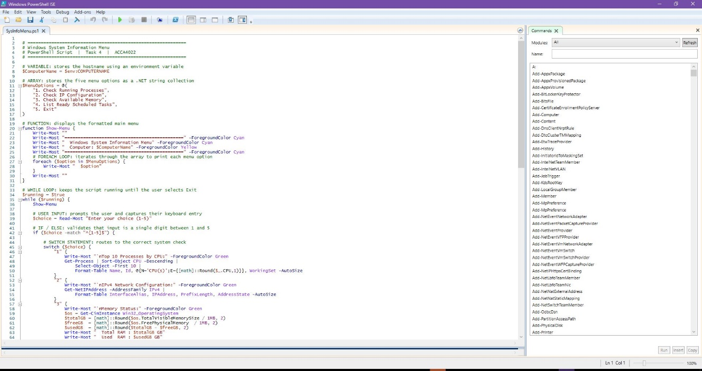
Figure 9a: PowerShell script (Windows System Information Menu) open in the script editor with syntax highlighting.
Showing the script in an editor shows that it was written as a .ps1 file rather than typed interactively. Syntax highlighting makes the variables, keywords, and functions visually distinguishable, which supports the explanation in Section 5.1.

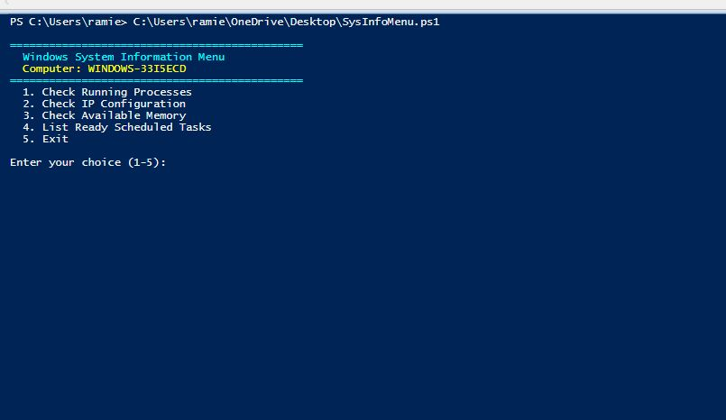
Figure 9b: PowerShell terminal showing the Windows System Information Menu running with the computer name in the header.
This screenshot proves the script runs without errors and produces the expected output. The computer name in the header confirms the $env:COMPUTERNAME variable is working, and the five options confirm the foreach loop over the array is displaying correctly.

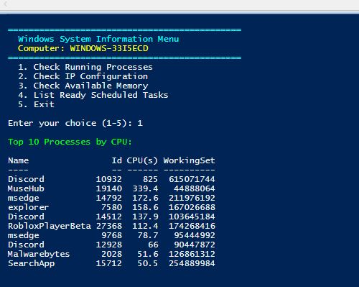

Figure 9c: PowerShell script output for option 1, showing the top ten processes sorted by CPU usage.
This demonstrates the switch statement routing correctly to option 1 and the Get-Process cmdlet producing sorted, formatted output. It provides direct evidence of the script working practically and shows the PowerShell object pipeline in use.

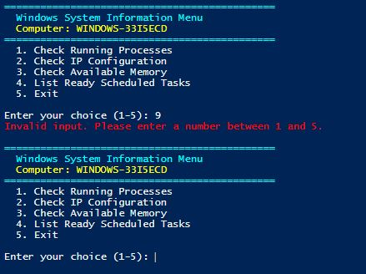

Figure 9d: PowerShell script showing input validation in action, with an invalid entry triggering the red error message.
This proves the if/else input validation is working. error handling shows the script is robust and handles edge cases, not just the expected happy-path inputs. This is evidence of thoughtful scripting practice.

6. Task 5: Use of Linux OS Scripts

Bash scripting is normally used to automate tasks on Linux and Unix based systems. A Bash script is simply a plain text file containing Bash commands. It usually begins with the shebang line #!/bin/bash which tells the OS kernel to start the Bash interpreter when the script runs [6]. The GNU bash manual describes Bash as both a command interpreter and a programming language. It provides variables, control flow, functions and I/O redirection as core features [6]. This is helpful for admin work. The same commands in the terminal can be moved into a script with only small changes and they can later be scheduled, logged or used across systems safely.

The script below is called the Linux System Check Menu and it follows the same structure as the PowerShell example in Task 4. It creates the same menu driven administration tool using Bash syntax. This matching layout is intentional because it makes the two languages easier to compare. The script was tested on Ubuntu 22.04 LTS, and inline comments clearly mark each syntax feature as it appears.

#!/bin/bash
# ============================================================
# Linux System Check Menu
# Bash Script | Task 5 | ACCA4022
# ============================================================

# VARIABLE: stores the hostname using command substitution
HOSTNAME_VAL=$(hostname)

# ARRAY: stores the five menu options
MENU_OPTIONS=(
"1. Check Running Processes"
"2. Check Memory Usage"
"3. Check Network Information"
"4. List Home Directory"
"5. Exit"
)

# FUNCTION: displays the formatted main menu
show_menu() {
echo ""
echo "============================================="
printf " Linux System Check Menu\n"
printf " Host: %s\n" "$HOSTNAME_VAL"
echo "============================================="
# FOR LOOP: iterates through the array to print each menu option
for option in "${MENU_OPTIONS[@]}"; do
echo " $option"
done
echo ""
}

# FUNCTION: runs the selected system check
run_check() {
local choice=$1
# CASE STATEMENT: routes to the correct system check based on input
case $choice in
1)
echo ""
echo "--- Running Processes (Top 15 by CPU) ---"
ps aux --sort=-%cpu | head -16
;;
2)
echo ""
echo "--- Memory Usage ---"
free -h
;;
3)
echo ""
echo "--- Network Interfaces ---"
ip addr show
;;
4)
echo ""
echo "--- Home Directory Contents ---"
ls -la ~
;;
5)
echo "Exiting. Goodbye!"
exit 0
;;
*)
echo "Error: invalid option. Please enter 1 to 5." >&2
;;
esac
}

# WHILE LOOP: keeps the menu running until the user selects Exit
while true; do
show_menu

# USER INPUT: reads the user's choice with an inline prompt
read -p "Enter your choice (1-5): " user_choice

# IF STATEMENT: validates input before passing to run_check
if [[ "$user_choice" =~ ^[1-5]$ ]]; then
run_check "$user_choice"
else
echo "Invalid input. Please enter a number between 1 and 5." >&2
fi

done

Code Block 2: Linux System Check Menu (Bash)

6.1 Script Explanation and Syntax Analysis
Shebang and variable: The #!/bin/bash shebang line should appear first because it tells the OS which interpreter to use. If it isn’t included, another shell may run the file and cause syntax issues [6]. HOSTNAME_VAL uses $() for command substitution, which runs the hostname command and assigns its output to the variable. This pattern lets Bash capture command output for later reuse.

Array and for loop: MENU_OPTIONS is created with Bash parentheses, and each quoted string becomes one array element. In show_menu, the for loop moves through every value using ${MENU_OPTIONS[@]}, which expands the complete array. Any variables that are made with local inside a function will stay within that function. This reduces the risk of any accidental overwrites when edits are made or maintenance.

Functions and case statement: The script uses show_menu for display and run_check for checking logic. Run_check takes the user’s choice as $1, the first positional parameter. A
case statement compares the value with five patterns. You can see each pattern closes with ;;. The final *) pattern catches wrong inputs and redirects the error message to stderr with >&2, like PowerShell’s switch statement.

User input and if statement: We can see the script collects input with read -p. This prints the prompt inline before waiting for a response. The if statement uses [[ ]] syntax with the =~ operator so a regular expression can check for a digit from 1 to 5. With a valid input, it is passed to run_check. Invalid input reaches the else branch. The while true loop runs until case 5 uses exit 0 [6].

Before we can run the script, it needs execute permission with cmhod +x system_check.sh. This links Task 5 to the file permission model in Section 2.7, and the cmhod command uses in Task 3. After that, it can be started with ./system_check.sh. A crontab -e entry can run it automatically at set times. This shows how CLI commands, scripting and task scheduling work together in everyday Linux admin work [12].

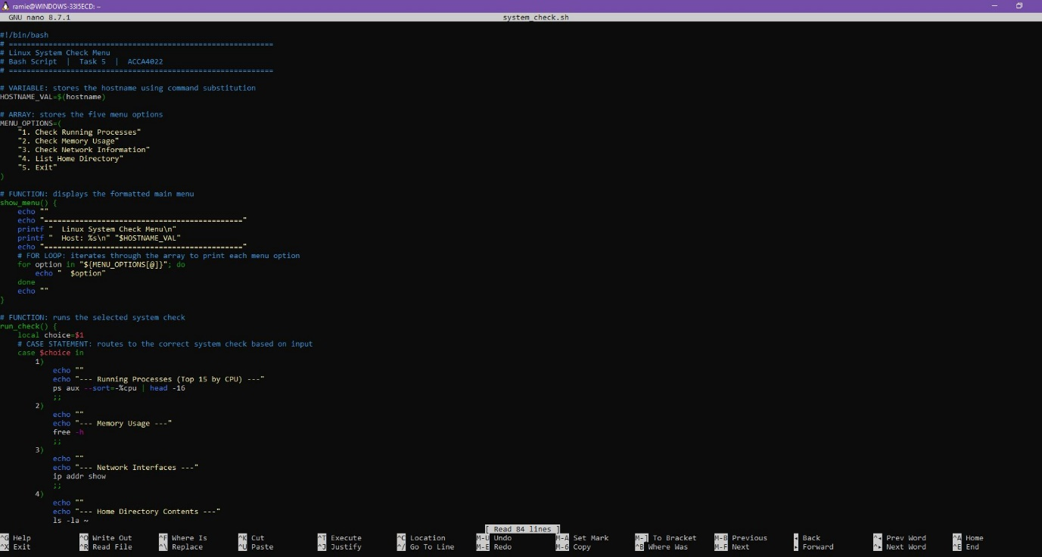
Figure 10a: Bash script (Linux System Check Menu) open in the nano text editor with the shebang line visible.
The shebang line #!/bin/bash visible at the top confirms this is a valid Bash script saved in the Linux environment.

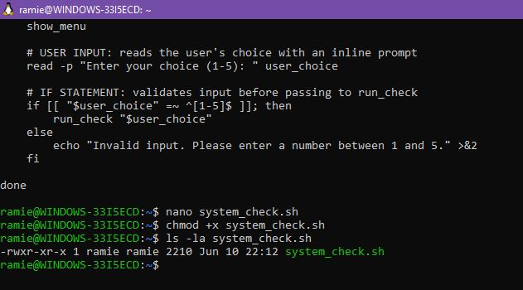
Figure 10b: Terminal showing chmod +x granting execute permission to the Bash script, confirmed by ls -la.
This links back to the chmod command in Task 3 and the permission model discussed in Section 2.7.

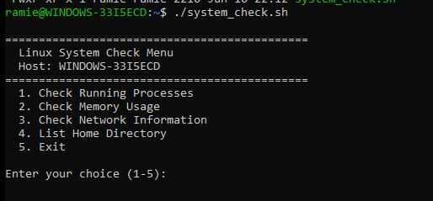
Figure 10c: Bash script running in the Linux terminal, displaying the system check menu with the hostname.
The menu displays correctly with the hostname showing that command substitution worked and all five options confirming the for loop ran through the array.
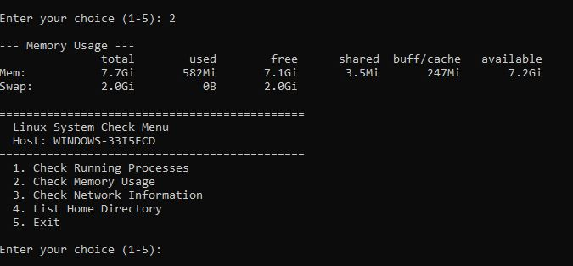
Figure 10d: Bash script output for option 2, displaying the free -h memory usage information.
Selecting option 2 shows the case statement routing correctly and free -h returning real memory data from the system.
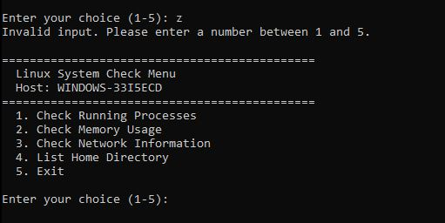
Figure 10e: Bash script showing input validation in action, with an invalid entry producing the error message.
Entering an invalid value triggers the error message, showing the if/else validation is working correctly.

7. Conclusion
In this report I covered the main functions of general purpose operating systems, CLI commands on Windows and Linux, and scripts in PowerShell and Bash. This showed that the OS is not just a launcher for applications. Process management, memory allocation, file permissions and security logging all run together, and tools like Task Manager, Resource Monitor and the Linux terminal make them visible.

Comparing Windows and Linux CLI showed clear differences. PowerShell is better for filtering and reporting because it works with structured objects through its pipeline. Linux Bash works mainly but its strength comes from small tools that can be combined efficiently. up for this through tools that work well together. Both are useful and the right choice depends on the environment.

The scripting tasks showed that variables, loops, functions and conditionals appear in both languages even with different syntax. Learning one makes it easier to pick up the other. However the scripts I wrote are fairly basic and a more advanced version would include proper error handling and logging. I would need more practice to become fully confident with debugging and writing scripts for real server environments. Overall this assignment has given me a strong foundation in operating systems and CLI tools that will be useful in a computing career.

References
[1] A. Silberschatz, P. B. Galvin, and G. Gagne, Operating System Concepts, 10th ed. Hoboken, NJ, USA: John Wiley and Sons, 2018.

[2] A. S. Tanenbaum and H. Bos, Modern Operating Systems, 4th ed. Harlow, UK: Pearson Education, 2015.

[3] W. Shotts, The Linux Command Line: A Complete Introduction, 2nd ed. San Francisco, CA, USA: No Starch Press, 2019.

[4] Microsoft Learn, "What is PowerShell?," Microsoft, 2024. [Online]. Available: https://learn.microsoft.com/en-us/powershell/scripting/overview

[5] M. Kerrisk, The Linux Programming Interface. San Francisco, CA, USA: No Starch Press, 2010.

[6] GNU Project, "Bash Reference Manual," Free Software Foundation, 2023. [Online]. Available: https://www.gnu.org/software/bash/manual/bash.html

[7] Red Hat, "Linux file permissions: Explained," Red Hat, Inc., 2024. [Online]. Available: https://www.redhat.com/en/blog/linux-file-permissions-explained

[8] Microsoft Learn, "ipconfig," Microsoft, 2023. [Online]. Available: https://learn.microsoft.com/en-us/windows-server/administration/windows-commands/ipconfig

[9] The Linux Foundation, "Introduction to Linux (LFS101)," The Linux Foundation, 2024. [Online]. Available: https://training.linuxfoundation.org/training/introduction-to-linux/

[10] Microsoft Learn, "Windows Commands reference," Microsoft, 2024. [Online]. Available: https://learn.microsoft.com/en-us/windows-server/administration/windows-commands/windows-commands

[11] Microsoft Learn, "PowerShell 101," Microsoft, 2024. [Online]. Available: https://learn.microsoft.com/en-us/powershell/scripting/learn/ps101/00-introduction

[12] Ubuntu Documentation Team, "CronHowto," Ubuntu Community Help Wiki, 2023. [Online]. Available: https://help.ubuntu.com/community/CronHowto

Appendix A: Tutorial Activity on OS Types
The following activity was completed as part of Tutorial 1 and goes through five categories of operating systems. Each category is described with reference to real examples.

General-Purpose Operating Systems

General-purpose operating systems are used for a wide mix of tasks, from basic office work and web browsing to gaming and software development. They are designed for normal laptops and desktop computers, so they need to support many types of users. Some examples include Microsoft Windows 11, Apple macOS 14 Sonoma and Ubuntu 22.04 LTS. These systems provide a graphical interface as well as large software libraries and good hardware support. Linux is more common on servers, cloud platforms and containerised workloads because it is stable, open source and easy to automate with scripts [1][2].

Mobile Operating Systems

Mobile operating systems are made for touchscreen devices, so they have to manage battery life, memory and processing power carefully. Android is based on a modified Linux kernel and is open source, so it can be used by many different manufacturers. This has helped it become the most common mobile OS globally. iOS is more controlled, as it is proprietary and only runs on Apple hardware. This lets Apple focus on security and consistent performance across its devices. Both systems use sandboxing to keep apps isolated from each other. They also control background processes to prevent the battery from draining too quickly. They also restrict admin access by default for security reasons [2].

Network Operating Systems

Network operating systems are used to manage network hardware and services such as DHCP, DNS, routing, file sharing and user authentication. Cisco IOS is one example, as it is used on Cisco routers and switches. Other examples include : Windows Server 2022 and server-focused Linux distributions such as Debian and Rocky Linux. These operating systems are commonly managed through the CLI, which makes command line knowledge essential for networking roles. Admins can also manage systems remotely using SSH on Linux-based devices or WinRM on Windows Server meaning they do not need to go and physically access the hardware [2][8]. This links directly to the CLI skills covered in Tasks 2 and 3.

Embedded and Real-Time Operating Systems

Embedded operating systems are used inside devices that are built to do one specific job, such as car engine control units, smart thermostats, industrial sensors and everyday electronic devices. Unlike a desktop OS, they usually run in the background and are not visible to the end user. Real-time operating systems are used in more time-sensitive situations, where the response must happen within a set period. FreeRTOS is common in IoT devices and microcontrollers, while VxWorks is used in aerospace and defence. An RTOS focuses more on predictable timing than maximum speed. In real-time control systems, missing a deadline can cause physical problems quite quickly [4].

AI and Quantum Operating Systems

New types of computing are also changing how operating systems are developing. AI-enhanced operating systems are starting to use machine learning to support decisions such as resource management and workload handling. Microsoft Copilot in Windows 11 and Google’s on-device AI features in Android 14 are early examples of systems becoming more adaptive to user behaviour. Quantum computing is less developed and remains mainly research focused. However, IBM’s Qiskit Runtime and Google’s Cirq already provide software layers that help developers work with quantum hardware without managing every single low-level detail. Commercial quantum operating systems are not yet mainstream, although the area could become more important in future professional computing [2].

Appendix B: Lecture and Tutorial Activity Evidence

This appendix provides evidence of engagement with the module materials and practical activities for this module. Each figure corresponds to work completed using the lecture and tutorial resources provided, supporting the Transferable Skills criterion of the marking grid.

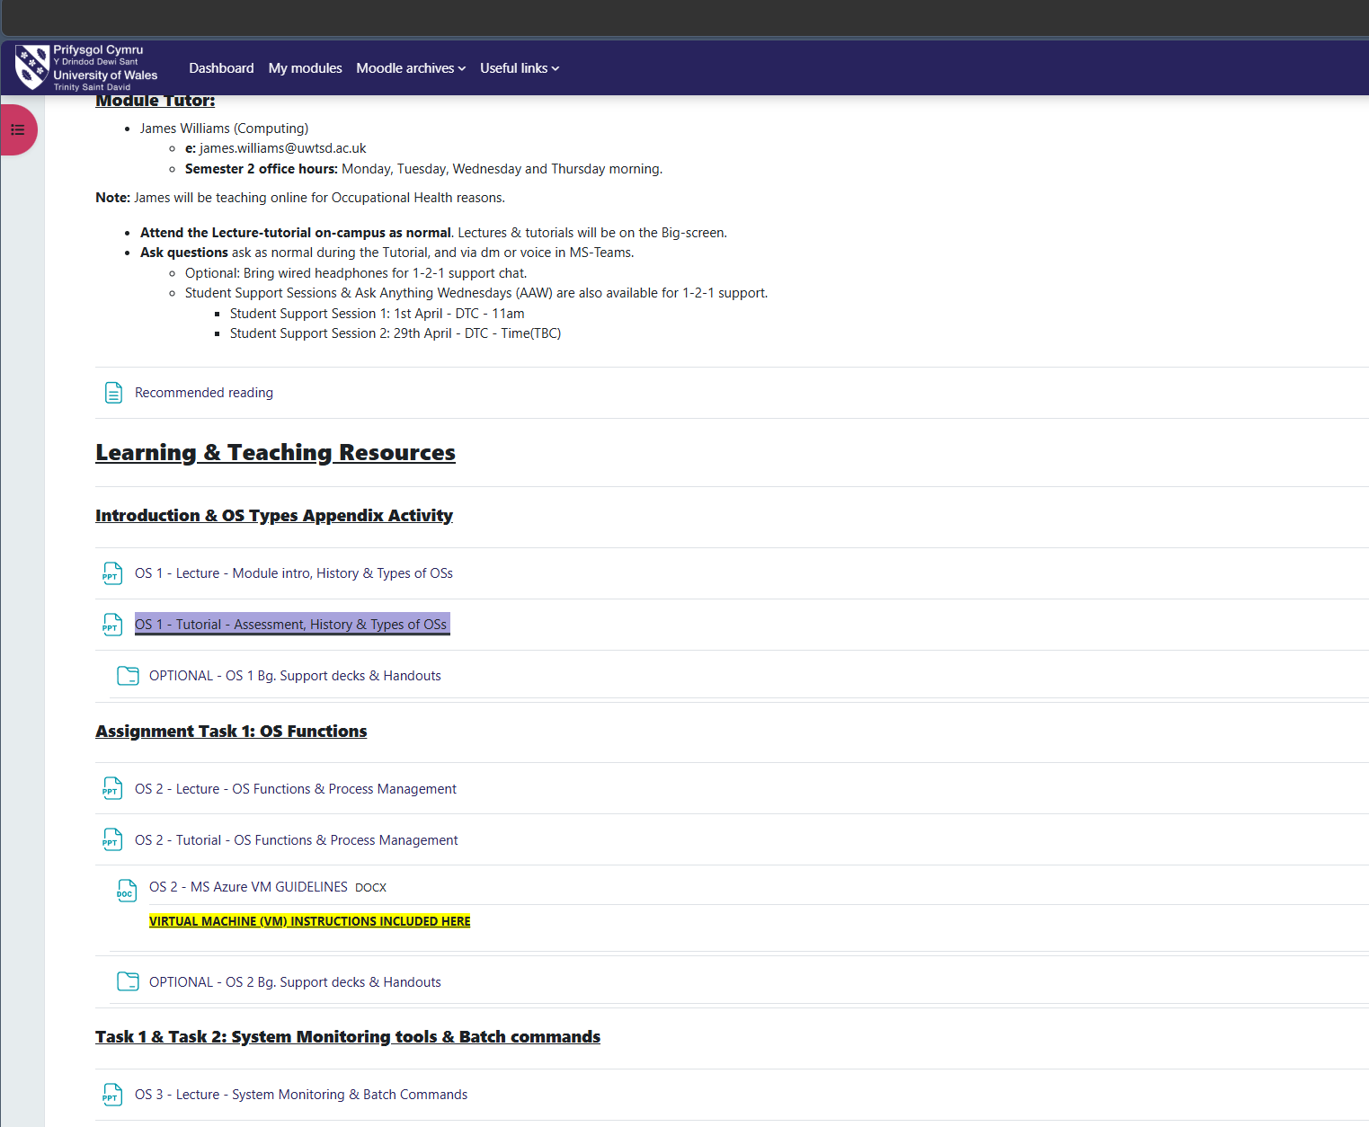
Figure B1: University of Wales Trinity Saint David Moodle page showing the Computer Architecture and Operating Systems module resources and lecture materials.

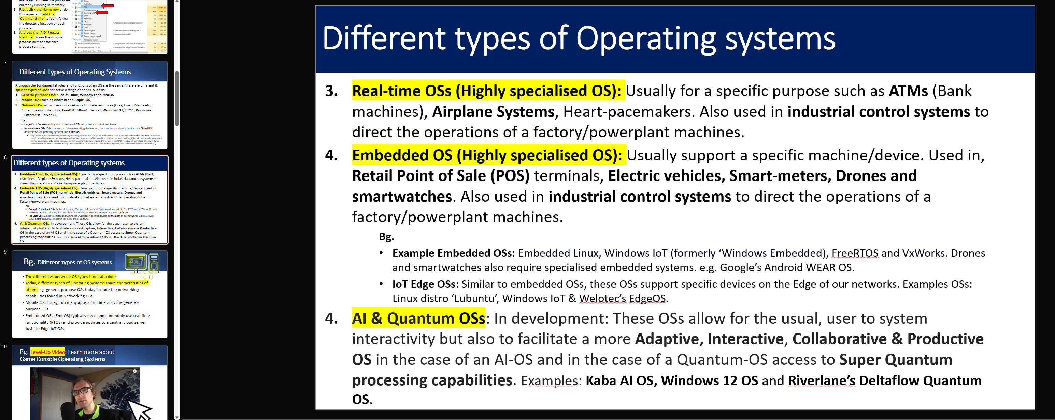

Figure B2: OS 1 Tutorial slides showing different types of operating systems including real-time, embedded, and AI and quantum operating systems.

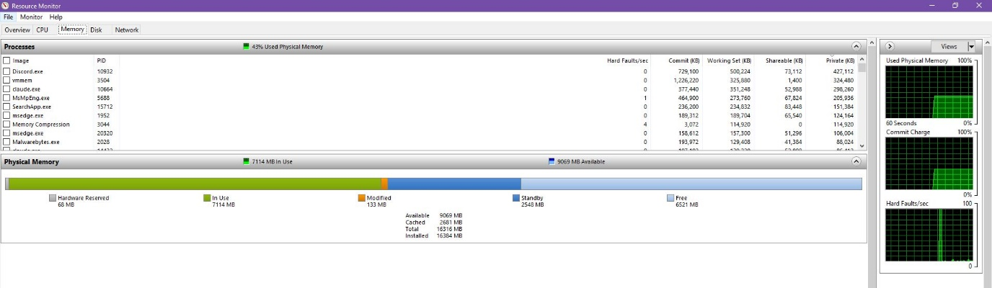
Figure B3: Windows Resource Monitor used during practical work, showing memory usage breakdown including In Use, Standby, and Free memory values.
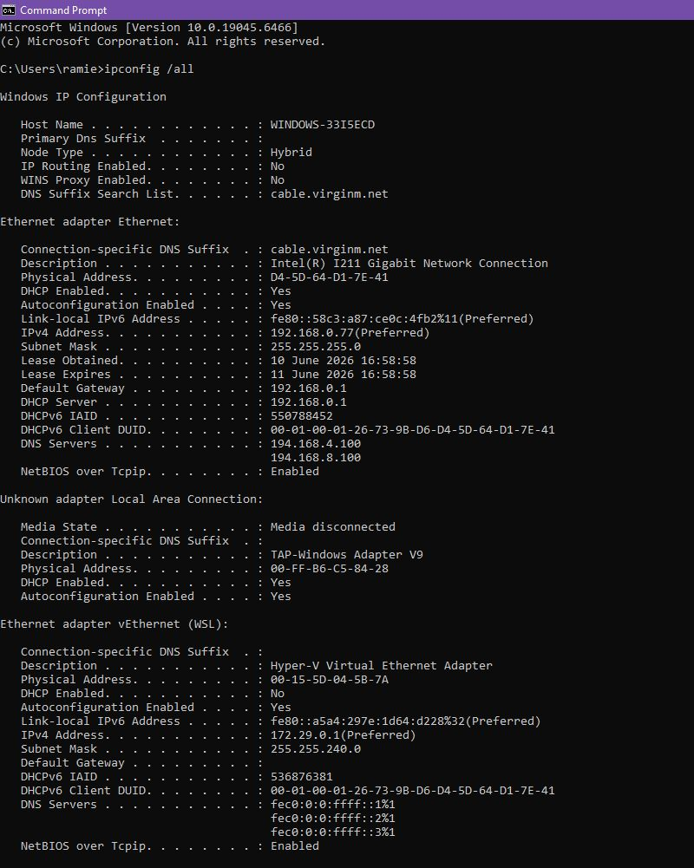
Figure B4a: Windows CLI practical evidence showing ipconfig /all displaying full network adapter configuration in Command Prompt.

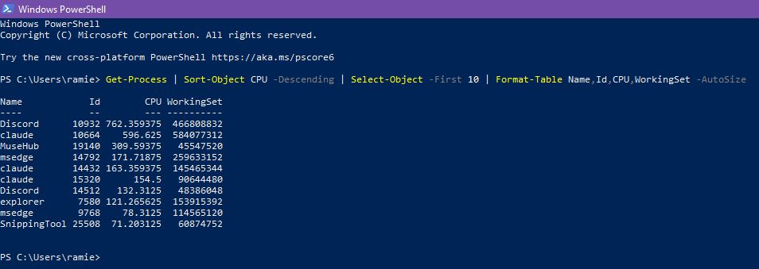
Figure B4b: Windows CLI practical evidence showing Get-Process in PowerShell displaying running processes sorted by CPU usage.

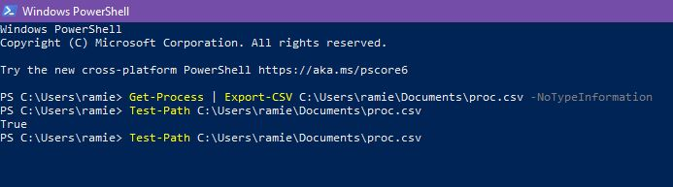
Figure B4c: Windows PowerShell practical evidence showing Get-Process exported to a CSV file using Export-CSV, with Test-Path confirming that the file was created successfully.

Figure B5a: Linux CLI practical evidence showing whoami and id commands displaying the current user identity, UID, GID and group memberships.

Figure B5b: Linux CLI practical evidence showing ping testing network connectivity to 8.8.8.8 and ip addr show listing network interfaces and IP addresses.

Figure B5c: Linux CLI practical evidence showing ps aux displaying all running processes with CPU and memory usage in the Ubuntu terminal.
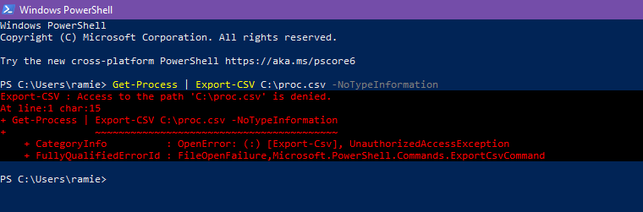
Figure B6: Script development evidence showing a PowerShell permission denied error when attempting to save the process list directly to C:\proc.csv. The command was later corrected by exporting the file to the user’s Documents folder.

Appendix C: Certified Course Evidence
As part of the continuing professional development (CPD) requirement for this assignment, a relevant online certified course was completed to supplement the module's taught content. The course was selected for its direct relevance to the practical skills covered in this report.

The course completed was Cisco Networking Academy: Linux Unhatched. The following screenshots provide evidence of enrolment, progress through the course content, and completion.

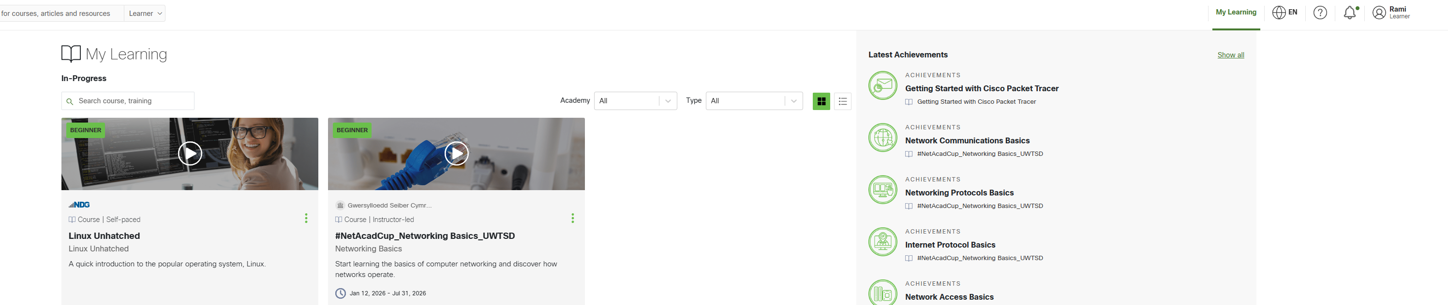
Figure C1: Cisco Networking Academy My Learning page showing enrolment on the Linux Unhatched course

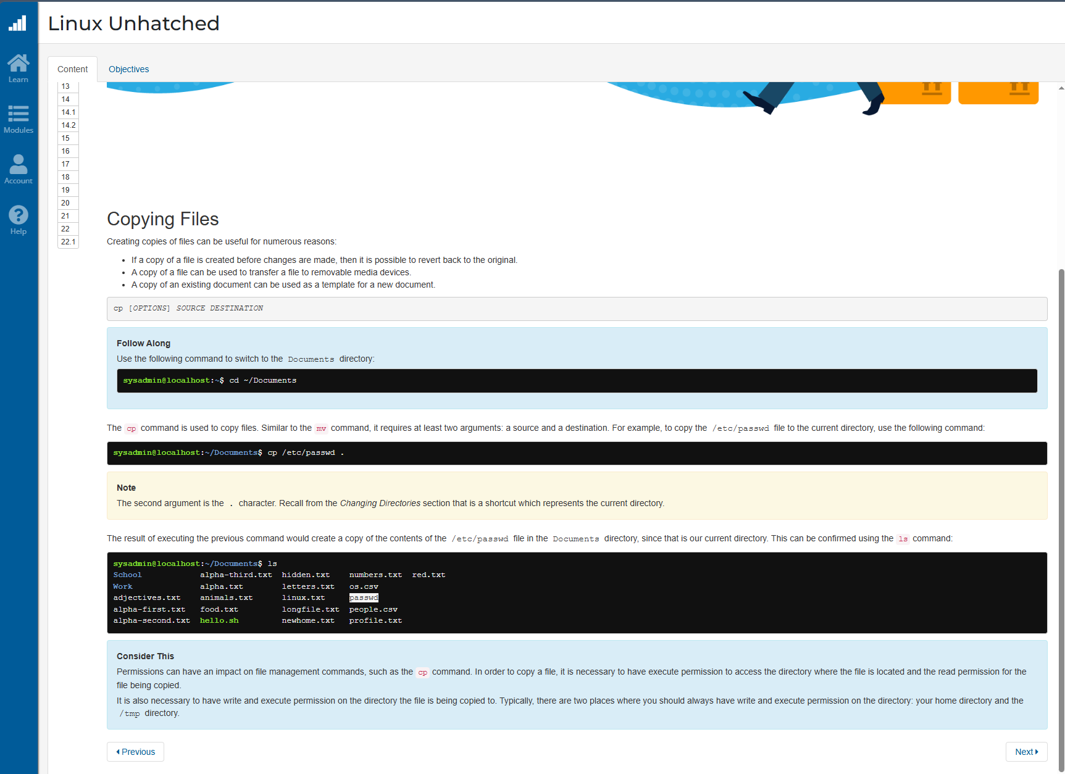
Figure C2: Linux Unhatched course content showing module progress through chapter 22, Copying Files.

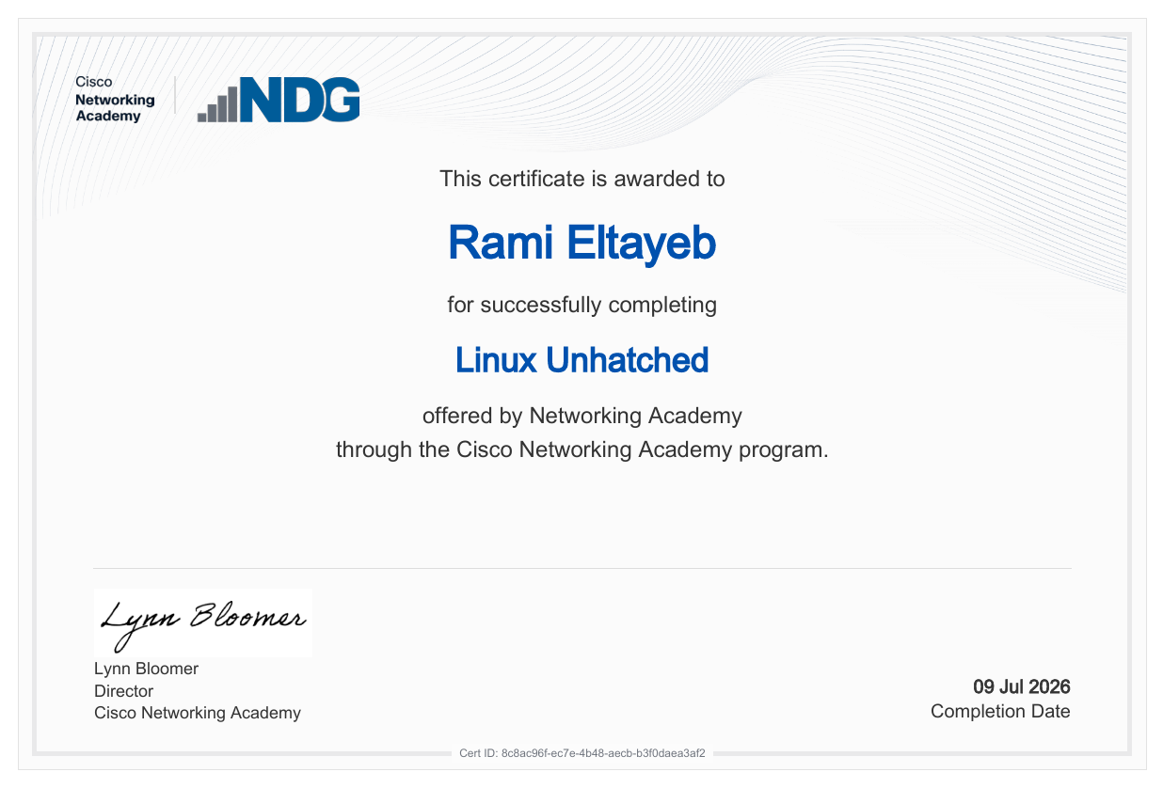
Figure C3: Cisco Networking Academy Linux Unhatched completion certificate awarded to Rami Eltayeb on 09 July 2026.

Course Reflection
The Linux Unhatched course reinforced the CLI commands covered in Task 3, particularly the permission model and the user management section. Working through the interactive exercises increased my confidence with commands such as chmod and whoami. It also helped me understand why permissions matter before running scripts or changing files. This directly supported the Bash work in task 5, because the script needed execute permissions before it could run. Overall, the course gave me extra practice outside the taught sessions and helped connect the assignment tasks to practical Linux use.

