Week 8 Rehabilitation

Arthrokinematic Considerations for the Knee in Rehabilitation

Assigned reading 1)

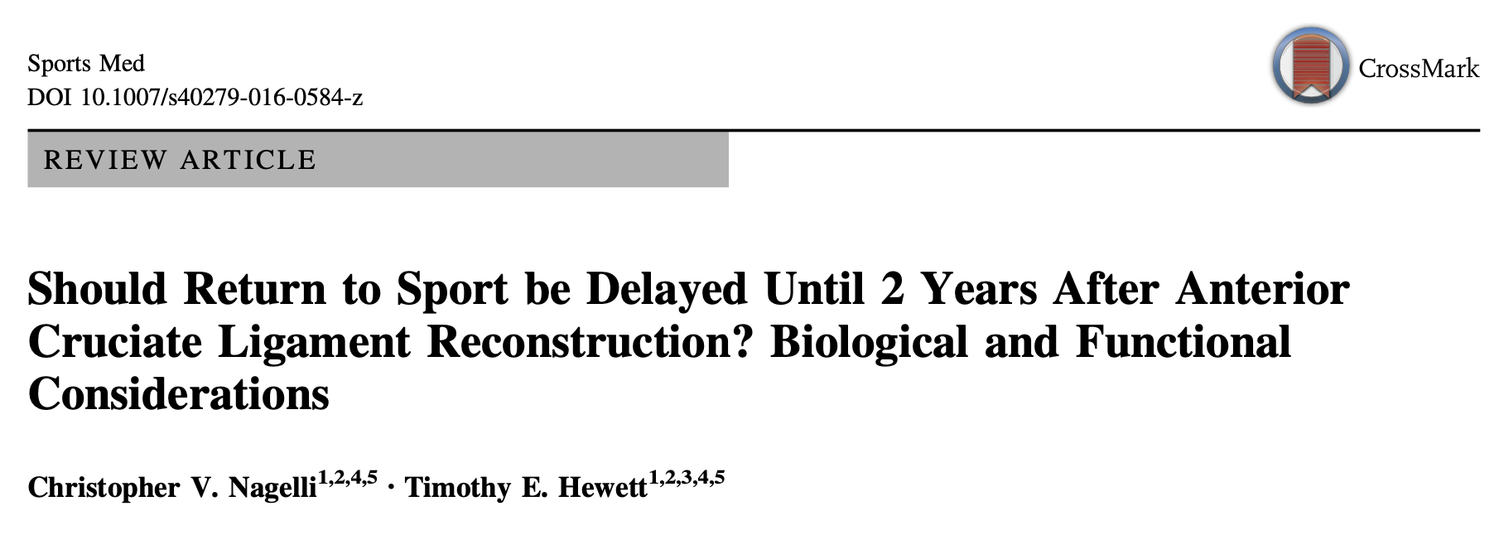

Assigned reading 2)



