

UNIVERSITY OF WALES: TRINITY SAINT DAVID
PRIFYSGOL CYMRU: Y DRINDOD DEWI SANT
School of Business
London Campus
Dissertation

STUDENT NAME: MANIBARATHI GOVINDARAJ
STUDENT ID: 2316981
SUPERVISOR NAME: JIA MIAO
MODULE CODE: LCMB7020
PROGRAMME - MBA IB
TITLE: A STUDY TO ASSESS THE CONSUMER BUYING BEHAVIOUR OF UNIVERSITY STUDENTS IN THE UK TOWARDS A LUXURY FASHION, ADIDAS
DATED: 13/10/2024

A STUDY TO ASSESS THE CONSUMER BUYING BEHAVIOUR OF UNIVERSITY STUDENTS IN THE UK TOWARDS A LUXURY FASHION, ADIDAS

Declaration


Master’s Degrees by Examination and Dissertation
Declaration Form.

I, MANIBARATHI GOVINDARAJ, declare that this dissertation has been composed by myself, that the work contained herein is entirely my own except where explicitly stated otherwise in the text, and that this work has not been submitted for any other degree or qualification, in whole or in part, except as specified.

Signature: MANIBARATHI GOVINDARAJ.

Date: 13/10/2024

Acknowledgement
I am sincerely grateful to my supervisor for their continuous guidance and support throughout the process of conducting this research. I also appreciate the students of UWTSD for contributing their time and knowledge to participate in the survey for this study. Their cooperation helped me to develop specific insights and develop valid outcomes for this study. I am also thankful to my friends and family for encouraging and assisting me throughout this research.

Thank You.

Abstract
Aim: The research aimed to analyse different factors that contributes to the purchasing intentions of university students towards luxury products of Adidas.
Literature Review: Brand awareness, product quality, brand equity and image are some of the potential factors that influence purchasing decisions of university students. They are influenced by various digital marketing strategies like influencer marketing, user-generated content, online and sponsored post and many more. It was found that brand loyalty and repeat purchase intentions of customers are influenced by different factors. These are the perceived value of the brand, affordability, brand awareness, and the store environment. In contrast, if products are perceived as poor quality, it creates a barrier in purchase intentions. High prices influence the purchase intentions of counterfeit products and lower the purchase decision of authentic ones.
Methodology: The research adopted a quantitative mono-method approach to achieve the research aim and objectives. The deductive method and positivist philosophy were applied to examine factual data and produce reliable conclusions from quantitative data. After employing a survey approach to gather cross-sectional quantitative data, statistical data analysis was performed.
Results: The results also highlight the fact that Adidas has a devoted following among college students due to a variety of characteristics, including product quality, comfort and style. These affect their degree of contentment and inclination to purchase. This evident by the approval of all four hypotheses.
Discussion: Product quality is the most significant factor that can both increase and decrease the purchasing frequency of university students for Adidas products. High-quality increases customer satisfaction whereas quality degradation produces dissatisfaction. Other than these, their purchasing behaviour is also influenced by stylish and trendy designs offered by Adidas along with comfort and luxury. University students are mainly influenced by influencers' recommendations and personalised marketing strategies. Moreover, the impacts of other digital marketing tactics cannot be denied as well. All these factors combined contribute to brand loyalty and repurchasing intentions of university students in the UK. Their purchasing intentions can be harmed due to price sensitivity and unethical practices of Adidas to comply with fast-fashion trends.
Conclusion and Recommendations: It can be concluded from the findings that university students are intensely loyal to Adidas. This is because of its product quality, style, comfort and many other factors. These impact their satisfaction level and purchasing intentions. However, price sensitivity has been identified as a significant barrier. To mitigate this barrier, Adidas can introduce flexibility in its payment system, enabling students to pay for high-end products through instalments. Moreover, Adidas can organise pop-up events on university campuses to influence university students to purchase Adidas products.

Table of Contents
Declaration iii
Acknowledgement iv
Abstract v
Chapter 1: Introduction 1
1.1 Research Background 1
1.2 Research Rationale 3
1.3 Problem Statement 4
1.4 Research Focus and Scope 5
1.5 Research Aim and Objectives 5
1.6 Research Question 6
1.7 Outline of the methodology 6
1.8 Dissertation Structures 6
1.9 Hypotheses and conceptual framework 7
1.10 Summary 8
Chapter 2: Literature Review 9
2.1 Introduction 9
2.2 Concept 9
2.2.1 Concept of consumer buying behaviour 9
2.3 Theoretical Framework 9
2.3.1 Theory of Planned Behaviour (TPB) 9
2.3.2 Keller's Brand Equity Model 11
2.4 Empirical Findings 12
2.4.1 Different Factors Influencing Purchasing Intentions of University Students for Luxury Fashion Products 12
2.4.2 Significance of Different Digital Marketing Strategies in Influencing the Purchasing Intentions of University Students 14
2.4.3 Factors Influencing Brand Loyalty and Their Impacts on Repeat Purchase Decisions of University Students 17
2.4.4 Barriers That Develop Negative Brand Perceptions of University Students Affecting Their Purchasing Behaviour 19
2.5 Literature Gap 21
2.6 Summary 22
Chapter 3: Research Methodology 23
3.1 Introduction 23
3.2 Research Onion 23
3.3 Research Philosophy 24
3.4 Research Approach 24
3.5 Research Design 25
3.6 Research Strategy 26
3.7 Research Method 26
3.8 Data Sampling Collection 27
3.8.1 Data Sampling 27
3.8.2 Data Collection Method and Instrument 27
3.9 Data Analysis 28
3.10 Ethical Consideration 28
3.11 Research Limitations 28
3.12 Summary 29
Chapter 4: Results 30
4.1 Introduction 30
4.2 Descriptive Statistics 30
4.2.1 Demographics 30
4.2.2 Variable Statistics 32
4.3 Inferential Statistics 46
4.3.1 Findings of Objective 1 46
4.3.2 Findings of Objective 2 50
4.3.3 Findings of Objective 3 53
4.3.4 Findings of Objective 4 55
4.4 Summary 58
Chapter 5: Discussion 59
5.1 Introduction 59
5.2 Discussion 59
5.2.1 Discussion of Objective 1 59
5.2.2 Discussion of Objective 2 61
5.2.3 Discussion of Objective 3 63
5.2.4 Discussion of Objective 4 65
5.3 Summary 68
Chapter 6: Conclusion and Recommendations 69
6.1 Overall Conclusion 69
6.2 Linking with Objectives 70
6.3 Research Contribution and Implications 71
6.4 Research Limitations and Future Scope 72
6.5 Recommendations 73
6.5.1 Introducing Flexible Payment System 73
6.5.2 Organising pop-up events on university campuses 74
Reference List 75
Appendices 93
Appendix 1: Survey Questionnaire 93
Appendix 2: Descriptive Statistics 95
Appendix 3: Regression Graph 106

List of Figures
Figure 1.1: Luxury fashion market revenues in the UK 1
Figure 1.2: Brand profile of Adidas in the UK 2
Figure 1.3: The global revenues of Nike, Adidas and Puma 4
Figure 1.4: Dissertation Structure 7
Figure 1.7: Conceptual framework 8
Figure 2.1: Theory of Planned Behaviour (TPB) 10
Figure 2.2: Keller’s Brand Equity Model or Customer-Based Brand Equity (CBBE) Model 11
Figure 2.3: Factors that affect purchasing intentions of university students for luxury fashion product 13
Figure 2.4: Most Influential Fashion Influencers 15
Figure 2.5: Frequency of purchasing luxury goods and services in the UK and the US 19
Figure 3.1: Research Onion 23
Figure 4.1: Age 30
Figure 4.2: Gender 31
Figure 4.3: Education Level 32
Figure 4.4: Purchase frequency and satisfaction for Adidas Products 33
Figure 4.5: Product Quality 33
Figure 4.6: Brand equity, image and reputation 34
Figure 4.7: Style and comfort of products 35
Figure 4.8: Elegant and trendy customized high-fashion streetwear 35
Figure 4.9: Role of peer influence 36
Figure 4.10: Diversity of brand portfolio 37
Figure 4.11: Continuous product innovation 37
Figure 4.12: Effectiveness of social media ads 38
Figure 4.13: Online banners and sponsored posts 38
Figure 4.14: Impacts of user-generated content posted by Adidas 39
Figure 4.15: Targeted advertising campaigns of Adidas 40
Figure 4.16: Personalized email follow-ups and recommendations 40
Figure 4.17: Product reviews and recommendations by influencers 41
Figure 4.18: Resonance of marketing tactics with personal values 41
Figure 4.19: Brand loyalty 42
Figure 4.20: Repeat purchasing intentions 43
Figure 4.21: Likelihood of recommending Adidas to friends and family 43
Figure 4.22: Quality degradation 44
Figure 4.23: Price sensitivity 45
Figure 4.24: Unethical operations 45
Figure 4.25: Fast-fashion trends 46

List of Tables
Table 4.1: Correlation between brand perception and purchasing behaviour 47
Table 4.2: Regression 48
Table 4.3: ANOVA 49
Table 4.4: Coefficient 49
Table 4.5: Correlation between digital marketing strategies and purchasing behaviour 50
Table 4.6: Regression 51
Table 4.7: ANOVA 52
Table 4.8: Coefficient 52
Table 4.9: Correlation between brand loyalty and purchasing behaviour 53
Table 4.10: Regression 54
Table 4.11: ANOVA 54
Table 4.12: Coefficient 55
Table 4.13: Correlation between barriers to brand perception and purchasing behaviour 56
Table 4.14: Regression 57
Table 4.15 ANOVA 57
Table 4.16: Coefficient 57
Table 6.1: SMART Recommendation 1 73
Table 6.2: SMART Recommendation 2 74

List of Abbreviations
CBBE: Customer-Based Brand Equity
PPC - pay-per-click
TPB: Theory of Planned Behaviour
UK: United Kingdom

Chapter 1: Introduction

1.1 Research Background
The luxury fashion market is one of the major markets in the UK. According to a Statista report, it is expected that the fashion apparel and fashion footwear market is expected to reach US$ 6.52 billion and US$ 2.16 billion, respectively in 2028 (Statista, 2024a) (Refer to Figure 1.1). The following figure also shows that the revenue of this market is constantly growing, signifying a constantly high demand for luxury fashion products. As per another Statist report, the forecasted value of the fashion market will be surpassed and is expected to reach US$7.39bn in 2024 (Statista, 2024b). One of the major reasons behind this growth is the increased per capita spending on fashion. The per capita figure is expected to be US$108.70 in 2024. Even though British multinational luxury fashion brands like Alexander McQueen and Burberry attract customers for unique design and craftsmanship, other fashion brands also lead this market (Reuters, 2021).
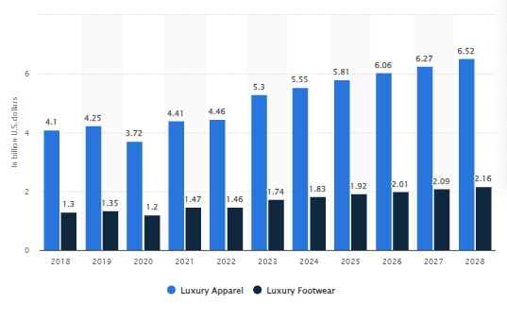

Figure 1.1: Luxury fashion market revenues in the UK
(Source: Statista, 2024a)
One of the largest companies in the luxury fashion industry is Adidas, mainly well-known for its sportswear. This German company was traced back to 1936 but started operating as Adidas in 1949 (Adidas, 2024a). It registered as ‘Adi Dassler adidas Sportschuhfabrik’ and started work with only 47 employees in the small town of Herzogenaurach. Adidas is the leading sportswear manufacturer in Europe and is the second largest in the world, after Nike. This makes Nike the largest competitor of Adidas (Tighe, 2024a). This fifth largest globally recognised luxury apparel brand had US$ 15 billion. In the UK, Adidas has 96% of brand awareness, followed by 58% popularity and 37% loyalty (Kunst, 2024) (Refer to Figure 1.2). However, considering the fact the brand has 47% usage, the brand loyalty of Adidas is 79%.
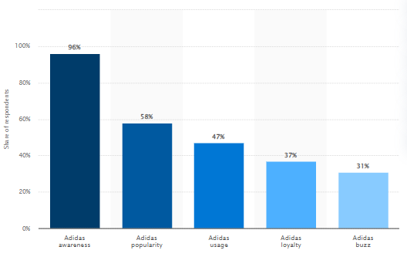

Figure 1.2: Brand profile of Adidas in the UK
(Source: Kunst, 2024)
The net sales of the company worldwide were approximately 21.4 billion euros, and it employs around 60k employees over all locations in the world (Tighe 2024b). Adidas is popular for manufacturing apparel, footwear, as well as accessories and its three-stripes logo, is globally recognisable. Bags, watches, eyewear and shirts. Overall, it is one of the most valuable luxury sportswear brands, known for its great quality products. On the other hand, Adidas has become one of the leading sportswear brands that blends luxury sports fashion with functional comfort and high-quality fabrics (Adidas UK 2024). Adidas is gaining popularity in the market, especially among the youth culture for providing wide range of luxury streetwear products.
In the UK, around 2.86 million students’ study in higher education institutions as of 2021/2022 (Bolton, 2024). Besides, a significant proportion of students also enrol in part-time classes in the UK. Even though the popularity of Adidas is significantly high in the UK, there is a considerable knowledge gap in understanding the popularity of this luxury fashion brand among UK university students. This research aims to shed light on this area for an in-depth investigation.

1.2 Research Rationale
Luxury fashion brands face some major challenges. Wang et al. (2019) stated that consumer trends, brand visuals and the demands for highly creative designs impact the purchase intentions of customers. Place, people, preferences as well as perspectives of customers change or vary consumer purchase intentions. The affordability of luxury fashion brands is another major factor that creates barriers to customers' purchase intentions. Appealing to price-sensitive customers is the most challenging thing for fashion brands. In the case of Adidas, the price range of its bags, shoes, garments and other product range is comparatively high. It has been seen that the manufacturing cost of Adidas products are very less. However, the company charges high price from its customers because of the labour cost, rent and utilities. On the contrary, the high price range of Adidas is also because of its strong brand value and reputation in the current market scenario. It is further supported by Ouattara (2022) who reported that luxury sportswear or streetwear brands like Adidas is not always affordable for university students. Many students want to have athletics wear from luxury brands but often fail to buy due to low budget. The university students belong to Gen Z, who are the primary consumers of luxury fashion brands. Customers belonging to Millennials and Gen Z are accountable for 45% of the total sales of luxury brands (Faria, 2024). In order to appeal to affluent millennial shoppers, the marketers of luxury fashion brands adopt Instagram to reach millennial shoppers. On the other hand, TikTok is the most popular tool for reaching Gen Z. The fashion brands often consider social media marketing to attract brand. Kaundal (2024) stated that even Adidas significantly spends on the social media marketing to attract customers.
The leading competitor of Adidas is Nike globally. Another competitor is Puma, even though in terms of sales and revenues worldwide, Nike is the only competitor of Adidas. As per another Statista report, the global revenue of Nike was around 47.78 billion euros. Nevertheless, Adidas could not even make half of this revenue. It only had a revenue of 22.51 billion euros in the same year (Refer to Figure 1.3).
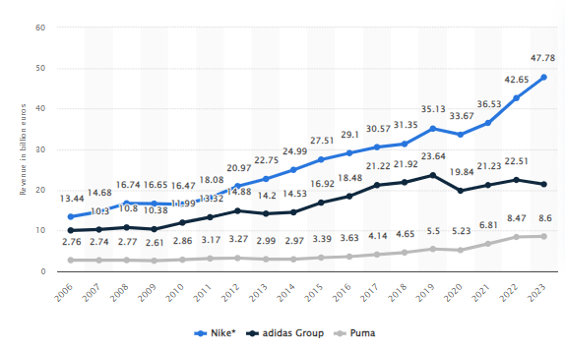

Figure 1.3: The global revenues of Nike, Adidas and Puma
(Source: Tighe, 2023c)
Mangalasserri et al. (2021) emphasised that price becomes the primary barrier to customers' purchase intention for fashion brands. Price becomes an obstacle in buying behaviour. In contrast, quality, as well as perceived values of luxury fashion brands, contribute to the purchase behaviour of customers. Therefore, it becomes crucial to investigate which factors majorly contribute to the purchase intentions of fashion brands, especially Adidas among UK university students.

1.3 Problem Statement
Based on the findings from the previous two sections, it can be stated that Adidas and other fashion brands face significant challenges in comprehending the purchase intentions of Gen Z customers. Price is a major barrier even though Adidas has substantially high brand awareness and popularity in the UK (Kunst 2024). In this regard, Ajitha and Sivakumar (2019) and Kapferer and Valette-Florence (2021) stated that the high price point of luxury brands quite often creates barriers for price-sensitive customers. It is highly likely that this might also be a probable barrier for University students, impacting the company's sales. The target customers are university students, mostly Gen Z, so it is worth investigating the consumer buying behaviour of this fashion brand. Considering this area for investigation, the aim and objectives of the research are formed in the 1.5 section.

1.4 Research Focus and Scope
The main focus of the research is consistent in evaluating different factors and assessing their impacts on influencing the purchasing behaviour of UK university students towards luxury brands like Adidas. According to Ang et al. (2022), current university students mainly belong to Generation Z whose purchasing behaviour is influenced by various social factors. The importance of product quality and social recognition in influencing the purchasing intentions of university students is the most significant. On the other hand, street fashions rule the heart of college and university students along with youth subculture (Maliene et al. 2022). Thus, Adidas has significantly developed a positive brand awareness among UK university students which influence their buying behaviour and purchasing intentions. On the contrary, the research has also focused on marketing strategy and aims to present it as an essential factor that influences the purchasing intentions of companies towards luxury fashion brands like Adidas.
Similarly, the main scope of the research lies in proving the significant impact of factors like product quality, marketing influence and peer pressure on developing a positive brand awareness for Adidas among University students in the UK. This is also evident in the findings of Kunst (2024) who reported 96% brand awareness of Adidas in the UK. However, the brand usage and loyalty of the brand are significantly lower compared to the brand awareness. Thus, the research scope lies in investigating the key reasons that develop a negative brand perception of university students and lower their engagement and loyalty towards Adidas.

1.5 Research Aim and Objectives
This research aims to assess the consumer buying behaviour of university students in the UK towards the luxury fashion brand Adidas. Based on this research aim, the objectives are created below.
Objectives
- To assess the impacts of different factors that influence the buying behaviour of UK university students for Adidas products
- To measure the effectiveness of different digital marketing strategies in shaping the attitudes and purchasing intentions of university students towards Adidas in the UK
- To determine the impacts of brand loyalty on university students to facilitate repeat purchases and brand recommendations for Adidas products
- To identify some barriers and measure their effects on the purchasing behaviour of university students of the UK towards Adidas

1.6 Research Question
- What are the impacts of different factors that influence the buying behaviour of UK university students for Adidas products?
- What is the effectiveness of different digital marketing strategies in shaping university students' attitudes and purchasing intentions towards Adidas in the UK?
- What are the impacts of brand loyalty on university students to facilitate repeat purchases and brand recommendations for Adidas products?
- What are some barriers and measure their effects on the purchasing behaviour of UK university students towards Adidas?

1.7 Outline of the methodology
The research has proceeded by adopting a primary quantitative research method. Positivism philosophy and deductive approach have been adopted to collect factual data and prove the causal relationship between the variables associated with the research topic. A survey strategy has been adopted where 25 close-ended questionnaires have been formed to collect data from the participants. The students of UWTSD and some other universities are the key research participants, and the sample size is 50. The collected quantitative data will be analysed statistically using SPSS software. Statistical tests like correlation, regression and ANOVA would be performed to generate valid outcomes. The primary data collection method has been adopted because it helped to get real-time insights about the key factors that influence the purchasing intentions of university students for Adidas products.

1.8 Dissertation Structures
The dissertation has six main chapters which bear various significance. The first chapter is “Introduction” which introduces the topic by offering a brief outline. The aim, objectives and questions are framed in this chapter along with identifying the main research issue. The second chapter, "Literature Review” analyses the existing literature evidence to develop a robust overview of the research topic. The third chapter is “Methodology” which is focused on identifying and further justifying the key research design adopted for this study. This chapter has justified its relevance in addressing the research objectives to achieve the main research aim. The fourth chapter is “Results” where the key findings are interpreted statistically. These statistical findings have been further discussed and triangulated with literature findings in the fifth chapter, i,e., “Discussion”. Furthermore, the overall research findings were summarised, and a specific conclusion is generated in the final chapter “Conclusion and Recommendation”. Effective recommendations based on the research findings were also provided in this chapter.
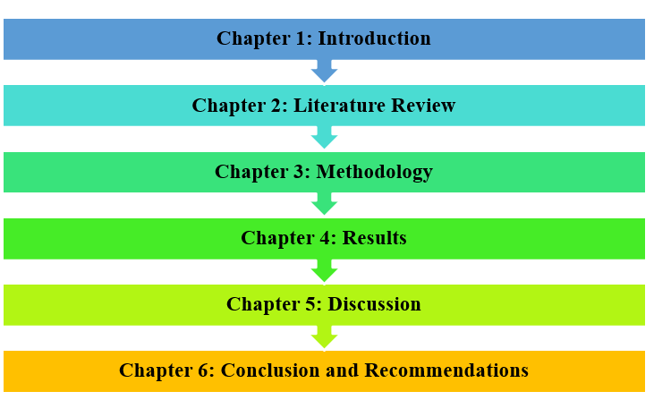

Figure 1.4: Dissertation Structure
(Source: Self-developed)

1.9 Hypotheses and conceptual framework
H1: Brand perception of UK university students towards Adidas significantly impact their purchasing behaviour
H2: Digital marketing strategies of Adisas significantly influence the purchasing intentions of UK university students for Adidas products
H3: Brand loyalty of the university students has a significant impact on their repurchasing intentions for Adidas products
H4: Barriers of brand perception influence the purchasing behaviour of UK university students towards Adidas

Conceptual framework
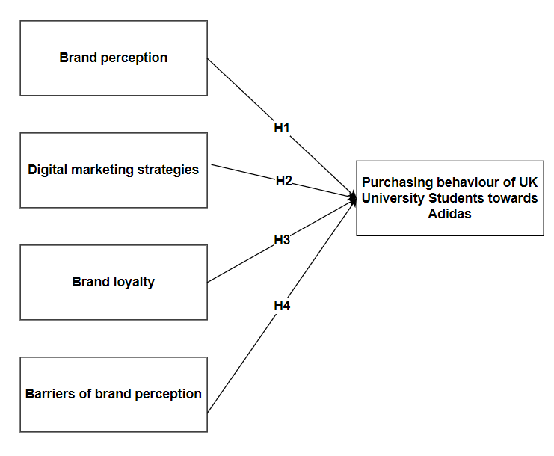

Figure 1.7: Conceptual framework
(Source: Self-created)

1.10 Summary
Therefore, the study summarises that researching the chosen topic is significant as it would provide significant brand management opportunities and similar luxury brands in the UK. As Gen Z holds a significant market share for luxury fashion products in the UK, researching university students is justified. The application of TPB and CBBE are identified as two core theoretical frameworks which explain consumer behaviour and brand management of Adidas effectively.

Chapter 2: Literature Review

2.1 Introduction
This chapter provides the existing knowledge, arguments and concepts on the buying behaviour of university students. The literature review is valuable in providing a comprehensive overview of the existing research on a topic. A literature review allows the researchers and readers to understand the research already done in an area. As this chapter is based on the existing literature, it poses the capacity to turn the wheel of the research. Hence, this chapter is valuable for getting a direction for this research by identifying the research gap.

2.2 Concept

2.2.1 Concept of consumer buying behaviour
It refers to the decision-making approaches and actions of an individual when purchasing any goods or services for their personal activities. The buying behaviour of a customer includes a wide range of activities, starting with problem recognition. The desire for purchasing a product only develops when a customer realises the need or desire for the product (Auf et al. 2018). After this realisation, they start gathering information about the product or service. Search engines or reviews from others are valuable at this stage because they also start comparing the products with the existing ones in the market. Searching for alternatives helps them to decide the best product or service that fulfils their needs. After a thorough evaluation, customers decide to purchase the item or service (Kumar et al. 2022). Several factors can influence customers' purchase decisions. Perception, belief, and motivation are internal or psychological factors, whereas, family, friends and social networks are the social factors.

2.3 Theoretical Framework

2.3.1 Theory of Planned Behaviour (TPB)
TPB is a psychological theory that offers a foundational structure to evaluate the consumer behaviour and purchasing intentions of potential customers (here, university students). According to TBP, the behavioural intentions of an individual are influenced by their attitudes, societal norms and perceived behavioural control (Chicoine, 2023; Figure 2.1). The application of TPB is relevant in this context because it discusses the behavioural beliefs and attitudes of university students toward purchasing Adidas products. On the contrary, as per Adegeest (2022), Adidas has transformed its brand identity from streetwear to high-street luxury fashion after collaborating with Gucci and Balenciaga. This fashion statement of Adidas gained media attention and attracted university students. Similarly, Adidas’s customised collections for university students acted as a major factor that shaped their brand attitude towards the chosen high-street fashion brand (Adidas News, 2023). This symbolises the fact that students of UK universities purchase Adidas products as a symbol of their elevated social status among their peers (Eastman et al. 2020). This helps them to be recognised socially showcasing their desire for luxury and elegant yet comfortable and trendy fashionwear. This further aligns with subjective or social norms, where the students' purchasing intentions align with peer influence in buying premium streetwear fashion products like Adidas. However, perceived behavioural control is a potential factor that identifies the key reasons that disrupt purchasing intentions (Kaur and Bhardwaj, 2021). These align with financial constraints, degraded product quality and declined brand reputation.
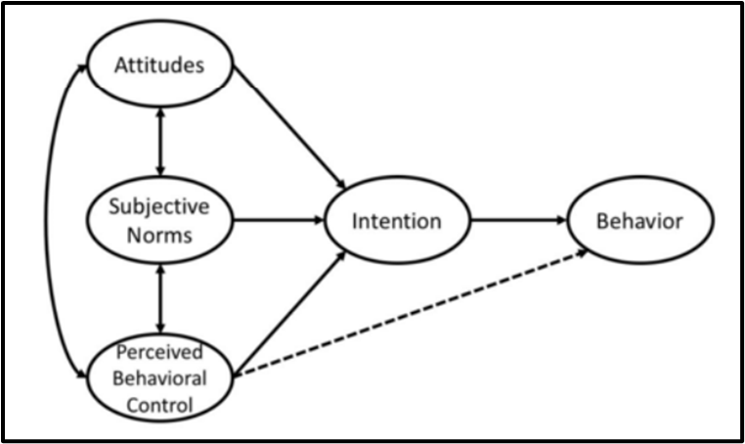

Figure 2.1: Theory of Planned Behaviour (TPB)
(Source: Chicoine, 2023)

2.3.2 Keller's Brand Equity Model
“Keller’s Brand Equity Model or Customer-Based Brand Equity (CBBE) Model” is a theoretical framework that offers the foundation for effective brand management. According to Tran et al. (2020), the CBBE model is distinguished into four layers: identity, meaning, response and relationships. Brand identity or salience determines consumers’ perception towards a brand (Liao et al. 202; Figure 2.2). On the other hand, the second layer is focused on communicating the brand's meaning to customers. This relates to brands’ performance in meeting customers’ demands and expectations. The key performance indicators for this include product quality, durability, customer service, designs and price. In the case of luxury streetwear brands like Adidas, these factors are highly crucial in shaping consumer perception (Ozuem and Ranfagni, 2021; Kelleci, 2022). In contrast, brand imagery determines the brand's appearance to the customers, including its logo and marketing strategies. The next two layers brand response and relationships determine customers' judgement and loyalty towards luxury fashion brands like Adidas. Therefore, the CBBE model depicts that university students’ perception towards Adidas and their purchasing intentions are shaped and influenced by the salience and meaning of the chosen brand.
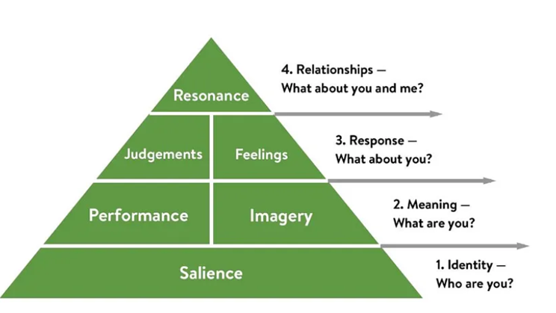

Figure 2.2: Keller’s Brand Equity Model or Customer-Based Brand Equity (CBBE) Model
(Source: Inspired by Stukalina and Pavlyuk, 2021)

2.4 Empirical Findings

2.4.1 Different Factors Influencing Purchasing Intentions of University Students for Luxury Fashion Products
Luxury fashion brands usually target individuals who prioritise social wealth and recognition by using high-end and premium products. College students are becoming prime targets of some brands, especially luxury streetwear because they are willing to pay more for high-quality and better things (Cardillo et al. 2024). The brand attitudes and purchasing intentions of college or university students are influenced by various external and behavioural factors. According to Islam and Singh (2020), brand awareness is one of the most influential factors that impact the purchasing decisions of university students (Refer to Figure 2.3). The authors claimed that college students are more likely to purchase products from a brand that has a positive brand image and social status. Moreover, the author lacked better understanding about brand equity and trust. The mechanism through which brand equity is shapes customers’ purchasing decisions are not discussed. These points are covered by Husain et al. (2022), who argued that brand equity, brand trust, and status consumption strongly influence people's purchasing intentions for luxury fashion brands. The author presented brand equity as the worth of a brand in the eyes of a consumer. The author claimed that brand equity is an important phenomenon which symbolises the superior and premium quality of the products offered by luxury fashion brands. The key strengths of this article are that it reviewed the main factors that influence customers’ purchasing decisions. However, some other factors like social influence, cultural and economic conditions are also responsible for shaping customers’ purchasing decisions. Moreover, the main limitation is that these factors are not identified or explored in this paper.
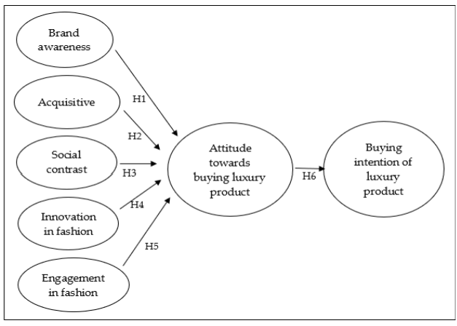

Figure 2.3: Factors that affect purchasing intentions of university students for luxury fashion product
(Source: Islam and Singh, 2020)
On the other hand, Nazarani and Suparnam (2021) contended that product quality is another potential factor that influences the purchasing intentions of customers towards luxury fashion products. The author statistically proved the significant impact of product quality in influencing the customers’ purchasing intentions. For example, customers are more likely to purchase a product from a brand if it offers high-quality materials. Therefore, it can be understood that this research has solely focused on the quality of materials which is the main influential factor for customers’ purchase. However, when it comes to luxury streetwear or sportswear brands, the purchasing intention of university students is also influenced by the comfortability of the products offered by a brand. Thus, the aspects of style and comfortability of luxury streetwear was not explored in this paper. Moreover, these aspects are covered by Gaurav et al. (2020) who presented that comfortability is an important characteristic that resonates with the perceived product quality of sportswear brands. The author further contended that brand value is the most important factor that contributes to the purchasing intentions of youths for sportswear. The author also contended that price is the least important factor that shapes the purchasing intentions of youths for luxury sportswear brands. This indicates that loyal customers of a brand stay loyal to it irrespective of their price.
On the other hand, Islam and Singh (2020) further shed light on the significance of social recognition and peer influence in shaping the purchasing intentions of university students. The author also claimed that students are influenced by the dressing patterns adopted by their peers. This also aligns with the findings of Cardillo et al. (2020) and Pa et al. (2021) who explained that peer influence shapes customers' brand attitudes and purchasing intentions for luxury streetwear brands. The authors also claimed that university students try to fit in with their peers to display trendy tastes. Other than peer influence, Cardillo et al. (2020) explored the importance of various other factors like self-identity, length of use, popularity, prestige and many more that influence students’ purchasing intentions. This is a major strength of this article because it explored various aspects. This also plays a crucial role in shaping the brand perception of the students, especially when they find that purchasing a particular brand product might mean wealth, strong social status, and the ability to lead a fabulous life.

2.4.2 Significance of Different Digital Marketing Strategies in Influencing the Purchasing Intentions of University Students
Companies incorporate various marketing strategies to reach their target audience in a broader context. In the current scenario, companies are employing different digital marketing tactics to reach the target audience irrespective of the geographic barriers. As per the perspective of Al-Azzam and Al-Mizeed (2021), digital marketing efforts play a crucial role in influencing students' decision-making. The authors statistically proved that email marketing, social media marketing, online advertising and mobile marketing are the key digital marketing tactics that influence students' purchasing behaviour. However, the author also claimed that email marketing has the least influence on the purchasing behaviour of students. This is a major gap in this literature which failed to evaluate the impacts of email marketing and proved as insignificant. Moreover, Astoriano et al. (2022) bridged this gap and statistically proved that email marketing is a potential digital marketing strategy. It is found that social media and email advertisements are highly effective in triggering purchasing intention of customers thereby increasing customer engagement. Moreover, in-depth analysis of these factors is found to be lacking in this literature which is a potential limitation. Thus, John et al. (2023) bridged this gap and contended that social media marketing is the most effective digital marketing strategy that highly influences students’ purchasing intentions. The author claimed that social media marketing stimulates materialism and hedonism among students which shapes their intentions to buy luxury products.
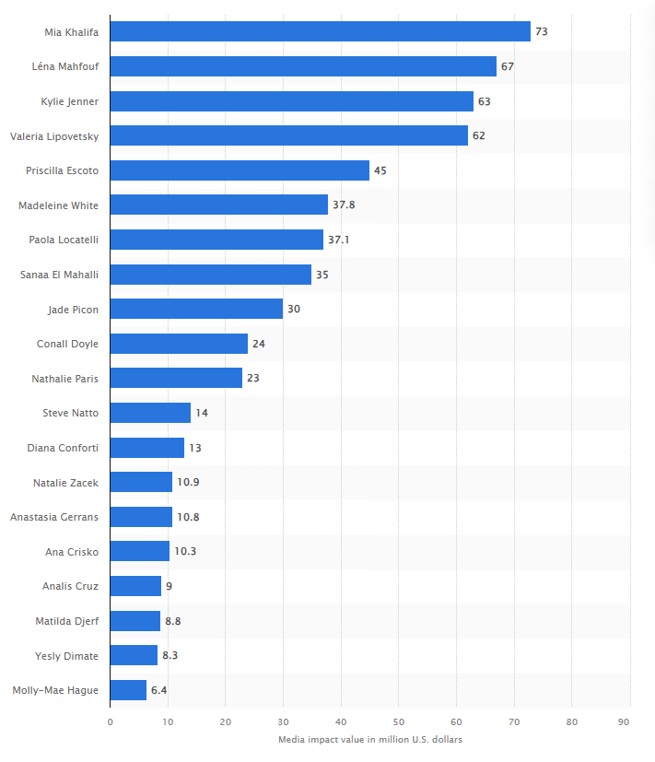

Figure 2.4: Most Influential Fashion Influencers
(Source: Statista, 2024)
In support of this statement, Abdullah et al. (2020) explored that social media influencers (SMI) play a crucial role in shaping the buying behaviour and intentions of university students for different products. SMI posts various informative content in the form of product reviews and recommendations. University students perceive these influencers as highly credible sources because they can interact with the SMIs through comments. In contrast, SMIs are found to be the trendsetters that align with the fashion styles and trends of the youth or university students. Thus, influencer marketing on social media platforms is found to be an important digital marketing tactic that shapes the purchasing intention of customers. As reported by the Statista report, Mia Khalifa is found to be the most influential fashion and sportswear influencer followed by Léna Mahfouf Kylie Jenner and GenZ consumers. Their net media value is found to be 73 million USD, 67 million USD and 63 million USD (Statista, 2024; Figure 2.4). For example, Shirodkar and Deshpande (2021) explained that Adidas often incorporate sports personalities to advertise its sportswear and streetwear range. This influences students and encourages them to purchase luxury streetwear products.
Tseng et al. (2020) suggested that emotional attachment is found to be a crucial factor that develops positive perceptions and influences the purchasing intentions of customers in the luxury streetwear industry. The author claimed that companies are prioritising the development of strong emotional connections with their potential customers. Due to this reason, luxury streetwear brands like Adidas, Nike, Jordan and many others have implemented targeted and personalised advertisement strategies. However, the authors did not mention about the mechanism that is responsible for developing emotional attachment. The literature also did not mention about other strategies of digital advertisements. In contrast, Putri (2021) portrayed online display advertisements such as banners as an effective marketing strategy adopted by different brands to develop brand awareness of customers. Online banners often act as a catalyst that facilitates customers' journey to purchase a product through pay-per-click (PPC). Other than these, Shona and Chuubi (2024) argued that university students are often perceived by targeted advertising and personalised emails and recommendation systems. The authors proclaimed that personalised content created by luxury fashion brands focuses on meeting the requirements of the customers by using historical data. This develops a sense of belonging among the customers thereby influencing their purchasing intentions. Similarly, as indicated by Kaium et al. (2024) and Irelli and Chaerudin (2020), user-generated content is another digital marketing tactic that can influence the purchasing intentions of university students. User-generated content is often generated by bloggers and fashion influencers on social media platforms and other online communities. This helps in developing a positive brand image which in turn shapes the purchasing intentions of university students to buy luxury fashion brands.

2.4.3 Factors Influencing Brand Loyalty and Their Impacts on Repeat Purchase Decisions of University Students
Brand loyalty and the repeat purchase intention of university students depend on various factors. In this regard, Su and Chang (2018) stated that the purchase intentions of university students depend on factors like brand awareness and the perceived value of a brand. Only if university students are familiar with a specific brand and the brand is renowned are their purchase and repeat purchase intentions influenced. The authors also concluded that brand uniqueness, as well as organisational associations, are also equally valuable. Nevertheless, affordability is also a crucial factor that attracts customer attention. The fulfilment of these factors not only influences their purchase decisions but also brand loyalty. Other than the perceived quality of a product, university students look for affordable products. Here, loyalty means the intention to repeat the purchase of the products. However, one of the major limitations of this research is that the authors focused on the self-reported data, which can introduce bias and thus, impact the validity and reliability of research. Moreover, the demographic focus of this study is also narrow which might impact the generalizability to other age groups.
Contrarily, research by "Lau, Chang, Moon and Liu (2006)" covered in the study by Gaurav et al. (2020), demonstrated that university students who are aged between 18 and 24 years are influenced by several factors. In luxury sportswear brands, the most crucial factors that influence their brand loyalty include brand name, quality, product prices, promotional activities, service quality, and store environment. Brands like Adidas, Nike, Fila, and Reebok fulfil the needs of university students. As a result, these luxury sportswear brands influence repeat purchase intentions and brand loyalty. This research is better than Su and Chang’s (2018) study because it covers broader demographics (both male and female from various educational background. The optimisation of a structured questionnaire is a more reliable data to conclude the findings. Most importantly, it examines various factors like quality, price, style, and comfort. These factors offered a more comprehensive view of brand loyalty.
Similarly, Junejo et al. (2018) also conducted another research to determine factors that influence the brand loyalty of luxury sportswear brands among business students. Two of the most influential factors that influence brand loyalty are brand name and price. The brand name is valuable in distinguishing one sportswear brand from another. Effective marketing helps them to recall brand names. The study confirmed that in the case of luxury sportswear bands, customers are even willing to pay high prices for good quality and brand reputation. The other factors are the service quality of the brand, store quality and styles. This study on brand loyalty of sportswear is focused on business students in Hyderabad, Sindh, Pakistan. This study also has few limitations which include a narrowed demographic focus on business students. Narrowed focus may not generalise to other student populations or age groups. Furthermore, it lacks a comprehensive analysis of factors influencing repeat purchase decisions. This study and the study by Jusoh et al. (2023) confirmed that customers become loyal towards a brand if the service quality is highly acceptable. University students also search for a comfortable store environment. Hence, footwear brands that can fulfil these expectations are most likely to develop brand loyalty in the competitive environment.
In contrast to these findings, when a survey was conducted to understand the frequency of purchase of luxury products in the UK and the US, it was found that only 19% of individuals aged 16-24 years regularly purchase luxury products. The 18 to 24 age group refers to the age when students go to their universities (Gaurav et al. 2020). The survey also revealed that 33% of them purchase luxury products as gifts, and 14% of them have never purchased luxury items in their life. The following Figure 2.5 shows the frequency of purchase of luxury goods and services. Therefore, the frequency of purchase (regular treaters) among the University students is low (only 19%).
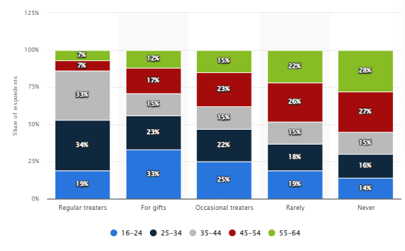

Figure 2.5: Frequency of purchasing luxury goods and services in the UK and the US
(Source: Sabanoglu, 2024)
These are the factors that influence brand loyalty, which ultimately impact the repeat purchase intentions of university students. Contrarily, Pa et al. (2021) showed that university students’ purchase intentions are influenced by service quality and promotions. The study by Pa et al. (2021) is considered better than the previous study by Junejo et al. (2018) for several reason. Firstly, the students included in this study is from various disciplines which offered a more comprehensive overview of brand loyalty across different backgrounds. The study also examines multiple factors influencing brand loyalty (such as brand name, product quality, price, style, store environment, promotion, and service quality). This offers a more holistic understanding of what drives brand loyalty among university students.

2.4.4 Barriers That Develop Negative Brand Perceptions of University Students Affecting Their Purchasing Behaviour
Several factors create barriers to the purchase intentions of luxury brands. Pencarelli et al. (2019) conducted research on the purchase intentions and barriers to purchasing luxury products. The research result revealed that young customers who belong to Generation Y and Z are more concerned about environmental sustainability. The growing awareness of sustainability and "Corporate Social Responsibility (CSR)" impact the CSR activities. The result showed that there was a prevalent tendency of Millennials to perceive sustainability as well as involvement in CSR activities as a modern trend. These trends are currently on the rise, so luxury brands that are not responsible for their actions are not supported to behave according to the trend. Pencarelli et al.’s (2019) study is based on self-reported data which introduced bias to this study. This mainly because respondents may not always accurate in reflecting their true attitude.
In contrast to these findings, Wang et al. (2021) stated that in China, people of all age groups prioritise purchasing luxury fashion products to stay exclusive. The less prioritise sustainable products, unlike the customers in the UK. In the UK, people prioritise purchasing luxury products that are unique and different to that of other products with sustainability features. Nevertheless, in both countries, poor product quality and reliability are the factors that prevent customers from purchasing luxury products. Therefore, the ethical and sustainable practices of luxury brands can be regarded as a factor in influencing or preventing purchase intentions. Wang et al.’s (2021) research is better because the optimisation of “Structured Equation Model (SEM) analysed data from responses gathered from 677 individuals. This ensured robustness and a more reliable result. Moreover, as this study investigated different value proposition such as conformity and exclusivity that influence the purchase intentions of luxury brands.
When purchasing luxury products like sportswear, students prioritise quality and brand name over anything else. In this regard, Sharma et al. (2021) stated that negative experiences of the students with customer support can lead to a loss of trust. A loss of trust in a brand is most likely to impact brand loyalty and customers' intention to purchase from the brand again. The authors further confirmed that the perceived usefulness of the brand and its economic value influence the purchase decisions of students. Luxury brands that fail to fulfil the show have noticed a decline in luxury product purchase intention. Sharma et al.’s (2021) study considered primary qualitative study that offered an in-depth insight into luxury purchase intentions among young consumers. There is very little scope to measure the reliability and validity of qualitative research. Therefore, the subjective responses might introduce bias to the research result.
On the contrary, Koay (2018) argued that the easy availability of replicas of luxury brands or counterfeit products is a major barrier to purchasing authentic luxury brands among university students. The authors also assured that university students receive less financial support from their parents and that luxury brands are expensive. This is the reason they are unlikely to spend on authentic luxury products. Hence, it can be stated that high product prices and the availability of cheaper counterfeit products are two major barriers to the purchase intention of luxury brands. Most importantly, this research used primary quantitative data where 213 was the sample size. The optimisation of SEM-PLS ensured a more reliable result. The results of this research have striking similarities with Abdullah and Yu (2019). This research also revealed that the advertisements of luxurious fashion brands influence the purchase intentions of customers. Nevertheless, price is a major barrier which influences the purchase intentions of counterfeit products among university students. The findings of this research is also better because Abdullah and Yu (2019) considered primary quantitative data. They collected data through a structured questionnaire distributed among university students to comprehend the attitudes and purchase intentions towards counterfeit luxury fashion products. Besides, Nazarani and Suparna (2021) argued that negative feedback from peers or bad reviews also influence how students perceive a brand, which can significantly impact their purchase decisions. Therefore, negative word-of-mouth can also develop a negative perception of a brand and can affect purchase intentions, and this is another barrier in brand loyalty.

2.5 Literature Gap
The literature has developed a detailed understanding of different factors and their influence on the purchasing decisions of university students for luxury fashion products. However, various gaps are noticed within the existing literature sources. For example, Islam and Singh (2020) identified and measured the impacts of different factors that shape brand attitudes and purchasing behaviour of university students. However, the main limitation of the literature source is that the sample was limited to only a few Korean university students. The sample size was also low to develop a generalised outcome. Thus, UK-specific data is missing in this literature source. Similarly, Su and Chang (2018) also discussed the role of brand awareness, product quality, and other factors that contribute to the development of brand loyalty among university students. However, in this case, the literature also lacked insights about UK universities and focused on US universities. Thus, it is identified as an important gap in the literature.
Moreover, other than these issues, the major gaps found in the literature is the lack of specific insights regarding the purchasing behaviour and intentions of university students for Adidas products. The literature by Pa et al. (2021); Al-Azzam and Al-Mizeedshed (2021) and Abdullah et al. (2020) shed light on different factors that promote purchasing behaviour, influence buying behaviour and enhance brand loyalty of university students for luxury fashion or streetwear brands. However, the existing research did not reveal different aspects of Adidas and its marketing tactics that influence university students to purchase products from it. This research would bridge these gaps by integrating primary data from UK university students.

2.6 Summary
Hence, the chapter concludes that university students prioritise various factors like brand awareness, brand reputation, brand equity, brand image, product quality and fashion innovations before purchasing any luxury products. Their purchasing intentions are easily influenced by digital marketing strategies like social media marketing, email marketing, personalised and targeted advertising and so on. The brand's ability to maintain consistency in product quality and better brand equity enhances the brand loyalty of the university students. As a result, this leads to customers making repeat purchases in the future.

Chapter 3: Research Methodology

3.1 Introduction
The methodological framework is the third framework of research which intends to analyse the key methodological approaches and tools adopted to conduct research. This chapter has discussed the philosophical assumptions, reasoning approach, design, data collection and analytical instrument applied for achieving the key objectives.

3.2 Research Onion
Research onion is an instrument proposed by Saunders et al. (2006) that aims to discuss the method of writing a dissertation at in six key stages. The research onion has six key layers which are peeled throughout the process to discuss each methodological consideration. [Refer to Figure 3.1]
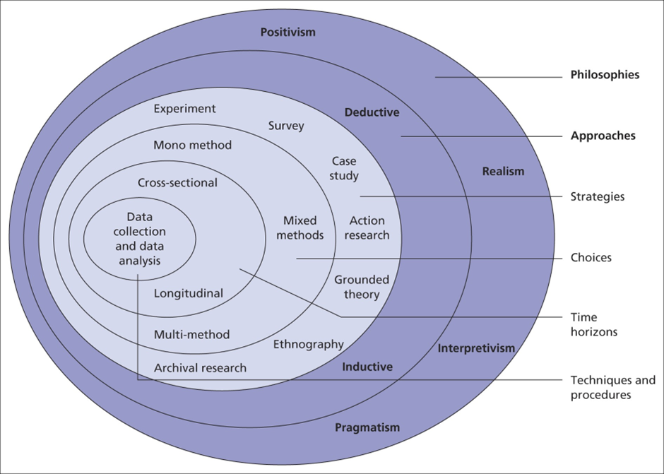

Figure 3.1: Research Onion
(Source: Saunders et al. 2006)
The research has adopted mono-method quantitative research choice based on which other considerations were made. Positivism philosophy along with deductive approach was adopted to analyse factual data and develop robust outcomes through quantitative data. Survey strategy was used to collect cross-sectional quantitative data followed by statistical data analysis. More details on these layers are discussed below.

3.3 Research Philosophy
Research philosophy is a broad term associated with the development and nature of specific knowledge. The ontological paradigm that has been used in this research is objectivism because the study focused on analysing singular reality through a quantitative research method. Saunders et al. (2009) claimed that “positivism, interpretivism, realism and pragmatism” are the four epistemological paradigms used by researchers in the current scenario. This research is considered a positivist philosophy because it followed the quantitative research technique.
Justification
Objectivism and positivism philosophical framework are considered in this research because it focuses on measuring the objective reality behind the consumer behaviour of college students regarding their buying intentions for Adidas products (Akpan, 2022). The selection of the positivism philosophy and objectivism is done based on the objectives and key research questions prepared in the first chapter. For example, the first objective was framed to measure the impacts of key factors that shapes brand perception of university students towards luxury fashion. The process of measuring the impacts of these factors on influencing the purchasing behaviour of these students justifies the objective nature of the research. Similarly, objectivism also helped in quantifying other factors like the digital marketing strategies, brand loyalty and barriers to brand perceptions which are further framed in Objectives 2, 3 and 4. These factors have been considered as independent phenomena that are responsible for impacting the buying decisions of college students in the UK for Adidas products. On the contrary, as per Younus and Zaidan (2022), the application of positivism philosophy helped in using empirical evidence as well as observable phenomena to derive scientific knowledge on the concerned research topic. This indicates that the positivism philosophy enabled the scientific analysis of consumer behaviour of college students towards Adidas products by collecting and analysing quantifiable numeric data.

3.4 Research Approach
According to Okoli (2023), deductive and inductive are the two main research approaches adopted by researchers based on their process of testing or generating hypotheses. This study adopted a deductive approach to reasoning which focused on deducing a hypothesis to explain the causal relationship between different variables.

Justification
The research employed a deductive approach since its main goal was to determine the causal relationship between the “dependent variable” (buying intentions) and “independent variables” (brand perception, digital marketing strategies, brand loyalty and barriers). Here, the TPB theory and Keller’s brand equity model (CBBE) theory is adopted as the foundational framework for the study. Thus, the quantitative data findings used a deductive approach to test the principles of these two theories (Kyando et al. 2022). This is done by analysing brand attitudes, perception, loyalty, brand identity and various other factors that influence the buying intentions of Adidas products by college students (Okoli, 2023). For example, the factors related to TPB principles such as social influence, brand awareness, product quality and others are tested to measure their impacts on students’ purchasing attitude and frequency. Furthermore, the impacts of brand equity, image and reputation and their impacts on students ‘purchasing frequency were hypothesised to generalise the findings using CBBE model. This is effective to address the first research objective and answer the adjacent research question. Similarly, the application of TPB and CBBE model also helped in achieving the second objective. For example, the impacts of social influence (influencer marketing and social media tactics) and ease-of-purchase (online banners and ad posts, targeted advertising, tailored emails) on shaping purchasing decisions of university students are measured. The impacts of these factors on developing brand resonance are also measured through hypothesis testing using deductive approach. The use of deductive approach to test hypothesis are further repeated for the third and fourth objectives as well. The hypothesis testing method enabled the researcher to prove that brand attitudes, perception, loyalty, and brand identity significantly influence college students’ buying preferences for Adidas products.

3.5 Research Design
This research was proceeded by considering the explanatory research design. Pandey and Pandey (2021) opined that the explanatory research design focuses on collecting numeric information and testing theory for establishing the “cause-and-effect” relationship between different variables.
Justification
The explanatory design is suitable for this quantitative study because it aims to explore the reasons behind the high consumption of Adidas products by university students in the UK. The employment of this design enabled the researcher to explain the impacts of social, psychological as well as materialistic factors on the preferences of university students for buying luxury fashion products. As mentioned earlier, explanatory research design analyses the causal relationship between different variables of a study (Ghanad, 2023). In this study, the effects of brand image, peer pressure, marketing strategies and brand loyalty on purchasing Adidas products repeatedly and further recommending them to others are measured by utilising explanatory design. As a result, the objectives and the research questions are addressed effectively.

3.6 Research Strategy
A survey strategy has been adopted to collect quantitative data from the students. The process involved the collection of numeric responses from the research participants through an internet-based (self-administered) questionnaire. The survey strategy helped in developing a structured and comprehensive questionnaire relevant to the research questions and objectives (Anwar and Abdullah, 2021). For example, close-ended questions were prepared to measure the satisfaction level of the university students regarding the product quality, style and comfort, brand equity, peer influence, diverse brand portfolio and other factors related to Adidas products. This helped to measure the impacts on these factors in developing brand satisfaction and awareness (Ilyas et al. 2020). It addresses the first objective which is concerned about analysing the impacts of brand perception factors on shaping purchasing behaviour of the university students. Similarly, for objective 2, questions were framed based on digital touchpoints such as social media posts, online banners, influencer marketing, email marketing and others. This helped to capture measurable insights on these factors and assess their impacts on consumers’ attitudes and brand equity of Adidas. The questions for Objectives 3 and 4 are also prepared based on the key factors like past purchasing behaviour, future intentions, price sensitivity, quality degradation, unethical practices and many more.

3.7 Research Method
As per the perspective of Cresswell (2002), the research method is classified into three main categories: “mono method, mixed method and multi-method. This research considered mono-method quantitative in which numeric data were collected from human participants (Taherdoost, 2021).
Justification
Mono-method quantitative has been considered for this research because the chosen topic is focused on measuring the impacts of different factors that shape the buying intentions and purchasing behaviour of university students. The key objectives framed in the first chapter align with the methodological approaches that prioritise the exploration of the objective reality of a research topic (Al-Ababneh, 2020). Real-time data about brand preferences and fashion consumption of university students was collected through primary method. Subjective biases were eliminated from this study by collecting quantitative data. This helped in developing meaningful insights into the factors that contribute to the purchasing behaviour and intentions of the university students for Adidas products (Jamieson et al. 2023).

3.8 Data Sampling Collection

3.8.1 Data Sampling
Sampling is important in primary research because collecting the responses of an entire population is unfeasible because of time, financial and resource limitations. A homogenous purposive sampling was considered in this study. Students from different universities are selected as the key participants. As per the perspective of Nyimbili and Nyimbili (2024), a homogeneous purposive sampling method has been considered because the study focused on recruiting participants with similar characteristics such as age, background, education and so on. Here university students have been considered who belong to a particular age group and have almost similar occupational backgrounds (as students). In this survey, 57 people were invited for the survey from which 50 people attended the survey.

3.8.2 Data Collection Method and Instrument
The research proceeded by using a “self-administered questionnaire” to gather numeric data from primary research participants. As opined by Faris et al. (2021), an internet and intranet-mediated questionnaire was selected as the primary data collection tool. An online survey method was considered in which “self-administered questionnaire” was prepared and utilised emails and social media platforms to reach the participants (Hooley et al. 2012; Theron et al. 2024). Students from different UK universities are recruited through their social media accounts and further reached through their emails.
The survey consisted of twenty-five closed-ended questions, the first three of which dealt with demographic characteristics. As mentioned in section 3.6, the research objective and questions were used as the key foundation to make the remaining questions of the survey questionnaire. According to Rich (2011), SurveyMonkey, Bristol Online and Qualtrics are some of the popular electronic web-based survey instruments used in research. However, Google Form is used in this study because it is simple and easy to handle. The questionnaire design that was applied to frame the objective-specific questions is a rating style. The responses were collected through ordinal data such as rating from 1 to 10 [refer to Appendix 1].

3.9 Data Analysis
This process deals with the interpretation of information collected from the data sources. According to Mohajan (2020) and Christou (2022), quantitative data is analysed statistically whereas qualitative data is analysed thematically. As this study is considered a quantitative research method, the statistical data analysis process is accepted. The descriptive analysis method was applied to analyse the collected quantitative information. In this method, the surveyed data are presented in tables and the central tendency of the data is measured by calculating mean, median and mode. On the contrary, the inferential analysis was conducted using the SPSS software. The key inferential statistics that were collected in this research are “correlation, regression and ANOVA” (Kinnear and Gray, 2007). These statistical tests were performed to measure the impacts of different external factors on influencing the purchasing behaviour of university students for Adidas products.

3.10 Ethical Consideration
The research was conducted by maintaining strict adherence to the ethical norms associated with business research. The research stringently complied with the rules and standards of the “UK Data Protection Act 2018” in regard to the use of participants' data in the exploration (Gov.uk. 2024). The anonymity and confidentiality of the research participants were strictly followed throughout this research. This suggests that the participants' identities were never uncovered in the public domain and the privacy of their commitment to the exploration was completely maintained. The survey did not enrol any vulnerable populace. Sensitive questions which could harm the oral integrity were not asked. A strong password-protected system was used to store data and only researcher and the supervisor accessed the data. Furthermore, the participation was completely voluntary and informed consent were taken from the participants before starting the survey.

3.11 Research Limitations
The outcomes of the research were harmed due to the presence of certain limitations. Time constraints are one of the major limitations of this research for which a large sample size cannot be adopted. On the contrary, response bias is another major limitation because the asked questions might have different meanings for different individuals. On the contrary, many participants might have not completed the full survey which led to a low response rate. Furthermore, a lack of in-depth understanding could be a potential limitation because of the lack of qualitative data.

3.12 Summary
The chapter summarises that the research objectives are addressed using primary quantitative research method. Positivism philosophy along with deductive approach and explanatory research design was adopted to generate reliable and valid results by using factual data. Primary data was used to get real-time insights, and statistical analysis was adopted to maintain the objectivity of the research.

Chapter 4: Results

4.1 Introduction
This chapter holds immense significance in this dissertation. The quantitative findings are analysed statistically in this section. Both “descriptive and inferential statistics” are performed in this chapter to study the characteristics of responses and analyse the causal relationships between each variable.

4.2 Descriptive Statistics

4.2.1 Demographics
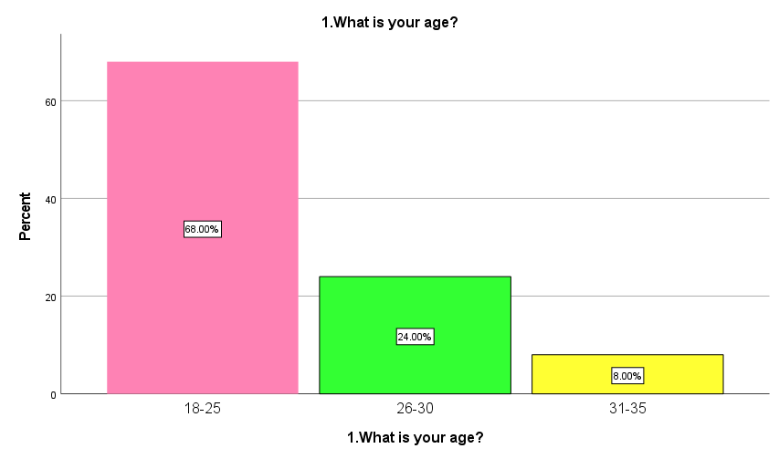

Figure 4.1: Age
The above graph implies that 34 participants who responded to this survey are 18 to 25 years of age. Another age group that holds the next majority is 26 to 30 years old (12 participants). The survey findings indicate that the college and university goers are mainly 18 to 30 years old. As opined by Twenge (2023), this age group falls under the GenZ and Millennial audiences who are the key target of this project.
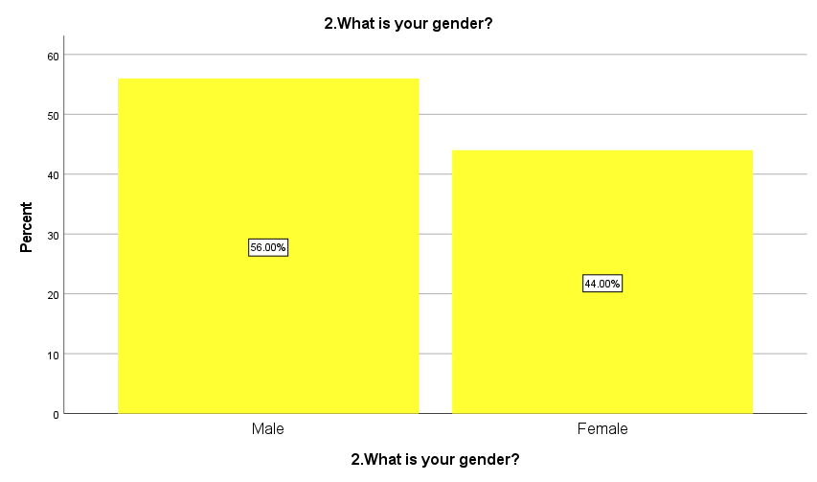

Figure 4.2: Gender
The survey findings on the gender of the participants symbolises that diversity is maintained in the research and both male (28) and female (22) university students prefer to buy products from Adidas.
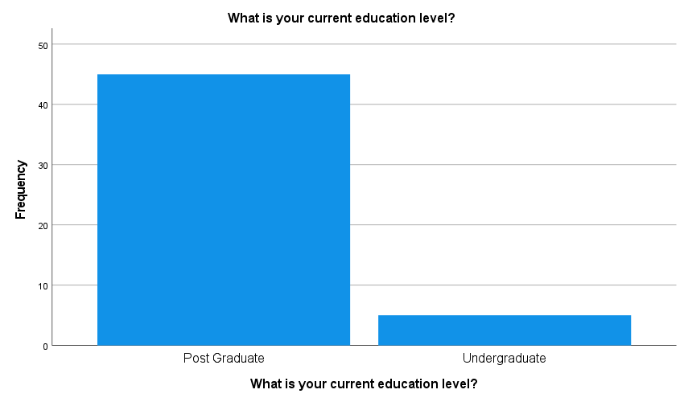

Figure 4.3: Education Level
The graphical representation suggests that most students who participated in this survey are pursuing post-graduation (90% or 45) from different universities in the UK. However, a minor group also belongs to the undergraduate students (10% or 5).

4.2.2 Variable Statistics
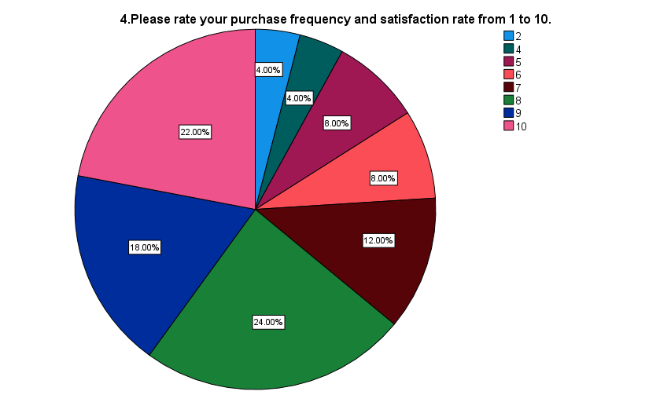

Figure 4.4: Purchase frequency and satisfaction for Adidas Products
The pie chart explains that the majority of the participants rated their purchasing frequency and satisfaction level with Adidas products from 8 to 10 (12 participants rated 8, 9 participants rated 9 and 11 participants rated 10). The value signifies that the university students of the UK are highly satisfied with Adidas products which further influenced their purchasing behaviour. The mean value of responses is 7.70 which means an average number of participants rated their purchasing frequency and satisfaction rate between 7 and 8. This aligns with Kataria and Saini (2020), who argued that customer satisfaction is the mediator of purchasing behaviour and brand loyalty. However, the standard deviation (SD) is valued and 2.073 which signifies dispersions in customers’ responses in the survey.
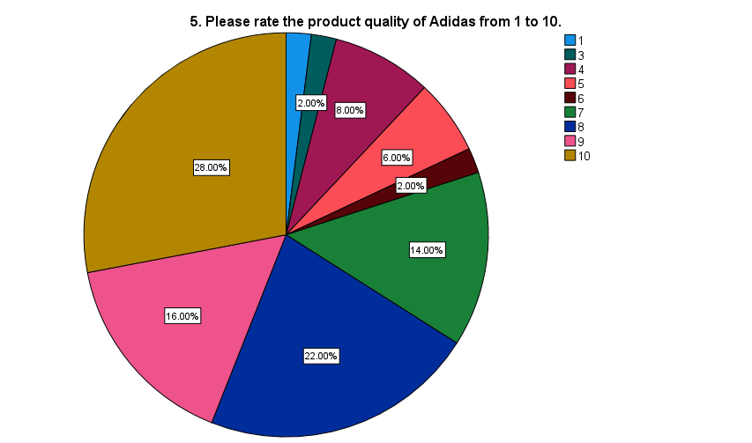

Figure 4.5: Product Quality
The pie chart implies that most of the participants (approximately 66%) have rated the product quality of Adidas as 8 or higher. The percentage for rating 10 is found to be the highest (11 participants rated 8, 8 participants rated 9 and 14 participants rated 10). The mean value of responses is 7.80 which means an average number of participants rated Adidas’s product quality between 7 and 8. This implies that the university students of the UK are highly satisfied with Adidas’s product quality. Moreover, the SD value is 2.204 which symbolises variations in participants’ responses.
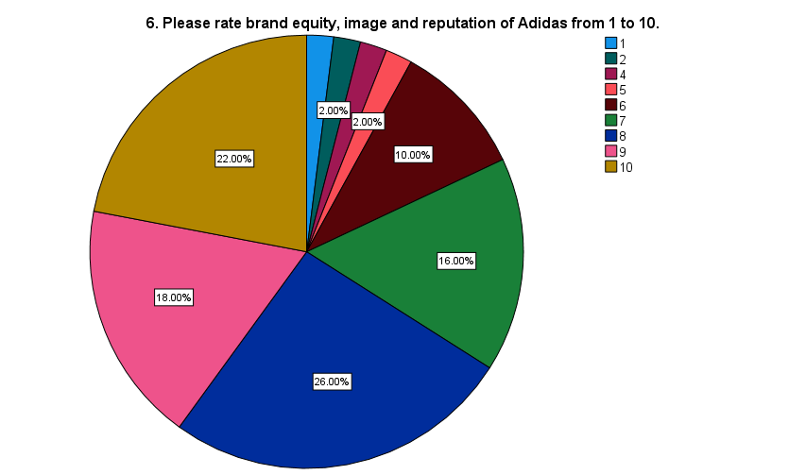

Figure 4.6: Brand equity, image and reputation
Based on the above chart, the brand reputation, image and equity of Adidas are positively perceived by university students. This is evident through a 26% (13 participants) response for rating 8 and a 22% (11 participants) response rate for 10. The mean value of responses is 7.86 which means an average number of participants rated the brand equity, image and reputation of Adidas between 7 and 8. However, a total of 8% of respondents rated the brand below 6 (1 participants each rated 1 to 5 and 4 participants rated 6). This signifies the variances in individual responses. This can be justified by the SD value of 1.969 in descriptive statistics.
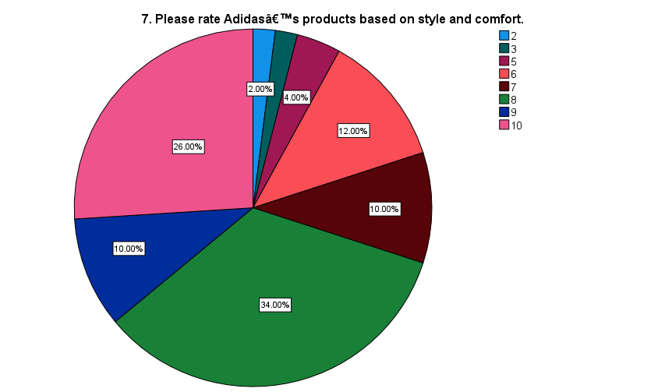

Figure 4.7: Style and comfort of products
Most of the university students rated Adidas products as 8 or higher for their style and comfort. 34% (17) of them rated 8 and 26% (13) of them rated 10. The mean value of responses is 7.94 which means an average number of participants believe Adidas’s products to be stylish and comfortable and thus rated between 7 and 8. This aligns with Munir (2020), who argued that style and comfort are two critical attributes that customers seek while purchasing fashion items. Moreover, the SD value of 1.834 determines the dispersion and variations in participants’ responses.
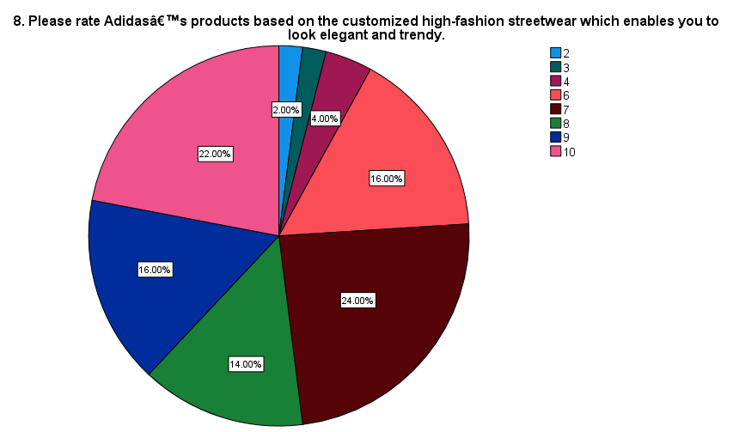

Figure 4.8: Elegant and trendy customized high-fashion streetwear
The pie chart highlights that most of the participants rated the product customisation of Adidas between 7 and 10 (12 participants rated 7, 7 participants rated 8, 8 participants rated 9 and 11 participants rated 10). This is also evident in the mean value of 7.66 which implies that an average number of participants believe the same. This implies that product customisation is highly valued by customers which impacts their purchasing intentions (Linardi et al. 2024). However, a rating below 6 suggests that some students might not resonate with the customised high-street fashion trends. This variation in responses can be justified by the SD value of 1.934.
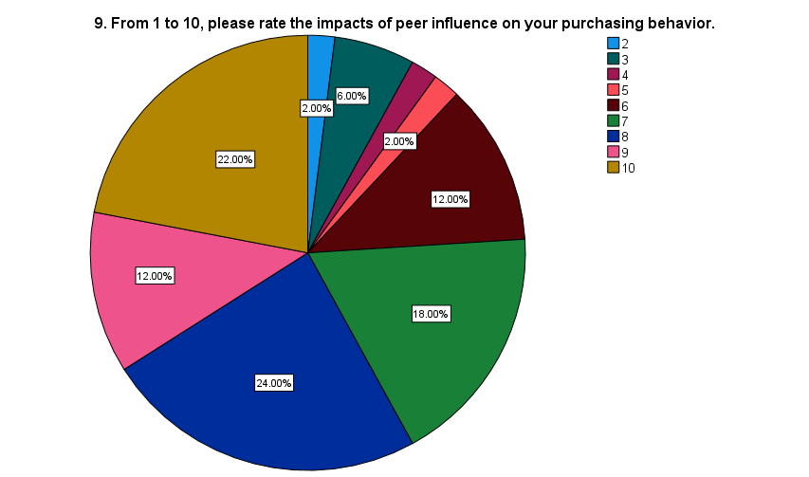

Figure 4.9: Role of peer influence
The graphical representation determines that peer influence is a potential factor (12 participants rated 8, 6 participants rated 9 and 11 participants rated 10) that influences the purchasing behaviour of students in different universities (Gunawan et al. 2023). This is also evident in the descriptive statistics where an average number of participants rated 7.58 to the influence of this factors. The response rate below 6 (1 participants rated each for 2, 4 and 5; 3 participants for 3 and 6 participants rated 6) suggests exceptional students who do not get influenced by peer pressure or recommendation. This variation is further explained by the SD value of 2.071.
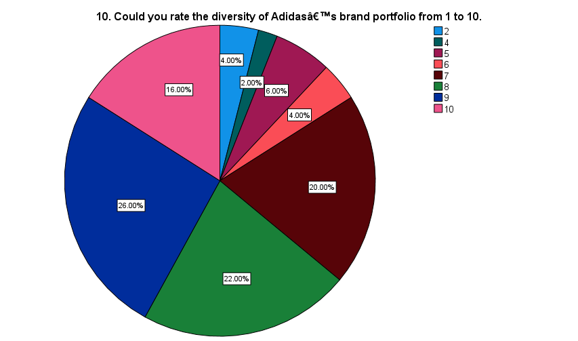

Figure 4.10: Diversity of brand portfolio
The maximum number of respondents rated 7 and 9 to the diversity in product range which is a major cause of customer satisfaction (10 participants rated 7, 11 participants rated 8 and 13 participants rated 9). This is evident in the mode value of 9. However, an average number of participants rated 7.80 which is evident in the mean value. Thus, their purchasing frequency is highly influenced by Adidas’s product portfolio (Adidas Group, 2020). Moreover, there are variations and dispersions in the responses which is evident through the SD value of 1.895.
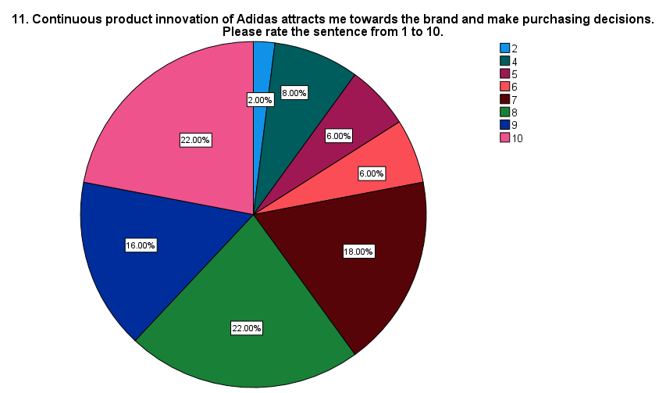

Figure 4.11: Continuous product innovation
Adidas is known for its continuous product innovation which influences customers’ purchasing behaviour (Adidas Group, 2024). Most of the participants (9 participants rated 7, 11 participants each rated for 8 and 10 and 8 participants rated for 9). rated product innovation 7 to 10 which identifies it as a potential factor that influences customers purchasing intentions. The mean value of this question’s responses is 7.68 whereas the SD value is 1.994. This means the dispersion in participant’s responses.
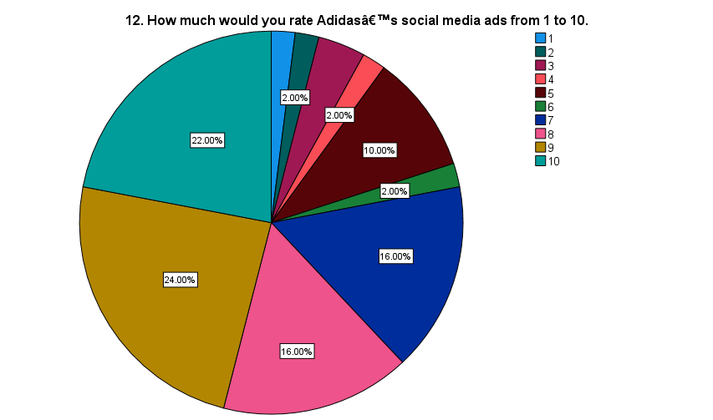

Figure 4.12: Effectiveness of social media ads
The social media ads of Adidas are highly welcomed by university students (8 participants each rated for 7 and 8, 12 participants rated for 9 and 11 participants rated for 12). This aligns with the mean value of 7.64 which symbolises an average number of participants agree with this fact. According to Kolhar et al. (2021), the time spent on social media by university students is generally higher than others. Moreover, variations in the responses are also noticed which is evident through the SD value of 2.292.
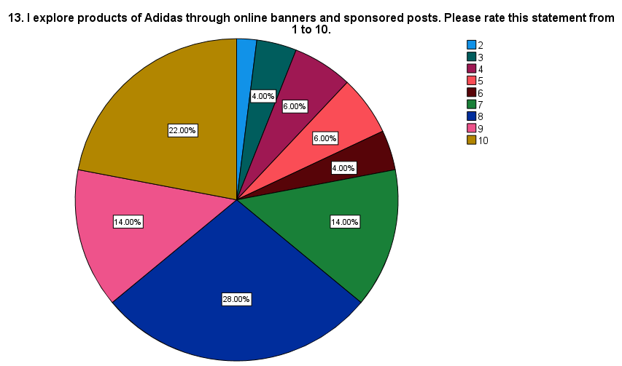

Figure 4.13: Online banners and sponsored posts
Most of the participants (64%) (14 participants rated 8, 7 participants rated 9 and 11 participants rated 10) rated online banners and sponsored posts of Adidas from 8 to 10. The mean value for this response is 7.62 which aligns with the asked fact. This implies that surfing online banners and sponsored content of Adidas is common. Moreover, dispersion in participant’s responses is also noticed which is justified through the SD value of 2.118.
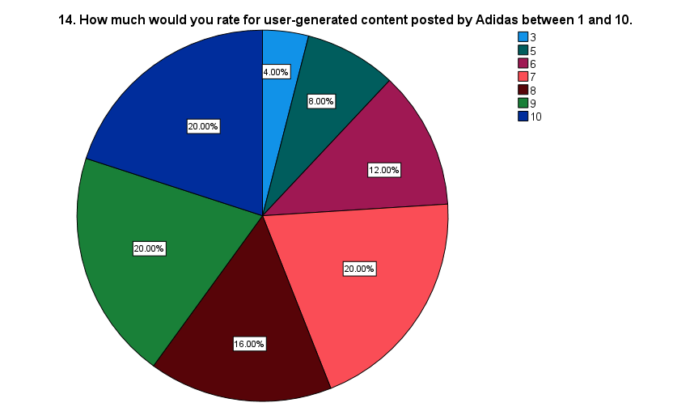

Figure 4.14: Impacts of user-generated content posted by Adidas
Belonging to GenZ, university students prioritise authenticity and personal connection which can be developed through user-generated content (Perera et al. 2020). Due to this reason, most students (56%) rated the user-generated content with 7 or higher values (10 participants rated each for 7, 9 and 10 and 8 of them rated 8). This aligns with the mean value of 7.72 where the average number of participants believe the same. However, disagreement towards the fact is also evident in the SD value of 1.841.
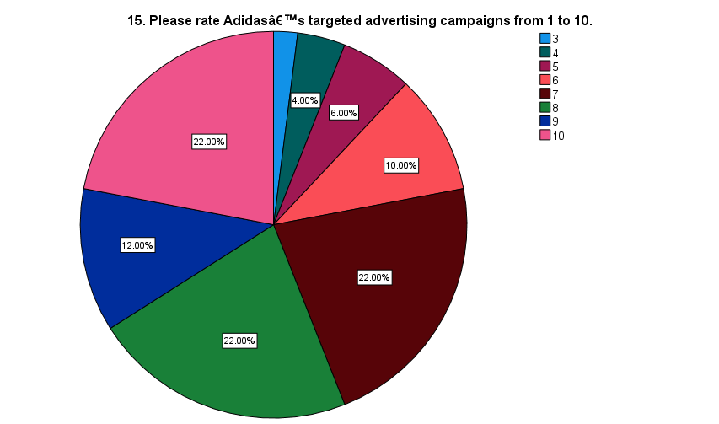

Figure 4.15: Targeted advertising campaigns of Adidas
56% of respondents rated them 7 or higher to the targeted advertising campaigns of Adidas. The most common ratings are 7, 8, and 10, each receiving 22% (11 participants each) of the responses. This aligns with Lee and Cho (2020), who argued that targeted advertising is highly effective in developing a sense of community and belonging. The average value (mean) for this response is 7.70 with the SD value of 1.810.
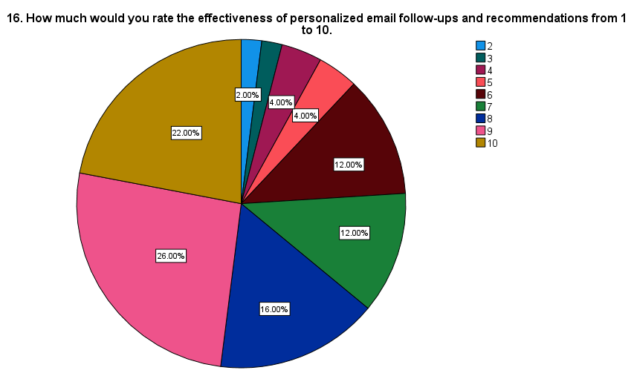

Figure 4.16: Personalized email follow-ups and recommendations
The effectiveness of personalized email follow-ups and recommendations is rated positively, with 48% of respondents giving it a score of 9 or 10. The most frequent rating is 9 (26% or 13 participants), followed by 10 (22% or 11 participants). This aligns with the average value of 7.84 and mode of 9. However, 24% rated it 6 or lower, indicating that while many find these personalized communications effective, there is a segment that feels improvements could be made. This indicates dispersion in responses which is evident through the SD value of 2.004.
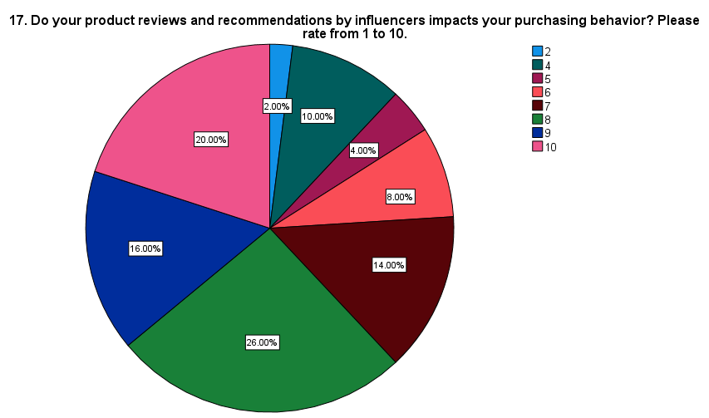

Figure 4.17: Product reviews and recommendations by influencers
Influencer recommendations are one of the most essential factors that facilitate the purchasing intentions of university students (Chetioui et al. 2020). This is why most participants in the survey rated the influencer marketing of Adidas from 8 to 10 (12 participants rated for 8, 8 participants rated 9 and 10 of them rated 10). This is evident with the mean value of 7.62 and mode value of 8. The SD value of 2.009 justifies dispersion in responses.
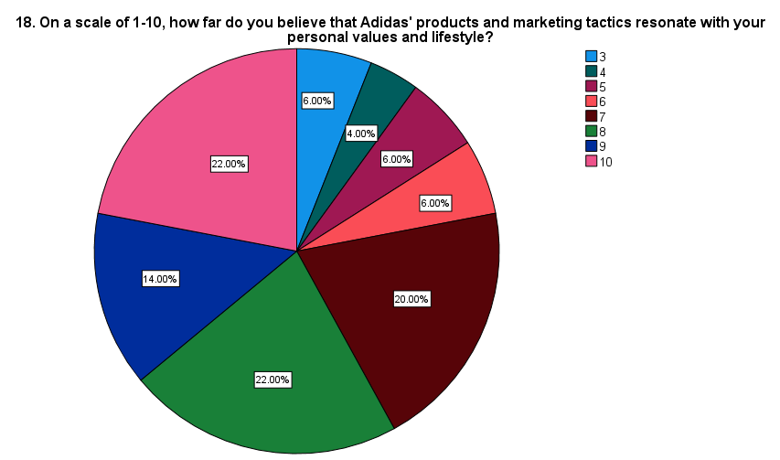

Figure 4.18: Resonance of marketing tactics with personal values
A majority of respondents (58%) rated Adidas' products and marketing tactics resonate strongly with their values and lifestyle. The highest ratings were 8 (22%) and 10 (22%) or (11 participants each) which shows Adidas aligns well with the values of many customers. The mean value (average) for the responses is 7.62 which signifies agreement with the fact. Moreover, the SD value is 2.019 which implies dispersion in the responses.
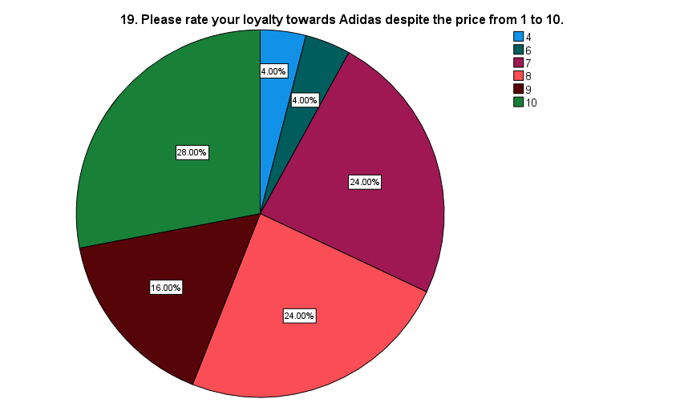

Figure 4.19: Brand loyalty
The pie chart shows that most of the participants (14 participants rated 10 and 12 participants each for 7 and 8) in the survey are brand-loyal to Adidas despite the price with a mean value of 8.24. This implies that brand loyalty of the customers influences their repeat purchasing intentions thereby enhancing the overall purchasing frequency. Variations in responses are also evident through the SD value of 1.519.

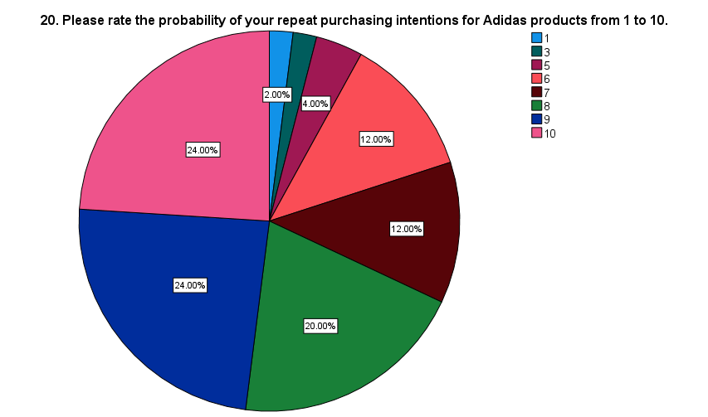

Figure 4.20: Repeat purchasing intentions
A high probability of the participants for repeat purchases is noted which is evident through their 9 and 10 ratings (12 participants each for 9 and 10 and 10 participants rated 8) with a mean and mode values of 8 and 9. This implies that a strong customer base is likely to continue purchasing Adidas products. Variations in responses are also evident through the SD value of 1.927
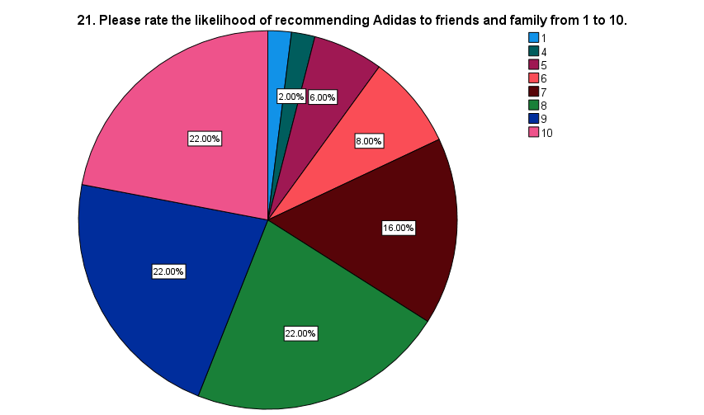

Figure 4.21: Likelihood of recommending Adidas to friends and family
The pie chart tested the brand loyalty of university students towards Adidas in terms of their probability of recommending it to others. It is noticed that most of the participants rated from 8 to 10 (or 11 participants each) with a mean and mode values of 7.94 and 8 which implies their strong brand loyalty. Dispersions in responses are also evident through the SD value of 1.867
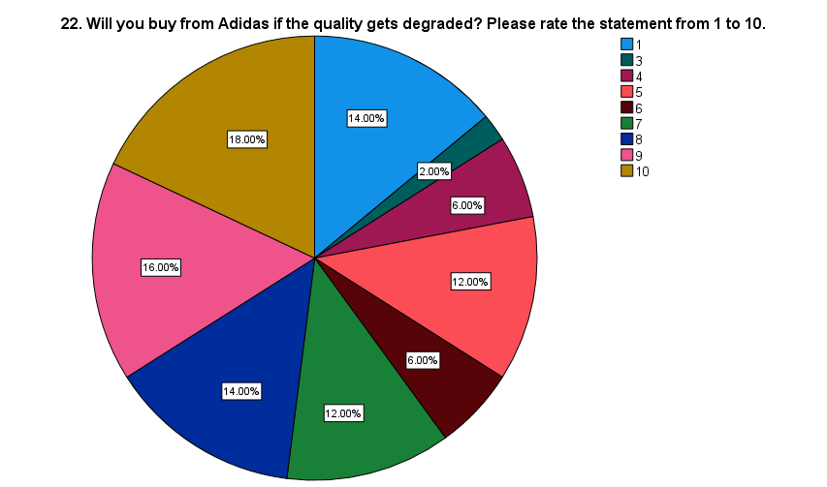

Figure 4.22: Quality degradation
The pie chart suggests that customers strongly agree with their purchasing intentions from Adidas even if its product quality declines (7 participants rated 8, 8 participants rated 9 and 9 participants rated 10). This is evident in the mean value of 6.60. However, the survey findings signify a strong dispersion (7 participants rated 1, 3 participants rated 4 and 6 and 6 participants rated 5 and 7) of the university students towards Adidas which is noticed with the SD value of 2.976.
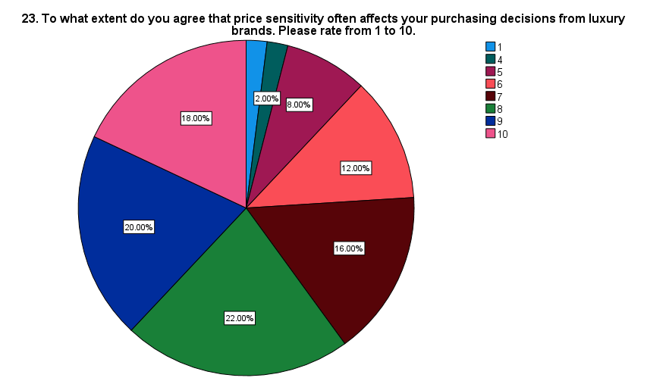

Figure 4.23: Price sensitivity
The chart shows that a majority of the participants are less likely to buy from Adidas due to price sensitivity. This is evident in the survey responses where 22% (or 11 participants) rated 8, 20% (or 10 participants) rated 9, and 18% (or 9 participants) rated 10 regarding the impacts of price sensitivity on their purchasing intentions with a mean of 7.70. This implies that price is a crucial factor that influence customers’ purchasing decisions (Hanaysha et al. 2021).
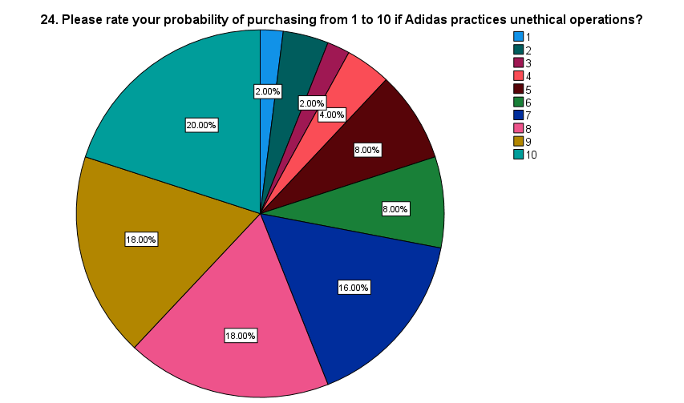

Figure 4.24: Unethical operations
It is found that a significant number of participants are still likely to purchase products from Adidas even if it practices unethical practices (9 participants each rated 8 and 9 whereas 10 participants rated 10). The mean value of 7.38 implies that most people prioritise brand loyalty, convenience and price over ethics and sustainability.
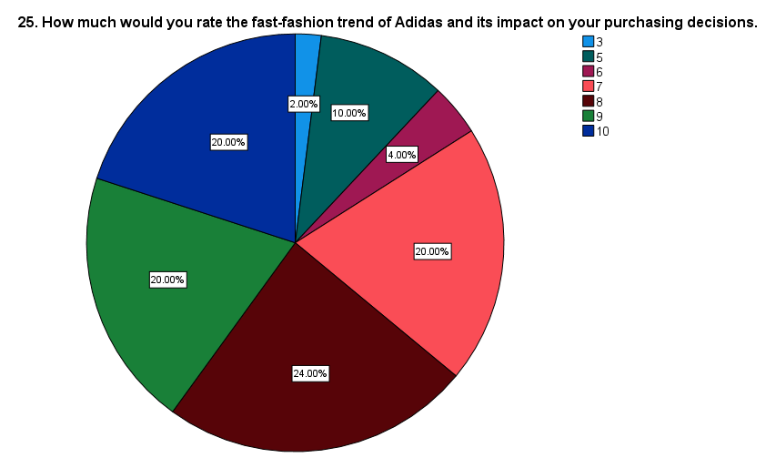

Figure 4.25: Fast-fashion trends
The highest rating is noticed in 8 (24% or 12 participants), 9 (20% or 10 participants) and 10 (20% or 10 participants) regarding the fast-fashion trends of Adidas. The mean value of 7.92 implies that despite the issues with the fast fashion model, loyal customers are very likely to stay loyal to Adidas and purchase its products.

4.3 Inferential Statistics

4.3.1 Findings of Objective 1
H1₀: Brand perception of UK university students towards Adidas does not have any impact on their purchasing behaviour
H1: Brand perception of UK university students towards Adidas significantly impacts their purchasing behaviour
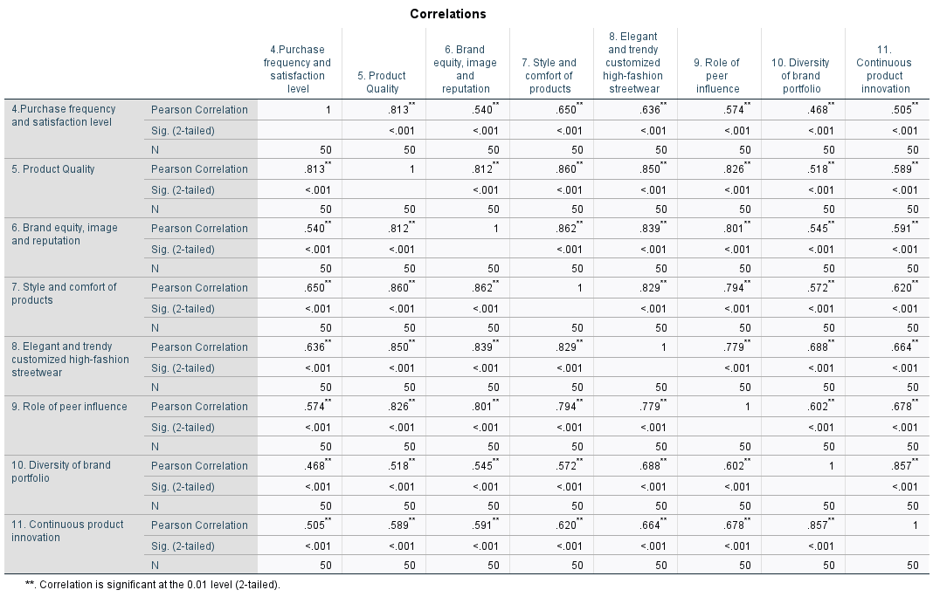

Table 4.1: Correlation between brand perception and purchasing behaviour
The above table highlights multi-collinearity in the model which symbolises the impacts of multiple factors on the purchasing frequency and satisfaction of the university students for Adidas products. Table 4.1 suggests that product quality is the most significant factor that influences the purchasing frequency of customers (r= 0.813; p-value< 0.01). This aligns with Jhonson (2023) who argued that Adidas is known for producing high-quality footwear and other related products.
A positive correlation of (r= 0.650; p-value< 0.01) between style and comfort of products and purchasing frequency suggests that university students perceive Adidas products as stylish and comfortable. For example, Narang (2024) argued that Adidas men’s shoes are durable, high-quality and comfortable for any physical activity. The unique designs and cushioned soles of the shoes offer long-lasting support which makes the shoes more comfortable and durable. On the contrary, the high-street fashion customisation curated uniquely for university students is also positively correlated to their purchasing frequency and satisfaction rate (r= 0.636; p-value< 0.01). This indicates that Adidas offers trendy and customised streetwear collections that resonate with the style and personalities of university students. As a result, this develops a positive brand perception thereby enhancing their purchasing frequency from Adidas.
The positive correlation of 0.574 at a p-value less than 0.01 between peer influence and purchasing frequency signifies the role of social dynamics in influencing students’ purchasing decisions. The correlation between purchasing frequency and brand equity and image, diversity of product portfolio and continuous product innovation are 0.540, 0.468 and 0.505 at a p-value less than 0.01. The correlation between brand diversity and continuous innovation is 0.857 which suggests that Adidas continuously innovate its products to develop a diverse portfolio. This develops a positive brand image followed by influencing the purchasing intentions of university students.
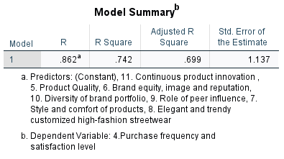

Table 4.2: Regression
The R-square value is 0.742 which means around 74.2% of variances in the purchasing frequency of university students is explained by different factors of brand perception for Adidas products. The adjusted R-square is 0.699 which signifies a 69.9% variance explains the test its a good model fit.
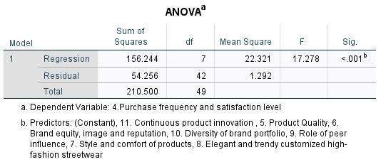

Table 4.3: ANOVA
The “F-statistics” of 17.278 justifies the impact of different factors of brand perception on purchasing behaviours of the university students for Adidas products are statistically significant.
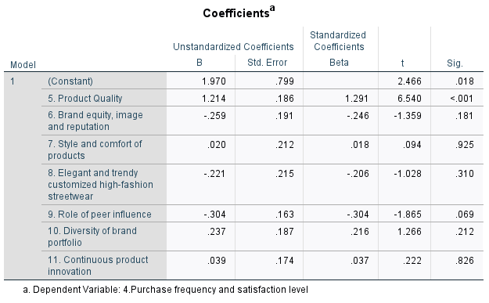

Table 4.4: Coefficient
The coefficient findings symbolise that the product quality of Adidas is the most significant predictor that has the highest and most significant impact on the purchasing intention of university students.

4.3.2 Findings of Objective 2
H2₀: Digital marketing strategies of Adidas significantly influence the purchasing intentions of UK university students for Adidas products
H2: Digital marketing strategies of Adidas significantly influence the purchasing intentions of UK university students for Adidas products
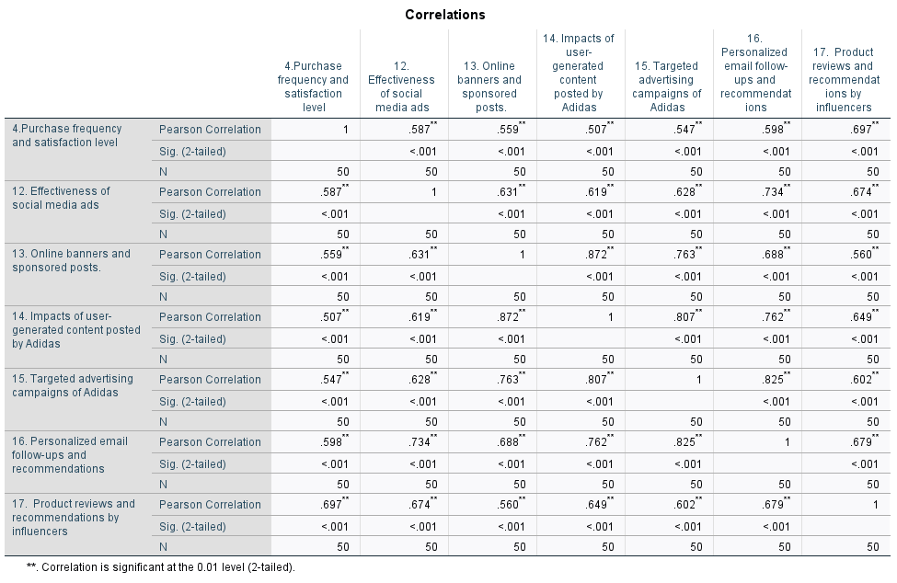

Table 4.5: Correlation between digital marketing strategies and purchasing behaviour
From the correlation findings, it is found that product reviews and recommendations by the influencers have the strongest correlation with the purchasing behaviour of university students for Adidas products (r= 0.697, p-value< 0.01). According to Tsarashafa and Qastharin (2021), university students strongly rely on product reviews and recommendations provided by influencers. This is because they believe influencers offer accurate information about the endorsed products. This develops a positive brand attitude thereby influencing their purchasing intentions. The university students also get influenced by personalised recommendations and email follow-ups offered by Adidas (r= 0.598, p-value< 0.01). Adidas enhanced its digital presence by launching its mobile app which is solely focused on personalising and enhancing the customer experience. Adidas wanted to create “premium, connected and personalised experiences” across all the sales channels through its App (Adidas Group, 2017).
The correlation between purchasing frequency and social media ads and sponsored online banners, user-generated content and targeted advertising are 0.587, 0.559, 0.507 and 547. The values imply that these digital marketing tactics have a moderate influence on purchasing decisions of university students. This is because these tactics develop positive brand awareness among the students about Adidas products through tailored promotional content and user-generated content which is perceived as authentic by the customers.
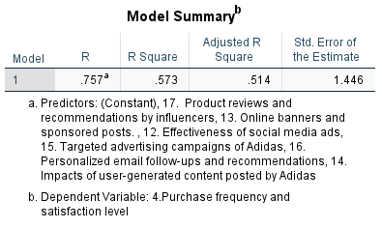

Table 4.6: Regression
The R-square value is 0.573 which implies around 57.3% of the variance in purchasing frequency of university students for Adidas products can be explained by digital marketing strategies. The adjusted R-square is 0.514 which means the variation becomes 51.4% which can also be determined as a good model fit.
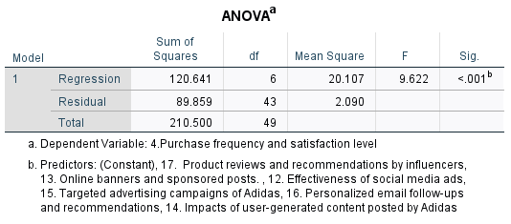

Table 4.7: ANOVA
The “F-statistics” is valued at 9.622 at a p-value less than 0.001. This means the impact of different digital marketing strategies on influencing the purchasing decisions of university students is statistically significant.
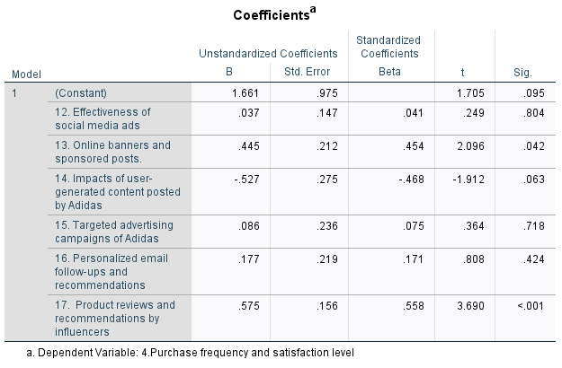

Table 4.8: Coefficient
The coefficient findings in Table 4.8 suggest that the most significant factor that influences university students’ purchasing behaviour is the influencers’ review and recommendations. University students belong to GenZ and Millennial generations who believe influencers the credible sources of information. Due to this reason, they purchase products from luxury brands like Adidas.

4.3.3 Findings of Objective 3
H3₀: Brand loyalty of the university students does not have any significant impact on their repurchasing intentions for Adidas products
H3: Brand loyalty of the university students has a significant impact on their repurchasing intentions for Adidas products
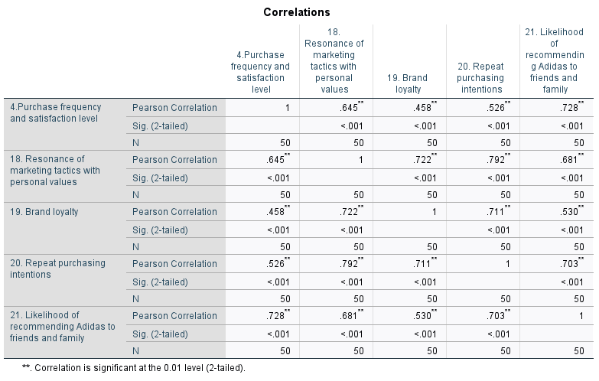

Table 4.9: Correlation between brand loyalty and purchasing behaviour
The correlation between purchasing frequency and resonance of marketing tactics with emotional values is 0.645. The strong positive correlation proves that customers develop a strong emotional connection if a brand’s marketing strategies align with their personal values (Voorn et al. 2021). The likelihood of recommending Adidas products to others is also directly correlated to the purchasing frequency. Here, customer satisfaction acts as a mediating factor which influences university students to make new purchases from Adidas and also recommend the products to others. On the other hand, the correlation also signifies that the purchasing frequency of Adidas products increases with an increase in the brand loyalty of university students (r=0458, p-value< 0.01; r= 0.526, p-value< 0.01). This aligns with Supiyandi et al. (2022), who argued that the purchasing intention of customers increases with an increase in their brand loyalty.
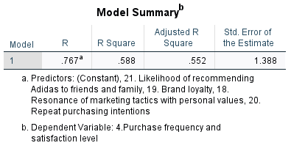

Table 4.10: Regression
The R-square value of 0.588 determines that around 58.8% of the variance in the purchasing behaviour of university students can be explained by their brand loyalty.
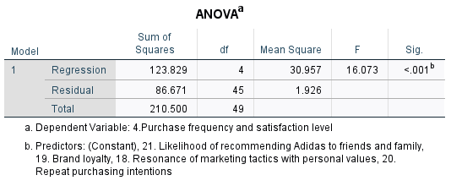

Table 4.11: ANOVA
The F-statistics is 16.073 at a p-value below the standard level of significance. Therefore, the dependence of students’ purchasing behaviour on their brand loyalty and repurchasing intentions are statistically significant.
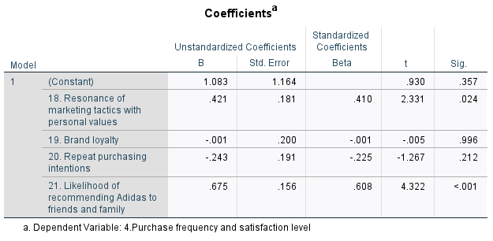

Table 4.12: Coefficient
The coefficient test signifies that brand resonance with customers’ values and the likelihood of product recommendation are the key strategies that influence their purchasing frequency. However, the likelihood of recommending others has more influence than brand resonance.

4.3.4 Findings of Objective 4
H4₀: There are no significant barriers to brand perception which could influence the purchasing behaviour of UK university students towards Adidas
H4: Barriers of brand perception influence the purchasing behaviour of UK university students towards Adidas
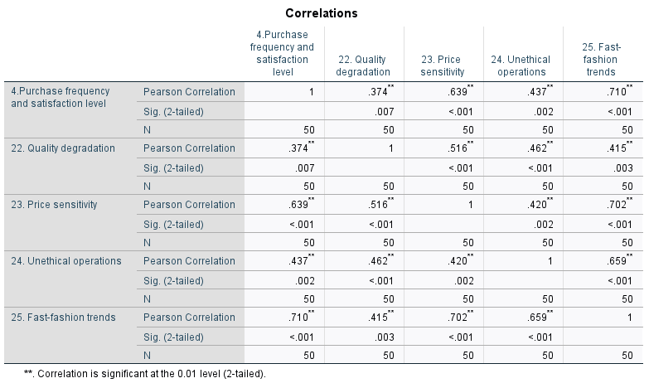

Table 4.13: Correlation between barriers to brand perception and purchasing behaviour
The key factors that affect the purchasing frequency of university students are quality degradation, price sensitivity, unethical business operations and fast-fashion trends. The positive correlation with all these factors strongly resonates with the key business operations of Adidas. As product quality is the most influential factor in purchasing behaviour, the degradation in product quality will highly affect their purchasing decisions. Similarly, the correlation value of 0.639 between price sensitivity and purchasing frequency suggests that university students sometimes become less likely to purchase from Adidas due to high prices. Another factor that could impact the brand perception and purchasing decisions of university students is unethical operations. This aligns with Zhang et al. (2023), who argued that GenZs are more likely to prioritise sustainable and ethical fashion. Therefore, a lack of ethical standards would decline their purchasing intentions for Adidas’s products. This also lines up with Adidas’s fast-fashion trend (r= 0.710, p-value<0.01). This means that university students prioritise trendy fashion which aligns with fast-fashion styles. However, Liu et al. (2023) contradict that the fast fashion business model is unethical which could negatively impact the purchasing behaviour of university students who belong to either GenZ or Millennials.
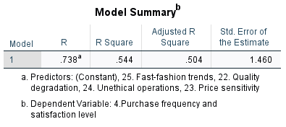

Table 4.14: Regression
The R-square is valued at 0.544 which means 54.4% of the variance in customers’ purchasing behaviour is influenced by the key barriers of brand perceptions.
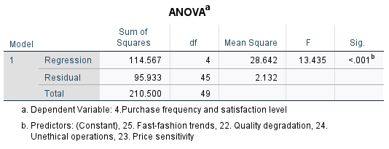

Table 4.15 ANOVA
The ANOVA model implies that the F-statistics is 13.435 which implies that the statistical relationship between these variables are significant.
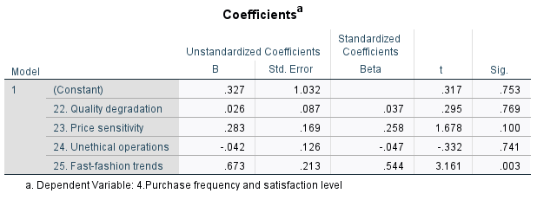

Table 4.16: Coefficient
The coefficient test determines that fast-fashion trends are the most influential factor that could increase of decline the purchasing frequency of university students for Adidas products. This is evident through the B-standardisation, t and p-values illustrated in Table 4.16.

4.4 Summary
Therefore, it can be summarized that the statistical analysis has accepted all the alternative hypotheses H1, H2, H3 and H4. However, a major limitation of this chapter is that correlation highlights linear association and does not necessarily offer categorical insights or justify causal relationships. Moreover, the linear relationship calculated through regression might not be always true in real-time scenario. Other than these, this chapter is based on categorical data which has low sensitivity and lacks logical order. This might impact the overall quality of research outcomes.

Chapter 5: Discussion

5.1 Introduction
This chapter is crucial for the interpretation and explanation of the findings of the research significance. Discussion allows placing the findings within the broader context of the research field which is necessary for highlighting the research contribution. Therefore, the findings of primary quantitative data analysis are interpreted and explained using the existing theories as well as literature.

5.2 Discussion

5.2.1 Discussion of Objective 1
The first objective aimed to analyse different factors of brand perception that strongly influence the buying behaviour of university students towards Adidas products. The statistically significant correlation of 0.813 between product quality and purchasing behaviour determines quality as the most influential factor among all. This aligns with Arıker and Toksoy (2017), who argued that a high-quality product is a necessary requirement that makes university students (GenZs) inclined towards a brand. The author claimed that good product quality is a precondition that shapes the primary motives, brand perception and purchasing intentions of the students. The findings show a strong similarity with Nazarani and Suparnam (2021) in LR section 2.4.1, who also statistically proved the influence of product quality on shaping the purchasing decisions of university students. However, the mechanism that makes product quality a potential factor was not discussed and is identified as a gap. This gap has been fulfilled by the primary findings of section 4.3.1.
On the other hand, style and comfort are another factor that has a statistically significant impact on students’ purchasing behaviour (r= 0.650; p-value< 0.01). Similarly, the primary findings also highlighted the moderately strong influence of elegance and trends on influencing the purchasing behaviour of university students. This aligns with the findings of Shin and Damhorst (2018), who argued that both functional and social fit are two crucial factors prioritised by consumers before purchasing a fashion product. The functional fit determines the physical comfort which is felt after wearing a fashion product. However, social or situational fit determines the ability of a fashion product to comply with the style, trends and elegance of the current fashion landscape. As opined by Jhonson (2023), Adidas is one of the fashion brands which is globally recognised for offering high-quality, comfortable, stylish and durable products to its customers. These findings resonate with the LR findings of Gaurav et al. (2020) in section 2.4.1. The gap regarding the mechanism of actions of these factors was further disclosed in the findings of section 4.3.1.
Peer influence is another factor that shapes the purchasing decision of university students for Adidas products. As per Lu et al. (2022), university students are susceptible to peer influence which enables them to develop a self of belongings in the society. Students often purchase high-end luxury products to contend with their wealth and to show their prestige and status in society. Thus, social recognition plays a crucial role in affecting the purchasing decisions of university students. This justifies that university students are influenced by peers to buy Adidas products to adjust to the university environment. These findings is also similar to the LR findings in section 2.4.1 This aligns with the TPB framework in section 2.3.1 where peer influence and fashion trends act as subjective norms that shape positive brand attitudes and influence purchasing intentions.
Some other factors that also have a moderate influence on students’ purchasing intentions are brand equity and image, diversity of product portfolio and continuous product innovation. This aligns with Awan et al. (2020) who argued that positive brand equity is the result of strong brand awareness and positive brand image. Brand equity is shaped by all the above factors, which further influence customers' purchasing decisions. All these factors align with Keller's brand equity model (CBBE model) which implies that product quality, comfort, style and designs are the key performance indicators which develop a strong brand meaning of Adidas thereby influencing purchasing intentions.
The findings imply that the key business strategy of Adidas revolves around maintaining the high product quality that highly influences the decision-making of university students in the UK. The findings also suggest the need for continuous investment in superior materials and manufacturing processes that help maintain a business's brand reputation for its product quality (Ninduwezuor-Ehiobu et al. 2023). On the contrary, it is also found that the product quality directly correlates with the style and comfort of Adidas products. For example, superior materials are effective in enhancing the functionality of a product like comfort, durability and usability. Similarly, Adidas also developed a business strategy that enables it to set style trends in the street fashion and footwear segment. Therefore, the findings imply that style and comfort are also two crucial factors that facilitate students’ decision-making while purchasing products from Adidas.
Furthermore, the role of continuous innovation in products is identified as another crucial factor that impacts students’ purchasing decisions. As suggested by Casciani et al. (2022), businesses should focus on innovating their products continuously to develop a diverse product portfolio. On the contrary, continuous innovation also facilitates the production of customisable collections which also resonate with the students’ demand to maintain uniqueness and trendiness. As a result, this helps in strengthening brand equity by fostering customer satisfaction and retention. Furthermore, the findings also identified the influence of peer pressure and social recognition to facilitate students’ decision-making. This implies that businesses should focus on implementing effective marketing strategies like community-building campaigns or peer-oriented promotions to enhance brand recognition and attract new customers (Raun and Christensen-Strynø, 2022). Thus, businesses should focus on developing and maintaining a strategy that embraces product quality, continuous innovation, diverse product portfolio and style and comfort.

5.2.2 Discussion of Objective 2
The second objective was constructed to determine the impacts of digital marketing strategies in shaping the purchasing intentions of university students for Adidas products. The statistical findings indicate that influencers’ reviews and recommendations are the most significant factors (r= 0.697, p-value< 0.01). As opined by Chopra et al. (2021), customers are more likely to follow influencers’ recommendations instead of brand advertisements. This is because both GenZ and Millennials perceive influencers as credible sources of information because many influencers give honest reviews for both sponsored and non-sponsored content. For example, Adidas collaborated with micro-influencers to capture the attention of the general audience and communicate its message that “Adidas is for everybody”. Adidas enables micro-influencers to create user-generated content which in turn influences customers by developing positive brand attitudes towards Adidas (Ash, 2024). Thus, influencer recommendation act as a subjective norm that influences and shapes brand attitudes which justifies the application of the TPB framework. The findings resonate with Abdullah et al. (2020) in LR section 2.4.2 which suggests that informative content posted by SMIs influences the purchasing decisions of university students for luxury brand products like Adidas.
Personalised marketing is another digital marketing strategy that strongly impacts the purchasing intentions of university students for Adidas products. According to Roggeveen et al. (2021), personalised experiences make the customers feel valued and recognised by the brands. As a result, this developed a positive brand attitude thereby influencing their purchasing intentions and customer satisfaction. This is supported by the correlation value of 0.598 at a statistically significant p-value. However, Gao and Liu (2023) contended that AI used in personalised marketing can offer irrelevant suggestions which could affect customer satisfaction in the long run.
Other than these, the correlation findings also imply that frequent social media ads and sponsored online banners, user-generated content and targeted advertising for Adidas products also encourage university students to purchase products from this brand (r= 0.587, 0.559, 0.507 and 547). This aligns with the findings of Al-Azzam and Al-Mizeed (2021), who reported that digital marketing strategies such as social media marketing, online advertising and email marketing strongly impact students' purchasing decisions. These marketing strategies increase products to appeal to university students and influence them to purchase products from a brand like Adidas. The moderately strong correlation of social media ads is explained by Hasan and Sohail (2021) who explored that social media ads and sponsored content increase brand awareness and interaction of students. As a result, this influences their purchasing behaviour. Furthermore, customers can avail of appealing discounts and promotional offers through targeted advertising strategies on digital media. The overall findings are supported by the R-value of 0.573 and F-value of 9.622. However, Chinwendu and Chinwuba (2018) contradicted that customers might get bombarded and dissatisfied if they are overwhelmed with targeted emails and messages.
The findings imply the benefits of marketing efforts that businesses should acquire to enhance their business performance. The key findings shed light on the effectiveness of influencer marketing in shaping brand perception and purchasing decisions of university students. This aligns with Kwiatek et al. (2021), who argued that influencers are perceived as a credible source of information because of their honest reviews and recommendations. It can be understood that students’ trust in influencers implies the need to implement influencer-driven marketing campaigns and approaches to drive brand engagement within the chosen demographic.
On the contrary, the findings also highlighted the importance of personalized marketing strategies to influence students’ purchasing decisions. This implies the need for investing in AI-powered personalization tools to offer tailored and seamless marketing experiences (Kumar et al. 2024). Moreover, businesses like Adidas and other brands should also be cautious about the fact that irrelevant content might backfire and cause customer dissatisfaction. Furthermore, the findings strongly highlight the benefits of other digital marketing strategies such as targeted advertising campaigns, social media ads and user-generated content. From the findings, it can be understood that these marketing efforts are highly effective in strengthening the digital presence of Adidas and other businesses in the current business landscape. This is because these strategies are beneficial in developing the visibility of brands and increasing the likelihood of purchase. Therefore, the findings imply that businesses can boost their customer engagement and drive sales by implementing digital marketing strategies.

5.2.3 Discussion of Objective 3
The third objective of this research was to determine the impacts of brand loyalty on university students to facilitate repeat purchases as well as brand recommendations for Adidas products. The quantitative analysis of the survey revealed that brand loyalty influences university students' purchasing behaviour for Adidas products significantly. This is evident in the fact that a strong correlation exists between brand loyalty and the repurchase intentions of customers. Besides, the value of R Square of the purchase behaviour (value 0.588 or around 58.8%) explains the possibility of repeat purchases and brand loyalty. The study by Silva et al. (2020) investigated whether brand loyalty of luxury basketball shoe brands like Adidas, Puma and Nike impacts the repeat purchase intentions of customers. The results of the study indicated that several factors, such as brand image and customer satisfaction, are two major factors that influence Adidas' purchase intentions. The authors emphasised that a strong brand image correlates with a high perceived quality of products that the brand offers. Consumers tend to associate well-known brands with superior quality which boosts their confidence in purchasing the products. On the contrary, a report mentioned that a positive brand image can create an emotional bond with the customers (HBR, 2018). Such emotional connections make customers choose Adidas that have superior quality to other brands' competitors. In the report, it is also argued that when customers feel a sense of trust and loyalty, they tend to repeat purchase products and also recommend the brand to others. With the digital core strategy, Adidas aims to make the customer experience more premium, personalised and most importantly, well-connected. These factors are used by the brand to boost sales and net promoter scores (likelihood of recommending the brand or products to others). The brand can also increase engagement through these initiatives.
Therefore, it can be stated that experience with the brand also plays an equally crucial role in building brand loyalty. The study by Shoffian et al. (2021) emphasised that loyal customers are more likely to repurchase and recommend products to others, which ultimately positively impacts the brand. In the UK, Adidas has gained popularity as a sports brand as it has 95% brand awareness and 59% popularity (Refer to Figure 4.26). 34% of the customers are loyal, in relation to 41% of customers who use this brand’s products. This makes the overall brand loyalty 83% (Kunst, 2024). Furthermore, Adidas is quite popular among the students of UK universities, as indicated by a survey conducted by Campus Society a few years back (Themarketingblog.co.uk, 2019). As per this survey results, Adidas is the third most admired brand by university students, following brands like Nike and Apple. Nike is a competitor of Adidas and is the most popular among university students. Therefore, it can be stated that even though Adidas even though University students admire Adidas they prefer Nike over Adidas. Despite this result, the popularity of Adidas is evident among UK university students which contributes to brand loyalty and repeat purchase behaviour.
The findings have striking similarities with the quantitative result. The results showed that customer satisfaction mediates brand loyalty and repeat purchase intention relationships. This signifies the increased likelihood of product recommendations. Nevertheless, Shoffian et al. (2021) argued that brand loyalty creates long-term relationships between customers and the brand, Adidas. In this regard, several factors influence Adidas' brand loyalty. Product quality, price, styles, service quality, and even the brand's promotion or advertisement strategies influence this loyalty. The authors emphasised the fact that the marketing strategies of Adidas are one of the crucial factors that influence the repurchase decisions of customers and ultimately brand loyalty. 2.4.3 section of the literature review has a striking similarity with these findings. Pa et al. (2021) showed that brand loyalty is very crucial for the success of branded footwear brands. The vital factors that influence the purchase intentions of university students are determined by promotional and service quality. Hence, luxury sportswear brands that conduct appealing marketing can develop higher brand loyalty among university students and also impact their repeat purchase intentions. Even "Keller's Brand Equity Model" aligns with these findings. This model highlighted that perceived brand quality and associations have a significant direct influence on brand loyalty. Therefore, it can be stated that when university students recognise a brand's value and have trust and strong emotional connections, brand loyalty is automatically enhanced. These factors lead to higher repurchase intentions and a willingness to recommend Adidas products to peers.
Similarly, the strong positive correlation between purchasing frequency and marketing tactics with emotional value indicates that when marketing resonates with students' value, it is most likely to foster emotional connections. The survey results showed strong emotional connection encourages repeat purchases of customers and also positive word-of-mouth for Adidas. Vrtana and Krizanova (2023) mentioned that emotional advertisement appeals can create strong emotional connections between brands and consumers. This connection even leads to impulsive and positive purchase decisions. University students, who are often influenced by their emotions, are easily appealed to through emotional advertisement strategies, and thus, repeat purchase behaviour can be influenced.

5.2.4 Discussion of Objective 4
The last objective was to identify some barriers and measure the effects of those barriers that affect university students' purchase behaviour towards Adidas in the UK. The survey results based on the questions asked to the university students revealed that several concerns significantly influence the purchasing behaviour towards Adidas. These factors are product quality, price, ethics and several other factors. Degraded quality of products has a significant influence on the purchasing behaviour of customers. Similarly, Osburg et al. (2024) found that perceived quality significantly influences consumer purchase intentions. When the quality of luxury products is perceived to be degraded, it negatively impacts consumers' willingness to purchase these products. This is because luxury consumers expect superior quality and are less tolerant of any decline in product standards. Therefore, a decline in product quality can lead to a loss of brand loyalty as customers think that brands no longer meet their high expectations. On the other hand, a correlation value of 0.639 between price sensitivity and purchasing frequency indicates that high prices decrease the likelihood of purchasing Adidas products.
These findings have striking similarities with the 2.4.4 section of the literature review. Nazarani and Suparna (2021) argued that luxury brands' image and product quality positively influence purchase intentions. However, if customers perceive the brand as poor quality or get negative feedback from their close ones, their purchase intentions automatically get reduced. Customers tend to believe in social proof which reinforces brand belief. However, negative feedback can reduce interest and engagement with the brand, thereby, brand loyalty. The inability of Adidas to maintain quality affects the purchase behaviour.
Most importantly, university students in the UK are more attracted to trendy fashion trends. Even though these students are attracted to trendy fashion, the fast fashion model of Adidas can be viewed as unethical and significantly discourages customers' purchase intentions. The correlation value of 0.710 confirmed this fact. Overall, the statistical results indicated that the relationship between the mentioned barriers and purchasing behaviour is statistically significant (F=13.435). Among all these factors, the fast-fashion trends are identified as the most decisive factor that affects customers' purchase frequency. Similar to these findings, Ross (2021) mentioned that university students are increasingly aware of the unethical labour practices that are associated with fast fashion. They recognise the exploitation of workers in developing countries and most importantly, the poor working conditions of workers in garment factories. This awareness influences their perception towards fast fashion brands as unethical. Blanco and Lima (2022) confirmed that factory workers at Adidas and two other renowned luxury brands reported receiving low wages. The wages failed to meet the basic needs of the workers. The employees faced exhaustive working routines where they had to work for over 10 hours, and they even had restrictions in using toilets. These are some ethical barriers associated with the purchase intentions of Adidas's products.
Adidas has been making several efforts and initiatives to enhance transparency in the supply chain. This is aimed at improving by enforcing different labour standards that are still significant concerns for the brand (Committees.parliament.uk, 2024). How workers are treated in the supply chain, especially in factories significantly increases ethical concerns regarding the brand. Adidas has admitted that unethical business practices including improper behaviour of business partners have a negative spillover effect on the reputation of Adidas (Adidas, 2021). This is directly associated with higher costs as well as liabilities that even disrupt different business activities. Increasing awareness of these issues among consumers can lead to a negative perception of the brand, which affects purchase intentions. The report also confirmed that ethical considerations are becoming more important for many consumers, especially younger demographics. Negative publicity around labour practices can damage Adidas’ brand image. This can make consumers hesitant to purchase their products. Therefore, it can be stated that the brand has to take steps to address these concerns. In order to address them, the brand can implement a comprehensive supply chain due diligence program (Committees.parliament.uk, 2024). This can help the brand to work independently and monitor labour conditions. Accordingly, it can take initiatives to improve labour conditions.

5.3 Summary
The interpretation of the findings confirmed that product quality is one of the most crucial factors influencing customers' purchase intentions significantly. Product quality is one of the most crucial factors, a reason why, degraded product quality at Adidas acts as a barrier towards purchase intentions and loyalty towards Adidas. Moreover, university students seek comfort and fit and when a brand like Adidas fulfils those needs, their purchase intentions get significantly influenced. Luxury fashion brands including Adidas consider influencer marketing strategies to capture the attention of the general audience and communicate its message. Moreover, personalised marketing also plays a crucial role in shaping university students' attitudes and purchasing intentions towards Adidas in the UK. Data interpretation also confirmed that brand loyalty influences the repeat purchase intentions of university students. However, mitigating barriers is crucial to influencing repeat purchase intentions among these students.

Chapter 6: Conclusion and Recommendations

6.1 Overall Conclusion
The initial investigation revealed that the luxury fashion industry is one of the world's biggest industries and is expected to witness massive growth in the upcoming years. Adidas is one of the leading luxury fashion and sportswear brands in the UK, very popular among the youths of this nation. High quality and comfort are two major factors contributing towards the popularity of Adidas. The price range of the brand and product diversity are two major factors that contribute to the competitive advantage of this company. This research aimed to investigate the buying behaviour of university students in the UK towards the luxury fashion brand Adidas. The literature review revealed that university students prioritise several factors before they consider purchasing luxury fashion products. Brand reputation, brand image and product quality were identified as some of the most crucial factors to influence the purchase intentions. However, several other factors act as barriers towards brand perception and, thus, significantly impact the purchase intentions of customers and university students. In the UK, customers prioritise ethical and sustainable products. The inability of brands to ensure sustainability and high-quality products acts as a barrier to customers' purchase intentions.
The literature review findings also concluded that a loss of trust due to negative customer experiences will most likely cause declined sales and brand loyalty. On the contrary, customers perceive a brand as applicable they tend to purchase from the same brand repeatedly. However, it is equally crucial that brands have positive perceived value, and that brand awareness is also high so that customers' repeat purchase intentions get influenced. When purchasing luxury products, customers, including university students, prioritise brand quality, product prices, quality, service quality, and even store environment before purchasing any luxury product from a brand. The literature review contributed to knowledge development and understanding of the research on the chosen area. However, it failed to disclose the most crucial perceived factors to influence UK university students' purchase intentions. Again, the different marketing aspects of Adidas could not be comprehended. These major gaps in the literature influenced a more in-depth investigation using primary quantitative data collected through surveys. The positivism philosophy, deductive approach and descriptive research design not only helped in bridging the literature gap but also helped in achieving research objectives. The survey results and discussion concluded that university students in the UK are strongly loyal to Adidas because of its product quality and style comfort. Although several other factors like the promotional approach of the brand are directly associated with higher levels of satisfaction and purchase intentions of customers. These factors impact UK university students' satisfaction level and purchasing intentions.
The survey results also concluded that the purchase intentions of university students towards Adidas are significantly influenced by several barriers. These barriers are related to product quality, price sensitivity and even ethical concerns associated with Adidas. A decline in perceived quality also negatively impacts brand loyalty, whereas the high product prices of Adidas deter budget-conscious students. The ethical concerns raise ethical considerations which further raise questions about the brand’s values. Therefore, it can be concluded that although UK university students are attracted to trendy designs, conflicts with sustainability concerns further complicate their purchase decisions. The study confirmed that a strong correlation exists between brand loyalty and repurchase intentions. However, for that, Adidas has to be careful about its product quality, pricing and marketing strategies. Emotional advertisement can be considered by Adidas to cultivate long-term loyalty. The students recognise brand value which enhances trust and emotional engagement. Trust and emotional engagement are essential for cultivating long-term loyalty and also purchase decisions of Adidas products among university students.

6.2 Linking with Objectives
The first objective is addressed in the LR section 2.4.1 and findings section 4.3.1 which identified different factors that influence the purchasing intentions of university students. The research findings conclude that positive brand perception is the main factor that influences the purchasing intentions of university students for Adidas products. However, this brand perception is combinedly and shaped by other sub-factors. These are product quality, brand equity, image, reputation, style and comfort, elegance and trends, peer influence, diverse brand portfolio and product innovation. It is found that product quality is the most influential factor whereas brand portfolio is the less influential factor of Adidas.
The second objective is achieved in LR section 2.4.2 and findings section 4.3.2 which identified different digital marketing strategies and their impacts on shaping the purchasing decisions of university students. The findings conclude that influencer marketing is the most influential tactic. It can be understood that university students are easily influenced by the reviews and recommendations offered by influencers. Adidas also adopted this strategy to capture a general audience and make its products available to all. Moreover, Adidas also offers personalised product recommendations through its digital app which makes customers feel valued and connected to the brand thereby shaping their purchasing decisions. Other than these, university students are also influenced by social media ads, online banners and user-generated content. This increases Adidas’s brand appeal to the students and influences their purchasing decisions.
The LR findings in 2.4.3 and primary findings in 4.3.3 highlighted the influence of brand loyalty on the repurchasing intentions of university students for Adidas products. Some of the key factors that promote brand loyalty of university students for Adidas products include brand image, product quality and emotional advertising. These factors enhance customer satisfaction and drive brand loyalty followed by repurchasing decisions and positive recommendations. The findings emphasise the fact that Adidas is efficient in fostering brand loyalty among university students in the UK by emphasising relevant and potential marketing tactics. As a result, it develops positive word-of-mouth and facilitates the long-term success of the chosen brand.
The fourth objective is addressed in LR section 2.4.4 and findings section 4.3.4. The findings conclude that price sensitivity is the most influential barrier that could reduce the purchasing frequency of university students. This means higher prices might reduce the likelihood of purchasing Adidas products. The findings of this objective resonate with objective 1 which emphasised the influence of product quality. As higher quality is the most significant factor influencing customer satisfaction, degradation of this quality causes immense dissatisfaction. As a result, this develops negative brand perception and brand image thereby reducing the purchasing intentions. Furthermore, Adidas’s operations to comply with fast-fashion trends include various unethical practices which also lower the purchasing intentions of university students towards Adidas products.

6.3 Research Contribution and Implications
This research has a significant contribution to the luxury fashion industry and not just Adidas. Brands that operate in the luxury fashion sector can comprehend what customers, particularly university students prefer the most or factors they consider before choosing a brand. Accordingly, those brands can design products, services and even marketing strategies. Most importantly, luxury brands can also recognise barriers in influencing the purchase intentions of customers. These brands can make strategies accordingly so that these barriers can be easily mitigated and customers choose their brands over any other in the market. Customer satisfaction is the key to organically raising revenues through positive word-of-mouth. Satisfied customers not only make repeated purchases from a brand but also recommend peers. Thus, brands can attract new customers without spending much on marketing. In the past, no other research specifically focused on UK university students and their purchase intentions as well as brand loyalty of Adidas.

6.4 Research Limitations and Future Scope
The results of this study were dependent on inferential statistics mainly. Correlation and regression analysis were done to achieve the research objectives. The major limitation of using correlation is that it does not imply causation (van't Hoff, 2024). Even if two variables are correlated, it does not mean one causes the other to change. Moreover, correlations only measure linear relationships. Non-linear relationships between variables might not be measured. Similarly, Regression also assumes a linear relationship between the independent and dependent variables (Osborne and Waters, 2019). If the relationship is non-linear, the model may not fit well. The quantitative analysis only helped in capturing the linear relations and failed to capture the variability and complexity in the behaviour of university students towards purchasing luxury brands like Adidas. Therefore, in future research, a mixed methodological approach can be considered, where primary qualitative data can be gathered from university students in the UK. Primary data will not only allow gaining the latest objective-precise data but also help in comprehending complex and subjective factors that facilitate buying and repeat buying behaviours. Semi-structured interviews can be considered to gather primary qualitative data, whereas the survey can be conducted to gather primary quantitative data. This approach will help in understanding the consumer buying behaviour of university students in the UK towards the luxury fashion brand Adidas.

6.5 Recommendations

6.5.1 Introducing Flexible Payment System
Price sensitivity is a major barrier to the purchasing decisions of university students for Adidas Products. Therefore, Adidas can introduce a “flexible payment option” for the students to overcome the barrier of price sensitivity.
Specific | Adidas can introduce flexibility in its payment system which would enable students to pay for high-end products through instalments (Pratika et al. 2021). This will offer financial flexibility to price-sensitive university students in the UK.
Measurable | The effectiveness of this strategy will be measured by an increase in the sale of 15% to university students through the flexible payment system.
Achievable | The recommended strategy can be achieved by collaborating with financial technology organisations that offer buy now and pay later services to customers (FUNG, 2024). For example, Klarna and AfterPay (Clearpay in UK) are two such companies that offer this service for customers who purchase products from online stores (Clearpay, 2024; Klarna UK, 2024)
Relevant | The strategy is highly relevant because it will meet the needs of price-sensitive customers (here, university students) who could not buy Adidas products due to financial constraints. As a result, Adidas can increase its sales among the student demographics.
Time-bound | The process of collaboration with the financial partners and the full-scale operations of flexible payment system might require 3 months to 6 months.

Table 6.1: SMART Recommendation 1

6.5.2 Organising pop-up events on university campuses
Some offline marketing such as organising pop-up events can also significantly influence these students to buy Adidas products.
Specific | Adidas can organise both on-campus and virtual events at different universities of the UK (Gary, 2017). This will offer them both interactive and immersive experience in the form of product trial and exclusive student rewards and discounts on Adidas products.
Measurable | The effectiveness of this strategy can be measured by an increase in conversion rate by 25% and brand mentions on social media platforms by 15%.
Achievable | Adidas should collaborate with sports clubs and student unions of different universities in the UK. Necessary budget allocation is also recommended for this purpose.
Relevant | The strategic recommendation is relevant because it will develop positive brand awareness for Adidas products among the chosen demographic (Arias, 2024). This is because fun and interactive experiences offered through pop-up events will resonate with the students’ lifestyle and influence their purchasing decisions.
Time-bound | 6 months to 1 year.

Table 6.2: SMART Recommendation 2

Reference List
Abdullah, Q.A. and Yu, J., (2019). Attitudes and purchase intention towards counterfeiting luxurious fashion products among Yemeni students in China. American Journal of Economics, 9(2), pp.53-64. DOI: 10.5923/j.economics.20190902.03
Abdullah, T., Deraman, S.N.S., Zainuddin, S.A., Azmi, N.F., Abdullah, S.S., Anuar, N.I.M., Mohamad, S.R., Hashim, N., Amri, N.A., Abdullah, A.R. and Rasdi, A.L.M., (2020). Impact of social media influencer on Instagram user purchase intention towards the fashion products: the perspectives of UMK Pengkalan Chepa campus students. European Journal of Molecular & Clinical Medicine. http://myscholar.umk.edu.my/bitstream/123456789/1413/1/Abdullah%20et%20al%202020.pdf
Adegeest, D.A., (2022). How Adidas went from street to luxury. Available at: https://fashionunited.com/news/fashion/how-adidas-went-from-street-to-luxury/2022060147910 [Accessed on: 15.07.2024]
Adidas Group (2017). Adidas expands digital presence and launches new adidas app. https://www.adidas-group.com/en/media/press-releases/adidas-expands-digital-presence-and-launches-new-adidas-app
Adidas Group (2020). THE CONSUMER AT THE HEART OF EVERYTHING WE DO. Available at: https://report.adidas-group.com/2020/en/group-management-report-our-company/global-brands.html#:~:text=adidas%20brand&text=Its%20broad%20and%20diverse%20portfolio,apparel%2C%20and%20accessories%20and%20gear. [Accessed on: 17.09.2024]
Adidas Group (2024). Innovation. Available at: https://www.adidas-group.com/en/magazine/innovation
Adidas News (2023). ADIDAS ORIGINALS UNVEILS FIRST-EVER FOOTWEAR COLLECTION CUSTOMIZED FOR UNIVERSITY STUDENTS AND FANS. Available at: https://news.adidas.com/basketball/adidas-originals-unveils-first-ever-footwear-collection-customized-for-university-students-and-fans/s/4f05a815-4526-467f-8b83-50ff9c417d23 [Accessed on: 15.07.2024]
Adidas UK (2024). Street Wear. Available at: https://www.adidas.co.uk/street_wear [Accessed On: 30 July 2024]
Adidas, 2021. Illustration of Risks. Available at: https://report.adidas-group.com/2021/en/group-management-report-financial-review/risk-and-opportunity-report/illustration-of-risks.html [Accessed On: 13 October 2024]
Adidas, 2024a. HISTORY. Available at: https://www.adidas-group.com/en/about/history [Accessed On: 15 July 2024]
Agarwal, M., (2020). Importance of User Generated Content as a part of Social Media Marketing that drives Customer‟ s Brand Awareness and Purchase Intentions. The International journal of analytical and experimental modal analysis, 12(2), p.3071. https://www.academia.edu/download/62513151/Importance_of_User_Generated_Content_as_a_part_of_Social_Media_Marketing_that20200328-51052-1favrrn.pdf
Ajitha, S. and Sivakumar, V.J., (2019). The moderating role of age and gender on the attitude towards new luxury fashion brands. Journal of Fashion Marketing and Management: An International Journal, 23(4), pp.440-465. https://doi.org/10.1108/JFMM-05-2018-0074
Akpan, E.C., (2022) Social Science Research and Philosophical Alignments. Social Science Research, 6(9), pp.93-99. https://www.researchgate.net/profile/Ekeabasi-Akpan/publication/371666223_Social_Science_Research_and_Philosophical_Alignments/links/648dea8eb9ed6874a5b59977/Social-Science-Research-and-Philosophical-Alignments.pdf?origin=journalDetail&_tp=eyJwYWdlIjoiam91cm5hbERldGFpbCJ9
Al-Ababneh, M., (2020) Linking ontology, epistemology and research methodology. Science & Philosophy, 8(1), pp.75-91. doi: 10.23756/sp.v8i1.500.
Al-Azzam, A.F. and Al-Mizeed, K., (2021). The effect of digital marketing on purchasing decisions: A case study in Jordan. The Journal of Asian Finance, Economics and Business, 8(5), pp.455-463. https://doi.org/10.13106/jafeb.2021.vol8.no5.0455
Al-Azzam, A.F. and Al-Mizeed, K., (2021). The effect of digital marketing on purchasing decisions: A case study in Jordan. The Journal of Asian Finance, Economics and Business, 8(5), pp.455-463. https://doi.org/10.13106/jafeb.2021.vol8.no5.0455
Ang, W.H.D., Shorey, S., Lopez, V., Chew, H.S.J. and Lau, Y., (2022). Generation Z undergraduate students’ resilience during the COVID-19 pandemic: a qualitative study. Current Psychology, 41(11), pp.8132-8146. https://doi.org/10.1007/s12144-021-01830-4
Anwar, G. and Abdullah, N.N., (2021). The impact of Human resource management practice on Organizational performance. International journal of Engineering, Business and Management (IJEBM), 5. https://dx.doi.org/10.22161/ijebm.5.1.4
Arias, J.C., (2024). Five Brands Hitting the Road this Fall with College Campus Pop-ups and Tours. https://www.eventmarketer.com/article/brands-fall-college-campus-pop-ups-tours/ [Accessed On: 30 September 2024]
Arıker, Ç. and Toksoy, A., (2017). Generation Z and CSR: Antecedents of purchasing intention of university students. Kafkas Üniversitesi İktisadi ve İdari Bilimler Fakültesi Dergisi, 8(16), pp.483-502. https://dergipark.org.tr/en/download/article-file/738813
Ash, P., (2023). How Adidas is Redefining Influencer Marketing by Leveraging Micro-Influencers and Dark Social for Greater Reach. Available at: https://hobo.video/blog/how-adidas-is-redefining-influencer-marketing-by-leveraging-micro-influencers-and-dark-social-for-greater-reach/ [Accessed On: 30 September 2024]
Astoriano, L., Gerona, J.A.D. and Marzan, J.C.R., 2022. The impact of digital marketing on customer buying intention of customers in the Philippines. Journal of Business and Management Studies, 4(2), pp.383-395. https://doi.org/10.32996/jbms.2022.4.2.29
Auf, M.A.A., Meddour, H., Saoula, O. and Majid, A.H.A., (2018). Consumer buying behaviour: the roles of price, motivation, perceived culture importance, and religious orientation. Journal of Business and Retail Management Research, 12(4). https://www.jbrmr.com/cdn/article_file/content_42685_18-07-04-01-09-53.pdf
Awan, H.M., Hayat, Z., Hayat, S. and Faiz, R., (2020). Impact of status consciousness on consumer purchase intention and brand equity: the Mediating role of brand associations. Journal of Business and Social Review in Emerging Economies, 6(1), pp.23-42. https://doi.org/10.1080/23311975.2021.1944008
Blanco, L., and Lima, P., (2022). Workers denounce low wages and illnesses at Brazilian factories of Adidas, Nike and Puma products. Available at: https://reporterbrasil.org.br/2022/12/workers-denounce-low-wages-and-illnesses-at-brazilian-factories-of-adidas-nike-and-puma-products/ [Accessed On: 30 September 2024]
Bolton, P., (2024). Higher education student numbers. https://commonslibrary.parliament.uk/research-briefings/cbp-7857/#:~:text=Key%20data%20on%20the%20overall,at%20UK%20higher%20education%20institutions.
Cardillo, A., Grama, C. and Ihnatenko, O., (2024). Brand Love towards Luxury Streetwear. The Yeezy Case. https://www.diva-portal.org/smash/get/diva2:1866158/FULLTEXT01.pdf
Casciani, D., Chkanikova, O. and Pal, R., (2022). Exploring the nature of digital transformation in the fashion industry: opportunities for supply chains, business models, and sustainability-oriented innovations. Sustainability: Science, Practice and Policy, 18(1), pp.773-795. https://doi.org/10.1080/15487733.2022.2125640
Chetioui, Y., Benlafqih, H., & Lebdaoui, H. (2020). How fashion influencers contribute to consumers' purchase intention. Journal of Fashion Marketing and Management: An International Journal, 24(3), 361-380. https://doi.org/10.1108/JFMM-08-2019-0157
Chicoine, D., (2023). Counterfeit Impact on High-end Luxury Products| investigating French Generation Z Consumers’ Attitude towards High-end Luxury Counterfeit Products and Purchasing Intention. https://www.theseus.fi/handle/10024/797745
Chinwendu, O.D. and Chinwuba, M.S., (2018). Subscribers’ attitude towards direct mail infiltration from unknown sources. International Journal of Marketing Research Innovation, 2(2), pp.15-19. https://doi.org/10.46281/ijmri.v2i2.209
Chopra, A., Avhad, V. and Jaju, A.S., (2021). Influencer marketing: An exploratory study to identify antecedents of consumer behavior of millennial. Business Perspectives and Research, 9(1), pp.77-91. https://doi.org/10.1177/2278533720923486
Christou, P.A., (2022) How to use thematic analysis in qualitative research. Journal of Qualitative Research in Tourism, 3(2), pp.79-95. https://doi.org/10.4337/jqrt.(2023)0006
Clearpay (2024). The app's where it's at. Available at: https://www.clearpay.co.uk/en-GB [Accessed On: 30 September 2024]
Committees.parliament.uk, 2024. Written evidence submitted by adidas UK (FL0008). Available at: https://committees.parliament.uk/writtenevidence/13102/pdf/ [Accessed On: 13 October 2024]
Cresswell, J. (2002) Research Design: Qualitative, Quantitative, and Mixed Methods Approaches, London: Sage Publications
Eastman, J.K., Shin, H. and Ruhland, K., (2020). The picture of luxury: A comprehensive examination of college student consumers' relationship with luxury brands. Psychology & Marketing, 37(1), pp.56-73. https://doi.org/10.1002/mar.21280
Faria, J., (2024). Luxury advertising and marketing. https://www.statista.com/topics/4149/luxury-advertising-and-marketing/#editorsPicks
Faris, A., Mustofa, M., Syukri, M., Yin, W.J. and Simpong, D.B., (2021) A Study on Factors That Influence Universiti Malaysia Kelantan (UMK) Undergraduate Students Food Choices.
FUNG, A., (2024). Buy Now, Pay Later: The New Face of Consumer Credit. https://www.progressivepolicy.org/wp-content/uploads/2024/08/PPI_Buy-Now-Pay-Later.pdf
Gao, Y. and Liu, H., (2023). Artificial intelligence-enabled personalization in interactive marketing: a customer journey perspective. Journal of Research in Interactive Marketing, 17(5), pp.663-680. https://doi.org/10.1108/JRIM-01-2022-0023
Gary, S., (2017). Effective Methods of Marketing an On-Campus Resource to College Students. https://digitalcommons.calpoly.edu/cgi/viewcontent.cgi?article=1164&context=grcsp [Accessed On: 30 September 2024]
Gaurav, K., Ray, A.S. and Sahu, N.K., (2020). Factors Determining the Role of Brand in Purchase Decision of Sportswear. PalArch’s Journal of Archaeology of Egypt/Egyptology, 17(7), pp.2168-2186. https://www.researchgate.net/profile/Kunal-Gaurav-5/publication/371811967_FACTORS_DETERMINING_THE_ROLE_OF_BRAND_IN_PURCHASE_DECISION_OF_SPORTSWEAR/links/6496c2ab8de7ed28ba523bc3/FACTORS-DETERMINING-THE-ROLE-OF-BRAND-IN-PURCHASE-DECISION-OF-SPORTSWEAR.pdf
Ghanad, A., (2023) An overview of quantitative research methods. International journal of multidisciplinary research and analysis, 6(8). https://doi.org/10.47191/ijmra/v6-i8-52
Gov.uk (2024). Data protection. Available at: https://www.gov.uk/data-protection
Gunawan, C.M., Rahmania, L. and Kenang, I.H., (2023). The influence of social influence and peer influence on intention to purchase in e-commerce. Review of Management and Entrepreneurship, 7(1), pp.61-84. https://doi.org/10.37715/rme.v7i1.3683
Hanaysha, J.R., Al Shaikh, M.E. and Alzoubi, H.M., (2021). Importance of marketing mix elements in determining consumer purchase decision in the retail market. International Journal of Service Science, Management, Engineering, and Technology (IJSSMET), 12(6), pp.56-72. DOI: 10.4018/IJSSMET.2021110104
Hasan, M. and Sohail, M.S., (2021). The influence of social media marketing on consumers’ purchase decision: investigating the effects of local and nonlocal brands. Journal of International Consumer Marketing, 33(3), pp.350-367. https://doi.org/10.1080/08961530.2020.1795043
HBR, 2018. How Consumer Insights and Digital Have Led to Adidas’ Growth. Available at: https://hbr.org/sponsored/2018/05/how-consumer-insights-and-digital-have-led-to-adidas-growth [Accessed On: 13 October 2024]
Hooley, T., Wellens, J. and Marriott, J., (2012). What is online research?: Using the internet for social science research (p. 176). Bloomsbury Academic.
Husain, R., Ahmad, A. and Khan, B.M., (2022). The impact of brand equity, status consumption, and brand trust on purchase intention of luxury brands. Cogent Business & Management, 9(1), p.2034234. https://doi.org/10.1080/23311975.2022.2034234
Ilyas, G.B., Rahmi, S., Tamsah, H., Munir, A.R. and Putra, A.H.P.K., (2020). Reflective model of brand awareness on repurchase intention and customer satisfaction. The Journal of Asian Finance, Economics and Business, 7(9), pp.427-438. https://doi.org/10.13106/jafeb.2020.vol7.no9.427
Irelli, R.S. and Chaerudin, R., (2020). Brand-generated content (BGC) and consumer-generated advertising (CGA) on Instagram: the influence of perceptions on purchase intention. KnE Social Sciences, pp.882-902. https://doi.org/10.18502/kss.v4i6.6649
Islam, M. and Singh, B.N., (2020). Factor Affecting attitude and purchase intention of luxury fashion product consumption: a case of Korean university students. Sustainability, 12(18), p.7497. https://doi.org/10.3390/su12187497
Jamieson, M.K., Govaart, G.H. and Pownall, M., (2023) Reflexivity in quantitative research: A rationale and beginner's guide. Social and Personality Psychology Compass, 17(4), p.e12735. https://doi.org/10.1111/spc3.12735
Jhonson, D., (2023). Is Adidas A Good Brand In 2023? Complete Analysis. Available at: https://medium.com/@dakota_68256/is-adidas-a-good-brand-in-2023-complete-analysis-edda8c53da66 [Accessed On: 30 September 2024]
John, A., Pujari, V. and Majumdar, S., (2023). Impact of social media marketing on purchasing intentions of luxury brands: the case of millennial consumers in the UAE. International Journal of Electronic Marketing and Retailing, 14(3), pp.275-293. https://doi.org/10.1504/IJEMR.2023.131812
Junejo, I., Khuhawar, K.H. and Sahito, I.H., (2018). Factors Influencing Brand Loyalty of Sportswear Among Business Students: A Case Study of Hyderabad, Sindh, Pakistan. Grassroots, 52(1), pp.138-143. https://www.researchgate.net/profile/Ikram-Uddin/publication/327866897_Factors_Influencing_Brand_Loyalty_of_Sportswear_among_Business_Students_A_Case_Study_of_Hyderabad_Sindh_Pakistan/links/5bc86ea8a6fdcc03c78f5c69/Factors-Influencing-Brand-Loyalty-of-Sportswear-among-Business-Students-A-Case-Study-of-Hyderabad-Sindh-Pakistan.pdf
Jusoh, Z.M., Yah, G.C., Bakar, E.A., Zainudin, N. and Osman, S., (2023). Factors Affecting UPM Students' Purchase Intention for Branded Sportswear. http://dx.doi.org/10.6007/IJARBSS/v13-i18/19944
Kaium, M.A., Zahan, I. and Rahman, M.S., (2024). Does user-generated content trigger university graduates’ online purchase intention? Mediating role of brand image. Asian Management and Business Review, pp.105-121. https://doi.org/10.20885/AMBR.vol4.iss1.art7
Kapferer, J.N. and Valette-Florence, P., (2021). Which consumers believe luxury must be expensive and why? A cross-cultural comparison of motivations. Journal of Business Research, 132, pp.301-313. https://doi.org/10.1016/j.jbusres.2021.04.003
Kataria, S. and Saini, V., (2020). The mediating impact of customer satisfaction in relation of brand equity and brand loyalty: An empirical synthesis and re-examination. South Asian Journal of Business Studies, 9(1), pp.62-87. https://doi.org/10.1108/SAJBS-03-2019-0046
Kaundal, S., 2024. Adidas' Digital Marketing Strategy Unpacked with the 5W & 1H Framework. Available at: https://www.linkedin.com/pulse/adidas-digital-marketing-strategy-unpacked-5w-1h-shubham-kaundal-dak1c/ [Accessed On: 15 July 2024]
Kaur, J. and Bhardwaj, N., (2021). Their control will make or break the sustainable clothing deal-a study of the moderating impact of actual behavioural control on the purchase intention-behaviour gap for sustainable clothing in india. Australasian Accounting, Business and Finance Journal, 15(5), p.59. http://dx.doi.org/10.14453/aabfj.v15i5.6
Kelleci, A., (2022). Key determinants of luxury marketing accordant with sustainability-oriented value perspectives. Sustainability, 14(10), p.5916. https://doi.org/10.3390/su14105916
Kinnear, P.R. and Gray, C. D. (2007) SPSS 15 Made Simple, Hove: Psychology Press
Klarna UK (2024). Save money with Klarna. Available at: https://www.klarna.com/uk/ [Accessed On: 30 September 2024]
Koay, K.Y., (2018). Understanding consumers’ purchase intention towards counterfeit luxury goods: an integrated model of neutralisation techniques and perceived risk theory. Asia Pacific Journal of Marketing and Logistics, 30(2), pp.495-516. https://doi.org/10.1108/APJML-05-2017-0100
Kolhar, M., Kazi, R.N.A. and Alameen, A., (2021). Effect of social media use on learning, social interactions, and sleep duration among university students. Saudi journal of biological sciences, 28(4), pp.2216-2222. https://doi.org/10.1016/j.sjbs.2021.01.010
Kumar, M.R., Ahluwalia, I.S., Hazarika, D.D., Kumar, K., Singh, M. and Goswami, C., (2022). Types of consumer buying behaviour. The journal of contemporary issues in business and government, 28(4), pp.372-378. https://cibgp.com/au/index.php/1323-6903/article/download/2459/2461
Kumar, V., Ashraf, A.R. and Nadeem, W., (2024). AI-powered marketing: What, where, and how?. International Journal of Information Management, 77, p.102783. https://doi.org/10.1016/j.ijinfomgt.2024.102783
Kunst, A., 2024. Adidas brand awareness, usage, popularity, loyalty, and buzz among sneakers owners in the UK in 2023. Available at: https://www.statista.com/forecasts/1352058/adidas-sneakers-brand-profile-in-the-uk [Accessed On: 15 July 2024]
Kunst, A., 2024. Adidas brand awareness, usage, popularity, loyalty, and buzz among sports and outdoor online shop users in the UK in 2023. Available at: https://www.statista.com/forecasts/1252324/adidas-sports-and-outdoor-online-shops-brand-profile-in-the-uk [Accessed On: 13 October 2024]
Kwiatek, P., Baltezarević, R. and Papakonstantinidis, S., (2021). THE IMPACT OF CREDIBILITY OF INFLUENCERS RECOMMENDATIONS ON SOCIAL MEDIA ON CONSUMERS BEHAVIOR TOWARDS BRANDS. Informatologia, 54. https://doi.org/10.32914/i.54.3-4.5
Kyando, A., Abayo, A. and Raphael, G., (2022) Determinants of the extent of usage of accounting information by Public Accounts Committee in Tanzania public corporations: Moderating role of effective communication. International Journal of Research in Business and Social Science (2147-4478), 11(9), pp.205-221. https://doi.org/10.20525/ijrbs.v11i9.2118
Lee, H. and Cho, C.H., (2020). Digital advertising: present and future prospects. International Journal of Advertising, 39(3), pp.332-341. https://doi.org/10.1080/02650487.2019.1642015
Liao, J., Dong, X., Luo, Z. and Guo, R., (2021). Oppositional loyalty as a brand identity-driven outcome: a conceptual framework and empirical evidence. Journal of Product & Brand Management, 30(8), pp.1134-1147. https://doi.org/10.1108/JPBM-08-2019-2511
Linardi, E.K., Lin, H.F. and Yeo, B., 2024. Effective digital advertising: the influence of customised ads, self-esteem and product attributes. Journal of Creative Communications, 19(2), pp.197-216. https://doi.org/10.1177/09732586231195241
Liu, C., Bernardoni, J.M. and Wang, Z., (2023). Examining Generation Z consumer online fashion resale participation and continuance intention through the lens of consumer perceived value. Sustainability, 15(10), p.8213. https://doi.org/10.3390/su15108213
Lu, C., Sang, Z., Song, K., Kikuchi, K. and Machida, I., (2022). The impact of culture on millennials' attitudes towards luxury brands: evidence from Tokyo and Shanghai. Asia Pacific Journal of Marketing and Logistics, 34(10), pp.2435-2451. https://doi.org/10.1108/APJML-07-2021-0468
Maliene, V., Fowles, S., Atkinson, I. and Malys, N., (2022). A sustainability assessment framework for the high street. Cities, 124, p.103571. https://doi.org/10.1016/j.cities.2022.103571
Mangalasserri, K., Regin, R., Venkateswaran, P.S., Kumar, A. and Rajest, S.S., (2021). A research for the determinants leading for counterfeit purchase and a genuine product. Turkish Journal of Physiotherapy and Rehabilitation, 32(3), pp.45415-45452. Available at: https://www.researchgate.net/profile/Anil-Kumar-739/publication/358635406_A_RESEARCH_FOR_THE_DETERMINANTS_LEADING_FOR_COUNTERFEIT_PURCHASE_AND_A_GENUINE_PRODUCT/links/636924d32f4bca7fd03d73c4/A-RESEARCH-FOR-THE-DETERMINANTS-LEADING-FOR-COUNTERFEIT-PURCHASE-AND-A-GENUINE-PRODUCT.pdf
Mohajan, H.K., (2020) Quantitative research: A successful investigation in natural and social sciences. Journal of Economic Development, Environment and People, 9(4), pp.50-79. https://mpra.ub.uni-muenchen.de/105149/
Munir, S., (2020). Eco-fashion adoption in the UAE: Understanding consumer barriers and motivational factors. Fashion Practice, 12(3), pp.371-393. https://doi.org/10.1080/17569370.2020.1777729
Narang, I., (2024). Adidas Shoes For Men: Wear Your Comfort and Style. Available at: https://english.jagran.com/top-deals/fashion/men-fashion/adidas-shoes-for-men-wear-your-comfort-and-style-10181193 [Accessed on: 17.09.2024]
Nazarani, M.R. and Suparna, G., (2021). The effect of luxury brand, brand image, and product quality on purchase intention. American Journal of Humanities and Social Sciences Research, 5(1), pp.290-295. https://www.ajhssr.com/wp-content/uploads/(2021)/01/ZM21501290295.pdf
Nazarani, M.R. and Suparna, G., (2021). The effect of luxury brand, brand image, and product quality on purchase intention. American Journal of Humanities and Social Sciences Research, 5(1), pp.290-295. https://www.ajhssr.com/wp-content/uploads/2021/01/ZM21501290295.pdf
Ninduwezuor-Ehiobu, N., Tula, O.A., Daraojimba, C., Ofonagoro, K.A., Ogunjobi, O.A., Gidiagba, J.O., Egbokhaebho, B.A. and Banso, A.A., (2023). Exploring innovative material integration in modern manufacturing for advancing us competitiveness in sustainable global economy. Engineering Science & Technology Journal, 4(3), pp.140-168. https://doi.org/10.51594/estj.v4i3.558
Nyimbili, F. and Nyimbili, L., (2024) Types of Purposive Sampling Techniques with Their Examples and Application in Qualitative Research Studies. British Journal of Multidisciplinary and Advanced Studies, 5(1), pp.90-99. https://doi.org/10.37745/bjmas.(2022)0419
Okoli, C., (2023) Inductive, abductive and deductive theorising. International Journal of Management Concepts and Philosophy, 16(3), pp.302-316. https://doi.org/10.1504/IJMCP.(2023)131769
Osborne, J.W. and Waters, E., (2019). Four assumptions of multiple regression that researchers should always test. Practical assessment, research, and evaluation, 8(1), p.2. https://scholarworks.umass.edu/cgi/viewcontent.cgi?article=1308&context=pare
Osburg, V.S., Yoganathan, V., Bartsch, F., Diallo, M.F. and Liu, H., (2024). How sustainable luxury influences product value perceptions and behavioral intentions: A comparative study of emerging vs. developed markets. Journal of Business Ethics, 191(4), pp.713-738. https://doi.org/10.1007/s10551-024-05661-8
Ouattara, B., (2022). Great athletic brands for college students on a budget. Available at: https://www.linkedin.com/pulse/great-workout-wear-college-students-budget-brenda-ouattara/ [Accessed On: 30 July 2024]
Ozuem, W. and Ranfagni, S., (2021). Art of Digital Marketing for Fashion and Luxury Brands. Springer International Publishing. https://www.academia.edu/download/107946471/The_Art_of_Digital_Marketing_for_Fashion_and_Luxury_Brands_Wilson_Ozuem_Silvia_Ranfagni.pdf
Pa, W.A.M.W., Zainal, M.S. and Mahmud, M.S., (2021). Factor Of Brand Loyalty In Sportswear Among Student Athletes. The journal of contemporary issues in business and government, 27(1), pp.2735-2744. https://www.researchgate.net/profile/Kunal-Gaurav-5/publication/371811967_FACTORS_DETERMINING_THE_ROLE_OF_BRAND_IN_PURCHASE_DECISION_OF_SPORTSWEAR/links/6496c2ab8de7ed28ba523bc3/FACTORS-DETERMINING-THE-ROLE-OF-BRAND-IN-PURCHASE-DECISION-OF-SPORTSWEAR.pdf
Pandey, P. and Pandey, M.M., (2021) Research methodology tools and techniques. Bridge Center. http://dspace.vnbrims.org:13000/jspui/bitstream/123456789/4666/1/RESEARCH%20METHODOLOGY%20TOOLS%20AND%20TECHNIQUES.pdf
Panya, K.O. and Nyarwath, O., (2022) Demystifying philosophies and paradigms underpinning scientific research. The Strategic Journal of Business & Change Management, 9(4), pp.1367-1382. https://www.researchgate.net/profile/Kennedy-Panya/publication/365360270_DEMYSTIFYING_PHILOSOPHIES_AND_PARADIGMS_UNDERPINNING_SCIENTIFIC_RESEARCH/links/6371cd7f37878b3e87ac4b3d/DEMYSTIFYING-PHILOSOPHIES-AND-PARADIGMS-UNDERPINNING-SCIENTIFIC-RESEARCH.pdf
Pencarelli, T., Ali Taha, V., Škerháková, V., Valentiny, T. and Fedorko, R., (2019). Luxury products and sustainability issues from the perspective of young Italian consumers. Sustainability, 12(1), p.245. https://doi.org/10.3390/su12010245
Perera, C.H., Nayak, R. and Van Nguyen, L.T., (2020). Impact of brand-related user-generated content on brand positioning: A study on private higher education institutes in Vietnam. Economics Business and Organization Research, pp.148-166. https://dergipark.org.tr/en/download/article-file/1472374
Pratika, Y., Salahudin, S., Riyanto, D.W.U. and Ambarwati, T., (2021). Analysis of pay later payment system on online shopping in Indonesia. Journal of Economics, Business, & Accountancy Ventura, 23(3), pp.329-339. DOI: 10.14414/jebav.v23i3.2343
Putri, D.R., (2021). Digital marketing strategy to increase brand awareness and customer purchase intention (case study: Ailesh green consulting). European Journal of Business and Management Research, 6(5), pp.87-93. DOI: 10.24018/ejbmr.2021.6.5.1063
Raun, T. and Christensen-Strynø, M.B., (2022). ‘We belong to something beautiful’: Julie Vu’s and Madeline Stuart’s use of minority identity as a popular feminist self-branding strategy on Instagram. Information, Communication & Society, 25(12), pp.1790-1807. https://doi.org/10.1080/1369118X.2021.1889638
Reuters, (2021). UK's Burberry poaches Versace boss Jonathan Akeroyd as CEO. https://hr.economictimes.indiatimes.com/news/industry/uks-burberry-poaches-versace-boss-jonathan-akeroyd-as-ceo/87181264
Rich, M., (2011) Student research in a web 2 world: Learning to use new technology to gather primary data. Electronic Journal of Business Research Methods, 9(1), pp.78-86.
Roggeveen, A.L., Grewal, D., Karsberg, J., Noble, S.M., Nordfält, J., Patrick, V.M., Schweiger, E., Soysal, G., Dillard, A., Cooper, N. and Olson, R., (2021). Forging meaningful consumer-brand relationships through creative merchandise offerings and innovative merchandising strategies. Journal of Retailing, 97(1), pp.81-98. https://doi.org/10.1016/j.jretai.2020.11.006
Ross, E., (2021). Fast Fashion Getting Faster: A Look at the Unethical Labor Practices Sustaining a Growing Industry. Available at: https://studentbriefs.law.gwu.edu/ilpb/2021/10/28/fast-fashion-getting-faster-a-look-at-the-unethical-labor-practices-sustaining-a-growing-industry/ [Accessed On: 30 September 2024]
Sabanoglu, T., (2024). Do you ever purchase high-end or luxury products / services? Available at: https://www.statista.com/statistics/1063812/luxury-good-and-service-purchase-frequency-by-age/#:~:text=As%20of%202019%2C%2034%20percent,into%20the%20regular%20treater%20category. [Accessed On: 30 July 2024]
Saunders, M., Lewis, P. and Thornhill, A., (2006) Research Methods for Business Students, Harlow: Prentice Hall
Saunders, M., Lewis, P. and Thornhill, A., (2009) Research methods for business students. Pearson education.
Sharma, P., Pradhan, S. and Srivastava, A., (2021). Understanding the luxury purchase intentions of young consumers: a qualitative analysis. Asia-Pacific Journal of Business Administration, 13(4), pp.452-476. https://doi.org/10.1108/APJBA-01-(2021)-0019
Shin, E. and Damhorst, M.L., (2018). How young consumers think about clothing fit?. International Journal of Fashion Design, Technology and Education, 11(3), pp.352-361. https://doi.org/10.1080/17543266.2018.1448461
Shirodkar, V. and Deshpande, A., (2021). The advertising power of sports personality-impact on sports brand (Adidas). NVEO-NATURAL VOLATILES & ESSENTIAL OILS Journal| NVEO, pp.10646-10652. https://www.nveo.org/index.php/journal/article/view/2183/1929
Shoffian, N.S.B.M., Salim, N.S.B.M., Razali, N.I.B., Saifu, P.Z.I.B.M., Bakar, S.A.B.A., Rossedi, S.N.A.B., Suwirman, W.I.B., Ramiah, V.D.G., Hee, S.C. and Krishnan, I.A., (2021). Influence of Branding Loyalty on Consumer Sportswear: A Case Study on Adidas. Malaysian Journal of Social Sciences and Humanities (MJSSH), 6(11), pp.454-463. https://doi.org/10.47405/mjssh.v6i11.1151
Shona, O. and Chuubi, D., (2024). Investigating the Influence of Social Media Marketing on Consumer Purchasing Intentions: A Case study of University Students in the Fashion Industry. https://www.diva-portal.org/smash/record.jsf?pid=diva2:1875335
Silva, K.D., Madhushani, A.A.L. and Jayalath, S.D.S., (2020). The Impact of Brand Loyalty on Customer Purchase Intention: An Empirical Study on Basketball Shoe Brands of Adidas, Nikeand Puma. Journal of Physical Education and Sports Management, 7(2), pp.17-25. https://doi.org/10.15640/jpesm.v7n2a3
Statista (2024). Leading fashion influencers among Gen Z worldwide 2023, by MIV. Available at; https://www.statista.com/statistics/1480432/fashion-influencers/#:~:text=Leading%20fashion%20influencers%20among%20Gen%20Z%20worldwide%202023%2C%20by%20MIV&text=Mia%20Khalifa%20was%20the%20most,a%20MIV%20of%2067%20million. [Accessed On: 30 July 2024]
Statista, (2024a). Revenue in the Luxury Fashion market for different segments United Kingdom from 2018 to 2028 (in billion U.S. dollars). https://www.statista.com/forecasts/1443858/revenue-luxury-fashion-market-for-different-segments-united-kingdom
Statista, (2024b). Luxury Fashion - United Kingdom. https://www.statista.com/outlook/cmo/luxury-goods/luxury-fashion/united-kingdom#:~:text=In%20terms%20of%20per%20capita,way%20in%20innovation%20and%20craftsmanship.
Stukalina, Y. and Pavlyuk, D., (2021). Using customer-based brand equity model in the higher education context: simulating the current university’s brand. Business, Management and Economics Engineering, 19(2), pp.272-288. https://doi.org/10.3846/bmee.2021.14692
Su, J. and Chang, A., (2018). Factors affecting college students’ brand loyalty toward fast fashion: A consumer-based brand equity approach. International Journal of Retail & Distribution Management, 46(1), pp.90-107. http://dx.doi.org/10.1108/IJRDM-01-2016-0015
Supiyandi, A., Hastjarjo, S. and Slamet, Y., (2022). Influence of brand awareness, brand association, perceived quality, and brand loyalty of shopee on consumers’ purchasing decisions. CommIT (Communication and Information Technology) Journal, 16(1), pp.9-18. https://doi.org/10.21512/commit.v16i1.7583
Taherdoost, H., (2021) Data collection methods and tools for research; a step-by-step guide to choose data collection technique for academic and business research projects. International Journal of Academic Research in Management (IJARM), 10(1), pp.10-38. https://hal.science/hal-03741847/document
Themarketingblog.co.uk, 2019. 2,255 university students decide the UK’s most admired brand – which one is it? Available at: https://www.themarketingblog.co.uk/2019/02/2255-university-students-decide-the-uks-most-admired-brand-which-one-is-it/ [Accessed On: 13 October 2024]
Theron, M., Cant, M. and Wiid, J., (2024) CSR communication and internal stakeholders: The overlooked market. International Journal of Research in Business and Social Science (2147-4478), 13(4), pp.292-301. https://doi.org/10.20525/ijrbs.v13i4.3160
Tighe, D., 2024a. adidas - statistics & facts. Available at: https://www.statista.com/topics/1257/adidas/ [Accessed On: 15 July 2024]
Tighe, D., 2024b. The adidas Group's net sales worldwide from 2000 to 2023 (in million euros). Available at: https://www.statista.com/statistics/268416/net-sales-of-the-adidas-group-worldwide-since-2000/ [Accessed On: 15 July 2024]
Tighe, D., 2024c. Global revenue of adidas, Nike and Puma from 2006 to 2023 (in billion euros). Available at: https://www.statista.com/statistics/269599/net-sales-of-adidas-and-puma-worldwide/ [Accessed On: 15 July 2024]
Tran, K., Nguyen, P.V., Do, H. and Nguyen, L.J.M.S.L., (2020). University students’ insight on brand equity. Management Science Letters, 10(9), pp.2053-2062. http://dx.doi.org/10.5267/j.msl.2020.2.006
Tsarashafa, T.A. and Qastharin, A.R., (2021). HOW FASHION INFLUENCER CONTRIBUTES TO CONSUMERS’PURCHASE INTENTION OF UNIVERSITY STUDENT. ADVANCED INTERNATIONAL JOURNAL OF BUSINESS, ENTREPRENEURSHIP AND SME'S (AIJBES), 3(9), pp.209-227. DOI 10.35631/AIJBES.39015
Tseng, T., Baker, B., O’brien, C. and Pillay, P., (2020). The impact of emotional attachment on purchase intentions in the South African luxury streetwear industry. Journal of Consumer Sciences. https://www.ajol.info/index.php/jfecs/article/view/201957/190435
Twenge, J.M., (2023). Generations: The Real Differences Between Gen Z, Millennials, Gen X, Boomers, and Silents—and What They Mean for America's Future. Simon and Schuster.
van't Hoff, N., (2024). Correlation Does Not Imply Causation: Essays in Causal Inference. https://portal.findresearcher.sdu.dk/files/253492792/PhD_thesis_Nadja_van_t_Hoff.pdf
Vinay, R., (2023). Examining the Impact of Social Media Marketing on Brand Awareness and Consumer Reach for Business. Journal of Student Research, 12(4). https://doi.org/10.47611/jsrhs.v12i4.5572
Voorn, R.J.J., Van der Veen, G., Van Rompay, T.J.L., Hegner, S.M. and Pruyn, A.T.H., (2021). Human values as added value (s) in consumer brand congruence: A comparison with traits and functional requirements. Journal of Brand management, 28, pp.48-59. https://doi.org/10.1057/s41262-020-00210-w
Vrtana, D. and Krizanova, A., (2023). The power of emotional advertising appeals: Examining their influence on consumer purchasing behavior and brand–customer relationship. Sustainability, 15(18), p.13337. https://doi.org/10.3390/su151813337
Wang, P., Kuah, A.T., Lu, Q., Wong, C., Thirumaran, K., Adegbite, E. and Kendall, W., (2021). The impact of value perceptions on purchase intention of sustainable luxury brands in China and the UK. Journal of Brand Management, 28(3), p.325. https://doi.org/10.1057%2Fs41262-020-00228-0
Wang, S.W., Pelton, L.E. and Hsu, M.K., (2019). Analysis of consumers’ attitudinal and emotional factors on luxury apparel brand purchase intentions. The Service Industries Journal, 39(11-12), pp.836-854. https://doi.org/10.1080/02642069.(2018).1494158
Yougov.co.uk, (2024). The Most Famous Luxury Brands (Q2 2024). https://yougov.co.uk/ratings/consumer/fame/luxury-brands/all
Younus, A.M. and Zaidan, M.N., (2022) The influence of quantitative research in business & information technology: An appropriate research methodology philosophical reflection. American Journal of Interdisciplinary Research and Development, 4, pp.61-79. http://www.ajird.journalspark.org/index.php/ajird/article/view/54/49
Zhang, Y., Liu, C. and Lyu, Y., (2023). Profiling consumers: Examination of Chinese Gen Z consumers’ sustainable fashion consumption. Sustainability, 15(11), p.8447. https://doi.org/10.3390/su15118447

Appendices

Appendix 1: Survey Questionnaire
1. What is your age?
- 18-25
- 26-30
- 31-35
- Above 35
2. What is your gender?
- Male
- Female
- Prefer not to say
3. What is your current education level?
- Undergraduate
- Post Graduate
Questions based on ratings where 1 means extremely poor or strong disagreement and 10 means the best and strong agreement.
4. Please rate your purchase frequency and satisfaction rate from 1 to 10.
Objective 1
5. Please rate the product quality of Adidas from 1 to 10.
6. Please rate brand equity, image and reputation of Adidas from 1 to 10.
7. Please rate Adidas’s products based on style and comfort
8. Please rate Adidas’s products based on the customised high-fashion streetwear which enables you to look elegant and trendy.
9. From 1 to 10, please rate the impacts of peer influence on your purchasing behaviour
10. Could you rate the diversity of Adidas’s brand portfolio from 1 to 10?
11. Continuous product innovation of Adidas attracts me towards the brand and make purchasing decisions. Please rate the sentence from 1 to 10.
Objective 2
12. How much would you rate Adidas’s social media ads from 1 to 10?
13. I explore products of Adidas through online banners and sponsored posts. Please rate this statement from 1 to 10
14. How much would you rate for user-generated content posted by Adidas between 1 and 10
15. Please rate Adidas’s targeted advertising campaigns from 1 to 10.
16. How much would you rate the effectiveness of personalised email follow-ups and recommendations from 1 to 10.
17. Do your product reviews and recommendations by influencers impacts your purchasing behaviour? Please rate from 1 to 10
Objective 3
18. On a scale of 1-10, how far do you believe that Adidas' products and marketing tactics resonate with your personal values and lifestyle?
19. Please rate your loyalty towards Adidas despite the price from 1 to 10.
20. Please rate the probability of your repeat purchasing intentions for Adidas products from 1 to 10
21. Please rate the likelihood of recommending Adidas to friends and family from 1 to 10
Objective 4
22. Will you buy from Adidas if the quality gets degraded? Please rate the statement from 1 to 10.
23. To what extent do you agree that price sensitivity often affects your purchasing decisions from luxury brands. Please rate from 1 to 10
24. Please rate your probability of purchasing from 1 to 10 if Adidas practices unethical operations.
25. How much would you rate the fast-fashion trend of Adidas and its impact on your purchasing decisions.

Appendix 2: Descriptive Statistics
 | Mean | Median | Mode | Std. Deviation
1.What is your age? | 1.40 | 1.00 | 1 | .639
2.What is your gender? | 1.44 | 1.00 | 1 | .501
3.What is your current education level? | 1.10 | 1.00 | 1 | .303
4.Purchase frequency and satisfaction level | 7.70 | 8.00 | 8 | 2.073
5. Product Quality | 7.80 | 8.00 | 10 | 2.204
6. Brand equity, image and reputation | 7.86 | 8.00 | 8 | 1.969
7. Style and comfort of products | 7.94 | 8.00 | 8 | 1.834
8. Elegant and trendy customized high-fashion streetwear | 7.66 | 8.00 | 7 | 1.934
9. Role of peer influence | 7.58 | 8.00 | 8 | 2.071
10. Diversity of brand portfolio | 7.80 | 8.00 | 9 | 1.895
11. Continuous product innovation | 7.68 | 8.00 | 8ª | 1.994
12. Effectiveness of social media ads | 7.64 | 8.00 | 9 | 2.292
13. Online banners and sponsored posts. | 7.62 | 8.00 | 8 | 2.118
14. Impacts of user-generated content posted by Adidas | 7.72 | 8.00 | 7ª | 1.841
15. Targeted advertising campaigns of Adidas | 7.70 | 8.00 | 7ª | 1.810
16. Personalized email follow-ups and recommendations | 7.84 | 8.00 | 9 | 2.004
17. Product reviews and recommendations by influencers | 7.62 | 8.00 | 8 | 2.009
18. Resonance of marketing tactics with personal values | 7.62 | 8.00 | 8ª | 2.019
19. Brand loyalty | 8.24 | 8.00 | 10 | 1.519
20. Repeat purchasing intentions | 8.00 | 8.00 | 9ª | 1.927
21. Likelihood of recommending Adidas to friends and family | 7.94 | 8.00 | 8ª | 1.867
22. Quality degradation | 6.60 | 7.00 | 10 | 2.976
23. Price sensitivity | 7.70 | 8.00 | 8 | 1.887
24. Unethical operations | 7.38 | 8.00 | 10 | 2.338
25. Fast-fashion trends | 7.92 | 8.00 | 8 | 1.676

What is your age?
 |  | Frequency | Percent | Valid Percent | Cumulative Percent
Valid | 18-25 | 34 | 68.0 | 68.0 | 68.0
Valid | 26-30 | 12 | 24.0 | 24.0 | 92.0
Valid | 31-35 | 4 | 8.0 | 8.0 | 100.0
Valid | Total | 50 | 100.0 | 100.0

What is your gender?
 |  | Frequency | Percent | Valid Percent | Cumulative Percent
Valid | Female | 22 | 44.0 | 44.0 | 44.0
Valid | Male | 28 | 56.0 | 56.0 | 100.0
Valid | Total | 50 | 100.0 | 100.0

What is your current education level?
 |  | Frequency | Percent | Valid Percent | Cumulative Percent
Valid | Postgraduate | 45 | 90.0 | 90.0 | 90.0
Valid | Undergraduate | 5 | 10.0 | 10.0 | 100.0
Valid | Total | 50 | 100.0 | 100.0

Please rate your purchase frequency and satisfaction rate from 1 to 10.
 |  | Frequency | Percent | Valid Percent | Cumulative Percent
Valid | 2 | 2 | 4.0 | 4.0 | 4.0
Valid | 4 | 2 | 4.0 | 4.0 | 8.0
Valid | 5 | 4 | 8.0 | 8.0 | 16.0
Valid | 6 | 4 | 8.0 | 8.0 | 24.0
Valid | 7 | 6 | 12.0 | 12.0 | 36.0
Valid | 8 | 12 | 24.0 | 24.0 | 60.0
Valid | 9 | 9 | 18.0 | 18.0 | 78.0
Valid | 10 | 11 | 22.0 | 22.0 | 100.0
Valid | Total | 50 | 100.0 | 100.0

Please rate the product quality of Adidas from 1 to 10.
 |  | Frequency | Percent | Valid Percent | Cumulative Percent
Valid | 1 | 1 | 2.0 | 2.0 | 2.0
Valid | 3 | 1 | 2.0 | 2.0 | 4.0
Valid | 4 | 4 | 8.0 | 8.0 | 12.0
Valid | 5 | 3 | 6.0 | 6.0 | 18.0
Valid | 6 | 1 | 2.0 | 2.0 | 20.0
Valid | 7 | 7 | 14.0 | 14.0 | 34.0
Valid | 8 | 11 | 22.0 | 22.0 | 56.0
Valid | 9 | 8 | 16.0 | 16.0 | 72.0
Valid | 10 | 14 | 28.0 | 28.0 | 100.0
Valid | Total | 50 | 100.0 | 100.0

Please rate brand equity, image and reputation of Adidas from 1 to 10.
 |  | Frequency | Percent | Valid Percent | Cumulative Percent
Valid | 1 | 1 | 2.0 | 2.0 | 2.0
Valid | 2 | 1 | 2.0 | 2.0 | 4.0
Valid | 4 | 1 | 2.0 | 2.0 | 6.0
Valid | 5 | 1 | 2.0 | 2.0 | 8.0
Valid | 6 | 5 | 10.0 | 10.0 | 18.0
Valid | 7 | 8 | 16.0 | 16.0 | 34.0
Valid | 8 | 13 | 26.0 | 26.0 | 60.0
Valid | 9 | 9 | 18.0 | 18.0 | 78.0
Valid | 10 | 11 | 22.0 | 22.0 | 100.0
Valid | Total | 50 | 100.0 | 100.0

Please rate Adidasâ€™s products based on style and comfort.
 |  | Frequency | Percent | Valid Percent | Cumulative Percent
Valid | 2 | 1 | 2.0 | 2.0 | 2.0
Valid | 3 | 1 | 2.0 | 2.0 | 4.0
Valid | 5 | 2 | 4.0 | 4.0 | 8.0
Valid | 6 | 6 | 12.0 | 12.0 | 20.0
Valid | 7 | 5 | 10.0 | 10.0 | 30.0
Valid | 8 | 17 | 34.0 | 34.0 | 64.0
Valid | 9 | 5 | 10.0 | 10.0 | 74.0
Valid | 10 | 13 | 26.0 | 26.0 | 100.0
Valid | Total | 50 | 100.0 | 100.0

Please rate Adidasâ€™s products based on the customized high-fashion streetwear which enables you to look elegant and trendy.
 |  | Frequency | Percent | Valid Percent | Cumulative Percent
Valid | 2 | 1 | 2.0 | 2.0 | 2.0
Valid | 3 | 1 | 2.0 | 2.0 | 4.0
Valid | 4 | 2 | 4.0 | 4.0 | 8.0
Valid | 6 | 8 | 16.0 | 16.0 | 24.0
Valid | 7 | 12 | 24.0 | 24.0 | 48.0
Valid | 8 | 7 | 14.0 | 14.0 | 62.0
Valid | 9 | 8 | 16.0 | 16.0 | 78.0
Valid | 10 | 11 | 22.0 | 22.0 | 100.0
Valid | Total | 50 | 100.0 | 100.0

From 1 to 10, please rate the impacts of peer influence on your purchasing behavior.
 |  | Frequency | Percent | Valid Percent | Cumulative Percent
Valid | 2 | 1 | 2.0 | 2.0 | 2.0
Valid | 3 | 3 | 6.0 | 6.0 | 8.0
Valid | 4 | 1 | 2.0 | 2.0 | 10.0
Valid | 5 | 1 | 2.0 | 2.0 | 12.0
Valid | 6 | 6 | 12.0 | 12.0 | 24.0
Valid | 7 | 9 | 18.0 | 18.0 | 42.0
Valid | 8 | 12 | 24.0 | 24.0 | 66.0
Valid | 9 | 6 | 12.0 | 12.0 | 78.0
Valid | 10 | 11 | 22.0 | 22.0 | 100.0
Valid | Total | 50 | 100.0 | 100.0

Could you rate the diversity of Adidas€™s brand portfolio from 1 to 10.
 |  | Frequency | Percent | Valid Percent | Cumulative Percent
Valid | 2 | 2 | 4.0 | 4.0 | 4.0
Valid | 4 | 1 | 2.0 | 2.0 | 6.0
Valid | 5 | 3 | 6.0 | 6.0 | 12.0
Valid | 6 | 2 | 4.0 | 4.0 | 16.0
Valid | 7 | 10 | 20.0 | 20.0 | 36.0
Valid | 8 | 11 | 22.0 | 22.0 | 58.0
Valid | 9 | 13 | 26.0 | 26.0 | 84.0
Valid | 10 | 8 | 16.0 | 16.0 | 100.0
Valid | Total | 50 | 100.0 | 100.0

Continuous product innovation of Adidas attracts me towards the brand and make purchasing decisions. Please rate the sentence from 1 to 10.
 |  | Frequency | Percent | Valid Percent | Cumulative Percent
Valid | 2 | 1 | 2.0 | 2.0 | 2.0
Valid | 4 | 4 | 8.0 | 8.0 | 10.0
Valid | 5 | 3 | 6.0 | 6.0 | 16.0
Valid | 6 | 3 | 6.0 | 6.0 | 22.0
Valid | 7 | 9 | 18.0 | 18.0 | 40.0
Valid | 8 | 11 | 22.0 | 22.0 | 62.0
Valid | 9 | 8 | 16.0 | 16.0 | 78.0
Valid | 10 | 11 | 22.0 | 22.0 | 100.0
Valid | Total | 50 | 100.0 | 100.0

How much would you rate Adidasâ€™s social media ads from 1 to 10.
 |  | Frequency | Percent | Valid Percent | Cumulative Percent
Valid | 1 | 1 | 2.0 | 2.0 | 2.0
Valid | 2 | 1 | 2.0 | 2.0 | 4.0
Valid | 3 | 2 | 4.0 | 4.0 | 8.0
Valid | 4 | 1 | 2.0 | 2.0 | 10.0
Valid | 5 | 5 | 10.0 | 10.0 | 20.0
Valid | 6 | 1 | 2.0 | 2.0 | 22.0
Valid | 7 | 8 | 16.0 | 16.0 | 38.0
Valid | 8 | 8 | 16.0 | 16.0 | 54.0
Valid | 9 | 12 | 24.0 | 24.0 | 78.0
Valid | 10 | 11 | 22.0 | 22.0 | 100.0
Valid | Total | 50 | 100.0 | 100.0

I explore products of Adidas through online banners and sponsored posts. Please rate this statement from 1 to 10.
 |  | Frequency | Percent | Valid Percent | Cumulative Percent
Valid | 2 | 1 | 2.0 | 2.0 | 2.0
Valid | 3 | 2 | 4.0 | 4.0 | 6.0
Valid | 4 | 3 | 6.0 | 6.0 | 12.0
Valid | 5 | 3 | 6.0 | 6.0 | 18.0
Valid | 6 | 2 | 4.0 | 4.0 | 22.0
Valid | 7 | 7 | 14.0 | 14.0 | 36.0
Valid | 8 | 14 | 28.0 | 28.0 | 64.0
Valid | 9 | 7 | 14.0 | 14.0 | 78.0
Valid | 10 | 11 | 22.0 | 22.0 | 100.0
Valid | Total | 50 | 100.0 | 100.0

How much would you rate for user-generated content posted by Adidas between 1 and 10.
 |  | Frequency | Percent | Valid Percent | Cumulative Percent
Valid | 3 | 2 | 4.0 | 4.0 | 4.0
Valid | 5 | 4 | 8.0 | 8.0 | 12.0
Valid | 6 | 6 | 12.0 | 12.0 | 24.0
Valid | 7 | 10 | 20.0 | 20.0 | 44.0
Valid | 8 | 8 | 16.0 | 16.0 | 60.0
Valid | 9 | 10 | 20.0 | 20.0 | 80.0
Valid | 10 | 10 | 20.0 | 20.0 | 100.0
Valid | Total | 50 | 100.0 | 100.0

Please rate Adidasâ€™s targeted advertising campaigns from 1 to 10.
 |  | Frequency | Percent | Valid Percent | Cumulative Percent
Valid | 3 | 1 | 2.0 | 2.0 | 2.0
Valid | 4 | 2 | 4.0 | 4.0 | 6.0
Valid | 5 | 3 | 6.0 | 6.0 | 12.0
Valid | 6 | 5 | 10.0 | 10.0 | 22.0
Valid | 7 | 11 | 22.0 | 22.0 | 44.0
Valid | 8 | 11 | 22.0 | 22.0 | 66.0
Valid | 9 | 6 | 12.0 | 12.0 | 78.0
Valid | 10 | 11 | 22.0 | 22.0 | 100.0
Valid | Total | 50 | 100.0 | 100.0

How much would you rate the effectiveness of personalized email follow-ups and recommendations from 1 to 10.
 |  | Frequency | Percent | Valid Percent | Cumulative Percent
Valid | 2 | 1 | 2.0 | 2.0 | 2.0
Valid | 3 | 1 | 2.0 | 2.0 | 4.0
Valid | 4 | 2 | 4.0 | 4.0 | 8.0
Valid | 5 | 2 | 4.0 | 4.0 | 12.0
Valid | 6 | 6 | 12.0 | 12.0 | 24.0
Valid | 7 | 6 | 12.0 | 12.0 | 36.0
Valid | 8 | 8 | 16.0 | 16.0 | 52.0
Valid | 9 | 13 | 26.0 | 26.0 | 78.0
Valid | 10 | 11 | 22.0 | 22.0 | 100.0
Valid | Total | 50 | 100.0 | 100.0

Do your product reviews and recommendations by influencers impacts your purchasing behaviour? Please rate from 1 to 10.
 |  | Frequency | Percent | Valid Percent | Cumulative Percent
Valid | 2 | 1 | 2.0 | 2.0 | 2.0
Valid | 4 | 5 | 10.0 | 10.0 | 12.0
Valid | 5 | 2 | 4.0 | 4.0 | 16.0
Valid | 6 | 4 | 8.0 | 8.0 | 24.0
Valid | 7 | 7 | 14.0 | 14.0 | 38.0
Valid | 8 | 13 | 26.0 | 26.0 | 64.0
Valid | 9 | 8 | 16.0 | 16.0 | 80.0
Valid | 10 | 10 | 20.0 | 20.0 | 100.0
Valid | Total | 50 | 100.0 | 100.0

On a scale of 1-10, how far do you believe that Adidas' products and marketing tactics resonate with your personal values and lifestyle?
 |  | Frequency | Percent | Valid Percent | Cumulative Percent
Valid | 3 | 3 | 6.0 | 6.0 | 6.0
Valid | 4 | 2 | 4.0 | 4.0 | 10.0
Valid | 5 | 3 | 6.0 | 6.0 | 16.0
Valid | 6 | 3 | 6.0 | 6.0 | 22.0
Valid | 7 | 10 | 20.0 | 20.0 | 42.0
Valid | 8 | 11 | 22.0 | 22.0 | 64.0
Valid | 9 | 7 | 14.0 | 14.0 | 78.0
Valid | 10 | 11 | 22.0 | 22.0 | 100.0
Valid | Total | 50 | 100.0 | 100.0

Please rate your loyalty towards Adidas despite the price from 1 to 10.
 |  | Frequency | Percent | Valid Percent | Cumulative Percent
Valid | 4 | 2 | 4.0 | 4.0 | 4.0
Valid | 6 | 2 | 4.0 | 4.0 | 8.0
Valid | 7 | 12 | 24.0 | 24.0 | 32.0
Valid | 8 | 12 | 24.0 | 24.0 | 56.0
Valid | 9 | 8 | 16.0 | 16.0 | 72.0
Valid | 10 | 14 | 28.0 | 28.0 | 100.0
Valid | Total | 50 | 100.0 | 100.0

Please rate the probability of your repeat purchasing intentions for Adidas products from 1 to 10.
 |  | Frequency | Percent | Valid Percent | Cumulative Percent
Valid | 1 | 1 | 2.0 | 2.0 | 2.0
Valid | 3 | 1 | 2.0 | 2.0 | 4.0
Valid | 5 | 2 | 4.0 | 4.0 | 8.0
Valid | 6 | 6 | 12.0 | 12.0 | 20.0
Valid | 7 | 6 | 12.0 | 12.0 | 32.0
Valid | 8 | 10 | 20.0 | 20.0 | 52.0
Valid | 9 | 12 | 24.0 | 24.0 | 76.0
Valid | 10 | 12 | 24.0 | 24.0 | 100.0
Valid | Total | 50 | 100.0 | 100.0

Please rate the likelihood of recommending Adidas to friends and family from 1 to 10.
 |  | Frequency | Percent | Valid Percent | Cumulative Percent
Valid | 1 | 1 | 2.0 | 2.0 | 2.0
Valid | 4 | 1 | 2.0 | 2.0 | 4.0
Valid | 5 | 3 | 6.0 | 6.0 | 10.0
Valid | 6 | 4 | 8.0 | 8.0 | 18.0
Valid | 7 | 8 | 16.0 | 16.0 | 34.0
Valid | 8 | 11 | 22.0 | 22.0 | 56.0
Valid | 9 | 11 | 22.0 | 22.0 | 78.0
Valid | 10 | 11 | 22.0 | 22.0 | 100.0
Valid | Total | 50 | 100.0 | 100.0

Will you buy from Adidas if the quality gets degraded? Please rate the statement from 1 to 10.
 |  | Frequency | Percent | Valid Percent | Cumulative Percent
Valid | 1 | 7 | 14.0 | 14.0 | 14.0
Valid | 3 | 1 | 2.0 | 2.0 | 16.0
Valid | 4 | 3 | 6.0 | 6.0 | 22.0
Valid | 5 | 6 | 12.0 | 12.0 | 34.0
Valid | 6 | 3 | 6.0 | 6.0 | 40.0
Valid | 7 | 6 | 12.0 | 12.0 | 52.0
Valid | 8 | 7 | 14.0 | 14.0 | 66.0
Valid | 9 | 8 | 16.0 | 16.0 | 82.0
Valid | 10 | 9 | 18.0 | 18.0 | 100.0
Valid | Total | 50 | 100.0 | 100.0

To what extent do you agree that price sensitivity often affects your purchasing decisions from luxury brands. Please rate from 1 to 10.
 |  | Frequency | Percent | Valid Percent | Cumulative Percent
Valid | 1 | 1 | 2.0 | 2.0 | 2.0
Valid | 4 | 1 | 2.0 | 2.0 | 4.0
Valid | 5 | 4 | 8.0 | 8.0 | 12.0
Valid | 6 | 6 | 12.0 | 12.0 | 24.0
Valid | 7 | 8 | 16.0 | 16.0 | 40.0
Valid | 8 | 11 | 22.0 | 22.0 | 62.0
Valid | 9 | 10 | 20.0 | 20.0 | 82.0
Valid | 10 | 9 | 18.0 | 18.0 | 100.0
Valid | Total | 50 | 100.0 | 100.0

Please rate your probability of purchasing from 1 to 10 if Adidas practices unethical operations?
 |  | Frequency | Percent | Valid Percent | Cumulative Percent
Valid | 1 | 1 | 2.0 | 2.0 | 2.0
Valid | 2 | 2 | 4.0 | 4.0 | 6.0
Valid | 3 | 1 | 2.0 | 2.0 | 8.0
Valid | 4 | 2 | 4.0 | 4.0 | 12.0
Valid | 5 | 4 | 8.0 | 8.0 | 20.0
Valid | 6 | 4 | 8.0 | 8.0 | 28.0
Valid | 7 | 8 | 16.0 | 16.0 | 44.0
Valid | 8 | 9 | 18.0 | 18.0 | 62.0
Valid | 9 | 9 | 18.0 | 18.0 | 80.0
Valid | 10 | 10 | 20.0 | 20.0 | 100.0
Valid | Total | 50 | 100.0 | 100.0

How much would you rate the fast-fashion trend of Adidas and its impact on your purchasing decisions.
 |  | Frequency | Percent | Valid Percent | Cumulative Percent
Valid | 3 | 1 | 2.0 | 2.0 | 2.0
Valid | 5 | 5 | 10.0 | 10.0 | 12.0
Valid | 6 | 2 | 4.0 | 4.0 | 16.0
Valid | 7 | 10 | 20.0 | 20.0 | 36.0
Valid | 8 | 12 | 24.0 | 24.0 | 60.0
Valid | 9 | 10 | 20.0 | 20.0 | 80.0
Valid | 10 | 10 | 20.0 | 20.0 | 100.0
Valid | Total | 50 | 100.0 | 100.0

Appendix 3: Regression Graph


