Tom Walters (0652274)
DDA – Networks & Security
Network Operating Systems and Services
Assignment 2

Table of Contents
Introduction 2
Network Design 3
Virtual Machine Requirements 3
Windows Server 2022 3
Windows 10 Client 3
Debian Server (CLI Only) 3
Debian Client (GUI) 4
IP Addressing Plan 4
Sites 4
Swansea 4
London 5
Routing Implementation 5
Active Directory Configuration 6
VPN Setup 7
DHCP Configuration 8
File Services 8
Web Services 9
Remote Access 9
Testing and Troubleshooting 9
SWA-DC01 Rebuild 10
SWA-CL01 Rebuild 10
Further Reading 12

Introduction
The virtualised enterprise network for NOSS2026 spans two sites (Swansea and London) deployed on Proxmox VE 9.1.6. The infrastructure comprises four virtual machines:
Swansea Site:
- SWA-DC01 (Windows Server 2022): Central domain controller running Active Directory Domain Services, Certificate Authority, DHCP server, and Routing and Remote Access Service (RRAS). This server consolidates all critical infrastructure roles.
- SWA-CL01 (Windows 11): Domain-joined client providing user-level access and testing capabilities.
London Site:
- LON-SVR01 (Debian CLI): Dedicated VPN endpoint running Libreswan for site-to-site IPsec connectivity; also functions as DHCP relay for London clients.
- LON-CL01 (Debian GNOME): Client VM providing GUI access and testing from the London site.

Network Design

Virtual Machine Requirements

Windows Server 2022
Component | Minimum | Recommended (Virtualbox)
CPU | 2 Cores | 2-4 Cores
RAM | 4GB | 6-8GB
Storage | 32GB | 60 GB
Network Adapter | Host Only + Internal Network | Same
Display | Default | 128Mb VRAM
OS Type | Windows Server 2022 (64-Bit) | Same

Notes
- Microsoft minimum is Gb, however this does not cater for additional services.
- Additional Fileshare to be mapped – E:\SwanseaFiles\

Windows 10 Client
Component | Minimum | Recommended (Virtualbox)
CPU | 1 Core | 2 Cores
RAM | 2GB | 4GB
Storage | 32GB | 40GB
Network Adapter | Host-Only / Internal | Same
Display | Default | 128Mb VRAM
OS Type | Windows 10 (64-Bit) | Same

Debian Server (CLI Only)
Component | Minimum | Recommended (Virtualbox)
CPU | 1 Core | 1-2 Cores
RAM | 512MB | 1GB
Storage | 8GB | 20GB
Network Adapter | Internal Network | Same
Display | Default | Default
OS Type | Debian (64-Bit) CLI | Same
Notes
- Base install will run on 512Mb, however DHCP Relay will increase minor overhead. 1GB will avoid any performance issues.

Debian Client (GUI)
Component | Minimum | Recommended (Virtualbox)
CPU | 1 Core | 2 Cores
RAM | 1GB | 2GB
Storage | 20GB | 25GB
Network Adapter | Internal network | Same
Display | Default | 128Mb VRAM
OS Type | Debian (64-Bit) | Same

Notes
- Desktop GUI Environment will affect performance – with XFCE to GNOME going from lightweight to resource intensive.

IP Addressing Plan

Sites

Swansea
Device | Role | IP
SWA-DC01 | Domain Controller,  Domain Name Server,  DHCP Server  Routing and Remote Access  IIS  Remote Desktop Services | 10.26.0.1
SWA-CL01 | Domain Client | DHCP Assigned (reservation)

Network: 10.26.0.0/26
Usable IP Range: 10.26.0.1 – 10.26.0.62
Broadcast : 10.26.0.63

London
Device | Role | IP
LON-SRV01 | Routing and DHCP | 10.26.0.65
LON-CL01 | Domain Client | DHCP Assigned (reserved)

Network: 10.26.0.64/26
Usable IP Range: 10.26.0.65 – 10.26.0.126
Broadcast : 10.26.0.127

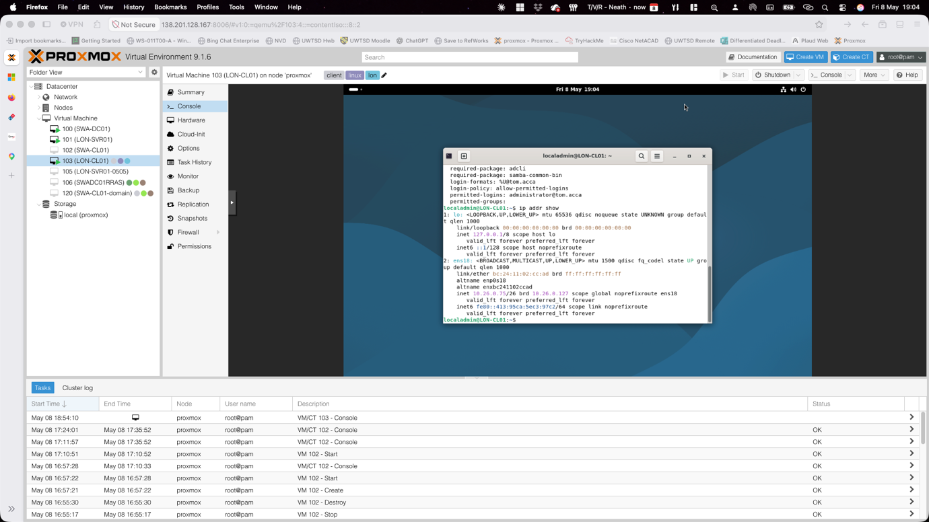

Routing Implementation
Name | Description | CIDR
VMBR1 | Swansea | 10.26.0.1/26
VMBR2 | London | 10.26.0.65/26
VMBR3 | Site-To-Site | 10.26.0.128/30

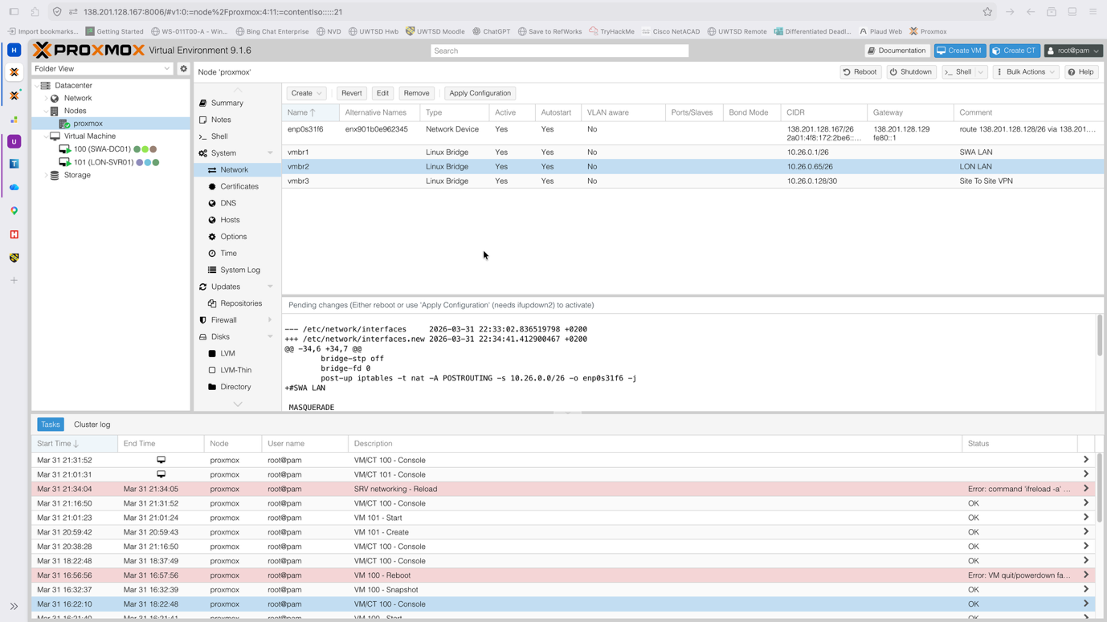

Active Directory Configuration
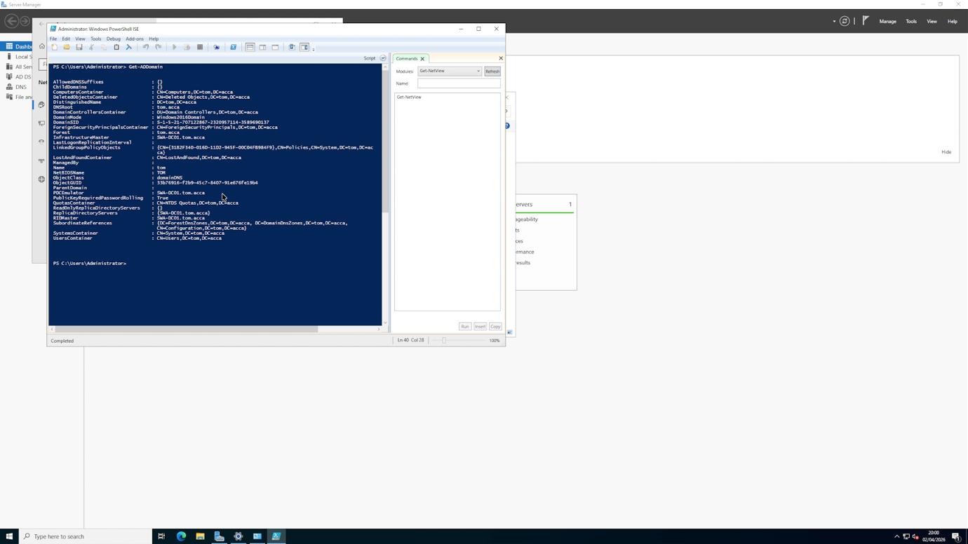
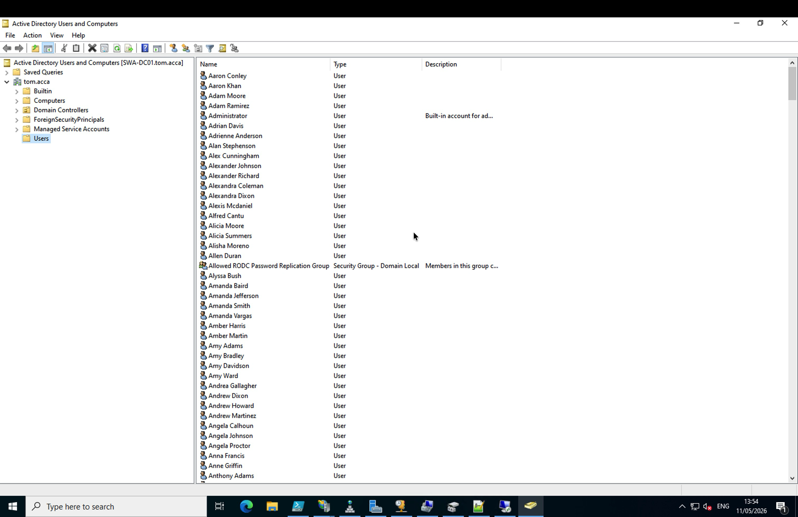
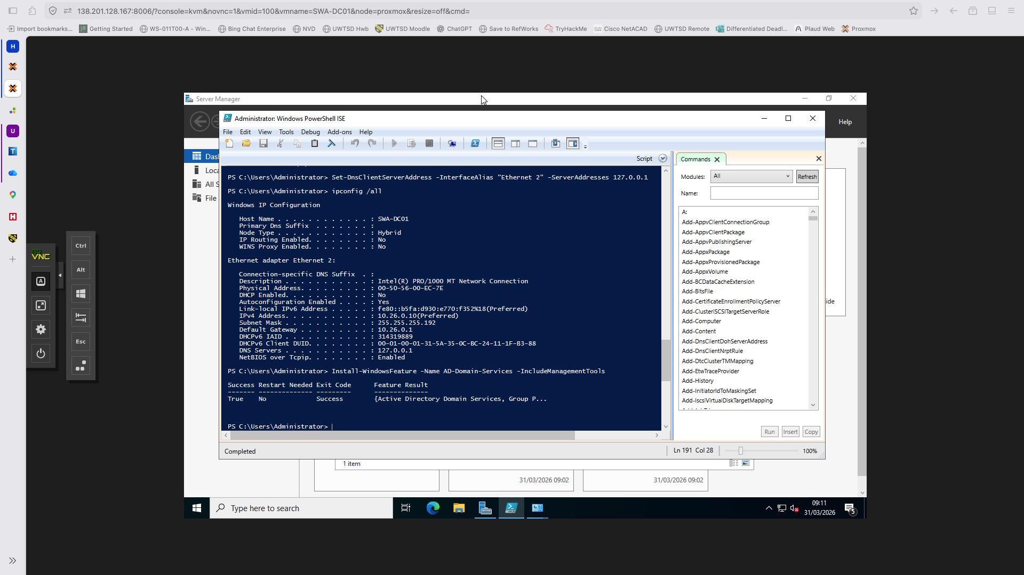

VPN Setup
The site-to-site VPN between my Swansea RRAS and London Libreswan setup was establishing connections but traffic wouldn't pass through the tunnel. I tried StrongSwan initially but switched to Libreswan instead. I disabled the LON-VPN demand-dial interface to stop a retry loop while I sorted out the Libreswan config. Post-rebuild, I need to finish configuring Libreswan on LON-SVR01, verify the PSK (NOSS2026!) is set correctly, test that traffic actually flows end-to-end, and confirm the encryption's working. Once that's done, the two sites should communicate securely.

DHCP Configuration

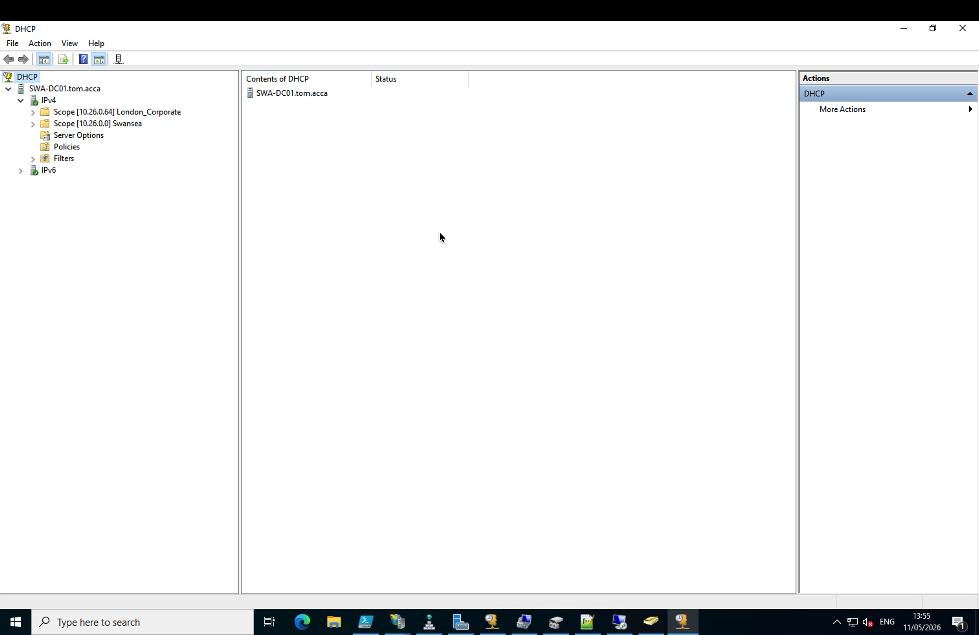

File Services
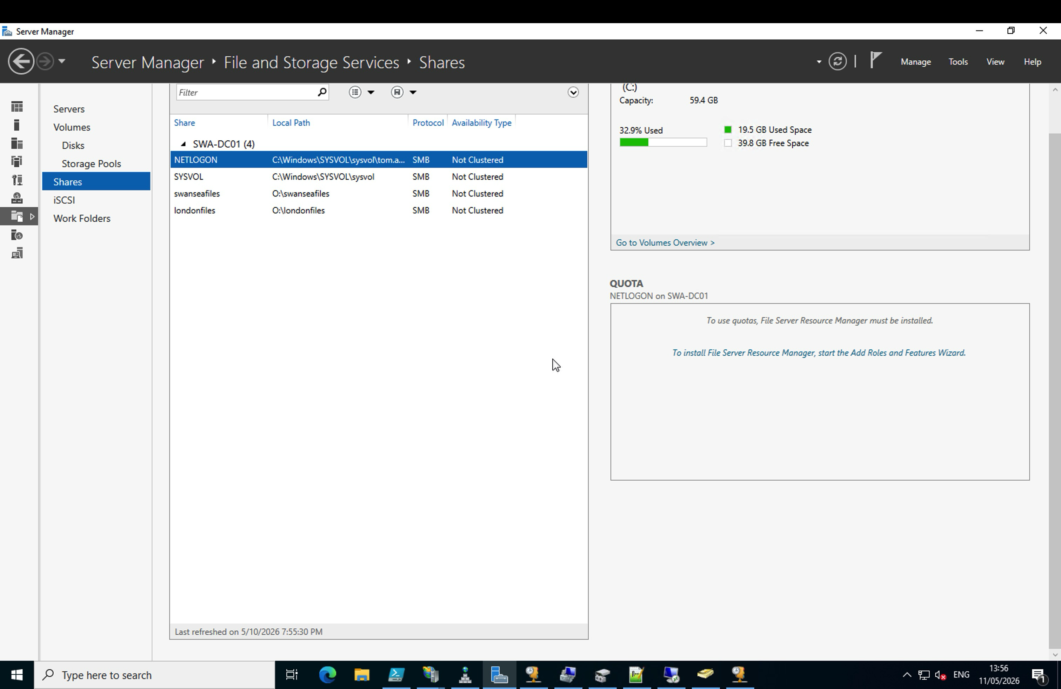

Web Services
CA issues prevented this working on the server itself – however could be viewed from the CL01 client, to be demonstrated.

Remote Access
I need to configure Remote Desktop Services on SWA-DC01 to enable secure remote access via https://rds.tom.acca. The CA on SWA-DC01 had issues initially—AD CS kept failing during earlier configuration attempts—so I spun up a dedicated CA VM (SWA-CA-01) to handle certificate services separately. Post-rebuild, I'll need to ensure the new CA is working properly and issuing valid certificates, then install and configure RDS on SWA-DC01 with those signed certificates. I'll test connectivity from LON-CL01 to verify domain users can authenticate and access the remote desktop securely. Once the CA stabilises, the certificate chain should be valid and trusted across both sites for proper HTTPS-based remote access.

Testing and Troubleshooting
Simplifying Hypervisor access – Issues with being able to remote access servers using ‘true’ RDP and SSH sessions rather than via NoVNC or SPICE. Fix : created reservations on the DHCP for the Clients requiring DHCP assigned addresses, then forwarded via port to specific machines
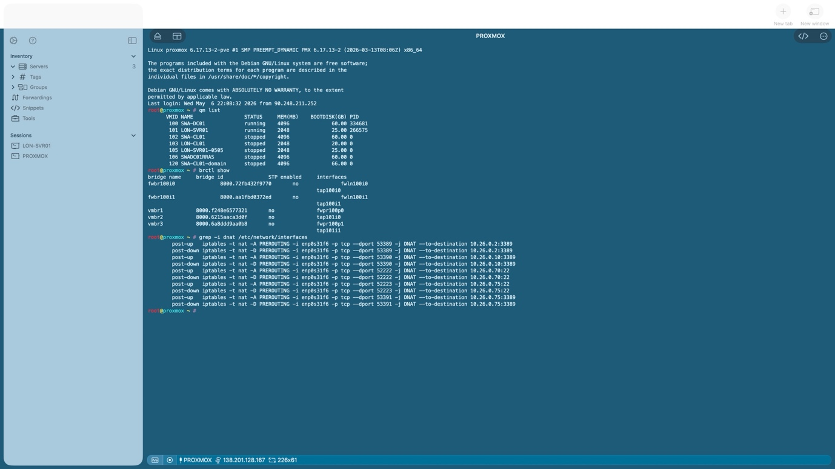
Demand Dial on VPN – LON-VPN – retry loop occurred while trying to apply Libreswan config Fix: Disabled the config
IPv6 causing additional reports in SWA-DC01. Fix: disable IPv6 on adapter.

SWA-DC01 Rebuild
During initial AD CS and RRAS configuration on SWA-DC01, multiple failures occurred: machine certificate auto-enrollment failed intermittently, DHCP scope exhaustion was triggered by RRAS pre-allocating addresses from the production range, and DNS cosmetic artefacts 1 results suggested underlying configuration conflicts. Rather than troubleshoot cascading issues, a complete SWA-DC01 rebuild was initiated using a master PowerShell script to provision the AD DS forest (tom.acca), Enterprise Root CA (RSA 2048/SHA-256/10-year), DHCP with corrected scopes, and RRAS with the static IP pool (10.26.0.30–10.26.0.40). This rebuild approach ensured clean state and eliminated inherited configuration drift.

SWA-CL01 Rebuild
Initial SWA-CL01 deployment used an incompatible Windows 11 ISO that failed to boot reliably on Proxmox. Rather than invest time in ISO troubleshooting, SWA-CL01 was rebuilt using a verified Windows Server 2022 Standard ISO (matching SWA-DC01's OS footprint for consistency). This provided a stable, testable client VM while reducing OS variance in the infrastructure.

Path Forward
Post-rebuild validation is underway. All three client/member VMs require domain join scripts to integrate with the rebuilt tom.acca domain. The critical outstanding task is completing Libreswan configuration on LON-SVR01 to establish the encrypted site-to-site VPN tunnel, enabling full bidirectional connectivity and service replication between sites.

Due to issues with Certificate Authority on SWA-DC01, I took the decision to follow industry practice in maintaining CA on a separate server, having tried obtaining the files regarded as missing through DISM, Windows Update, WinSXS and the ISO itself and being unsuccessful, I took the decision to download a new ISO of Windows 2025 Server which is being configured.

Further Reading
Debian Project, "Debian Documentation," https://www.debian.org/doc/
Debian Project, "Debian GNU/Linux Installation Guide," https://www.debian.org/releases/stable/amd64/install.en.html
Debian Project, "Debian Reference," https://www.debian.org/doc/manuals/debian-reference/
Ubuntu Community, "Ubuntu Tutorials," https://ubuntu.com/tutorials/
Ubuntu Community, "Ubuntu Server Documentation," https://ubuntu.com/server/docs
Ubuntu Community, "Ubuntu Release Notes," https://wiki.ubuntu.com/Releases
Proxmox Virtual Environment
Proxmox Server Solutions GmbH, "Proxmox VE Installation," https://pve.proxmox.com/wiki/Installation
Proxmox Server Solutions GmbH, "Proxmox VE Administration Guide," https://pve.proxmox.com/pve-docs/pve-admin-guide.html
Proxmox Community, "Proxmox Forums," https://forum.proxmox.com/
Ryan Tutorials, "Linux Tutorial for Beginners," https://ryanstutorials.net/linuxtutorial/
freeCodeCamp, "The Linux Command Handbook," https://www.freecodecamp.org/news/the-linux-commands-handbook/
LinuxCommand.org, "Learn The Linux Command Line," https://linuxcommand.org/
Microsoft Windows Server and Active Directory
Microsoft Learn, "Windows Server Documentation," https://learn.microsoft.com/en-us/windows-server/
Microsoft Learn, "Active Directory Administrative Center," https://learn.microsoft.com/en-us/windows-server/identity/ad-ds/get-started/virtual-machine-deployment-guide
Microsoft Learn, "Windows Server Networking," https://learn.microsoft.com/en-us/windows-server/networking/networking-overview

