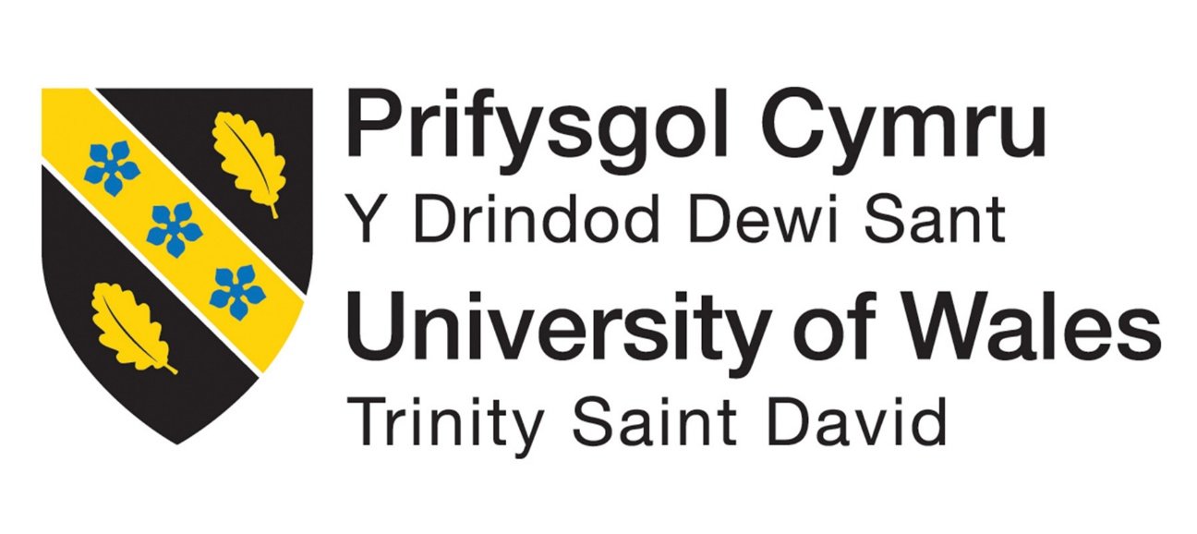

Module Name: Developing the Learning Organisation
Module Code: BMSK5010
Assignment Title: Developing the Learning Organisation
Assignment Word Count: 4000 Words
Submitted Word Count: 4380 Words
Student Name: Sebastian Ropel
Student Number: 2423021
Lecturer: Christine Joy
Deadline: 11/10/2026

Al Acknowledgement
I confirm that I have not presented any Al generated materials as my own work. I confirm that I have copies of my drafts, notes, and other resources I used, which I may be asked to provide in evidence

Contents
Introduction 2
Developing Individuals in the Workplace 3
The Michigan Model 4
Toulmin’s argument model 4
Holland's Career Theory 5
Managing Development Expectations 5
SMART Objectives 6
Development Methods 7
Continuing professional development (CPD) 8
Proposed Development Plan 9
Performance Management 10
Evaluating the Development Plan and Workplace Relationships 11
Conclusion 12
References 13
Appendixes 18

Introduction
This report examines the importance of developing individuals in the workplace and shows how this can benefit employees and the organisation. The report is based on my workplace, Swansea Leisure Centre, where I work as a gym instructor and personal trainer. My role involves delivering one-to-one personal training sessions, delivering fitness classes, creating tailored training program plans, giving fitness advice, helping customers use the gym safely and effectively, and working alongside other gym instructors and personal trainers.
The main development issue identified in my workplace is that gym instructors can have different levels of knowledge and confidence when providing personal training session and giving different fitness advice to customers. This can lead to differences and confusion in the information customers receive. Developing employees is important because it can improve their knowledge, confidence and performance while also helping the organisation to retain more customers and provide a more consistent customer experience.
The report will examine the benefits of developing individuals, how development expectations can be managed, and different methods that can be used to support employee development. It will then apply these ideas to a 12-week workplace development plan. For this report I will use several theories and models from the module to support the report. The Michigan Model is used to link employee development with workplace performance. Senge's Learning Organisation is used to show how individual learning can support team learning. Holland's Career Theory is used to consider different career interests and development needs. SMART objectives are used to set clear goals, Miller's Pyramid, Kirkpatrick's model and the CPD cycle are used to assess, evaluate and support the ongoing development.

Developing Individuals in the Workplace
Employee development can improve knowledge, skills and confidence, but training alone does not always lead to these improvements (Haile, 2021). Garavan et al. (2021), based on 119 studies, found that training had a great effect on organisational performance, and this effect has become stronger over time. This is important for gym instructors. Having good knowledge is essential, but they also need good communication, listening and decision-making skills. Kraiger and Ford (2021) explain that good training and effective learning are important for workplace development while Arabi and Garza (2023) say that learning something new does not always mean employees will use it effectively in the workplace.
Development at Swansea Leisure Centre should focus on what employees actually do at work (Gemmano et al., 2022). Including observing how employees interact with customers, checking if the information they give is correct and seeing how confidently they communicate. The main focus should not only be on whether an employee completed the training, but on whether the training has led to better performance at work (Bhurtel & Bhattarai, 2023).

The Michigan Model
The Michigan Model of Human Resource Management can also be used to explain how employees can be developed in the workplace. Tamunimiebi et al. (2023) explain that the Michigan Model connects Human Resource practices, including recruitment, appraisal, rewards and employee development, to organisational performance. If employees are expected to improve, the organisation also needs to provide appropriate support, regular feedback and opportunities to use what they have learned.
At the leisure centre, employee development should focus on the needs and expectations of the gym team. For example, if staff are expected to provide consistent information about personal training, they need access to the same basic information, opportunities to discuss questions and feedback on their performance.

Toulmin’s argument model
Toulmin’s argument model uses a claim, evidence and reasoning to support an argument (Toulmin, 1958). At Swansea Leisure Centre, the claim could be that differences in gym instructors’ knowledge may lead to customers receiving inconsistent information. Workplace observations and knowledge tests could provide evidence to support this claim. This would explain how improving staff knowledge could help them give customers more consistent information.
Senge's Learning Organisation
Senge's learning organisation model shows that learning should be shared across the workplace rather than remaining with one individual (Zhang et al., 2022). Wiese et al. (2022) studied results from 7,758 teams across different studies and found that teams that learn and share knowledge tend to perform better. Harvey et al. (2022) also mentioned the importance of team learning in connecting individual and organisational learning. If gym instructors have different levels of knowledge, the solution should not be to send one person on a course. Employees should develop their skills individually and learn together as a team. Staff could discuss common customer questions, share useful information and agree on the basic guidance that should be given to customers.
Another benefit of development is its possible effect on the customer experience. Customers are more likely to have confidence in a service when they receive clear and reliable information. However, there is a difference between consistency and giving everyone identical advice. Customers have different abilities, goals and circumstances, so staff still need to adapt their communication. Employee development should help staff build their knowledge and decision-making skills instead of simply following a set script. Ng et al. (2024) found that when employers support career development, employees can perform better and feel more connected to the organisation. This is important because employees may be more engaged when they can see how development relates to their future career. Completing additional training does not guarantee promotion, more clients or higher pay.

Holland's Career Theory
Holland's Career Theory provides another useful way of looking at this issue. Holland (1997) said that people have different vocational interests and that career satisfaction can be affected by how well a person's interests fit their working environment. His theory identifies six main interest areas: realistic, investigative, artistic, social, enterprising and conventional. For gym instructors and personal trainers, some of these areas can be relevant. The social side of the role involves working with and helping customers. The practical side involves working with exercises and gym equipment. The enterprising side may become more important for employees who want to develop a career in personal training, as Personal trainer work involves communicating with clients, promoting services and building a client base.
Holland's theory should not be used to place employees into fixed groups. Instead, it can help managers understand their interests and support their development. Employee who enjoys working with customers but has little interest in sales may have different development needs from someone who wants to develop a career in personal training. Understanding these differences can help make development more individual and meaningful. One employee may need more knowledge, while another may need more confidence in communication or an opportunity to practise consultation skills. Development should consider the needs of the organisation and the interests and career aims of the employee.
There are also possible benefits for employee confidence and motivation. Employees who are given opportunities to develop may feel more capable in their role. Confidence should not be confused with competence. An employee can feel confident while still having gaps in their knowledge. Miller's pyramid shows this progression by moving from knowing information, to knowing how to use it, showing how it can be applied and finally performing the skill in practice (Miller, 1990). This is why workplace observation is important. If an instructor passes a knowledge test but cannot explain the information correctly to a customer, the development has not fully transferred into practice. Development should include knowledge and workplace performance. The main benefit of employee development is not that employees gain more qualifications. The best benefit is when learning improves behaviour, communication, teamwork and the service provided to customers.

Managing Development Expectations
Employee development needs to be managed carefully because employees and organisations may have different expectations. An employee may see development as a chance to get promoted, earn more money or gain more PT clients, while the organisation may be more focused on improving service, employee performance and customer satisfaction. These expectations need to be discussed before development begins. Development should be treated as a shared process rather than something that is given to an employee. Employees should understand why they need to develop, what they need to improve and how their progress will be measured. At the same time, the organisation needs to be clear about what support it can provide. Development may improve an employee's knowledge and confidence, but it cannot guarantee promotion, higher pay or a specific number of personal training clients. Employees should also have an active role in deciding what they need to develop, based on their needs, abilities and preferences (Svicher & Di Fabio, 2021). If a manager tells an employee that they have a knowledge problem, the employee may become defensive. Managers could ask employees which areas they feel less confident in, what questions they often receive from customers and what skills they would like to improve.
Smeets et al. (2021) found that support from supervisors, including feedback and guidance, can affect how employees learn from their mistakes. Managers should create a workplace environment where employees feel comfortable saying when they do not know something, without worrying that it will be seen as poor performance. Staff should have opportunities to discuss progress rather than waiting until the programme is finished. Regular short conversations could be used to identify problems, review progress and make changes where necessary.

SMART Objectives
SMART objectives can be useful in managing development expectations. Objectives should be specific, measurable, achievable, relevant and time bound. Rather than saying that an employee should improve their personal training knowledge, a more useful objective would be to improve their knowledge of personal training services and demonstrate the ability to explain these services accurately to customers within 12 weeks. Progress could be checked through a knowledge assessment and workplace observation. SMART objectives give employees a clear goal to work towards, but they also have some limitations. Some aspects of development are difficult to measure using simple numbers. Confidence, communication and the quality of customer interactions cannot be shown accurately through a score. It is important to look at other forms of development evidence, such as feedback, observations and regular conversations, when reviewing employee development.

Pearson’s RED model
Pearson’s RED model stands for Recognise assumptions, Evaluate arguments and Draw conclusions (Wulandari et al., 2021). At Swansea Leisure Centre, it could help managers avoid making assumptions about gym instructors’ knowledge. Instead, they could use workplace observations and knowledge tests to check what employees know and identify any gaps. The results could then be used to decide what development and support staff need.

Development Methods
Formal training can be helpful when employees need to learn the same basic knowledge. Structured sessions could be used to explain the personal training service, customer communication and when a customer may be referred to a personal trainer. The main advantage is that employees receive the same information. Training can be expensive and there is no guarantee that employees will use the information afterwards. Employees should have opportunities to apply what they have learned in the workplace.
Coaching is more focused on workplace behaviour. A manager or experienced colleague could shadow and observe the instructor speaking with a customer and provide feedback afterwards (Cannon-Bowers et al., 2023). For example, the coach could look at whether the instructor listened properly, asked appropriate questions, gave accurate information and explained the personal training service clearly.
Research suggests that workplace coaching can have a very beneficial outcomes. Cannon-Bowers et al. (2023) found that it can support employee development and improve performance, while de Haan and Nilsson (2023) also suggest that coaching can have a positive impact on employees. However, coaching is not always effective. The quality of the coach and how the coaching is delivered is important.
Nyfoudi et al. (2023) found that managerial coaching can support team performance, but this can also depend on factors such as team knowledge and the manager's learning orientation. This suggests that coaching should not involve telling employees what they have done wrong. It should involve discussion, reflection and practical improvement.
Mentoring is different from coaching because it can be more focused on longer-term development and career direction. An experienced personal trainer or instructor could support a less experienced employee by sharing knowledge and discussing career development. This could be useful for someone who is interested in progressing into personal training. The main risk with mentoring is that the mentor's knowledge may not always be correct or up to date. Mentoring should follow workplace standards and use up-to-date information. The mentor should support the employee's development instead of only sharing their own opinions.
Job shadowing could also be useful. An instructor who is interested in personal training could observe an experienced personal trainer carrying out a consultation, designing a programme or communicating with a client. This would allow the employee to see how knowledge is used in practice. It can also be a more affordable option than using external training. Job shadowing has the same problem as mentoring: employees can copy poor practice if the person they are observing does not work to the expected standard. Shadowing should be followed by discussion and feedback about what was observed and why particular approaches were used.
Peer learning is another effective method as the issue identified in this report is linked to differences in knowledge and practice among the gym team. Employees could discuss common customer questions, compare experiences and share information. This supports Senge's (1990) idea of team learning. However, peer learning can also create incorrect group habits if employees share information that is not evidence-based. For this reason, employees should follow clear workplace guidance when sharing knowledge.
360-degree feedback could also be useful because it allows employees to receive feedback from managers, colleagues and customers. It can identify areas where employees may not be aware of their own weaknesses that they could improve. Feedback may not always be completely objective, as personal relationships can affect how people respond. The feedback should focus on particular areas of performance rather than general statements about whether someone is good or bad at their job (Smither et al., 2005)
Drouvelis and Paiardini (2022) found that the quality of feedback can influence employee productivity, showing why feedback should be clear and useful during development. At the leisure centre, feedback could be based on areas such as how staff communicate, the accuracy of the information they provide, their listening skills and how they interact with customers.
Formal training can help employees gain consistent knowledge, while coaching can help them put this knowledge into practice at work. Mentoring can support longer-term career development, job shadowing can provide practical experience and peer learning can improve team knowledge. The development plan should use a combination of methods instead of relying on one type of training. This also supports the learning organisation approach, as development can take place at individual, team and organisational levels.

Continuing professional development (CPD)
Continuing professional development (CPD) can provide longer-term support after the initial development programme. The CPD cycle encourages employees to identify development needs, plan learning, carry it out and reflect on the results. The weakness of CPD is that it can become a box-ticking exercise. An employee could complete several courses without actually changing their workplace behaviour. This is why CPD should focus on what has been learned and how it has been applied rather than simply counting the number of hours completed.

Proposed Development Plan
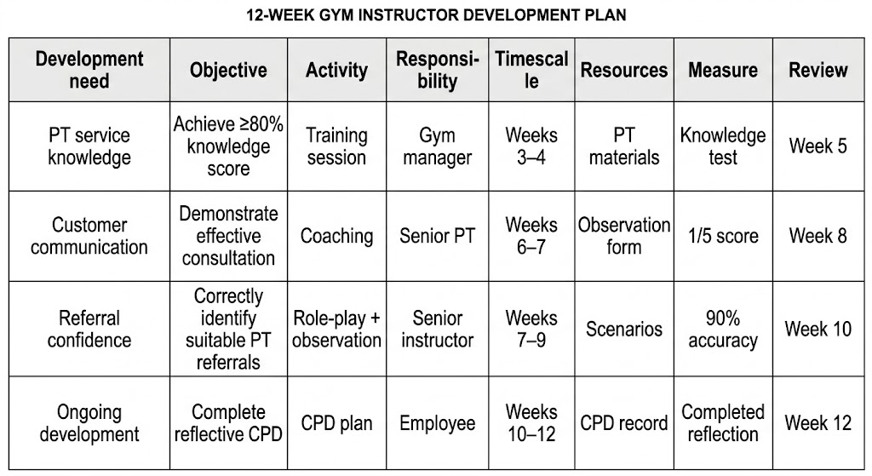
The main development identified is to improve the consistency of gym instructors’ knowledge and communication when discussing personal training. The purpose is not to turn gym instructors into personal trainers. Instead, they should have enough knowledge to give accurate information, understand the role of personal training and recognise when a customer may benefit from speaking to a personal trainer. The development plan would run for 12 weeks and be divided into four stages. Please see the appendix A below illustrating the 12-week development plan.

Appendix A: 12-week Development Plan (Open AI, 2026).
During the first two weeks, employees would complete a short knowledge assessment and self-assessment. The knowledge assessment could cover the personal training service, professional boundaries, basic customer communication and appropriate referral to a personal trainer. Employees would also be asked to identify areas where they feel less confident.
A manager or experienced staff member could also observe how employees interact with customers during their usual work. They could assess whether the information provided is correct and look at communication, listening skills and confidence. The first assessment is important because it shows employees' starting level. Without this information, it would be harder to measure whether the programme has helped them improve.
Weeks three to five would focus on shared learning. Short team sessions could cover the role of the gym instructor, the role of the personal trainer, the personal training service, customer communication and when to refer a customer to a personal trainer. Staff could also discuss common customer questions and situations that they have experienced. This stage would include formal learning with peer learning. It would also support Senge's concept of team learning by allowing employees to learn from each other.
Weeks six to nine, employees would put their learning into practice with support from a coach. Their work would be observed, followed by feedback to help them understand what they are doing well and where they could improve. The observation could look at whether the employee gives accurate information, listens to the customer, asks appropriate questions, communicates clearly and knows when to refer the customer to a personal trainer. The employee should also have the opportunity to reflect on the interaction and identify ways to improve their approach to work (Demerouti et al., 2021). It should be able to explain what went well, what could have been better and what they would do differently next time.
Weeks ten to twelve would focus on review and evaluation. Employees could complete the knowledge test again, and the results of workplace observations could be compared with the first assessment. Employees could also repeat their confidence assessment and discuss whether they feel the development has been useful. The targets could include scoring at least 80% in the knowledge test, showing better communication with customers and providing information about personal training that matches the agreed guidance. A target of 90% consistency could be set, although the final target should be decided once the initial results are available.
Customer feedback and enquiries about personal training could also be tracked. However, these results may be influenced by the number of members, marketing activities, seasonal changes and customer demand. Therefore, it would be difficult to claim that any increase was caused only by the development programme. The plan should also make clear who is responsible for each task. The manager would organise the programme and provide coaching or arrange for someone else to deliver it. Experienced gym instructors or personal trainers could help by sharing their knowledge and observing employees at work. Employees would need to take part in the activities, complete the agreed tasks and use what they have learned in their daily work (Suhaimy et al., 2023). The plan should not create too much administration work or take up too much staff time, as this could affect customer service. Short and regular activities would be easier to manage than long training sessions that may be difficult to fit into the gym's daily routine.

Performance Management
Employee development should be included in regular performance reviews instead of being treated as a separate training activity. Performance management should involve setting expectations, supporting employees, monitoring progress and reviewing performance. Employees are more likely to improve when they can put their learning into practice at work.
The Michigan Model also relates to this approach, as it connects activities such as performance reviews and employee development with staff performance and the results achieved by the organisation. Development objectives should be connected to the employee's normal role. For a gym instructor, this could include customer communication, knowledge, health and safety, class delivery and awareness of the personal training service. Regular feedback should be used instead of relying only on an annual review. Short conversations after observations would allow employees to understand what they are doing well and what they need to improve.

Evaluating the Development Plan and Workplace Relationships
The proposed plan combines different development methods. Formal training can help ensure that all employees receive the same information, while coaching and observation can help them use this knowledge in their everyday work. Mentoring and peer learning can provide longer-term support. This is important because employees have different levels of experience, confidence and career interests. Holland's theory also suggests that employees may have different career interests. Someone who wants to progress into personal training may be interested in additional development opportunities, while another employee may prefer to focus on becoming a stronger gym instructor.
The plan also has some drawbacks. One issue is time. Gym instructors have to continue supporting customers while taking part in development activities. Spending too much time on training could affect the quality of service provided to customers. Another issue is employee engagement. Not every employee will have the same interest in development. Some may feel that they already have enough experience or may not see personal training as part of their career. This is why development expectations need to be discussed with employees.
There is also a problem with measuring the effect of the programme. For example, more customers asking about personal training could indicate progress, but it would not necessarily mean that the development programme was responsible for the increase. Marketing, membership numbers, seasonal changes and customer demand could also influence the results. The programme should be evaluated using different measures instead of depending on a single result.
The same applies to confidence. Employees may feel more confident after training, but this does not necessarily mean they have the skills and knowledge needed to do the job well. This is why the plan uses self-assessment alongside knowledge tests, workplace observations and feedback. Miller's Pyramid is relevant because it shows the difference between knowing information and being able to demonstrate and use it in practice.
The results should also be checked after the 12-week programme has ended. Employees may forget what they have learned if they do not get the chance to use it regularly at work. Short team discussions, observations and CPD activities would help maintain the improvements. This reflects the learning organisation approach because learning becomes part of everyday work instead of happening only once.
The plan could also be evaluated using Kirkpatrick's model (Kirkpatrick, 1994). The first level looks at how employees felt about the training and whether they found the sessions useful. The second level measures what employees have learned through knowledge tests. The third level looks at changes in employee behaviour, which can be checked by observing them at work. The fourth level looks at the overall results, including whether employees provide more consistent information and whether customer experiences improve. Using these levels would provide a more complete evaluation rather than just recording whether employees attended training.
Good workplace relationships are also important for the plan to work. If employees feel that the aim of development is to point out their mistakes, they may be less comfortable talking about areas where they need support. Managers should explain that finding areas where employees need to improve is a normal part of learning and does not mean they have done a bad job.
Smeets et al. (2021) show that the way supervisors support employees can affect how they learn from their mistakes. Managers should give helpful feedback while making sure employees follow professional standards. It is important to support staff while also holding them responsible for their actions. Issues involving health and safety or incorrect professional advice still need to be addressed appropriately.
Team learning can also improve workplace relationships because employees have opportunities to share knowledge and discuss different experiences. Rather than everyone working on their own, staff can agree on how to give customers the right support. This could help reduce differences in the information staff provide and make it easier to direct customers to the right service.
However, employees should not be expected to work in exactly the same way. They have different skills and experiences that can benefit the team. The aim is to make sure everyone follows the correct guidance and professional standards while still allowing them to communicate with customers in their own way and use their judgement.

Conclusion
Developing employees can benefit both staff and the organisation, but training alone does not guarantee better performance at work. The issue discussed in this report shows that employee development should involve more than individual training. Differences in gym instructors' knowledge also show the need for the team to learn and share information together. Senge's learning organisation model provides a useful framework because it shows the importance of personal development, team learning and understanding how the workplace operates. The Michigan Model also demonstrates the importance of connecting development with human resource activities such as performance management and appraisal. Holland's Career Theory provides another useful perspective by recognising that employees have different interests and career goals. Both theories show why development should meet the needs of the organisation while also considering individual employees.
Formal training helps ensure that employees have the same basic knowledge, while coaching and observation help them apply what they have learned in their daily work. Mentoring and job shadowing can help employees gain experience and develop their careers, while peer learning and CPD can help staff continue learning and sharing knowledge. The proposed 12-week plan provides a structured areas for improvement, support employee learning, put new skills into practice and reviewing the results. By using knowledge tests, workplace observations, feedback and employee reflection, the plan checks whether staff can use what they have learned rather than just whether they attended the training.
The plan may face some challenges, such as limited time, low employee involvement and difficulties in showing whether the programme has led to certain results. Therefore, the plan should be reviewed regularly and changed where necessary. Employee development at Swansea Leisure Centre could help staff improve their knowledge, confidence, communication skills and career prospects, while also encouraging better teamwork and more consistent service (Bagdadli et al., 2021). The biggest benefit is likely to come when employees share what they have learned with their colleagues and use it in their everyday work.

References
Arabi, E., & Garza, T. (2023). Training design enhancement through training evaluation: Effects on training transfer. International Journal of Training and Development, 27(2), 191–219. https://doi.org/10.1111/ijtd.12295

Bagdadli, S., Gianecchini, M., Andresen, M., Cotton, R., Kaše, R., Lazarova, M., Smale, A., Bosak, J., Briscoe, J. P., Chudzikowski, K., Dello Russo, S., & Reichel, A. (2021). Human capital development practices and career success: The moderating role of country development and income inequality. Journal of Organizational Behavior, 42(4), 429–447. https://doi.org/10.1002/job.2506

Bhurtel, A., & Bhattarai, P. C. (2023). Environmental factors affecting training transfer among the instructors. Vocations and Learning, 16, 293–312. https://doi.org/10.1007/s12186-023-09317-y

Cannon-Bowers, J. A., Bowers, C. A., Carlson, C. E., Doherty, S. L., Evans, J., & Hall, J. (2023). Workplace coaching: A meta-analysis and recommendations for advancing the science of coaching. Frontiers in Psychology, 14, 1204166. https://doi.org/10.3389/fpsyg.2023.1204166

de Haan, E., & Nilsson, V. O. (2023). What can we know about the effectiveness of coaching? A meta-analysis based only on randomized controlled trials. Academy of Management Learning & Education, 22(4), 641–665. https://doi.org/10.5465/amle.2022.0107

Demerouti, E., Soyer, L. M. A., Vakola, M., & Xanthopoulou, D. (2021). The effects of a job crafting intervention on the success of an organizational change effort in a blue-collar work environment. Journal of Occupational and Organizational Psychology, 94(2), 374–399. https://doi.org/10.1111/joop.12330

Drouvelis, M., & Paiardini, P. (2022). Feedback quality and performance in organisations. The Leadership Quarterly, 33(6), 101534. https://doi.org/10.1016/j.leaqua.2021.101534

Garavan, T., McCarthy, A., Lai, Y., Murphy, K., Sheehan, M., & Carbery, R. (2021). Training and organisational performance: A meta-analysis of temporal, institutional and organisational context moderators. Human Resource Management Journal, 31(1), 93–119. https://doi.org/10.1111/1748-8583.12284

Gemmano, C. G., Manuti, A., & Giancaspro, M. L. (2022). “It’s just a matter of culture”: An explorative study on the relationship between training transfer and work performance. Journal of Workplace Learning, 34(6), 532–548. https://doi.org/10.1108/JWL-10-2021-0133

Haile, G. A. (2021). Organisational accreditation, workforce training and perceptions of performance. Industrial Relations Journal, 52(4), 291–314. https://doi.org/10.1111/irj.12327

Harvey, J.-F., Bresman, H., Edmondson, A. C., & Pisano, G. P. (2022). A strategic view of team learning in organizations. Academy of Management Annals, 16(2), 476–499. https://doi.org/10.5465/annals.2020.0352
Holland, J. L. (1997). Making vocational choices: A theory of vocational personalities and work environments (3rd ed.). Psychological Assessment Resources.

Kirkpatrick, D. L. (1994). Evaluating training programs: The four levels. Berrett-Koehler.

Kraiger, K., & Ford, J. K. (2021). The science of workplace instruction: Learning and development applied to work. Annual Review of Organizational Psychology and Organizational Behavior, 8, 45–72. https://doi.org/10.1146/annurev-orgpsych-012420-060109
Miller, G. E. (1990). The assessment of clinical skills/competence/performance. Academic Medicine, 65(9 Suppl), S63–S67. https://doi.org/10.1097/00001888-199009000-00045

Ng, T. W. H., Yim, F. H. K., Chen, H., & Zou, Y. (2024). Employer-sponsored career development practices and employee performance and turnover: A meta-analysis. Journal of Management, 50(2), 685–721. https://doi.org/10.1177/01492063221125143

Nyfoudi, M., Shipton, H., Theodorakopoulos, N., & Budhwar, P. (2023). Managerial coaching skill and team performance: How does the relationship work and under what conditions? Human Resource Management Journal, 33(2), 328–345. https://doi.org/10.1111/1748-8583.12443

Senge, P. M. (1990). The fifth discipline: The art and practice of the learning organization. Doubleday.

Smeets, L., Gijselaers, W. H., Meuwissen, R. H. G., & Grohnert, T. (2021). Beyond psychological safety: The role of direct supervisor behavior in fostering learning from errors at the workplace. Vocations and Learning, 14(3), 533–558. https://doi.org/10.1007/s12186-021-09272-6

Smither, J. W., London, M., & Reilly, R. R. (2005). Does performance improve following multisource feedback? A theoretical model, meta-analysis, and review of empirical findings. Personnel Psychology, 58(1), 33–66. https://doi.org/10.1111/j.1744-6570.2005.514_1.x

Suhaimy, M. H., Sumardi, W. A., Sumardi, W. H., & Anshari, M. (2023). An empirical study of training transfer in an apprenticeship programme for conducive workforce. International Journal of Training Research, 21(2), 134–166. https://doi.org/10.1080/14480220.2022.2152471

Svicher, A., & Di Fabio, A. (2021). Job crafting: A challenge to promote decent work for vulnerable workers. Frontiers in Psychology, 12, 681022. https://doi.org/10.3389/fpsyg.2021.681022

Tamunimiebi, M. D., Nyedah, B. B., & Okoh, E. (2023). The matching model of human resource management: A conceptual review. The Strategic Journal of Business & Change Management, 10(3), 23–34. https://doi.org/10.61426/sjbcm.v10i3.2684

Toulmin, S. E. (1958). The uses of argument. Cambridge University Press.

Wiese, C. W., Burke, C. S., Tang, Y., Hernandez, C., & Howell, R. (2022). Team learning behaviors and performance: A meta-analysis of direct effects and moderators. Group & Organization Management, 47(3), 571–611. https://doi.org/10.1177/10596011211016928

Wulandari, R., Baedhowi, & Hindrayani, A. (2021). Measuring critical thinking skills with the RED model. Journal of Physics: Conference Series, 1808(1), Article 012030. https://doi.org/10.1088/1742-6596/1808/1/012030

Zhang, J., Xu, H., & Xiao, X. (2022). The role of organizational learning in mediating the relationship between business model design and innovation performance. Discrete Dynamics in Nature and Society, 2022, Article 1317646. https://doi.org/10.1155/2022/1317646

Appendixes

Appendix A: Open AI, (2026). 12-week Development Plan.

