Guidance Paper
Departmental guide on the application of evidence-based practice and analytics for the
People Practice team

Introduction

Evidence-based practice and people analytics are still emerging in the field of HR, and many people professionals are familiarising themselves with scientific research in their practice (Barends et al., 2017).

This guidance paper is split into two sections. The first section aims to support our People Practice team by providing an overview of the importance of applying evidence-based practice and analytics to inform sound and justified decision-making in the organisation. The second section applies the theory of evidence-based practice and analytics by carrying out statistical analysis of a data table and providing recommendations for the People Practice team.

Section 1

AC 1.1 What is evidence-based practice? How can it be applied in an organisation? How can different types of evidence-based practice be used to inform principle-led judgements and outcomes for an organisation?

Evidence-based practice (EBP) is defined as 'making decisions through the conscientious, explicit and judicious use of the best available evidence from multiple sources…to increase the likelihood of a favourable outcome' (Barends, Rousseau and Briner, 2014, pp. 4). It has been adopted in the field of HR as it has proven to better people professionals' decision-making on the development and application of 'people strategies, people policies and procedures' (Waite et al., 2021, pp. 47).

EBP is an essential element to an organisation's broader strategy as it prevents only depending upon personal experience and intuition, which can be tainted by biases (Barends et al., 2017; Young, 2022), and encourages critical thinking when evaluating whether to follow the example of another organisation's success of a certain initiative (Barends, Rousseau and Briner, 2014).

EBP combines four primary sources of evidence- stakeholder opinions, scientific research, professional expertise, and organisational data, e.g. people analytics- and each has unique qualities. Taking stakeholder evidence into account means hearing from internal and external interest groups to understand how an organisation's decisions may affect them (Waite et al., 2021). The evidence can then influence the overall outcomes of judgements as organisations choose to listen to stakeholder opinions. This type of evidence differs from scientific research as the information is from published literature, such as peer-reviewed journal articles, in HR, management, and psychology (Waite et al., 2021). The decisions made using the evidence gathered in this case will be backed by hard data that other researchers have cross-checked.

AC 1.2 What is the importance of using data and why does it need to be accurate when determining problems?

Data forms a part of EBP (Hill and Houghton, 2018), and organisations that use data analytics perform better than those that do not (Miller, 2019). In the age of artificial intelligence (AI), which has fostered more complex data, the bulk of crucial information has been supplied by big data (Barnard and Walls, 2020). Big data's ability to provide high volumes of a variety of valuable data at real-time speed has evolved to become a leading player in 'innovation and competitive advantage by transforming decision-making and potentially leading to new strategic methods' (Barnard and Walls, 2020, pp. 2).

To transform data (like big data) into value, organisations are increasingly using people analytics which is 'statistical techniques…that are used to show the impact of HR activities' (Marler and Boudreau, 2017, pp. 14). It uses an evidence-based approach and a range of technologies to collect and present data, such as employee engagement and organisational performance, to make better decisions. This is useful as it can highlight to practitioners which areas require monitoring or urgent addressing (Charlwood, Stuart and Trusson, 2017).

However, not all organisations can apply data effectively because they may not have the right conditions in place (Barrends et al., 2017) or fall into the danger of blindly accepting 'algorithm-based' (Giermindl et al., 2022, pp. 411) decisions. To successfully apply data and see improvements in organisational performance, firms need to have the proper infrastructure and systems to store, analyse and manage them (Barnard and Walls, 2020). They also need to embed a strong culture driven by analytics and help employees develop data skills by training them to locate and recognise valuable data to the organisation (Davenport et al., 2019).

AC 1.3 Explain different quantitative and qualitative data measurements used by people professionals.

Data can be either quantitative or qualitative in nature- the former presenting as numbers (objective and measurable), whereas the latter is presented through words (subjective and interpretive) (Mohdzaini, 2022).

Two examples of quantitative data are an organisation's absence and turnover rates. Employee absence can exist for a variety of reasons. It is important, therefore, to monitor the absence rate to identify any issues before it becomes persistent by checking in on employees' well-being and seeing how they can be supported (Ryley, 2017). Persistent absenteeism indicates a serious problem within the workforce and will have to be addressed through structural changes in management and policies if the cause mainly lies within the organisation (Suff, 2022).

A similar indication of how well the organisation is operating from the 'people side of business' (Marler and Boudreau, 2017, pp. 14) is the turnover rate. In organisations where recruitment takes time and is expensive, or the skills required are highly specialised, employees leaving will become an issue (Maxwell, 2021). Understanding the turnover rate will direct employers to improve employee experience and the organisation's overall culture to maintain staff retention (Shweta and Main, 2022).

Exit interviews are a form of qualitative data that can also help with retention and lower turnover. Listening to why employees decide to leave will spotlight key areas and perhaps themes that are not working well in the workplace (Spain and Groysberg, 2016). Further importance is sharing the analysed data with senior leaders and acting on findings (Maxwell, 2021).

AC 1.6 How does the application of agreed policies and procedures inform decisions?

Set policies and procedures create simple and specific guidance on organisational issues by improving the swiftness of decision-making in line with the organisation's strategy.

Organisations considering hiring a new employee must deal with the current average figure for non-managerial posts having increased from £2000 in 2017 (Leatherbarrow and Fletcher, 2019). As such, effective policies and procedures are important to increase the reliability of a new hire and reduce unnecessary costs. By thoroughly implementing the selection procedure, enough evidence will be gathered at each stage of the hiring process to make an informed decision on whether to pick the candidate. The values and priorities of the organisation and the responsibilities entailed in the job will have been clearly expressed. Moreover, the competencies and character of the candidate will have been identified and analysed so that the role, candidate, and organisation are a 'good fit' (Leatherbarrow and Fletcher, 2019, pp. 207) for both parties (Picardi, 2020). Honing this process will also enhance the customer-focused strategy as the right person for the job will perform their duties well, thus having a positive spill-over effect on customers (Arthur, 2023).

Furthermore, the selection policy must incorporate equality measures, providing a fair opportunity to all. These form part of a larger imperative to ensure that an organisation's diversity, equality and inclusivity (DEI) policy promise is applied in all business areas (George, 2022). This not only shapes external customers' perceptions of the organisation as being trustworthy and having integrity, but it also signals to the organisation's internal customers (the employees) that they are important and valued.

AC 2.1 How do people professionals create value for people, organisations, and wider stakeholders?

People professionals are uniquely positioned to create value for many different groups in meaningful ways. As mentioned before, people professionals have a role in developing employees’ skills and knowledge, which creates a more valuable workforce. As employees increase productivity, they help the business by minimising expenses and producing more work at a better quality, leading to increases in other areas, such as profits and customer satisfaction (Waite et al., 2021).

Regarding line managers (LMs), people professionals can create value by helping them to implement HR practices effectively. Using the Ability-Motivation-Opportunity (AMO) framework, Trullen et al. (2016) explain that people professionals play a role in enhancing:

- Ability- by developing core competencies and knowledge in LMs through providing clear and straightforward support material, i.e. handbooks and support services like an ‘open door policy’ (pp. 457).
- Motivation- by co-creating HR practices with them; framing practices in an appealing way to get LM buy-in; and recognising them for their work (Marler and Boudreau, 2017).
- Opportunity- by identifying the appropriate environment to introduce HR practices, garnering CEO support for the practices, and hiring external specialists who will provide added validity.

Research has shown a direct link between the effective implementation of HR practices and improved employee satisfaction with management, which has an affirmative connection to organisational performance (Trullen et al., 2016).

While people professionals work to create value in these different areas, ethical principles can be maintained by adopting a ‘question-based mindset’ (Hill and Houghton, 2018, p9), which seeks to find out what the effect of something will be on specific stakeholders.

AC 2.2 Summary of ways you can be customer-focused, and standards-driven in your own context

Being customer-focused and standards-driven is intrinsic in the NHS because of the values by which it is driven (NHS England, 2017), however, we can always strive to be better.

According to research, such as that done by Arthur (2023), 'non-monetary public recognition and award programs' (p2) prove quite effective in encouraging healthcare employees to practice more 'customer-oriented behaviour (COB)' (p1). Patients taking the time to write their feelings is an expression of their satisfaction with the exceptional service being provided. The written patient feedback, which HR collects and shares with the department, becomes a motivational driver for employees to continue practising COB and maintaining high standards to satisfy patients further.

Customer experience (CX) is also broadly linked to employee experience (EX) in that employees' behaviours affect their work, thus impacting the service they provide customers. One approach to preserving and growing the customer base through high customer satisfaction and a value-driven philosophy is to 'understand and improve EX' (HBR, 2021, p2) in the workplace. The level of EX can be gauged through data such as surveys which can be consolidated with employees' performance reviews. Additionally, communication can be improved across the hierarchy to achieve a positive work culture (Waite et al., 2021).

As identified and highlighted by the CIPD in their profession map, creating value for an organisation involves exhibiting the 'core behaviour' of 'commercial drive' (CIPD, no date), which links a customer-focused ethos to business strategy. This behaviour, as such, entails analysing the areas in which we as a people function perform least well and taking the necessary steps to make improvements. This could include collaborating with other functions in the organisation to provide the best standard of customer service (HBR, 2021).

Section 2

AC 1.4 For department’s C and D, present each age range as a percentage of the total in each department.

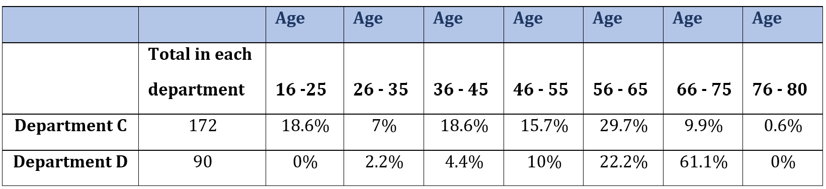

The above table figures show the employee age distributions in departments C and D by presenting the percentage of employees in each of the seven age ranges. The numbers are expressed as a percentage and rounded to 1 decimal place so that it is clearer for readers to understand and remains as accurate as possible.

The following formula was used to calculate the percentages:

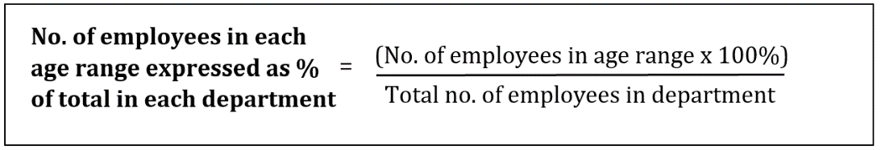

For example:

For the age range ‘16-25’ in Department C, the following calculation was made-

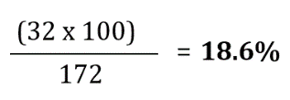

AC 1.5 Present your findings using two different diagrammatic forms so it can be easily understood by end users and from analysis of the findings, comment on any issues that might be revealed in the data and recommend potential solutions.

The data findings in AC 1.4 for departments C and D are respectively presented in a pie chart and a bar graph as follows:

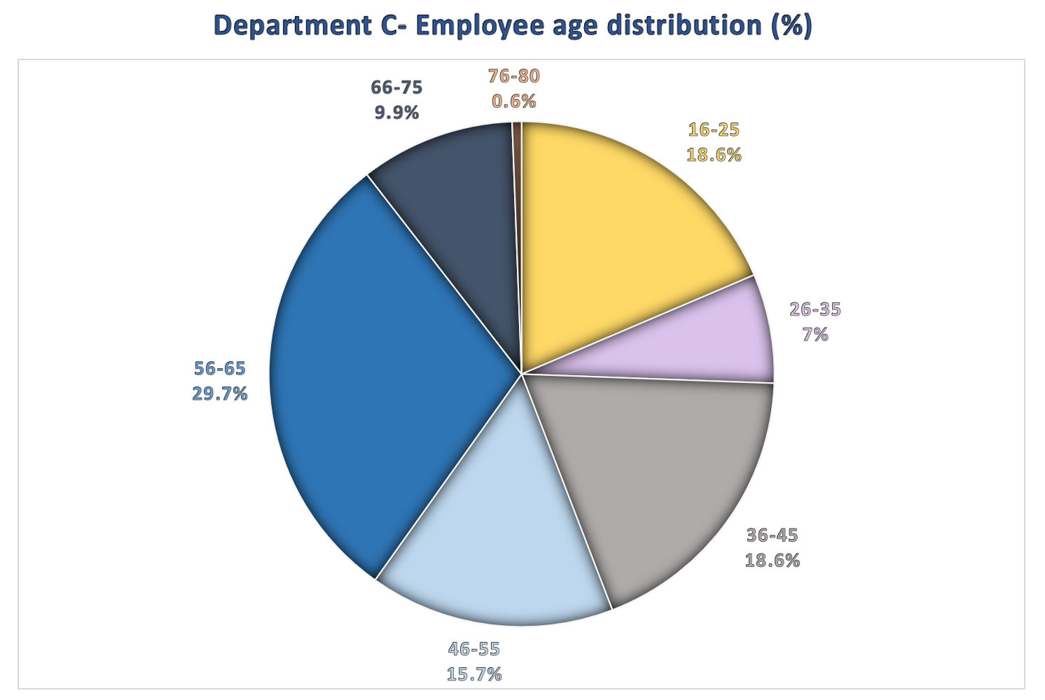

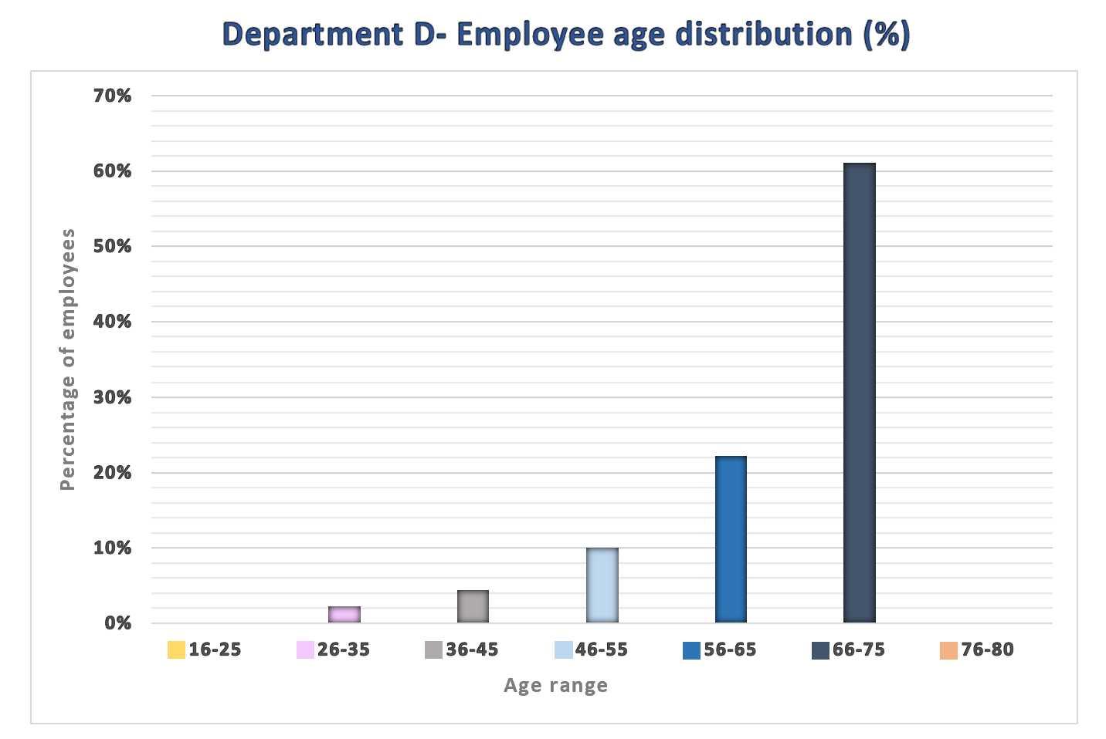
The two diagrams clearly show that both departments have a significantly older workforce. In department C, just over a quarter of employees are between the ages of 56 and 65; in department D, 93% are over 46. With the average retirement age in the UK in 2019 at '65.3 years old for men and 64.3 for women' (Green, 2023), a striking number of employees in the two departments will be set to retire in the short and medium term. An ageing workforce challenges the NHS and the departments as it adds to the pressure employees are already facing from the negative impacts of Brexit, covid, and the cost of living crisis/strikes on turnover and vacancy rates. To retain these workers, they could be offered flexible working arrangements (Cotton, 2017) and 'early access to occupational health workers' (CIPD, 2022, pp. 18) along with continued well-being support.

Another recommendation is to look into recruitment to ensure workforce stability. Department D's absence of employees aged between 16-25 and a low percentage of 26 to 35-year-olds raises questions about the quality of the organisation's graduate scheme or whether young workers are being given enough support (Leatherbarrow and Fletcher, 2019). The NHS has struggled to recruit enough workers for some time now (Ungoed-Thomas, 2021). With few young talent in the workplace, employers and staff are missing out on the benefits they could bring, such as fresh perspectives, driving forward data initiatives as well as plugging in gaps in the workforce. We need to generate an excellent reputation of the department and use technology like social media to increase recruitment among the younger to middle-aged population (Waite et al., 2021). Furthermore, we need to support our existing young workforce effectively, whether through mentoring or creating more trust in the workplace, to retain them.

Conclusion

This guidance paper hopes to have shed some light on a growing number of research on EBP and people analytics in HR for people professionals to apply in the organisation. The effect they have in aiding decision-making and improving organisational performance is remarkable. There is a shift taking place, albeit slow, where practitioners are seeing the value of EBP and analytics in improving the quality of their work, and the people function plays a crucial role in driving their implementation (Barends et al., 2017).

Main body word count: 2026
Section 1= 1568
Section 2= 458

References
Arthur, J. B. (2023) ‘Public announcements of employee recognitions from customers and customer satisfaction: Longitudinal effects in the healthcare context’, Journal of business research, 157, pp. 1-11. Available at: https://doi.org/10.1016/j.jbusres.2022.113568.
Barends, E., Rousseau, D. M and Briner, R. B. (2014) Evidence-Based Management: The Basic Principles. Center for Evidence-Based Management. Available at: https://www.cebma.org/wp-content/uploads/Evidence-Based-Practice-The-Basic-Principles.pdf (Accessed: 22 December 2022).
Barends, E. et al. (2017) ‘Managerial attitudes and perceived barriers regarding evidence-based practice: An international survey’, PLoS ONE, 12(10), pp. 1-15. Available at: https://doi.org/10.1371/journal.pone.0184594
Barnard, B. and Walls, C. (2020) ‘Success Factors of Big Data to Achieve Organisational Performance: Theoretical Perspectives’, Expert Journal of Business and Management, 8(1), pp. 1-16. Available at: https://business.expertjournals.com/23446781-801/ (Accessed 15 January 2023).
Charlwood, A., Stuart, M. and Trusson, C. (2017) Human capital metrics and analytics: assessing the evidence of the value and impact of people data. London: CIPD. Available at: https://www.cipd.co.uk/Images/human-capital-metrics-and-analytics-assessing-the-evidence_tcm18-22291.pdf (Accessed: 3 January 2023).
CIPD (no date) Commercial drive. Available at: https://peopleprofession.cipd.org/profession-map/core-behaviours/commercial-drive (Accessed: 1 February 2023).
CIPD. (2022) Understanding older workers: analysis and recommendations to support longer and more fulfilling working lives. London: Chartered Institute of Personnel and Development.
Cotton, J. (2017) The challenges of an ageing workforce. Available at: https://www.employment-studies.co.uk/news/challenges-ageing-workforce (Accessed: 7 February 2023).
Davenport, T. H. et al. (2019) Analytics and AI-driven enterprises thrive in the Age of With: The culture catalyst. Available at: https://www2.deloitte.com/us/en/insights/topics/analytics/insight-driven-organization.html (Accessed: 3 January 2023).
George, S. (2022) HR policies. Available at: https://www.cipd.co.uk/knowledge/fundamentals/people/hr/policies-factsheet (Accessed: 27 January 2023).
Giermindl, L. M. et al. (2022) ‘The dark sides of people analytics: reviewing the perils for organisations and employees’, European Journal of Information Systems, 31(3), pp. 410-435. Available at: https://doi.org/10.1080/0960085X.2021.1927213
Green, N. (2023) When can I retire? Calculate your best retirement age. Available at: https://www.unbiased.co.uk/discover/pensions-retirement/planning-for-retirement/when-can-i-retire-calculate-your-best-retirement-age#:~:text=What%20is%20the%20average%20retirement%20age%20in%20the,from%20highs%20of%2067.2%20and%2063.9%20in%201950 (Accessed: 6 February 2023).
HBR (2021) HR’s New Role in Improving Customer Experience. Available at: https://hbr.org/resources/pdfs/comm/salesforce/SalesforceCXCHRO.pdf (Accessed: 29 January 2023).
Hill, S. and Houghton, E. (2018) Getting started with people analytics: a practitioners’ guide. London: CIPD. Available at: https://www.cipd.co.uk/Images/peope-analytics-guide_tcm18-51569.pdf (Accessed: 3 February 2023).
Leatherbarrow, C. and Fletcher, J. (2019) Introduction to Human Resource Management: A Guide to HR in Practice. 4th ed. London: Kogan Page.
Marler, J. H. and Boudreau, J. W. (2017) ‘An evidence-based review of HR Analytics’, The International Journal of Human Resource Management, 28(1), pp. 3-26. Available at: https://doi.org/10.1080/09585192.2016.1244699
Maxwell, G. (2021) Employee turnover and retention. Available at: https://www.cipd.ie/news-resources/practical-guidance/factsheets/turnover-retention (Accessed: 10 January 2023).
Miller, K. (2019) Data-Driven Decision Making: A Primer for Beginners. Available at: https://www.northeastern.edu/graduate/blog/data-driven-decision-making/ (Accessed: 20 December 2022).
Mohdzaini, H. (2022) People analytics. Available at: https://www.cipd.co.uk/knowledge/strategy/analytics/factsheet (Accessed: 27 December 2022).
NHS England (2017) NHS values in action and making a difference. Available at: https://www.england.nhs.uk/2014/02/nhs-values-in-action/ (Accessed: 7 February 2023).
Picardi, C. (2020). Recruitment and selection: Strategies for workforce planning and assessment. California: SAGE Publications, Inc.
Ryley, M. (2017) Managing ‘tricky’ absences from work. Available at: https://www.peoplemanagement.co.uk/article/1745709/managing-tricky-work-absences (Accessed: 10 January 2023).
Shweta and Main, K. (2022). Employee Turnover Rate: Definition & Calculation. Available at: https://www.forbes.com/advisor/business/employee-turnover-rate/ (Accessed: 10 January 2023).
Spain, E. and Groysberg, B. (2016) Making Exit Interviews Count. Available at: https://hbr.org/2016/04/making-exit-interviews-count (Accessed: 11 January 2023).
Suff, R. (2022) Absence measurement and management. Available at: https://www.cipd.co.uk/knowledge/fundamentals/relations/absence/factsheet#6399 (Accessed: 10 January 2023).
Trullen, J. et al. (2016) ‘The HR department's contribution to line managers' effective implementation of HR practices’, Human Management Resource Journal, 26(4), pp. 449-470. Available at: https://doi.org/10.1111/1748-8583.12116
Ungoed-Thomas, J. (2021) ‘Nursing crisis sweeps wards as NHS battles to find recruits’, The Guardian, 9 October. Available at: https://www.theguardian.com/society/2021/oct/09/nursing-crisis-sweeps-wards-as-nhs-battles-to-find-recruits (Accessed: 9 February 2023).
Waite, K. et al. (2021) People Practice: A Complete Guide. London: Kogan Page.
Young, J. (2022) Evidence-based practice for effective decision-making. Available at: https://www.cipd.co.uk/knowledge/strategy/analytics/evidence-based-practice-factsheet (Accessed: 22 December 2022).

