DIGITAL INTELLIGENCE &ANALYTICS
Executive Summary
The Digital Intelligence & Analytics assignment broadly analyses data-driven decision-making. In the utilizing pivotable graphics and lookup processes. The report includes product subcategories, quarterly breakdowns, year sales and profit, and geographical performance. In the strength of sales and profit trends is one of the important results as well as emphasizing the value of quarterly evaluations for strategic planning. In the variations among locations and subcategories highlight the requirement of focused approach.

TABLE OF CONTENTS
Introduction 4
Pivotable 4
Charts 7
Lookup 10
Conclusion 11
References 11

Introduction
The main goal of this topic is Digital Intelligence & Analytics assignment to be examine and explain the essential components of data-driven decision-making by using pivotable charts and search algorithms. The digital intelligence before managing into the fundamental ideas of analytics. In the use of pivotable charts to help visualize large, complicated data sets and help perceptive interpretations. Moreover, the task will highlight how crucial search methods are for accessing and retrieving relevant data, which will improve the effectiveness of digital intelligence systems. The research reports offer a thorough comprehension of how Digital Intelligence & Analytics particularly by utilizing pivotable charts and lookup features to be support well-informed decision-making in modern digital environments through a focused investigation of key components.

Pivotable
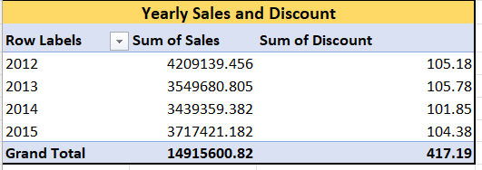
Figure 1: Yearly Sales and Discount
(Source: Self-created)
In every one of the four years from 2012 to 2015 the annual sales showed variations. Sales data peaked in 2012 at $4,209,139.46 (Tsao 2021). They then declined over the next few years, but in 2015 they increased to $3,717,421.18. The corresponding annual savings varied slightly, with the largest savings documented in 2013 at $105.78. The overall trend indicates a dynamic sales environment, notwithstanding fluctuations in discounts and offers. This data indicates that more investigation is necessary to determine the driving forces behind these trends and to maximize managed with at for long-term expansion and efficient discounting.
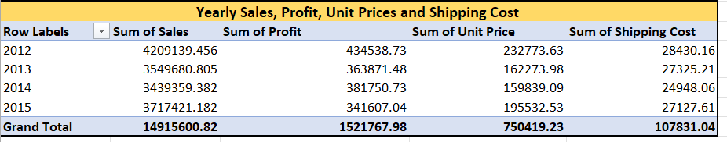
Figure 2: Yearly Sales, Profit, Unit Price and Shipping
(Source: Self-created)
In this information emphasises how crucial it is to examine how sales, earnings, and operating expenses interact when making strategic decisions. It is important to do more research on the elements that influences in these patterns in order to optimize pricing strategies and cost management to be utilized with the sales and profit unit sales and shipping cost is variables for last four years.
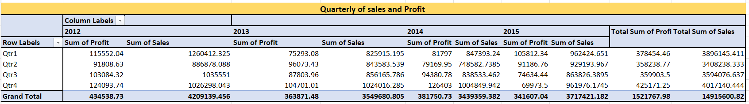
Figure 3: Quarterly of sales and Profit
(Source: Self-created)
From 2012 to 2015 is represented by the sales and profit were broken down quarterly. In each quarter had differences variations, with Quarterly 4 of 2012. They can be recording the most overall profit (Zhou et al. 2021). Although there are fluctuations of the general pattern demonstrates durability in terms of both profit and sales. They also importance the need of evaluating, quarterly performance for the purposes of resource allocation and strategic planning.
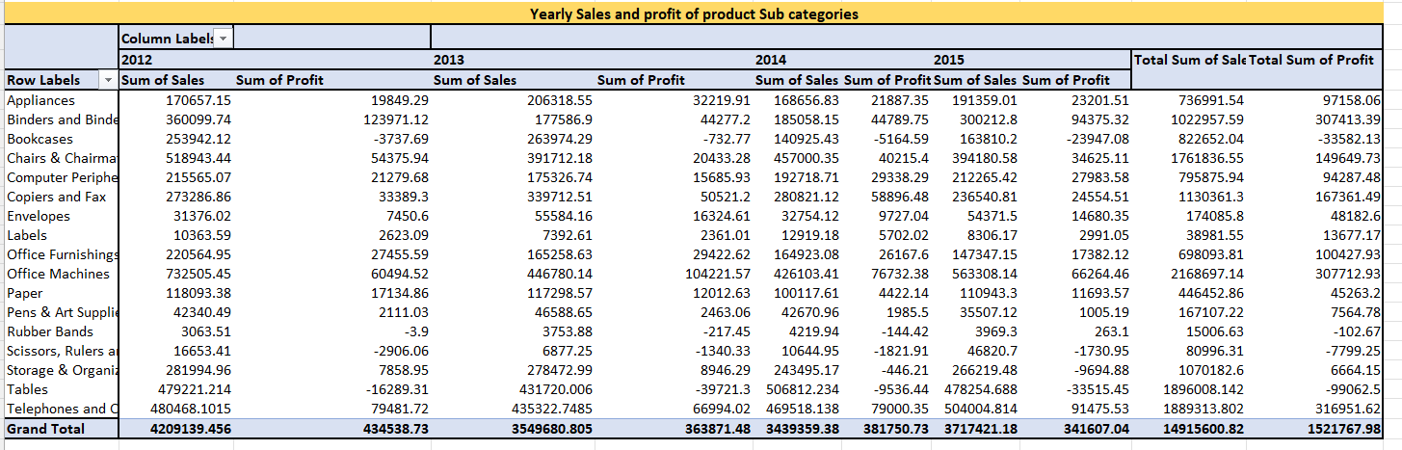
Figure 4: Yearly Sales and Profit of Product subcategories
(Source: Self-created)
The yearly product sub categories is identified with the differences between various sectors. They are brought analyzing annual sales and profit for product sub-categories (Luo et al. 2021). As an illustration, whereas Chairs & Chairmats is a continuously make a positive contribution. The Tables have negative profitability is an suggesting possible areas for development. The strategic selections are directed by this detailed research, which allows targeted efforts to improve overall profitability as well as optimize product portfolios.
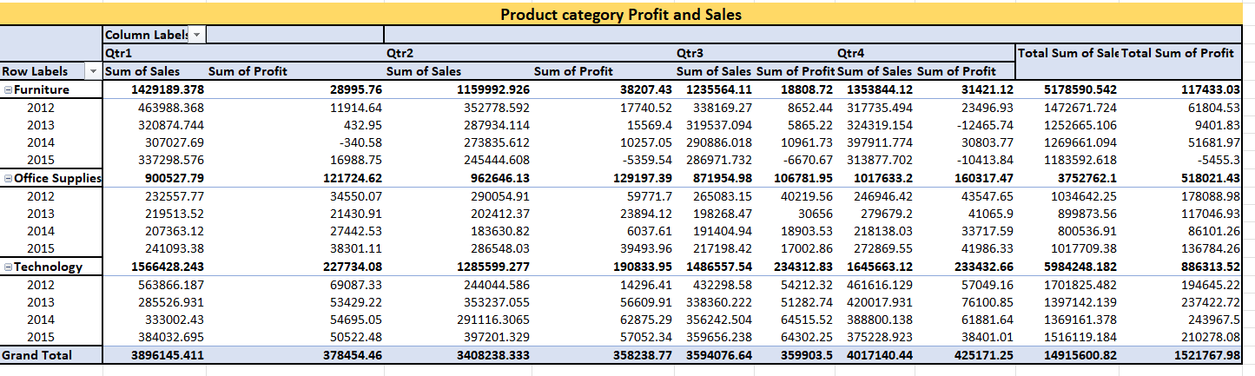
Figure 5: Product categories of Profit and Sales
(Source: Self-created)
In this figure is represented by the sales and profit of quarterly profit and sales for several product categories from 2012 to 201. It is an offers insightful information on performance dynamics. In the sub product such as Furniture has always made a solid contribution. The quarterly has always produced the largest earnings (Jelen 2021). In the office Supplies showed consistent increase throughout the quarters, while Technology displayed the greatest overall sales and profit is an mostly due to a stellar Qtr3 result.
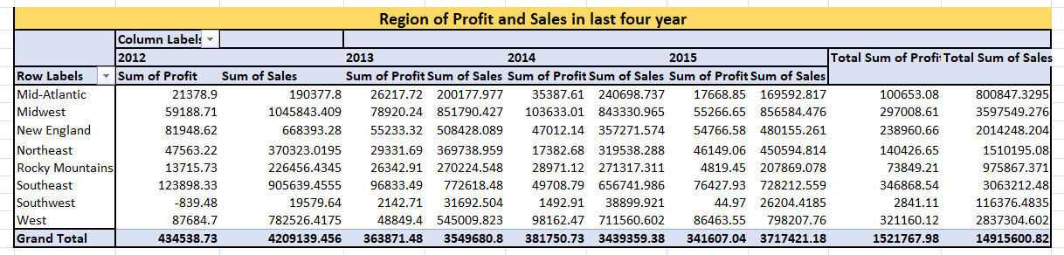
Figure 6: Region of Profit and Sales in last Four year
(Source: Self-created)
Diverse performance trends are evident when looking at the profit and sales split by region during the last four years. With the largest overall sales and profit, the Southeast continued to show itself as a major contributor. While the West had impressive sales and profit numbers, the Midwest showed stability with consistent growth. On the other hand, the Southwest encountered difficulties and saw times of negative profit. This regional analysis emphasises the necessity of focused tactics made to fit the particulars of every location. Comprehending regional dynamics is of utmost importance in order to enhance operations, detect prospects for expansion, and address obstacles in order to provide steady and equitable regional performance throughout the heterogeneous terrain.

Charts
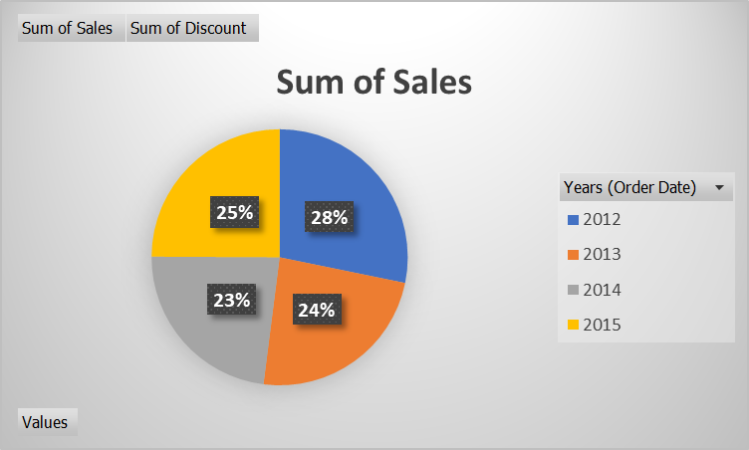
Chart 1: Sales
(Source: Self-created)
The chart is represented by yearly wise in 2012 is 28%, 2013 is 24%,2014 is 23% and 2015 is 3% indicates for the total sales performances at the metrics.
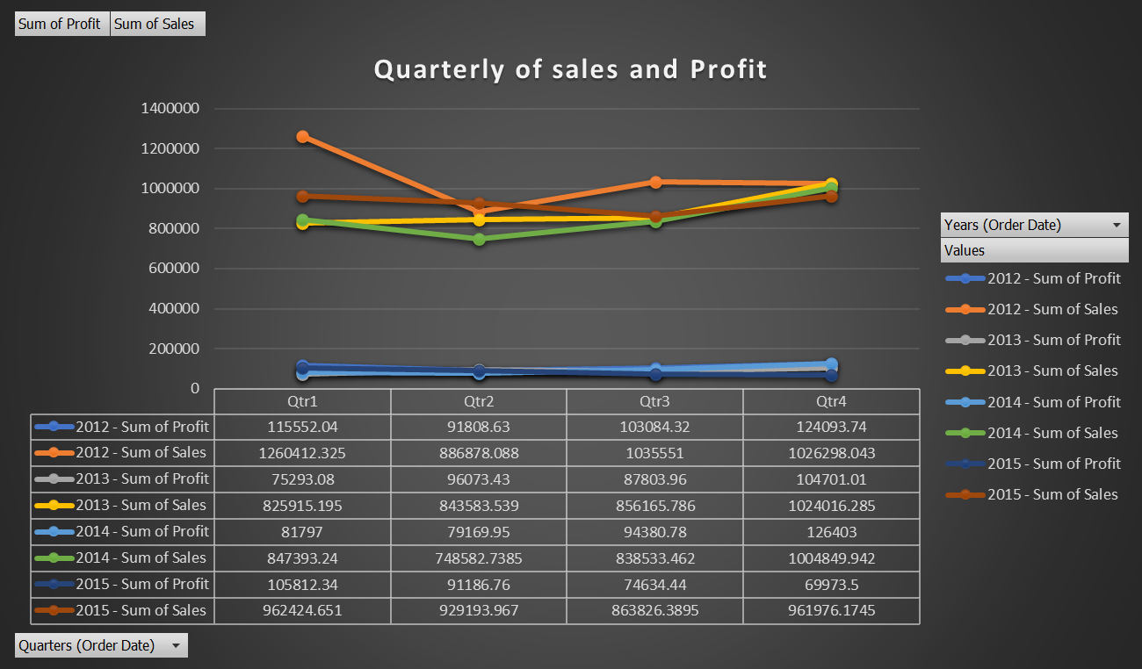
Chart 2: Quarterly Profit and Sales
(Source: Self-created)
From 2012 to 2015, quarterly sales and profit showed fluctuations, with Qtr 4, 2012,producing the greatest total profit (binti Rajab 2021). The consistent pattern, managed for a subject to variations, emphasizes. At the significance of quarterly performance evaluation in terms of efficient resource distribution and strategic planning.
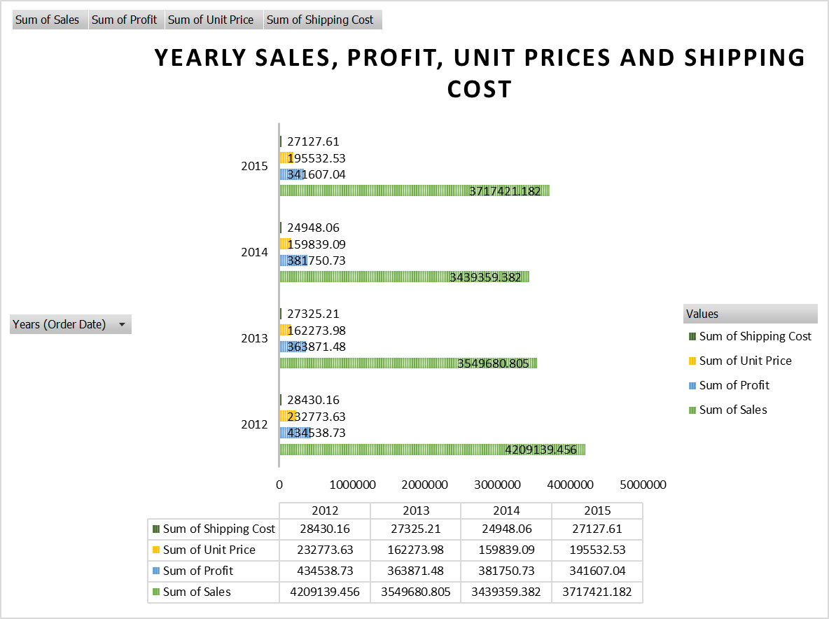
Chart 3: Yearly Profit, Unit Price and Shipping Cost and Sales
(Source: Self-created)
The financial data shows dynamic patterns in annual sales, profit, unit pricing, and shipping costs throughout the four years from 2012 to 2015. Although revenues were unpredictable, topping in 2012 and then increasing again in 2015, profit margins were stable, constantly making a positive contribution. Over time, unit prices varied, and although they did alter, transportation costs maintained a comparatively lower percentage of total expenditures.

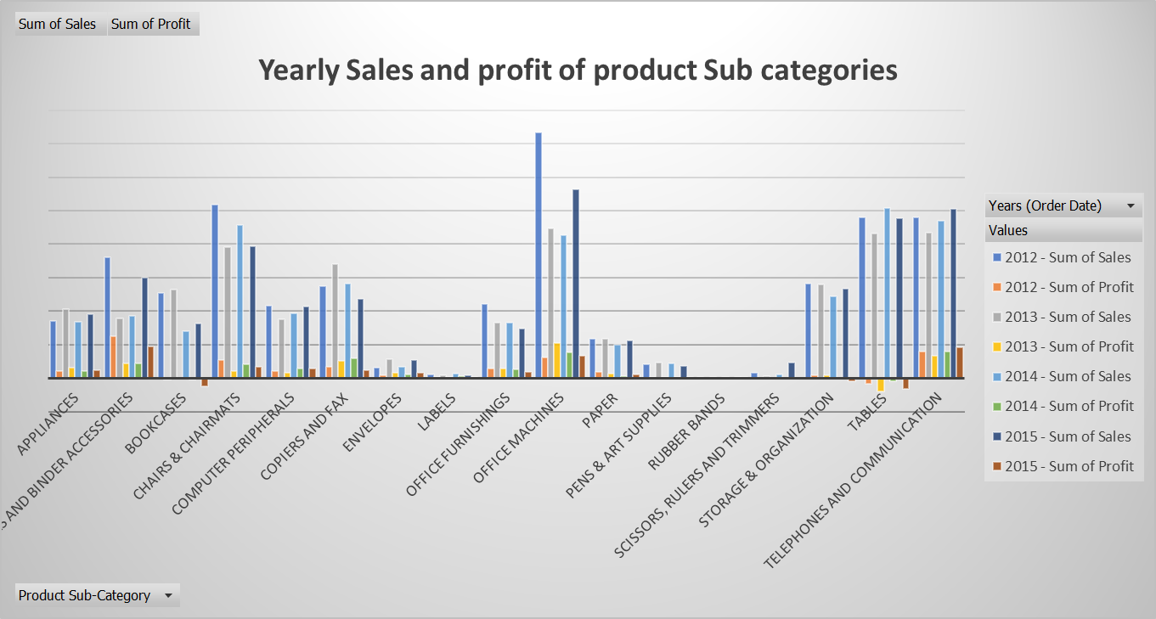
Chart 4: Yearly Profi and Sales of Sub categories
(Source: Self-created)
Disparities are seen when yearly sales and profit for product subcategories are examined. The different product is identified by the Chairs and chairmats are consistently profitable. It is indicating areas that might use development, whereas tables show negative profitability (Lim 2022). Strategic decisions are guided by this thorough analysis, which allows targeted efforts to maximize product portfolio optimization and overall profitability.

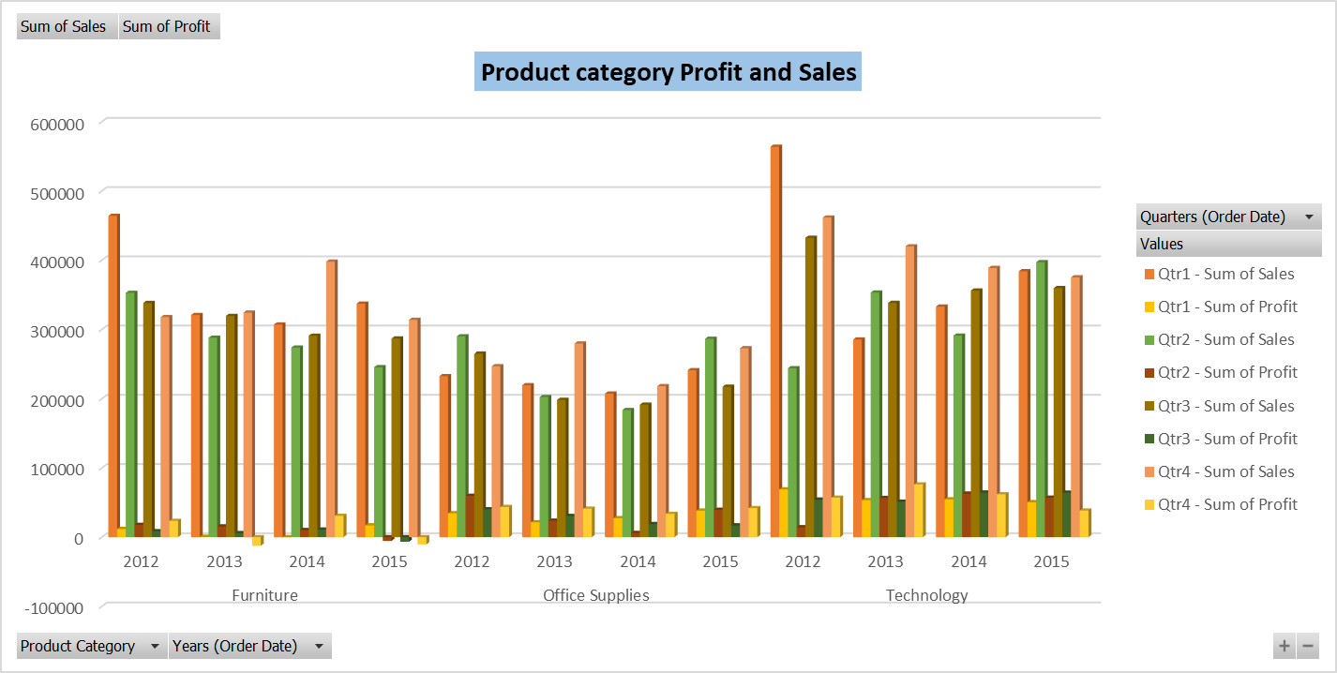
Chart 5: Yearly Profi and Sales of Product categories
(Source: Self-created)
The significance of customizing tactics for every product category according to quarterly developments is shown by these findings. Strategic planning to capitalize on strengths and handle obstacles is made possible by the recognition of various patterns within the furniture, office supplies, and technology industries. This promotes continuous growth in the diversified product portfolio

Lookup
Order Priority | Customer Name | Sales | Profit
Low | Henry MacAllister | 4215.83 | 972.19
High | Jim Kriz | 197.49 | -52.84
Medium | Kelly Williams | 401.37 | 13.31
Not Specified | Tracy Collins | 4300.626 | 685.21
Critical | Shahid Shariari | 436.4835 | 0.85
Ship Mode | Product bases Margin | Region | States
Regular Air | 0.58 | Southeast | South Carolina
Delivery Truck | 0.69 | Mid-Atlantic | Delaware
Express Air | 0.39 | Southeast | South Carolina
Customer Segements | Product Category | Product Sub-Category | Shiping | Unit Price
Small Business | Technology | Telephones and Communication | 8.8 | 65.99
Consumer | Office Supplies | Binders and Binder Accessories | 3.5 | 33.62
Home Office | Office Supplies | Storage & Organization | 35 | 95.99
Corporate | Technology | Computer Peripherals | 3.52 | 7.28

Conclusion
The overall assessment is examination of digital intelligence and analytics digs into essential components including search and pivotable infographics. A thorough examination of quarterly, annual, and local data reveals a variety of patterns and highlights the significance of resource allocation and strategic planning. Informed decision-making is facilitated by the careful analysis of product categories and subcategories, which promotes balanced growth and maximized profitability in the dynamic digital environment.

References
Journal
binti Rajab, S.M., 2021. AN INTRODUCTION TO SPREADSHEET.
Jelen, B., 2021. Microsoft Excel Inside Out (Office 2021 and Microsoft 365). Microsoft Press.
Lim, T.H., 2022. Using INDEX and MATCH in Microsoft Excel or Google Spreadsheet/Lim Teck Heng. e-Lingua.
Luo, J., Li, Z., Wang, J. and Lin, C.Y., 2021. Chartocr: Data extraction from charts images via a deep hybrid framework. In Proceedings of the IEEE/CVF winter conference on applications of computer vision (pp. 1917-1925).
Tsao, G., 2021. What are the Factors that Influence the Adoption of Data Analytics and Artificial Intelligence in Auditing?.
Zhou, M., Li, Q., He, X., Li, Y., Liu, Y., Ji, W., Han, S., Chen, Y., Jiang, D. and Zhang, D., 2021, August. Table2Charts: Recommending charts by learning shared table representations. In Proceedings of the 27th ACM SIGKDD Conference on Knowledge Discovery & Data Mining (pp. 2389-2399).

