L4 - Introduction to Web and Database Concepts

  - Cristian Stefan Stancu
  - Student ID: 2008911
  - Course: L4 Introduction to Web and Database Concepts
  - Module: ACCA4023

Table of Contents
Introduction 3
Research & findings 3
Implementation 4
Conclusion 5

Introduction

As Celtic Caterers expanded their business to the Greater Swansea Area with new stores opened in Neath, Port Talbot, Llanelli and Carmarthen, they need a digital solution to manage their customers, orders and stocks.

Research & findings

Following the workflow of the company for one of the stores, we identified the following dataflow diagram (DFD) which could lead us to provide the best software solution for the company.

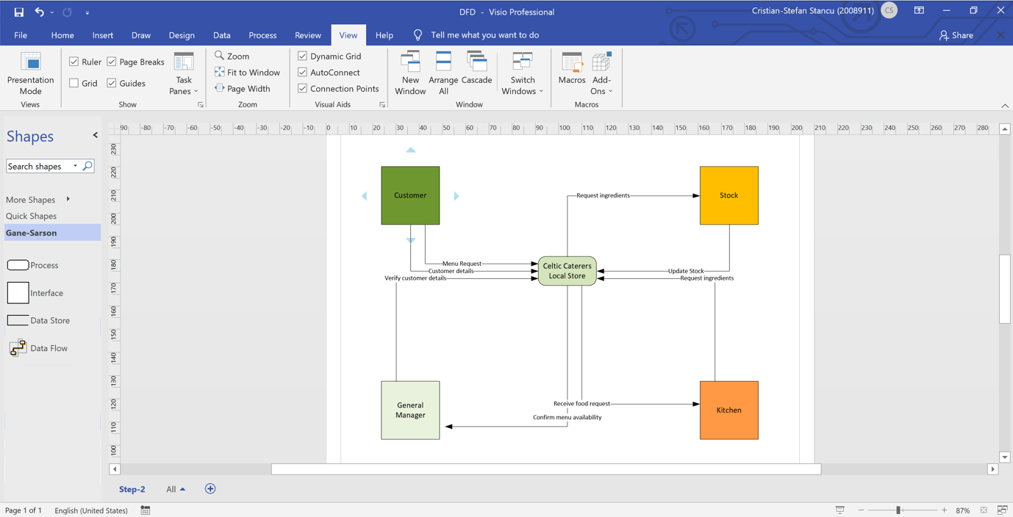

The Swansea store workflow lead us to develop the Entity Relationship Diagram (ERD) which will help us develop the proper solution for all the company stores. We have designed the tables in a way to meet the rule of third normal form (3NF). Our Database will have 7 Tables and one intermediary or associative table. The relationships between the tables are one-to-many and we have one many-to-many relationship which is using the intermediate table. We had to choose that option as the “courses” of meals can have more “ingredients” and each “ingredient” can belong to more “courses”. Also, in order to keep the stock of raw food we had to split each course into the ingredients needed to be prepared.

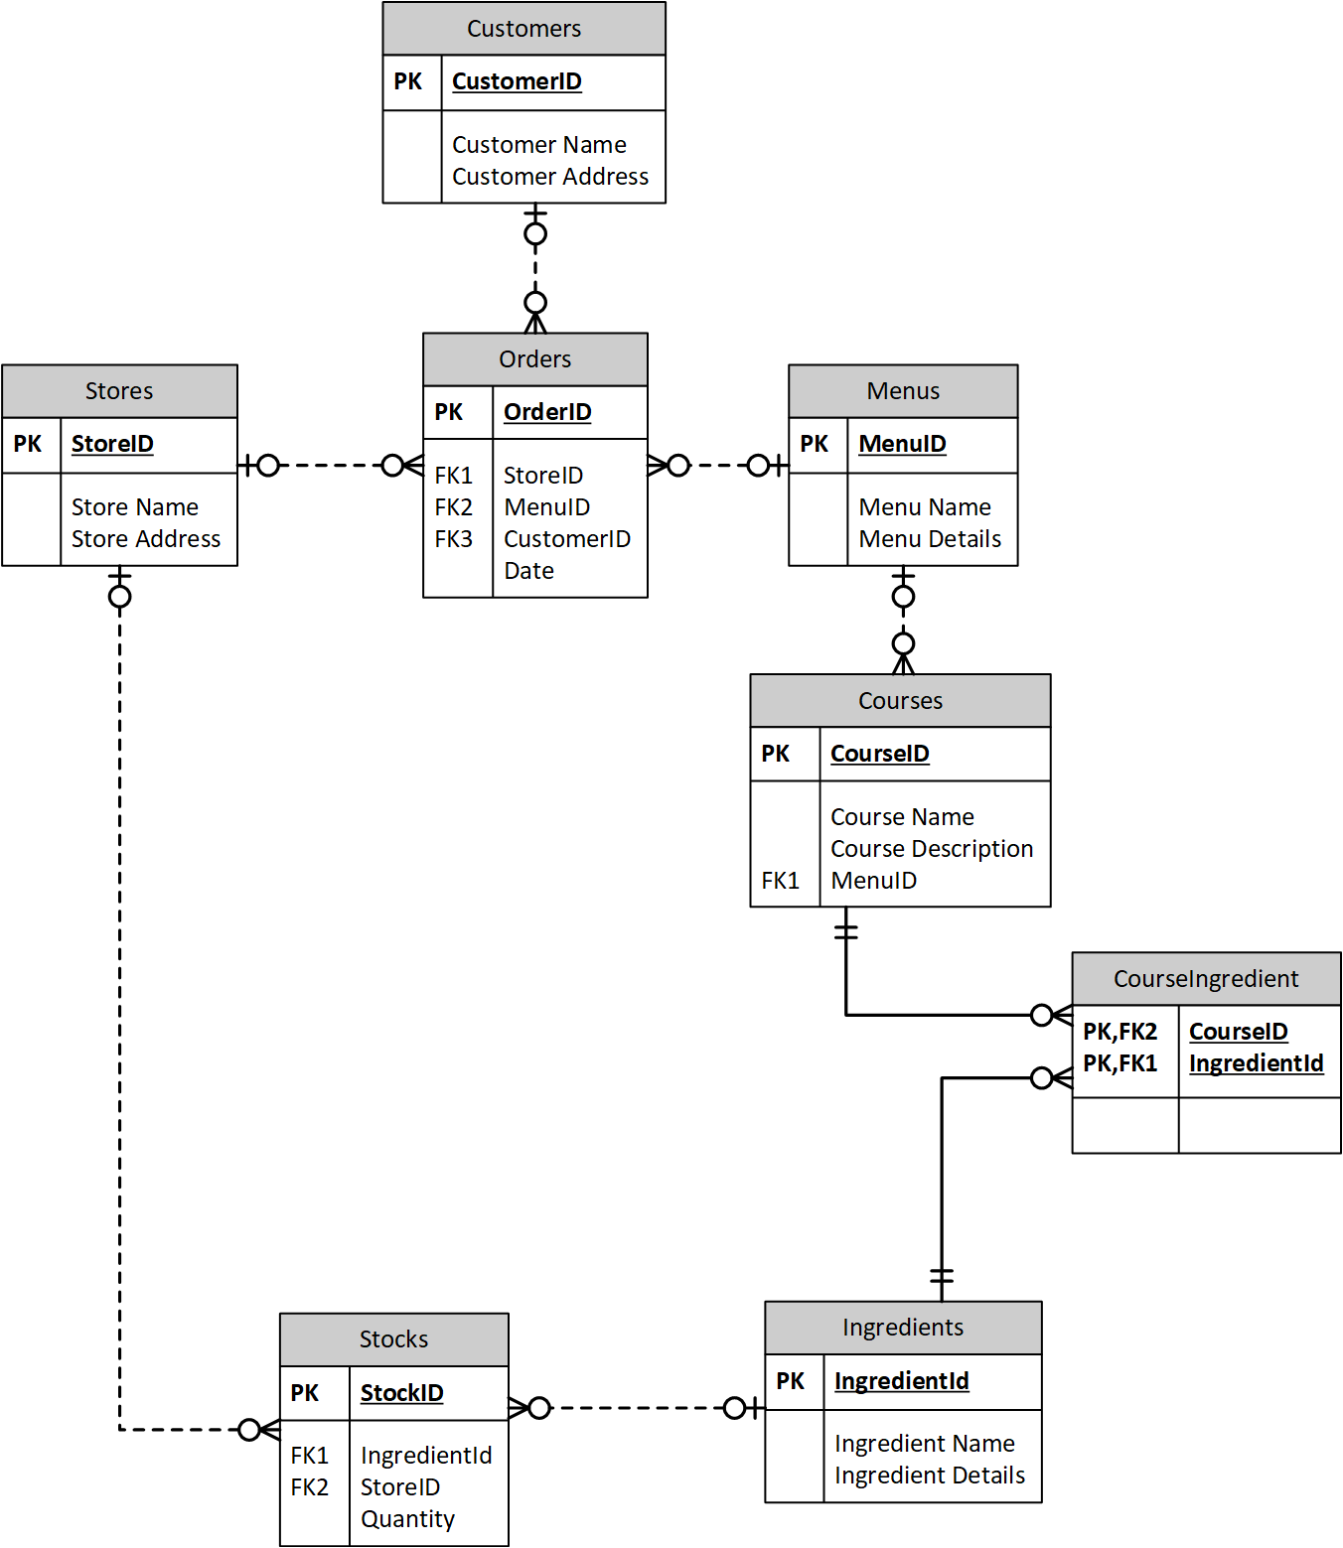

Implementation

The ERD helped us to develop a MS Access solution for the company to keep track better of the stock of raw food, orders and customers.
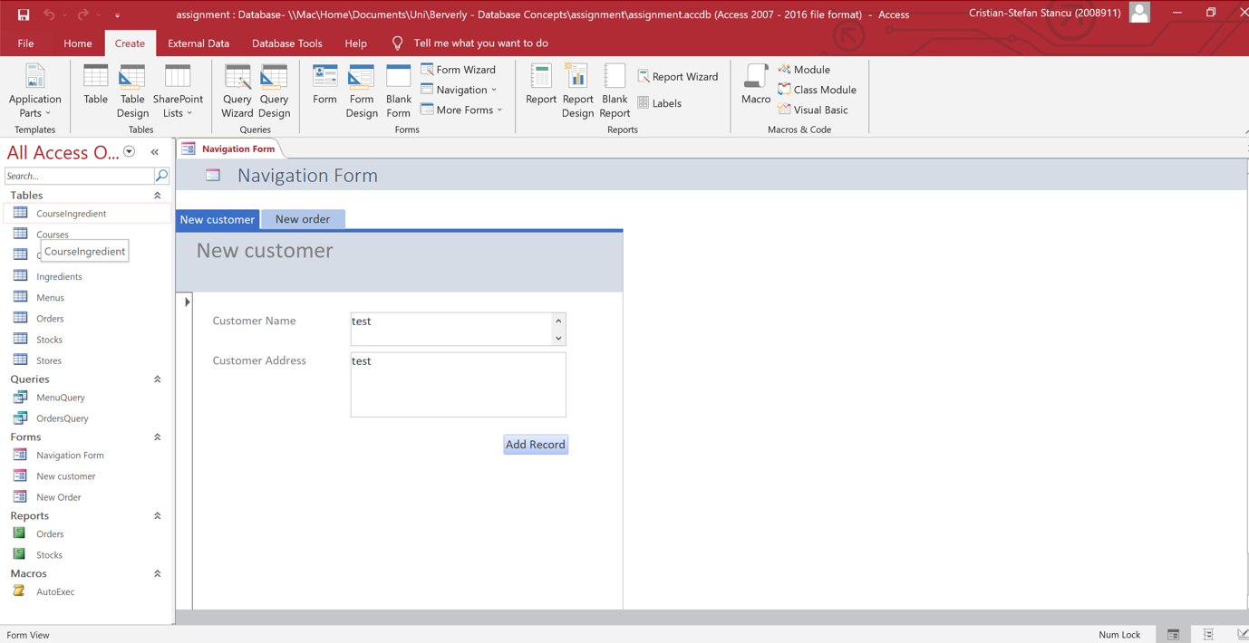

Inside the MS Access solution, the Store managers can add new customers, add new orders and check the stock necessary to fulfil the order menus. Also, reports can be generated for orders and current stock available.

Conclusion

Using a digital solution is much easier for an expanding business to maintain control over the company resources and keep track of the income.

