Managing People
Assessment 2
Galina Rais
2020307

Contents
1. Introduction 3
2. Concept of Engagement 4
3. Drivers of Employee Engagement 5
4. Diagnostic tools to measure engagement 5
5. Employee Value Proposition 6
6. Strategies to raise level of engagement 8
7. Conclusion 9
8. References 9

Introduction
Employee engagement is an extent to which an employee believes and put efforts in the mission and values of organization and exhibit a strong commitment with his or her organization through actions and their relationship with employers and customers of organization (Yadav, 2020).
Primary source of advantage for any organization is its employees if they are engaged or committed towards organization then achieving goals and targets become an easy task. The term employee engagement exhibits main point of management which is to direct employee towards goals and objectives of organization. HR managers think that engagement is also related to how employee think about their work in organization and how they are treated in organization. Further engagement is directly proportional to emotions and some people never both to engage themselves no matter how hard HR managers try to engage them (S Jha, 2019).
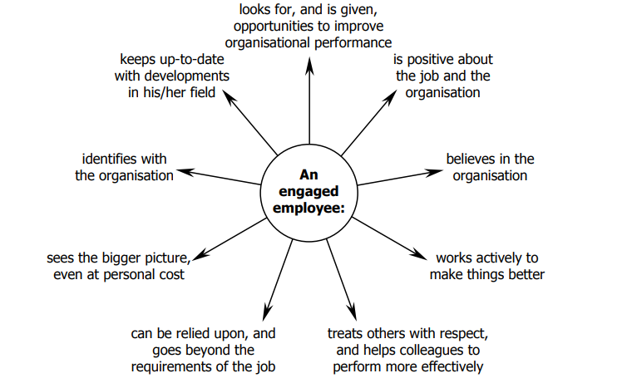
Figure 1 Characteristics of an Engaged Employee (Barreiro and Treglown, 2020)
In our report we are going to shed some light on concept and drivers of employee engagement as well as we will demonstrate tools to measure engagement in an employee. Further we will construct employee value proposition and will consider strategies to highlight level of engagement finally with a conclusion.

Concept of Engagement
Foundational theories of sociology and psychology introduced by Kahn (1990) was the first person who introduced employee engagement and gave concept of it. He elaborated personal engagement at workplace as “Expression and employment of a person’s own self simultaneously in tasks of company that exhibit connection with work and other employees, presence of personal and active performance Ac According to Kahn, people who are engaged to their organization “express and show themselves physically, mentally during performances of their roles” while people who are disengaged “withdraw themselves and do not take interest physically, mentally during performance of their roles (Jeung, 2011).
According to (Smith, 2020) it is an HR concept which states level of dedication an employee has towards its job. Employees who care about their job and work show tremendous performance for the company. Employee engagement is a critical factor for success of a company and communicating with an employee is also an important factor to maintain employee engagement and it is the responsibility of HR manager. Employers or HR managers can communicate with their employees through various means like communicating clearly, offering of prizes, promotions and keep them updated about performance of the company.
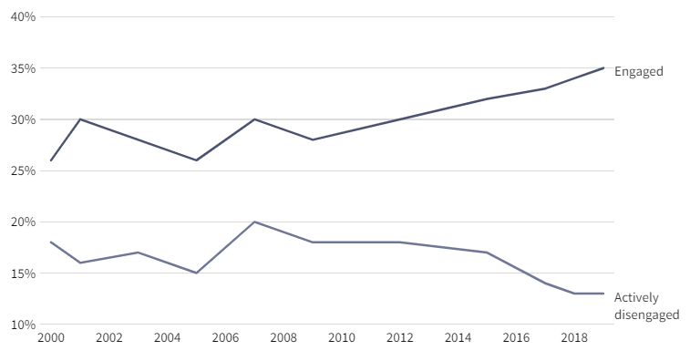
Figure 2 Active Employee Engagement Scenarios (Smith, 2020)

Drivers of Employee Engagement
Strongest driver of engagement is a sense of being valued and appreciated by organization. Following are the drivers which boosts employees’ sense of engagement and their commitment towards organization strong.
- Autonomy at workplace involve employees in decision making process, it means they are being valued.
- An environment where ideas of employees are listened and managers appreciate them for having such views.
- Providing employees opportunities to develop their skills and make them polish for future
- An environment where company is concerned about their well being and health of employees
- Every type of resource must be available to them so employees can put their physical and mental effort into work.
- Co-worker relationships are also an important driver when team members have mutual respect for one another result is always positive and trust is developed.
- It is the duty of HR managers to update employees regarding their feedback so that they can improve themselves according to expectations of company.
- In order for employees to remain connected with employees’ goals and visions their leader must be available to them every time.
- Integrity of leader is also an important driver which ensures that employees under him or her are committed and working for organization (Shahid, 2019).

Diagnostic tools to measure engagement
- Utrecht Work Engagement Scale: Developed and confirmed by different health psychologists, UWES scale is not used for stress domain or burn out domain but it is also used for HR and in research for organizations (Leiter and Durup, 1994). Before construction of UWES model, many practitioners measured engagement by MBI (Maslach Burnout Inventory). Reason for using MBI is because its conceptualized engagement of employee as opposite of UWES. So Schaufeli et al. (2002) stated that both interrelate somehow but both are separate so they developed an independent instrument for measuring engagement. There are three subscales of UWES vigour, dedication and absorption which are structured as opposite to burnout model. UWES has two versions, a 17-item full version (vigour has six items, dedication has five and absorption has six) and a short version of 9 item (three items divided equally in each subdimension) (Delina and Samuel, 2020). Samples items were stated as “At my work, I feel bursting with energy” (vigour), “I find the work that I do full of meaning and purpose” (dedication), and “Time flies when I am working” (absorption). Validity and credibility of UWES has been confirmed as a good instrument in many multinational organizations. However, some authors like Newman and Harrison has pointed out some confusing complication that this instrument focus on psychological condition of engagement rather than being focus on engagement (Cunningham, 2018).
- Gallup Q12: Gallup developed and validated Q12 which is also known by name Gallup Workplace Audit (Jeung, 2011, p.11). After UWES Q12 has been the most famous employee engagement measuring tool so far, especially for the consulting industry. Credibility and validity of 12 items have been examined continuously and confirmed in different international contexts with huge number of samples. According to this tool engagement can be analysed by four antecedents:
clarity in expectations and resources delivered (What do I get?)
feelings of employee towards the organization (what do I give?)
something belonging to employee which beyond oneself (do I belong?)
feelings that are required in order to make progress and grow (how can we grow?) (Jeung, 2011, p.12).
Despite of this new approach, Q12 has also been criticized just like UWES, and this critic argued that it measures pre-conditions of engagement rather than measuring engagement itself. Other authors McKay and Wilson also stated that Q12 model has reflected Kahn (1990) psychological conditions (meaningfulness, safety and availability) for enhancing engagement. This is also considered one of the main limitations of Q12.

Employee Value Proposition
EVP is a combination of benefits and rewards for employee in return for his or her performance at organization. According (reganmcgregor, 2021) delivering on an EVP decreases turnover of annual employee by 70% and early new hire commitment by 30%.
An EVP represents what a company has to offer to its employees. It is in the form of statements and what company will be offering like intangible or tangible benefits. Some companies put emphasis on EVP statements like multinational organizations while some utilizes quotes, blogs to present a life at their organization. It also represents company at a common manifesto (reganmcgregor, 2021).

While EVP is mainly used for branding of employer and can be considered asset of company. EVP is basically offering what kind of benefits, perks and compensation you will get in our organization as a result of your dedication to our company.
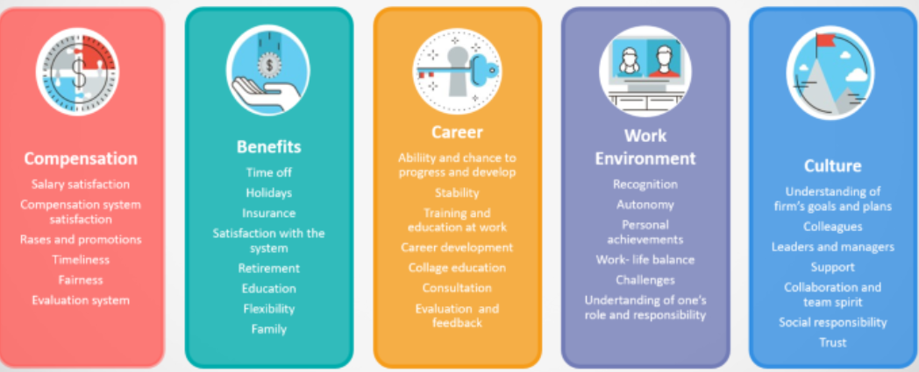
Figure 3 Employee Value Proposition Diagram (Martic, 2018)
Taking an example of retail organization, I will be constructing Employee value proposition.
- Compensation: It has been an important factor in contributing towards hiring top talent. After Covid-19 many organizations are facing challenges in maintaining compensation level with employees, most importantly compensation related to revenue and profits (Crosby, 2014).
- Opportunity: Flexibility is the most important factor in driving excellence of organization. Many adults are parents and they have responsibilities and many find it difficult to manage their work-life balance. So flexible organizations are those which benefit their employee by giving them options to work from home, part-time and flexible hours for the organization.
- Organization: In EVP it must be exhibited that organization promotes, diversity, inclusion and respect to LGBTQ+ community. Speaking of these Highers factors is the best strategy to retain top talent. Having a diverse culture in retail organization and promotion of inclusion at workplace retain employees and their dedication for the organization increases (Crosby, 2014).
- People and wellbeing: In retail, managers can take care of well-being of their customers and employees as well. Managers can implement (Buy online pickup in store) or different pickup options of products in this way they can serve their customers. During pandemic everything went upside down so employees can be taken care by hiring more people and providing substitute. In this employee relation with organization will get stronger.
- Innovation: In retail it is necessary to deliver customer product on time and quality must be not be affected. So, alternatives regarding transport should be managed to make supply chain process smooth. Innovative organizations use every possibility as an opportunity to reinvent and improve themselves as much as they can. This not increase the morale of employees but ultimately increases their employee engagement (Arslan, 2017).

Strategies to raise level of engagement
There are many ways to improve level of engagement among employees. Following are few strategies that can be followed to increase level of engagement in employees.
- Focus on onboarding: There is a well-known saying, first impression is the last impression. HR managers must focus on creating a systematic onboarding process for new employees with out having any error. Reason is it will help them to connect better with company’s goals and missions. This process can be used to show how unique your company is and what your contributions will be in team.
- Training of Employees: According to (Jeung, 2011) main reason for employees to seek another job is better growth opportunities. Every employee wants to be appreciated and accepted for its contribution for the organization. It is necessary for the HR managers to conduct training of the newly joined employees and extra training for the current employees regarding career counselling and growth opportunities.
- Reward Employees: Recognition for employee is of vital importance in this way they are keenly motivated for the organization. HR managers must initiate reward schemes for best performing employee and gave them early incentive with their salaries. Make habit of celebrating completing projects or achieving small milestones in company.
- Communicating feedback: Good internal communications between employees increase their morale at work, they can easily communicate with each other if they encounter any problem. HR managers should be responsible for maintaining communication between employees, managers and higherups etc. In order to do that HR managers must share honest feedback regarding employees. They need to make sure that important decisions have reached employees.
- Promote healthy work habits: Line managers should encourage making of healthy environment at workplace. Taking a short break from work will help employees that they are being taken care of. Ensuring that office workplace is comfortable and every type of facility is available for employees, like refreshments, first aid etc. Managers should also promote flexible work schedule in order to boost performance of employees.
- Conduct Surveys: This is an important step to improve employee engagement among employees. HR or Line managers should conduct surveys across various departments regarding satisfaction of employees. Managers should analyse surveys and decide to counter issue felt by employees. Moreover, they should create an environment where employees should tell them freely regarding issues. In this way morale of employees will be increased (Yaneva, 2018).

Conclusion
Employee engagement factor is of vital importance for any corporate organization in order to keep record of engagement of their employees. Engagement of employee be measured by using different diagnostic tools and it can be increased if employees are treated fairly. Hence it is concluded that employees who are engaged means they are aware of company’s goals and visions and are keen in working for it. Engaged employees directly affects the performance of organization because their dedication is on different level than rest of employees. So, HR managers should always keep track of engaged employees and must make working environment comfortable for everyone.

References
Arslan, M. (2017). Organizational Cynicism and Employee Performance: Moderating Role of Employee Engagement. SSRN Electronic Journal, 1(1).
Barreiro, C.A. and Treglown, L. (2020). What makes an engaged employee? A facet-level approach to trait emotional intelligence as a predictor of employee engagement. Personality and Individual Differences, 159, p.109892.
Crosby, D.H. (2014). Improving Employee Retention in the Public Sector by Increasing Employee Engagement. SSRN Electronic Journal.
Cunningham, Q.W. (2018). Book Review: Enhancing employee engagement: An evidence-based approach. Management Learning, 50(2), pp.250–251.
Delina, G. and Samuel, P.E. (2020). A study on the interrelationships between employee engagement, employee engagement initiatives and job satisfaction. International Journal of Business Excellence, 20(2), p.242.
Jeung, C.-W. (2011). The concept of employee engagement: a comprehensive review from a positive organizational behavior perspective. Performance Improvement Quarterly, 24(2), pp.49–69.
Leiter, M.P. and Durup, J. (1994). The discriminant validity of burnout and depression: A confirmatory factor analytic study. Anxiety, Stress, & Coping, 7(4), pp.357–373.
Martic, K. (2018). Define your Employee Value Proposition (EVP) and use it to attract candidates? [online] Medium. Available at: https://medium.com/hr-blog-resources/define-your-employee-value-proposition-evp-and-use-it-to-attract-candidates-734be0f2fe74.
reganmcgregor (2021). 13 Inspiring Employee Value Proposition Examples That Work. [online] vervoe.com. Available at: https://vervoe.com/employee-value-proposition/.
S Jha (2019). Employee Engagement: Introduction, Meaning, Types and Components. [online] Your Article Library. Available at: https://www.yourarticlelibrary.com/human-resource-management-2/employee-engagement/99680.
Shahid, A. (2019). The Employee Engagement Framework: High Impact Drivers and Outcomes. Journal of Management Research, 11(2), p.45.
Smith, T. (2020). Employee Engagement. [online] Investopedia. Available at: https://www.investopedia.com/terms/e/employee-engagement.asp.
Yadav, S. (2020). Determining the Relationship between Employee Engagement and Employee Satisfaction: A Review of Literature. International Journal of Psychosocial Rehabilitation, 24(5), pp.5038–5048.
Yaneva, M. (2018). Employee Satisfaction vs. Employee Engagement vs. Employee NPS. European Journal of Economics and Business Studies, 4(1), pp.221–227.

