Module : Effective Team Working and Communication

Module code: BMSW4002

Component 1 - Report Effective Teamworking for team success

Student Name & ID : Alexandra Felicia Merauta 2121306

Lecturer : Akash Puranik

Abstract/Executive Summary
This report is about teamwork from the context of an organisation and its new project for which a new team is required. While discussing effective teamwork, the requirement was to apply models and theories in the context of the given organisation. First of all, the introduction in this report started with a brief discussion about the teams and their importance in the business landscape and placed a brief outline. The next part deals with the importance of teamwork and the factors that contribute to effective team building. The third part discusses the team development model while applying it to the given situation and comparing it with another established model. The fourth phase is about defining team roles for the project and discussing why it is significant. The fifth stage is solely based on my own judgement and discusses the advantages of teamwork. A part of this also discusses the challenges in the way of teamwork. And finally, the conclusion and recommendation hold the gist of the report and places suggestion for effective team building.

Contents
Abstract/Executive Summary 2
Introduction 3
Overview of Teamworking 4
Development models 4
Team roles 6
Discussion 8
Conclusion and Recommendations 9
References 9

Introduction
The current business landscape all over the world shows a significant shift in several aspects. Teamwork is one of them which emphasises collective work to get a better outcome. The development of teamwork over the last decade is noteworthy and the organisations have been observed to reap the benefit of it.
In this report, the two major aspects related to the team will be discussed - the development of the team and team roles. While the report is centred on these two topics mainly, it started with the concept of team and factors that influence effective team building. The model of team development comes after it and has been applied in the context of Next Plc. Here Tuckman's team development model has been considered suitable for Next Plc. To define the team roles, Belbin's team roles theory is discussed in the next phase.

Overview of Teamworking

A team can be defined as a number of individuals who work together for achieving a shared goal to which they are mutually committed. Though the term team is often used interchangeably with the group, there are some distinctions between these two. For example, in a team members are collectively accountable while group members are individually responsible for their work.
To make the teamwork effective, there can be some rules centring the activities of the team. The conditions can be explained from the context of Next Plc which is planning to make effective teams for its new initiative. First of all, defining the roles of the members associated with the launching of the new product line should create a sense of interdependence (Bell et al, 2018). The determination of decision-making style is also important since it also defines the leadership style of that team. The team should have stable members since the launch of the product will be a long journey and it takes time to learn and coordinate work. There should be a collective mission and established goal that can direct the flow of work of the team members (Nancarrow et al, 2013). Collectively all should work hard to form a learning environment where every member will be able to share ideas and be provided with feedback.

Development models
Regarding the development of a team, Tuckman’s model has long been a popular theory. The five stages of this model demonstrate a complete journey of a team and the expected behaviour and outcome in each of that phases (Largent, 2016). This model can be applied in the context of Next since it is going to launch a whole new line of products and for that purpose, a new team is required. The team is expected to go through the following phases of development according to the model.

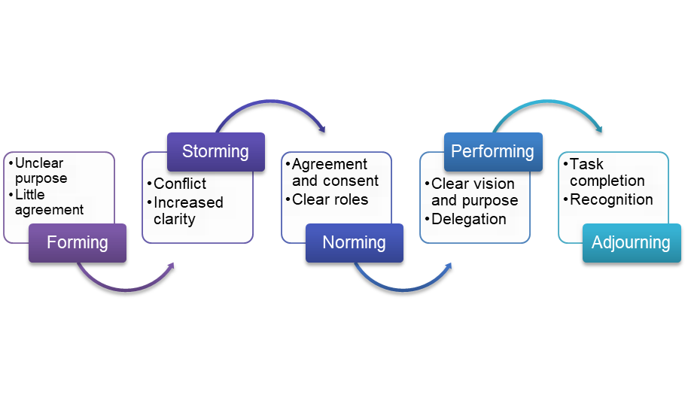
Figure 1: Team development model of Tuckman
Source: Self-designed
Since the model talks about every phase from the initiation to maturity, it can be a guideline for the new team of Next Plc. In other words, the team is expected to go through a similar process as described by Tuckman’s model. In the formation phase, the members will be in an uncertain condition and set the primary guidelines of work. In the storming phase, they have a dispute regarding facts such as how the marketing of the product will be done. In the norming stage, the team is expected to settle things through mutual agreement regarding the terms and conditions (Largent, 2016). The performing stage will be focused on making the work happen since the goal will be clear. For example, the team will be working on promoting the new product as per the goal set. Finally, the adjourning stage can be regarded as the phase where each member has completed tasks assigned and received recognition.
Another important model regarding team effectiveness is the GRPI model developed by Rubin, Plovnick and Fry. This is comparatively a simple model including four aspects – goals, roles, procedures and interpersonal relationships (Raue et al, 2013). This is more focused on setting standards for the team incorporating what should be done and in which manner.

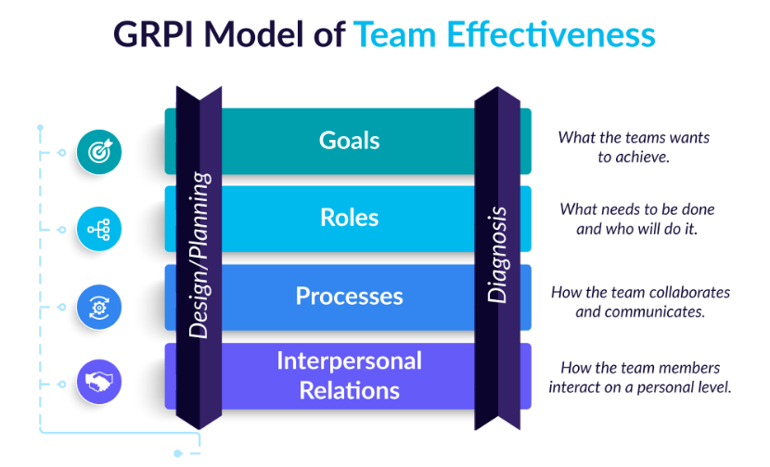
Figure 2: GRPI model
Source: (AIHR, 2022)
This model is more applicable for the teams that have lost track and need a new start. However, in Next, the team will start a new journey for which this model cannot be a good fit. Rather, Tuckman’s model will be appropriate which will guide the path of maturity through each of the phases. As a result, they will be more collaborative and focused on the goal. Considering the suitable structure and purpose of Tuckman’s model to develop a new team and nurture that, it can be said more useful in the context of Next.

Team roles
Defining the roles of each member at the early stages of team formation is necessary to ensure smooth functioning and better conflict management. There are some established theories about team roles among which Belbin’s team role is the most popular one. The roles defined in this theory can be considered crucial for forming an effective team since it has divided the roles according to the tasks necessary for almost every team (Belbin, 2012). The roles of the effective team can be outlined as the following according to Belbin’s model.
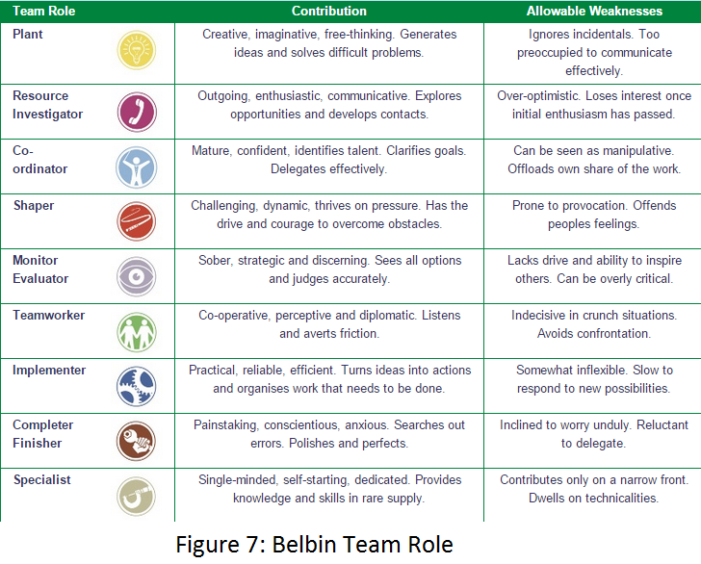
Figure 3: Belbin’s team roles theory
Source: (PrePearl Training Development, 2022)

The team members of Next’s new project may possess all the attributes defined here and pick a suitable role or may focus on the ones necessary for accomplishing the task. For example, the role of the plant is required in this project since it is a new one and needs creative persons for devising new strategies (Belbin, 2012). Again a coordinator is a must because the firm is going to have a large range of operations worldwide and work in different units that need to be combined. Again the members should assume the role of team worker since cooperation is needed in any teamwork. The rest of the roles are also important and can be possessed by the members of that product launching team to make it dynamic and effective.
Considering team roles in the process of recruitment is necessary because the team should have a combination and balance of roles. Next, the recruiters should consider the required attributes from the team members, define their roles and hire people who possess them (West, 2012). For example, the role of plant, team worker and coordinator is mostly relevant for this new project. If the management fails to hire people who can execute the desired performance in these roles the team won’t be an effective one. There can be a lack or surplus of certain attributes required for running the project. Hence it is wise to decide on the activities beforehand and set required roles accordingly so it can help the management to hire suitable persons for the team and the organisation.

Discussion
The advantages of teamwork can be numerous and the business world is getting the utmost benefit out of it. Working as a team can be helpful to promote a sense of belongingness in the workplace. It can strengthen the bond between workers and the personnel can take it as a source of motivation. Working as a team creates more opportunities for innovation which can be a positive side for Next since the launch of the new product will require a creative strategy for promotion and marketing. Here are some more advantages which can be derived by Next from effective teamwork.
Better problem solving
Teamwork facilities problem-solving by a number of people and enable the sharing of knowledge and understanding. When people with diversified backgrounds, wisdom and insight get combined in a team, they can contribute to the decision-making more effectively (Orjonikidze and Gogidze, 2015). Next, the team members from the different geographical regions are expected to have distinct knowledge. They can share their knowledge as a team and solve a problem in an efficient manner.
Enhanced Personal Growth
Since the members in a group possess different levels of intellect and skill, it creates an opportunity for all to learn from the others. Through holding frequent meetings and coaching sessions, the members can share their knowledge and skill to empower other members. Next, the team will hold a discussion about different matters and in this process, one can learn how to develop a market strategy from the other.
Increased Productivity
Teamwork can help to complete the work faster since it facilitates dividing the work into a number of members (Orjonikidze and Gogidze, 2015). Next, the tasks will be assigned according to the expertise one possesses. Since one gets to do the work s/he has specialisation in it becomes easy to complete the task fast and efficiently. As the time and cost are saved, it can add to the productivity of the firm. For example, one member of the team is an expert in data analysis and can process a great number of customer data within an hour. Next Plc can be benefitted as it will have more information regarding customer behaviour and choice and be able to make decisions timely.
However, there can be some challenges in the way of effective teamwork coming from both internal and external sources. Some of the challenges can be listed as the following.
Diversified Workforce: Since Next is going to operate in different countries it is expected to hold a culturally diversified workforce. It can give rise to conflict among the team members which will hamper easy coordination of work (Davis et al, 2022). Again if the team members do not feel comfortable working with each other it will end up wasting the time and resources of the organisation. The management can turn this into an advantage for the firm but the inability to do so will cause an immense cost for the organisation.
Lack of Communication: In Next Plc, the team members may work from overseas as it is going to have an international operation. In that case, the communication among them can be a challenging factor and it can hinder the natural flow of work (Al Zain, Vasilache and Incze, 2018). It can lead to the waste of valuable time of the organisation and a lack of coordination. As a result, the launching of the product will not be successful.
Interior Competition: If the members tend to compete among themselves it will not bring anything good to the organisation or to the project. Since Next is launching a new product, some members can think about working individually without informing others about this to get the credit. Such a phenomenon can hamper the overall flow of work and make the project unsuccessful.
It can be understood from the above discussion that the impact of an ineffective team can hamper the overall productivity and profitability of the firm as well as any particular project. To ensure the usefulness of the time and the resources, does not only require forming a team rather it depends on the well-functioning of the team. the challenges should be overcome to ensure the highest level of potential for each member of the team.

Conclusion and Recommendations
In this world full of competitors it is necessary to get a competitive advantage in the market. A firm cannot ensure an advantage if the team working behind this are not efficient. A good team can bring innovative ideas to the organisation which can give it an edge. Again it can lead to better performance for both the individuals as they get to learn from others and the organisation in the form of increased profitability.
However, there are some factors which must be considered while forming an effective team. First of all, the team members should possess a combination of knowledge and skills. Secondly, the members should be able to trust their coworkers and value their opinions. Thirdly, an effective team is one that is flexible and can take any shape when any uncertain situation arises. There can be a number of other factors as well that have an impact on building an effective team.

References
- AIHR. 2022. The GRPI Model of Team Effectiveness: Explained. [online] Available at: <https://www.aihr.com/blog/grpi-model/> [Accessed 27 June 2022].
- Al Zain, N.L., Vasilache, S. and Incze, C.B., 2018, May. The significance and managerial challenges of virtual teamworking. In Proceedings of the International Conference on Business Excellence (Vol. 12, No. 1, pp. 25-33).
- Belbin, R.M., 2012. Team roles at work. Routledge.
- Bell, S.T., Brown, S.G., Colaneri, A. and Outland, N., 2018. Team composition and the ABCs of teamwork. American Psychologist, 73(4), p.349.
- Davis, A.S., Kafka, A.M., González-Morales, M.G. and Feitosa, J., 2022. Team Belonging: Integrating Teamwork and Diversity Training Through Emotions. Small Group Research, 53(1), pp.88-127.
- Largent, D.L., 2016. Measuring and understanding team development by capturing self-assessed enthusiasm and skill levels. ACM Transactions on Computing Education (TOCE), 16(2), pp.1-27.
- Nancarrow, S.A., Booth, A., Ariss, S., Smith, T., Enderby, P. and Roots, A., 2013. Ten principles of good interdisciplinary team work. Human resources for Health, 11(1), pp.1-11.
- Orjonikidze, N. and Gogidze, M., 2015. The Advantages of “Teamwork” Approach during Personnel Management. Journal of Business, 4(1), pp.17-19.
- PrePearl Training Development. 2022. Belbin Team Roles. [online] Available at: <https://www.prepearl.net/belbin-team-roles/> [Accessed 27 June 2022].
- Raue, S., Tang, S.H., Weiland, C. and Wenzlik, C., 2013. The GRPI model–an approach for team development. White Paper Draft, SE Group.
- West, M.A., 2012. Effective teamwork: Practical lessons from organizational research. John Wiley & Sons.

