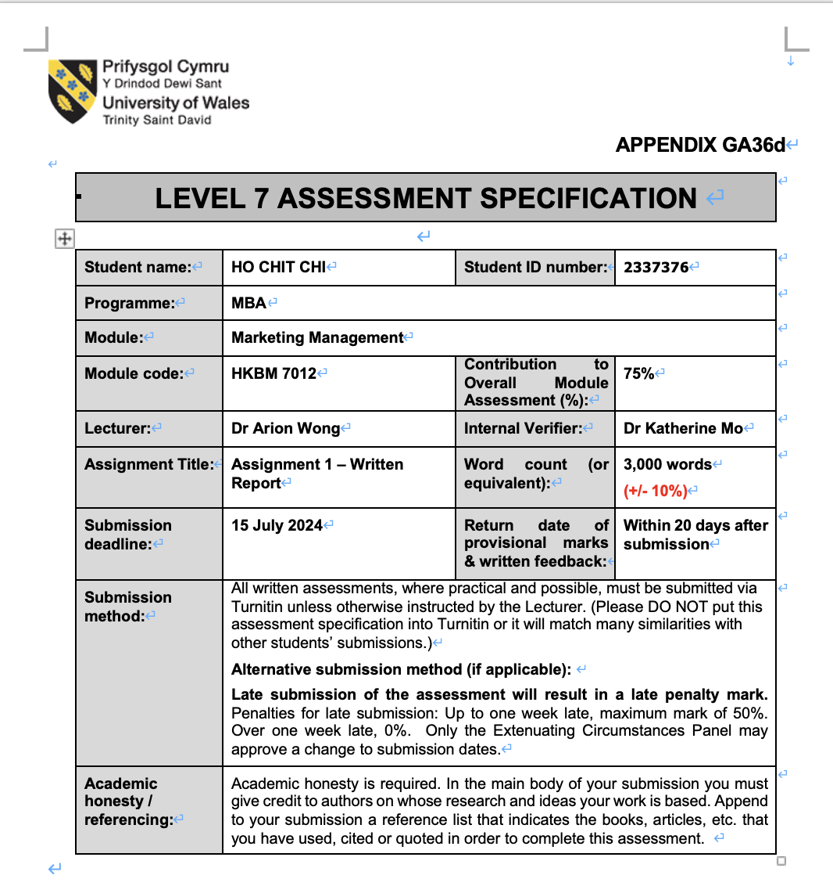

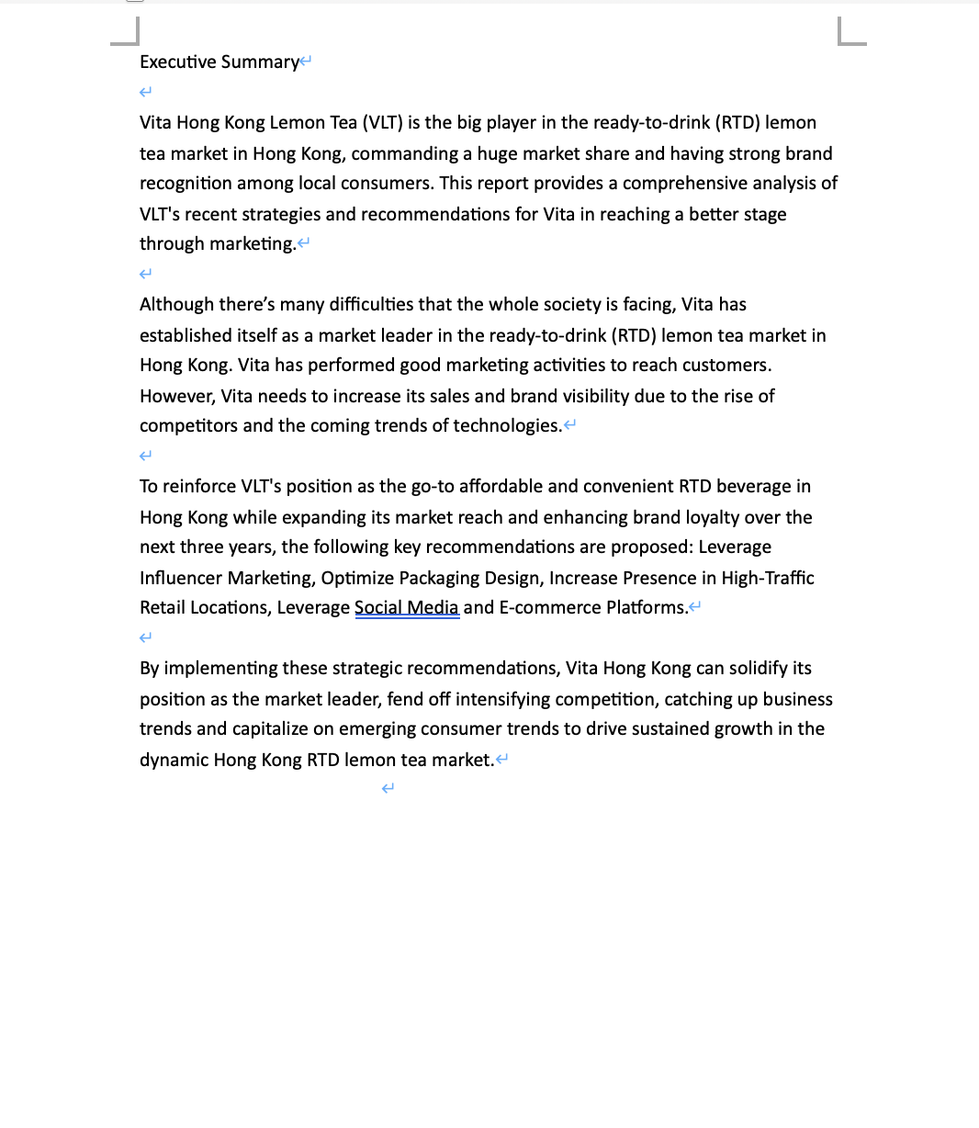
By implementing these strategic recommendations, Vita Hong Kong can solidify its position as the market leader, fend off intensifying competition, catching up business trends and capitalize on emerging consumer trends to drive sustained growth in the dynamic Hong Kong RTD lemon tea market.

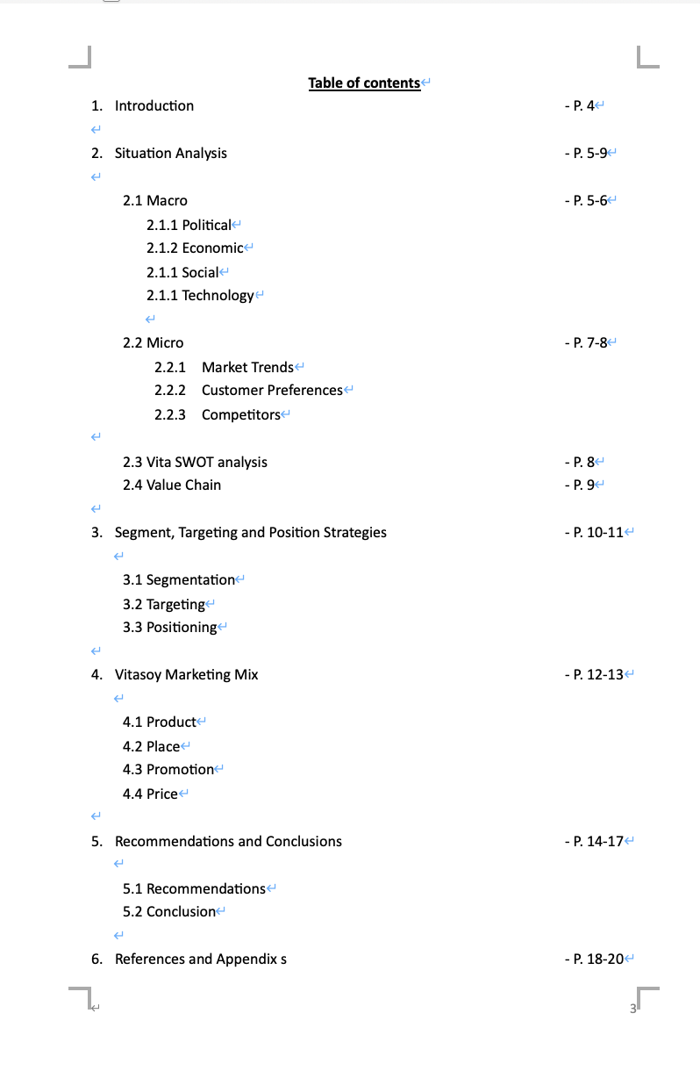
1. introduction

Vitasoy International Holdings Limited (Vita) is a Hong Kong-based food and beverage company that was founded in 1940. Its products are mainly soy milk beverage brand Vita Milk, as well as tea drinks, juice and milk under Vita. It claims to be "a production and distributor of plant drinks and food in Hong Kong". In addition, Vita provides catering services and catering services to primary and secondary schools in Hong Kong under the name of "Vita World" and to primary and secondary schools in Hong Kong under the name of "Hong Kong Food".

"Vitasoy" is regarded as the world's first soybean milk product successfully manufactured on a large scale and sold at an affordable price created before World War II. Vita expand its product lines and products to other ready-to-drink(RTD) beverage, such as tea drinks, juice, Distilled water, etc.

This marketing plan will take focus on the Vita Lemon Tea product line. The Vita Lemon Tea product line includes boxed version and plastic bottles version. This product line include different versions of flavors, for instance: original version, lime version, low sugar version, honey version. supericy version and ceylon version. In this marketing plan, a comprehensive 3-year marketing plan would be mentioned in order to boost performances and stand out in this business environment.

2. Situation Analysis

2.1 Macro
The macro environment for the Vita Lemon Tea series is shaped by several key factors.

2.1.1 Political

Politically, Vita Hong Kong faces several challenges that affects its business in Hong Kong. First of all, Hong Kong government sets a Statutory Minimum Wage since 2011, the Statutory Minimum Wage rate is raised to $40 per hour in 2023 (Labour Department HKSAR, 2023). Vita Hong Kong has its factory in Hong Kong to manufacture its products including the lemon tea series. Therefore, the increase of Statutory Minimum Wage may lead to increase of worker costs which affects Vita Hong Kong.

2.1.2 Economic

Economically, one of the economic challenges Vita facing in Hong Kong is the extremely high cost of living. Hong Kong is well-known as one of the highest costs of living in the world, with sky-high rents, labor expenses, and overhead costs that can severely squeeze the profit margins of Vita (Cheung & Chou, 2018).

Furthermore, Hong Kong’s economic ran slow due to lower cost in Mainland China compared with Hong Kong. Many Hong Kong people buy their necessities, eat and enjoy services in Mainland China due to lower cost but similar traveling time at the same time. To extent, the retail and catering industry went to a economic winter due to the reduced consumers in Hong Kong.

2.1.3 Social

Socially, the population in Hong Kong has increased year by year. According to the statistics released by the Census and Statistics Department, the provisional estimate of the Hong Kong population was 7 503 100 at end-2023 (Census and Statistics Department HKSAR, 2023). It has increased 4.43% compared with 2012. The increase of population which increase the number of potential customers of Vita’s products.

2.1.4 Technology

Technologically, The ready-to-drink (RTD) tea market in Hong Kong is increasingly being shaped by evolving consumer preferences and technological advancements. Vita Lemon Tea, as a prominent player in this market, must stay focus onto technological trends to maintain its competitive status.

One key technological consideration for Vita is the growing importance of e-commerce and online ordering platforms. With the rise of e-commerce platforms, consumers expect smooth digital ordering and fulfillment options. Vita must ensure its products are available and easily accessible through these digital channels, enabling customers to conveniently purchase their favorite lemon tea products.

2.2 Micro

2.2.1 Market Trends

The Ready-to-Drink (RTD) market in Hong Kong has been substantial growth, driven by changing consumer lifestyles and preferences. According to Smith (Smith, 2022), the global RTD beverage market has seen a consistent annual growth rate, with Asia, particularly Hong Kong, being a significant contributor due to the urban population's demand for convenience. It has been highlighted that the increasing awareness of health and wellness is shaping market dynamics, prompting a surge in the popularity of RTD teas (Lee and Chan, 2021). Vita Hong Kong Lemon Tea capitalizes on these trends by offering a product that aligns with consumer desires for both convenience and perceived health benefits.

2.2.2 Customer Preferences

Consumers in Hong Kong exhibit a strong preference for beverages that combine taste, convenience, and health benefits. It has been emphasized that RTD tea beverages are popular due to their refreshing flavor and cultural relevance (Wong and Lam, 2020). It has been further note that health consciousness is a significant factor influencing beverage choices, with consumers gravitating towards products with natural ingredients and lower sugar content (Zhang and Chen, 2019). Vita Hong Kong Lemon Tea has adeptly positioned itself to meet these preferences by offering a product that is not only convenient but also aligns with the health-conscious trends prevalent among Hong Kong consumers.

2.2.3 Competitors

The RTD beverage market in Hong Kong is highly competitive, with numerous local and international brands vying for consumer attention. Ng and Tsang (Ng and Tsang, 2021) provide an in-depth analysis of the competitive landscape, identifying Vita Hong Kong Lemon Tea as a market leader due to its strong brand heritage and consistent product quality. However, the market is also characterized by intense competition from both established brands and new entrants offering innovative flavors and healthier options. Liu and Wong (Liu and Wong, 2019) discuss how market positioning and strategic marketing are crucial for maintaining competitiveness. Vita's strategy of leveraging its brand legacy while continuously innovating in product offerings and packaging has helped it maintain a robust market position amidst growing competition.

Table 1: Hong Kong Ready-to-drink(RTD) Lemon Tea Competitors Rank
Brand | VLT  (Vita HK) | Yeung Gwong (Under Coca-Cola HK) | NESTEA  (Under Coca-Cola HK) | Other brands
Market share | 45% | 10% | 35% | 10%
Estimate Profit | Ard HKD 50 Million | Ard HKD 20 Million | Ard HKD 40 Million | N.A.
Rank | 1 | 3 | 2 | N.A.
Arranged by research results.

Furthermore, the rise of "handshake drink" shops in Hong Kong has had a significant impact on the broader catering industry in the city and affects Vita’s business in Hong Kong. The popularity of handshake drink shops, particularly among younger consumers, has shifted consumption habits away from cheaper ready-to-go towards handmade, on-the-go beverage options. This has reduced foot traffic and revenue for many beverage brands.

2.3 Vita Lemon Tea SWOT Analysis
S (Strength) | W (Weakness)
- As a Well-known Brand in Hong Kong, people adopt its products easily.  - Huge distribution network and selling channels, customers could find its products easily.  - Affordable price for customers. | - Increasing in manufacturing cost, causing decrease in profit  - Too many choices on Ready-to-drink for customers other than lemon tea, especially those with better taste, healthier and cheaper price.  - Increase of competitors
O (Opportunities) | T (Threats)
- Increase of potential customers due to increase of population  - People able to buy things after the pandemic situation | - The rise of handshake drinks trend  - Increase of Statutory Minimum Wage  - Some citizens more concerned on healthy and they look for healthier drinks
2.4 Value Chain

The value chain framework provides a comprehensive lens to evaluate Vita Lemon Tea's activities and identify opportunities for optimization. By examining each link in the chain, from inbound logistics and operations to marketing, sales, and service, the brand can uncover areas for improvement. For instance, Vita can assess its procurement and inventory management practices to ensure reliable supply and minimize waste. The manufacturing processes can be analyzed for efficiency, while the distribution network can be scrutinized for timely and cost-effective delivery. Additionally, the brand's marketing and sales strategies, digital initiatives, and customer service can be evaluated to enhance brand visibility, customer engagement, and loyalty. Integrating a value chain perspective allows Vita Lemon Tea to take a holistic approach to enhancing its overall competitiveness and driving sustainable growth in the dynamic Hong Kong market.

- Segment, Targeting and Position Strategies

3.1 Segmentation

According to Antara and Lestari (2022), segmentation refers to dividing the market into distinct groups, i.e. segments. Vita segments its market into demographic and geographic segmentation to establish target audiences for Vita.

Age and Income is used regarding demographic segmentation. Selling locations is used regarding geographic segmentation.

3.2 Targeting

According to Antara and Lestari (2022), targeting refers to determining which segment(s) to focus on.

Regarding demographic segmentation, Vitasoy targets all ages and even all levels of income by the provision of an extensive range of products for every consumer. It appeals to people from a wide range of demographics to enjoy their products. Vita able to establish long-term relationships with young generation. Making an impact on young consumers is essential for a brand’s long-term sustainability. The following figure shows the index on the age range of Vita’s consumer in 2019. The result reflects that the consumer who under 24 is the largest market of Vita.

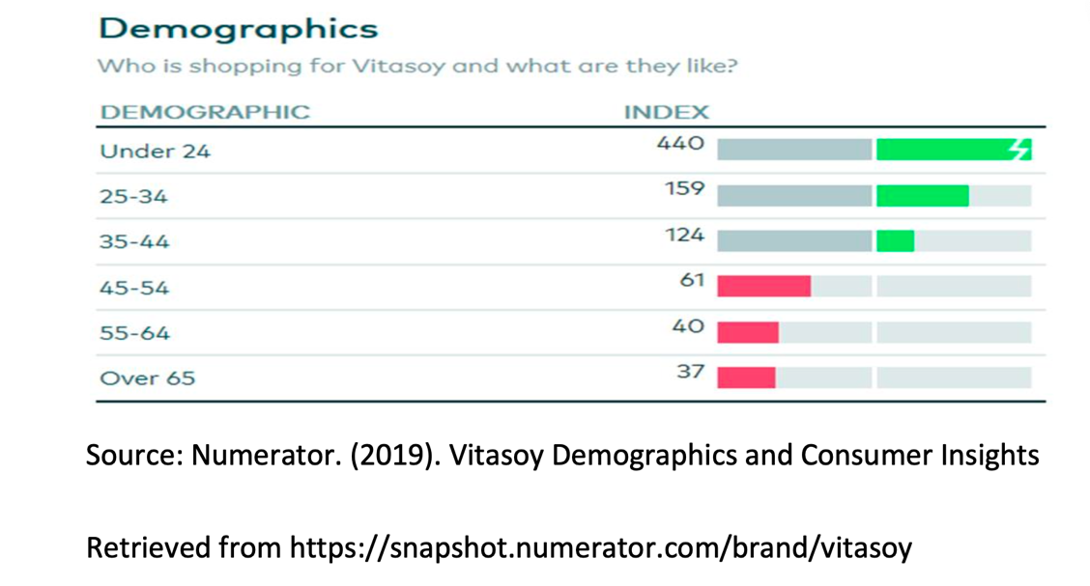
Figure 1. Who is shopping for Vitasoy and what are they like?

3.3 Positioning

Kotler and Keller (Kotler and Keller, 2009) clarify positioning as “the act of designing the company’s offering and image to occupy a distinctive place in the minds of the target market”. Vita has strategically established its brand image based on strong beliefs and values. To reinforce its "Stand By Me" positioning, Vitasoy has actively engaged in advertising campaigns (Chan, J., 2015), portraying the brand as an active companion that can be enjoyed anytime and anywhere. In comparison to competing brands, Vitasoy stands out by offering superior customer value through its combination of affordable prices and high-quality products. This distinction positions Vitasoy as the preferred choice in the minds of customers.

4. Evaluation of the effectiveness of Vita’s marketing mix

The marketing 4P framework, also known as the marketing mix, is a fundamental concept in marketing that represents four key elements essential for a company's marketing strategy. These elements are Product, Place, Price and Promotion (Kotler, P., & Armstrong, G., 2018).

4.1 Product

The Vita Lemon Tea product line includes boxed version and plastic bottles version. This product line include different versions of flavors, for instance: original version, lime version, low sugar version, honey version. supericy version and ceylon version. These products are sold through offline and online channels.

4.2 Place

Regarding offline selling methods, Vita Lemon Tea products are sold in convenient stores, supermarkets and pop-up stores.

Convenience stores, such as 7-Eleven, Circle K, and VanGO are an important sales channel for ready-to-drink products like Vita lemon tea, as they provide easy accessibility and impulse purchase opportunities for consumers. Conveniences store allow busy individuals to buy RTD products at a cheaper price with convenience. Also, convenience stores available almost every street across the city. However, it has a higher slotting fees and requires higher trade discounts compared with supermarkets.

Supermarkets, such as Park n Shop, Wellcome and Fusion allow Vita to reach a broader consumer base and offer a wider selection of beverages and grocery items. Supermarket provide opportunities in bulk/multi-pack sales which convenience store could not provide. Also, supermarket provide more variety of RTDs whatever in brand or product lines. However, supermarket’s environment lets customers compare between brands which may lower the sales performance.

Furthermore, Vita had customized pop-up stores depending on its marketing campaigns. Pop-up stores allow maximize flexibilities on marketing activities. Vita could promote their entire product line in pop-up stores and highlight any product according to project needs. However, the cost of pop-up stores is high. Also, the effectiveness of these stores is not stable which depends on many circumstances.

Regarding online selling methods, Vita Lemon Tea products are sold on online stores, such as HKTVMALL, Vita and supermarket websites. It could bring huge sales performance by social media and influencer promotion, especially the younger age customers.

4.3 Promotion

Vita Lemon Tea frequently launches limited-edition or seasonal flavor variants to generate excitement and encourage consumers to try new product offerings. To boost sales and repeat purchases, Vita Lemon Tea implements various pricing promotions, such as temporary discounts, lucky draws, multi-pack bundles, and loyalty program rewards. The company also leverages its physical presence to maximum effect, establishing eye-catching pop-up stores and in-store displays in high-traffic locations like shopping malls and transportation hubs. For example, Vita held a big marketing campaign collaborated with T.O.P (shopping mall in Mong Kok) recently, they had customized setups inside the shopping mall. Additionally, the brand curates engaging social media content to reach and attract new customers.
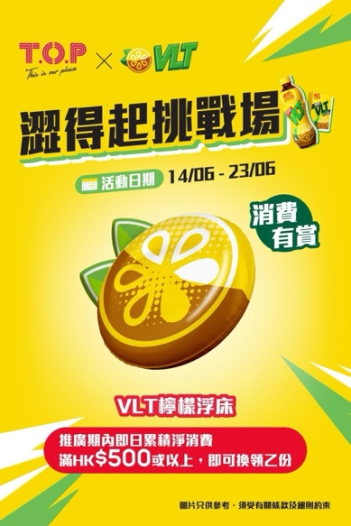
Source: T.O.P. Instagram

4.4 Price
By comparison of other brands, the pricing of Vita’s lemon tea is higher than its competitors (Appendix 1). Vita offers a great combination of
quality and excellent service to reasonable price by implementing the good-
value pricing approach base on customer’s perceived value. However, Vita needs to consider the pricing strategies comparing with other lower price lemon tea brands.
5. Recommendation and Conclusion

5.1 Recommendations

Some recommendations would be given after analyzing Vita’s marketing mix, performing situation analysis, SWOT and STP. Over the next three years, VITA Lemon Tea (VLT) should focus on reinforcing its position as the go-to affordable and convenient RTD beverage in Hong Kong while expanding its market reach and enhancing brand loyalty.

Firstly, Vita should invest more resources on influencer marketing. Influencer marketing is hybrid of old and new marketing tools, combining the concept of celebrity endorsement with social media marketing. It authentic connections and leveraging influencers’ reach to enhance brand exposure (Glenister, 2021). Influencer marketing could bring huge sales performance and brand visibility to the public. Taking 1664 Blanc as an example, they recruited Keung To to promote their product. They has experienced a 30% sales growth and huge expand in female market (FINANCE730, 2022). A study highlights that influencer marketing campaigns can result in higher consumer engagement and interaction, which further amplifies brand visibility (Breves et al., 2019). Vita could recruit famous influencers to promote the Lemon Tea product line.

Other than using influencers in social media campaigns, Vita could also change the packaging of the products with the influencer’s appearance on it. Packaging plays a critical role in influencing customers' preferences and purchasing decisions, especially in the Ready-to-Drink (RTD) beverage market as people usually reach out RTD products offline. A study by Silayoi and Speece (Silayoi and Speece, 2004) found that visual elements of packaging, such as color, shape, and imagery, significantly impact consumer perception and choice. Effective packaging design can enhance brand recognition and recall.

Secondly, increasing the presence of VLT in high-traffic retail locations is crucial, especially convenience stores. According to figure below, there is over 1388 convenience stores in Hong Kong. Vita may increase then VLT stocks in high traffic areas, such as train stations, school areas, huge bus stations, shopping mall areas, etc. People who are busy individuals, students, and working professionals who prefer quick and easy solutions would visit those convenient stores. Also, people who needs to refill their transportation saving cards (OCTOPUS in HK) would visit convenience stores, so it was good opportunities to attract their attention. Vita could buy storage spaces near cashiers to enrich visibility and sales performances.
Figure 2. Number of leading convenience stores in Hong Kong as of 2022
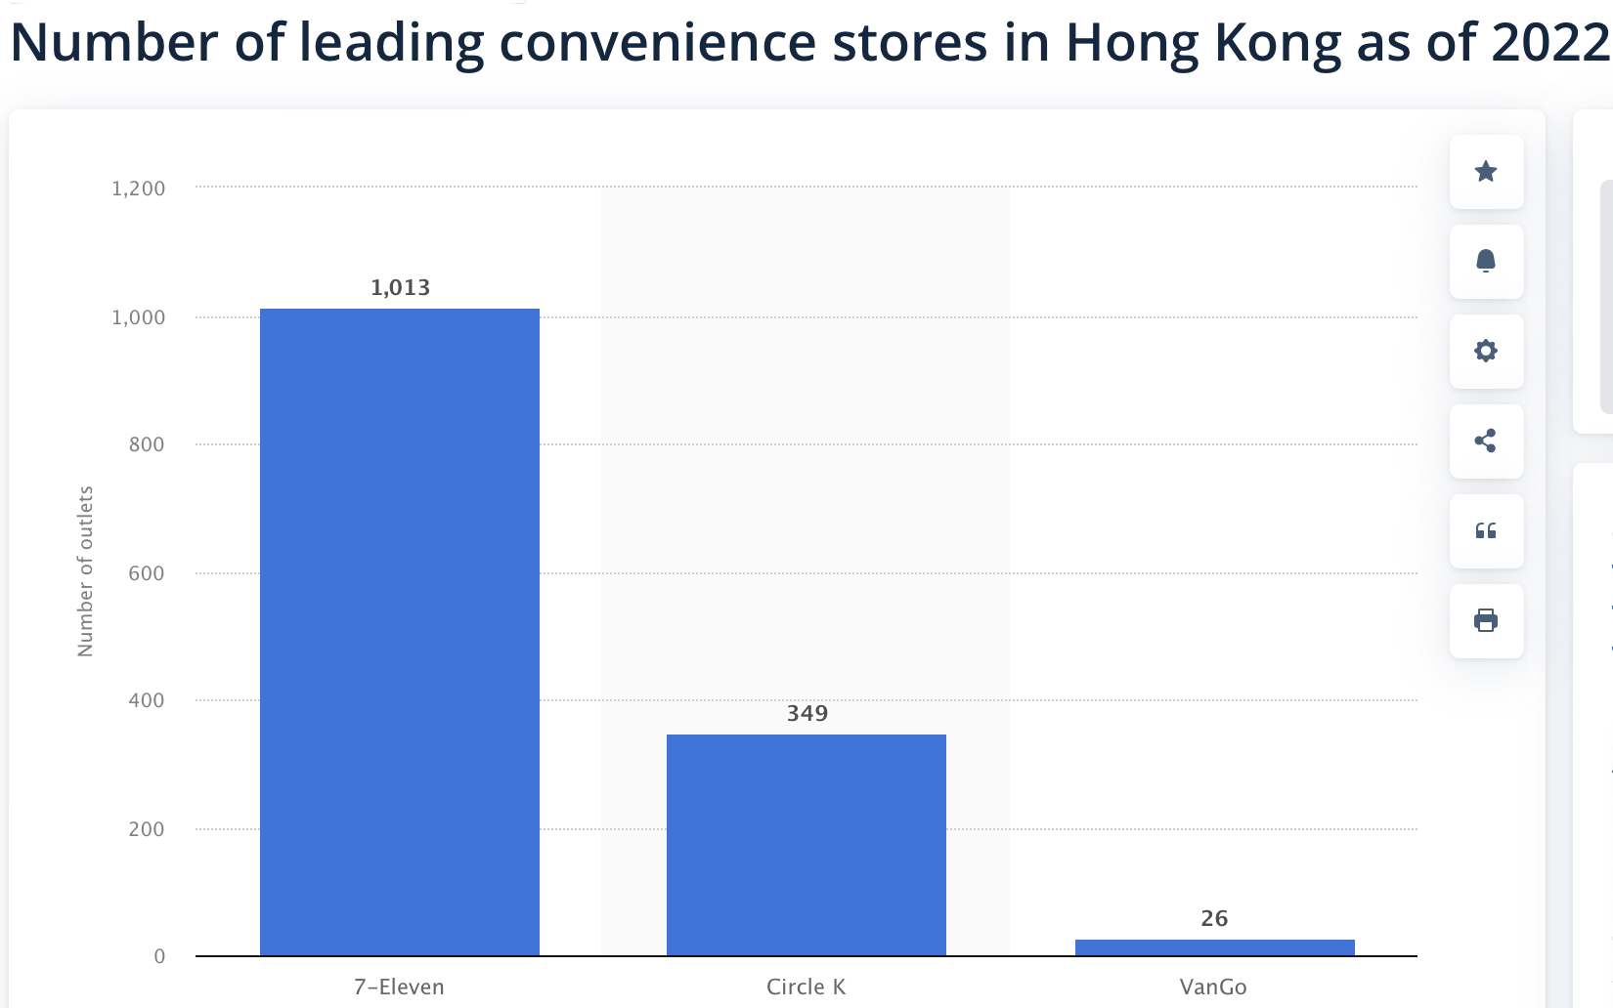
Source: statista. (2022).

Thirdly, Vita should try to adopt technology and AI to their businesses as it would be major tools in running business in the future. According to Kumar et al. (2019), personalized marketing driven by AI can significantly enhance customer engagement and sales by delivering tailored content and offers. Invest in AI-Driven Personalization allows Vita create personalized marketing campaigns based on consumer data, which tailored promotions, product recommendations, and personalized content can increase customer engagement and loyalty.

Fourthly, Vita could adjust the price by often providing individual or bundle discounts. Although Vita provide high quality products with its high brand value, they has to adjust the price in order to attract customers to buy their lemon tea products.

Lastly, Vita should capitalize on the growing trend of online shopping by social media marketing. Vita should launch paid advertisements in social media and online shopping platforms. Paid advertisements in social media could raise the brand and product awareness to the younger generation customers, as younger customers use social media more often (GilPress, 2024). Paid advertisements in online shopping platforms like HKTVMALL could persuade online shoppers to buy additional with their original purchase items. These could help boost the sales performance of Vita Lemon tea series. Additionally, Vita should promote the goods of its RTD Lemon tea products in the social media marketing campaigns, comparing with handshake drinks such as the cheaper price and better convenience. This could attract the younger customers to buy Vita’s products.

5.2 Conclusion

After a thorough analysis of Vita Hong Kong Lemon Tea (VLT) through its marketing mix, situation analysis, SWOT, and STP, several strategic recommendations have been identified to reinforce its market position and drive growth over the next three years. Those strategies including influencer marketing, pricing strategy, strategic retail presence, online and social media marketing, and adoption of technology and AI

Implementing these strategies will enable Vita Hong Kong Lemon Tea to solidify its position as the preferred affordable and convenient RTD beverage in Hong Kong, while expanding market reach and enhancing brand loyalty.

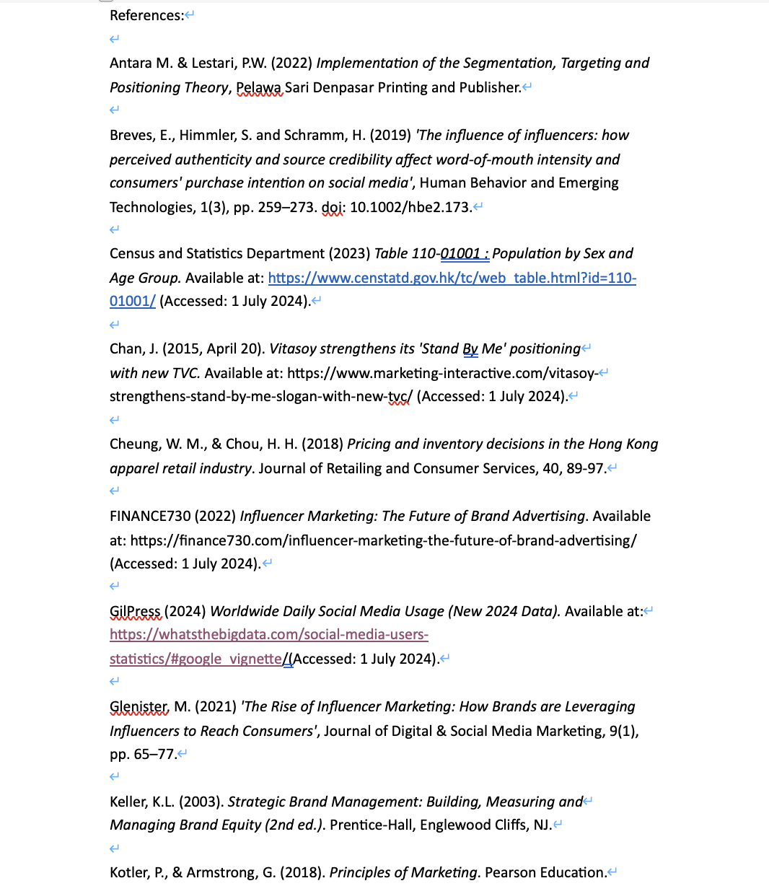

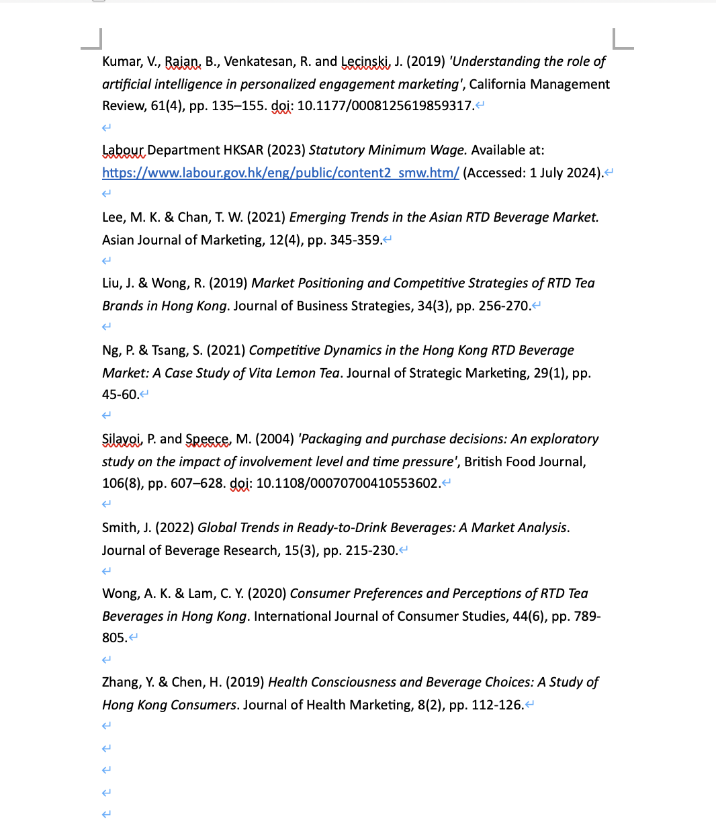

Appendix 1.
Online Price Watch Source from Consumer Council
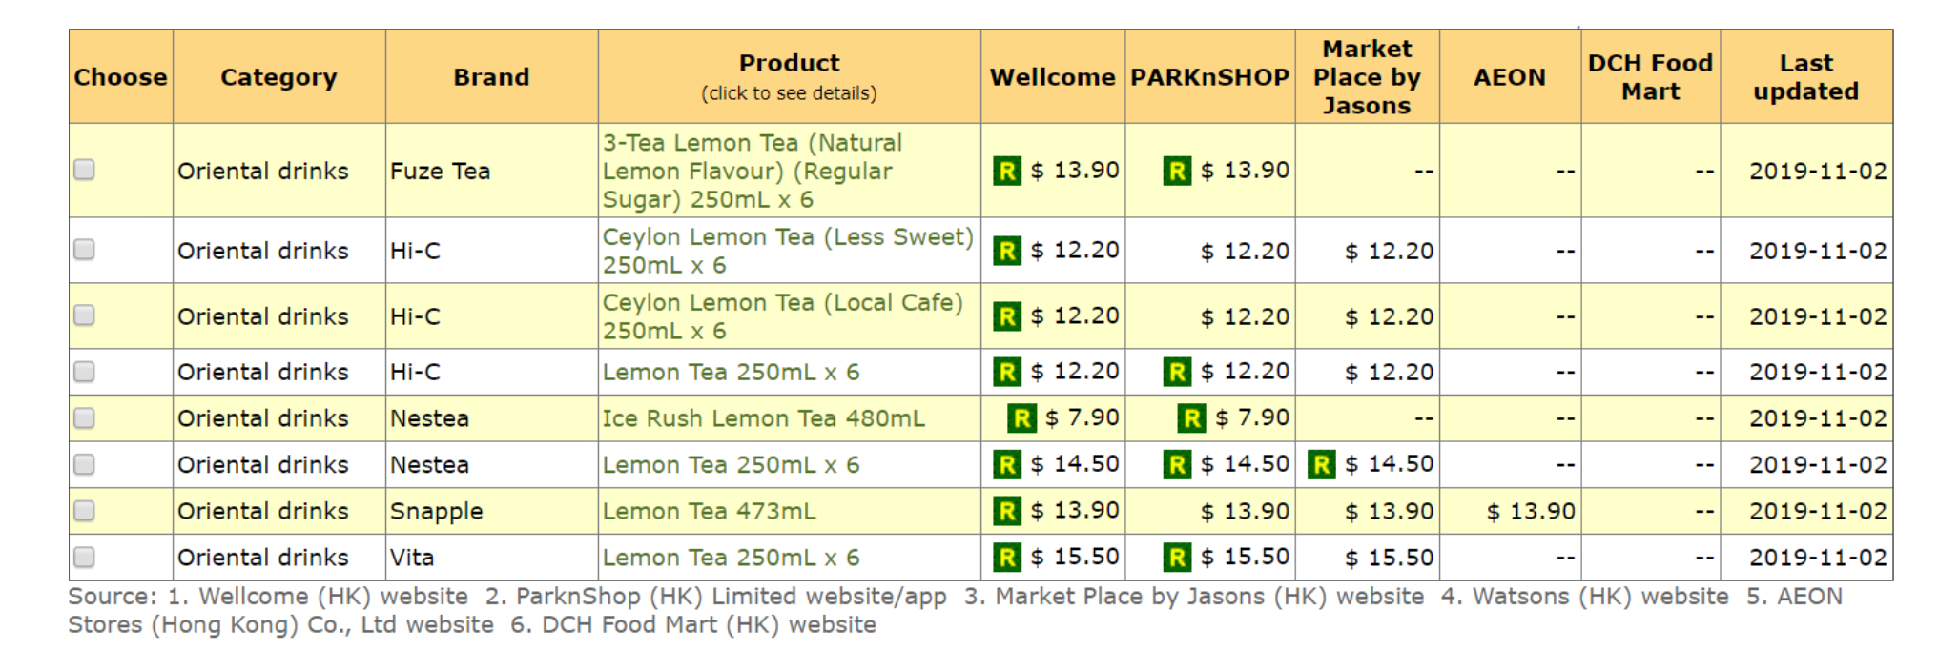

Appendix 2
Vita Lemon Tea (VLT) Promotions


