Installing and Managing Virtual Networked Systems M4X01500 Lecturer Lee Cobley
Iskander Abd-Al-Kerim 0250002

Contents
1. Abstract 2
2. Introduction 2
3. Main 3
3.1. Advantages/disadvantages of using type 2 hypervisor program. 3
3.1.1. Advantages: 3
3.1.2. Disadvantages: 4
3.2. Why give importance to Monitoring programs in your network? 4
3.3. Active Directory Service role. 4
3.4. Domains, Forests/Trees, Schema, Objects and Domain Controller in the context of Active Directory. 5
3.5. The four stages of DHCP operation. 5
4. Practical 6
4.1. Installing VirtualBox 6
6
4.2. Installing Clients and Servers 6
4.3. Network Settings Configuration 20
4.4. Investigating Utility and Application Program softwareQWer12 24
4.4.1. Performance Monitor 24
4.4.2. Reliability Monitor 25
4.4.3. System Configuration Utility 27
4.5. Configuring virtual networking and Upgrading a member server to a Domain Controller 28
4.5.1. Creating an Active Directory Domain 29
4.5.2. Installing Client Computers and Basic Object creation in the Active Directory 32
4.6. Installing and configuring the DHCP Service 37
4.6.1. DHCP Part A: INSTALL / AUTHORISE THE DHCP SERVICE. 37
4.6.2. DHCP Part B: CREATING A DHCP SCOPE FOR LEASING IP ADDRESSES TO DHCP CLIENTS ON THE PRIVATE NETWORK 38
4.6.3. DHCP Part C: TESTING DHCP LEASES 39
4.6.4. DHCP Part D: CONFIGURING DHCP OPTIONS 40
4.6.5. DHCP Part D: CONFIGURING DHCP OPTIONS 41
5. Conclusion 43
References 44

Abstract

This report can be treading as a workbook it shows work carried out regarding setting up and maintaining system networks. It will answer some serious questions regarding the functions and importance of monitoring program and how to set up an Active directory within virtual servers and client machines built within VirtualBox.
The practical section outlines the steps taken to carry out these tasks.

Introduction

This report will outline the benefits and features available for using software such as VirtualBox virtual machine management software. However, saying that is all it is, is like “judging a book by its cover”. Beyond simply building the virtual machines it looks at how the systems build functions with regards to internal security in organisations across multiple locations if necessary.
By the end, it will be a fully functional system with private (local scope) and public (global scope) IP addresses [1]. DHCP server implementation [2] will allow for dynamically allocated IP addresses to be used by the client PCs.

Main

A hypervisor is known as a VMM (Virtual Machine Monitor) which appropriately distributing the resources of the physical computer between distinct secure environments. Through them, multiple guests can see their executions being run and managed by a single host concurrently. [3]

Advantages/disadvantages of using type 2 hypervisor program.

A type 1 Hypervisor runs on bare metal, but type 2 will run on top of an operating system. Each one has its pro and cons [4]. Here are some advantages and disadvantages of type 2:

Advantages:

- Can monitor and run concurrent virtual machines on a host.
- Co-existing on one system is made possible by VMMs.
- consolidate multiple operating environments and workloads.
- Isolates and abstracts different applications and operating systems from the underlying host, thus creating independence.
- the operating environment is secured from internal conflicts by the hypervisor.
- No more underutilized resources!
- it removes any dependency over applications and physical OS.
- hypervisors achieve a better level of availability, computing performance and scalability.
- VMM reduces time consumption in testing and run-time debugging.
- hypervisors improve expenditures and IT throughput.
- It provides economic relaxation around the datacentre, hardware servers, OS backup and even cuts down on power usage, which in turn makes it an overall cost-effective transition.
- VMM offers better uptime faster reduced workload, deployment, and cost predictions for operational needs. [3]

Disadvantages:

- Find a reliable hypervisor service for your enterprise needs within budget can become challenging.
- running VMs on domestic computers is not within its skillset.
- hypervisors may become an easy cyberattack target.
- Vulnerability increases because of the company network, centralized system, server rooms, etc.
- these functions could cause a possible denial-of-service attack and more intrusions.
- virtualization is not something ass systems or software are fit for. [3]

Why give importance to Monitoring programs in your network?

Guru99 says Pandora FMS, Splunk, Fiddler, OP5 Monitor, Logic Monitor, ConnectWise Automate, Incinga, Zabbix, WhatsUp Gold 2017, Microsoft Network Monitor, GFI LanGuard, Network Configuration Manager, Intermapper, Paessler PRTG, Site24x7, ManageEngine OpManager, Obkio, Network Bandwidth Analyzer and NetCrunch are some of the best networking tools in 2021 [4]. Some of the ways they can help organisations Monitor their networks are:
- For availability and network performance optimisation.
- Keep informed!
- Diagnose issues!
- Report issues
- Eliminate manual checking being required!
- Proactive approach
- Trend tracking
- Availability data and performance benchmarking. [5]

Active Directory Service role.

Active Directory Domain Services or DC AS for short make up the core functions in AD which will manage computers and users. By allowing system admins to logical hierarchies to organise the data into. AD DS will provide security certificates, Single Sign-On/SSO, Lightweight Directory Access Protocol/LDAP and rights management.
All Cyber attacks will affect AD, knowing what to look for is then crucial for Incident Response (IR) and cybersecurity practitioners. [6]

Domains, Forests/Trees, Schema, Objects and Domain Controller in the context of Active Directory.

The overall directory database in a windows domain is referred to as an active directory [8]. The domain controller is where the common account database is held, they must have an associated DNS as their primary suffix [8]. A domain makes part of a network organized by a single authentication database; the domain is a logical grouping of objects within the network [9].
Domains can be grouped the group is called a forest. The root domain is where the schema and configuration for the forest. When additional domains are added to the root to form a tree structure or the forest structure, this is dependant on the domain name requirements [10].
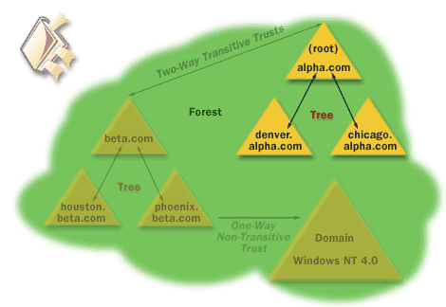 [10]
The cohesive group of domains are called trees, which are referred to as child domains or subdomains, they grow from the root domain. The contiguous namespace is shared by all domains within a tree. Forests are then the classification of a grouping of root domains, the contiguous namespace is not shared by them [10].
Objects are then physical network entities within a domain, these can be shared files or folders, hardware resources, servers, computers and end-users [9].

The four stages of DHCP operation.

At the time, a host (DHCP Client) has IP configuration needs, it will connect to a DHCP Server where it will make an IP configuration request. There are several pre-configured IP configurations within the DHCP server.
When the DHCP client sends a DHCP request to the server, IP Configurations are given to the client from what IP Configurations are available. The four stages: Discover, Offer, Request and Acknowledgement. As seen in the diagram below. [7]
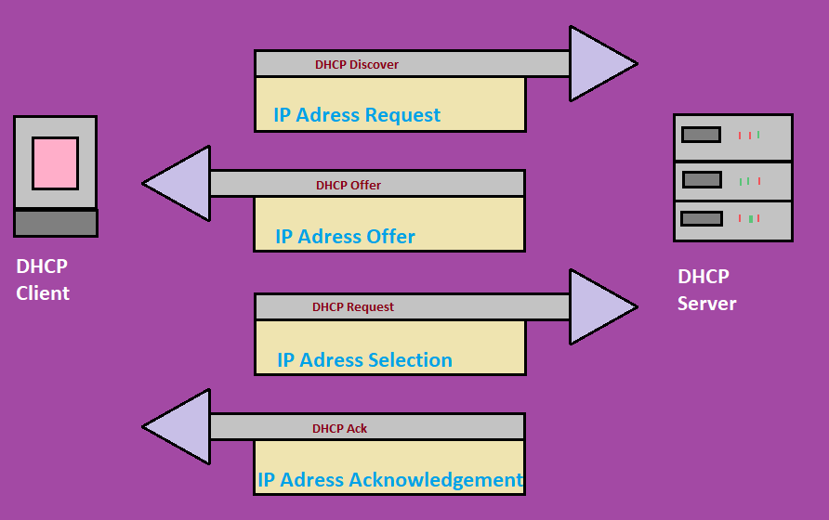

Practical

Installing VirtualBox

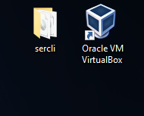
Firstly, I downloaded Virtual box from https://www.virtualbox.org/ and cleared a folder for my ISO files. This was a simple process and the set up was straight forward.

Installing Clients and Servers

The ISO files I downloaded were Windows server 2019 and Windows OS consumer edition 202 update version. I acquired them through https://portal.azure.com/ where my university grants me access to various software for my studies.
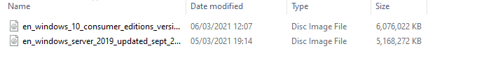
On opening VirtualBox, I am faced with several options I am here simply to create several new machines.
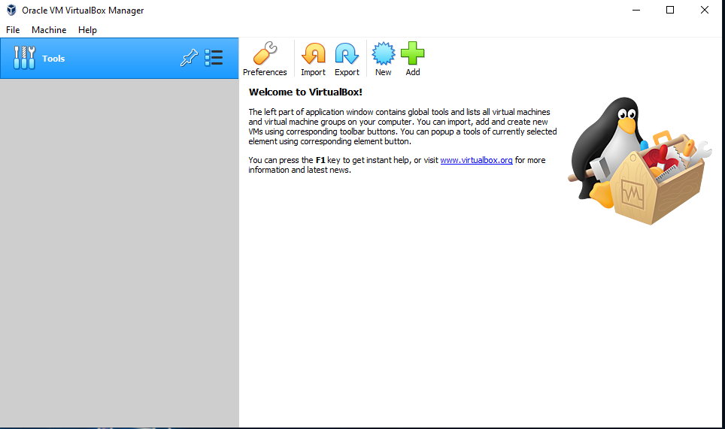
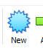
I did this by clicking new, alternately I could have used the file menu and selected “New” in there.
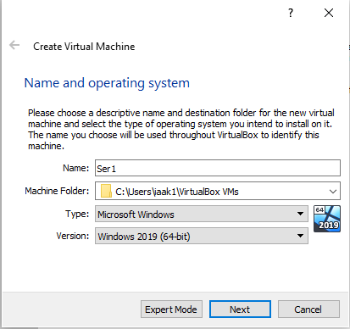
I'm now looking at the “Create New Virtual Machine” window. Have named my machine ser1 as it will function as one of two servers I am creating. I need to change the Version to Windows 2019 (64 bit), I am happy with the location the file is saving into.
I then click “Next”.

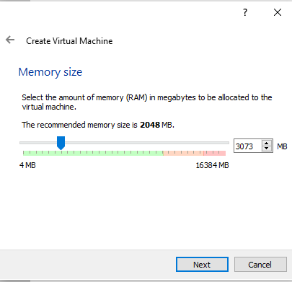
Now I am faced with a “Memory Size” window. I would normally enter 4096 here if I was using a remoter computer but my internet is a little slow today so therefore as my computer only has 16GB of ram I will keep 4096 for its function and spread the rest out across the 4 machines I’m going to build today. Also, it is still 50% over the minimum recommended amount so this should not cause issues for me.
Again, I click “Next”.

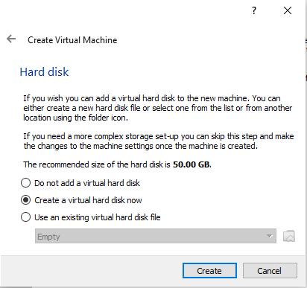
Now I’m faced with the “Hard Disk” window. This time I will select “Create Virtual Hard Disk Now” because I need an HD to store my Virtual server on. I could use an existing file if I wanted to create a copy of the hard disk on my computer. However, this is not the case.

I “Create”.

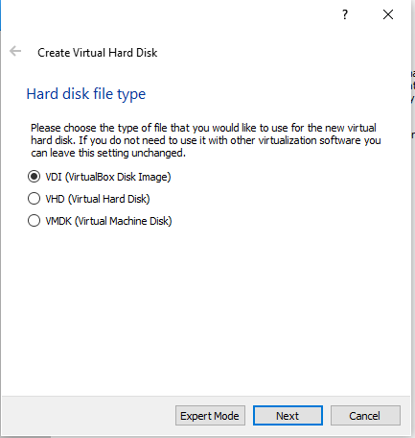
In the “Hard Disk File Type” window I am faced with three options. I have selected VDI this is a native VirtualBox format that tends to not be supported by other virtualisation software but since I am only using VirtualBox I use this option. Also, if need be I could quite easily convert into other formats.
We could also use VHD if we were using Windows server 2012 but we are not we would need to need to use VHDX but that would mean changing our virtualisation tool as VirtualBox does not support this format currently.
VMDK is also possible however it is not created by VirtualBox and although it's able to split storage file sizes if we were to limit our file size limit in the file system. [8]
So, we select “VDI” and hit “Next”.
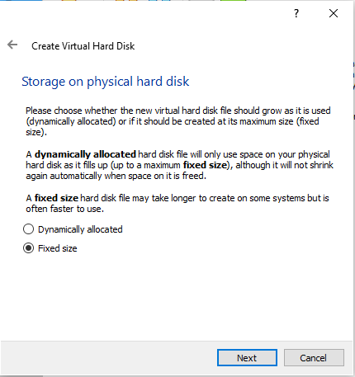
I now see the “Storage on physical hard disk” window in which I am faced with two options.
I could select “Dynamically Allocated” if I wanted my HD size to be able to grow as I add more items to it.
However, I know I would need much for the builds I am making and therefore I will select “Fixed Size”.
And hit “Next”

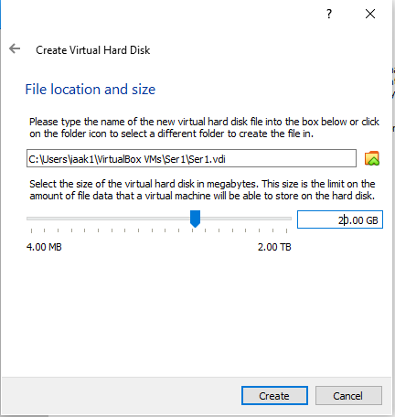
Now I see the “File location and size” window where I can select the fixed amount of maximum storage that may be used by this VMs HD.
I will select 20GB as I don’t intend to use this machine for any heavy work.
I click “Create”

There we go I have created my first machine. However, even though it's named ser1 it holds no data it's in a sense simply representing a piece of hardware at this stage.
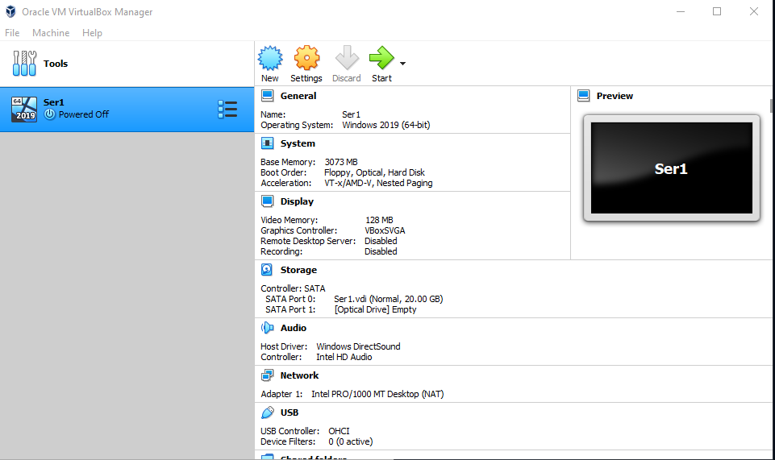
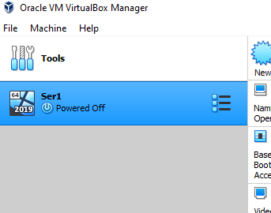

So, whilst I have my machine in this unaltered pure state I will simply clone it three times by right-clicking on the blue highlighted section of Ser1 and select duplicate. I do these three times.

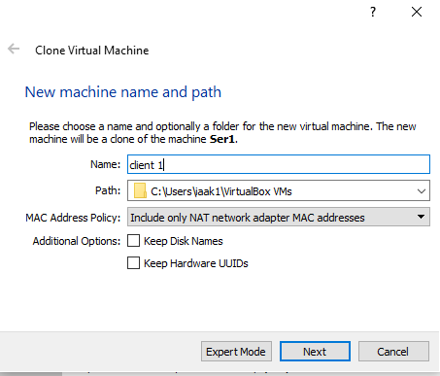

Each time I select to clone a machine I am faced with a “new machine name and path” window. I simply change the name and create one Ser 2, client 1 and client 2.
Then I click “Next”.

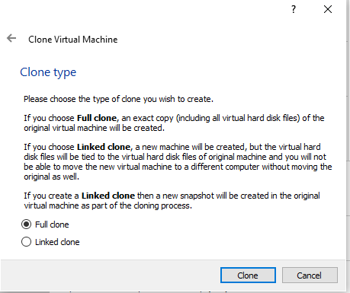

I do a full clone as I’m simply looking to build multiple machines at this current state with which I can work further.

I hit “clone”.

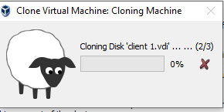

Now I sit and watch my machines getting clone like Dolly once was except they are not likely to make babies. Or are they…... [9]
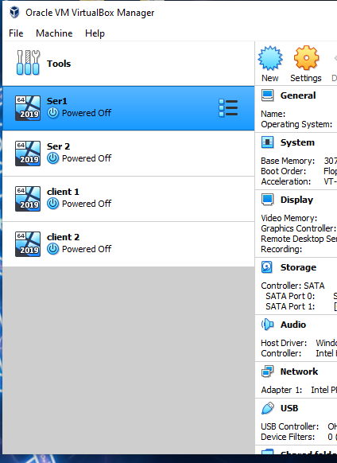
Now I have a grand list of 4 machines waiting to be brought to life with software. I will conduct multiple simultaneous installations as I have left enough RAM on my computer to handle the strain.
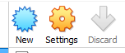
I start by doing some work on the machine settings before I conduct the initial boot. Select a machine then hit the settings icon is how I like to do it. Although I could right-click the machine on the list and select setting from the dropdown list.
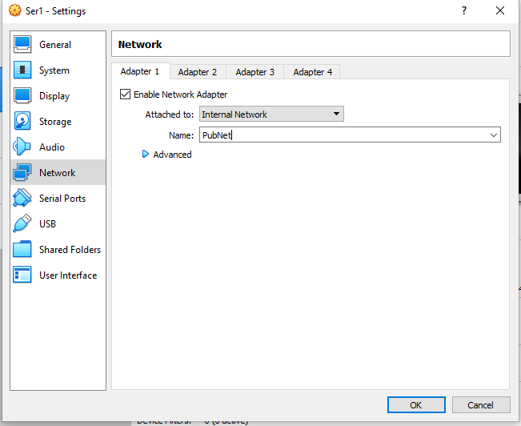
In the Network section of settings, I can configure up to four of the network cards. If I wanted to configure all eight I would do so in the command line with VBoxManage modifyvm. [10]
The previous picture shows me accessing the Network TAB in settings where I changed the Attached from “NAT” to “Internal Network” and name it PubNet. (This by no means reflects my desire to attend a beer garden. Honestly!).
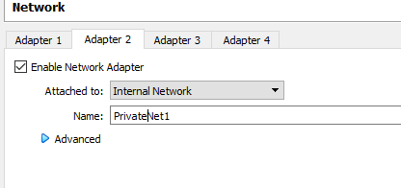
Then on Adapter 2 I do the same but set the name to PrivateNet1. I do the same for Server 2 except I name my second adapter Private Net2.
I click ok to save my work and renter the settings menu.
For my client machines, I will only use one adapter and name then PrivateNet1&2
The client machines should only have one adapter which will also be on internal network however client one will be on PrivateNet1 and vice versa.
I untick floppy in the “Boot Order” and move it to the bottom.

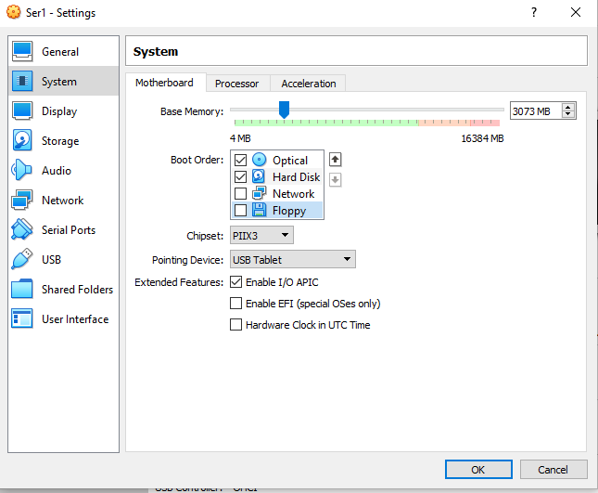

Then in the processor tab, I up my system up to two CPUs.
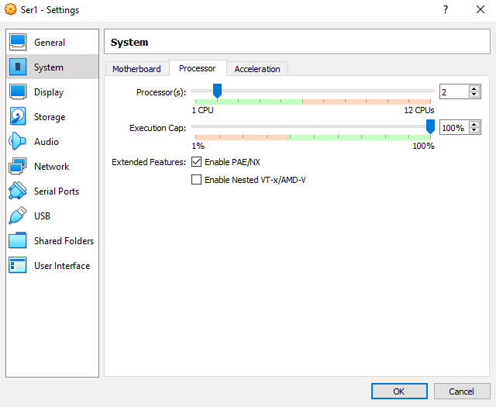
Under the acceleration Tab Uncheck “Enable Nested Paging”
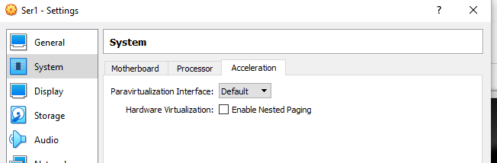
And hit OK.

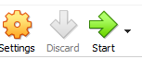
I first select Ser1 and hit the start/green arrow.
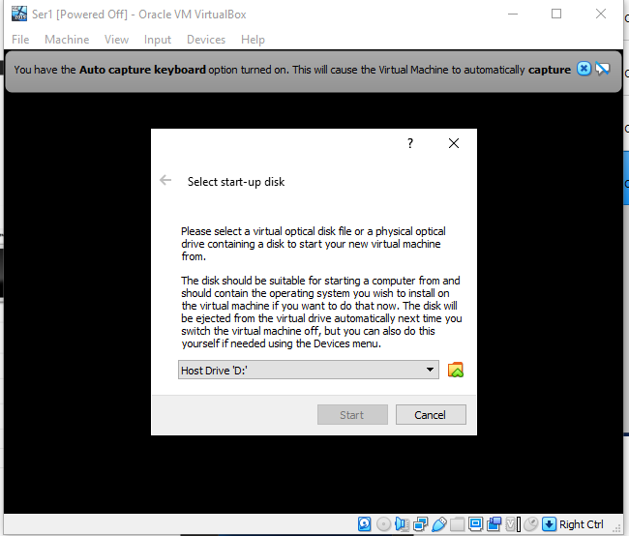

Now Virtual Box asks me what drive I would like to start my machine from. I know I have yet to install any OS so therefore I need to assign one. I click on to go through to the relevant window to select a drive.

Now I can see my available drives. However, none have any OS added, so I click ADD.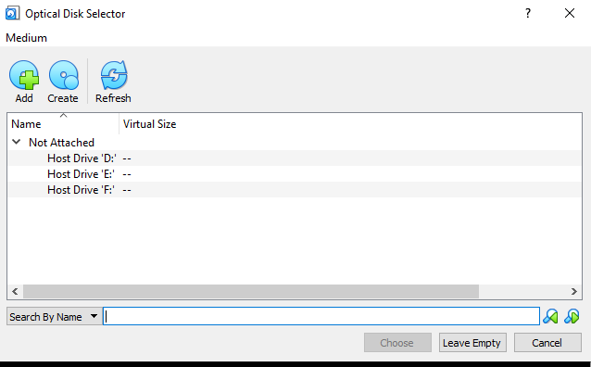
I now select my Windows server ISO to be added to my list. I will do this for windows consumer edition also to make it available for my client builds.
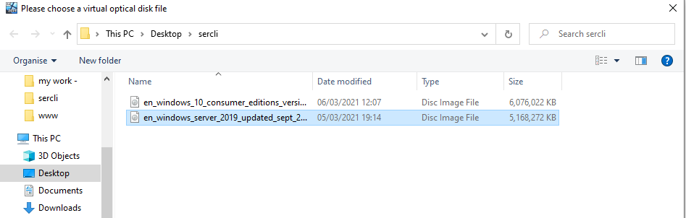
Now my optical driver selector looks like this. I will select windows server and hit “choose”.
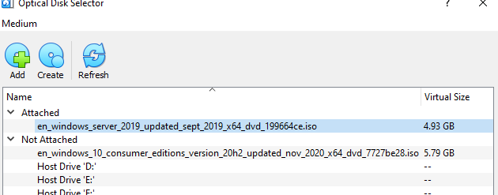
Now I see my machine running with a setup window open. As I am in the UK I will change the time zone and keyboard to the United Kingdom and hit “Next”, language cannot be changed on server edition.
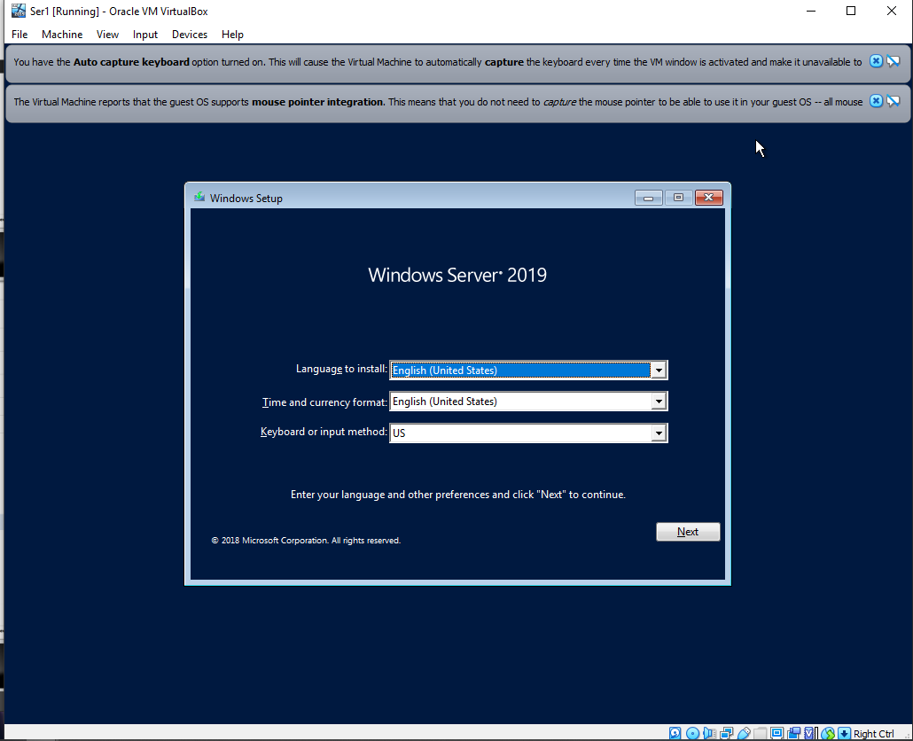

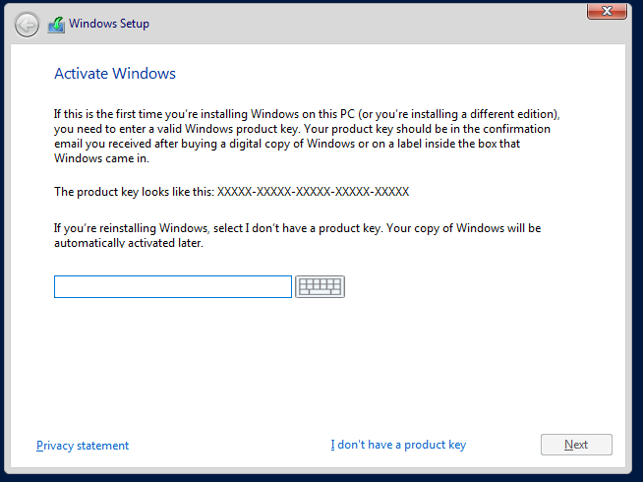

The next set up window asks me for a product key which I do have but will not use this time as I do not intend on keeping this build I am simply practising.
I click “I do not have a product key”

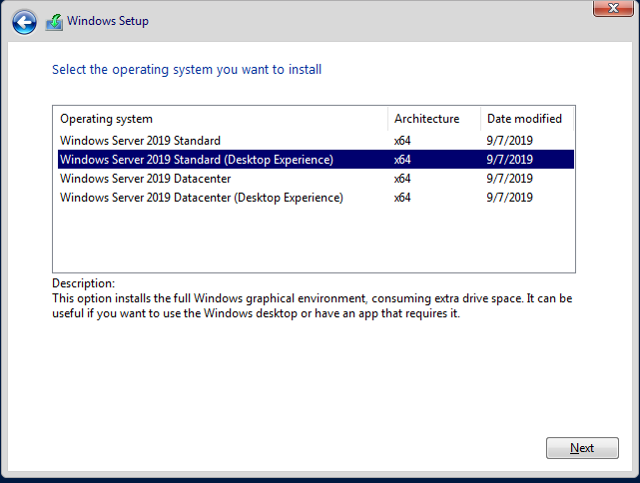
The Next set up window asks me to select which operating system I would like to install. I select Windows Server 2019 Standard (Desktop Edition) as I do not want the core which is simply a shell that comes without a GUI and would need to be managed via the command line tools which is not what I am looking for I need the full package. Which is what the Desktop edition offers [11]. The datacentre is for datacentre management. For the client machines, I select the education version.
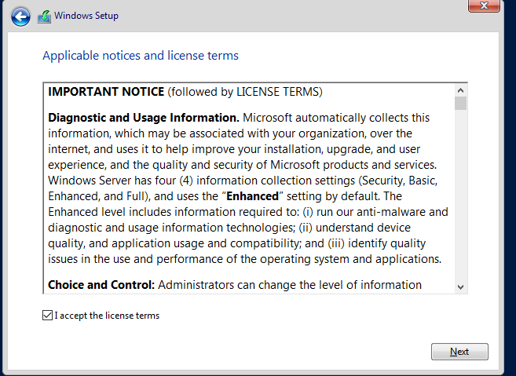
Having accepted the licence terms in the next window I select “Custom: Install Windows only (advanced)”
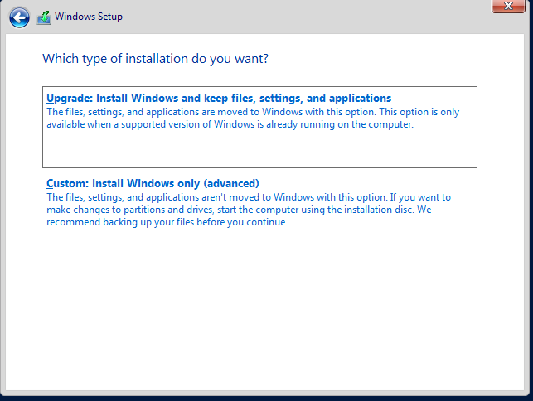
Select the right drive to use ( I should only see one the 20GB one I created earlier)
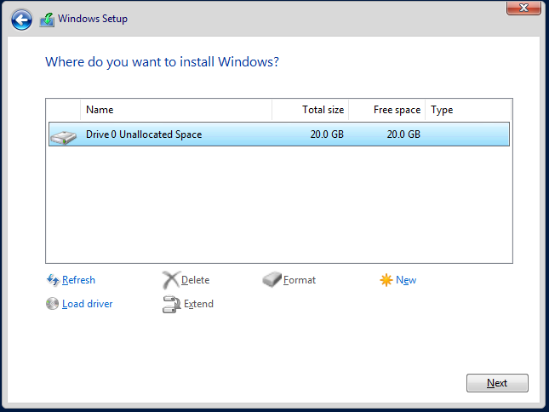
Great now I sit back and watch the installation I do this for both server machines. I conduct the installation process and set my password to P@ssw0rd this ensures my password is easy to remember across my virtual machines and it has all the necessary character required by windows.
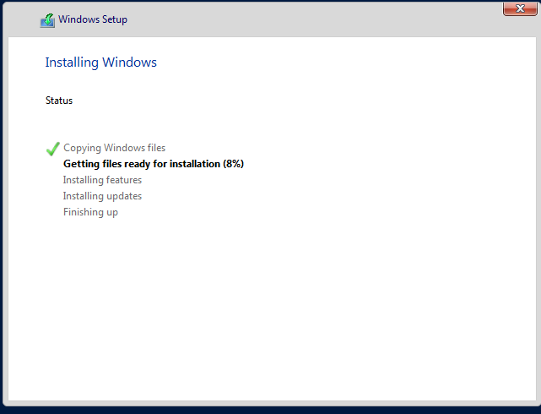

Network Settings Configuration

I'll configure the network to look as follows.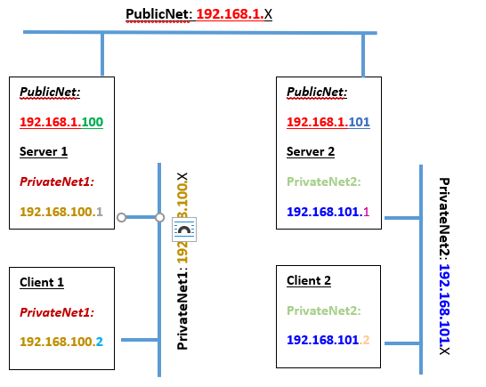

By right-clicking on start I get an options list from which I can choose network connections then ethernet and finally change adapter options. Client 1 on the right shows one available connection and server1 shows two.
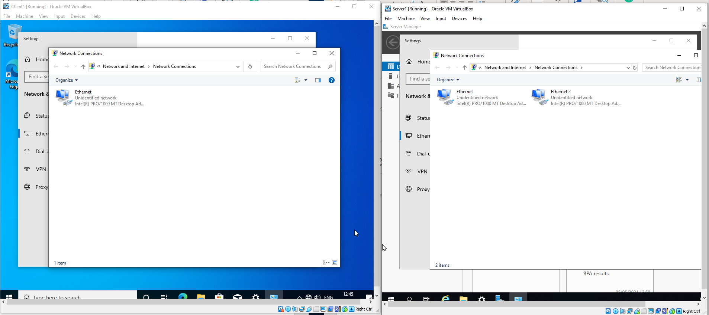
I change the names on all four machines to correspond so that client one and server one are connected in private net 1 and vice versa. 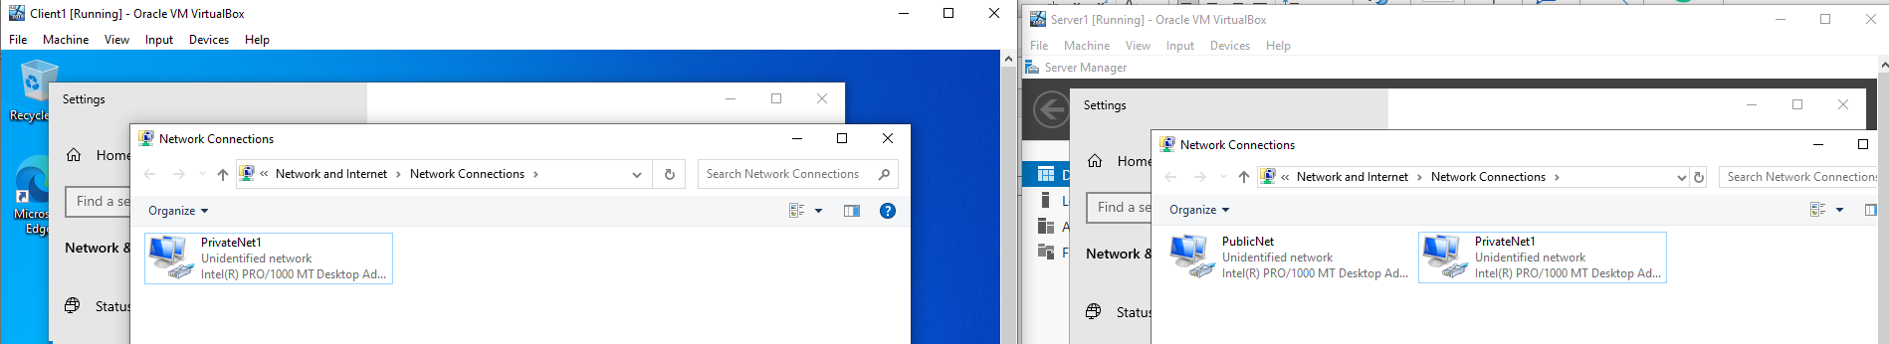
  - To give each switch the right IP address I double click on it and choose properties.
  - Double click Internet Protocol Version 4

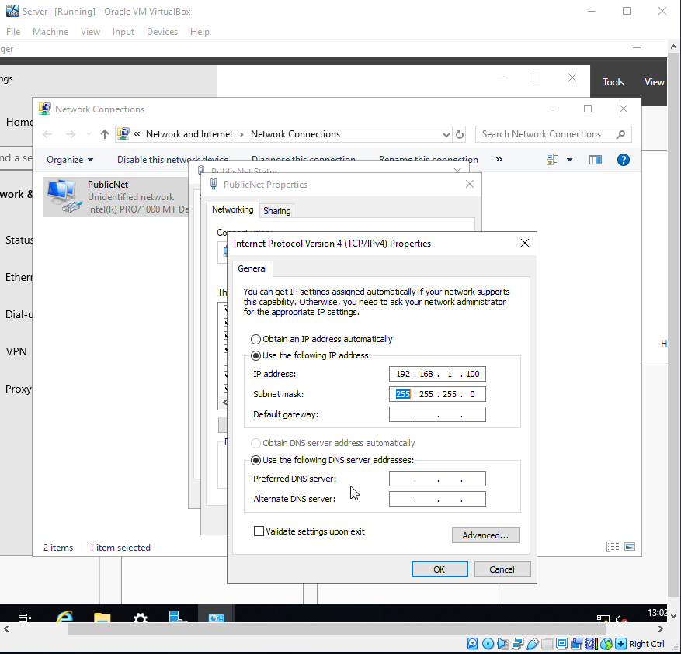
For the PublicNet connection on server one I use the above setting I do the same for server 2 PublicNet connection however the IP address that I use ends in 101.
Heading over to privateNet1 both in server1 and client1 I set the switches up as following.
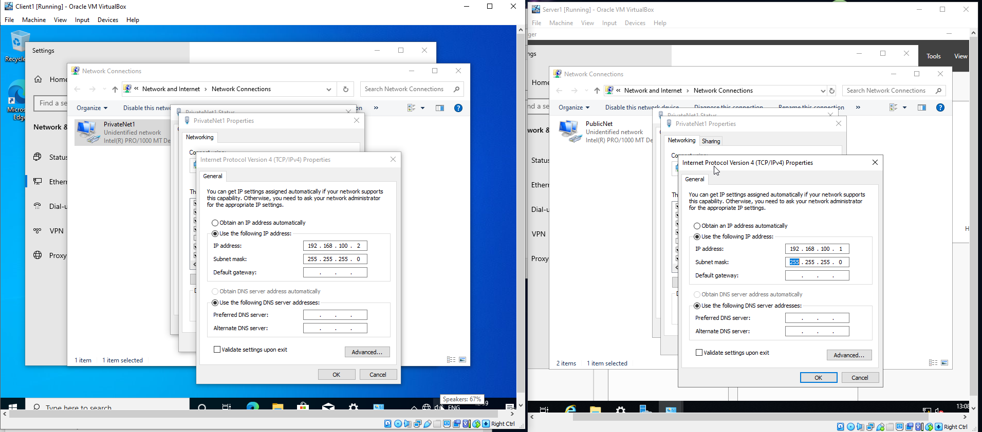
I do the same with clien1 and server2 with they are corresponding IP addresses.
Now I need to turn off the firewall in servers, so I go to the control panel – system security – windows firewall and turn off the firewall.
By going into CMD in server1 I can ping server 2. I type ping 192.168.1.101 and to ping from 2 to 1 I type ping 192.168.1.100.
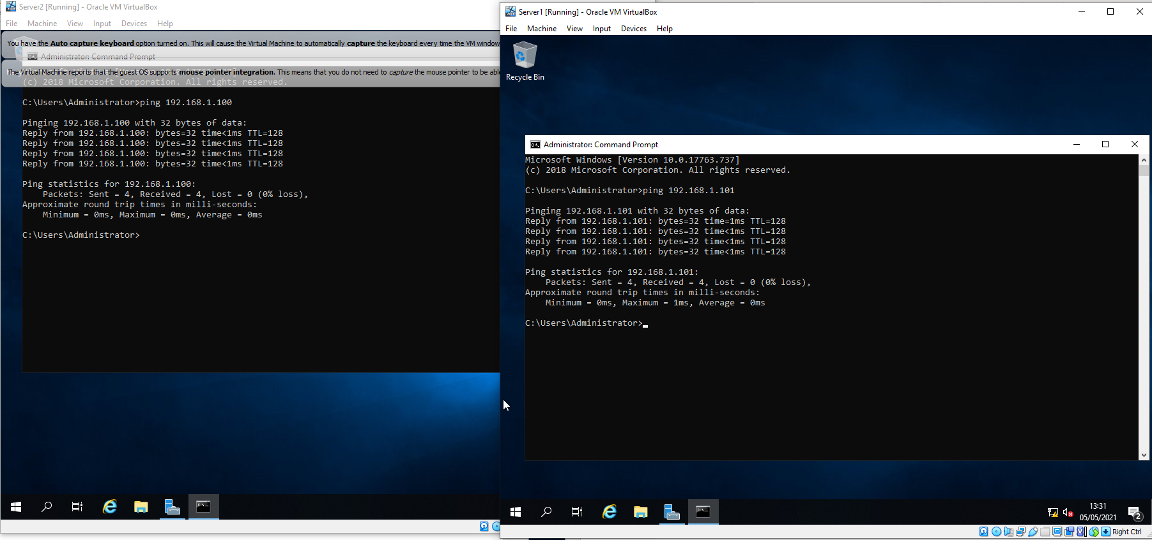
The same is done from client1 to server1 and vice versa.
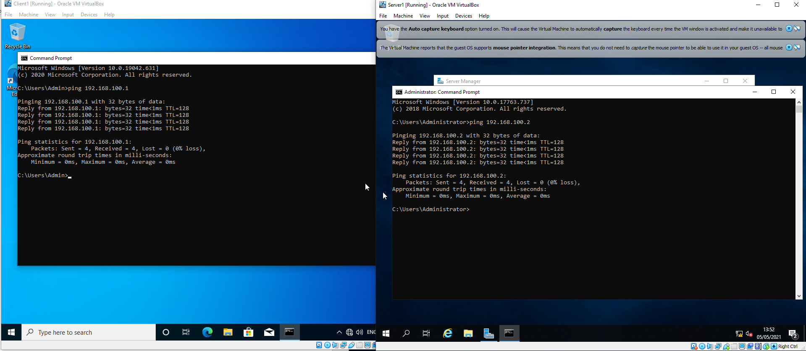
Once done testing ping I must remember to turn back the firewalls.
If I want to see each machine set up I can type ipconfig into cmd.
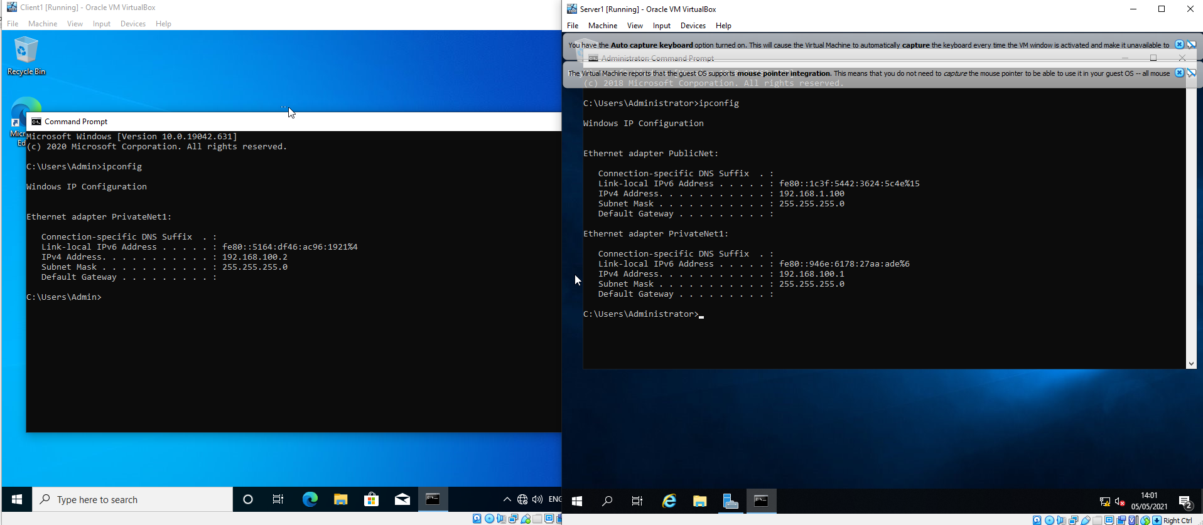

Investigating Utility and Application Program softwareQWer12

Performance Monitor
In server manager, I click on the tool and select performance monitor.
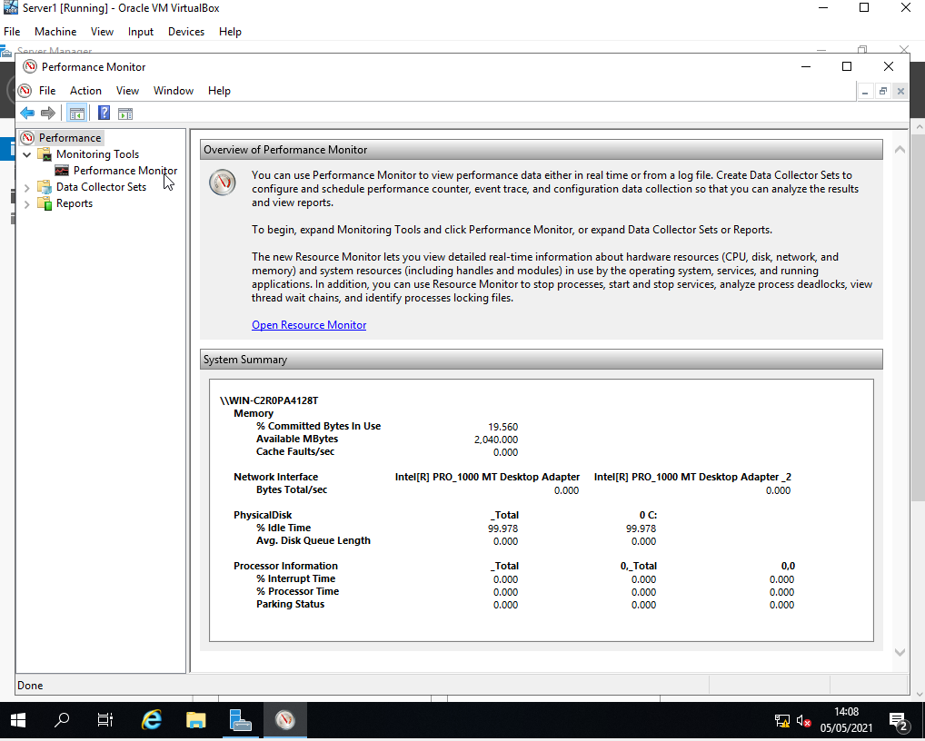
I'm going to now add counters to the performance monitor by clicking on the green plus sign.
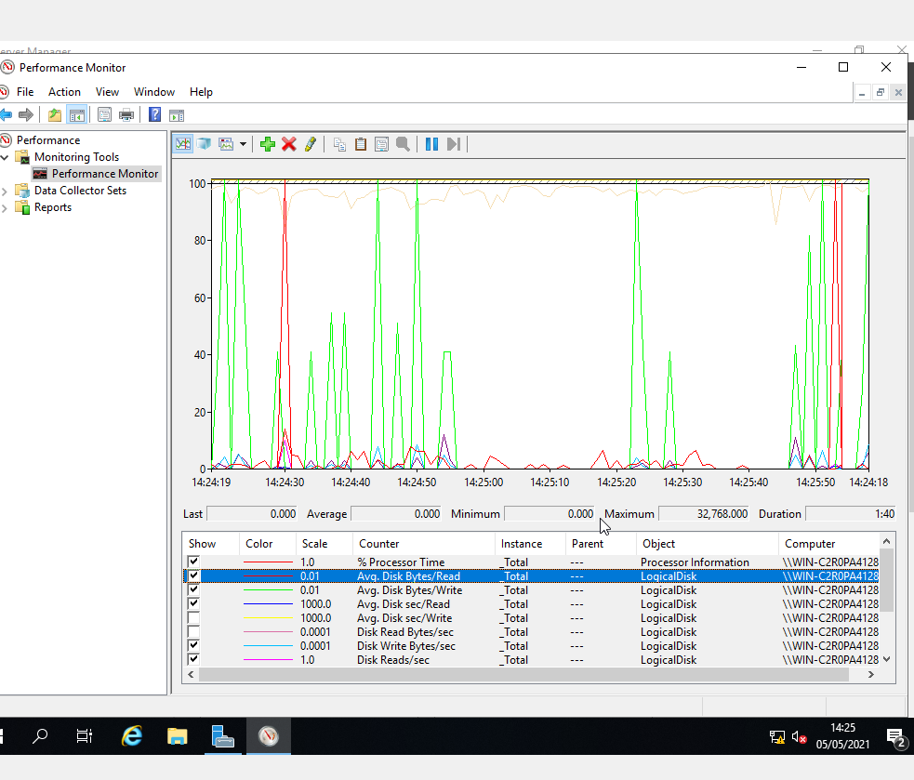
I can uncheck some items in the list if I have too much going on in my graph as I have added an extensive list of counters/metrics into my performance monitor.

Reliability Monitor

By right-clicking on Monitor tools I can select view system reliability.
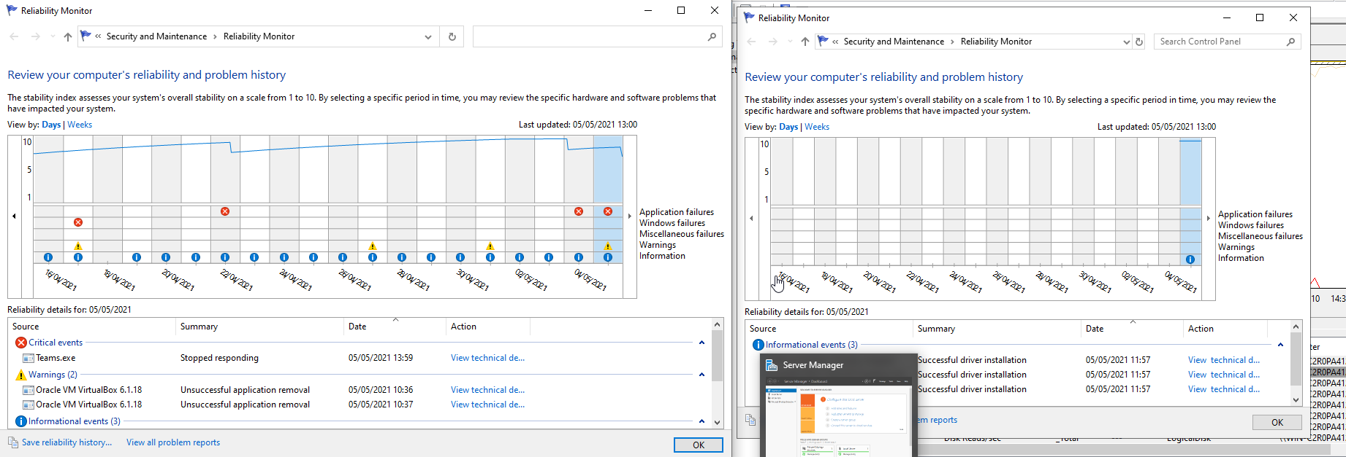
The image on the right is my virtual machine but I have added a snip of my computer to show some examples of events that have occurred.
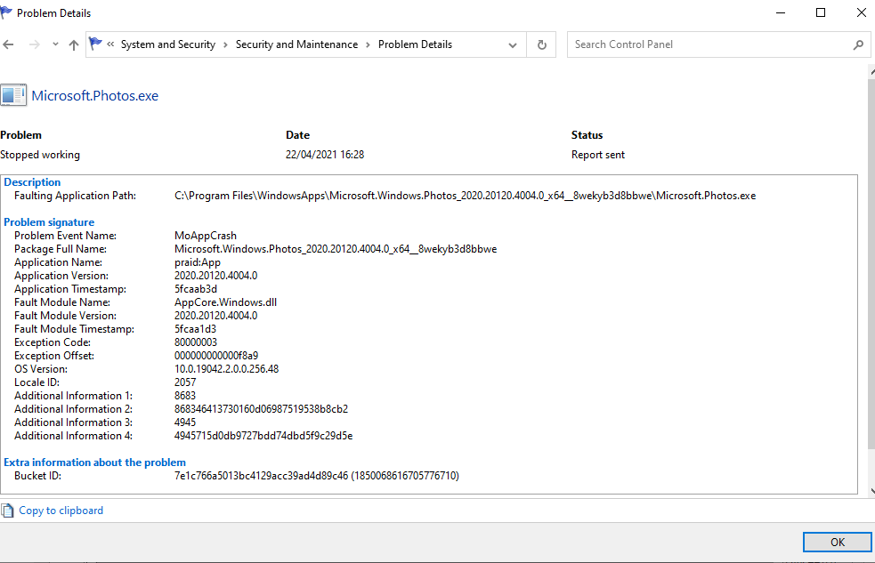
I double-clicked on an event to view its details and see what has occurred to be informed as to what I need to alter on my set up.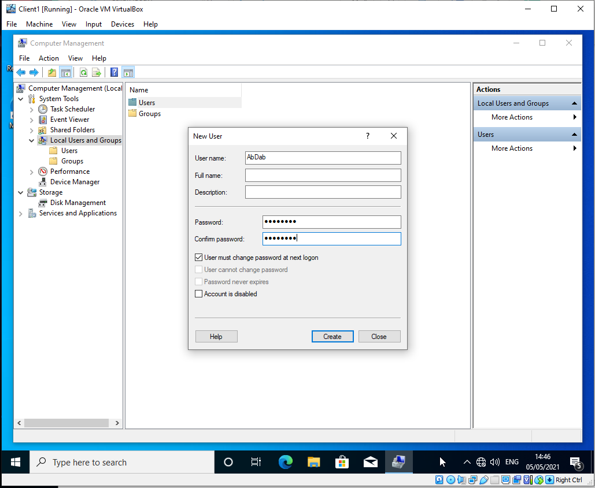
By logging into client one I can begin to create a new local user. I search computer management on windows. Go to local user and groups and right-click on users and selected new user.
Once I've added the new user I can add them to a group, I will make this user part of the admin group.
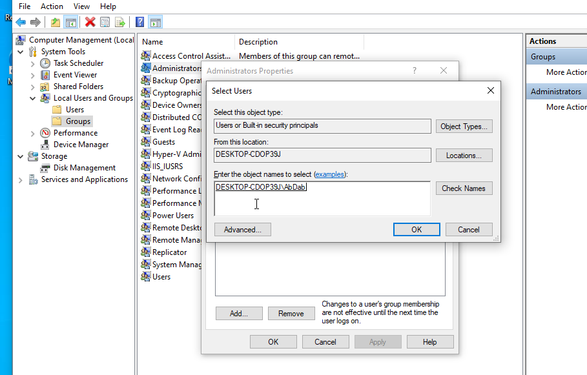

Within Computer management, I can also view many useful bits of information. If I look at my disk management in storage I can see how my disk is managed.
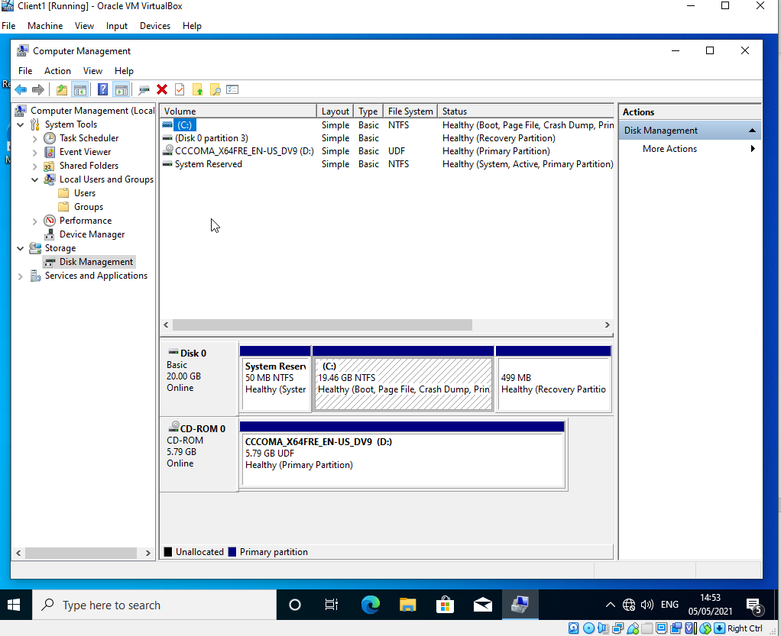

System Configuration Utility
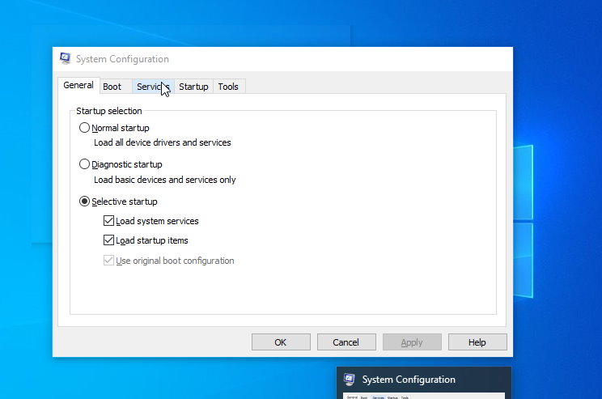I simply type in MSCONFIG into windows search and open the system configuration utility where I can configure multiple setting if things are being problematic. I look at boot I can add additional disks to the boot menu, I can force safe mode boots, nu GUI boots, boot logs etc…
The start-up tab takes you into task manager. I can manage what items open on start-up if I find I’m slow booting up.

Configuring virtual networking and Upgrading a member server to a Domain Controller

In server1&2 I open the roles directory within the server manager window, I then go to add roles in the summary of the role.
Click next on the Before you begin section until I get to server roles. Here I selected Active directory domain services.
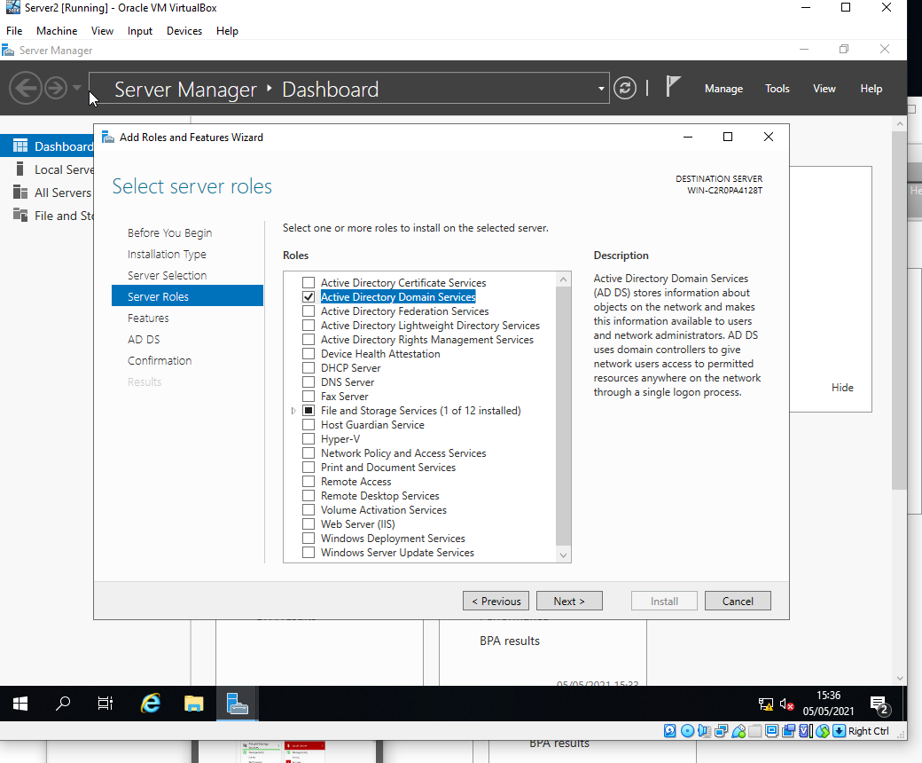

I the confirmation page section I clicked install. Once it's successfully added I click close.
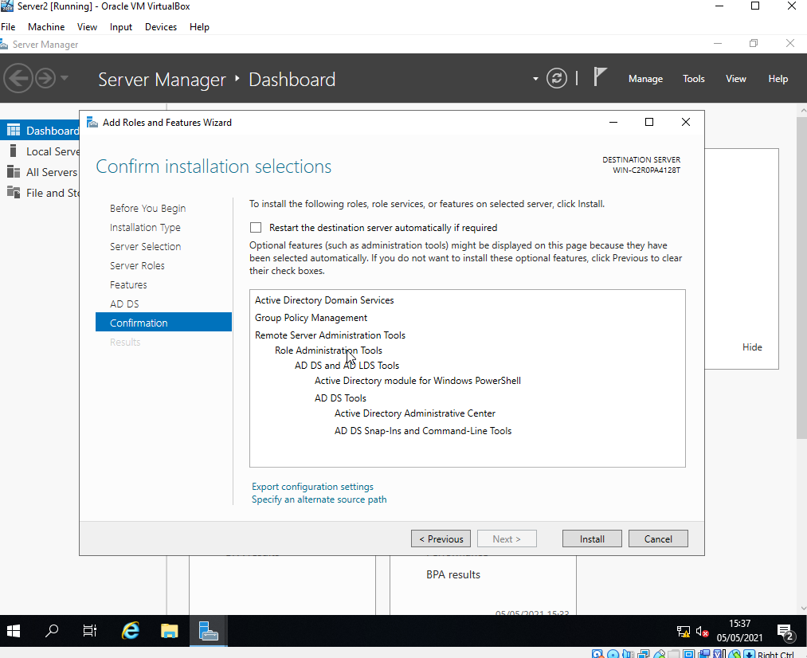
I did this for server2.

Creating an Active Directory Domain

I have a warning notification in my Server Manager Dashboard asking me to configure active domain services. When I clicked it and it took me to the Deployment configuration. Here I will add a new forest and use the root domain name uwtsd.com
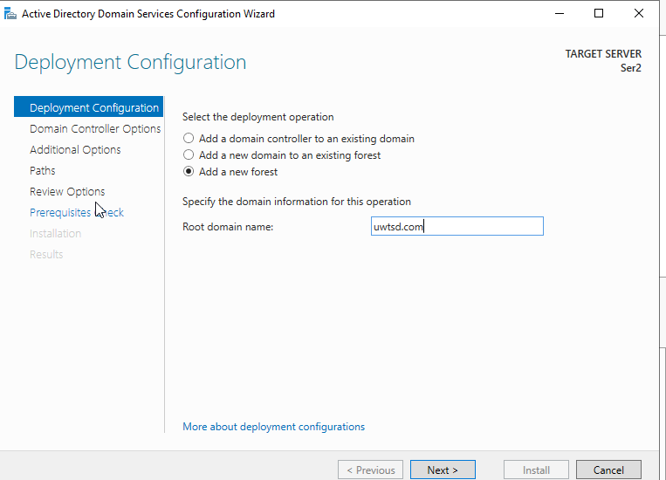

Now I faced with domain controller options window where I ensure the server selected for forest/domain function levels are after 2008, I left DNS and GC clicked. I use the normal P@ssw0rd.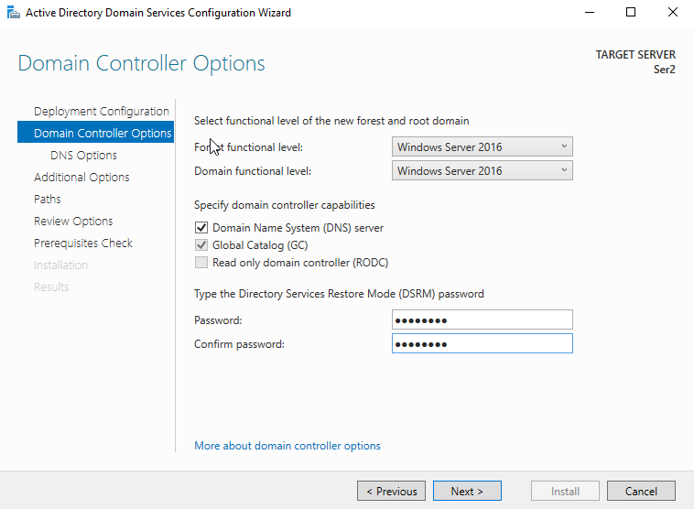
I can click through to review the items I have selected.
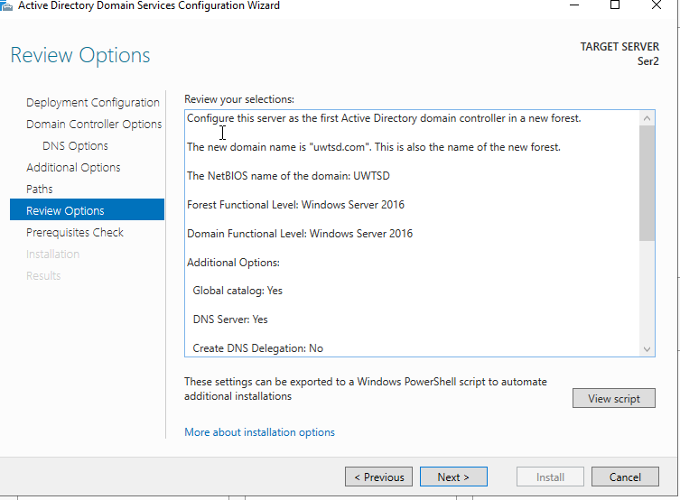

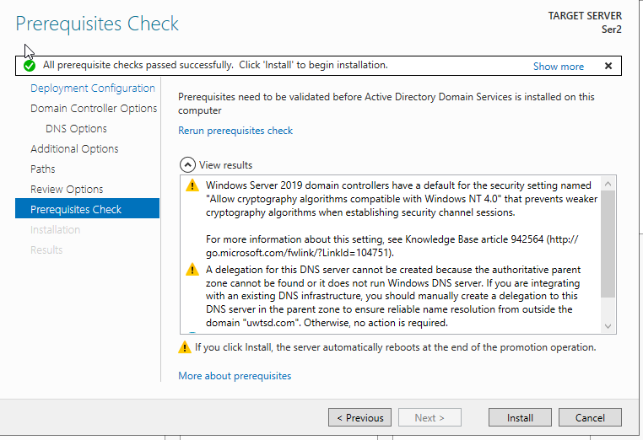Providing all the prerequisites have passed I can now click install. Now my server will perform an automatic restart.
Now I have a new user account I can log into which is UWTSD I use my normal credentials however I could log into it locally by typing user as “.\”.
Now in tools within my server manager, I can select active directory users and computers.
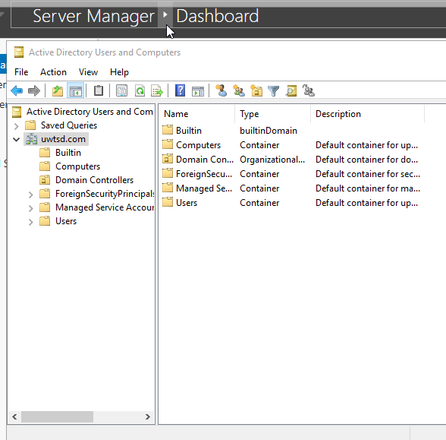

Installing Client Computers and Basic Object creation in the Active Directory

Going into tools on server2’s server management and looking at UWTSD I can see UWTSD as a root with 6 trees:
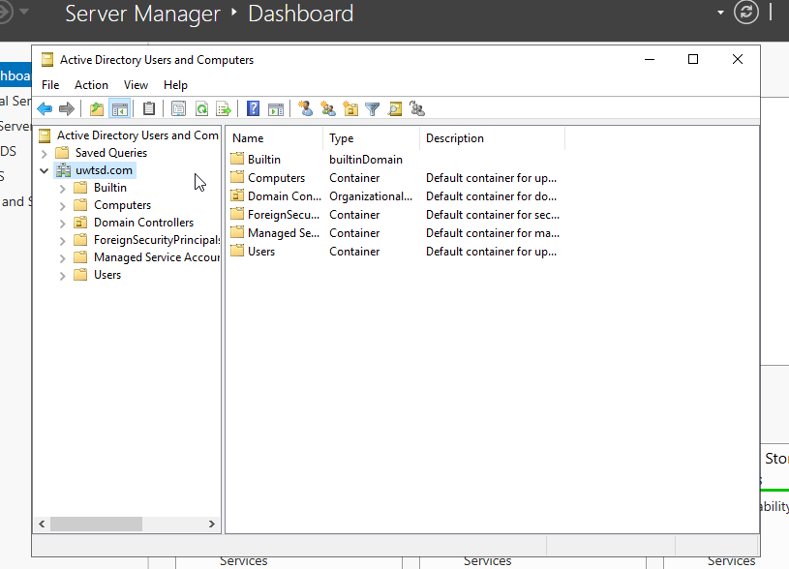
By right-clicking on UWTSD root I can create a new organizational unit named SwanzCopms, I must remember there are two different distinctions the one I just created is an organisational unit to which I can apply group policies to.

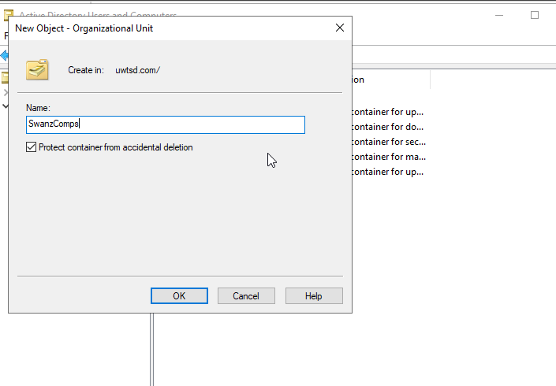

I can go into SwanzComps and create a new user by right-clicking inside the area where folders are supposed to be selecting new-user. I used a strong PW which the user must change.
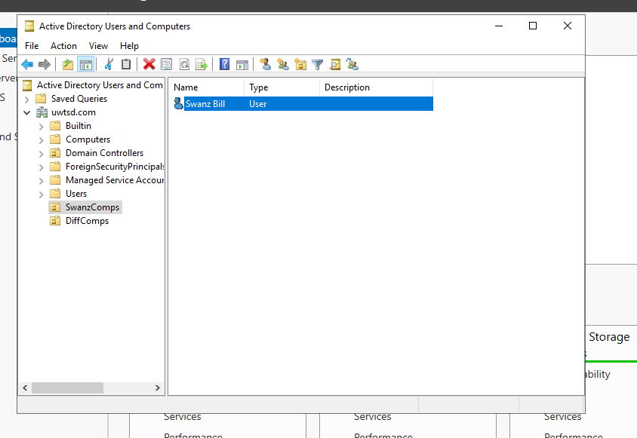
Within User, I then double click on Administrator- select the member of tab double-clicked on domain admins – went to member and added swans bill to have a backup user account within active directory.

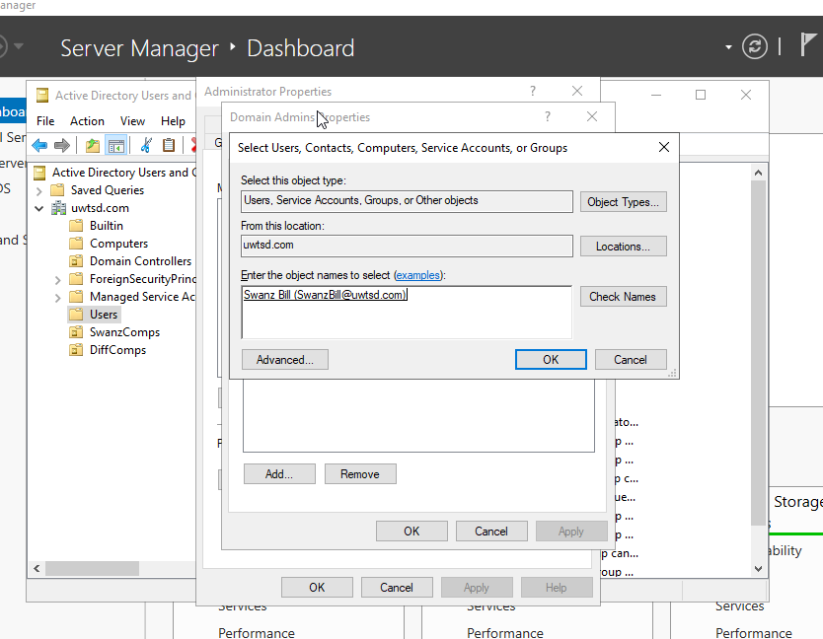

By selecting the computer and right-clicking in the box I can create a new computer.
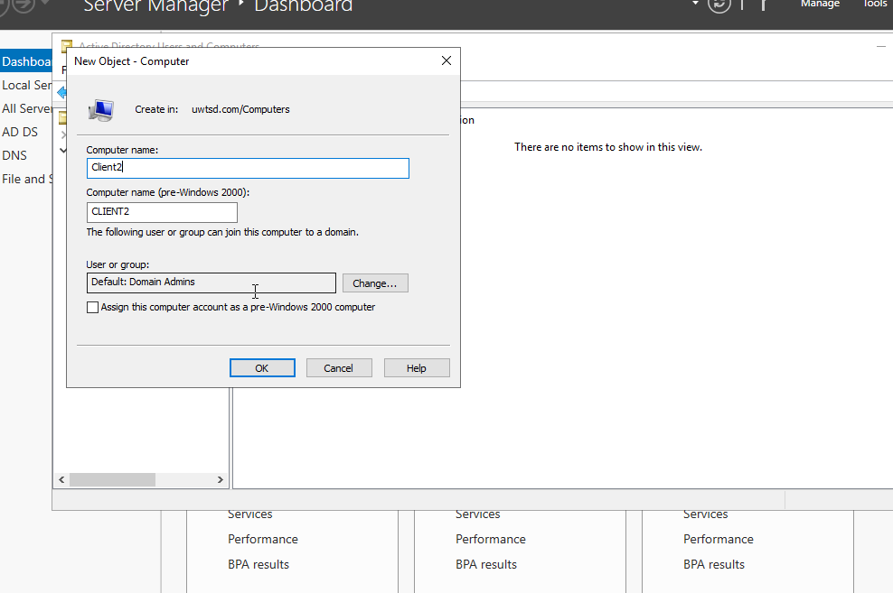

Installing/Connecting client to the domain

I then set up client 2 to make requests to the correct DNS server.
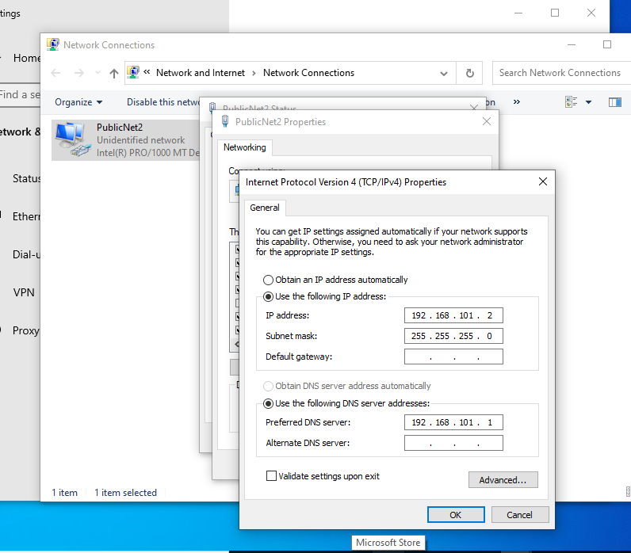

By searching windows for advanced system settings within client2, I can select the computer name tab and ensure the machine name is set correctly.
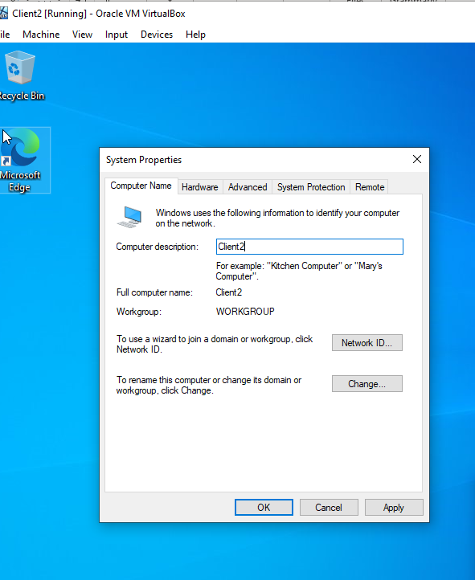

I hit change and also add the correct domain name.
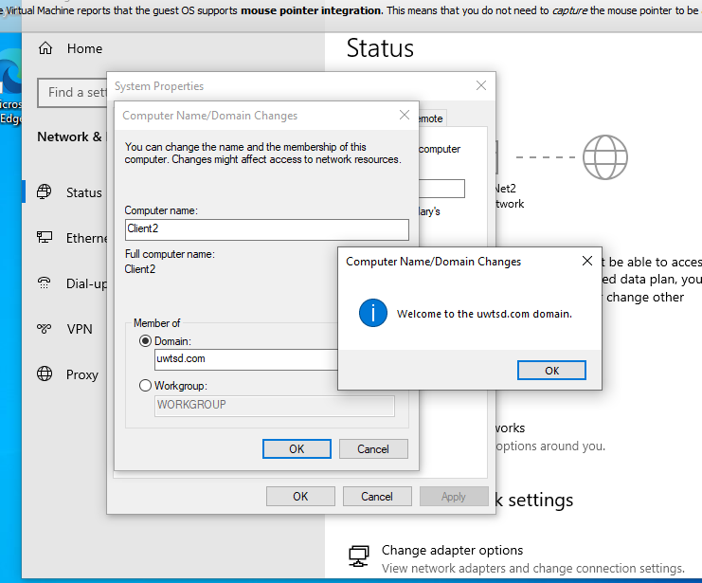
I then confirm the computer has been added to the computers tree in my active directory.
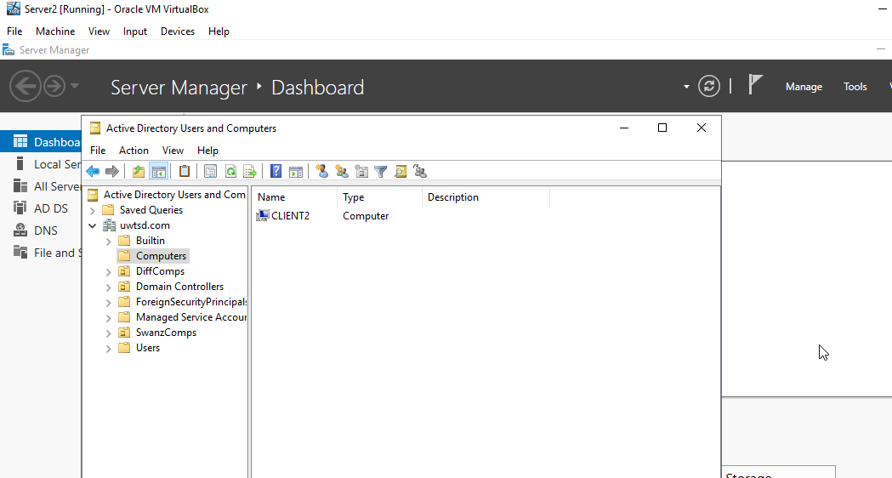

Installing and configuring the DHCP Service

DHCP Part A: INSTALL / AUTHORISE THE DHCP SERVICE.

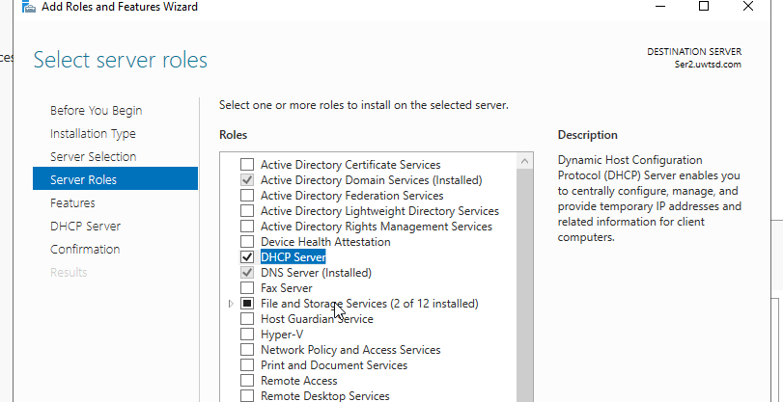
I installed DHCP server
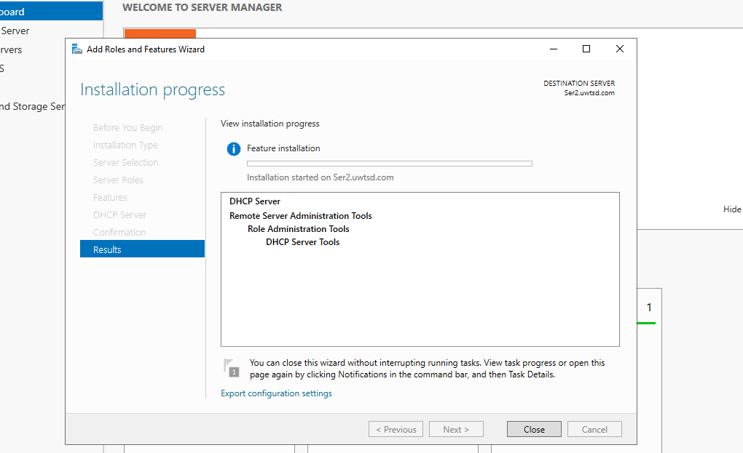

Then I completed the configuration
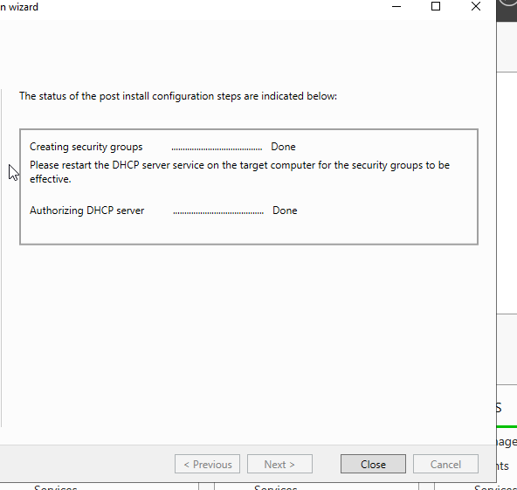

DHCP Part B: CREATING A DHCP SCOPE FOR LEASING IP ADDRESSES TO DHCP CLIENTS ON THE PRIVATE NETWORK

I then went to DHCP in tools and created a new scope for Ipv4
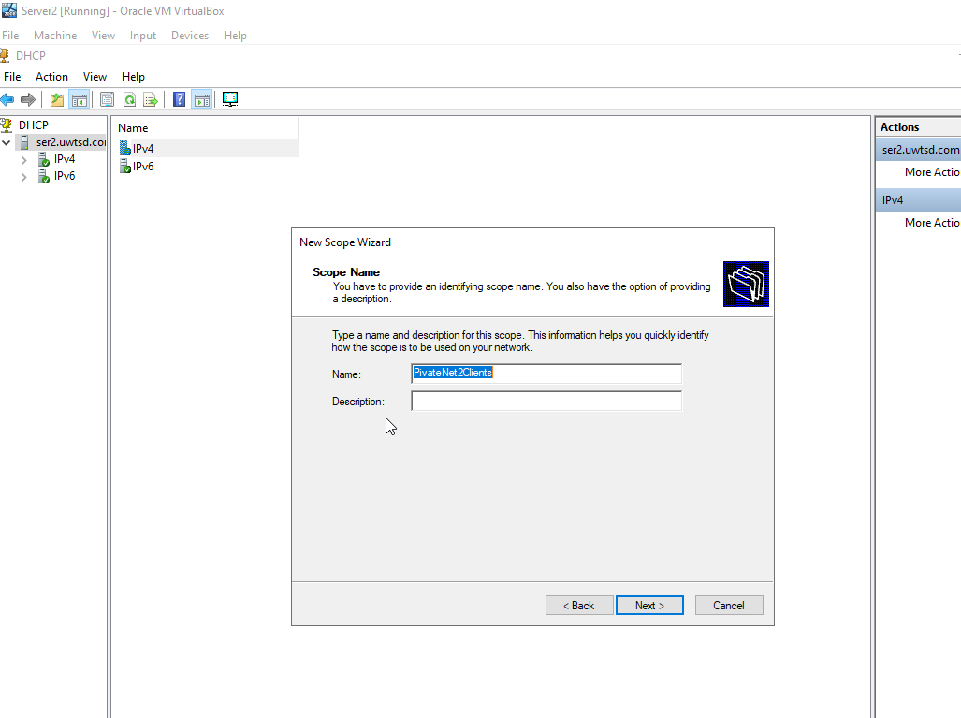
As I only have one client I only assign one address however I could raise this if I had more machines.
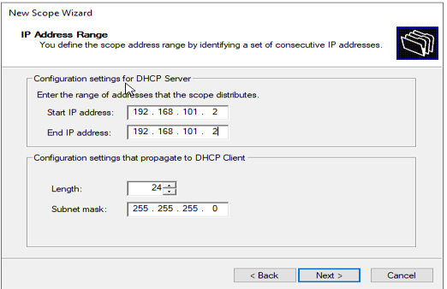
I assign the lease to 6 days to ensure each address becomes available each week.

DHCP Part C: TESTING DHCP LEASES

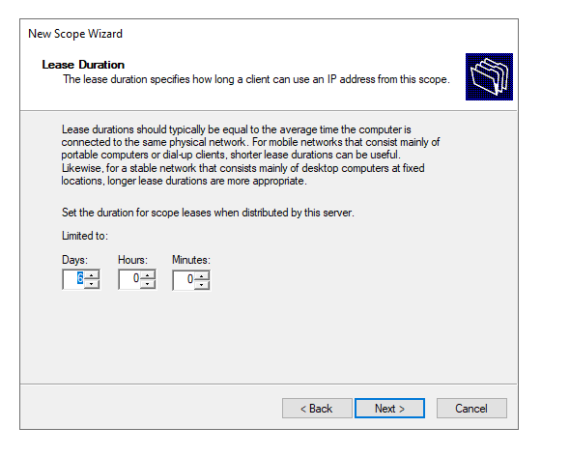
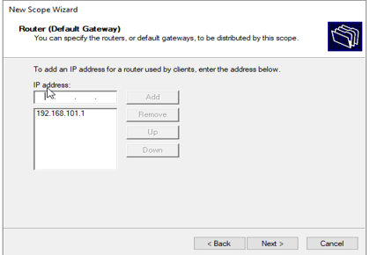
I added a default gateway, and now I see I have scope for PrivateNet2Clients
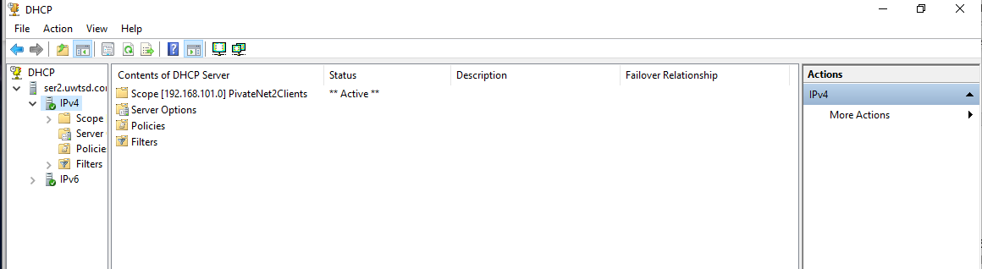

Then in the client machine, I tested the connection.

DHCP Part D: CONFIGURING DHCP OPTIONS

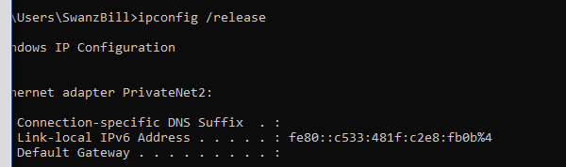

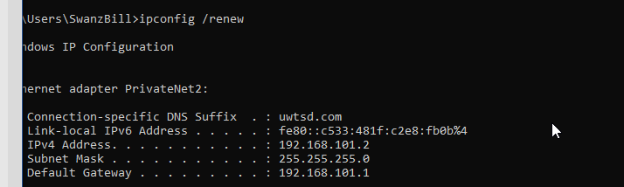
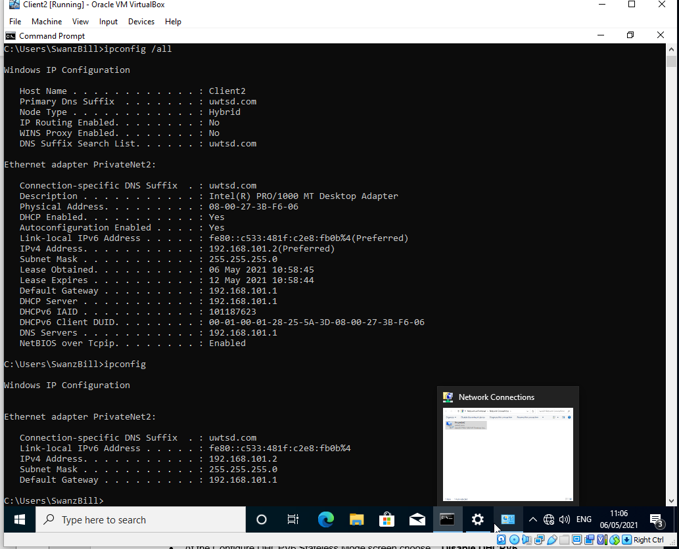

DHCP Part D: CONFIGURING DHCP OPTIONS

In the server, I can see the client computer in DHCP
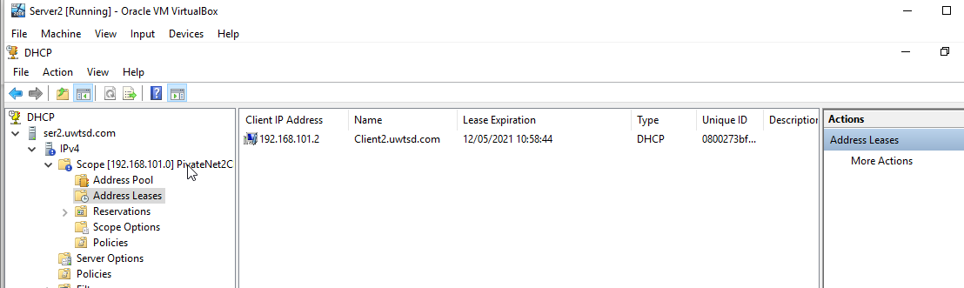
I configured DHCP scope options
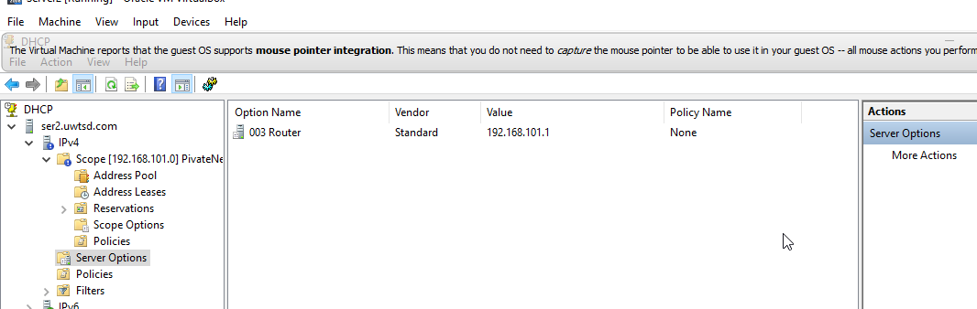
And tested it in the client machine
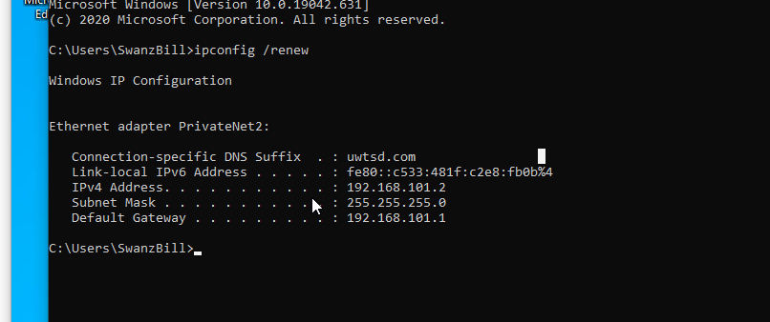
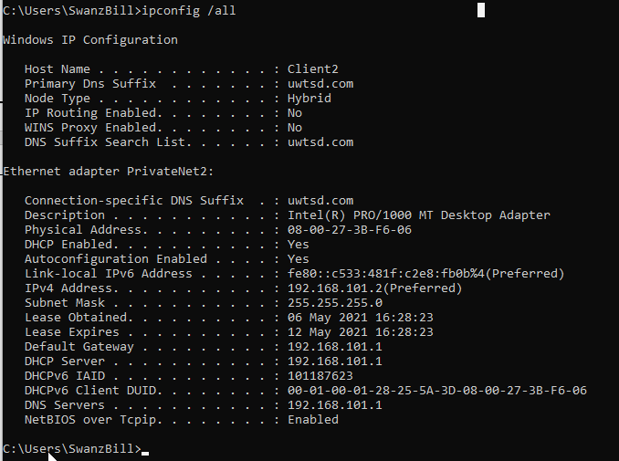

Conclusion

Keeping in mind the drawbacks and benefits of Hypervisors depends upon the type of VMM and vendor an organisation opts for.
If anything, high-level due diligence is required when selecting the Hypervisor as the user interface, support, overhead and management system all depend heavily on what type of Hypervisor is employed. [3]

References

[1] | GeeksforGeeks, “Difference between Private and Public IP addresses,” GeeksforGeeks, 30 7 2019. [Online]. Available: https://www.geeksforgeeks.org/difference-between-private-and-public-ip-addresses/. [Accessed 2 5 2021].
[2] | cisco, “IP Addresses and Services Configuration Guide for Cisco NCS 5000 Series Routers, IOS XR Release 6.4.x,” cisco, [Online]. Available: https://www.cisco.com/c/en/us/td/docs/iosxr/ncs5000/ip-addresses/64x/b-ip-addresses-configuration-guide-ncs5000-64x/m-implementing-dhcp-ncs5000.html. [Accessed 02 05 2021].
[3] | K. Taylor, “What are the Advantages and Disadvantages of Hypervisors?,” hitechnectar, [Online]. Available: https://www.hitechnectar.com/blogs/hypervisors-advantages-disadvantages/. [Accessed 04 05 2021].
[4] | Guru00, “40 Best FREE Network Monitoring Tools & Software (2021),” Guru00, 2021. [Online]. Available: https://www.guru99.com/network-monitoring-tools.html. [Accessed 04 05 2021].
[5] | opsview, “The Importance of Monitoring Your Networks,” opsview, [Online]. Available: https://www.opsview.com/resources/network/blog/importance-monitoring-your-networks#:~:text=Finally%2C%20network%20monitoring%20systems%20can,comes%20to%20addressing%20the%20problem.&text=To%20optimize%20network%20performance%20and%20availability. [Accessed 03 05 2021].
[6] | J. Peters, “Active Directory Domain Services (AD DS): Overview and Functions,” VARONIS, 03 29 2020. [Online]. Available: https://www.varonis.com/blog/active-directory-domain-services/. [Accessed 03 05 2021].
[7] | By ComputerNetworkingNotes , “How DHCP works Explained with Examples,” By ComputerNetworkingNotes , 16 10 2020. [Online]. Available: https://www.computernetworkingnotes.com/ccna-study-guide/how-dhcp-works-explained-with-examples.html#:~:text=When%20it%20receives%20a%20DHCP,Offer%2C%20Request%2C%20and%20Acknowledgment.. [Accessed 03 05 2021].
[8] | R. V. d. Paar, “What disk image should I use with VirtualBox, VDI, VMDK, VHD or HDD? (11 Solutions!!),” Roel Van de Paar, 07 08 2020. [Online]. Available: https://www.youtube.com/watch?v=uH7Ac8PInhI. [Accessed 09 03 2021].
[9] | multiple, “Dolly (sheep),” Wikipedia, - - -. [Online]. Available: https://en.wikipedia.org/wiki/Dolly_(sheep). [Accessed 08 03 2021].
[10] | virtualbox, “Chapter 6. Virtual Networking,” [Online]. Available: https://www.virtualbox.org/manual/ch06.html. [Accessed 10 03 2021].
[11] | N. Thoms, “Windows Server 2019: Desktop or Core?,” fasthosts, 14 12 2020. [Online]. Available: https://www.fasthosts.co.uk/blog/windows-server-2019-desktop-or-core/. [Accessed 08 03 2021].

