CILT LOGISTICS AND TRANSPORT LEVEL 5 PD05 A3 ASSIGNMENT
Report seeking authority to undertake planning and completing road move from Taunton to Albania during EXERCISE COUGAR 2014

LECTURER: GRAHAM ORR
STUDENT: MICHAEL WILLIAMS
STUDENT I.D: 1708504

Page 1 of 6

CONTENTS

Page 1 Cover page
Page 2 Contents page
Page 3 2.5.1 Implement a project risk analysis
Page 4 3.2.1 Define authorisation and acceptance procedures and their associated inputs and outputs for a given project
Page 4 3.3.1 Define the processes that need to be controlled and monitored during the life of a given project
Page 4 3.4.1 Identify the risk triggers, progress, tolerances and need for re-evaluation of a given project
Page 5 3.6.1 Analyse the risks associated with a given project and implement risk minimisation techniques
Page 5 4.2.1 Implement effective quality management for a given project
Page 6 Reference page

Page 2 of 6
    - Implement a project risk analysis
Risk analysis is the process in which the projects definition and analysis of dangers to individuals and business are posed by potential natural or human caused adverse events are acessed. A risk is a set of events that should they occur will effect the project achieving its required objective. In order to implement a risk analysis we need to use risk management. Risk management is a number of stages (steps) which will allow the risks to be identified, accessed and controlled. The project environment needs to be understood and stakeholders, users, suppliers and teams need to contribute to identifying risks. A approach for the project must be established. Reports must be made at suitable intervals in regards to risk and a definition of risk as in roles and responsibilities.
Threats and opportunities of risk identified within the project must be recorded within a Risk Register. This is used as a report which will also include information in the risk status and history. Other information recorded within the risk register will be unique serial number for each risk, the person raising the risk (Risk Author), date, risk category, description, probability impact (very low, low, normal, e.t.c), risk response category, risk response, status, risk owner (person managing the risk).

The Risk Register

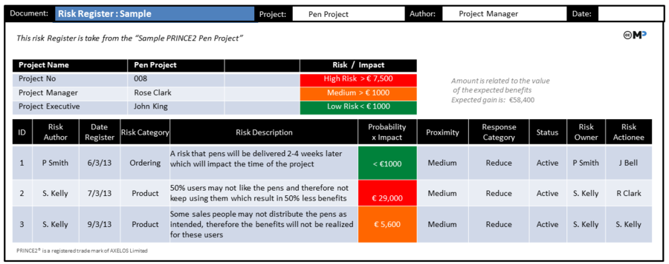

To respond to any threats six main responses are advised Avoid, Reduce, Fallback,Transfer, Share and accept. A Risk Budget is a sum of money reserved and put to one side so to deal with specific responses to threats or any opportunities, used for this and only this! Each response to risk may be different and will require individual actions which will need the money from the risk budget.

Page 3 of 6
Risk management consists of five stages identity, assess risk, plan, implement and communicate. The identify part involves tolerance of the project, type of project, cost of failure, risk management strategy document and checklists. During stage two assess risk covers estimation and risk evaluation. Estimating refers to the probability of the risk and the impacts. Evaluating consists of risks grouped together including threats and opportunities. Plan involving all relevant planning pre-empting. Implement any strategies to allow for a more successful project. Finally communicate successes and failiures verbally and in report format.
3.2.1 Define authorisation and acceptance procedures and their associated inputs and outputs for a given project
The acceptance criteria requirements for this project will include performance standards and essential conditions necessary for the projects success. These must be met in order to deliver the project to a suitable finished standard which then in turn can be accepted by the customer. A guide can be used to confirm the circumstances that the user will accept the finished output. Testing of the project is required in the form of back up and restore the service or product. UAT (User acceptance testing) is a good assessment before handing over the project. BCP (Business continuity plan) needs to be accessed when necessary.
A INPUT refers to an item or a product connected to a device which can progress a process within a project. A good example could be the work package. A OUTPUT is what is produced and can be the end process such as approved products, checkpoint reports or a quality register.
3.3.1 Define the processes that need to be controlled and monitored during the life of a given project
This projects progress required constant evaluation in order to identify variances within plan and to also monitor the time frame to show any delay or advance of time to realise the end product finish date. Any missed task finish date over run may require changes to work force size, extra working hours, budget adjustment or schedule changes.
Scope change management is used to document and control any changes to the project scope. Quality control will measure all deliverables to assess if quality requirements are met. Time and schedule control will allow time to repond to schedule changes within each stage of the project. Cost control will manage any required responses to cost changes or developments. Risk control will respond to any variances to risk throughout the project.
3.4.1 Identify the risk triggers, progress, tolerances and need for re-evaluation of a given project
When an event action is undertaken to do with mitigation strategy or use of a contingency plan this is known as a risk trigger. A risk threshold is the boundary deviation allowed from projected estimated predicted outputs to excessive levels which are defined as triggers. A project tolerance is the approved reasonable deviation accepted parameter. This tolerance will mostly be assigned to costs or time considerations quite often five percent plus or minus the allocated budget. Other project tolerances deviations may include quality control, scope and risks. Tolerances are useful in providing an accepted change in cost or time previously agreed and accepted by the ministry of defence. This deviation is also known as slack which is crucial in allowing a project to flow even when problems arise and allows the project manager more control and responsibility.

Page 4 of 6
3.6.1 Analyse the risks associated with a given project and implement risk minimisation techniques
Project risks can be very destructive to the ministry of defence or any sponsor no matter the size of the risk. Even a low level risk can produce huge financial loss and project failure especially if not managed correctly. It is very important to minimize project risks and the whole project team must be proactive and conscious of the rewards received when successful projects are completed. The project must be continually analysed in good time to allow time to act on risks.
First any risks have to be identified, risks will differ depending on the route taken to complete each task. Different task processes will be either higher or lower risk. By identifying the risk awareness is made of other possible choices to complete each issue. It will provide written proof for decision making instead of just going with the first option and will show intent and purpose.
Its important to have an insurance plan so that project risks are minimized and a action plan if risks occur within the project. Forward planning for potential hazards is crucial, prepare for the worst and hope for the best.
It is necessary to prioritize an implementation strategy to be able to regain progression within the PM team. Major changes can happen at short notice and a PM must be versatile and adapt to this quickly and wisely dependent on risk. A lower risk solution may be a must better overall choice to implement into the project to move it forward. An alternate path may be a blessing in disguise however it wil take a experienced PM to change due to resources invested in original path.
The impact of most likely risks must be quantified by working out thetime, expense and opportunity of the issue. Each issue my need a new insurance plan or different plan of action this will have to be accessed. Most project risks can be reduced by using the right strategy and an experienced confident PM team.
4.2.1 Implement effective quality management for a given project
Quality management is to ensure the desired quality is reached for the client in order to deliver a successful end product. The quality must be maintained throughout the project duration decided by stakeholders, owners and the clients of this project. Three main parts of quality management include quality planning, quality assurance and quality control.
Quality planning is the creation of the quality plan which will include an objective. This objective including a level of standard must be presented to all stakeholders. The level set must meet the standards and expectations of all key players. When all this has been accessed team members will initiate the quality plan.
Quality assurance will be in action throughout all stages within the project until the very end. It is a constant evaluation to ensure quality standards are met. When quality goals are not met, corrective action must take place and the stage must be suspended before moving on. Once corrective actions have been observed and checked the project can more on.
Quality control takes place to ensure correct techniques are used to meet quality standards. When problems occur, quality control comes into action to correct and maintain quality throughout and this will stop any potentially rectification work before handover of project to the client. A quality register can be updated when product or service has passed or failed quality tests. The PM will need to check this register to be able to monitor the overall project progress

Page 5 of 6

Reference Page

Brilliant project management by Rob Cole
Prince 2 Principles
Project management by Harold Kerzner
https://www.pmi.org/pmbok-guide-standards/about
The project managers desk reference 3rd edition by Lewis James
Managing successful projects with Prince 2
Project change management H. James Harrington
The definitive guide, to project management – The fast track to getting the job done on time and within budget

Page 6 of 6

