Conrod dynamic Forces Report
Mbemba Jammeh

Abstract

This report will show the conrod dynamic forces by using two engines to analysis and research the maximum tensile and the compressive forces that the rod under goes when it’s at max and minimum and this will be done by using the excel spreadsheet and the engine that Is used in this report is (BMW M20 90kw 121 bhp) This was an early age engine 1977-1982 and the second engine used was the newer engines (1.5-litre turbocharged petrol engine 140 bhp) manufactured in 2013 . Its also one of BMW smallest engine builds because it a 3-cylinder engine their reason behind this design for this engine is mostly emissions seeing as the law is getting strict with emission’s BMW had to design something more environmentally friendly. There reason why these two engines were used was because they wanted to see the difference from an old model vehicle to a more modern engine in the production line and so how far the BMW engineers have come over 35 years and see if the maximum tensile load was better back in 1977 or 2013. And this will be shown with graphs has a source to show prove for this report.

Table of Contents
Abstract 1
Abstract: 3
Figures: 3
Introduction: 3
Research: 3
Methodology 3
1.1: 3
1.2: 3
Analysis: 3
Conclusion: 3
Recommendations: 3
References: 3
Appendices: 3
4
List of Figures 4
INTRODUCTION 5
Research/Literature review 6
Methodology 7
Analysis 8
Conclusion 9
Recommendations for Further Study 10
References 11

Abstract:

Figures:

Introduction:

Research:

Methodology

1.1:

1.2:

Analysis:

Conclusion:

Recommendations:

References:

List of Figures
Graph showing height of piston head labelled as figure one on page 8.
Graph showing velocity head labelled as figure two on page 8.
Graph showing acceleration and Force head labelled as figure three on page 8.

INTRODUCTION

Conrod is one of the main parts of the engine it connects to the piston to the crankshaft and when they both are connected it makes a repeated motion. It’s mostly made out of aluminium cast there reason why is because this saves 2grams of weight which is key if you want to make your engine run faster. Going back 100 years ago people wanted their vehicles to be able to take them A to B and wasn’t really interested on how powerful the vehicle was because you would have been privileged to be driving a vehicle but bring it 50 years engineers had to change how the conrod was being made because people wanted faster vehicles and to feel the immense power and control and the way the engineer made this happen was by making the conrod out of aluminium and also to make it lighter so that the work of the conrod would be faster causing the engine to produce a faster bhp. And the conrod is the centre of this report and analysis.

Research/Literature review

A conrod is short for connecting rod and it connects to the crankshaft and is one of the main components for the engine Both ends of the connecting rod are free to pivot there smaller end is connected to the piston the bigger end has bearing inserts which lowers friction but also holds oil to exact oil clearance another thing the connecting rod does is constantly stretching and bending which means the conrod undergoes through a lot of load that’s why it needs to be strong and mainly made out of cast aluminium alloy to keep the cost down as possible.

Methodology
1.1: The software mainly used in this to undertake the analysis was Microsoft office excel there reason why it was used was because it allows you to see graphs at the height, velocity also can check the maximum and minimum tensile and this was done by using these values.
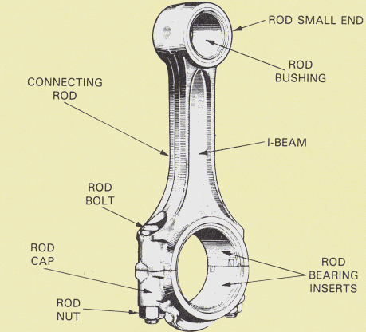
-Crank Radius.
-Conrod Length.
-RPM
-Mass of piston etc.
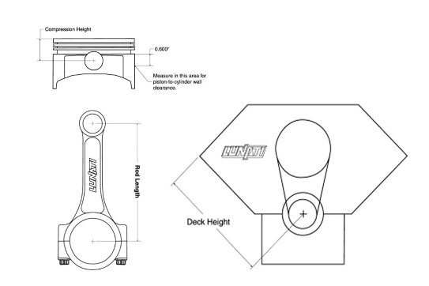
1.2: Too work out the crank radius the crankshaft was position to top dead centre then use a height gauge to measure the big end journal then measure the distance then divide it by two and their result should be your crank radius.
Conrod length was measured with a Vernier calliper
Rpm was found by reading up the engine specs and see what potential bhp it could it was found that it runs 163 bhp on stock and could be tuned up to 500bhp
Mass was found by the weight of the piston and the gaugeon pin and the total of them will produce the mass
Once all these values are found from both engines they will be entered into the Microsoft excel and show up on the graphs and then you see what the maximum tensile and also the load on the conrod that could cause to conrod to break at certain rpm.

Analysis

Looking at the graph figure one is representing height and this is showing the top of the connecting rod and the centre point of crank and the height starts at 180mm at zero seconds and ends at 0.0294 with a height of 170mm.
The next graph figure two shows velocity and that’s the degree of the crankshaft when the crank at top dead centre the degrees at 0 once it starts moving to bottom dead centre the degrees change to minus 20 when the crankshaft goes up backup to top dead centre position it hits a degree of 22 and that’s a big change from -20 to 22.

Finally figure 3 shows acceleration and force.


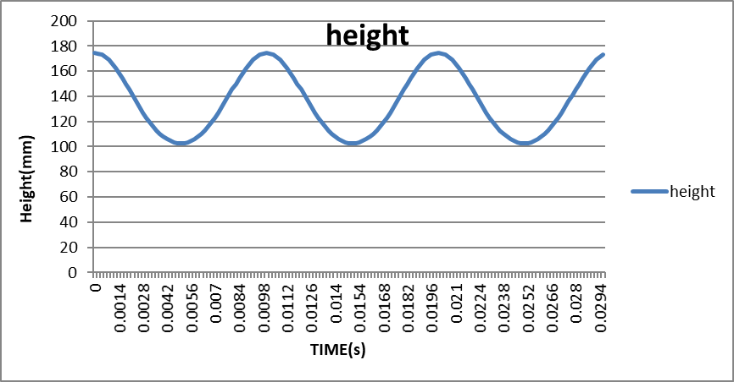

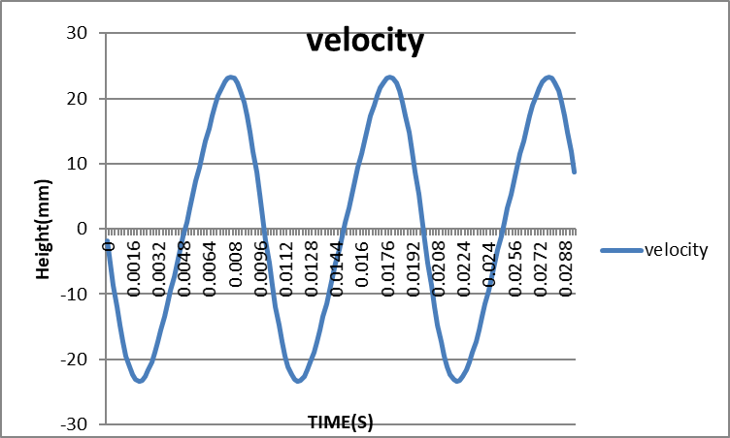

Figure 2
Showing velocity
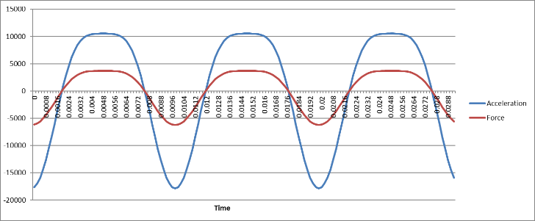

Figure 3
Showing acceleration and Force

Conclusion

In this report findings were found that the B38 engine 1.5 three-cylinder petrol is overall better then the M20 engine six-cylinder petrol and this all backed up by the excel graph showing the tensile load for the B38 engine it could hold a max load of 13717.77904 for the M20 engine it holds a load of 6254.241888 This shows over the 35 years engineers have developed over the years on making a crankshaft and conrod.

Recommendations for Further Study
For example, if there was more time available to do more research I would have improved on the methodology where speaking about the values and also talking about the engine and also the reading of the graph could be more spread out and so can be easier to read.

References

This first reference is from a website-Metric mechanic m20 engine series published on January 2006 -http://metricmechanic.com/wp-content/uploads/2016/07/m20-engine-booklet.pdf.

The second reference is from a website -Analysis reciprocating engine connecting rods-https://www.engineersedge.com/material_science/connecting-rod-analysis.htm

The third reference is from website with loads of technical data for engines BMW M20B25 Engine-http://mywikimotors.com/m20b25/

This reference was written by Vinayak V. Nair, M. Eng. Automotive Engineering, University of Windsor (2018) This shows a insight to what a gaugeon Quora looks like what it does purpose of the gaugeon pin-https://www.quora.com/What-is-the-purpose-of-the-gudgeon-pin-in-an-internal-combustion-engine4.

This reference was written by Ben Watson (1953) Pro engine Blueprinting. https://books.google.co.uk/books?id=AfTLFdCZ93IC&pg=PA31&lpg=PA31&dq=how+to+do+a+introduction+about+conrods+engines&source=bl&ots=LFOtZy_6iF&sig=ACfU3U2uqITvlSybm82S45GX23P2-T0HIA&hl=en&sa=X&ved=2ahUKEwiq5rCM0-XlAhWjolwKHeSwAZ0Q6AEwEXoECAgQAQ#v=onepage&q&f=false

Book used: Mike Mavrigian (2003): Modern Engine Blueprinting Techniques: A Practical Guide to Precision Engine Blueprinting (Pro Series)
Paul Rosch (1996) The UNIX Nerd’s Domaine, online http://www.unixnerd.demon.co.uk/b38.html
Rohan Dekate (2017), [Online]. Available https://www.quora.com/How-do-I-calculate-the-crank-radius-and-length-of-a-connecting-rod-in-an-engine.
Marco polo (2015) [Online]. Available https://www.babybmw.net/forum/viewtopic.php?t=76630&start=15

Chris-W (18 June 2008) [Online]. Available https://www.e30zone.net/e30wiki/index.php?title=M20&action=info

