
MASTER OF BUSINESS ADMINISTRATION

INTERNATIONAL MARKETING: PRINCIPLES AND PRACTICES (LCMB7026)

ASSESSMENT COMPONENT 1: INDIVIDUAL REPORT
- KFC IN CHINA

- Lecturer’s Name: TUSHARA BALENDRAN
- Student Name: MAHIPALSINH GOHIL
- Student ID: 2510635

Executive Summary

The report evaluates the international marketing of KFC in India and China in view of some critical frameworks, such as PESTLE, Hofstede cultural dimensions, STP, and the 7Ps marketing mix. Through the results, India is a price-sensitive and culturally diverse market which needs localisation and affordability, as compared to China. which has a more favourable environment towards premium positioning and experience-based strategies. In terms of Hofstede cultural analysis, cultural sensitivity is, however, found to be a fundamental ingredient, especially in India where there are products limitations due to dietary restrictions. All in all, cultural commonalities enable some form of standardisation but the dissimilarities in collectivism and long-term orientation require a much-localised orientation that is aimed at maximising performance in both markets.
In general, the 7Ps comparison indicates that KFC has a stable global brand image; nevertheless, it does not reject its marketing mix to align with the needs of the local market. The strategy of India is mainly based on the cheap price and cultural adaptation, as the strategy of China is fixed on experience, high positioning, and technological incorporation. This underscores the essence of localisation on the realisation of success in international markets. Ansoff Matrix was also used in the report to assess ethical issues and the potential growth opportunities. Strategic advice is offered based on the analysis to improve market growth, better ethical business and to augment the competitive strength of KFC in the two countries.

Table of Contents

Section 1: International Marketing Mix of KFC in India and China 5
1. Introduction 5
1.1 Company background 5
2. PESTLE Analysis 6
2.1 India 6
2.2 China 8
3.STP Analysis (Segmentation, Targeting, Positioning) 12
3.1 Comparative STP Analysis between India and China 12
3.2 Perceptual map 15
4. Marketing Mix (7Ps) 16
4.1 Product 16
4.2 Price 16
4.3 Place 17
4.4 Promotion 17
4.5 People 17
4.6 Process 18
4.7 Physical evidence 19
5. Directional Development Strategy of KFC in India 19
6. Ethical Issues 20
6.1 Ethical Marketing Practices 20
6.2 Unethical Marketing Problems 20
7. Recommendations 21
8. Conclusion 22
Section 2: Reflective Report 23
Description 23
Feelings 24
Evaluation 24
Analysis 24
Conclusion 25
Action Plan 25
References 26

Section 1: International Marketing Mix of KFC in India and China

1. Introduction
An international marketing mix is all about analysing certain internal factors that are key to adapting to diverse cultural, legal, and economic environments. This is exclusively important for brands that are operating internationally, as this strategy is not only essential for driving global growth, but significantly helps in enhancing brand recognition in operating markets. As per Lubis et al. (2025), marketing mix facilitates market penetration, apart from ensuring that services or products being sold in specific locations are meeting local needs and demands.
In this report, focus has been given on the International Marketing Mix of KFC in two different countries of India and China. It is an American fast food restaurant chain (KFC, 2026a). This report will indulge into a comparison between China and India using PESTLE framework. This will help in discussing differences or similarities in consumer behaviour and culture in these two countries, besides conducting a Segmentation, Targeting, and Positioning (STP) and 7Ps International Marketing Mix analysis. The Gibbs Reflective Cycle is also introduced in this report as a systematic form to identify learning experience and promote constant betterment in the academic and professional practice in the future.

1.1 Company background
KFC (Kentucky Fried Chicken) specializes in selling fried chicken. This brand was launched in 1930 by Harland David Sanders who once served the US Army. Today, it is one of the fastest growing companies with a global footprint of more than 30,000 quick-service restaurants around 150 different countries (KFC, 2026a). It believes the transformative abilities of fried chicken, made the right way. It is not just about taste, but the moments it creates, the communities it gives back to, and how it can grow the business in a sustainable way, with a solid commitment to social good. Its mission and vision indicate the transformative power of fried chicken, which is beyond taste. Its global footprint is revealed from its 30,000+ restaurants (KFC, 2026). In China alone, it is the largest fast-food chain with more than 11.9k outlets. Its first restaurant was opened in Beijing back in 1987 (KFC, 2026c). It comes under the foremost business strategy of KFC to prioritise its classic products, followed by offering consumers with more local choices as per local demands. On the other hand, KFC opened its first restaurant in Bangaluru, India in 1995, which is marked as one of the first key foreign fast-food chains to open. Its popularity in India is, however, now in direct competition with some renowned chains, namely McDonald’s, Domino’s and Burger King.

2. PESTLE Analysis
PESTLE analysis refers to a framework that makes scopes for organizations to examine a list of most influencing external factors (Andersen, 2025).
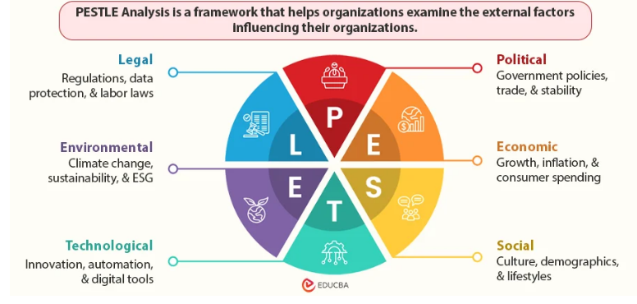
Figure 1: PESTLE framework
(Source: Inspired by Andersen, 2025)

2.1 India
Political: There is a stable democratic system and governance in India. There is 100% FDI allowed in the food retail sector (Government of India, 2025). Along with GST reforms standardising the tax structure between 5–18% (Government of India, 2025a). The good policy impetus favoring foreign investments would favour long-term growth and expansion of franchising thus favouring KFC. Gupta et al. (2024) claimed that the most ideal benefit of having multinational firms in the market with low entry barriers and enormous opportunities to expand is the existence of a stable governance and favourable policies of foreign investment.
Economic: India recorded a GDP growth of 6.8% in 2024 (News on Air, 2025). In 2036 the middle and rich consumers will contribute 93% of total spending, as opposed to 80% by 2026 (We Forum, 2025). Nonetheless, inflation of 5.4% (Economic Times, 2024) impacts food prices. Urban areas have an increasing disposable income which is favourable as the onward impetus of demand. India offers a powerful platform, which KFC can expand its franchise network and capitalize on the growing urban needs. Still, the pressure on the economy incorporates inflation and price sensitivity among customers demand consideration attentive pricing strategies, which support the importance of value-based propositions (Economic Times, 2024).
Social and Cultural: India is a very diverse society, with 30-40% of the population being vegetarian (Times of India, 2025) and also, the population is young with a median age of 28 years. The trend in regards to the consumption of the fast-food is also increasing in the cities. India has a lower individualism score (24) suggesting both collectivist and individualistic attitudes (The Culture Factor, 2026). Moreover, the long-term orientation in India is comparatively lower when compared to China implies that consumers are more price-sensitive and value-oriented (as shown below in Hofstede model). Indulgence has a relatively low score indicating that it has controlled spending behaviour, which indicates affordability-based offerings. Nevertheless, uncertainty avoidance is low, depicting that KFC can roll out new dishes and localised flavour easily.
Technological: Adoption of digital payment has reached 65% of urban users in India (PIB, 2026), and food delivery platforms are growing, smartphone penetration is high, and cloud kitchens and orders via apps are increasing. These reinforce accessibility and effectiveness of delivery, which makes the technological environment favourable.
Legal: India possesses stringent food safety standards imposed by FSSAI, creation of increased labour legalities, regulations on ads and licensing of food joints. These add to their operational expenses and regulation, making legal environment unfavourable. Schilling-Vacaflor and Gustafsson (2024) claimed that high and sustainable legal environment and necessity can increase cost of compliance and reduce the possibilities of the global brands to operate. Compliance and sustainability in practices are expensive due to the stringent regulations of food safety, as well as environmental regulations in India (Kathuria and Anand, 2022). All those may lower the profit margins, yet, ethical branding and adding sustainability as a long-term position will be a priority. India, therefore, offers a high growth potential.
Environmental: The environmental issues are a single-use plastic ban, increasing consumer awareness of the sustainability, driven consumption in waste management, and worries about energy and water use. These forces favour sustainable packaging and operational modifications and thus the environment is not in favour. Despite the favourable growth conditions, there are constraints on operations that are posed by regulatory and environmental factors.
- Favourable and Unfavourable conditions:
India enjoys a favourable macro-environment as it is politically stable, has favourable FDI policies, a robust economic growth, an increasing disposable income, and a fast pace of technology adoption including digital payments and food delivery platforms. This market has social elasticity and a young population also adds to market prospects and allows KFC to grow (innovate) and cover various consumer groups. Nonetheless, high inflation, price elasticity, stringent legal and environmental factors like sustainability demand pose operational challenges. Standardisation is constrained by cultural diversity and dietary restrictions, whereas compliance costs and regulatory complexities augment financial load and KFC would be hard-pressed to sustain profitability and uniform operations in various regions in India.

2.2 China
Political: The political system in China is strongly one-party, which has guaranteed stability. But foreign businesses and regulation are highly regulated by the government and trade policies and geopolitical strains over imports exist. The government is also promoting localisation and local production. Although that ensures a balance in the environment, it restricts the flexibility of operations in the case of foreign companies, which is why this makes the political climate in general hybrid.
Economic: In 2025, China saw a 5% growth in GDP due to a high number of middle classes amounting to about 400 million consumers (China Briefing, 2025). The fast urbanisation and growing disposable income creates a high demand of fast food. But, increasing labour and operational cost affect profitability. Overall, the economic environment is favourable for KFC. According to Boafo et al. (2021), the rapidly urbanising economies with the growing middle classes present huge opportunities to the brands of quick-service restaurants.
Social and Cultural: The culture of Western fast-food has been highly acceptable in China, as a high population of people in its urban environment has boosted demand of convenience food. The culture of eating out and the localisation of flavours and menu innovation is also high (China briefing, 2024). This reflects the strong collectivist culture and long-term orientation where there is heavy utilisation of group dining experience and brand loyalty. This helps to facilitate introduction of repeat consumption and acceptance of foreign brand like KFC. The individualism score in China is higher than the score in India (43), yet there are also tendencies towards collectivism where the decision to spend communally is essential (as shown below in Hofstede model). Also, brand loyalty and repeat purchase behaviour is aided by the high long-term orientation (77) (The Culture Factor, 2026).
Technological: China has a well-established food delivery marketplace and tech-savvy ecosystem. It is estimated that digital payments comprise 82% of all transactions (Orcasia, 2025). Mobile applications are widespread and support this assertion. Strong AI and automation uptake in fast food restaurants and high smartphone penetration. These considerations amplify the customer experience and efficiency resulting in the operational environment being very favourable. More specifically, better digital landscape of the country may help make the company work more effectively, delivering tools of delivery and introducing no-cash practices, so KFC can successfully introduce technology into its service offering.
Legal: China has stringent food safety, especially after food scandals in the past. The foreign brands are strictly monitored by the government, as well as the labour policies, compliance standards, and data privacy and cybersecurity regulations. These contribute towards compliance burden and augment operational risk and the legal environment does not favour this. According to Meyer and Li (2022), multinational corporations can experience strategic limitations because of the high level of government intervention and crippling legal regimes. The cost of compliance and chances of operations are also increased by stringent food safety regulations, industry information protection laws and government regulations pertinent to China.
Environmental: China has been actively driving towards carbon neutrality and very stringent waste management and recycling policies by 2060 (BBC, 2026). Sustainable sourcing and packaging are on the rise and the pressures of environmental regulations have implications on supply chains. These aspects compel organisations such as KFC to resort to sustainable operations and it raises the cost of operation and the environment is no longer favourable. The environmental policies also apply pressure on the firms to be environmentally friendly, and this may alter the cost structures.
- Favourable and Unfavourable conditions:
China is a very favourable environment because of its good economic growth, big and growing middle class, rapid urbanisation and high level of acceptance of Western fast food. Intensive technological infrastructure, large-scale online payments, and great culture of restaurant meals promote growth, which allows operating effectively and taking the leading positions in the market. Nonetheless, there are tight government regulations, high degree of legal compliance requirement and political control that restrain operational flexibility of foreign companies. Increased labour and operational costs, high environmental policies, increase financial pressures. There are also regulatory risks and government action, which pose strategic uncertainty to KFC, and it is difficult to ensure that they remain profitable and able to operate freely in China.
Implication for marketing using the Hofstede cultural model for comparing India and China
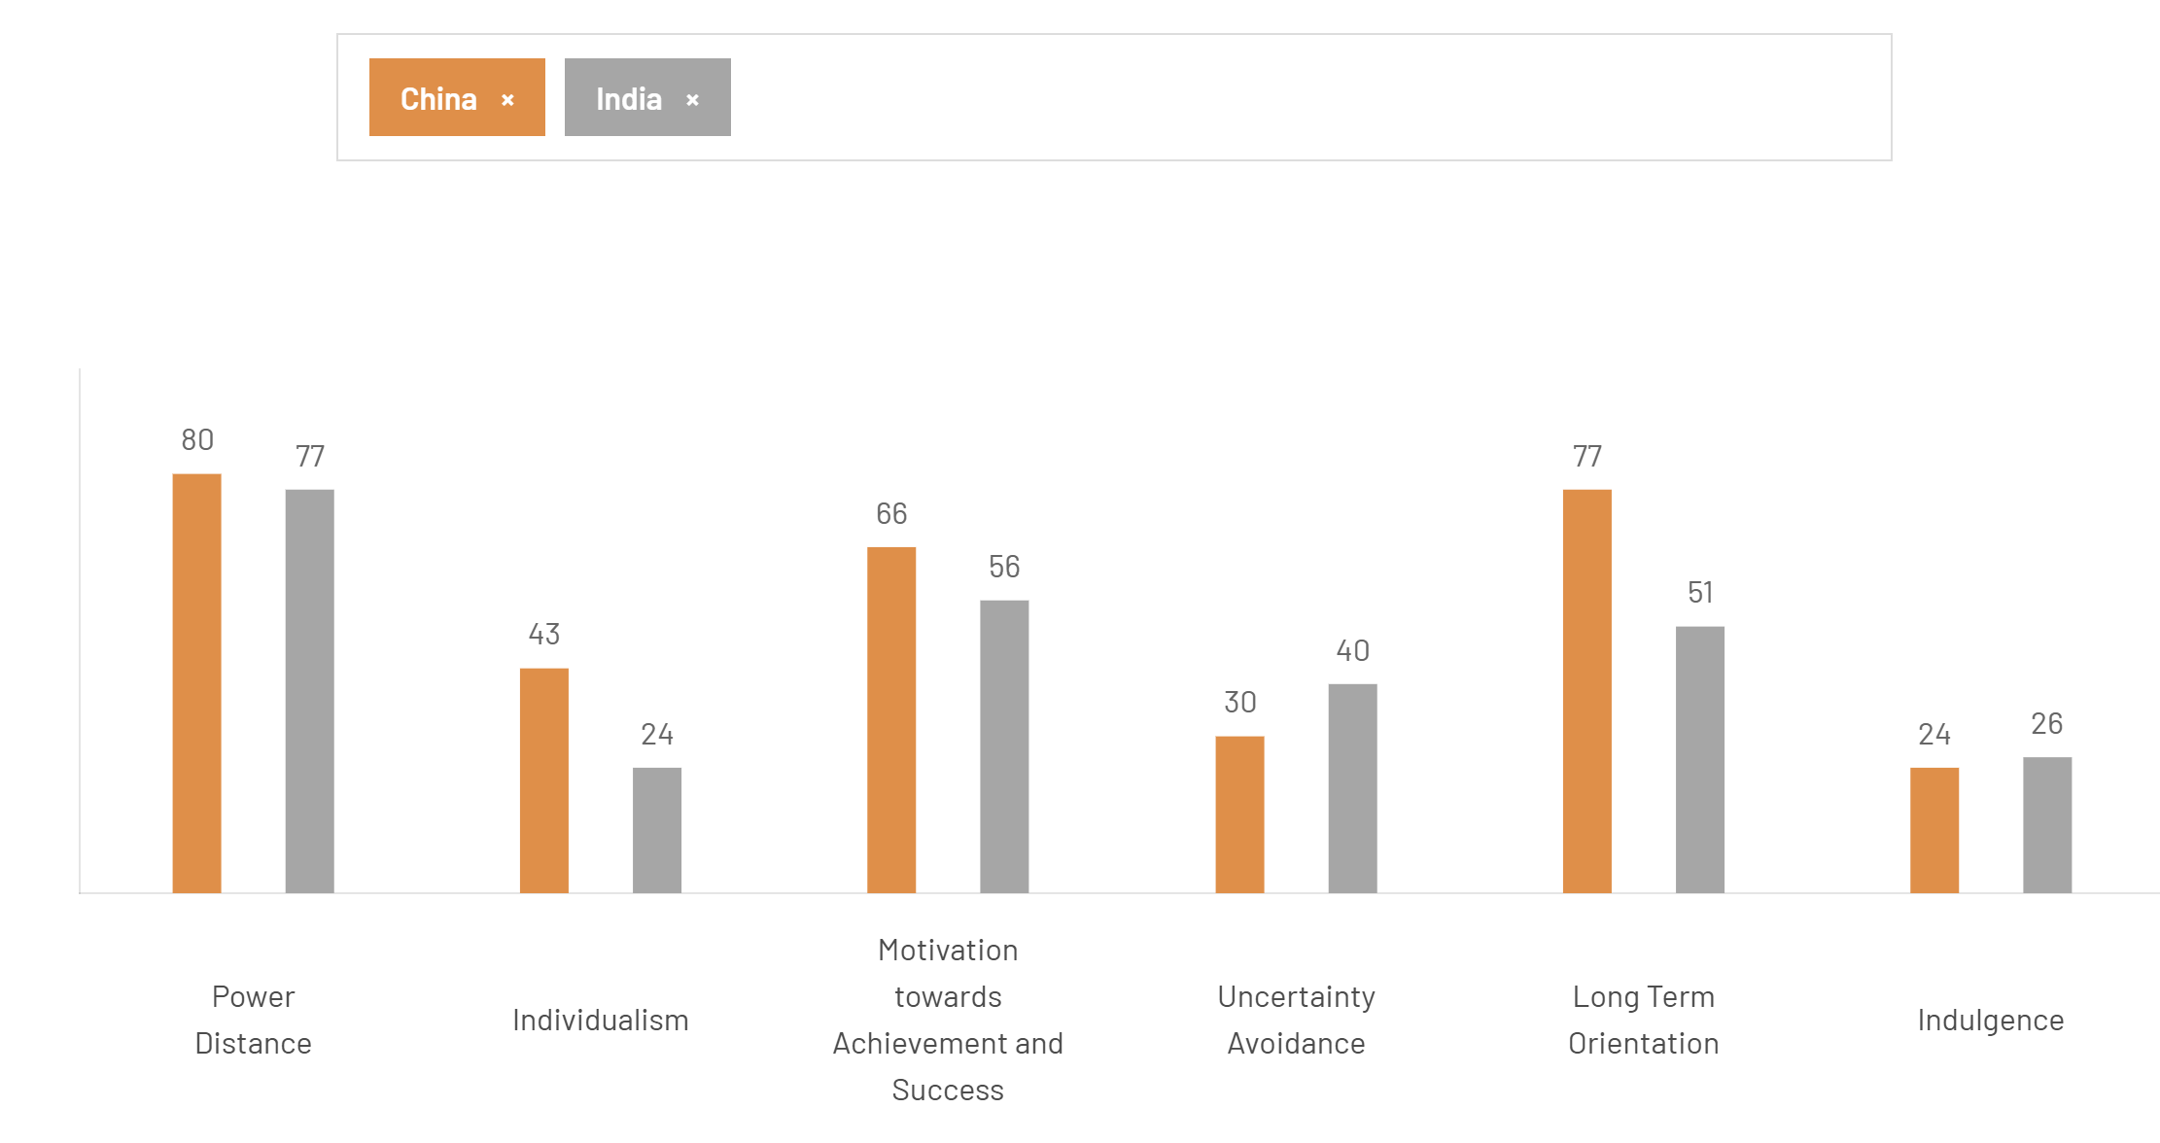
Figure 2: Hofstede Cultural Comparison – India vs China
(Source: The Culture Factor, 2026)
Similarities and comparison
KFC has an overall favourable macro-environment in India that is mainly fuelled by political stability and robust economic growth. Nonetheless, KFC needs to ensure that it must strike a balance between expansion and adherence to measures and regulations as well as cultural sensitivity that grows its competitiveness. Overall, India is a more cost-reactive and restrictive culturally market economy compared to China (The Culture Factor, 2026).
One of the most favourable yet complex macro-environment of KFC is in China, where the macro-environment has been favourable in terms of high growth in the economy and technological advancement (Baldwin, 2024). One of the main reasons that has made KFC capture a dominant market share in China Despite China being a high growth potential environment, KFC will have to be abreast with the complexity of its laws and high localisation rates to lead its competitive advantage. China offers a more advanced and consumer facing environment, which will enable KFC to adopt a high-quality positioning and experience-based strategy with strong digital support.

- Advantages & Disadvantages of the Hofstede Model
These cultural dimensions have a direct impact on KFC marketing policies, with pricing policies in India needing to be value based because of increased price sensitivity but in China, relatively premium-pricing policies are possible with enhanced brand loyalty. Concerning promotion, collectivist cultures in the two nations facilitate the family-based and group-based marketing campaigns primarily in China (The Culture Factor, 2026). Further, product strategies should be geared towards localisation, including vegetarian product in India and locally oriented menu innovations in China, to match consumer behaviour, and cultural anticipations. Vidani and Das (2021) state that organisations need to comprehend the consumer behaviour, decision-making styles, and communication likes in various cultures.
Although this is useful, the Hofstede model is limited in several ways especially in the current global markets (Taras et al., 2023). It also simplifies the national cultures, which do not take regional and individual differences within nationalities into account. It also simplifies the complex cultural dynamics and might not reflect dynamic consumer behaviour subject to globalisation, digitalisation and socio-economic shifts.

3.STP Analysis (Segmentation, Targeting, Positioning)

3.1 Comparative STP Analysis between India and China
STP Element | India | China
Segmentation | - KFC caters primarily to younger audiences (18-35 old), particularly in the city.  - The target market is the price-sensitive groups in the middle-income strata.  - Convenience can shape consumer lifestyles, and so is cultural diversity due to vegetarian and non-vegetarian tastes.  - Eating out is not always regular, but a one-up one-down affair. | - In China, KFC divides a larger market, such as youthful specialists and families (KFC, 2026c).  - The target group is mostly made up of the middle and upper-middle class which is growing.  - Consumers are busy urban dwellers with an advanced eating out habit.
Targeting | - KFC targets urban millennials, Gen Z, and middle-income families, particularly in Tier 1 and Tier 2 cities.  - On the one hand, the brand targets consumers who seek to have affordable and convenient meals. | - China: KFC is focusing on a broader market, which consists of urban families, professional population, and tech-savvy customers.  - The target market is the customers who habitually consume fast food and use digital platforms.
Positioning | - KFC is aligned as a localized and cheap fast-food.  - It focuses on value meals, competitive pricing, as well as menu additions including vegetarian meals to adapt to the local tastes. | - In China, KFC is a high quality and affordable western brand.  - It focuses on customer service, menu development and a good brand image which it supports with localised offerings.
Table 3: STP analysis for India and China
The STP strategy embraced by KFC in India and China indicates a very responsive approach that is suited to the variation in consumer behaviour, economic status and cultural orientation. According to Arnett (2024), segmentation is essential in determining market entry and expansion efforts, proper segmentation can help firms to ensure that their offerings are matched with the heterogeneous consumer needs. The income sensitivity and cultural diversity are the major factors influencing the segmentation in India where vegetarianism is a major element that dictates consumption patterns. This requires differentiation of products to incorporate vegetarian products that are not as pronounced in China. On the other hand, the segmentation in China is behaviourally-based (Gu, 2024). The frequency of consumption and lifestyle trends focus as urban Chinese consumers are turning to convenience food in the face of time constraints.
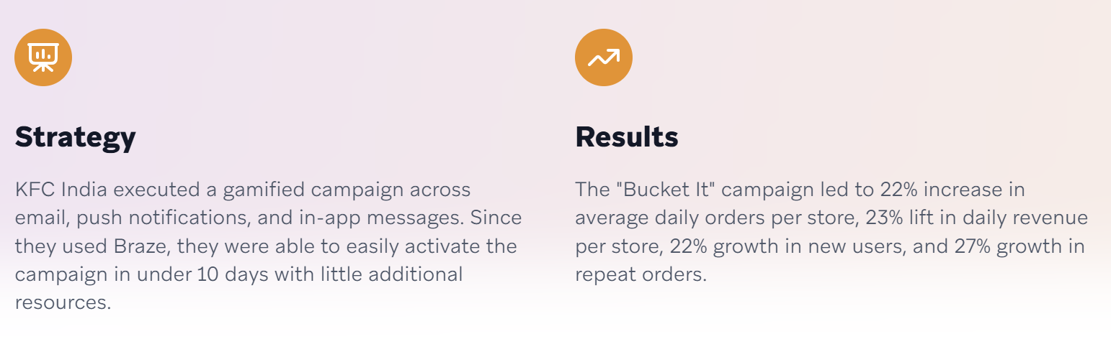
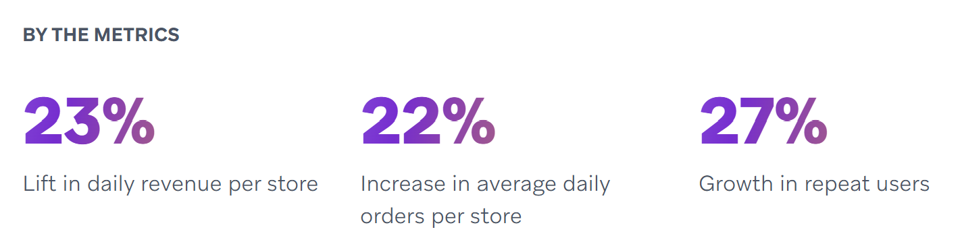
Figure 3: customer retention strategy used by KFC in India
(Source: Braze, 2026)
KFC uses the selective targeting strategy in India to target the urban young population and middle-income consumers who are in need of a cheap meal. Here, price sensitivity is a major factor determining purchasing decisions. Figure 3 has helped in understanding the positive impact of KFC India’s 'Bucket It' Campaign that increased daily revenues by 23% (Braze, 2026). Graham and Kennedy (2022) noted that targeting in new markets must focus on cost and availability to maximise penetration in the market. Conversely, targeting in the Chinese market is more extensive in that it includes more people as mass market like families, working people. This country has a higher level of disposable income and the fast-food culture, which would enable KFC to enjoy repeat purchase and a better customer retention.
The most notable difference of the KFC strategy in the two countries is on positioning. KFC in India is being placed as a value-competitive and localised brand in that it competes based on the value and menu fit. It is critical in a market where competition is high and the consumer is very price-conscious. Conversely, KFC in China has managed to establish itself as a reputable and quality Western brand that does not only serve food, but also as an experience (Gu, 2024; KFC, 2026c). The brand positions will increase perceived value and customer loyalty as was observed in the KFC case of dominating the Chinese market.

3.2 Perceptual map
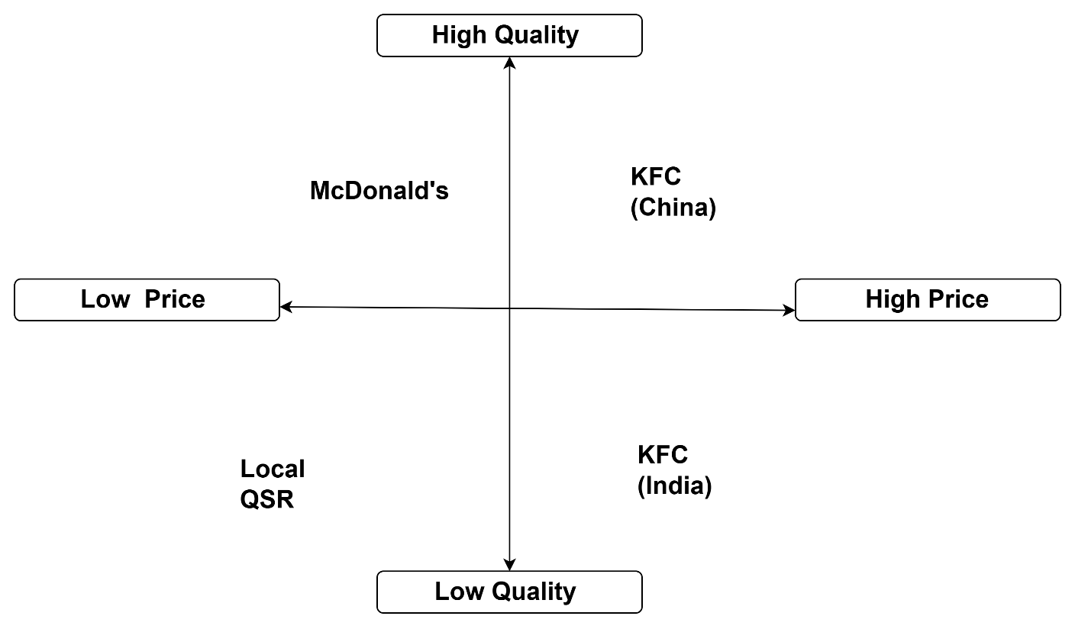
Figure 4: Perceptual Map
(Source: Self-developed)

Similarities: Operations of KFC in India and China are similar in terms of target consumers of young people and segments consisting of urban population. Also, the two markets participate in localisation strategies of their products to meet the culture and consumer expectations.
Differences: KFC in India is majorly scaled as brand with price sensitivity and value emphasis as the strategies of low costs and competition prices. On the contrary, KFC in China uses experience-based and rather premium positioning, which is promoted by increased consumer purchasing power, implemented digitalization, and high brand awareness (Gu, 2024).

4. Marketing Mix (7Ps)
The marketing mix (7Ps) is a business strategy, which is used to study how companies design and execute their marketing strategies. The extended marketing mix is needed in service-based industries as it is what integrates both tangible and intangible factors that determine customer experience (Ulziibadrakh et al. 2025). The modification of the marketing mix 7Ps also brings out the capability of KFC to reconcile global standardisation and local responsiveness in India and China. Among the most important areas of differentiation is the product strategy.

4.1 Product
In India, cultural and religious inclinations of diet greatly impact on the product offering of KFC, especially the large percentage of vegetarian customers. It has resulted in vegetarian menu and locally desirable flavours. Okonkwo et al. (2023) indicate that the localisation of products is fundamental in a culturally diverse market that involves the acceptance and relevance of the products. Comparatively, KFC in China employs even more localisation strategy providing rice-based foods and local region-specific foods, which are indicative of a greater penetration into local food culture (KFC, 2026c). KFC is also able to expose innovative and localised menu offerings without a great deal of uncertainty due to low uncertainty avoidance.

4.2 Price
Market dynamics are also different in pricing strategies. KFC has also employed value-based pricing strategy in India to attract price-sensitive consumers by giving them discounts and combo meals in order to compete. This is consistent with Zheng et al. (2022) who propose that the pricing strategy in emerging markets should be cost-effective to the consumer. On the other hand, KFC China has a comparatively high pricing platform that is sustained by increased disposable income and willingness to spend on brand experiences. This would enable the brand to have better margins and build its position as a premium product.

4.3 Place
There is also a great variation in place (distribution) strategy in the two countries. India KFC is concentrated on the growth of its business in Tier 1 and Tier 2 cities, with a total of almost 1,200 stores (India Retailer Bureau, 2026). It has partnered with food delivery platforms, namely Zomato and Swiggy. However, in China, KFC has recorded a high level of market penetration having a highly established network of stores spread in urban centres. Teguh et al. (2021) explained that the key competitive advantage in international markets is a strong network of distribution. The high level of infrastructure and concentration in China ensures a favourable climate for KFC.

4.4 Promotion
Promotion strategies bring out an apparent difference between transactional and experiential marketing strategies. Promotional activity in India is very price conscious and is centered around discounts, value meals and online promotion to capture the low-end consumer. As evident, KFC has partnered with an Indian start-up, Naagin, in 2024 to introduce a blend of flavours that retain authenticity of its global appeal with Indian tastes across its 1,100 Stores (Licence India Bureau, 2024). It operates in India under the operations of Sapphire Foods India Ltd. (India Retailer Bureau, 2026). KFC in China, however, is much more focused on the experience with the brand by promoting digital platforms, loyalty programs, and interactive campaigns to attract customers. In China, KFC is one of the largest restaurant chains that has 10,000 stores (Baldwin, 2024). According to Utami et al. (2025), promotion strategies should align with cultural values where a collectivist society reacts better to promotion strategies based on experience.

4.5 People
The People factor displays the variations in service expectations and customer interaction. Employees in India are mainly trained on efficiency and cost management to accomplish a speedy delivery of service. In China, however, interaction with customers and quality of services offered is much more prioritised, which helps in increasing the quality of dining experience. Singh et al. (2022) argued that employee behaviour is essential to determine customer satisfaction and brand perception in the service sector.
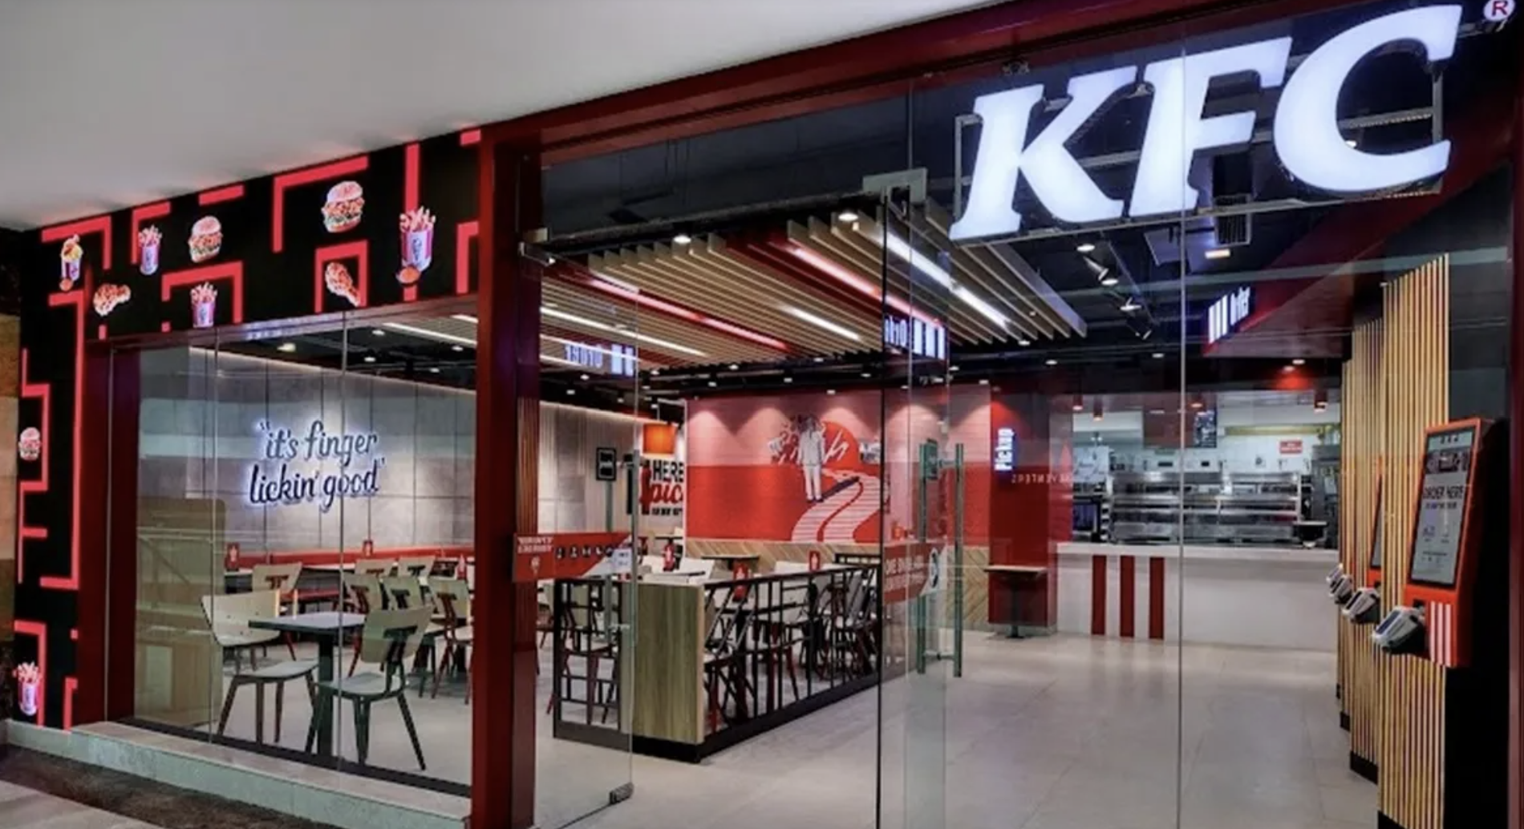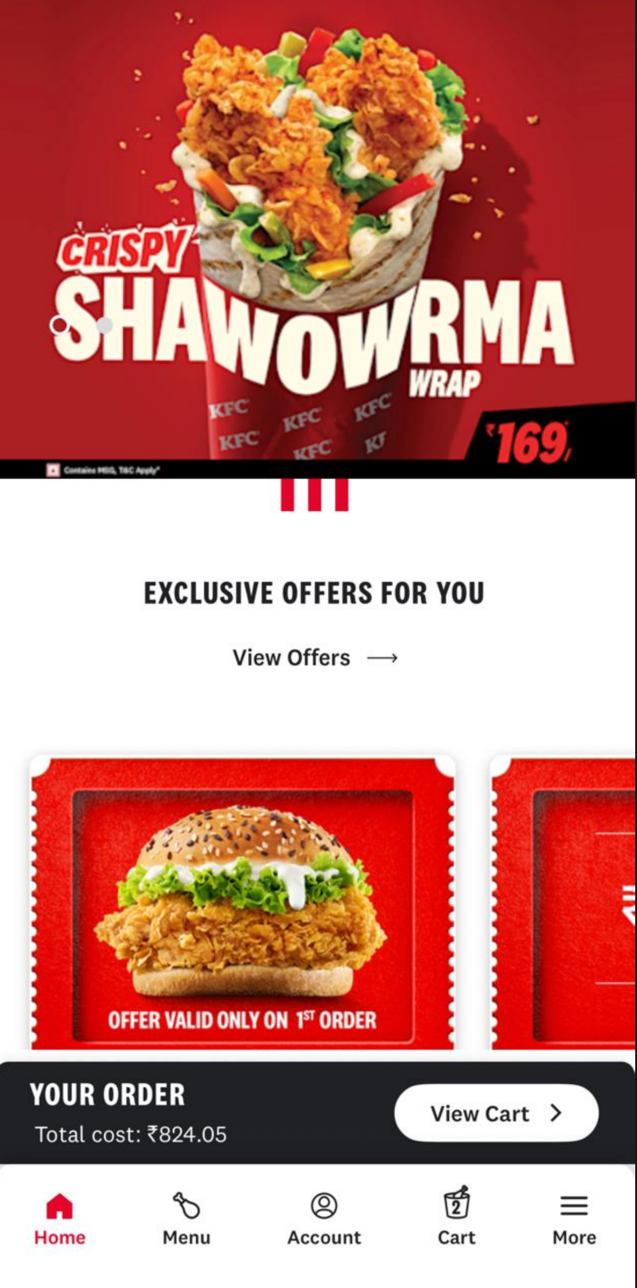
Figure 5: Smart restaurants and “KFC Smart App” in India
(Source: ETHospitalityWorld, 2022)

4.6 Process
Process strategies also add to the contribution of technology in improvement of service delivery. Figure 5 has revealed that in India, KFC has introduced digital kiosk-sort of systems of ordering and delivery through its smart restaurants (ETHospitalityWorld, 2022). Also, orders can be placed by scanning the QR code using the KFC Smart App. In comparison, the Chinese ecosystem is highly digitalised, which facilitates ordering, payment, and delivery, as the technology of WeChat and Alipay could help. This is in line with Masoud and Basahel (2023) who emphasize the need of digital transformation in enhancing customer experience.

4.7 Physical evidence
The physical evidence is the embodiment of the physical representation of the brand. KFC stores are operational and efficient in India with an average focus on the ambience. Conversely, outlets in China are more up-to-date and luxury with a comfortable and interactive atmosphere to dine in (KFC, 2026c).

5. Directional Development Strategy of KFC in India
Directional development strategy is the approach a company takes towards its growth, by increasing products and market (Erzurumlu et al., 2023). The Ansoff matrix states four strategies that can enable firms to grow.
Strategy | Application to KFC India
Market Penetration | Promoting sales by offering discounts, combo deals, and digital delivery systems such as Zomato and Swiggy to encourage the repeat clientele.
Market Development | Diversification to the Tier 2 and Tier 3 cities to capture the untapped markets and reach more customers.
Product Development | Vegetarian menu additions and Indianisation of flavours to cater to the local taste.
Diversification | Inadequate diversification by new format into KFC cafes and snack products.
Table 5: Ansoff Matrix
(Source: Self-developed)
The growth of KFC in India is mainly directed to the penetration and product development strategy because of necessity to adapt to the market which is very price sensitive and culturally diversified. The least risk approach by which Singer and Jones (2025) assume is increased consumption frequency through the use of discounts and value meals is market penetration. Nevertheless, the competitive pressure could decrease the profit levels and undercut the perception of the premium brands overreliance on price. Moreover, menu localisation, especially introduction of vegetarian food has played a key role in product development. Jadhav (2024) emphasizes that product modification to the local cultural value would maximize the relevance of the product to the market and customer satisfaction levels. Nevertheless, its diversification is not extensive, which is an indication that KFC is conservative when venturing into new markets.
STP analysis proved that in India, the segmentation power of the market is determined by affordability and cultural diversity, as opposed to increased frequency of consumption and wider market in China. India is more of a selective and price-influenced market, causing KFC to employ value-based positioning. The merger deal of KFC with Devyani International Ltd was finalised in $934 million. This turned out to be helpful for KFC to launch a new store in Panipat, Haryana, India (India Retailer Bureau, 2026). On the whole, the development strategy promotes stable growth, but the long-term success would rely on the necessity to balance between affordability and brand differentiation.

6. Ethical Issues
Ethical marketing is described as the practices that guarantee fairness, transparency and responsibility towards consumer and the society (Ahmed and Ahmed, 2025). In terms of ethical marketing, experiences of KFC in India have shown that various ethical issues. This includes quality of the product, animal welfare, and food safety.

6.1 Ethical Marketing Practices
Product localisation is one of the ethical practices implemented by KFC where a vegetarian option was launched in India to be respectful to cultural and religious customs. This aligns with ethical marketing of considering the needs of consumers and inclusiveness. KFC has been involved in corporate social responsibility (CSR) activities, such as sustainability and responsible sourcing. To combat issues of meals faced by officegoers amidst the pandemic, it partnered with Smile Foundation (Smile Foundation, 2020). These contribute to brand trust and social responsibility.

6.2 Unethical Marketing Problems
Nevertheless, KFC has had a major ethical crisis in India. Regulatory authorities discovered that KFC products had MSG levels that were far beyond the authorised levels indicating food safety and health complications to consumers (ICMR India, 2025). The animal rights organisations including PETA had also alleged that KFC was mistreating their chickens in suppliers’ farms thus drawing wide protests and negative publicity. Recently, in a case of the 2025 food inspection, the fungal contamination of food was reported in a KFC store, which shows that compliance issues are still present (Times of India, 2025). These ethical questions reveal a disparity between KFC international brand image and local market functioning in the local countries. As Celestin et al. (2024) stated, unethical actions may adversely affect the consumer trust and the brand equity in the long run. Although KFC has already performed correct actions, the problematic occurrence has shown that it has to be tightened to controlled quality control and ethical supply chain management.

7. Recommendations
Recommendations for India:
In India, KFC ought to increase its operations in the Tier 2 and Tier 3 cities where increasing disposable income and urbanisation are generating new demand of quick-service restaurants. Also, the interest of health-aware consumers can be drawn to the menu by offering more nutritious foods like grilled or low-caloric items. This aligns with Ntalie et al. (2025) that identifying underserved segments enhances long-term growth potential. The move into these segments will enable KFC to engage in the further penetration of the market outside the already saturated urban regions. Oladimeji and Owoade (2024) stated that the technological integration in digital tools enhances the efficiency of services and customer engagement greatly. KFC should adopt a greater quality control and frequent auditing. Understanding in sourcing practices can be transformed into re-establishing consumer trust (Agu et al. 2024).
Recommendations for China:
KFC have to keep reinforcing its high-end marketing in China by improving its customer experience by incorporating the latest digital features, such as ordering via AI and promoting to individuals. Moreover, the introduction of new menu items according to regional preferences and a good brand loyalty programmes will contribute to the preservation of competitive advantage (Manhas et al. 2024). The business of KFC should also aim at ensuring that it is involved in strict regulatory compliance and sustainability practices to respond to the environmental and legal pressures in the Chinese market.

8. Conclusion
The success in India and China illustrates the need to incorporate culture, economic and consumers differences in the marketing approach at KFC. Whereas India is in need of affordability and localisation, China promotes the premium and experience-based strategies. On the whole, the utilization of PESTLE, Hofstede, STP, and 7Ps is a useful tool that helps KFC maintain a competitive edge in a variety of international markets. The PESTLE analysis has revealed strong cultural and religious food restrictions in India, with China showing a strong culture of eating out. The cultural comparison between India and China shows the presence of both similarities as well as the major differences that must directly affect the international marketing strategies of KFC. In this context, the Hofstede Model advocates strategic adjustment by determining the key dimensions of the cultural aspect that determine consumption.

Section 2: Reflective Report
Reflective practice is very in the improvement of learning as well as professional growth through providing one an opportunity to critique the experience. This is a systematic way of reflecting on the process of doing the international marketing assignment on KFC in India and China.
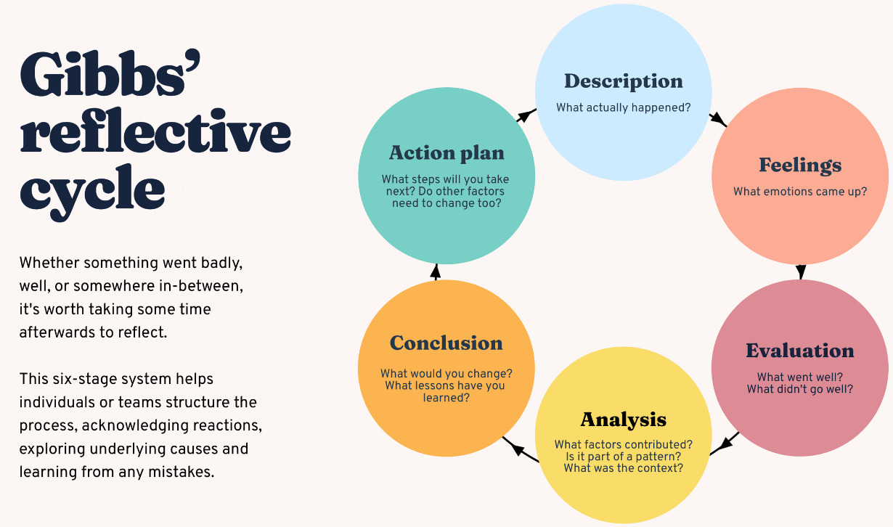
Figure 6: Gibbs reflective cycle
(Source: Inspired by Trimasse, 2025)

Description
In the assignment, I was expected to undertake an in-depth study of KFC international marketing strategies in India and China, based on some of the most important marketing frameworks, namely, PESTEL, cultural dimensions as formulated by Hofstede, STP, and the 7Ps marketing mix. It was also a task of determining and identifying ethical issues and giving recommendations on how it could be improved. I used real-time information gathered through real sources throughout the process, equated macro-environmental variables, and examined the impacts of cultural and economic differences on marketing decisions. This meant that there was a need to blend theoretical ideas with practical implementation especially in the area of how international brands conform their strategies in various markets. Experiential learning as indicated by Wijenen-Meijer et al. (2022) implies changing the knowledge by using it, and this is also obvious in this assignment.

Feelings
The initial part of the assignment has made me feel overwhelmed as the task seemed too complicated and I had to apply several frameworks in an organized way. The requirement to integrate the real-time statistical data and real sources made it more difficult, as they had to be thoroughly researched and checked. However, as I advanced, my confidence grew, particularly when I started to realize how all the frameworks could be related to the actual business practices. The cultural comparison was of particular interest to me, as it presented information on the differences in consumer behaviour between countries.

Evaluation
The possibility to engage into critical comparison of India and China and not to conduct them as two different analyses was one of the main strengths of my work. Having the PESTLE and Hofstede frameworks allowed an understanding of the structure of the report and facilitated its organisation. Also, the usage of real-life data contributed to the persuasiveness of my arguments. Nonetheless, some problems existed. It was also hard to control the number of words and at the same time be deep in analysis because every part needed to be described and criticized. Moreover, searching current and valid data on both of the countries required time. As pointed out by Kramar (2022), reflection presupposes identifying both positive and negative sides of an experience, which is the key to further performance enhancement.

Analysis
This assignment has greatly contributed to my perceptions of international marketing especially the need to customize strategies in line with local market environments. I found out that cultural factors are the important issue that cannot be disregarded in consumer behaviour and that should be considered when entering the global market. Indicatively, KFC has been able to succeed in China because it has been able to localise its menu and fit in the culturally orientation of collectivism whereas affordability and diets are more the drivers in India. This reinforces the idea that Liu (2023) presented that the marketing performance and the choice consumers make are highly influenced by cultural values.
In addition, ethical problem analysis revealed the need to ensure transparency and accountability in the international business. I also learnt that the impact of unethical practices, although unintended, might be disastrous to the brand name and loyalty. The fact that several frameworks were used also enhanced my analytical skills giving me the ability to relate theory and practice and have a more organized argument. Reflective practice enables one to critically think about their actions, as well as enhance professional competence (Mohamed et al. 2022).

Conclusion
Altogether, this assignment gave me important insights into the complications of international marketing and the significance of cultural, economic, and ethical considerations. I also gained a better insight into the process of global brands adjusting their strategy to various markets and the importance of formal structures in the analysis of business environments. The experience also helped me to be more critical and do research.

Action Plan
In future, I will enhance my time management abilities to make research and analysis more efficient. My data collection will start earlier and information will be sorted out systematically so as to eliminate last-minute rush. I also wish to work on improving my application of academic journal sources to build the theoretical basis of my work. I would also train further on the critical analysis, trying to challenge the assumptions and pursue other viewpoints.

References
Agu, E.E., Iyelolu, T.V., Idemudia, C. and Ijomah, T.I., 2024. Exploring the relationship between sustainable business practices and increased brand loyalty. International Journal of Management & Entrepreneurship Research, 6(8), pp.2463-2475. https://www.researchgate.net/profile/Tochukwu-Ijomah-2/publication/383847817_Exploring_the_relationship_between_sustainable_business_practices_and_increased_brand_loyalty/links/66dc447d2390e50b2c7212e7/Exploring-the-relationship-between-sustainable-business-practices-and-increased-brand-loyalty.pdf [Accessed on: 15.03.2026]
Ahmed, A. and Ahmed, U., 2025. Ethical marketing practices: Building trust and authenticity. Strategic marketing tactics: Developing your competitive edge in today's market, pp.292-313. https://www.gbppublications.com/_files/ugd/5e526c_d512b35bd3f04b9eac3a95ed47ef78ea.pdf#page=305 [Accessed on: 21.03.2026]
Andersen, P.D., (2025). The PESTEL framework and its variants for analysing the strategic environment: Evolution, limitations and adoption in energy policy research. Limitations and Adoption in Energy Policy Research. https://papers.ssrn.com/sol3/Delivery.cfm?abstractid=5266562 [Accessed on: 18.03.2026]
Arnett, D.B., 2024. Market segmentation strategy, target markets, and competitors: a resource-advantage theory perspective. Journal of Marketing Management, 40(13-14), pp.1269-1285. https://www.tandfonline.com/doi/pdf/10.1080/0267257X.2024.2391367?casa_token=WO34oUetmA0AAAAA:a_hN7nJeX2NE3Rx37vBD7vQzrW9Cit1AtwIin_5oqkJVCVh9FWUP4PkBrGe9dYmdPZE1lmllhjDf [Accessed on: 17.03.2026]
Baldwin, S. (2024). How KFC won over China? Available at: https://www.cnbc.com/2024/01/11/how-kfc-won-over-china.html [Accessed on: 21.03.2026]
BBC, (2026). Climate change: China aims for 'carbon neutrality by 2060'. Available at: https://www.bbc.com/news/science-environment-54256826 [Accessed on: 25.03.2026]
Boafo, J., Sarku, R. and Obodai, J., 2021. From the kitchen to fast food restaurants: The changing culture of food in urban Ghana. Food Studies, 10(4), p.15. https://www.researchgate.net/profile/James-Boafo/publication/348472615_From_the_Kitchen_to_Fast_Food_Restaurants_The_Changing_Culture_of_Food_in_Urban_Ghana/links/65276ba1bc063850eab75868/From-the-Kitchen-to-Fast-Food-Restaurants-The-Changing-Culture-of-Food-in-Urban-Ghana.pdf [Accessed on: 21.03.2026]
Braze. (2026). KFC India boosts customer retention and revenue with gamified “Bucket It” campaign. Available at: https://www.braze.com/customers/kfc-india-case-study [Accessed on: 21.03.2026]
Celestin, M., Sujatha, S. and Kumar, A.D., 2024. Analyzing the role of ethical business practices in building consumer trust and long-term brand loyalty: Leveraging corporate ethics as a competitive advantage. World, 1. https://www.academia.edu/download/119245258/6721c550089bc_WCMRD_001.pdf [Accessed on: 22.03.2026]
China briefing, (2025). China's Middle Class – Growth, Policy, and Consumption. Available at: https://www.china-briefing.com/news/china-middle-class-growth-policy-and-consumption/ [Accessed on: 25.03.2026]
Economic Times, (2025). RBI raises FY24 inflation forecast to 5.4%; flags need to go. Available at: https://m.economictimes.com/news/economy/policy/monetary-policy-rbi-raises-inflation-forecast-for-fy24-to-5-4-amid-galloping-food-prices/articleshow/102593741.cms [Accessed on: 21.03.2026]
Erzurumlu, S.S., Deets, S., Nersessian, D. and Rodgers, V.L., (2023). Strategic engagement of business with sustainable development goals: A systems thinking approach. Business Strategy and the Environment, 32(7), pp.4954-4969. https://onlinelibrary.wiley.com/doi/abs/10.1002/bse.3402 [Accessed on: 21.03.2026]
ETHospitalityWorld. (2022). KFC launches its smart restaurants. Available at: https://hospitality.economictimes.indiatimes.com/news/restaurants/kfc-launches-its-smart-restaurants/95030757 [Accessed on: 22.03.2026]
Government of India, (2025). policy measures to support food processing sector. Available at: https://www.pib.gov.in/PressReleaseIframePage.aspx?PRID=1848845 [Accessed on: 20.03.2026]
Government of India, (2025a). GST Reforms 2025: Relief for Common Man, Boost. Available at: https://www.pib.gov.in/PressNoteDetails.aspx?NoteId=155151&ModuleId=3 [Accessed on: 21.03.2026]
Graham, C. and Kennedy, R., 2022. Quantifying the target market for advertisers. Journal of Consumer Behaviour, 21(1), pp.33-48. https://onlinelibrary.wiley.com/doi/pdfdirect/10.1002/cb.1986?casa_token=B8YTFZyaqFcAAAAA:vAdliV3ppSVlrMPrREG47FDIDIm_uqPIz_XF6dKpaYaUOfSCfSeIgkszUGYo5qyfZdeOyByT3yuEUA [Accessed on: 25.03.2026]
Gu, Q. (2024). Analysis of KFC's localized marketing strategy in China. Frontiers in Humanities and Social Sciences, 4(6), pp.340-346. https://www.researchgate.net/publication/381716424_Analysis_of_KFC's_localized_marketing_strategy_in_China [Accessed on: 25.03.2026]
Gupta, A., Swain, P.C., Mishra, R.R., Joshi, S. and Andrabi, R., 2024. Examine the possibilities and obstacles of global business expansion. Journal of Information Education and Research (J Inform Educ Res), 4(2), pp.635-643. https://www.researchgate.net/profile/Syed-Andrabi-4/publication/380075712_Examine_the_Possibilities_and_Obstacles_of_Global_Business_Expansion/links/662a435f06ea3d0b740ba962/Examine-the-Possibilities-and-Obstacles-of-Global-Business-Expansion.pdf [Accessed on: 21.03.2026]
ICMR India, (2025). KFC in India: Ethical Issues. Available at: https://www.icmrindia.org/case-study-details?casecode=BECG044 [Accessed on: 25.03.2026]
IMF, (2026). IMF Executive Board Concludes 2025 Article IV. Available at: https://www.imf.org/en/news/articles/2026/02/18/pr-26053-china-imf-executive-board-concludes-2025-article-iv-consultation [Accessed on: 25.03.2026]
India Retailer Bureau. (2026). KFC Continues Rapid Expansion in India with Panipat Store Launch after Merger Deal. Available at: https://www.indianretailer.com/news/kfc-continues-rapid-expansion-india-panipat-store-launch-after-merger-deal [Accessed on: 21.03.2026]
Jadhav, R., 2024. Examine How Cultural Differences Impact Marketing Strategies and Consumer Preferences. International Journal For Multidisciplinary Research, 6(6). https://www.researchgate.net/profile/Rupali-Jadhav-6/publication/397785924_Examine_How_Cultural_Differences_Impact_Marketing_Strategies_and_Consumer_Preferences/links/696676beabecff2489ead815/Examine-How-Cultural-Differences-Impact-Marketing-Strategies-and-Consumer-Preferences.pdf [Accessed on: 24.03.2026]
Kathuria, A.K. and Anand, D., (2022). Safe, healthy, and sustainable diets: Role of food regulatory bodies and innovations from India. World Bank. https://openknowledge.worldbank.org/server/api/core/bitstreams/413f6eb8-7cae-5908-8a2c-3652be1a42bb/content [Accessed on: 21.03.2026]
KFC. (2026). KFC. Available at: https://global.kfc.com/ [Accessed on 25.02.2026].
KFC. (2026a). OUR HISTORY. Available at: https://global.kfc.com/our-history [Accessed on 20.02.2026].
KFC. (2026c). KFC in China. Available at: https://www-kfc-com-cn.translate.goog/?_x_tr_sl=zh-CN&_x_tr_tl=en&_x_tr_hl=en&_x_tr_pto=sc [Accessed on 25.02.2026].
Kramar, R., 2022. Sustainable human resource management: Six defining characteristics. Asia Pacific Journal of Human Resources, 60(1), pp.146-170. https://onlinelibrary.wiley.com/doi/pdf/10.1111/1744-7941.12321?casa_token=6rDlcPpJrl8AAAAA:m15LcD5hSqm6fi4CY2ruPiG-UXAgGn2zIrq0BWg32RGCUf5Od2GJFk69wAtqNe0l9FHOHOq9wPAznQ [Accessed on: 19.03.2026]
Licence India Bureau. (2024). KFC India Partners with Naagin, Introducing Indian Flavors Across 1,100 Stores. Available at: https://indianretailer.com/franchisetv/archives/news/kfc-india-partners-naagin-introducing-indian-flavors-across-1100-stores [Accessed on: 21.03.2026]
Liu, H., 2023. Cultural influence on consumer behavior: Strategies for adapting marketing campaigns in a globalized world. International Journal of Education, Humanities and Social Sciences, 1(1), pp.10-70088. https://papers.ssrn.com/sol3/Delivery.cfm?abstractid=5038476 [Accessed on: 21.03.2026]
Liu, T., Juvan, E., Qiu, H. and Dolnicar, S., 2022. Context-and culture-dependent behaviors for the greater good: A comparative analysis of plate waste generation. Journal of Sustainable Tourism, 30(6), pp.1200-1218. https://www.tandfonline.com/doi/pdf/10.1080/09669582.2021.1918132?casa_token=SrgOPt9SnjMAAAAA:mC1BVk93uDDluwmsi0mPDR-rLDPFTu-2YzUjWdnTATBLdXuOf7KdKPo0NTJ9PCi8r4QO0wrZvQho [Accessed on: 18.03.2026]
Lubis, A., Purike, E., Stiadi, M., Judijanto, L. and Tobing, F., 2025. The triad of marketing success: product innovation, customer engagement, and market penetration. INTERNATIONAL JOURNAL OF FINANCIAL ECONOMICS, 1(8), pp.245-257. https://wikep.net/index.php/IJEFE/article/download/920/749 [Accessed on: 21.03.2026]
Manhas, P.S., Sharma, P. and Quintela, J.A., 2024. Product innovation and customer experience: catalysts for enhancing satisfaction in quick service restaurants. Tourism and Hospitality, 5(3), pp.559-576. https://www.academia.edu/download/121053532/2282.pdf [Accessed on: 18.03.2026]
Masoud, R. and Basahel, S., 2023. The effects of digital transformation on firm performance: The role of customer experience and IT innovation. Digital, 3(2), pp.109-126. https://www.mdpi.com/2673-6470/3/2/8 [Accessed on: 21.03.2026]
Meyer, K.E. and Li, C., 2022. The MNE and its subsidiaries at times of global disruptions: An international relations perspective. Global Strategy Journal, 12(3), pp.555-577. https://sms.onlinelibrary.wiley.com/doi/pdfdirect/10.1002/gsj.1436?download=true [Accessed on: 21.03.2026]
Mohamed, M., Rashid, R.A. and Alqaryouti, M.H., 2022. Conceptualizing the complexity of reflective practice in education. Frontiers in psychology, 13, p.1008234. https://www.frontiersin.org/journals/psychology/articles/10.3389/fpsyg.2022.1008234/pdf [Accessed on: 20.03.2026]
News on Air, (2025). IMF Raises India's GDP Growth Projection to 6.8% for FY. Available at: https://www.newsonair.gov.in/imf-raises-indias-gdp-growth-projection-to-6-8-for-fy-2024-25/ [Accessed on: 29.03.2026]
Ntalie, W., Ahmed, S., John, A. and Das, M.S., 2025. Evaluating the sustainability and long-term impact of microfinance institutions in driving economic development in underserved communities. https://www.researchgate.net/profile/Ada-John/publication/388004291_Evaluating_the_Sustainability_and_Long-Term_Impact_of_Microfinance_Institutions_in_Driving_Economic_Development_in_Underserved_Communities/links/6786e651d587995ad105c7dc/Evaluating-the-Sustainability-and-Long-Term-Impact-of-Microfinance-Institutions-in-Driving-Economic-Development-in-Underserved-Communities.pdf [Accessed on: 21.03.2026]
Okonkwo, I., Mujinga, J., Namkoisse, E. and Francisco, A., 2023. Localization and global marketing: Adapting digital strategies for diverse audiences. Journal of Digital Marketing and Communication, 3(2), pp.66-80. https://tecnoscientifica.com/journal/jdmc/article/download/311/173 [Accessed on: 21.03.2026]
Oladimeji, R. and Owoade, Y., 2024. Navigating the digital frontier: empowering SMBs with transformational strategies for operational efficiency, enhanced customer engagement, and competitive edge. Journal of Scientific and Engineering Research, 11(5), pp.86-99. https://www.researchgate.net/profile/Ruth-Oladimeji-2/publication/380752469_Navigating_the_Digital_Frontier_Empowering_SMBs_with_Transformational_Strategies_for_Operational_Efficiency_Enhanced_Customer_Engagement_and_Competitive_Edge/links/664cd4c6479366623a052e91/Navigating-the-Digital-Frontier-Empowering-SMBs-with-Transformational-Strategies-for-Operational-Efficiency-Enhanced-Customer-Engagement-and-Competitive-Edge.pdf [Accessed on: 17.03.2026]
Orcasia, (2025). PART 1 - DIGITAL PAYMENTS SYSTEM IN CHINA. Available at: https://www.orcasia.org/article/172/part-1-digital-payments-system-in-china [Accessed on: 27.03.2026]
PIB, (2026). DFS, M/o Finance releases Report titled “Socio-Economic. Available at: https://www.pib.gov.in/PressReleasePage.aspx?PRID=2228651&reg=1&lang=1 [Accessed on: 29.03.2026]
Rehman, A.U., 2022. Consumers' perceived value of luxury goods through the lens of Hofstede cultural dimensions: A cross‐cultural study. Journal of Public Affairs, 22(4), p.e2660. https://onlinelibrary.wiley.com/doi/pdf/10.1002/pa.2660?casa_token=g87ULZZlaIoAAAAA:-1AXNXhEnIB2nURISq1IIUXcREbNk_0hM3uCFO3aVBRXObdQZ_hMQEfGTEJ8MgF5uvctFN8QJrvzyg [Accessed on: 20.03.2026]
Schilling-Vacaflor, A. and Gustafsson, M.T., 2024. Towards more sustainable global supply chains? Company compliance with new human rights and environmental due diligence laws. Environmental Politics, 33(3), pp.422-443. https://www.tandfonline.com/doi/pdf/10.1080/09644016.2023.2221983 [Accessed on: 21.03.2026]
Singer, M.F. and Jones, O.E., 2025. Constructing authenticity in digital landscapes: Deion Sanders’s social media presence and its impact on fan perceptions. Societies, 15(5), p.134. https://www.mdpi.com/2075-4698/15/5/134 [Accessed on: 21.03.2026]
Singh, P., Arora, L. and Choudhry, A., 2022. Consumer behavior in the service industry: An integrative literature review and research agenda. Sustainability, 15(1), p.250. https://www.mdpi.com/2071-1050/15/1/250 [Accessed on: 22.03.2026]
Smile Foundation. (2020). CSR: KFC India partners with Smile Foundation to support Dabbawalas. Available at: https://www.smilefoundationindia.org/csr-kfc-india-partners-with-smile-foundation-to-support-dabbawalascsr-kfc-india-partners-with-smile-foundation-to-support-dabbawalas/ [Accessed on: 27.03.2026]
Taras, V., Steel, P. and Stackhouse, M., (2023). A comparative evaluation of seven instruments for measuring values comprising Hofstede's model of culture. Journal of World Business, 58(1), p.101386. https://sites.hofstra.edu/boonghee-yoo/wp-content/uploads/sites/32/2023/03/2023_JWB.pdf [Accessed on: 23.03.2026]
Teguh, S., Hartiwi, P., Ridho, B.I., BACHTIAR, S.H., SYNTHIA, A.S. and Noor, H.A., 2021. Innovation capability and sustainable competitive advantage: An entrepreneurial marketing perspective. The Journal of Asian Finance, Economics and Business, 8(5), pp.127-134. https://www.academia.edu/download/110880538/JAKO202112748674887.pdf [Accessed on: 25.03.2026]
The Culture Factor. (2026). Country Comparison tool. Available at: https://www.theculturefactor.com/country-comparison-tool?countries=china%2Cindia [Accessed on: 21.03.2026]
Times of India, (2025). 10 Countries with the largest vegetarian populations. Available at: https://timesofindia.indiatimes.com/life-style/food-news/10-countries-with-the-largest-vegetarian-populations/articleshow/115022264.cms [Accessed on: 25.03.2026]
Times of India, (2025). The food safety department has filed complaints against three food outlets Available at: https://timesofindia.indiatimes.com/city/gurgaon/fungal-contamination-to-insect-infestation-gurgaon-food-outlets-in-hot-water-over-safety-breaches/articleshow/125920746.cms [Accessed on: 30.03.2026]
Trimasse, N., 2025. The use of reflective reports in higher education. Reflective Practice, 26(1), pp.154-171. https://www.tandfonline.com/doi/pdf/10.1080/14623943.2024.2424520?casa_token=Di1IPN1-6IsAAAAA:exlFzSrM2fzl6cwstH62jeRQ-qW0IDDoNEhIlKkeYfabBju30hGYTSveRcs-lsMKHkvaquUrB9-S [Accessed on: 29.03.2026]
Ulziibadrakh, Z., Sándor, K. and Szakály, Z., 2025. Influence of the service marketing mix on audience decision-making in Mongolian performing arts. Humanities and Social Sciences Communications, 12(1), pp.1-12. https://www.nature.com/articles/s41599-025-05167-2.pdf [Accessed on: 21.03.2026]
Utami, H.N., Elfa, M.O.J., Wiyono, S.N., Sari, D.N. and Perdana, T., 2025. Sustaining Consumer Excitement: The Role of Online Customer Experience and Engagement in Shaping Behavioural Intentions in Food Social Commerce. Sustainability, 17(17), p.8061. https://www.mdpi.com/2071-1050/17/17/8061 [Accessed on: 21.03.2026]
Vidani, J. and Das, S.G., 2021. A Review on Evolution of Social Media Influencer Marketing: Reflection on Consumer Behaviour and Consumer's Decision-Making Process. Turkish Online Journal of Qualitative Inquiry, 12(9). https://www.researchgate.net/profile/Jignesh-Vidani-2/publication/354388861_A_Review_on_Evolution_of_Social_Media_Influencer_Marketing_Reflection_on_Consumer_Behavior_and_Consumer's_Decision-Making_Process_A_Review_on_Evolution_of_Social_Media_Influencer_Marketing_Reflection_/links/61364ac3c69a4e4879842c59/A-Review-on-Evolution-of-Social-Media-Influencer-Marketing-Reflection-on-Consumer-Behavior-and-Consumers-Decision-Making-Process-A-Review-on-Evolution-of-Social-Media-Influencer-Marketing-Reflection-o.pdf [Accessed on: 27.03.2026]
Vidani, J. and Das, S.G., 2021. A Review on Evolution of Social Media Influencer Marketing: Reflection on Consumer Behaviour and Consumer's Decision-Making Process. Turkish Online Journal of Qualitative Inquiry, 12(9). https://www.researchgate.net/profile/Jignesh-Vidani-2/publication/354388861_A_Review_on_Evolution_of_Social_Media_Influencer_Marketing_Reflection_on_Consumer_Behavior_and_Consumer's_Decision-Making_Process_A_Review_on_Evolution_of_Social_Media_Influencer_Marketing_Reflection_/links/61364ac3c69a4e4879842c59/A-Review-on-Evolution-of-Social-Media-Influencer-Marketing-Reflection-on-Consumer-Behavior-and-Consumers-Decision-Making-Process-A-Review-on-Evolution-of-Social-Media-Influencer-Marketing-Reflection-o.pdf
We Forum, (2025). India's consumer growth is happening where you're not. Available at: https://www.weforum.org/stories/2026/02/massive-urban-shift-in-india-consumer-growth-decentralizing/ [Accessed on: 29.03.2026]
Wijnen-Meijer, M., Brandhuber, T., Schneider, A. and Berberat, P.O., 2022. Implementing Kolb s experiential learning cycle by linking real experience, case-based discussion and simulation. Journal of medical education and curricular development, 9, p.23821205221091511. https://journals.sagepub.com/doi/pdf/10.1177/23821205221091511 [Accessed on: 21.03.2026]
Zheng, R., Li, Z. and Na, S., 2022. How customer engagement in the live-streaming affects purchase intention and customer acquisition, E-tailer's perspective. Journal of retailing and consumer services, 68, p.103015. https://www.sciencedirect.com/science/article/pii/S0969698922001084 [Accessed on: 30.03.2026]

