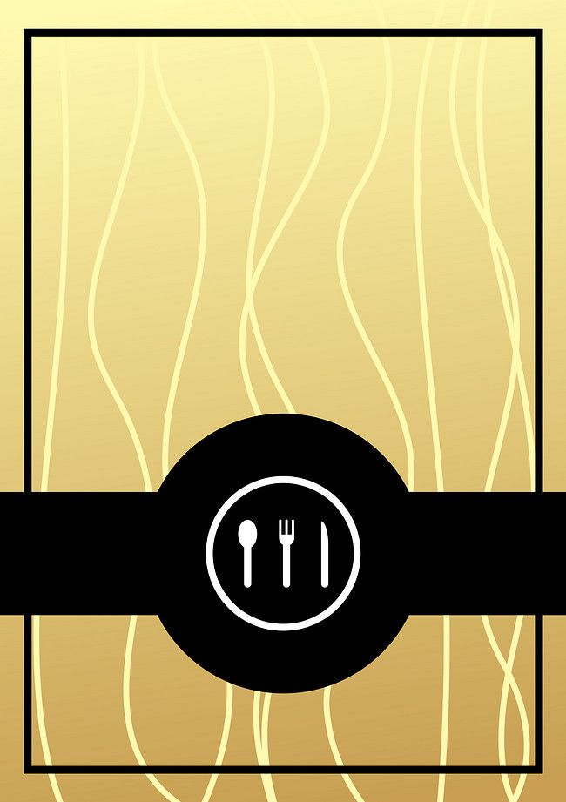


 `
Hotel
Trinity
Menu
A la Carte

Tel: 0191 972371
Any Allergies please inform member of Staff
Hamida Begum
BMIH4002
Student number: 2120540

Baked Brie (V) 95 Cal (1oz)
With lightly toasted sliced Baguette, topped with roasted walnuts.
Crispy Tuna kebabs (served with salad)
Shredded Tuna mixed with finely chopped peppers; a mix blend of spices, light fried in oil.
£ 9.00
£ 8.50
Bruschetta (V) 93 Cal
Crispy toasted bread topped with Ricotta cheese, finely chopped tomatoes, onions covered in balsamic vinegar, avocado.
£6.50
Honey roasted Carrot soup (V) 70 Cal
Honey Glazed carrots blended with a hint of spice, comes with bread.
£4.50
£5.50
Vegetable pockets (V) 60 Cals
Spiced Vegetables in Filo Pastry shallow fried in Oil.
Starter
]
£10
£20
£15
Orange leaf Scallops 60 Cals
Shallow fried scallops in garlic Butter, thyme & orange flavouring with a hint of Sea Salt.
Served best with Chardonnay. (Please note there will be an extra charge for the wine).

Grilled Chicken Salad (H) 90 Cals
Peri peri Grilled chicken, on a bed of Italian salad with homemade curried Mayonnaise.
Braised Lamb Shank (H) 100 Cals
Slow cooked to Perfection with Aromatic Spices infused in the lamb, served with creamy Mash Potatoes
Why not try our finest Wine Grenache/ Sangiovese (Brunello di Montalcino
(Please note there will be an extra charge for the wine).
£15
Glazed Salmon (V) 100 Cals
Honey Glazed Salmon Chargrilled with a Hint of spice, on a bed of Spice infused couscous & Vegetables.
Try with our 6year old Sauvignon Blanc all the way from New Zealand.
(Please note there will be an extra charge for the wine)
Main Course
Loaded Brownies
Gooey-licous Brownie served on a hotplate topped off with chocolate Ganache sauce & sea salt. (Best served with Cream).
(Best served with Sauvignon Blanc)
£15
Trio of cheesecakes
A buttery Biscuit base filled with creamy soft cheese.
3 flavours of cheesecakes
White chocolate & Pistachio, chocolate & Hazelnut & Mango Passionfruit.
(Best served with our finest bottle of Riesling)

£10
£10
Sticky Toffee Pudding
Feel the warmth with our warm Sticky toffee pudding, served with our finest delicious toffee sauce & Vanilla Clotted Ice cream.
(Best served with our finest bottle of Sherry)
£14.99
Pistachio & white chocolate Baklava
Freshly made with filo pastry, finely crushed Pistachio’s covered in our home-made sugar Syrup & white chocolate.
Served with Vanilla ice cream. (Made at the table)
Dessert
Reference
Decanter (2021) Best wine with Lamb: great styles to try. Available at:
https://www.decanter.com/learn/food/wine-with-lamb-easter-food-matching-296118/
(Accessed: 10 June 2022)

Winefolly our advice for pairing wine with salmon, (Basic to pairing wine with salmon)
Available at: https://winefolly.com/wine-pairing/pairing-wine-with-salmon/
(Accessed: 10 June 2022)

Just a little bit of bacon (2017) Rich Pistachio & chocolate baklava. Available at: https://www.justalittlebitofbacon.com/rich-pistachio-chocolate-baklava/
Axxsessed at: (12 June 2022)

