

Student name: Rabeya Payel
Student ID:2513891
Module name: Introduction To Health & Social Care.
Module code: LCHS4003
Lecturer name Shepherd Ziko
Content page

Element 1 Poster ………………………………………………. 3
Element 2
The Development and Importance of Ambulance Services in the UK
Introduction………………………………………………. 4
Origins of Ambulance Services……………………………………4
Current Functioning of Ambulance Services…………………….4-5
Importance for Service Users……………………………………5
Conclusion…………………………………………………………..5
Reference………………………………………………………….6-7

Current Care Home:


Conclusion
In conclusion, residential care homes play critical role in supporting individuals who cannot live independently. Care homes offer safe environment with personal care, emotional support and improve the service user’s quality of life. Over time, care home became an important part of UK’s Health and social care system. However, care homes face significant challenges such as financial pressure and staff shortages, which can affect the quality of care provided to the residents. To ensure care homes provide the high-quality of care to its residents ongoing investment, improved staffing, and better support system are essential.

Source: Capacity Tracker
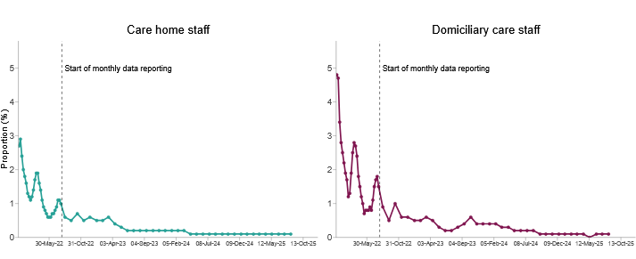
Key Challenges: 1. Financial Pressure: Financial challenge is a big problem for residential care home. Challenges such as increasing operational costs, limited resources. The financials challenges in care homes have been on the rise. The care homes are under pressure because of the increasing wage bills, including national living wage rate. In addition, there have been situations where the increased resources have not matched the increasing cost care delivery. Because of that care homes face challenges in maintaining high quality care service to residents (Moore Kingston Smith,2026)
2.⁠ ⁠Workforce Shortages: The second challenge facing the NHS is the workforce shortages. There are not enough qualified staff to provide mental health support. Many NHS organizations are facing a challenge in recruiting qualified staff such as mental health nurses. Due to the staff shortages experienced by the NHS some people may not get the support they need on time and This can worsen their health condition (NHS Providers, 2019).
How Residential Care Homes Function Today: Now residential care homes function as supportive living environments which provides accommodation and personal care services to individuals who cannot live independently due to age related issues, illness or disability. Residential care homes provide 24-hour support services from trained caregivers who assist residents with their daily needs while maintaining their safety and well-being. One of the major ways that residential care home’s function is by offering personal care services to their residents. These services can include assistance with bathing, dressing, eating and mobility. The patience can have physical disability, a learning disability, mental health problems, addiction or other care needs. The worker enables residents to maintain their dignity while receiving assistance with daily activities. Also, residential care homes provide meals and nutrition services to their residents. The caregivers may aid residents who require medication. Residential care homes also provide social services through games, exercise sessions, and social activities that enhance the mental well-being of their residents. (Carehome.co.uk, 2025)

Why Residential Homes?
Residential care home offers accommodation and personal care for the people who are unable to live independently because of various factors such as age, disability, illness or mobility difficulties. These services include personal care that involves assisting people who are unable to perform their daily activities without assistance. The main goal in a residential care setting is to support older people with dignity, ensuring they can enjoy as much independence as possible, while still receiving the care and support they need. Residents of them are usually the elderly or disabled people who need regular supervision and assistance. Residential care homes is different from nursing care homes as they do not offer medical care to the patients. They offer personal care services. But Healthcare workers such as general practitioners, community nurses and therapists often visit the patients. Overall, Residential care homes play a vital role in the UK health care system since they offer a safe environment, emotional support, and personal care services to people who are unable to live independently (Oakdene Care,2025).

Brief History: The concept of care homes in the United Kingdom can go back to medieval times when charitable institutions also referred to as almshouses were established to meet the needs of old and disadvantaged individuals. The first care home was established in York in 936 AD and religious institutions and wealthy individuals offered support to those people who were poor and unable to provide for themselves. These homes were supported through charitable donations and had a close association with religious institutions. In the 17th and 18th centuries social care started to be associated with the Poor Laws which introduced institutions such as workhouses. These institutions offered support to elderly, handicapped and poor individuals. However, these homes offered very poor living conditions. With the increasing population and urbanization in the 19th century it was more structured form of residential care. This included charitable homes and nursing homes that offered support and healthcare to individuals. But in the 20th century there was a major shift on care homes when the National Health Service (NHS) was established in 1948. This improved healthcare services in the UK. The traditional concept of old individuals’ homes gradually emerged to become care homes that offered support to individuals who required assistance with daily living and healthcare. Currently care homes play a critical role in healthcare and social care services. They offer support and healthcare to elderly and disadvantaged individuals. Care homes not only focus on providing physical support to individuals but also promote independence and a high quality of life (Carehome.co.uk, 2025).

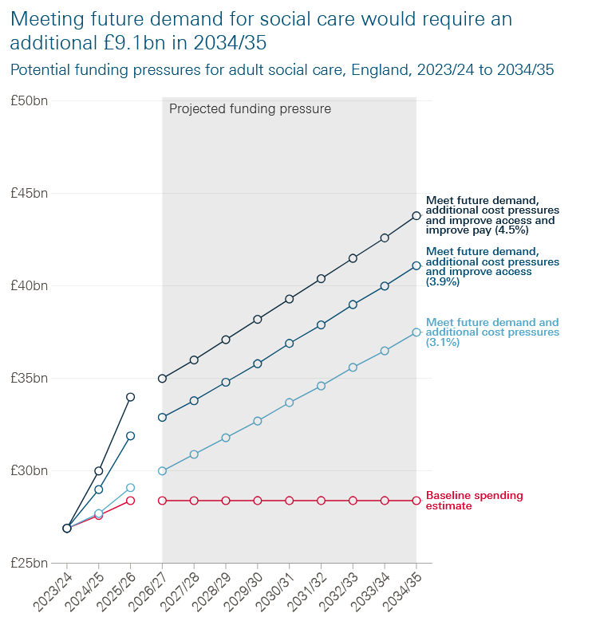
Source: The Health Foundation

- old almshouse

Residential Care Homes
Name: Rabeya Payel Course Name: Introduction To Health & Social Care

Element 2
The Development and Importance of Ambulance Services in the UK
Introduction
In today's UK time ambulance services are a lifeline in the health system providing urgent medical care and transportation for those in need of immediate medical attention. Ambulance services are a bridge connecting people with hospital care. They are at the heart of the urgent and emergency care system and in this report, we will investigate how they came into being, how they are used today and their importance in enhancing people's quality of life.
Origins of Ambulance Services
The concept of ambulance services dates to the late 1800s when a cart pulled by a horse was used to carry people who were injured to hospitals for medical attention. This concept emerged in urban cities where people were more likely to be injured in their places of work.
In the UK ambulance services began to take shape in the early 1900s with a major milestone in 1948 when National Health Service (NHS) was formed which included ambulance services. This meant that medical transport was made available for everyone in the UK and people could receive emergency medical care for free.
After that ambulance services have evolved from simple medical transportation vehicles into emergency medical services that are able to offer medical care on their way to hospital. The days of transporting patients with just a stretcher, a splint and some basic breathing apparatuses are long gone. We now have an ambulance fleet fit for the 21st century including fully electric ambulances, sophisticated technology, life-saving medications and interventions, as well as up to date digital equipment to aid response to patients (London Ambulance Service NHS Trust,2025)
Current Functioning of Ambulance Services
Today ambulance services operate as part of the NHS and provide both emergency and non-emergency medical transport. The UK currently has several regional ambulances trusts responsible for services in England, Scotland, Wales and Northern Ireland. Additionally, The Patient handover time from ambulance to hospital is fast now. The average time nationally was 30 minutes and 56 seconds. However, there’s significant variation country-wide, with one ambulance trust reporting a mean time of 18 minutes and 49 seconds and the longest mean time at 51 minutes and 3 seconds (NHS Providers,2024).
Modern ambulance service has many functions such as: In 2017 the NHS introduced new ambulance standards to ensure the best, most appropriate response is provided for each patient first time. Emergency call handlers get calls from the 999 system and dispatch ambulances to emergency places. Now The Call handlers will change the way they assess cases and will have slightly more time to decide the most appropriate clinical response. As a result, cardiac arrest patients can be identified quicker than ever before, with evidence showing this could save up to 250 lives every year. Ambulances will now be expected to reach the most seriously ill patients in an average time of seven minutes. The ‘clock’ will only stop when the most appropriate response arrives on scene rather than the first. This will free up more vehicles and staff to respond to emergencies. Currently, three or even four vehicles may be sent to the same 999 call to be sure of meeting the 8-minute target, meaning that across the country one in four are stood down before reaching their destination According to independent analysis of what has been the world’s largest clinical ambulance trial, the new standards mean that up to 750,000 calls a year that currently go into a queue will get an immediate response (NHS England,2017).
Importance for Service Users
Ambulance services do a lot more than just get people from A to B. They save lives by speeding up access to urgent medical treatment such as the event of a heart attack, stroke or other serious injury or health related issues by helping to avoid more complications and reduce the number of deaths. They can also provide a sense of security for a community that help coming as soon as possible in medical emergency. This is more important for vulnerable groups such as the old people and those who suffer from chronic conditions and need quick medical transportation. They can help reduce the pressure that hospitals face by helping by providing medical help in the community and the Ambulance staff work with passion and commitment in some of the most pressured environments and across complex geographies providing compassionate care to patients (NHS, England 2024).
Conclusion:
Ambulance services have evolved considerably from their early origins as basic transport systems and crucial part of the healthcare system in the UK. However, the sector experience significant, systemic pressures, with high demand and performance, staff shortage and in some cases delays in attendance that affects patient’s safety. Despite facing all these challenges with fast response times, clinical expertise in the field and safe transportation for patients’ ambulances play a vital role in protecting public health.

Reference

Carehome.co.uk (2025) A history of care homes. Available at: https://www.carehome.co.uk/advice/a-history-of-care-homes (Accessed: 15 March 2026).
Carehome.co.uk (2025) What is a residential care home? Available at: https://www.carehome.co.uk/advice/what-is-a-residential-care-home (Accessed: 15 March 2026).
Carehome.co.uk (2025) Care home stats: number of settings, population and workforce. Available at: https://www.carehome.co.uk/advice/care-home-stats-number-of-settings-population-workforce (Accessed: 15 March 2026).
Department of Health and Social Care (2025) Adult social care in England: monthly statistics, September 2025. Available at: https://www.gov.uk/government/statistics/adult-social-care-in-england-monthly-statistics-september-2025/adult-social-care-in-england-monthly-statistics-september-2025 (Accessed: 15 March 2026).
London Ambulance Service NHS Trust (2025) Our history. Available at: https://www.londonambulance.nhs.uk/about-us/our-history (Accessed: 15 March 2026).
Moore Kingston Smith (2026) How can care homes respond to the financial challenges they face? Available at: https://mooreks.co.uk/insights/how-can-care-homes-respond-to-the-financial-challenges-they-face/ (Accessed: 15 March 2026).
NHS England (2017) New ambulance service standards announced. Available at: https://www.england.nhs.uk/2017/07/new-ambulance-service-standards-announced (Accessed: 15 March 2026).
NHS Providers (2019) Mental health services: Addressing the care deficit – The workforce challenge. Available at: https://nhsproviders.org/resources/mental-health-services-addressing-the-care-deficit/the-workforce-challenge (Accessed: 15 March 2026).
NHS Providers (2024) NHS activity tracker 2024/25: Ambulance sector – August 2024. Available at: https://nhsproviders.org/resources/nhs-activity-tracker-202425/august-2024/ambulance-sector
(Accessed: 15 March 2026).
NHS England (2024) Culture review of ambulance trusts. Available at: https://www.england.nhs.uk/long-read/culture-review-of-ambulance-trusts (Accessed: 15 March 2026). ￼
Oakdene Care (2025) What is a residential care home and who does it benefit? Available at: https://www.oakdenecare.co.uk/news-events/what-is-a-residential-care-home-and-who-does-it-benefit (Accessed: 15 March 2026).
Paperclip (2025) Care homes. Available at: https://www.paperclip.co.uk/care-homes/ (Accessed: 15 March 2026).
The Health Foundation (2023) Adult social care funding pressures 2023–2035. Available at: https://www.health.org.uk/reports-and-analysis/analysis/adult-social-care-funding-pressures-2023-35 (Accessed: 15 March 2026).

